**Task 4**

In this task we will perform multiple subtask one by one. First of all we lean about regexpression as shown below I perform multiple expression on access.log file as shown below

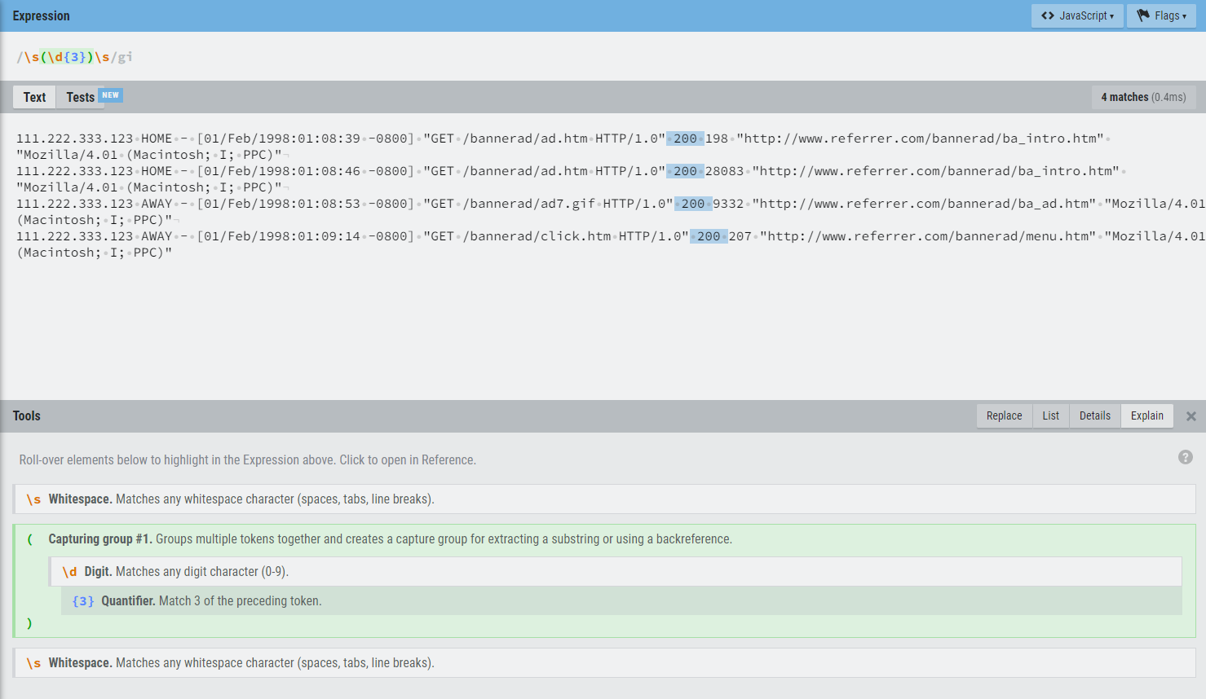

Now we will use this expression in our python file to check where it work to find the status code in file. As shown below in code

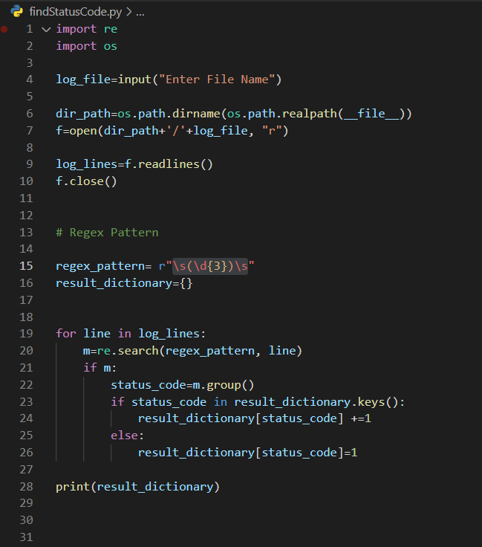

Above code will help us to find the dictionary result for status code in log file output for this log is

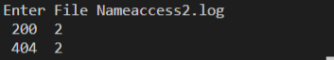

Now after that status code we will perform it on ip address. We have a regex for ip address as shown in below code we will run the following code for out put

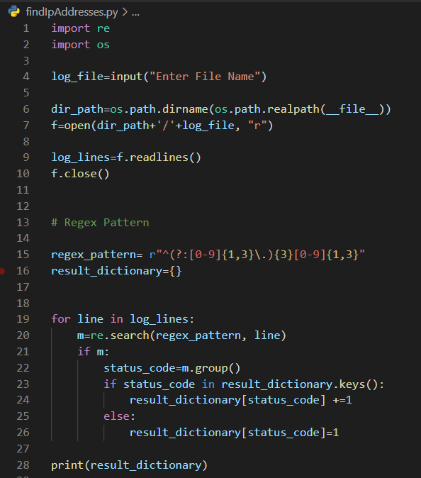

When we run the above code we get the following output



Above output shows the number of count of accurance of each output.

Now let’s use another regex for wild card entry to detect any kind of hacking in our web server

Following code will trace any wild card access on our server

