**Wallet Instructions**

**Step One:**

Download either the Connect.me or IdRamp Digital Wallet App for your phone from either the Apple App Store or Google Play.

](https://idramp.com/passport-identity-wallet/)*

**Step Two:**

Follow your new mobile wallet instructions to set up your profile.

**Step Three:**

From the Teacher Wallet site select “WALLETS”

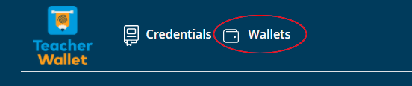

**Step Four:**

Choose “Connect your wallet.” This will generate a unique QR code.

**Step Five:**

Scan this QR code with the mobile wallet app. This will create a connection.

**Step Six:**

Share desired credentials from the Teacher Wallet with your mobile wallet.