Simulating Time-Varying Estimators to Understand Potential Bias and Precision in Policy Effects

Methods

Observed Data
We used data on observed opioid-related overdoses between 1999 and 2016, obtained from the 1999-2016 National Vital Statistics System – Multiple Cause of Death mortality files. Opioid-related overdose deaths were identified using the ICD-10 external cause of injury codes X40-X44, X60-64, X85, and Y10-14. We aggregated injury codes and calculated state-level overdose rates per 100,000 state residents. We also included state-level unemployment rate per 100 state residents as covariate in included model specifications, given the close association between unemployment and overdose mortality.

Simulated Treatment and Outcome
We simulated treatment status by state and year so we could assess relative model performance under a known data-generating process. To do so, we built on prior simulation work which has compared the performance of statistical methods in recovering policy effects on total firearm deaths and opioid-related mortality (Schell, Griffin, Morral, 2018; Griffin et al., 2021; Griffin et al., 2023).
To do so, for each state and year, we generated a binary-indicator $T_{i,t}$ which indicated whether a hypothetical overdose policy had been in effect between 1999 and 2016. Once a policy was in effect, the state remained treated for all remaining years. Control states were coded as $T_{i,t} =0$ for the entire study period. For each simulation dataset, we randomly selected a given number of treated states, and applied treatment to a randomly selected year. We created simulation datasets for 5, 25, and 45 states being treated across the time-period (for more detail on simulation scenario, see section X).
We then generated synthetic outcomes for treated states based on four time-varying effect scenarios. For control units, we set the outcome variable to be the same as the observed state-specific, year-specific opioid overdose rate. For treated units, we set the outcome value to be equal to the observed state-specific, year-specific opioid overdose rate ($Y_{i,t})$, augmented by a synthetic policy effect ($α_{t}$) which differed based on the number of years since initial treatment:
$Y_{i,t}^{*}=Y_{i,t}+ \sum_{t = 1}^{5}{α_{t}}$
We chose values of simulated policy effects to be small, within a 10% change from the annual mortality rate across states, which corresponded to standardized mean difference between 0 and 0.2 (Cohen, 2013). Figure X displays the four scenarios we applied to treated units as standardized mean differences. These scenarios were meant to reflect policy effects analysts could reasonably encounter in applied work, specifically, a policy which takes five years to ramp up until a full effect is achieved; a policy which has wide participation in year one and is slowly sunset; a policy which responds to a shock and takes time to apply, then is rescinded; and a policy which takes time to ramp up, then is sunset after a full effect is achieved.

Bad Figure X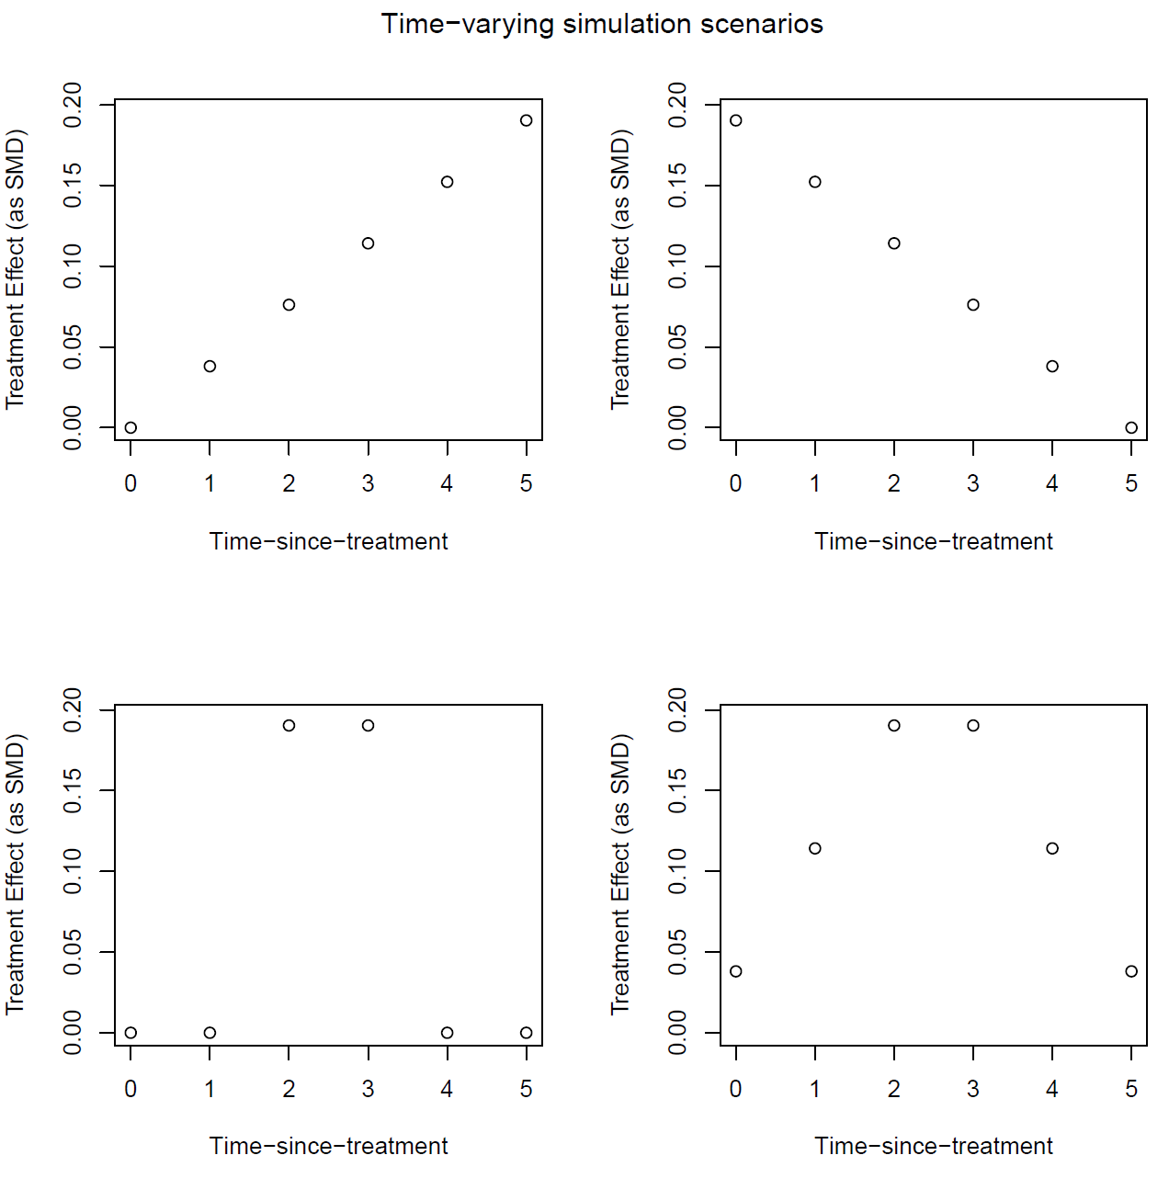
We generated 1000 simulated datasets for each simulation scenario, which varied in the number of treated units (10, 25, or 40 treated states) or assumed time-varying policy effects (e.g. Figure X).

Empirical Methods
We compared results from seven statistical models applied to the simulated datasets: (1) An event study (ES); (2) An event study with a one-period lagged autoregressive term (AR); (3) An augmented synthetic control model (ASCM) with staggered; (4) A Callaway and Sant’Anna staggered adoption difference-in-difference estimator (CSA); (5) A Sun and Abraham event study model (SA); (6) A two-stage difference-in-difference estimator (G); and (7) a difference-in-difference imputation estimator (BJS). We briefly describe how we estimated time-varying treatment effects using each of these methods in the following section.

Event Study
Event study models are commonly used to estimate time-varying treatment effects using longitudinal data. This approach estimates time-varying treatment effects using a binary indicator corresponding to the number of periods since treatment was implemented. This model aims to control for confounding using unit and time fixed effects, along with covariate adjustment. For all considered models, we estimated treatment effects using the following specification:
$$Y_{i,t}^{*}= \sum_{j= -m}^{m}{γ_{j}}{·D}_{i,t-j}+ α_{i}+ δ_{t}+β·X_{i,t}+ϵ_{i,t}$$
Where $γ_{j}$ is an estimated effect for event-time $j$. The event-time indicates a period relative to the first year of treatment. For example, if a policy was adopted in 2014 and the year was 2016, then the event-time would be two years ($j=2)$ while if the year was 2010, the event-time would be four years past ($j$ = -4). $D_{i,t-j}$ is an indicator variable for treatment status in event-time, which equals one if treatment occurred within exactly $j$ periods since year $t.$ $-m, m$ denotes start and endpoints in event-time, which can differ depending on when a state $i$ was first treated. Throughout this paper, we only display results for j = {1, 5}, though we estimated effects for all anticipation periods (i.e., $j$ < 0) and additional treatment event-periods (i.e., $j>5)$.
The specification also includes unit and time fixed effects ($α_{i}$ and $δ_{t}$, respectively). Like a difference-in-difference estimator, the fixed effects remove time-invariant confounding between treated and untreated units. We also adjusted the model for an additional confounder $X_{i,t}:$ the unemployment rate.

Event Study with Autoregressive Term
We also estimated an event study model using an autoregressive term rather than a fixed effect. This model may improve estimation of treatment effects when outcomes are highly autocorrelated.
$$Y_{i,t}^{*}=\sum_{j= -m}^{5}{t_{j}}{·D}_{i,t-j}+ Y_{i,t-1}^{*}+ δ_{t}+β·X_{i,t}+ϵ_{i,t}$$
We only included a single lag term within estimated models.

Augmented Synthetic Control Model
We also considered a partially pooled augmented synthetic control model using staggered adoption (ASCM). ASCM is closely related to the synthetic control method, which uses untreated units to create a weighted synthetic control group that closely matches a single treated unit in pre-treatment outcomes and covariates. ASCM using staggered adoption extends the synthetic control method to settings with multiple treated units and improves the weighting of control units by adding a bias-correction procedure.
This approach uses two steps to estimate dynamic treatment effects. First, ASCM estimates separate synthetic control units for each treated unit by constructing weights. These weights are determined using a partial pooling approach to minimize imbalance between pre-treatment outcomes in treated units and the weighted average control unit. Second, using this weighted average control unit and additional adjustment covariates, ASCM solves an optimization problem to estimate a synthetic counterfactual outcome under control for each treated unit. This counterfactual outcome is then used to calculate time-varying treatment effects for a given number of post-treatment periods. Across synthetic datasets and simulation scenarios, we estimated treatment effects using ASCM for five years after treatment using unemployment rate as an additional adjustment covariate. We used the augsynth v0.2 R package for all estimated models.

Callaway and Sant’Anna
We examined estimation of time-varying treatment effects using an approach to difference-in-difference analysis suggested by Callaway and Sant’Anna, 2021. This approach comprises two steps for estimating an average treatment effect: (1) estimating cohort average treatment effects, (2) aggregating cohort average treatment effects into a measure of the average treatment effect. Cohort-specific average treatment effects correspond to estimates of the treatment effect for units which received treatment at the same time.
For step one, we employed a doubly-robust estimator. This estimator uses a combination of probability weighting and an outcome regression to construct a consistent estimate of the treatment effect, when either the probability weighting model or outcome regression model is correctly specified. For step two, we weighted estimated group-time average treatment effects into dynamic treatment effects, following procedures in Callaway and Sant’Anna, 2021. We used the DID v2.1.2. package in R to estimate all models.

Sun and Abraham event study
Sun and Abraham, 2021 provide an alternative two-step estimation strategy to calculate time-varying treatment effects. In the first step, an event-study design is modified to use cohort-specific interaction terms rather than event-time interaction terms. Then, the estimated cohort-specific interaction estimates are weighted by the relative share of each cohort within an event-time period, then aggregated to construct time-varying treatment effects. We estimated Sun and Abraham event study models using the Fixest v0.11.1 package in R.

Two-Stage Difference-in-Differences
We estimated an additional set of models using the two-stage difference-in-difference design adapted to event-studies, as proposed by Gardner, 2022. This approach, as the name suggests, uses two steps to estimate time-varying treatment effects. However, this approach differs from Callaway and Sant’Anna, and Sun and Abraham by instead estimating an “imputed” treatment effect for untreated groups, rather than weighting estimated treatment effects of various treated groups.
In the first stage, two-stage difference-in-difference constructs an outcome model using only untreated observations (both control units and before-treatment units) to estimate fixed effects for group and time. Then the estimated fixed effects are subtracted from observed outcomes and the adjusted outcome is regressed on event-time indicator variables to estimate time-varying treatment effects.

Difference-in-Difference Imputation Estimator
The last model we estimated across simulation scenarios was a difference-in-difference estimator using an imputation form. This estimator follows a similar strategy to two-stage difference-in-differences, starting with an outcome model which uses untreated observations to estimate fixed effects for group and time. However, rather than adjusting the outcome variable using these fixed effects, instead this approach predicts (“imputes”) a counterfactual untreated outcome based on the fixed effect parameters. Then for each treated unit and time, the counterfactual outcome is subtracted from the observed outcome to obtain unit-time-specific treatment effect. Lastly, the unit-time treatment effects are averaged by event-time to construct average event-time treatment effects.

Performance Metrics
For each empirical dataset and simulation scenario, we calculated performance metrics across simulations to assess average standardized bias, average effect variance, root mean squared error across simulations, and coverage. More formally,
- Average Standardized Simulation Bias. For each empirical method, we calculated the average difference across simulations between the estimated effect and the true effect. To ensure bias was on a similar scale independent of differing effect sizes by time-since-treatment scenario, we report standardized bias by dividing estimated bias by the estimated standard deviation of the outcome within a given simulation iteration. So, $Bias_{α_{t}}=\sum_{k=1}^{1000}{\frac{|{\hat{α}}_{t,k}-α_{t}|}{1000*sd({Y^{*}}_{i,t})}}$
- Average simulation variance. We also calculated the average variance of estimated effects across simulations to interpret the precision of included methods. $\overline{var_{α_{t}}}=\sum_{k=1}^{1000}{var({\hat{α}}_{t,k})}$
- Variance of mean simulation effects. In addition to summarizing the variance of estimated effects, we summarized the variance of mean estimated effects across simulations. $Var_{α_{t}}=\sum_{k=1}^{1000}{\frac{{\left({\hat{α}}_{t,k}-mean\left({\hat{α}}_{t,k}\right)\right)}^{2}}{1000}}$
- Root Mean Squared Simulation Error. We calculated RMSE quantify the simulation error of modeling procedures considering bias and variance in tandem, calculated as follows: $RMSE_{α_{t}}= \sqrt{\sum_{k=1}^{1000}{\frac{{\left({\hat{α}}_{t,k}-α_{t}\right)}^{2}}{1000}}}$
- Coverage: Lastly, we calculated the percentage of iterations by method procedure in which the 95% confidence interval of the estimated event-time contained the true policy effect.
All simulations were conducted in the OPTIC v1.0.1. package in R. Code for reproducing the simulations, as well as the empirical data is available in Github.

Bibliography
Cohen, J. (2013). Statistical power analysis for the behavioral sciences. Academic press.
Griffin, B.A., Schuler, M.S., Stuart, E.A., Patrick S., McNeer, E., Smart, R., Powell, D., Stein, B.D., Schell, T.L., & Pacula, R.L. (2021). Moving beyond the classic difference-in-differences model: a simulation study comparing statistical methods for estimating effectiveness of state-level policies. BMC medical research methodology 1-19.
Griffin, B.A., Schuler, M.S., Stone, E.M., Patrick, S.W., Stein, B.D., Lima, P.N.D., Griswold, M., Scherling, A., & Stuart, E.A. (2023). Identifying Optimal Methods for Addressing Confounding Bias When Estimating the Effects of State-level Policies. Epidemiology 34, no. 6. 856-864.
Schell, T. L., Griffin, B. A., & Morral, A. R. (2018). Evaluating methods to estimate the effect of state laws on firearm deaths: A simulation study.

