Simulating Time-Varying Estimators to Understand Potential Bias and Precision in Policy Effects

Methods

Our simulated data comprise annual state-level data on the outcome (opioid-related mortality) and control covariate (unemployment rate). The policy variable represents a hypothetical policy intended to reduce opioid-related mortality and is simulated to reflect staggered policy adoption. The study was approved by the corresponding author’s Institutional Review Board with a waiver of consent (Assurance Number: FWA00003425).
Causal inference notation and primary treatment effects of interest
Using potential outcomes notation, let Yit1 denote the potential outcome for state i (i=1,…,50) if the policy was in effect at time t, while Yit0 denotes the potential outcome for state i if the policy was not in effect at time t. Thus, each state has two potential outcomes at each time point, representing the mortality rates that would be observed with and without the policy in effect. Our primary treatment effect of interest is E[Y1-Y0], averaging across both states and times. Let Ait= {0,1} denote an indicator for whether state i had the policy in effect at time t (where t=1,…,T). Then, Yitobs= Yit1*Ait+Yit0*1-Ait denotes the observed outcome for state i at time t as measured longitudinally for state i over time t=1,…,T. Let Xit denote the observed time-varying covariate of unemployment rate at the state level which was included in all models discussed below.

Empirical Methods
We compared results from seven statistical models applied to the simulated datasets: (1) an event study (ES); (2) an event study with a one-period lagged autoregressive term (AR); (3) an augmented synthetic control model (ASCM) with staggered adoption; (4) a Callaway and Sant’Anna staggered adoption difference-in-difference estimator (CSA); (5) a Sun and Abraham event study model (SA); (6) a two-stage difference-in-difference estimator (G); and (7) a difference-in-difference imputation estimator (BJS). We briefly describe how we estimated time-varying treatment effects using each of these methods in the following section. We chose these models based on previous policy simulation studies and on recently proposed design-based methods for addressing time-varying effect heterogeneity in policy evaluations. The models differ in how they address confounding effect heterogeneity in longitudinal DID-type studies.

Event Study
Event study models are commonly used to estimate time-varying treatment effects using longitudinal data. This approach estimates time-varying treatment effects using a binary indicator corresponding to the number of periods since treatment was implemented. This model aims to control for confounding using unit and time fixed effects, along with covariate adjustment. For all considered models, we estimated treatment effects using the following specification:
$$Y_{i,t}^{*}= \sum_{j= -m}^{m}{γ_{j}}{·D}_{i,t-j}+ α_{i}+ δ_{t}+β·X_{i,t}+ϵ_{i,t}$$
Where $γ_{j}$ is an estimated effect for event-time $j$. The event-time indicates a period relative to the first year of treatment.j=2)j. $D_{i,t-j}$ is an indicator variable for treatment status in event-time, which equals one if treatment occurred within exactly $j$ periods since year $t.$ $-m, m$ denotes start and endpoints in event-time, which can differ depending on when a state $i$ was first treated. Throughout this paper, we only display results for j = {1, 5}, though we estimated effects for all anticipation periods (i.e., $j$ < 0) and additional treatment event-periods (i.e., $j>5)$. The specification also includes unit and time fixed effects ($α_{i}$ and $δ_{t}$, respectively). Like a difference-in-difference estimator, the fixed effects remove time-invariant confounding between treated and untreated units. Xi,t:Standard errors from this model were estimated by applying a cluster adjustment. We estimated the model using the XXX command in R and the YY command for performing the needed cluster adjustment.

Event Study with Autoregressive Term
We also estimated an event study model using an autoregressive term rather than a fixed effect for state. Previous simulation studies demonstrated that autoregressive models perform very well for estimating state policy effects. These models include one or more lagged measures of the outcome variable (e.g., Yit-1obs) as covariates to control for potential confounding from differences in prior outcome trends across treated and comparison states. As such, these models improve estimation of treatment effects when outcomes are highly autocorrelated, as with annual measures of state-level opioid-related mortality. Of note, the event study specification of the autoregressive model has not yet been examined and we test this specification which only includes a single lag since partial autocorrelation plots support that one lag should suffice:
Yi,t*=j= -m5tj·Di,t-j+ γ·Yi,t-1*+ δt+β·Xi,t+ϵi,t
We estimated the model using the XXX command in R and note that no cluster adjustment was performed since prior simulation results have shown that use of the cluster adjustment is not needed here.

Augmented Synthetic Control Model
We also considered a partially pooled augmented synthetic control model (ASCM) for the staggered adoption setting. ASCM is closely related to the synthetic control method, which uses untreated units to create a weighted synthetic control group that closely matches a single treated unit in pre-treatment outcomes and covariates. ASCM for staggered adoption extends the synthetic control method to settings with multiple treated units and improves the weighting of control units by adding a bias-correction procedure. This approach uses two steps to estimate dynamic treatment effects. First, ASCM estimates separate synthetic control unit weights for each treated unit by using a partial pooling approach to minimize imbalance between pre-treatment outcomes in treated units and the weighted average control unit. Second, using this weighted average control unit and additional adjustment covariates, ASCM solves an optimization problem to estimate a synthetic counterfactual outcome under control for each treated unit. This counterfactual outcome is then used to calculate time-varying treatment effects for a given number of post-treatment periods. We used the augsynth v0.2 R package for all estimated models using the YYY option to obtain inference/standard errors.

Callaway and Sant’Anna
We also examined estimation of time-varying treatment effects using an approach to difference-in-difference analysis suggested by Callaway and Sant’Anna, 2021. This approach comprises two steps for estimating an average time-varying treatment effects across years since enactment. First, it estimates cohort-specific time-varying treatment effects and then it aggregates those cohort average treatment effects into measures of the average time-varying treatment effect across the sample. This estimator uses a combination of probability weighting and an outcome regression in step 1 to construct a consistent, doubly-robust estimate of the time-varying treatment effect, when either the probability weighting model or outcome regression model is correctly specified. Cohort-specific average treatment effects correspond to estimates of the time-varying treatment effect for units which received treatment at the same time. For step 2, the estimator weights estimated group-time average treatment effects into a final set of time-vary effects across the sample. We estimated this model following procedures in Callaway and Sant’Anna, 2021 and used the DID v2.1.2. package in R to estimate all CSA models.

Sun and Abraham event study
Sun and Abraham, 2021 provide an alternative two-step estimation strategy to calculate time-varying treatment effects. In the first step, an event-study design is modified to use cohort-specific interaction terms rather than event-time interaction terms. Then, the estimated cohort-specific interaction estimates are weighted by the relative share of each cohort within an event-time period, then aggregated to construct time-varying treatment effects. We estimated Sun and Abraham event study models using the Fixest v0.11.1 package in R.

Two-Stage Difference-in-Differences
We estimated an additional set of models using the two-stage difference-in-difference design adapted to event-studies, as proposed by Gardner, 2022. This approach, as the name suggests, uses two steps to estimate time-varying treatment effects. However, this approach differs from Callaway and Sant’Anna, and Sun and Abraham by instead estimating an “imputed” treatment effect for untreated groups, rather than weighting estimated treatment effects of various treated groups. In the first stage, two-stage difference-in-difference constructs an outcome model using only untreated observations (both control units and before-treatment units) to estimate fixed effects for group and time. Then the estimated fixed effects are subtracted from observed outcomes and the adjusted outcome is regressed on event-time indicator variables to estimate time-varying treatment effects. We used the XX command in R to estimate these models.

Difference-in-Difference Imputation Estimator
The last model we estimated across simulation scenarios was a difference-in-difference estimator using an imputation form. This estimator follows a similar strategy to two-stage difference-in-differences, starting with an outcome model which uses untreated observations to estimate fixed effects for group and time. However, rather than adjusting the outcome variable using these fixed effects, instead this approach predicts (“imputes”) a counterfactual untreated outcome based on the fixed effect parameters. Then for each treated unit and time, the counterfactual outcome is subtracted from the observed outcome to obtain unit-time-specific treatment effect. Lastly, the unit-time treatment effects are averaged by event-time to construct average event-time treatment effects. We used the YY command in R to estimate these models.

Simulation Design
Since it is impossible to test model assumptions in practice, we used a simulation study with a known data-generating process to assess the relative performance of these statistical models under several different scenarios related to the potential time-varying effects of a state policy. We built our current work using prior simulation work which has compared the performance of statistical methods in recovering policy effects on total firearm deaths and opioid-related mortality (Schell, Griffin, Morral, 2018; Griffin et al., 2021; Griffin et al., 2023).

Observed Data
We used data on observed opioid-related overdoses between 1999 and 2016, obtained from the 1999-2016 National Vital Statistics System – Multiple Cause of Death mortality files. Opioid-related overdose deaths were identified using the ICD-10 external cause of injury codes X40-X44, X60-64, X85, and Y10-14. We aggregated injury codes and calculated state-level overdose rates per 100,000 state residents. We also included state-level unemployment rate per 100 state residents as covariate in all model specifications since it is frequently considered an important control covariate for state policy evaluations because unemployment rates tend to be associated with opioid-related mortality as well as likelihood of policy adoption.

Simulating Time-Varying Treatment Effects
We simulated treatment status by state and year so we could assess relative model performance under a known data-generating process.
To do so, for each state and year, we generated a binary-indicator $T_{i,t}$ which indicated whether a hypothetical state policy had been in effect between 1999 and 2016. Once a policy was in effect, the state remained treated for all remaining years. Control states were coded as $T_{i,t} =0$ for the entire study period. For each simulation dataset, we randomly selected a given number of treated states, and applied treatment to a randomly selected year.
We then generated synthetic outcomes for treated states based on four time-varying effect scenarios. For control units, we set the outcome variable to be the same as the observed state-specific, year-specific opioid overdose rate. For treated units, we set the outcome value to be equal to the observed opioid overdose rate ($Y_{i,t})$ for state i and year t, augmented by a synthetic policy effect ($α_{t}$) which differed based on the number of years since initial treatment:
$Y_{i,t}^{*}=Y_{i,t}+ \sum_{t = 1}^{5}{α_{t}}$
We chose values of simulated policy effects to be small, within a 10% change from the annual opioid-related mortality rate across states, which corresponded to standardized mean difference between 0 and 0.2 (Cohen, 2013). Figure X displays the four scenarios we applied to treated units as standardized mean differences. These scenarios were meant to reflect policy effects analysts could reasonably encounter in applied work, specifically: (i) a policy which takes five years to ramp up until a full effect is achieved; (ii) a policy which has wide participation in year one and is slowly sunset; (iii) a policy which responds to a shock and takes time to apply, then is rescinded; and (iv) a policy which takes time to ramp up, then is sunset after a full effect is achieved.

Bad Figure X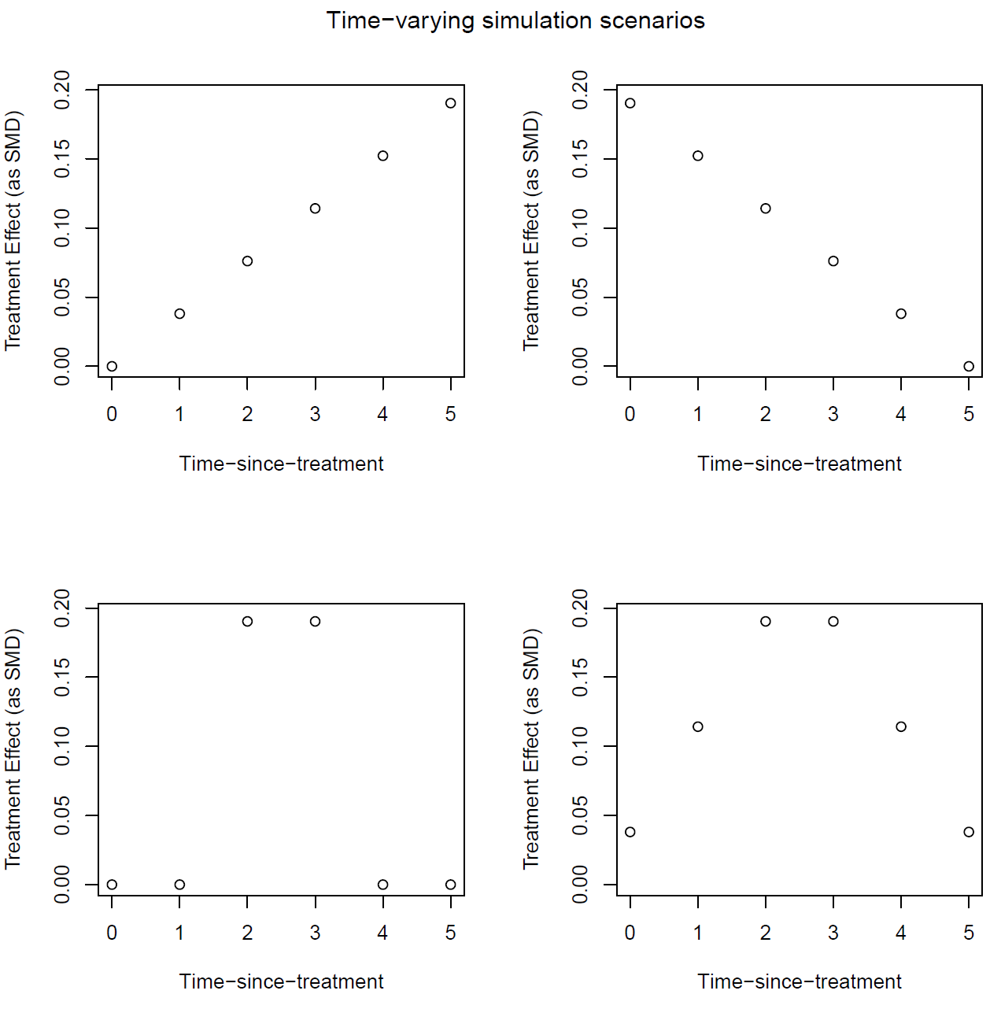
We generated 1000 simulated datasets for each simulation scenario, which varied in the number of treated units (10, 25, or 40 treated states) or assumed time-varying policy effects (e.g. Figure X).

Performance Metrics
For each simulation scenario, we calculated performance metrics across simulations to assess average standardized bias and variance, root mean squared error , and coverage for each time-varying effect αt for j = {1, 5}.

More formally,
Thinking we don’t have to talk about each of these…..since coverage should give us the story for average variance in 2. Can streamline these once confirm what we want to showcase in results section
- Average Standardized Simulation Bias. For each empirical method, we calculated the average difference across simulations between the estimated effect and the true effect to obtain bias. To ensure bias was on a similar scale independent of differing effect sizes by time-since-treatment scenario, we report standardized bias by dividing estimated bias by the estimated standard deviation of the outcome within a given simulation iteration. So, $Bias_{α_{t}}=\sum_{k=1}^{1000}{\frac{|{\hat{α}}_{t,k}-α_{t}|}{1000*sd({Y^{*}}_{i,t})}}$
- Average model variance. We also calculated the average variance of estimated effects across simulations to interpret the precision of included methods. $\overline{var_{α_{t}}}=\sum_{k=1}^{1000}{var({\hat{α}}_{t,k})}$
- Variance of mean simulation effects. Here we summarized the variance of mean estimated effects across simulations using: $Var_{α_{t}}=\sum_{k=1}^{1000}{\frac{{\left({\hat{α}}_{t,k}-mean\left({\hat{α}}_{t,k}\right)\right)}^{2}}{1000}}$
- Root Mean Squared Simulation Error. We calculated RMSE to quantify the simulation error of modeling procedures considering bias and variance in tandem, calculated as follows: $RMSE_{α_{t}}= \sqrt{\sum_{k=1}^{1000}{\frac{{\left({\hat{α}}_{t,k}-α_{t}\right)}^{2}}{1000}}}$
- Coverage: Lastly, we calculated the percentage of iterations by method procedure in which the 95% confidence interval of the estimated event-time contained the true policy effect.
All simulations were conducted in the OPTIC v1.0.1. package in R. Code for reproducing the simulations, as well as the empirical data is available in Github.
The appendix includes the code used to estimate the models and run the simulations

Bibliography
Cohen, J. (2013). Statistical power analysis for the behavioral sciences. Academic press.
Griffin, B.A., Schuler, M.S., Stuart, E.A., Patrick S., McNeer, E., Smart, R., Powell, D., Stein, B.D., Schell, T.L., & Pacula, R.L. (2021). Moving beyond the classic difference-in-differences model: a simulation study comparing statistical methods for estimating effectiveness of state-level policies. BMC medical research methodology 1-19.
Griffin, B.A., Schuler, M.S., Stone, E.M., Patrick, S.W., Stein, B.D., Lima, P.N.D., Griswold, M., Scherling, A., & Stuart, E.A. (2023). Identifying Optimal Methods for Addressing Confounding Bias When Estimating the Effects of State-level Policies. Epidemiology 34, no. 6. 856-864.
Schell, T. L., Griffin, B. A., & Morral, A. R. (2018). Evaluating methods to estimate the effect of state laws on firearm deaths: A simulation study.

