Software Requirements Specification (SRS) Document
< BIG LIBRARY, an electronic knowledge hub, Raghib Musarrat (IS201401036), Randhir Prakash (IS201401037)>

Feature requirements (described using use cases)

No. | User Case Name | Description | Release
 | USER | When the user open Web App for the first time they must have to register themselves and once they get registered then they get a unique Id and Password, by using that id and password the user can access the Web App..
 | CATEGORY | Divide the available books of user in various category like Autobiography ,Science fiction ,Novel etc.
 | USER INTEREST | Users will also have a separate record of their functionality.
 | BOOKS | Basically here user arrange their books according to their interest.
 | BOOK CATEGORY | Here user will aware with the various category of available book which help them in searching the books easily.
 | Shelf | It is like shelf in their cupboard where they can store their book and can read it later.
 | UPLOAD BOOK | It is like shelf in their cupboard where they can store their book and can read it later.

Use case diagram

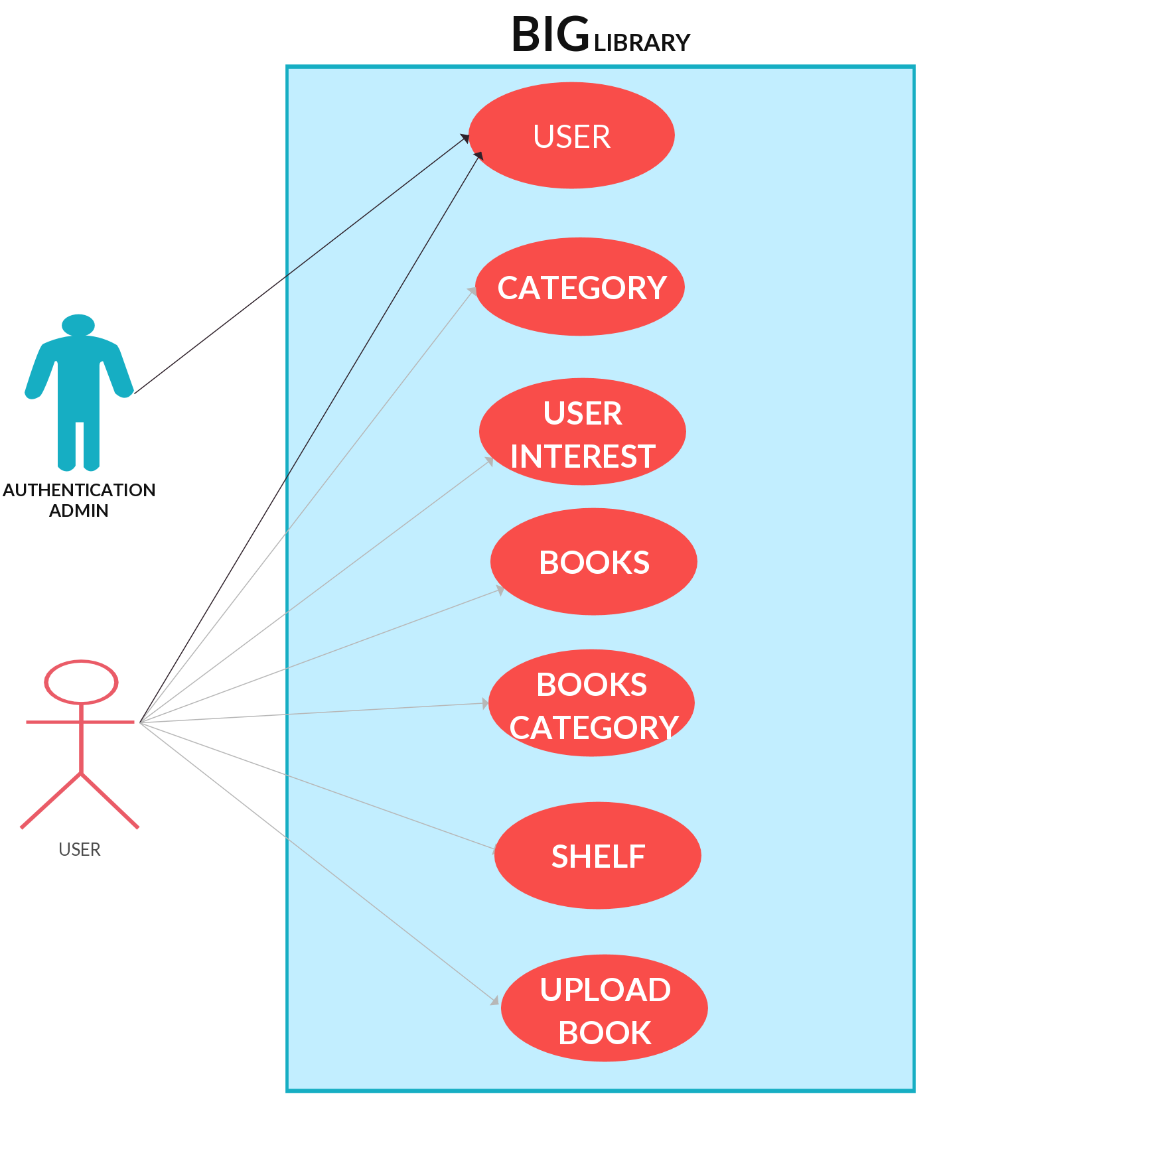

Use case description

Use Case Number: | UC-01
Use Case Name: | USER
Overview: | When the user open Web App for the first time they must have to register themselves and once they get registered then they get a unique Id and Password, by using that id and password the user can access the Web App.
Actors: | Admin
Pre  condition: | User must have either a mobile number or an email address to verify their authentication while signup for first time ,or the user must have their own unique Id and Password if they have registered themselves to the Web App.
Flow: | Main (success) Flow:  - If authentication completed then user gets a unique login Id and  Password and then able to access the web app.
Alternate Flow:
If users don’t have unique Id and password then they are not
able to access any functionality of the Web App.
Post Condition: | After getting a unique login ID and Password the user can access the Web App.

Use Case Number: | UC-02
Use Case Name: | CATEGORY
Overview: | Divide the available books of user in various category like Autobiography ,Science fiction ,Novel etc
Actors: | Users
Pre  condition: | User must have been login with their unique login Id and password.
Flow: | Main (success) Flow:  - User can able to arrange their books in various category  which help them in searching any particular books easily.
Alternate Flow:
It include only the feature of last use case and the users are
not able to complete the required task of current use case i.e they
can’t arrange their books in various category.

Post Condition: | At this stage user can able to read the available books as well as they can arrange their available books in various category.

Use Case Number: | UC-03
Use Case Name: | USER INTEREST
Overview: | Basically here user arrange their books according to their interest.
Actors: | Users
Pre  condition: | User must have login with their unique Id and Password.
Flow: | Main (success) Flow:  1) User can arrange the available books according to their interest
Alternate Flow:
It include only the feature of last use case and the users are
not able to complete the required task of current use case i.e they
can’t arrange their books according to their interest.

Post Condition: | At this stage user can able to read the available books and they can arrange their available books according to their interest.

Use Case Number: | UC-04
Use Case Name: | BOOKS
Overview: | Here user will aware with the details of books like the book category , and also whether the user have read this book or they want to read it later.
Actors: | Users
Pre  condition: | User must have login with their unique Id and Password.
Flow: | Main (success) Flow:  - User know the details of available book.  - Make aware that the user have already read that book or they want to read it in future.
Alternate Flow:
It include only the feature of last use case and the users are
not able to complete the required task of current use case i.e they
can’t aware with various details of available book .
Post Condition: | At this stage user can able to read the available books and they can arrange their available books according to their interest and they can also know the various details of the book.

Use Case Number: | UC-05
Use Case Name: | BOOK CATEGORY
Overview: | Here user will aware with the various category of available book which help them in searching the books easily.
Actors: | Users
Pre  condition: | User must have login with their unique Id and Password.
Flow: | Main (success) Flow:  1) User know the various category of available book.
Alternate Flow:
It include only the feature of last use case and the users are
not able to complete the required task of current use case i.e they
can’t aware with various category of available book and we need
to identify their category .
Post Condition: | At this stage user can able to read the available books and they can arrange their available books according to their interest and they can also know the various details and various category of the book easily.

Use Case Number: | UC-06
Use Case Name: | Shelf
Overview: | It is like shelf in their cupboard where they can store their book and can read it later.
Actors: | Users
Pre  condition: | User must have login with their unique Id and Password.
Flow: | Main (success) Flow:  1)User can store the book to read later.
Alternate Flow:
It include only the feature of last use case and the users are
not able to complete the required task of current use case i.e they
can’t store the book to read later.

Post Condition: | At this stage user can able to read the available books and they can arrange their available books according to their interest and they can also know the various details and various category of the book easily. And they can also store the books to read it later.

Use Case Number: | UC-07
Use Case Name: | UPLOAD BOOK
Overview: | Users will also have an option to uploaded books to the Web App.
Actors: | Users
Pre  condition: | User must have login with their unique Id and Password.
Flow: | Main (success) Flow:  1) They can upload books.
Alternate Flow:
It include only the feature of last use case and the users are
not able to complete the required task of current use case i.e they
can’t upload book.

Post Condition: | At this stage user can able to read the available books and they can arrange their available books according to their interest and they can also know the various details and various category of the book easily. And they can store the book that they want to read later and also upload books to the web app.

