Atria Institute of Technology



**Department of Information Science and Engineering**

**Big Data Analytics (18CS72)**

**Assignment-1**

**SUBMITTED BY**

Name: SAIRANJAN JAGTAP P

USN:1AT20IS078

Section:7 ISE-2

Submission Date:27-11-2023

**Course Handling Faculty Name:**

Dr. K S Ananda Kumar

Associate Professor

Dept of ISE, Atria IT.

**Table of contents**

|  |  |
| --- | --- |
| **Sl. No** | **Description** |
| 1 | 1. create an **EC2 Linux** instance in AWS Cloud /Any cloud  INSTANCE NAME - **YOUR NAME**  INSTANCE TYPE - t2.micro/any other also.  key pair name- your name  storage - 10 GB  Take the screenshot of instance running status  Mention the private IP address and Public IP address.  (Execute this program/concept and take a screenshot of the output) |
| 2 | Execute the basic Linux commands/ simple program on the instance  (Execute this program and take a screenshot of the output) |
| 3 | Create the **GitHub** Account with your credentials, Same things stored in public repository in Github. Share the assignment in github link. |

**Note:**

1. Minimum 10 Screenshots with proper explanation
2. Minimum no of pages – 10
3. Submit your Assignment soft copy (Word & PDF) to [anandakumar.ks@atria.edu](mailto:anandakumar.ks@atria.edu).

**Subject Line in mail:** Student_Name_USN_BDA_Assignment1

1. Share your assignment Github link in Assignment Document.
2. Submit Assignment on or before **27th Nov 2023.**

**Instance Creation-01**

/List the steps with proper explanation & Screenshots/

/Any number of pages/

* Sign in to the AWS Management Console:
* Go to the AWS Management Console (https://aws.amazon.com/).
* Sign in with your AWS account credentials.
* Navigate to EC2:
* In the AWS Management Console, navigate to the "EC2" service.
* Launch Instance:
* Click on the "Instances" link in the EC2 Dashboard.
* Click the "Launch Instance" button.
* Choose an Amazon Machine Image (AMI):
* Select an AMI from the list. This is the operating system for your instance.
* Choose an Instance Type:
* Select an instance type based on your requirements. The types differ in terms of CPU, memory, storage, and networking capacity.
* Configure Instance:
* Set the number of instances to launch.
* Configure other instance details like network settings, subnet, auto-assign public IP, etc.
* Add Storage:
* Specify the amount of storage for your instance.
* Add Tags:
* Add tags to your instance for better organization. Tags are key-value pairs.
* Configure Security Group:
* Create a new security group or select an existing one. This controls inbound and outbound traffic to your instance.
* Review and Launch:
* Review your configuration settings.
* Click the "Launch" button.
* Create Key Pair:
* If you don't have a key pair, you'll be prompted to create one. This is used to securely connect to your instance.
* Launch Instances:
* Click "Launch Instances" to create your EC2 instance.

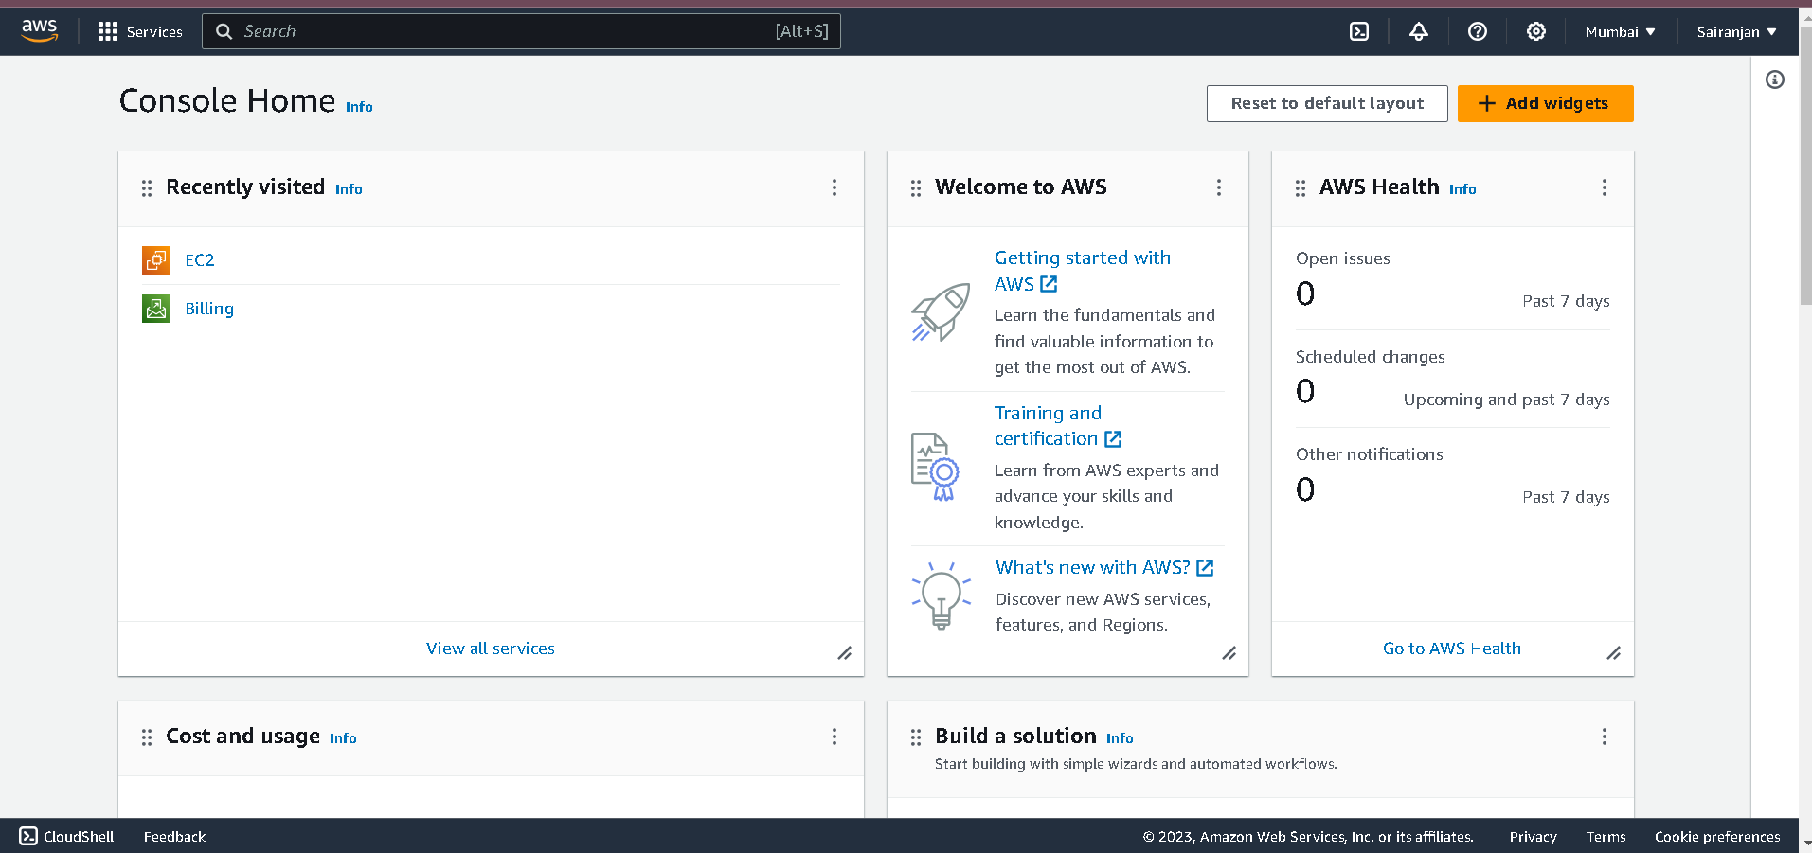**SCREENSHOTS**

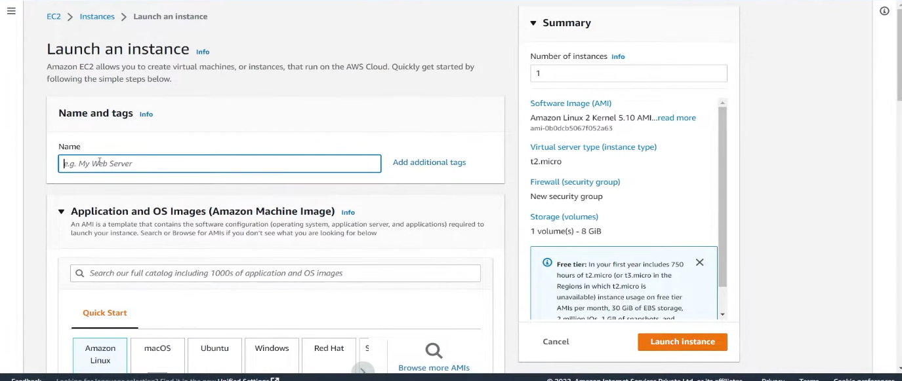

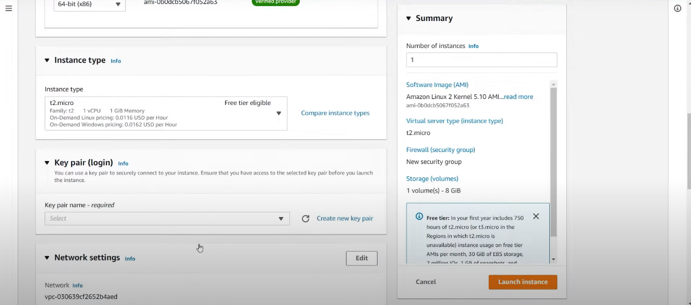

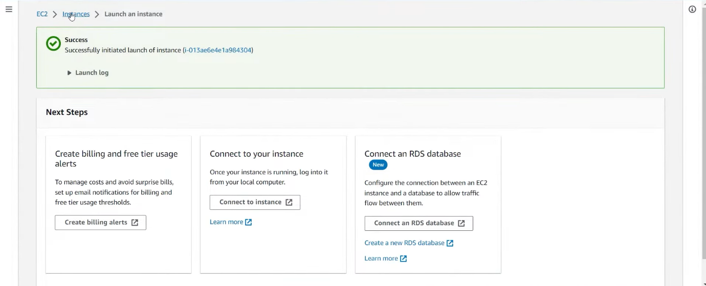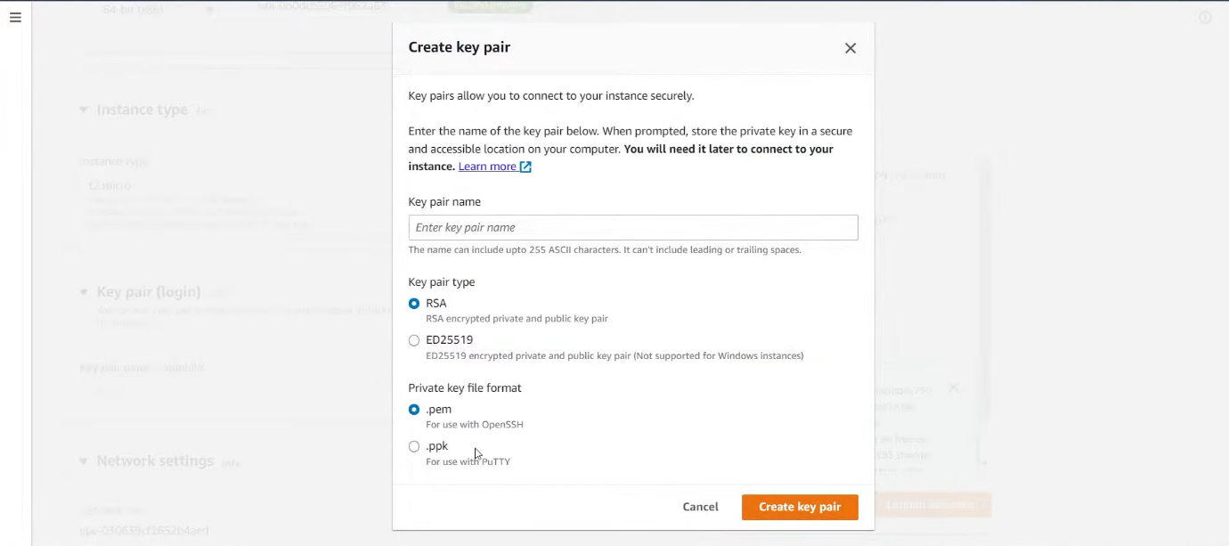

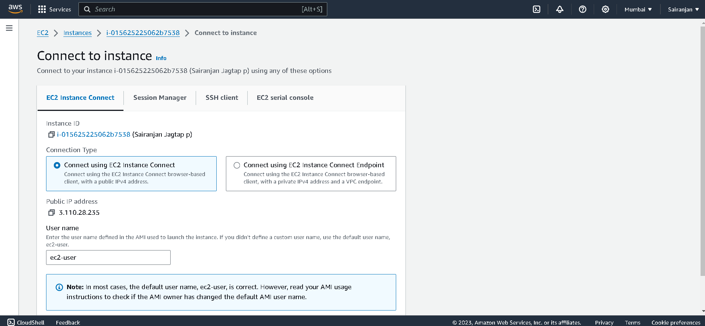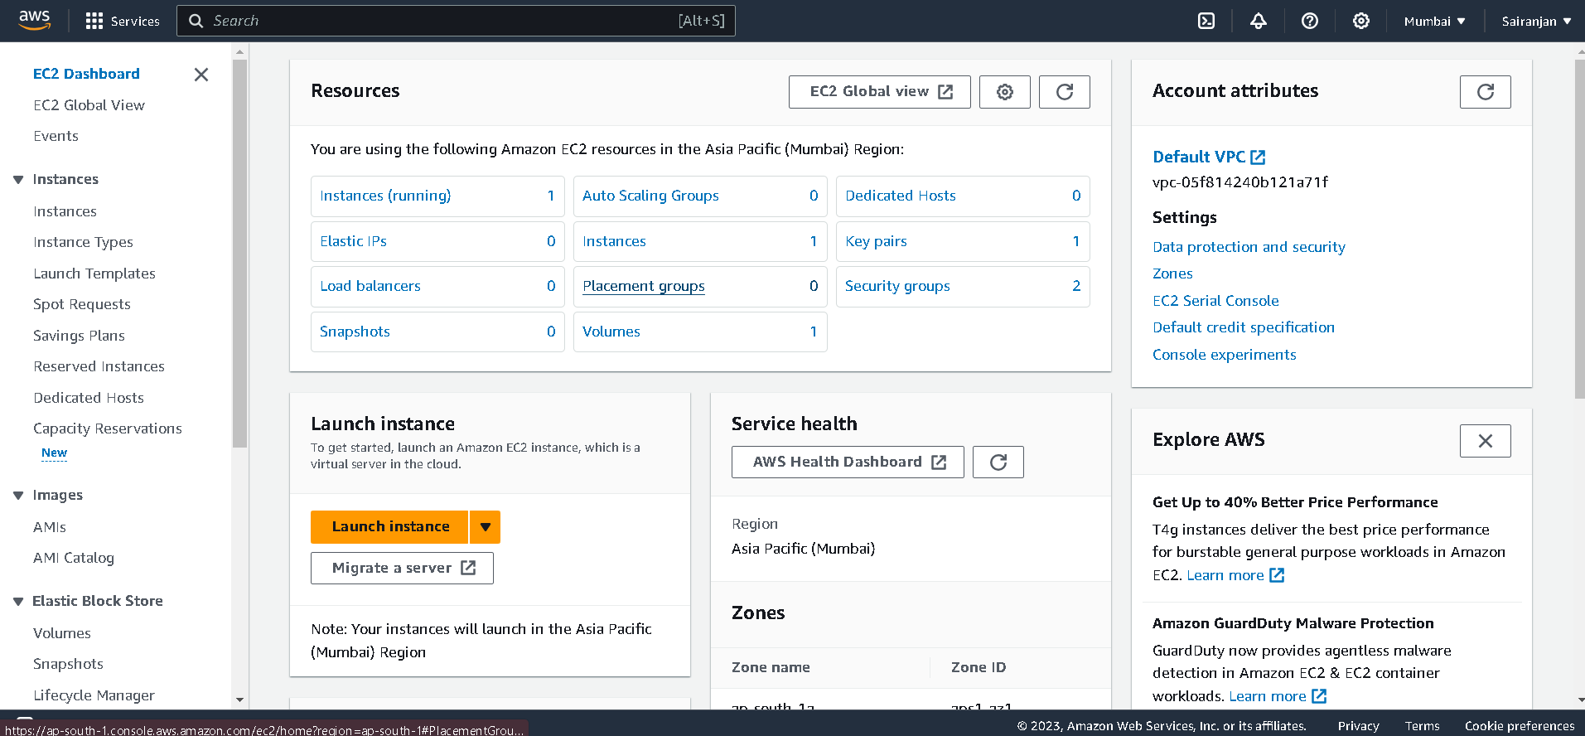

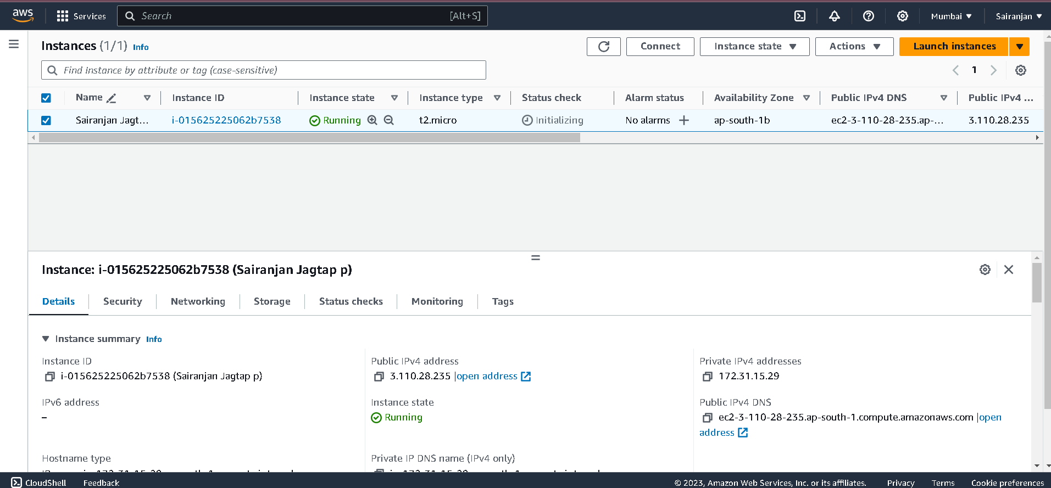

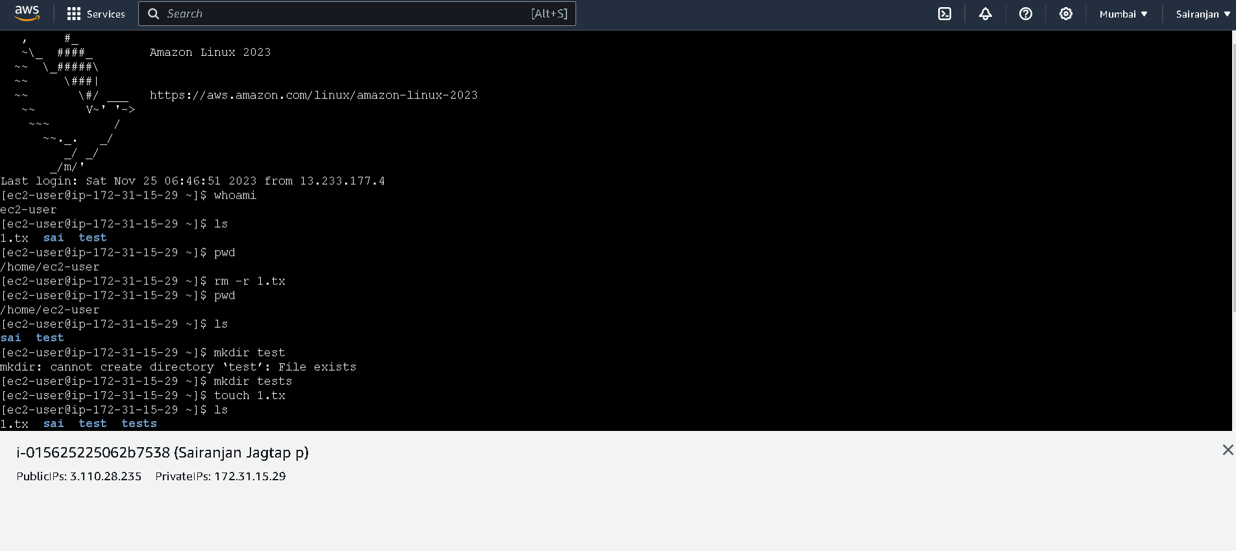

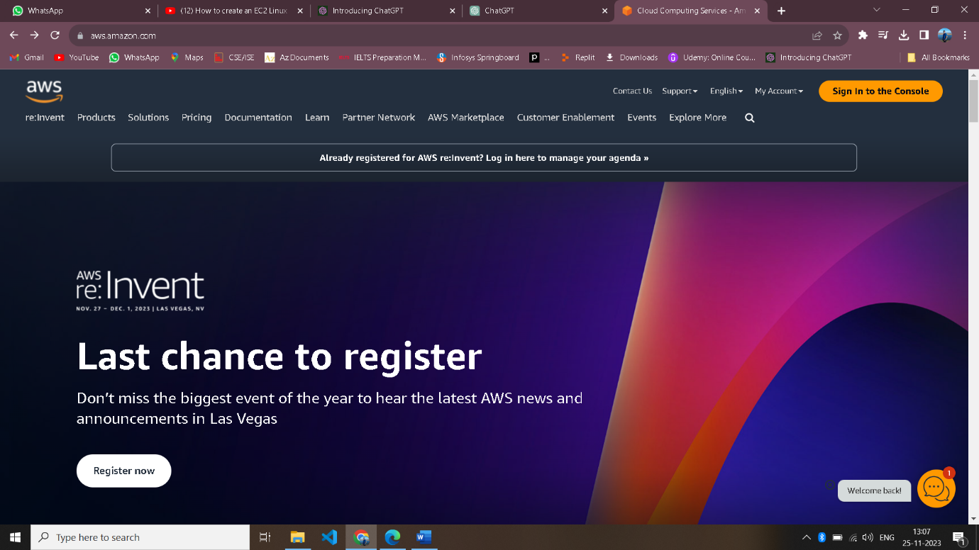

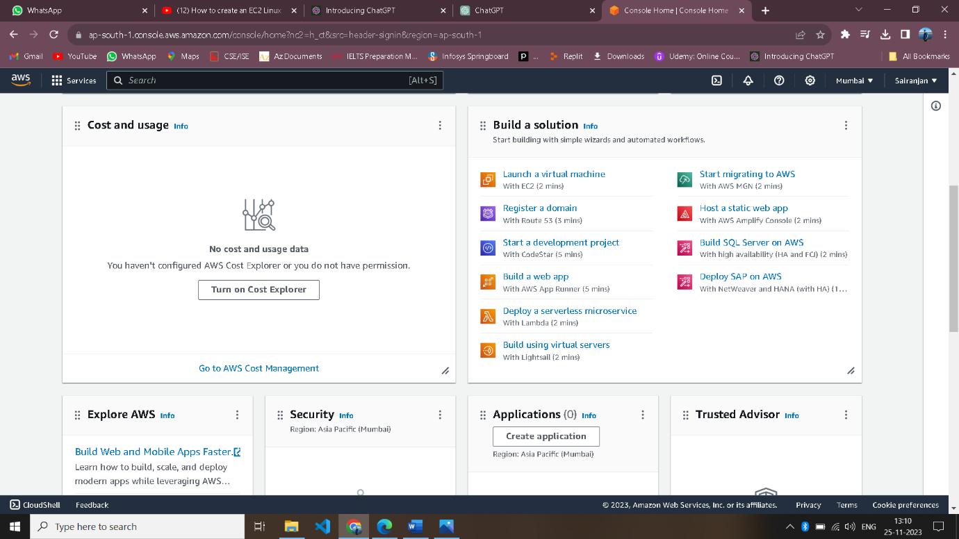

**Running sample Program on Linux Instance**

List the steps with proper explanation & Screenshots

Any number of pages

1. Ls:**ls** is probably the first **command** every Linux user typed in their terminal. It allows you to list the contents of the directory you want (the current directory.
2. pwd: The **PWD** stands for the print working directory · the command will return an absolute (full) path that starts with a forward slash (/).
3. Rmdir: This **mkdir command** allows you to create fresh directories in the terminal itself. The default syntax is mkdir <directory name> and the new directory would be created within the current directory.
4. Touch: The **touch command** in Linux. To create a new file, the **touch command** will be used.
5. **Rm-r**: Will recursively delete a directory and all its contents (normally rm will not delete directories, while rmdir will only delete empty directories).

**Assignment GitHub Link (**[**https://github.com/login**](https://github.com/login)**). (using this link able to access your work)**