**CREDIT CARD FRAUD DETECTION**

|  |  |
| --- | --- |
| **Date** | **04-10-2023** |
| **Team ID** | **3864** |
| **Project Name** | **Credit Card Fraud Detection** |

**Table of Contents**

|  |  |
| --- | --- |
| 1 | Introduction |
| 2 | Problem Statement |
| 3 | Design and Innovation Strategies |
| 3.1 | Data Analytics and Machine Learning |
| 3.2 | Forecasting techniques |
| 3.3 | Accuracy increasing |
| 3.4 | Device Fingerprinting |
| 3.5 | Multi-Factor Authentication |
| 3.6 | Real-Time Alerts |
| 4 | Conclusion |

**1.Introduction**

Credit card fraud detection is a vital shield against the rising threat of unauthorized transactions and financial losses in today's digital economy. This crucial endeavor employs advanced technologies, data analytics, and machine learning algorithms to scrutinize transaction data for patterns and anomalies, ensuring the rapid identification and prevention of fraudulent activity. It not only safeguards consumers from financial harm but also protects financial institutions from substantial liabilities, making it an indispensable component of financial security in an era of data breaches and cyber threats.

**2. Problem Statement**

The challenge is the increasing threat of credit card fraud in the digital age, necessitating the development of sophisticated fraud detection systems using advanced technology and machine learning. These systems must swiftly analyze transaction data, adapt to evolving fraud tactics, and minimize financial losses for consumers and institutions alike.

**3. Design and Innovation Strategies**

**3.1 Data Analytics and Machine Learning:**

Utilize advanced data analytics and machine learning algorithms to analyze transaction data in real-time.Employ anomaly detection techniques to identify unusual patterns or behaviors.

**3.2 Forecasting Techniques:**

**Time Series Analysis:**

Time series analysis involves studying transaction data over time to detect patterns, trends, and seasonal.

**Machine Learning Algorithms:**

Machine learning techniques such as supervised learning (classification) can be used for fraud detection.Common algorithms include logistic regression, decision trees, random forests, support vector machines, and neural networks.

**Graph Analytics:**

Represent credit card transactions as a graph where nodes are users/accounts, and edges are transactions.Detect unusual patterns, clusters, or connections in the graph structure that may indicate fraudulent activities

**Predictive Modeling:**

Build predictive models that estimate the likelihood of a transaction being fraudulent.These models assign a fraud score to each transaction, which can be used to prioritize investigation efforts.

**3.3 Accuracy Increasing:**

**Hyperparameter Tuning:**

Fine-tune the hyperparameters of your models using techniques like grid search or random search.Optimize hyperparameters for the best balance between precision and recall.

**Cross-Validation:**

Use cross-validation techniques to assess the generalization performance of your models and reduce overfitting.Consider techniques like k-fold cross-validation or stratified sampling.

**Threshold Adjustment:**

Adjust the classification threshold to balance precision and recall based on the specific requirements of your fraud detection system.Use ROC curves and precision-recall curves to visualize trade-offs.

**3.4 Device Fingerprinting**:

Create unique fingerprints for devices used in transactions, including computers, smartphones, and tablets .Track changes in device characteristics or unusual device behavior that may indicate fraudulent activity.

**3.5 Multi-Factor Authentication (MFA):**

Implement MFA for high-risk transactions or account changes. Require additional authentication steps when a transaction appears suspicious.

**3.6 Real-Time Alerts:**

Set up automated alert systems to notify cardholders and financial institutions of potentially fraudulent activity. Allow cardholders to customize their alert preferences, such as transaction value thresholds.

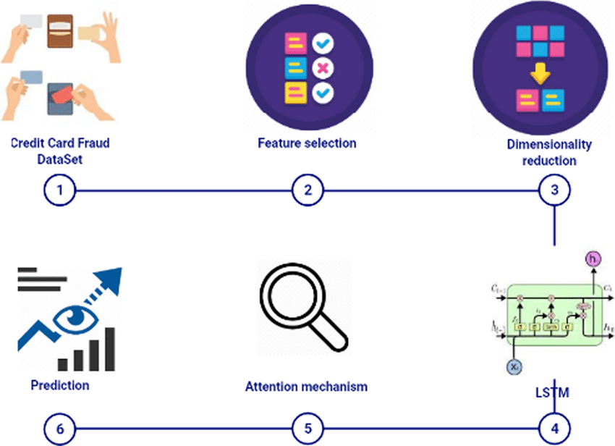

FIG 1: PREDECTION ALGORITHM

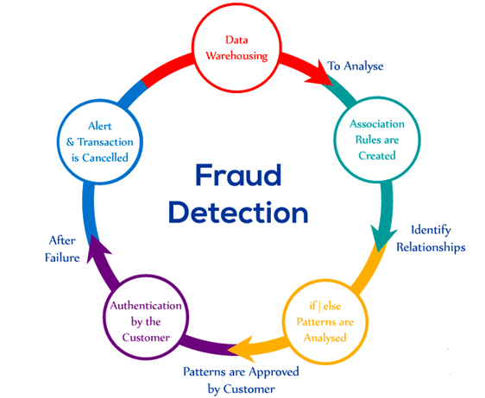

**FIG 2:LIFE CYCLE OF FRAUD DETECTION**

**4. Conclusion :**

Credit card fraud detection is a multifaceted challenge that demands a holistic and evolving approach. Utilizing advanced analytics, machine learning, and real-time monitoring is fundamental for success in this critical area of financial security. To maximize accuracy, organizations must prioritize data quality, address class imbalance, and fine-tune their models with rigorous cross-validation. Collaboration with industry peers and the integration of external data sources further strengthen detection capabilities.