DFR-TSD: A Deep Learning Based Framework for Robust Traffic Sign Detection Under Challenging Weather Conditions

Many algorithms are available to detect traffic signs but all those algorithms are trained on clear images and expect clear images only for detection but some time due to weather condition quality of the image will be degrade and existing algorithm may not able to detect signs from such weather affected images. To overcome from above problem author of this paper has introduced CNN algorithm which consists of two parts. First part will remove weather affected part from the image and clear it and second part will detect traffic signs.

Propose algorithm is based on Deep learning CNN algorithm to detect traffic signs robustly hence called as DFR-TSD. Propose algorithm get trained on ‘CURE-TSD’ dataset and able to get accuracy up to 99%.

To implement this project we have designed following modules

1. Generate & Load Traffic Sign CNN Model: using this module we will generate and load Traffic sign CNN model
2. Upload Test Image & Clear: using this module we will upload test image and then apply CNN model to clear weather affected images
3. Detect Sign from Clear Image: now clear image will be input to CNN sign detection model to detect sign
4. Propose CNN Training Graph: using this module we will plot CNN training accuracy and loss graph

SCREEN SHOTS

To run project double click on ‘run.bat’ file to get below screen

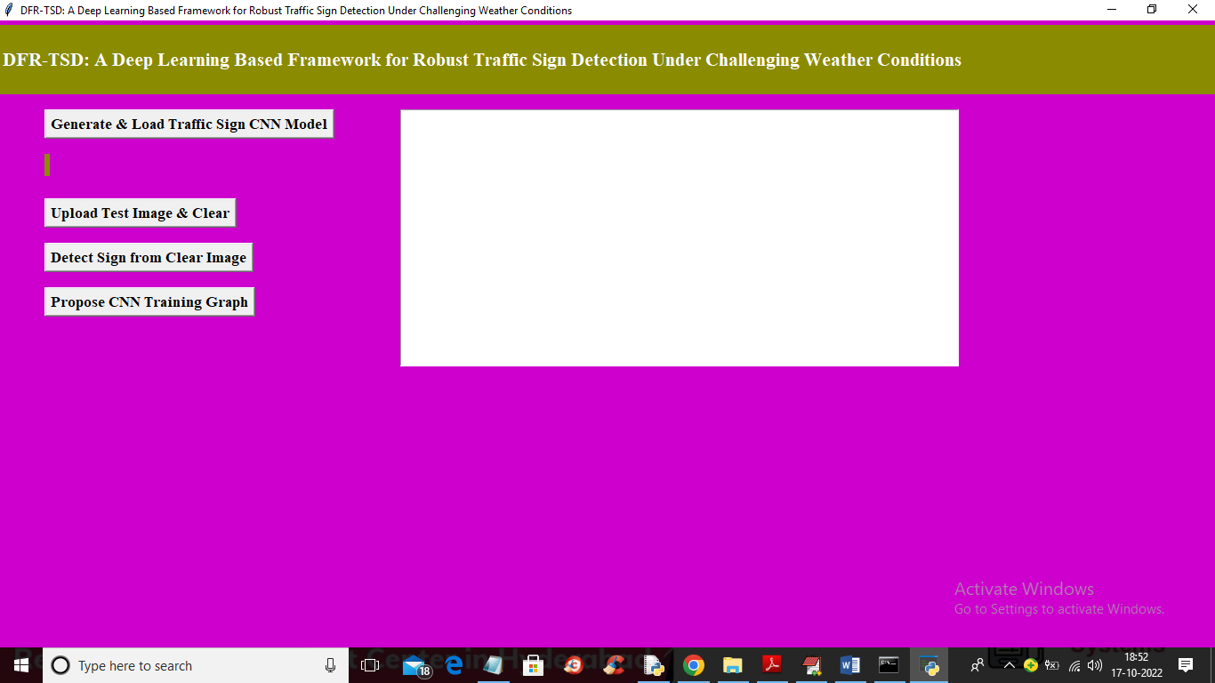

In above screen click on ‘Generate & Load Traffic Sign CNN Model’ button to generate and load CNN model and get below screen

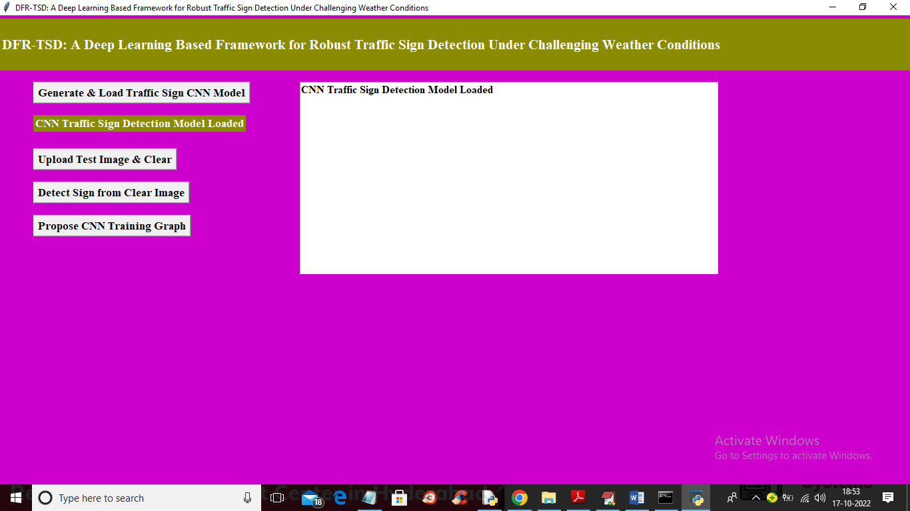

In above screen CNN Model loaded and now click on ‘Upload Test Image & Clear’ button to upload weather affected test image and then clean it

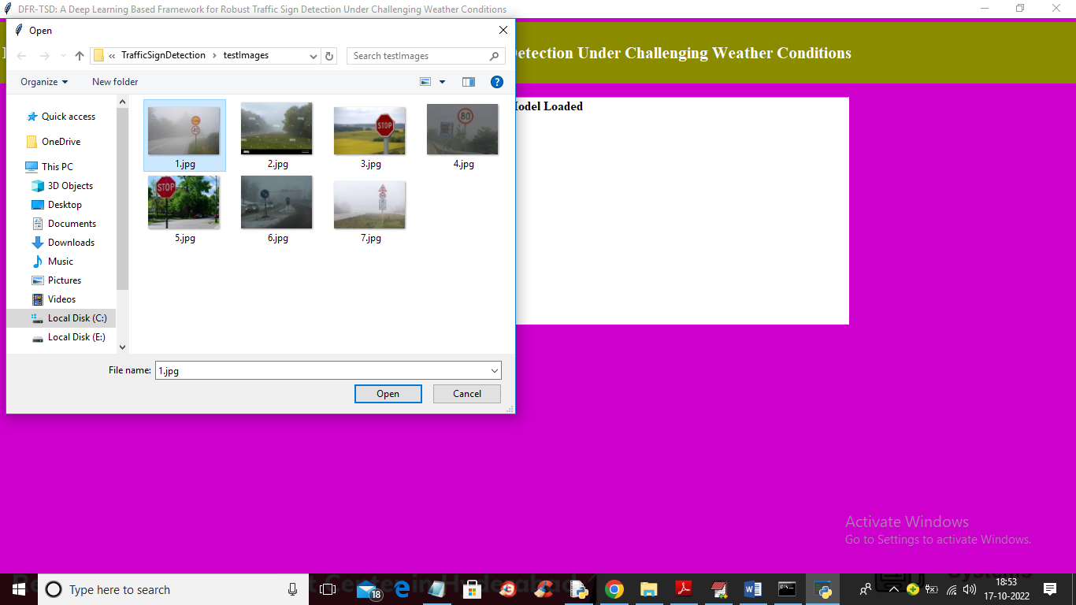

In above screen selecting and uploading ‘1.jpg’ file and then click on ‘Open’ button to load and clean image and get below output

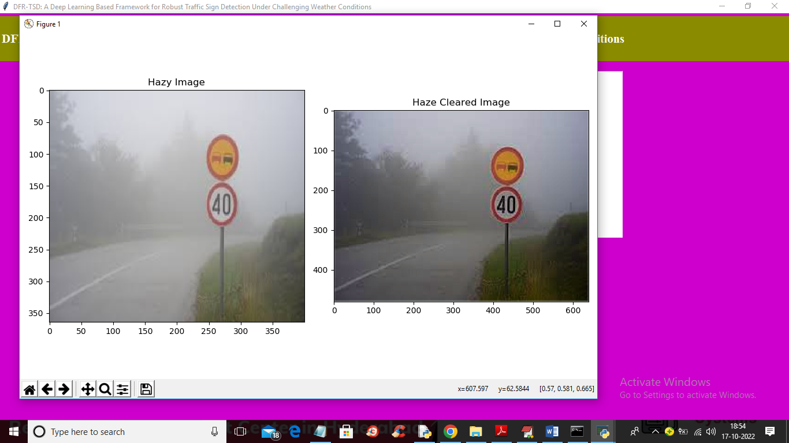

In above screen first image is the weather affected image (which can be from cloudy haze, rain, or bad light or bad camera lens) and second is the clean image and you can see the difference between both images and now click on ‘Detect Sign from Clear Image’ button to get below output

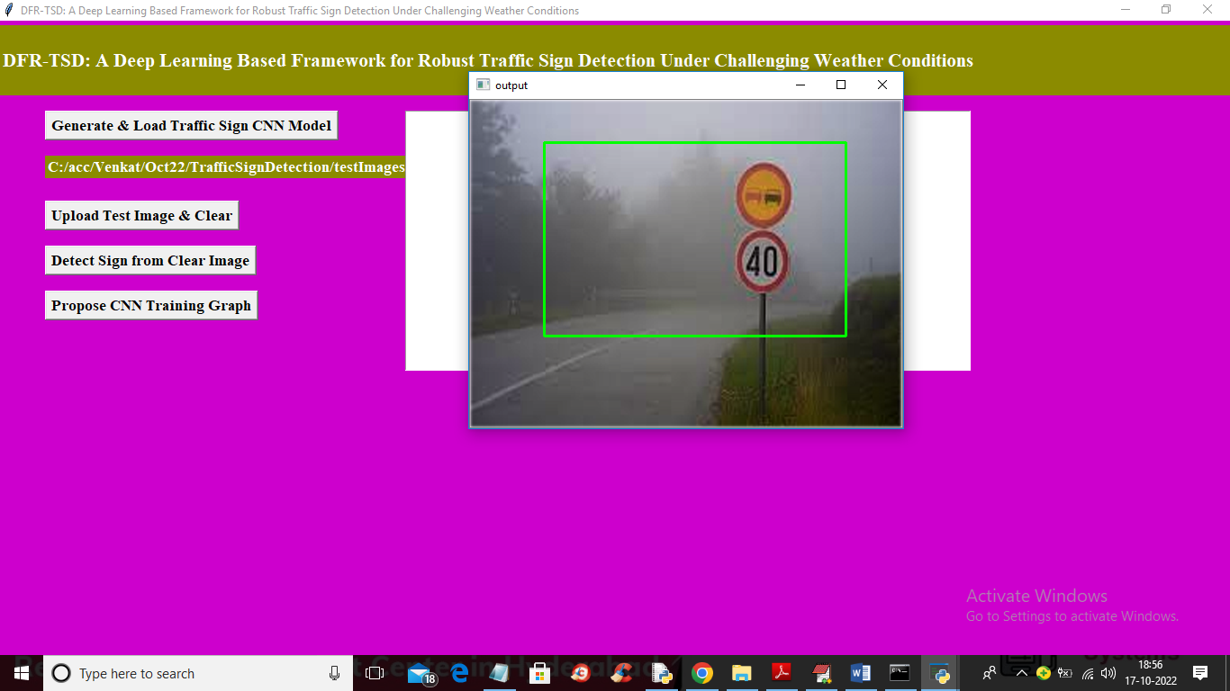

In above screen CNN model detected traffic sign and put bounding box around it and now test other image

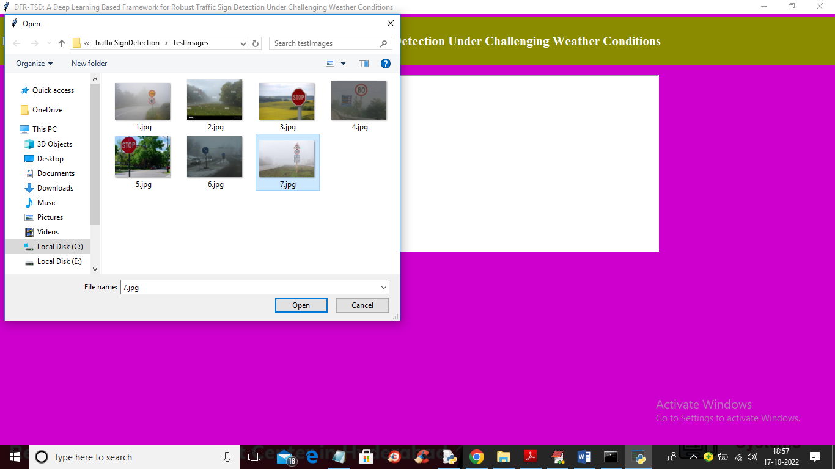

In above screen selecting and uploading 7.jpg and then click on ‘Open’ button to get below output

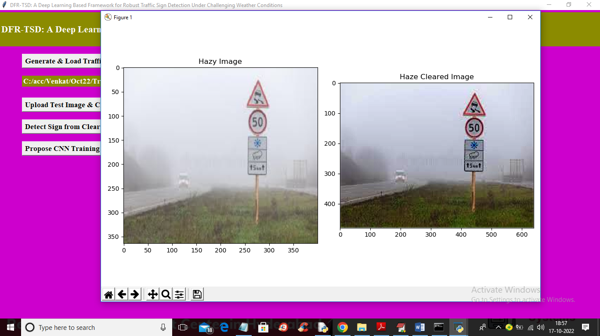

In above screen first image is the weather affected image and second one is the clean image and now click on ‘Detect Sign from Clear Image’ button to get detection output

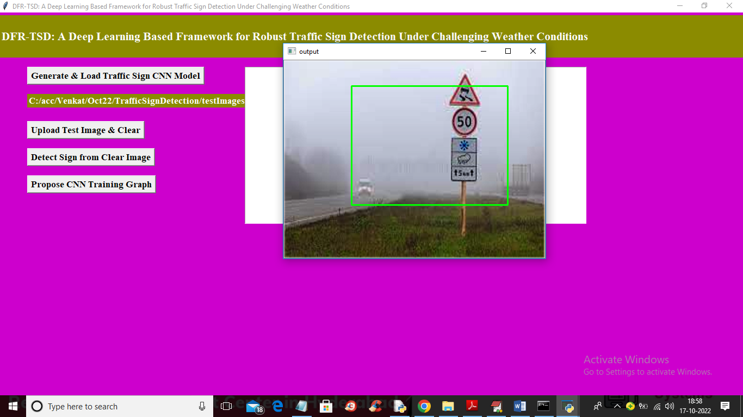

In above screen traffic sign detected and similarly you can upload and test other images and now click on ‘Propose CNN Training Graph’ button to get below output

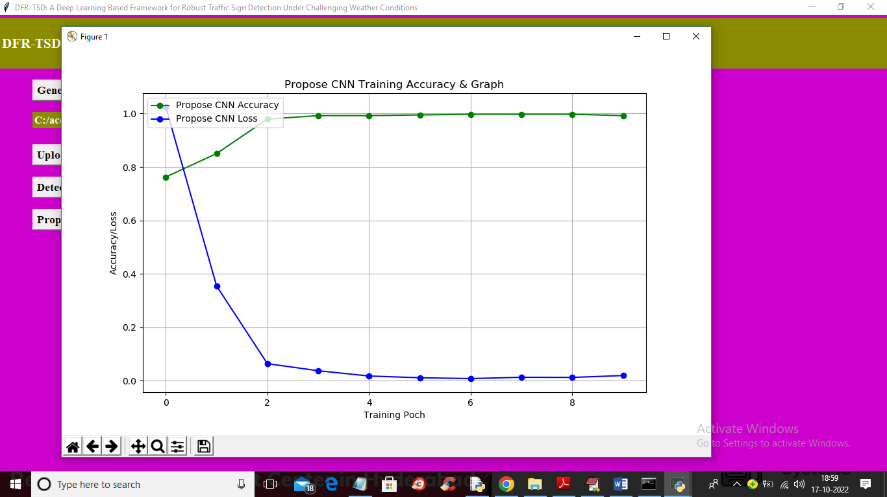

In above graph x-axis represents ‘Training Epoch’ and y-axis represents ‘Accuracy and loss values’ and green line represents accuracy and blue line represents loss. In above graph we can see with each increasing epoch accuracy got increase and loss got decrease.

Note: no detection algorithms are accurate so sometime some bounding boxes may not predict accurately