PRIM'ERA Café
Café Website

In Partial Fulfillment of the Requirement for the
Subject Web Systems and Technologies 2

Members
Gatchalian, Mark Lester R.
Salvador, Earon M.
Cayabyab, Kim M.
Collado, Andre James
Loro Rachell

BSIT 2-C
Instructor
Mrs. Roan G. Cochanco
November 2026
BUSINESS WORKFLOW OVERVIEW
PRIM'ERA Café's website introduces the business, presents its featured coffee and pastry menu, shares customer reviews, and provides café background and contact details. A customer can browse the offerings, select items of interest, then contact the café by phone or Facebook to confirm availability, current pricing, and order arrangements. The café confirms the order and coordinates preparation and collection directly with the customer.

PROPOSED BUSINESS WORKFLOW DIAGRAM

1.Discover 2. Learn 3. Read Reviews
Review product descriptions, prices, café details, and contact information.
4. Share Feedback

Complete and submit the review form to share your visit and rating.
Browse café information, menu items, and customer reviews.
View feedback shared by other café visitors.
DETAILED BUSINESS WORKFLOW

Process | Description
Website  Navigation | Customer browse the Home, Menu, Reviews, and About pages to learn about PRIM'ERA Café.
Menu Information | Visitors review coffee and pastry categories, item descriptions, types, and listed prices, and can open product details for more information.
Café Information | Visitors learn about the café's story, view its photo gallery, and find its phone number, location, and Facebook link.
Read Reviews | Visitors read feedback posted by other café visitors on the Reviews page.
Submit a Review | Customer will login to review page to add their review or feedback with feelings about the specific product they tried they will select star rating and submits the form. The site then displays the review in its review lists

INFORMATION AND REVIEW WORKFLOW
The website's main visitor workflow is to provide café information and let visitors share feedback.
1. A visitor opens the Home page and learns about PRIM'ERA Café.
2. The visitor browses the coffee and pastry menu, product details, photos, and café information.
3. The visitor opens the Reviews page to read existing customer feedback or choose to add a comment.
4. To submit feedback, the visitor completes the review form with their name, email, favorite category, visit date, star rating, satisfaction score, and written review.
5. The visitor may also indicate whether they recommend the café, then submits the form.
6. The website displays the submitted review in the review list. The site does not accept or process orders or payments.
ROLES AND RESPONSIBILITIES
User / Role | Responsibility
Customer/Visitor | Browses café information, menu items, and reviews; may complete and submit the review form to share feedback.
Website | Presents café information, product details, photos, contact information, and customer reviews; provides a form for visitors to submit a rating and written review.
Reviews | provides a form for visitors to submit a rating and written review.
Café Staff | Maintains café information and offerings through website content updates and responds to visitors through the published contact channels.
PROJECT SCOPE
The project focuses on a responsive informational and review website for PRIM'ERA Café. Its purpose is to help visitors learn about the café, explore its offerings, read community feedback, and find contact information on desktop and mobile devices.
The website includes the following features:
1. Home Page introduces the café with a welcome message, video hero, and navigation to the site sections.
2. Menu Page presents coffee and pastry categories with item descriptions, types, prices, and detail views.
3. Reviews Page displays customer feedback and provides a form for visitors to share their visit and rating.
4. About Page shares the café's story, images, phone number, location, and Facebook link.
5. Photo Gallery lets visitors view café and product images in an enlarged dialog.
6. Responsive Navigation provides access to the site sections on desktop and mobile devices.

PROJECT LIMITATIONS
The website is informational and supports customer reviews; it does not provide online ordering, reservations, or payment processing. The review form and account flow are front-end features, and submitted reviews are held in browser memory rather than saved to a central database, so they are not guaranteed to persist after a page reload. The website has no administrative dashboard or content management system; updates to menu items, prices, and other content must be made through the source code.

SITEMAP
SITEMAP
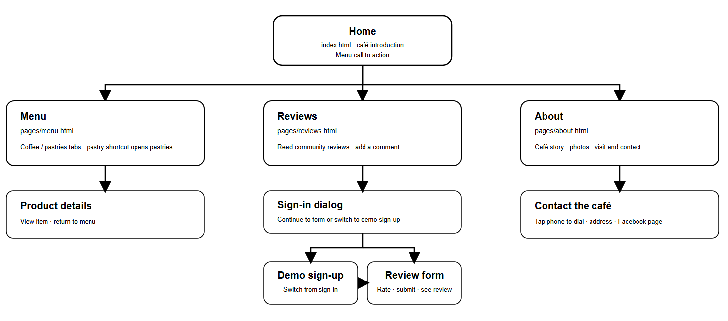
WIREFRAME
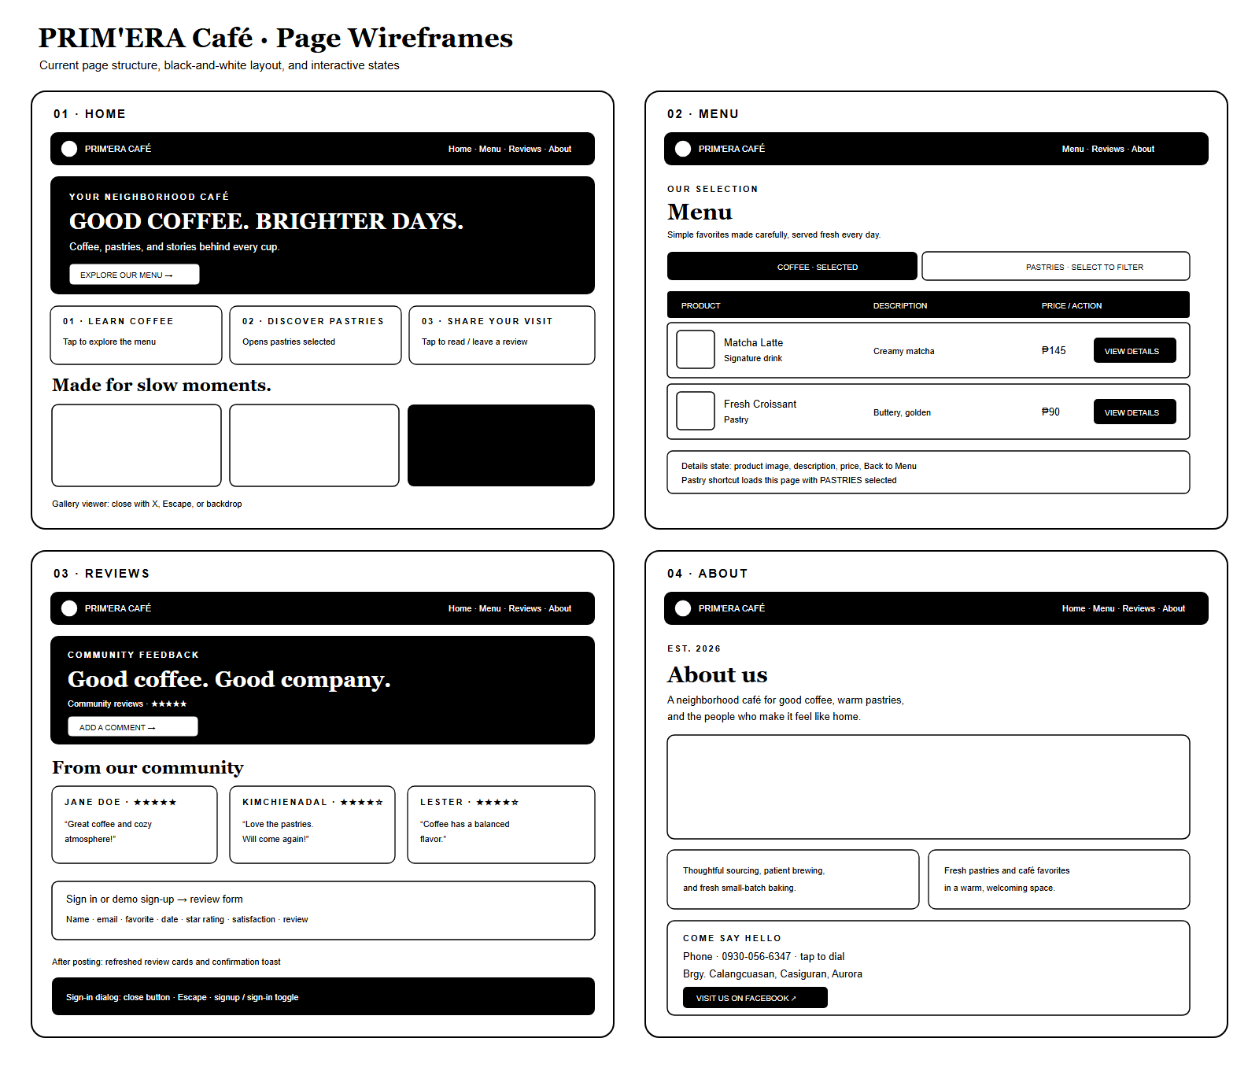

Menu
Menu
This page presents the café's available drinks and pastries, along with their categories, descriptions, and prices.
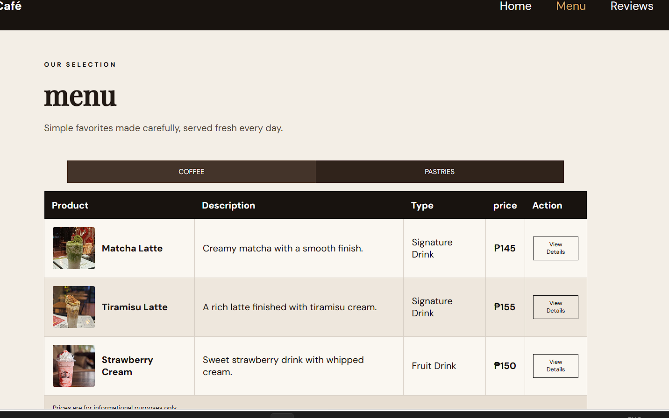
Reviews
Reviews
This page displays customer feedback and ratings. Visitors can enter visit details, choose a star rating, and share a written review.
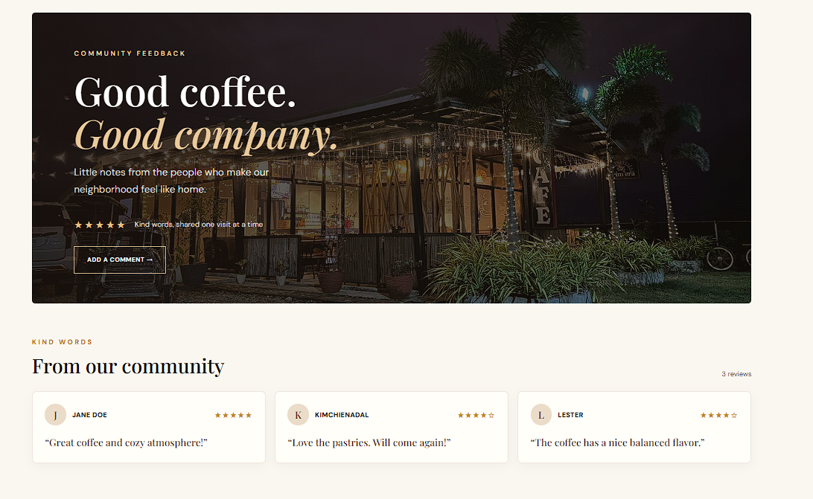

About
About
This page provides background and identity information about PRIM'ERA Café, emphasizing the neighborhood and hospitality atmosphere.
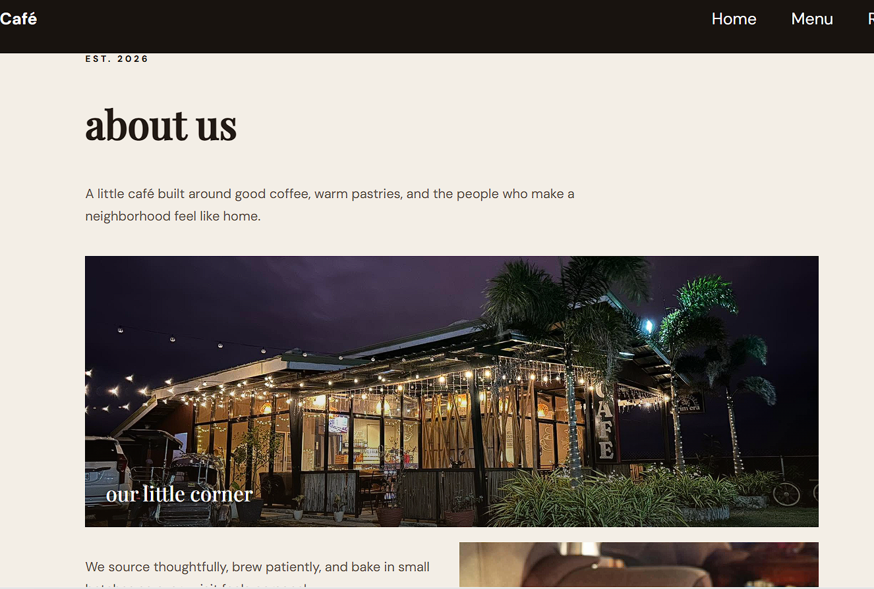
Sign In / Create Account
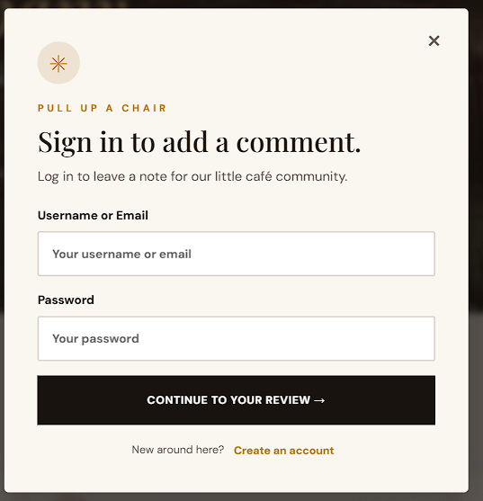
Review
The review form collects a visitor's name, email, favorite category, visit date, star rating, satisfaction score, written review, and recommendation preference.
Responsive Homepage
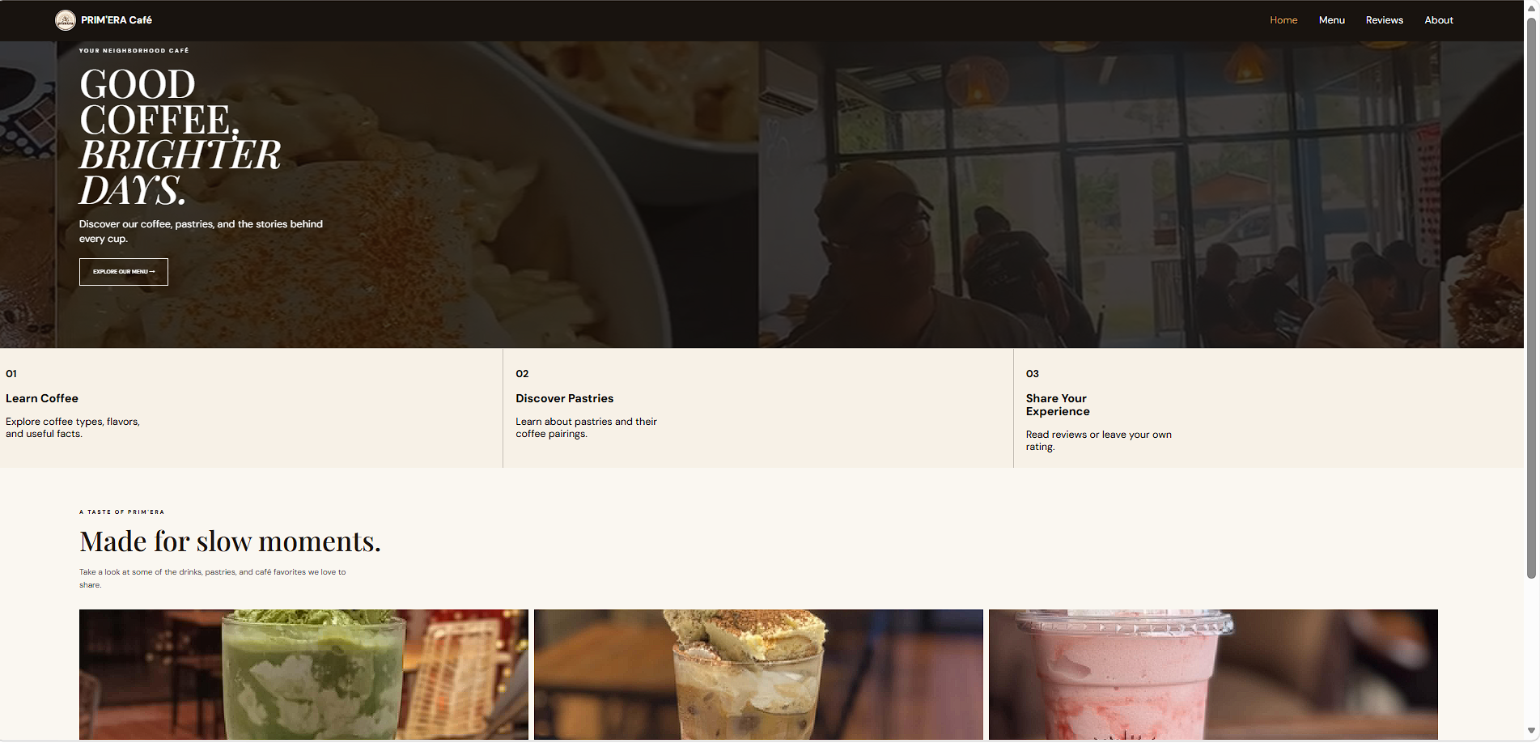
Responsive Homepage
The homepage adapts its layout and navigation for mobile, tablet, and desktop screens.
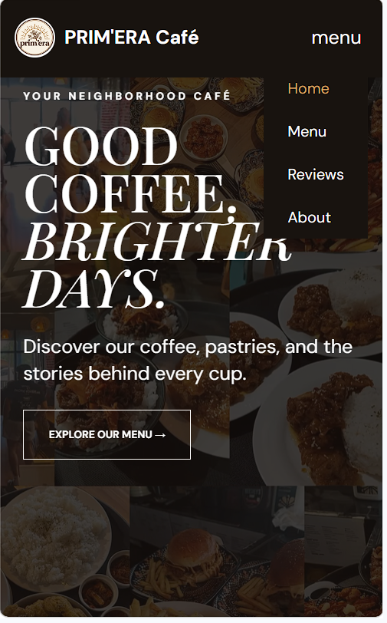
z.

