A PROJECT SCHOOL REPORT ON
KANDAGATLA MEGHANA |  | 245323748037
GONE VENKATA VEDA RAO |  | 245323748094
GUTHA SINDHU |  | 245323748096
RASAM YESHASVI |  | 245323748112
VUPPALA DHEERAJ GUPTA |  | 245323748124
AGRI VISION: Smart Vision – Language Diagnosis for Plants
Submitted By

Under the guidance
of
Hari Babu KVN
Assistant Professor
CSE (AIML)


NEIL GOGTE INSTITUTE OF TECHNOLOGY
Kachavanisingaram Village, Hyderabad, Telangana 500058.

December, 2025

NEIL GOGTE INSTITUTE OF TECHNOLOGY
A Unit of Keshav Memorial Technical Education (KMTES)
Approved by AICTE, New Delhi & Affiliated to Osmania University, Hyderabad

CERTIFICATE

This is to certify that the project work entitled “AGRI VISION: Smart Vision- Language Diagnosis for Plants” is a bonafide work carried out by “KANDAGATLA MEGHANA, GONE VENKATA VEDA RAO, GUTHA SINDHU, RASAM YESHASVI, VUPPALA DHEERAJ GUPTA” of III-year V semester Bachelor of Engineering in CSE (AIML) during the academic year 2025-2026 and is a record of bonafide work carried out by them.

Project Mentor
Hari Babu KVN
Assistant professor
CSE(AIML)

ABSTRACT

Plant diseases pose a significant threat to agricultural productivity, making early and accurate diagnosis essential for sustainable farming. Although recent deep learning models have achieved high accuracy in plant disease classification, they often lack interpretability and reasoning capability, limiting their usefulness in real-world agricultural decision-making. To address this limitation, this paper presents a visual reasoning–based framework for plant disease diagnosis that reformulates the task as a visual question answering problem, enabling models to analyse leaf images, reason over visual symptoms, and produce explainable diagnostic outputs.
The proposed framework explores three complementary approaches. The first approach adapts the Reason-RFT paradigm by combining Chain-of-Thought supervised fine-tuning with Group Relative Policy Optimization and a Plant Pathology Reward Module to improve reasoning alignment and reduce hallucinations. The second approach investigates a Tiny Recurrent Memory–based latent reasoning model, in which diagnostic refinement occurs through iterative memory updates without explicit textual reasoning. The third approach employs CLIP-based multimodal embeddings coupled with recursive GRU reasoning and reinforcement learning to efficiently generate structured diagnostic explanations.
Experiments conducted on a redesigned PlantVillage dataset demonstrate that reinforcement learning significantly improves generalization and prediction stability in low-resource agricultural settings. The Reason-RFT approach improves accuracy from approximately 71% after reinforcement learning, while the CLIP-based recursive reasoning model achieves the highest performance of 79% with GRPO fine-tuning. Despite operating without explicit reasoning supervision, the TRM-based model attains a decent competitive classification accuracy. These results highlight the effectiveness of reasoning-centric training and domain-specific reward modelling, demonstrating the feasibility of deploying interpretable and reliable visual reasoning systems for real-world plant disease diagnosis.

TABLE OF CONTENTS

S. NO. | TITLE | PAGE NO.
 | ABSTRACT | ii
 | TABLE OF CONTENTS | iii
 | LIST OF FIGURES | iv
1 | Introduction
 | 1.1 Project Overview | 1
 | 1.2 Background | 1
 | 1.3 Objectives | 2
 | 1.4 Methodology | 3
 | 1.5 Potential Impact | 3
2 | Literature Survey | 4
3 | Proposed System Architecture, Technology Stack and Implementation Details
 | 3.1 Proposed System Architecture | 7
 | 3.2 Technology Stack | 14
 | 3.3 User Interface | 15
4 | Results

4.1 System Configuration 16
4.2 Quantitative Analysis 17
4.3 Qualitative Analysis 20
5 Conclusion and Future Scope
5.1 Conclusion 23
5.2 Future Scope 24
6 References 25

LIST OF FIGURES

Fig No. | Figure Name | Page No.
1 | Reason-RFT Architecture Diagram | 9
2 | TRM based Latent Reasoning Architecture Diagram | 11
3 | CLIP + Recursive GRU Reasoning Architecture Diagram | 13
4 | Training Loss vs Epoch Curves for Reason-RFT | 18
5 | Training Loss vs Epoch Curves for CLIP-Recursive GRU | 19
6 | Welcome Page of the website | 20
7 | Diagnose Page - Visual Enquiry | 21
8 | Resultant Diagnosis Page | 22

CHAPTER -1

INTRODUCTION

Project Overview

Agriculture plays a crucial role in ensuring food security and economic stability across the world. However, plant diseases remain a major challenge, leading to significant crop yield losses and economic damage every year. Early and accurate diagnosis of plant diseases is essential for timely intervention, effective treatment, and sustainable farming practices. With recent advances in artificial intelligence, computer vision, and deep learning, automated plant disease detection systems have emerged as promising solutions to assist farmers and agronomists.

This project focuses on developing a visual reasoning–based plant disease diagnosis system using advanced vision–language models (VLMs) and reasoning-oriented learning frameworks. Unlike traditional image classification systems that only predict disease labels, the proposed system aims to analyze, reason, and explain plant disease symptoms from leaf images. The work explores three complementary approaches: (i) Reason-RFT using Chain-of-Thought Supervised Fine-Tuning (CoT-SFT) and Reinforcement Learning with GRPO, (ii) a TRM-based latent reasoning framework, and (iii) a CLIP-based recursive reasoning model. These approaches are evaluated on a redesigned PlantVillage dataset covering plant diseases.

Background and Motivation

Traditional plant disease detection methods rely heavily on manual inspection by agricultural experts, which is time-consuming, expensive, and often inaccessible to farmers in rural or resource-constrained regions. Early machine learning approaches used handcrafted features and shallow classifiers, which were sensitive to lighting conditions, background noise, and visual variability. More recently, deep convolutional neural networks (CNNs) and vision transformers (ViTs) have achieved high classification accuracy on plant disease datasets. However, these models operate as black boxes and lack interpretability, making it difficult to trust their predictions in real-world agricultural settings.

Furthermore, most existing models are limited to single-label classification and cannot answer diagnostic questions such as symptom verification, disease severity, or reasoning behind predictions. In practical farming scenarios, explainability and reliability are as important as accuracy. This motivates the need for reasoning-capable models that can integrate visual cues with domain knowledge and generate meaningful explanations.

Recent advances in vision–language models and reinforcement learning, such as Reason-RFT and TRM, have demonstrated strong reasoning capabilities in synthetic and controlled tasks. However, their application to real-world agricultural domains remains largely unexplored. This project is motivated by the challenge of adapting such advanced reasoning frameworks to plant pathology, where data is limited, images are noisy, and domain correctness is critical.

Objectives

To build a multimodal system that integrates leaf images and diagnostic questions for plant disease analysis.

To activate and refine reasoning capabilities in vision–language models using Chain-of-Thought supervision and reinforcement learning.

To explore lightweight latent reasoning mechanisms such as Tiny Recurrent Memory (TRM) for low-resource settings.

To evaluate and compare three different reasoning approaches in terms of accuracy, generalization, and interpretability.

To reduce hallucinations and incorrect predictions through domain-specific reward modeling.

To demonstrate the feasibility of applying advanced reasoning frameworks to real-world agricultural datasets with limited annotations.

1.4 Methodology

The project follows a structured, multi-stage methodology involving dataset preparation, model training, and evaluation. Initially, the PlantVillage dataset is redesigned into a multi-question visual question answering (VQA) format, with each image associated with multiple diagnostic queries and annotated reasoning steps. The dataset consists of approximately 400 supervised fine-tuning samples and 150 reinforcement learning samples covering 17 plant disease classes.

Three distinct approaches are implemented and analyzed. The first approach, Reason-RFT, uses a two-stage training strategy where the model is first trained using supervised Chain-of-Thought reasoning and then refined using Group Relative Policy Optimization (GRPO) with a Plant Pathology Reward Module. The second approach employs a TRM-based latent reasoning framework, where reasoning occurs through iterative refinement of internal memory states without explicit textual explanations. The third approach combines CLIP-based multimodal embeddings with recursive GRU-based reasoning, followed by optional reinforcement learning for performance enhancement. Each approach is evaluated based on classification accuracy, reasoning quality, generalization ability, and robustness under limited data conditions.

1.5 Potential Impact

The proposed system has significant potential impact in the field of smart agriculture and precision farming. By enabling accurate and explainable plant disease diagnosis, the system can assist farmers in making informed decisions about crop management and treatment. The ability to generate reasoning and symptom-based explanations increases trust in AI-driven recommendations and facilitates adoption in real-world environments.

Additionally, the lightweight nature of the proposed models, particularly the TRM and CLIP based approaches, makes them suitable for deployment on edge devices such as smartphones and low-power agricultural monitoring systems. From a research perspective, this project demonstrates the adaptability of advanced visual reasoning frameworks to real-world domains and highlights the importance of domain-specific reward modeling and reasoning supervision.

CHAPTER - 2 LITERATURE SURVEY

S.No. | Authors & Year | Title / Method Used | Dataset / Domain | Key Findings | Limitations
1 | Wei et al. (2022) | Chain-of-Thought Prompting for Reasoning in LLMs | GSM8K, Multi-Step QA | Showing that CoT supervision enhances reasoning stability and interpretability in large models. | Depends on large model sizes and extensive annotated reasoning data.
2 | Ouyang et al. (2022) | Instruction Tuning + RLHF (PPO) | InstructGPT, Human Feedback | Reinforcement learning with human feedback boosts accuracy and reduces hallucinations. | Computationally expensive; RLHF can be unstable without careful reward design.
3 | Yang et al. (2024) | GRPO: Group Relative Policy Optimization (used in Qwen) | Qwen2,RL datasets | GRPO lowers RL compute demands and stabilizes optimization, allowing smaller models to benefit from RL. | Performance strongly tied to reward quality and sampling diversity.
4 | Liu et al. (2023) | LLaVA: Large Language and Vision Assistant | COCO, Vision-Language Instruction Tasks | Introduced multimodal instruction tuning improving VQA, captioning, and visual reasoning. | Struggles with domain-specific reasoning without targeted fine-tuning.
5 | Bai et al. (2024) | Qwen2-VL Multimodal Large Language Model | Image-Text Multimodal Corpora | Delivers strong visual–text reasoning and supports detailed CoT generation. | Still prone to hallucinations in specialized fields without domain adaptation.
6 | Radford et al. (2021) | CLIP (Contrastive Language–Image Pretraining) | 400M Web Image-Text Pairs | Provides powerful vision–language features enabling zero-shot recognition. | Domain shift issues limit performance in specialized areas like plant pathology.
7 | Kim et al. (2025) | Samsung TRM: Tiny Recurrent Memory for Visual Reasoning | Synthetic Reasoning Benchmarks | Iterative latent-state refinement enables compact yet stable reasoning. | Needs large datasets and pretrained decoders for coherent natural-language output.
8 | Mohanty et al. (2016) | Deep Learning for Plant Disease Identification | PlantVillage Dataset | Reported >99% accuracy with CNNs on controlled plant disease images. | Lacks reasoning capability and performs poorly on real-field or noisy data.
9 | Ferentinos (2018) | CNN-Based Plant Disease Detection | Real-world greenhouse images | Confirmed feasibility of CNNs for agricultural diagnostics. | Provides classification only; lacks interpretability mechanisms.
10 | Zhu et al. (2022) | Vision Transformers for Plant Disease Recognition | Custom crop datasets | ViTs improve robustness and generalization across varied leaf patterns. | High computational cost; no explicit reasoning component.
11 | Sladojevic et al. (2016) | Deep Neural Networks for Plant Disease Classification | PlantVillage | Early CNN-based plant disease classifier with strong performance. | Limited to closed-set diseases; no multimodal reasoning abilities.
12 | Xu et al. (2023) | Recursive Reasoning in VQA Using RNN Modules | VQA Benchmarks | Multi-step refinement improves answer stability and reduces noise in VQA tasks. | RNNs lag behind transformers on complex reasoning workloads.
13 | Chen et al. (2023) | Multimodal Reward Models for Vision-Language RL | Multimodal RLHF datasets | Reward-guided tuning enhances accuracy and reduces hallucinations. | Strong dependence on quality and reliability of reward models.
14 | Wang et al. (2024) | Open-R1: Reinforcement Fine-Tuning for DeepSeek-R1 | Math, Code, Logic RL datasets | Showed RL can emulate DeepSeek-style reasoning via multi-sample reward ranking. | Sensitive to sampling temperature and diversity choices.
15 | Hughes et al. (2015) | PlantVillage: Open Dataset for Plant Disease Detection | PlantVillage (14 crops, 38 diseases) | Standard benchmark dataset widely used for plant disease research. | Lab-like conditions limit realism and field generalization.

CHAPTER – 3

PROPOSED SYSTEM ARCHITECTURE, TECHONOLOGY STACK & IMPLEMENTATION DETAILS

Proposed System Architecture

This chapter describes the overall system architecture proposed for visual reasoning–based plant disease diagnosis. The system is designed to process plant leaf images and diagnostic questions, perform multimodal reasoning, and generate accurate and interpretable disease predictions. To comprehensively study reasoning under different constraints, three distinct yet complementary architectures are proposed and evaluated. Each approach follows a modular design philosophy, enabling independent experimentation while maintaining a common problem formulation.

Overall System Architecture

The proposed system reformulates plant disease diagnosis as a visual question answering (VQA) and visual reasoning task. Given a leaf image and a diagnostic query, the system predicts the disease class and, where applicable, generates an explanatory reasoning sequence. The overall pipeline consists of four high-level components:

Input Processing Module – handles image loading, preprocessing, and question formatting.

Multimodal Encoding Module – extracts visual and textual representations.

Reasoning Module – performs either explicit or latent reasoning depending on the approach.

Output Module – produces disease predictions and optional explanations.

While all three approaches share this conceptual pipeline, they differ significantly in how reasoning is implemented and optimized.

Approach 1 Architecture: Reason-RFT (CoT-SFT + GRPO)

Approach 1 adopts a two-stage reasoning architecture based on the Reason-RFT framework using a pretrained vision–language model.

Stage 1: Supervised Reasoning Activation

In the first stage, a pretrained vision–language model (Qwen2-VL) serves as the backbone. The image is encoded into visual tokens, while the diagnostic question is tokenized and embedded using the language encoder. These multimodal embeddings are jointly processed by the model to generate structured outputs.

The model is fine-tuned using Chain-of-Thought (CoT) Supervised Fine-Tuning, where each training sample includes explicit reasoning steps describing observed symptoms followed by a final diagnosis. This stage teaches the model how to reason over visual symptoms and align its outputs with domain-specific diagnostic logic.

Stage 2: Reinforcement Learning with GRPO

In the second stage, the model undergoes reinforcement learning using Group Relative Policy Optimization (GRPO). For each image–question pair, multiple candidate answers are sampled. These candidates are evaluated using a Plant Pathology Reward Module, which scores responses based on disease correctness, symptom relevance, yes/no verification accuracy, and hallucination penalties.

GRPO updates the model by comparing candidates within each group, increasing the likelihood of high-reward responses and suppressing incorrect or hallucinated outputs. This stage significantly improves generalization, stability, and factual correctness.

Output

The final output includes a disease prediction along with a coherent, human-readable chain-of-thought explanation, making this approach highly interpretable and suitable for real-world deployment.

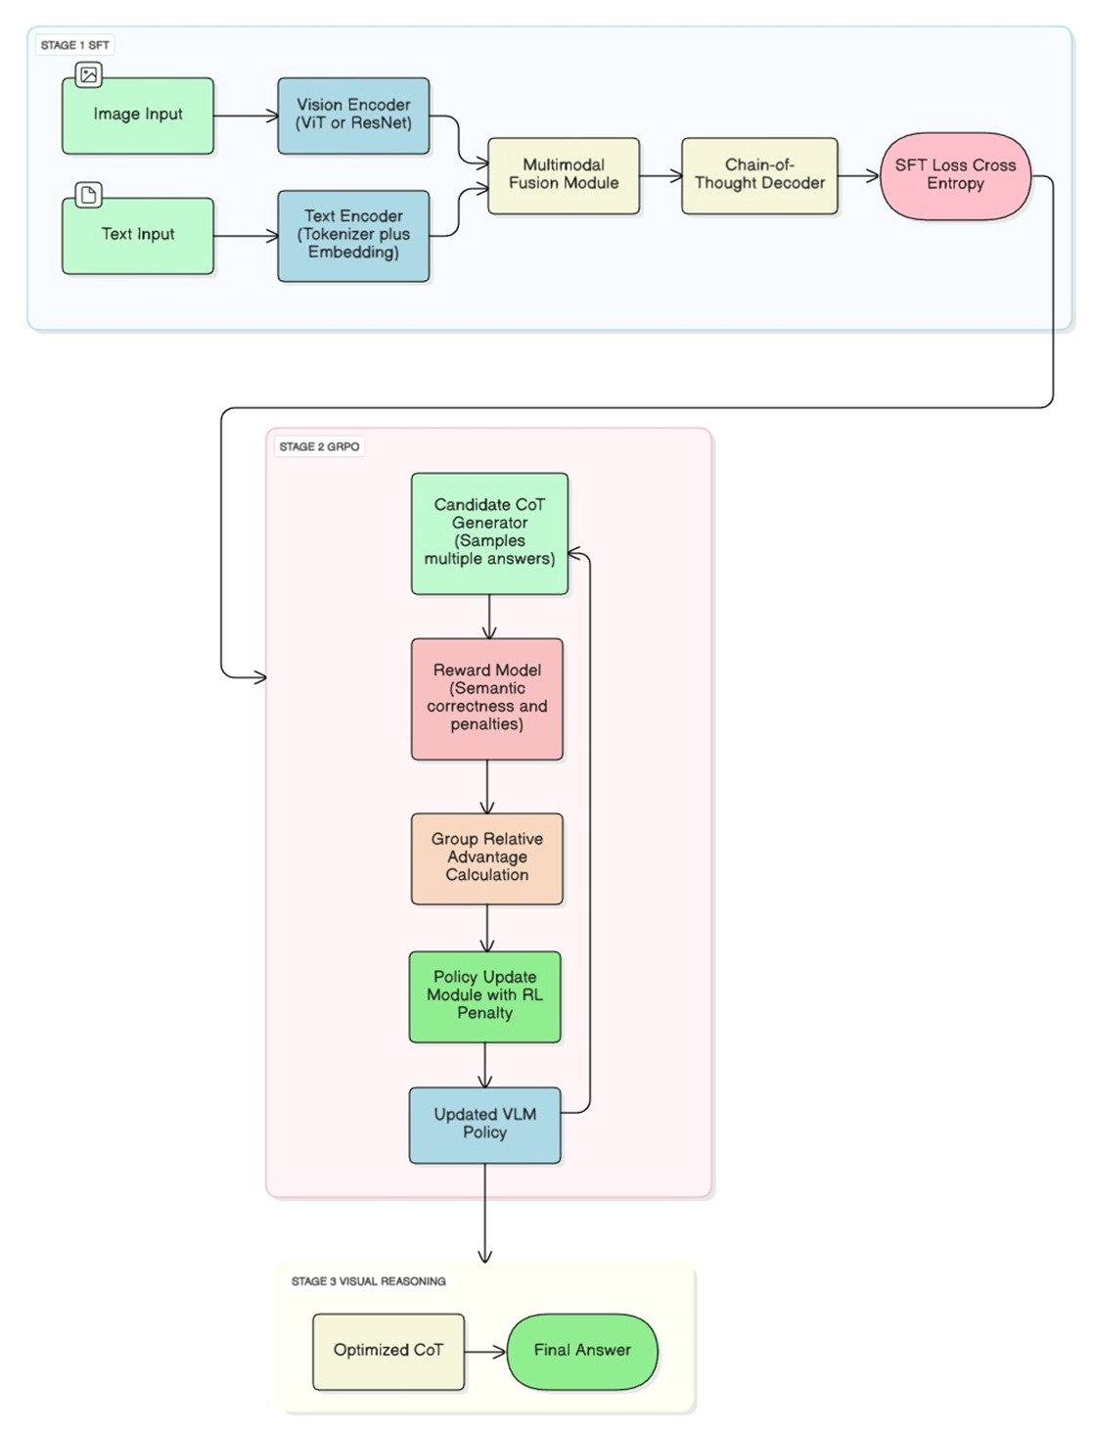
Fig 1: Reason-RFT Architecture Diagram

3.1.3 Approach 2 Architecture: TRM-Based Latent Reasoning
Approach 2 introduces a lightweight latent reasoning architecture based on the Tiny Recurrent Memory (TRM) framework. Unlike Approach 1, reasoning is performed internally without generating explicit textual explanations.

3.1.3.1 Stage 1: Multimodal Encoding and Initialization
A compact vision encoder (MobileNetV3-Small) extracts visual features from the input leaf image. Simultaneously, the diagnostic question is encoded using a minimal text representation incorporating both the question content and its type. These embeddings are fused to form a joint representation, from which an initial answer state and an initial memory state are generated.
This stage provides a fast, coarse diagnostic hypothesis that serves as the starting point for iterative refinement.
3.1.3.2 Stage 2: TRM Iterative Reasoning
The core reasoning module consists of a Tiny Recurrent Memory that maintains two latent states: an answer state and a memory state. Through multiple recurrent iterations, the memory state accumulates evidence from the visual input, while the answer state is progressively refined based on the updated memory.
Deep supervision is applied at selected iterations to stabilize training, allowing the model to perform multi-step latent reasoning efficiently. This iterative refinement enables the system to correct early mispredictions and strengthen confident diagnoses.
3.1.3.3 Stage 3: Optional Explanation Decoder
An optional transformer-based decoder is introduced to map the final latent reasoning state to natural language explanations. However, due to limited explanation data and lack of pretrained language models, this component remains underdeveloped. As a result, the primary output of Approach 2 is a refined classification rather than a textual explanation.

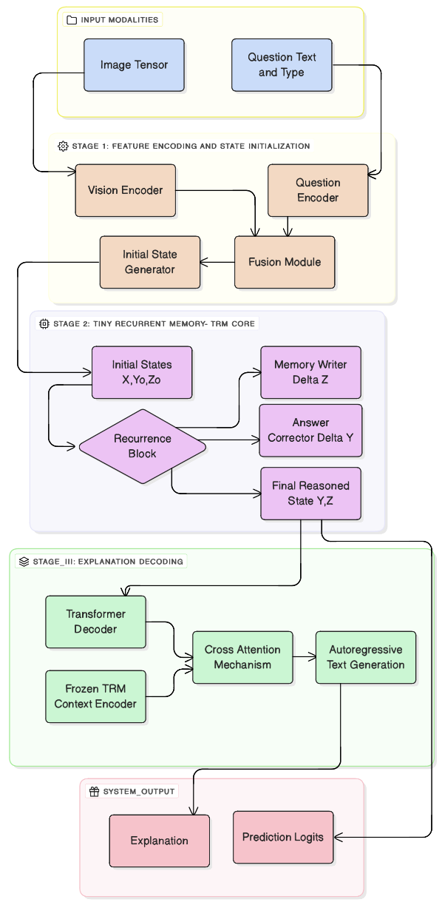

Fig 2: TRM based Latent Reasoning Architecture Diagram

3.1.4 Approach 3 Architecture: CLIP + Recursive GRU Reasoning
Approach 3 integrates pretrained multimodal representations with lightweight recursive reasoning, achieving a balance between interpretability, reasoning depth, and computational efficiency.

3.1.4.1 Multimodal Feature Extraction
CLIP image and text encoders are employed to extract aligned embeddings from the plant leaf image and the corresponding diagnostic question. The frozen CLIP backbone encodes visual symptom patterns and semantic query intent into a shared embedding space, providing robust multimodal representations without additional fine-tuning overhead.
3.1.4.2 Recursive Reasoning Layer
The concatenated CLIP image and text embeddings are passed into a GRUCell-based recursive reasoning layer. This module iteratively updates an internal hidden state over multiple reasoning steps, allowing the model to repeatedly condition on the same multimodal evidence. This recursive refinement simulates a latent chain-of-thought process, progressively enhancing the contextual understanding of the disease.
3.1.4.3 Explanation Generation and Reinforcement Learning
A GRU-based decoder generates chain-of-thought explanations autoregressively from the refined reasoning context. The model is first trained using supervised learning with teacher forcing to ensure fluent and coherent explanation generation. Subsequently, Group Relative Policy Optimization (GRPO) is applied as a reinforcement learning fine-tuning stage, using a reward signal based on semantic overlap with ground-truth explanations. This hybrid training strategy improves reasoning consistency and diagnostic relevance while maintaining computational efficiency.
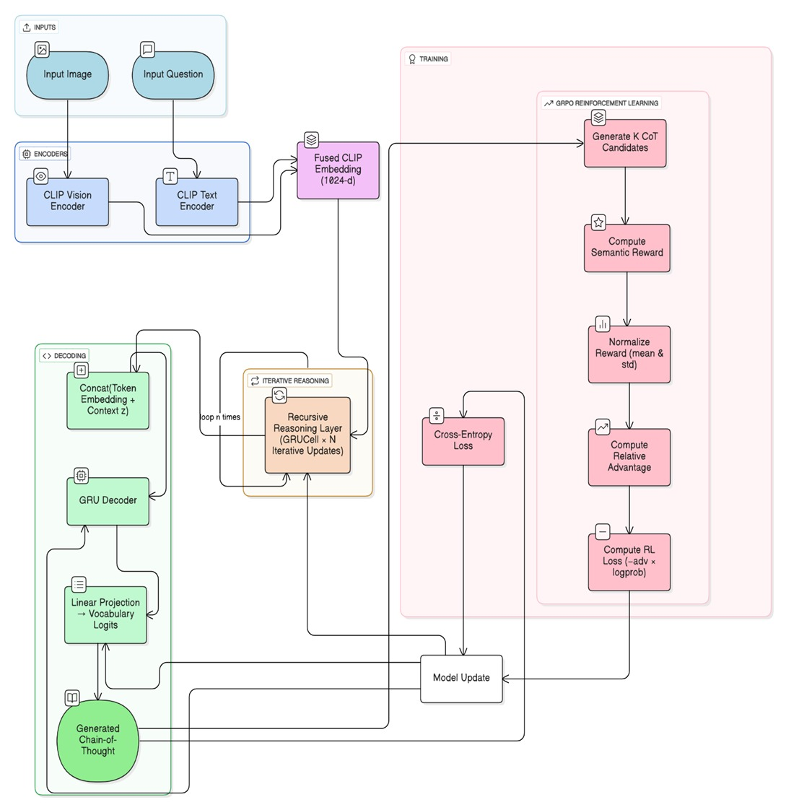
Fig3: CLIP + Recursive GRU Reasoning Architecture Diagram

3.2 Technology Stack
The proposed system was implemented using Python 3.10 as the primary programming language, with PyTorch serving as the core deep learning framework across all approaches. Model training and experimentation were conducted on Google Colab utilizing NVIDIA CUDA-enabled GPUs for hardware acceleration.

For Approach 1 (Reason-RFT), pretrained vision–language models were implemented using the Hugging Face Transformers library. The Qwen2-VL-2B-Instruct model was used through AutoModelForVision2Seq,AutoModelForImageTextToText, AutoProcessor, and AutoTokenizer. Parameter-efficient fine-tuning was performed using PEFT (LoRA). Image processing was handled using PIL, while NumPy, Pandas, and scikit-learn were used for data handling and evaluation.
For Approach 2 (TRM-Based Latent Reasoning), the architecture was implemented entirely using PyTorch modules, including torch.nn, torch.nn.functional, and torch.utils.data. Image preprocessing and augmentation were performed using PIL and torchvision, while optimization was handled using torch.optim (AdamW) with GPU support via torch.cuda. Supporting Python libraries included os, json, random, zipfile, math, time, and collections, with argparse used for experiment configuration. Components from the transformer’s library, such as AutoTokenizer and TransformerDecoderLayer, were used for the explanation decoder.
For Approach 3 (CLIP + Recursive GRU Reasoning), multimodal embeddings were generated using the CLIP model from Hugging Face Transformers, with recursive reasoning implemented using GRU-based recurrent neural networks in PyTorch. Image handling and numerical operations were supported by Pillow, NumPy, and JSON-based tokenization.
A lightweight frontend interface was implemented using React.js, with Tailwind CSS, Framer Motion, and Vite. Backend inference was developed using FastAPI, hosted with Uvicorn.

  - User Interface
The user interface of AGRI VISION: Smart Vision–Language Diagnosis for Plants was designed to enable seamless interaction between users and the underlying vision–language reasoning models. The interface prioritizes usability and accessibility, allowing users with limited technical expertise to perform plant disease diagnosis effectively. The web application was implemented using React.js for frontend development, Tailwind CSS for responsive and consistent styling, and FastAPI for backend inference and API handling.
The frontend provides a structured interface through which users can upload plant leaf images in standard formats such as JPG and PNG. Along with image upload, the system allows users to input natural language queries related to plant health and disease symptoms. These inputs are transmitted to the backend, where the vision–language models perform multimodal reasoning and generate diagnostic outputs.
The interface supports two primary operations: (1) visual plant disease identification, where the system predicts the disease class based on the uploaded leaf image, and (2) visual question answering, where user queries are answered by jointly analyzing the image and the associated question. The diagnostic results are returned in real time and displayed in a structured output section.
The interface layout maintains a clear separation between input components and output responses to ensure a smooth user workflow. The design emphasizes responsiveness and clarity, enabling consistent performance across different devices and screen sizes. This user interface serves as an effective front-end layer for deploying the AGRI VISION system as a practical plant disease diagnosis tool.

CHAPTER - 4 RESULTS
This chapter presents and discusses the experimental results obtained from the three vision-based reasoning architectures developed for plant disease diagnosis: the Reason-RFT framework built on Qwen2-VL, the Samsung Tiny Recurrent Memory (TRM) model, and the CLIP-based Recursive GRU reasoning system.

4.1 System Configuration
The training, experimentation, and evaluation of the proposed plant disease diagnosis system were carried out using a combination of cloud-based GPU environments and local development setups to ensure both computational efficiency and reproducibility. Given the high computational demands of vision–language models and reinforcement learning pipelines, most model training and fine-tuning tasks were executed on cloud platforms with GPU acceleration.

The primary training environment was Google Colab, which provided access to NVIDIA Tesla T4 GPUs, along with 16 GB of RAM and virtual CPU cores. This configuration was sufficient for running multimodal models such as Qwen2-VL, executing supervised fine-tuning with Chain-of-Thought annotations, and performing reinforcement learning using GRPO without encountering memory overflow or instability issues. The GPU environment enabled efficient batch processing of image–text inputs, backpropagation during supervised fine-tuning, and stable reward-based optimization during reinforcement learning.

For lightweight experimentation and inference testing, a local system equipped with an Intel Core i5 processor, 16 GB RAM, and Windows 10 operating system was used. This environment supported dataset preprocessing, prompt evaluation, model inference using pretrained checkpoints, and visualization of outputs. While full-scale model training was not feasible on the local setup due to hardware limitations, it was adequate for debugging, analysis, and demonstration purposes.

The software environment was built using Python 3.10 as the primary programming language. The deep learning framework PyTorch was used for model training, loss computation, and optimization. Multimodal processing and transformer-based architectures were implemented using the Hugging Face Transformers library, while Hugging Face TRL was utilized to support reinforcement learning with GRPO. Image processing operations were handled using PIL, and dataset handling was managed through structured JSON and JSONL files.

4.2 Quantitative Analysis
This section presents a quantitative evaluation of the three proposed approaches for plant disease diagnosis: Approach 1 (Reason-RFT), Approach 2 (Samsung TRM), and Approach 3 (CLIP + Recursive GRU). The analysis is based on training loss convergence and standard classification metrics.
Approach 1: Reason-RFT (CoT-SFT + GRPO)
The Reason-RFT model was trained using a two-stage framework consisting of supervised Chain-of-Thought (CoT) fine-tuning followed by reinforcement learning with Group Relative Policy Optimization (GRPO). The training loss curve shows a gradual decrease from approximately 13 to around 6, indicating stable convergence while learning structured visual reasoning.
After completing Stage 2 (GRPO-based reinforcement learning), the model achieved a final overall accuracy of 71.43%. The corresponding precision and recall values of 80.00% each indicate reliable disease prediction with balanced sensitivity. The F1-score of 76.67% reflects consistent classification performance across disease classes.
Although reinforcement learning did not produce a large numerical gain in accuracy, it significantly improved generalization and output stability, reducing hallucinated disease predictions and aligning responses with domain-specific plant pathology constraints. These improvements are critical for practical deployment, where consistency and biological plausibility are as important as raw accuracy.
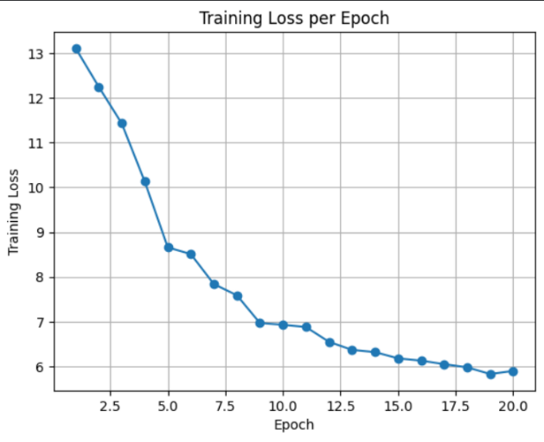

Fig 4: Training Loss Vs Epoch for Reason-RFT

Approach 2: Samsung TRM Latent-Reasoning Model
The Samsung TRM-based model focuses on latent iterative reasoning without explicit textual explanation generation. During Stage 1 (vision and question encoding), the model achieved a disease classification accuracy of approximately 78%, demonstrating effective learning of visual–semantic disease features.
In Stage 2, recursive memory refinement converged rapidly over a small number of latent steps, and deep supervision stabilized the internal reasoning process. However, due to limited training data and the absence of a pretrained language decoder, the model was unable to generate coherent natural-language explanations. As a result, evaluation was restricted to classification performance, where the TRM model showed competitive accuracy despite the lack of explicit reasoning supervision.

Approach 3: CLIP + Recursive GRU Reasoning
The CLIP-based recursive reasoning model leverages pretrained multimodal embeddings combined with iterative GRU-based refinement. The training loss curve demonstrates fast and stable convergence, decreasing from approximately 3.2 to below 0.3, reflecting efficient optimization.

After completing the full training pipeline, including GRPO-based reinforcement learning, the model achieved a final overall accuracy of approximately 79.10%, the highest among all three approaches.
Precision, recall, and F1-score values also improved after reinforcement learning, indicating enhanced consistency and reduced ambiguity in predictions.
These results show that recursive latent reasoning combined with strong pretrained representations and reward-based alignment can significantly outperform both explicit CoT-based reasoning and purely latent models in low-resource agricultural settings.

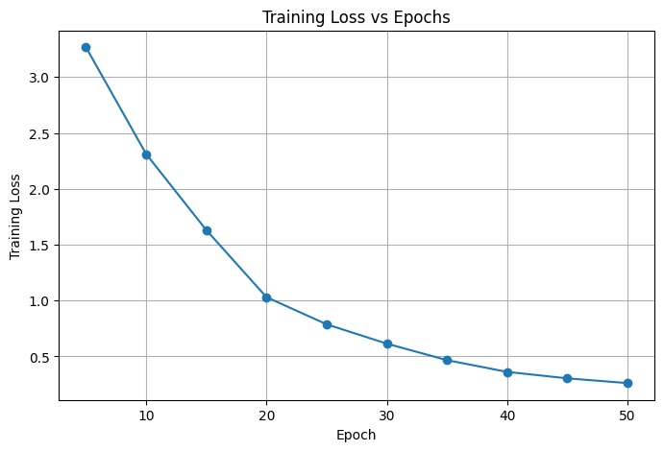

Fig5: Training Loss Vs Epoch for CLIP + Recursive GRU

Overall Performance Review:
Among the three approaches, Approach 3 achieved the best quantitative performance, Approach 1 provided interpretable reasoning with stable generalization, and Approach 2 remains incomplete for the expected reasoning objective and is designated for future extension. These results highlight the importance of both pretrained representations and reinforcement learning for building reliable, explainable plant disease diagnosis systems under limited data constraints.

4.3 Qualitative Analysis
Beyond numerical performance, it is essential to evaluate the system based on user experience, design intuitiveness, and practical functionality. The AGRIVISION platform was developed to make advanced computer vision and visual QA models accessible through an immersive, nature-inspired web interface. The qualitative analysis focuses on the visual layout, task workflows, and the clarity of outputs generated for plant disease diagnosis.
The platform interface is organized across several key screens: a cinematic Home Page, a botanical Enquiry Dashboard for diagnosis, and a Result Revelation page. Each of these components has been designed with the aim of demystifying AI operations and enabling users—farmers, gardeners, and researchers—to interact with models seamlessly within a calming digital environment.
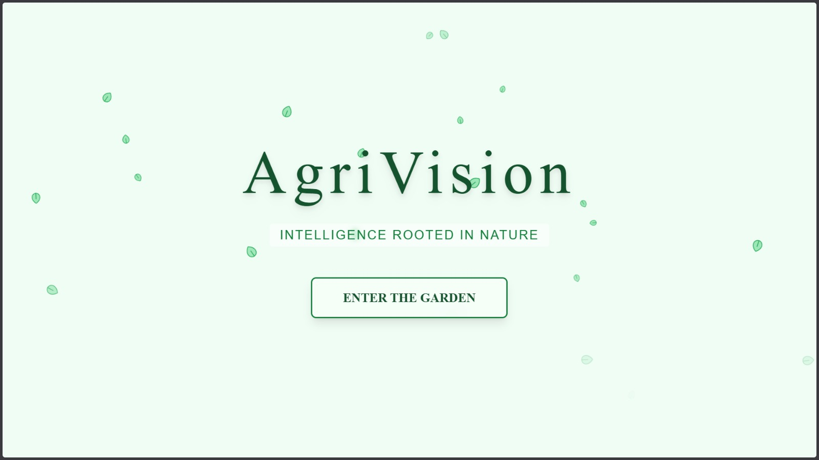

Fig 6: Welcome Page of the website

The Home Page serves as the atmospheric entry point to the AgriVision platform. It introduces the system’s "Magic Forest" aesthetic, featuring a gentle "Falling Leaves" animation that immediately establishes a connection with nature. The design is clean and focused, with a prominent "Enter the Garden" call-to-action that guides the user effortlessly into the main workflow. This page sets the tone for a serene and professional user experience, distinguishing it from sterile, utility-focused tools.


Fig 7: Diagnose Page - Visual Enquiry

The Enquiry Dashboard is the primary user interaction zone, where plant images can be uploaded for processing. Users can drag and drop a leaf image onto the "Upload Card" and input a specific natural language query (e.g., "Is this leaf healthy?"). The system handles the complex multimodal inference in the backend while displaying a "Divining..." animation to the user. This animated feedback loop ensures transparency in the system's status and keeps the user engaged during the brief processing time.

Fig 8: Result Page

Upon completion of the analysis, the interface transitions to the Result Page. Here, the system presents the diagnosis not as raw data, but as a revealed truth from "The Garden." The uploaded image is displayed alongside the generated insight in a glassmorphism-styled container, floating above the animated background. This layout ensures that the diagnosis is easy to read and contextually linked to the visual evidence, enabling the user to assess the model’s reasoning capabilities in a practical agricultural setting. The inclusion of a "Consult Again" navigation option ensures a smooth loop for repetitive task.

CHAPTER – 5
CONCLUSION AND FUTURE SCOPE

5.1 Conclusion
This project presented an explainable and reasoning-oriented framework for automated plant disease diagnosis using advanced vision–language models and reinforcement learning techniques. Unlike conventional image-based classification systems that operate as black boxes, the proposed approach emphasizes interpretable decision-making by integrating visual perception, natural language understanding, and reasoning-driven learning.
Three complementary methodologies were explored: a Reason-RFT–based vision–language model trained using supervised chain-of-thought learning followed by GRPO-based reinforcement learning; a CLIP-guided recursive reasoning architecture capable of refining multimodal representations; and a lightweight Tiny Recurrent Memory (TRM) framework designed for iterative latent reasoning. Each approach contributes a unique perspective toward achieving accurate and transparent disease diagnosis, while collectively demonstrating the effectiveness of reasoning-aware AI systems in agriculture.
Experimental observations indicate that incorporating structured reasoning and reinforcement learning improves diagnostic reliability and reduces uncertainty when compared to traditional supervised models. By shifting the focus from mere label prediction to explanation-supported diagnosis, the system provides more trustworthy outputs that align with practical agricultural decision-making needs.
Overall, this work highlights the potential of combining vision–language reasoning, reinforcement learning, and lightweight architectures to build intelligent, interpretable, and reliable plant disease diagnostic systems suitable for real-world agricultural applications.

5.2 Future Scope

Several directions can be explored to extend and improve the AGRI VISION framework. First, expanding the dataset to include field-captured images under varying environmental conditions such as lighting changes, occlusion, and background noise would improve robustness and real-world applicability. Incorporating severity-level annotations and multi-stage disease progression data can further enhance diagnostic precision.

Second, future work may focus on improving explanation generation by integrating pretrained language decoders or larger vision–language backbones, particularly for the TRM-based latent reasoning approach. This would enable more fluent and detailed diagnostic explanations while preserving computational efficiency.

Third, integrating external agricultural knowledge bases and plant pathology ontologies could strengthen domain grounding and reduce reliance on handcrafted reward functions. Additionally, exploring multimodal reinforcement learning with adaptive reward modeling may further improve reasoning alignment.

Finally, the system can be extended toward real-world deployment by optimizing inference latency, enabling mobile or edge-device compatibility, and integrating real-time data streams from IoT sensors or drone-based imaging systems. These enhancements would position AGRI VISION as a practical and scalable decision-support tool for precision agriculture and sustainable farming practices.

REFERENCES

[1] D. P. Hughes and M. Salathé, “An open access repository of images on plant health to enable the development of mobile disease diagnostics,” arXiv preprint arXiv:1511.08060, 2015. https://arxiv.org/abs/1511.08060
[2] H. Kim, J. Park, S. Yun, and J. Choi, “Less Is More: Recursive Reasoning with Tiny Networks,” arXiv preprint arXiv:2503.20752, 2025. https://arxiv.org/abs/2503.20752
[3] H. Tan, Y. Ji, X. Hao, M. Lin, P. Wang, Z. Wang, and S. Zhang, “Reason-RFT: Reinforcement Fine-Tuning for Visual Reasoning,” arXiv preprint arXiv:2503.20752, 2025. https://arxiv.org/abs/2503.20752
[4] J. Yang et al., “GRPO: Group Relative Policy Optimization,” Qwen Team, Alibaba, 2024.
https://arxiv.org/abs/2407.21787
[5] Y. Bai et al., “Qwen2-VL: Multimodal Large Language Models,” Alibaba, 2024.
https://arxiv.org/abs/2407.15882
[6] A. Radford et al., “CLIP: Connecting Vision and Language Through Contrastive Learning,” OpenAI, 2021.
https://arxiv.org/abs/2103.00020
[7] J. Chung et al., “Gated Recurrent Unit (GRU),” arXiv preprint arXiv:1412.3555, 2014.
https://arxiv.org/abs/1412.3555
[8] R. Sutton and A. Barto, “Reinforcement Learning: An Introduction,” MIT Press, 2018. http://incompleteideas.net/book/the-book-2nd.html
[9] K. P. Ferentinos, “Deep Learning Models for Plant Disease Detection and Diagnosis,” Computers and Electronics in Agriculture, 2018. https://doi.org/10.1016/j.compag.2018.01.009

[10] A. Ramesh et al., “Learning Transferable Visual Models from Natural Language Supervision” NeurIPS, 2021. https://arxiv.org/abs/2103.00020
[11] J. Wei et al., “Chain-of-Thought Prompting Elicits Reasoning in Large Language Models,” NeurIPS, 2022. https://arxiv.org/abs/2201.11903

