# 4c

**Aim: Interface 8051 with D/A converter and generate square wave of given frequency on oscilloscope.**

Problem definition: Write an embedded C program to generate a square wave of frequency 1KHz and duty cycle equal to 50% using 8051 microcontroller and a DAC. Connect the CRO through DAC interface to the output port of 8051

microcontroller to see the waveform and trace it. Algorithm 1. Set port 1 as output port.

1. Send maximum value at port 1
2. Call delay for calculated time interval go generate 1kHz square wave. i.e. time delay = 1/ 1000 = 1 ms
3. Send min value to port1
4. Call same delay to obtain 50% duty cycle. 6. Repeat in infinite loop.

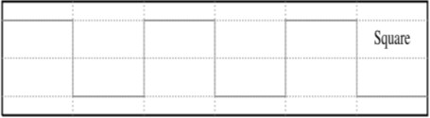

# Hardware connections:

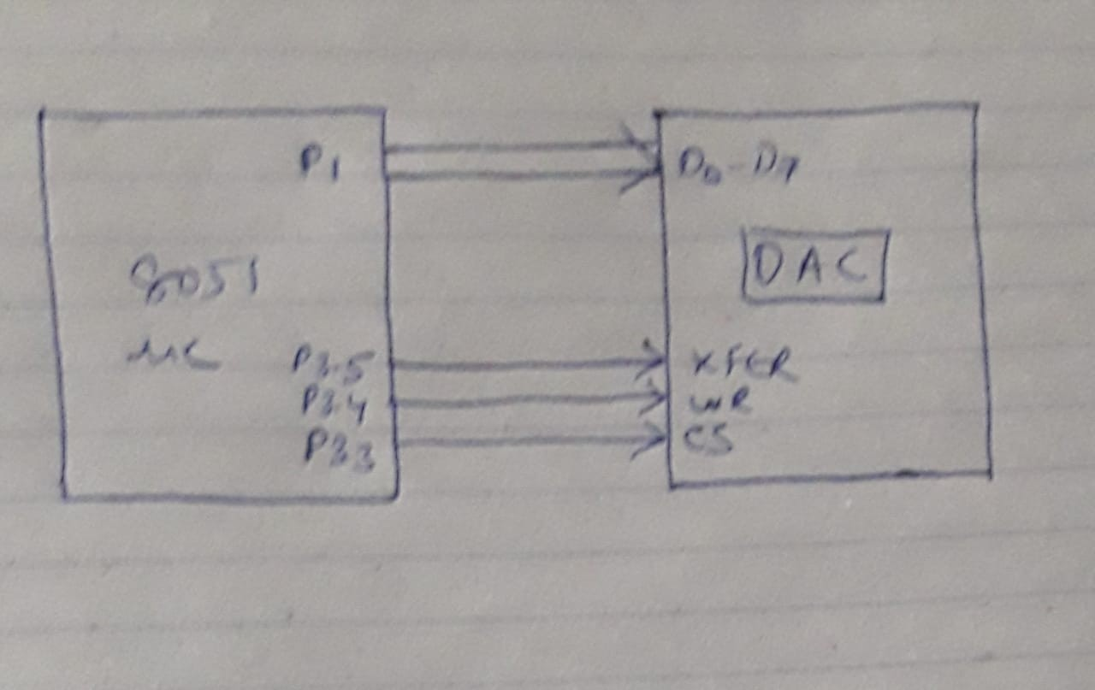

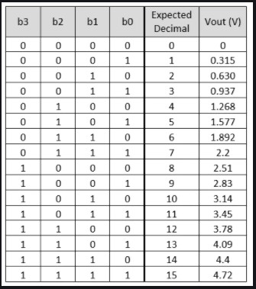

#include<reg51.h>

sbit cs=P3^3;

sbit wr1=P3^4;

sbit xfer=P3^5;

void delay(int time);

void main()

{

while(1)

{

P1 = 0x00;

cs=0; wr1=1;

xfer=1;

P1 = 0xFF; // Send maximum value to Port1 for getting High Period of Square Wave

delay(1);

wr1=0;

xfer=0;

wr1=1;

xfer=1;

P1 = 0x00; // Send maximum value to Port1 for getting Low Period of Square Wave

delay(1);

wr1=0;

xfer=0;

}

}

void delay(int time) // delay of 1ms thus frequency of 1kHz.

{

int i,j;

for(i=0;i<=time;i++)

for(j=0;j<=1275;j++);

}