**Internship in data science for molecular metabolomics:**

**AI data extraction from molecular NMR spectroscopy**

UKSH, CAU, Section Biomedical Imaging

Am Botanishen Garten 14, 24118, Kiel

Prof J.-B. Hövener and

Dr A. N. Pravdivtsev

Contact us: andrey.pravdivtsev@rad.uni-kiel.de

Analyzing an organism's metabolism is crucial for understanding and monitoring diseases and treatments. Magnetic resonance imaging (MRI) is the only technique to measure the metabolism non-invasively, in vivo, and in vitro.

Deuterium-labeled MRI was demonstrated recently in humans and allows for cancer diagnosis (**Figure 1**). Our study uses different cell lines and various deuterium-labeled (nonradioactive!) substrates to find the ideal tracers for specific diseases.

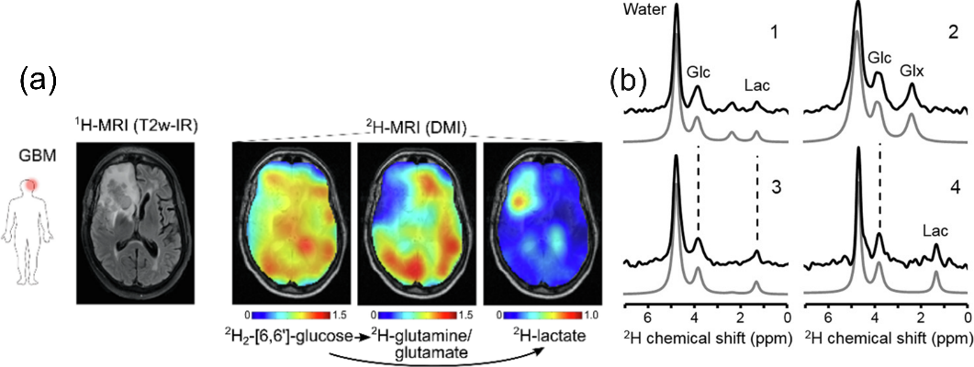**Fig 1.** (a) 1H-MRI and 2H-MRI (DMI) images of clinical glioblastoma multiforme (GBM). DMI of glucose and metabolites Glx = glutamine/glutamate and lactate. DMIs show lower levels of 2H-labeled Glx and higher concentrations of 2H-lactate in and around the tumor, reviling the active Warburg effect. Subjects orally ingested 0.6–0.75 g [6,6']-2H2-glucose per kg body weight. (b) 2H NMR spectra from different areas reveal different metabolisms that can be well seen in (a). The analysis of such spectra using AI tools for better sensitivity is a crucial part of the project. Here, the grey spectra (1-4) were fitted to the experimental black spectra and used for color-coded images. The figure is part of the ref. *De Feyter, H. M. et al. Science Advances 4, eaat7314 (2018)*.

**We would like to achieve the following together:**

Open source, automated metabolic data analysis tool.

**We will provide you with:**

(1) Metabolic data; (2) access to our bio lab if you like it; (3) support with the data analysis and metabolic models; (4) publication in a journal if the minimal viable tool is ready for use.

**Background:**

NMR industry-standard commercial analysis packages like Chenomx’ NMR Suite require advanced training and manual analysis to achieve reproducible metabolic results. Recently, algorithm-based automatic analyzers such as BATMAN [DOI: 10.1093/bioinformatics/bts308] and LCModel [DOI: 10.1002/nbm.698] have addressed some of these challenges.

Adopting deep-learning approaches, including convolutional neural networks (CNNs) like NMRQNet [DOI: 10.1101/2023.03.01.530642], demonstrates a big success in metabolic analysis. These pipelines automate the process, enabling the accurate, unsupervised identification and quantification of metabolites in complex data sets. Your task will be to develop something similar for deuterium MRI data analysis.