BILL MANGEMENT SYSTEM USING CPP

**THIS PRODUCTS PROVIDES THE FOLLOWING FEATURES:**

*\*\* IT WILL TAKE THE NO OF ITEMS*

*\*\*ITEMS DETAILS-*

*NAME

*QUANTITY

*PRICE

AND OUTPUT WILL BE AS-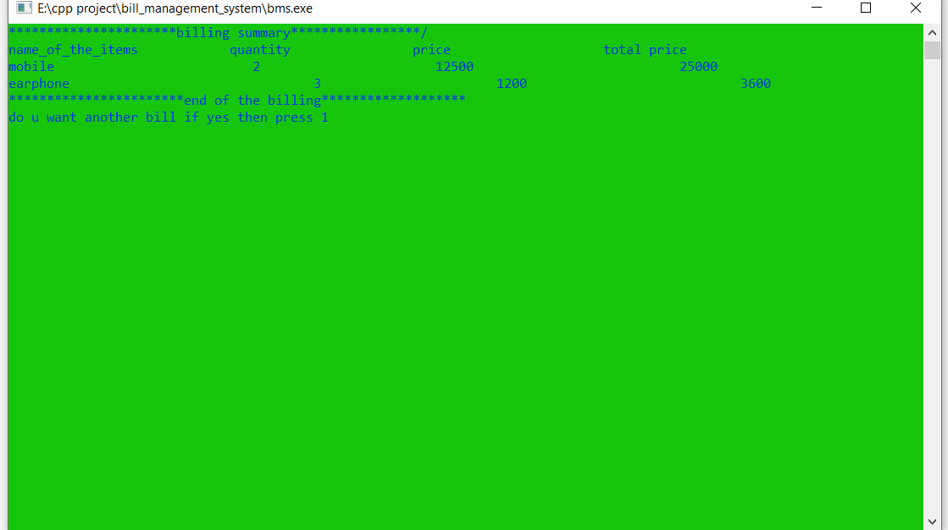

Thank you