PHD RESEARCH / EXPERIMENT REPORT

RAVEN
SuperMimic-Inspired Dynamics Learning
Daily progress, experiments and research findings
Research session: 25–26 October 2026 | NVIDIA Isaac Sim / Isaac Lab | Unitree G1 + physical tripod
2 × 7,501  120 Hz state–action recordings | 100%  RGB-D actor detection, both runs | 66.7 ms  Eight-step predictive horizon

Executive summary
The session established a reproducible data-to-model workflow for the RAVEN humanoid robotic cinematography system: validated camera tracking, full-rate G1/tripod telemetry capture, offline differentiable dynamics-model training, and evaluation on a separate actor trajectory. The working perception, assisted-grasp and tracking baseline was preserved.
NEW RESEARCH FINDING
On the independently recorded trajectory, the learned world model reduced 66.7 ms pan-prediction error relative to assuming no motion (0.1933° versus 0.2433° MAE), but was less accurate than constant-velocity extrapolation (0.1677° MAE). This is evidence of useful learned motion prediction, not yet of superiority over a simple physics-informed baseline.

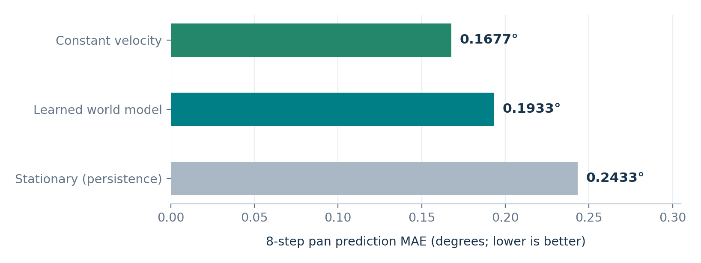
Figure 1. Independent trajectory: eight-step pan prediction MAE. The constant-velocity method is the strongest of the three tested predictors.
Research significance. The result motivates a residual dynamics model that learns deviations from constant-velocity motion, rather than modelling full pan dynamics from scratch. No reinforcement-learning policy has been trained or deployed.

1 Work completed during the session
IMPLEMENTATION AND VERIFICATION
Stage | Delivered / observed
Repository and environment | GitHub main at 1e2ea38; working feature branch feature/supermimic-integration; PyTorch 2.7.0+cu128 and CUDA available on RTX 4060 Laptop GPU.
Full-rate capture | New raven_g1_rl_data_capture.py records 51 G1 joints, joint targets, measured velocities, tripod pan/tilt and RGB-D observation metadata at 120 Hz.
First recording | 7,501 state–action samples, 351/351 successful actor detections, original tracking run complete.
World-model V1 | PyTorch residual MLP; eight-step differentiable rollout; 60 training epochs; checkpoint and metrics exported.
Independent recording | Second 7,501-sample capture on a different actor motion trajectory, with complete camera tracking.
Out-of-sample evaluation | Frozen model tested on 1,049 overlapping eight-step windows; compared against stationary and constant-velocity baselines.

2 Recorded experiments
Capture characteristic | Recording A · training | Recording B · independent
Run identifier | 20261025_230816_212515 | 20261026_004925_836186
Physics samples | 7,501 | 7,501
Physics rate | 120 Hz | 120 Hz
RGB-D detections | 351 / 351 | 351 / 351
Actor motion amplitude | ±0.40 m | ±0.30 m
Actor motion period | 11 s | 7 s
Physical pan range | −8.69° to +9.25° | −6.56° to +6.80°
Tracking summary MAE | 0.349° | 0.410°
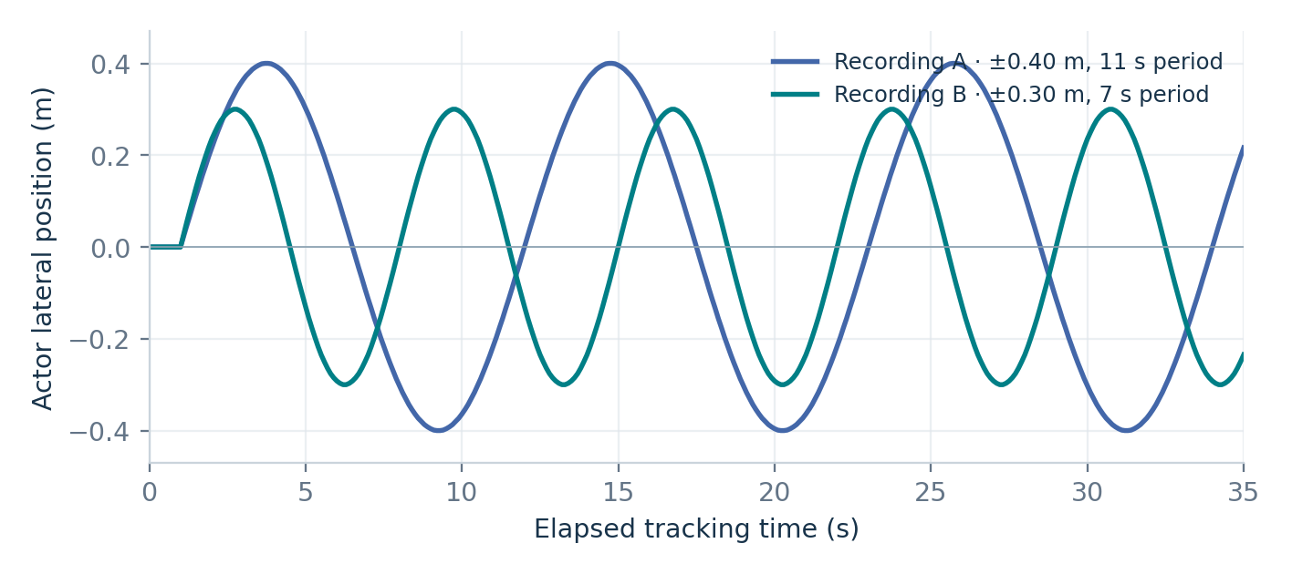
Figure 2. Ground-truth actor lateral motion (used here only for experiment characterisation, not as controller input). The independent run is faster and has smaller displacement.

3 Differentiable world-model V1
A SuperMimic-inspired offline model was trained in PyTorch from state transitions recorded with Isaac Sim at 120 Hz. The architecture is a residual multilayer perceptron: it predicts a normalised next-state correction conditioned on the current state and the commanded joint-position targets. Its predictions are recursively unrolled for eight physics steps.
Component | Configuration
State (20 values) | 8 selected G1 joint positions, 8 joint velocities, tripod pan/tilt positions and velocities.
Action (8 values) | Position targets for waist yaw and 7 left-arm joints; not direct torque commands.
Model | Residual MLP, 2 hidden layers of 128 units, SiLU activation.
Training | Adam; 60 epochs; 8-step rollouts; 120 Hz samples; CUDA on RTX 4060.
Single-run split | Chronological 70% train / 15% validation / 15% test, with rollout windows confined to each partition.
Original test windows | 734 training / 156 validation / 156 test.
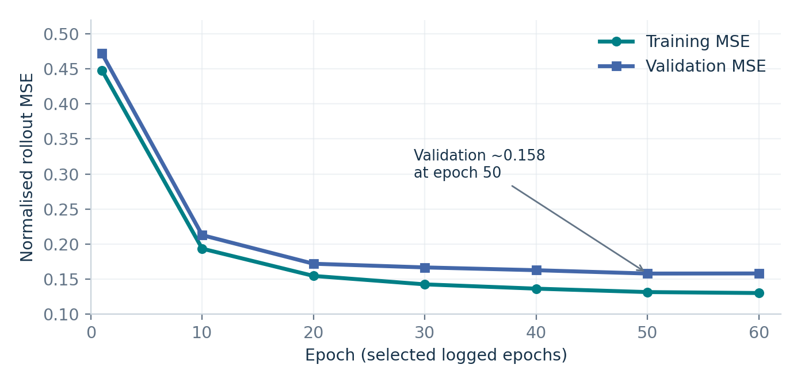
Figure 3. Logged training and validation normalised rollout MSE (selected epochs). Validation improves from ~0.472 at epoch 1 to ~0.158 at epoch 60.

Initial within-trajectory evaluation
0.1521°  World-model 8-step pan MAE | 0.2063°  Stationary baseline MAE | 26.3%  Relative MAE reduction

The initial result is promising but limited: the test windows were held out chronologically from the same simulated trajectory, which does not demonstrate generalisation to new operating conditions. This motivated the subsequent fully separate trajectory evaluation.

4 Independent trajectory generalisation
The trained checkpoint was frozen and evaluated on the second recording. The actor movement differed in both amplitude (±0.30 m) and period (7 s) from the first run. No model weights were updated using this second dataset.
STEP-8 PREDICTION: 66.7 MILLISECONDS AHEAD
Method | Pan MAE | Pan P95 | Pan max error
Constant velocity | 0.1677° | 0.3387° | 0.4945°
Learned model | 0.1933° | 0.4810° | 1.1399°
Stationary (persistence) | 0.2433° | 0.4258° | 0.4874°
For pan, the learned model is 20.55% better than stationary persistence, but its MAE is 15.26% higher than constant velocity. The learned model also has the largest observed tail error: 1.1399° maximum versus 0.4945° for constant velocity.
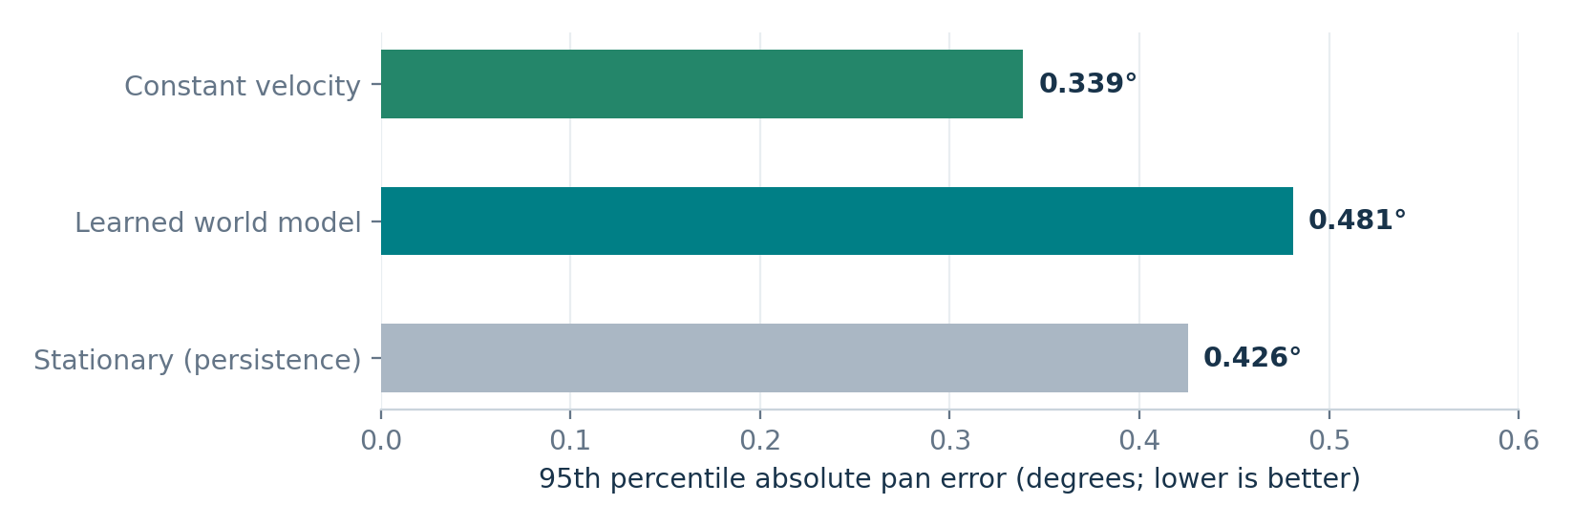
Figure 4. Independent pan-error P95. The learned predictor has poorer tail accuracy than both baselines despite improving mean error over persistence.

Tilt predictions and capture integrity
Tilt: step-8 MAE | Learned model | Stationary | Constant velocity
Degrees | 0.0225° | 0.0241° | 0.0913°
For tilt, the learned model slightly improves on persistence and clearly beats a constant-velocity extrapolation. This indicates that pan and tilt have different predictive structure in the present constrained-tripod configuration. The independent run supplied 4,202 tracking-phase states and 1,049 overlapping evaluation windows, with no camera detection failures.

5 System-level evidence and setbacks
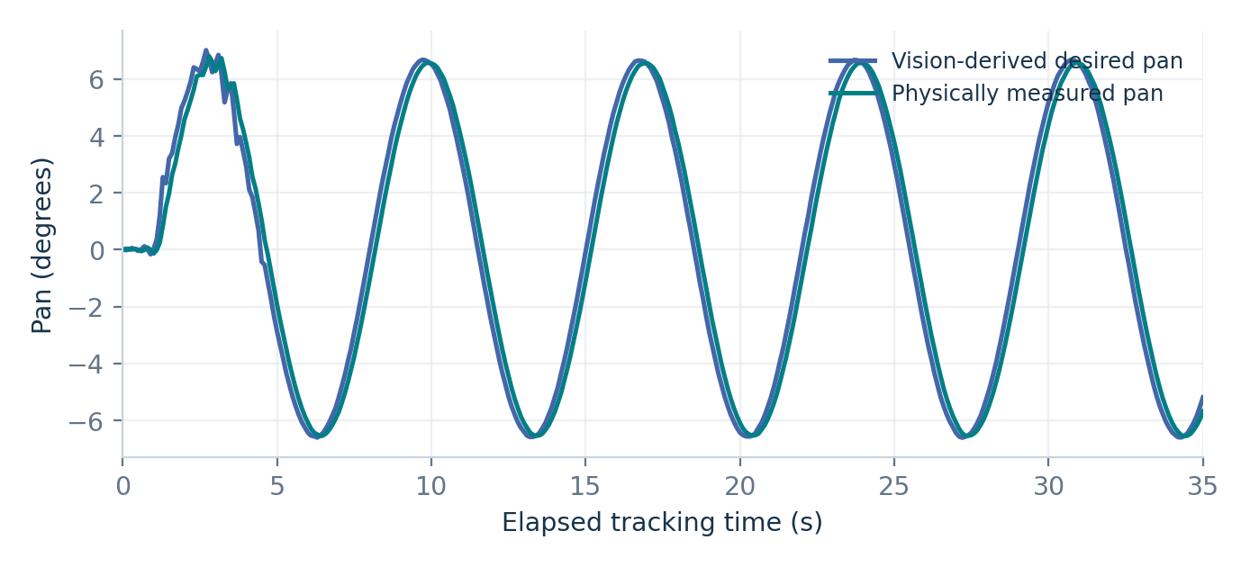
Figure 5. Vision-derived desired pan and physically observed tripod pan on the independent run. This graph shows the existing tracking controller, not world-model-driven control.

Grasp ergonomics: open engineering issue
A side-view inspection revealed an unnatural left-elbow configuration near its upper flexion limit. A 10 cm closer operator stance was explored, together with faster grasp and manual calibration interfaces. The original tracking setup remained the reference baseline after these experimental variants did not produce reliable alignment.
Experimental change | Observed issue
Closer operator + downward elbow objective | Pre-release pan drift reached +7.49°, beyond the ±0.75° permitted limit.
Closer stance with elbow-prep disabled | Pre-release pan drift of −1.42°; experiment stopped.
Closed-grip retargeting | Hand-to-target position error 87.2 mm; assisted grasp correctly refused.
Viewport gizmo calibration | Isaac Sim exited; provided shutdown warnings were insufficient to isolate the root exception.
Decision for this research milestone
Stop further calibration experiments temporarily. Preserve the successful original G1–tripod controller and progress with offline world-model validation; return to grasp ergonomics as a separately controlled engineering workstream.

6 Next research milestones
- World Model V2: predict a learned correction to constant-velocity pan and an appropriate separate tilt prior, with regularisation against excessive overshoot.
- Training diversity: train using multiple distinct trajectories and reserve a third, unseen motion profile for genuine episode-level evaluation.
- Latency-aware evaluation: explicitly align sensor timestamps with robot/actuator states and measure performance under delayed or intermittent RGB-D observations.
- Only after robust generalisation: evaluate model-based action optimisation offline, then integrate a guarded predictive controller into Isaac Sim without replacing the validated baseline.

7 Research interpretation and reproducibility

Primary finding
In a camera-guidance task combining humanoid joint actuation, assisted grasp and a passive physical tripod, a learned eight-step world model provides useful short-horizon pan estimates compared with a motionless-state assumption. However, a low-complexity constant-velocity model generalises more accurately to the independently recorded, faster actor motion. Therefore, architectural inductive bias and appropriate motion priors may matter more than model capacity at this stage.

Evidence boundaries
- One additional trajectory establishes a limited cross-trajectory test, not broad statistical generalisation or a formal controlled benchmark.
- The 1,049 evaluation windows overlap substantially and should not be interpreted as 1,049 independent episodes.
- The predictor receives future recorded joint-position targets for each eight-step rollout; it has not yet learned to select actions, operate under unseen action sequences, or control the robot online.
- The pipeline implements a SuperMimic-inspired differentiable dynamics model. It is not the published SuperMimic training system, and no reinforcement-learning policy has been optimised.
- Perception logging records observation read-time age, not validated camera exposure timestamps; latency claims require dedicated sensor-frame synchronisation experiments.

Source artefacts used
Primary experimental files (repository-relative paths):
scripts/raven_g1_rl_data_capture.py — 120 Hz robot/tripod state–action recorder.
scripts/raven_supermimic_120hz_world_model.py — Offline residual world-model training implementation.
scripts/raven_supermimic_independent_eval.py — Frozen-checkpoint independent generalisation evaluator.
raven_training_results/supermimic_capture/20261025_230816_212515/ — Recording A: original capture and world-model checkpoint.
raven_training_results/supermimic_capture/20261026_004925_836186/ — Recording B: independent capture and evaluation metrics.

Numerical definitions
MAE = mean absolute error; P95 = 95th percentile absolute error; RGB-D = colour plus depth imaging; IK = inverse kinematics; world model = learned mapping from current physical state and action to predicted future state. Smaller error is better for all quoted prediction metrics.
Recommended next experiment
Implement and evaluate a physics-residual World Model V2, benchmarking against constant-velocity extrapolation on a third withheld actor trajectory. Advance to policy optimisation only if it improves both mean and tail prediction accuracy under unseen conditions.

