**INHERITANCE**

**PROGRAMS**

PROGRAM 1

A superclass Number is defined to calculate the factorial of a number. Define a subclass Series to find the sum of the series S = 1! + 2! + 3! + 4! + ………. + n!

The details of the members of both classes are given below:  
Class name: Number  
Data member/instance variable:  
n: to store an integer number  
Member functions/methods:  
Number(): constructor to initialize the data member

int factorial(int a): returns the factorial of a number  
(factorial of n = 1 × 2 × 3 × …… × n)  
void display()  
Class name: Series  
Data member/instance variable:  
sum: to store the sum of the series  
Member functions/methods:  
Series(…) : parameterized constructor to initialize the data members of both the classes  
void calSum(): calculates the sum of the given series  
void display(): displays the data members of both the classes  
Assume that the superclass Number has been defined. Using the concept of inheritance, specify the class Series giving the details of the constructor (…), void calSum(), and void display().

245

Algorithm

**ALGORITHM FOR Number()**

Step 1: Start

Step 2: To receive the number and store it to instance variable nn.

Step 3: Stop.

**ALGORITHM FOR factorial()**

Step 1: Start.

Step 2: run a loop i from 1 upto the number.

Step 2.1: Multiply f with ith value to get the factorial of num and return it.

Step 3: return f

Step 4: Stop.

**ALGORITHM FOR display()**

Step 1: Start

Step 2: Print nn as the number.

Step 3: Stop.

**ALGORITHM FOR series()**

Step 1: Start

Step 2: Invoke the super classes constructor

Step 3: initialize sum as 0.

Step 4: Stop.

**ALGORITHM FOR calcSum()**

Step 1: Start

Step 2: calculate the summation of the factorials from 1 to nn and store it to *sum* variable

Step 3: Stop.

**ALGORITHM FOR display()**

Step 1: Start

Step 2: invoke the super classes display ()

Step 3: print *sum* as the summation of the factorial of the numbers

246

Step 3: Stop

**ALGORITHM FOR main()**

Step 1: Start

Step 2: scanner class object declared

Step 3: accept the number from the user.

Step 4: create an object Series. The object calls the functions calcSum() and display()

Step 5: Stop.

247

Source Code

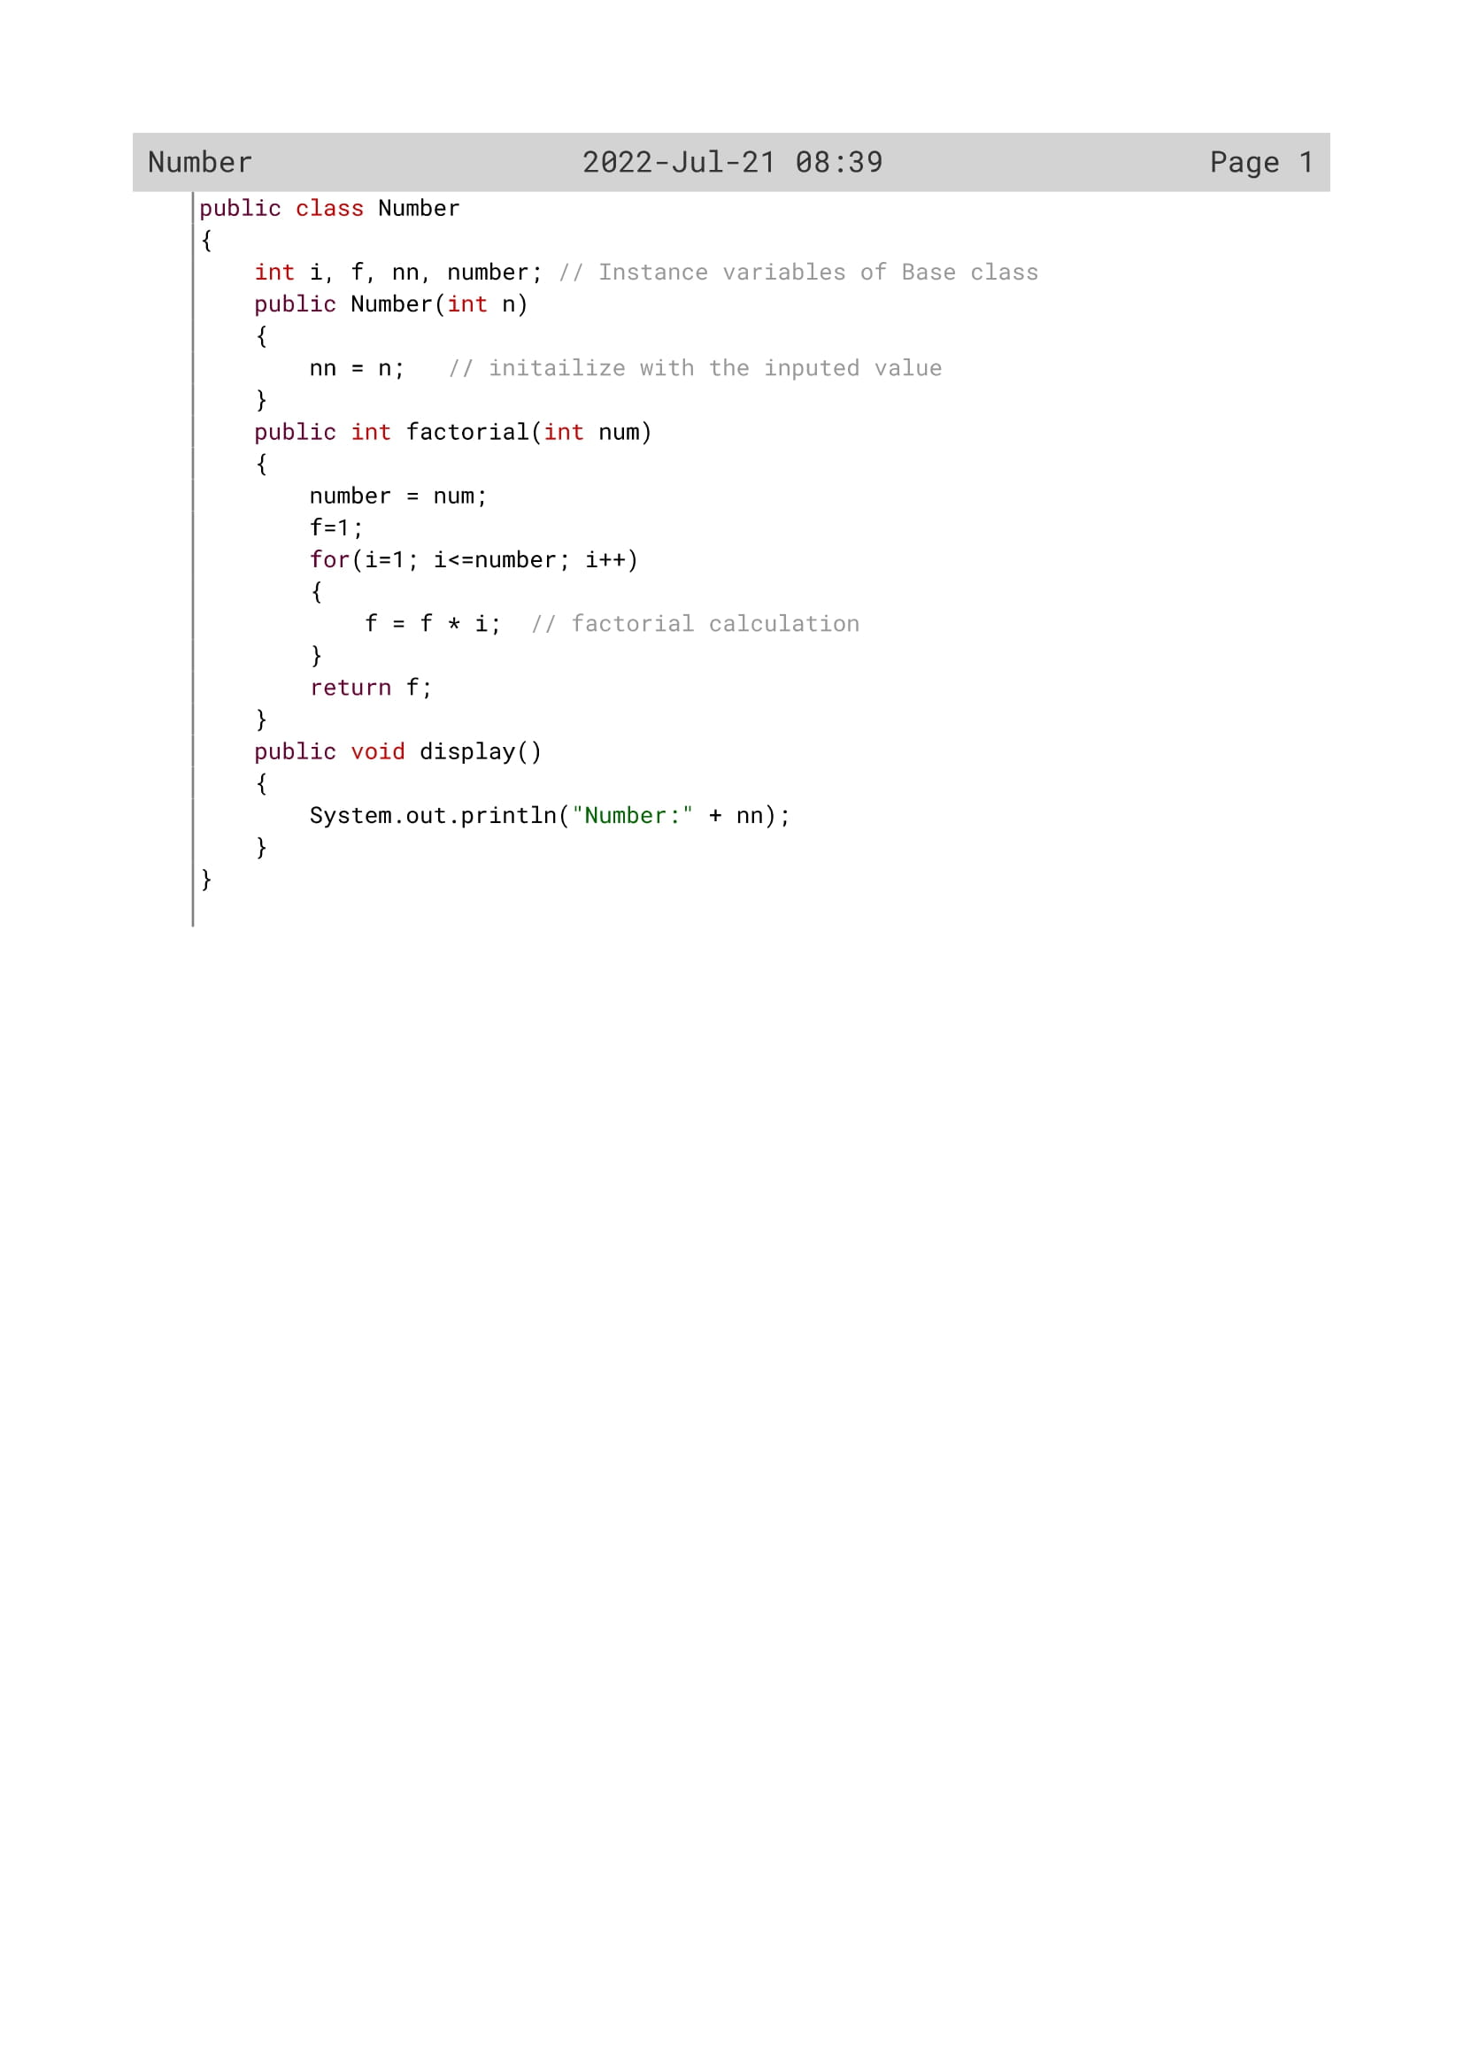

248

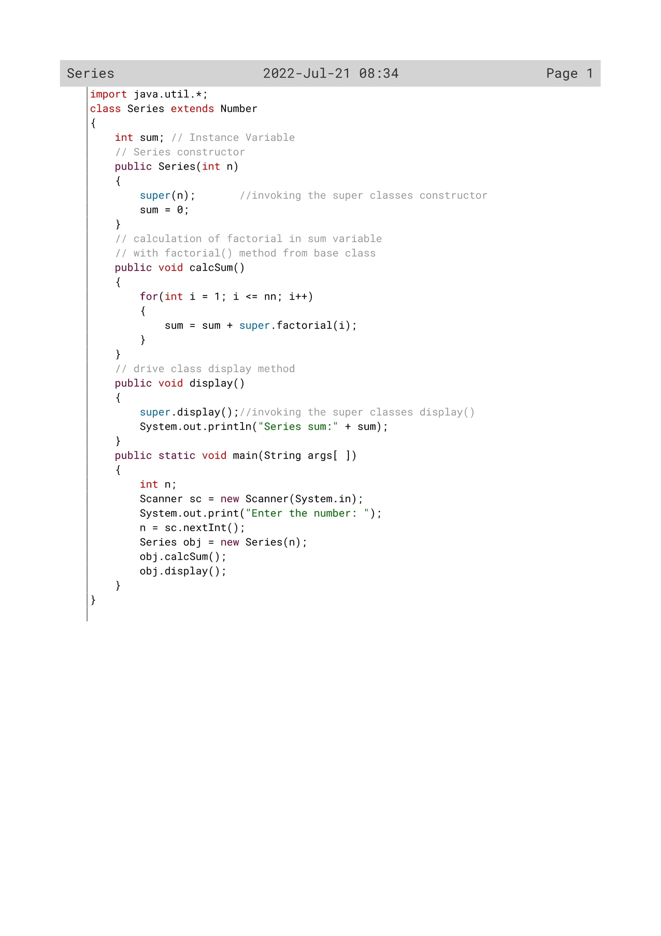

249

Variable description

|  |  |  |
| --- | --- | --- |
| Variable name | Data type | Description |
| i | Int | Loop variable |
| f | int | To find the factorial of the number |
| nn | Int | To store the value of n |
| number | Int | To store the value of num |
| num | Int | To store a number |
| n | Int | To store an integer number |
| sum | int | To calculate the sum of factorial |
| a | Int | Returns the factorial of a number |

250

Function Description

|  |  |  |
| --- | --- | --- |
| Function name | Data type | description |
| calcSum() | void | To store summation of factorials |
| display() | void | To display the series sum |
| factorial() | Int | To calculate the factorial |

251

OUTPUT

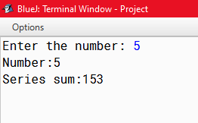

252