* This is a Sample Project to help you understand the concept of the work. Few lines of the Sample have been typed for demonstration.
* You are required to type the exact text from the left box to the blank box at the right.
* The size of the text should be 8-10 and theme should be ‘Arial’ or ‘Times New Roman’.
* 15 errors per page is permissible. Pages containing more than 15 errors are not eligible for payment.
* Only spelling and punctuation errors are counted.
* Paragraph spacing, alignment, word position etc. are not considered errors.
* The text which are underlined or italic should be underlined and italic.
* Payment per page depends on the plan chosen.
* The main project would contain further information regarding submission of assignment.

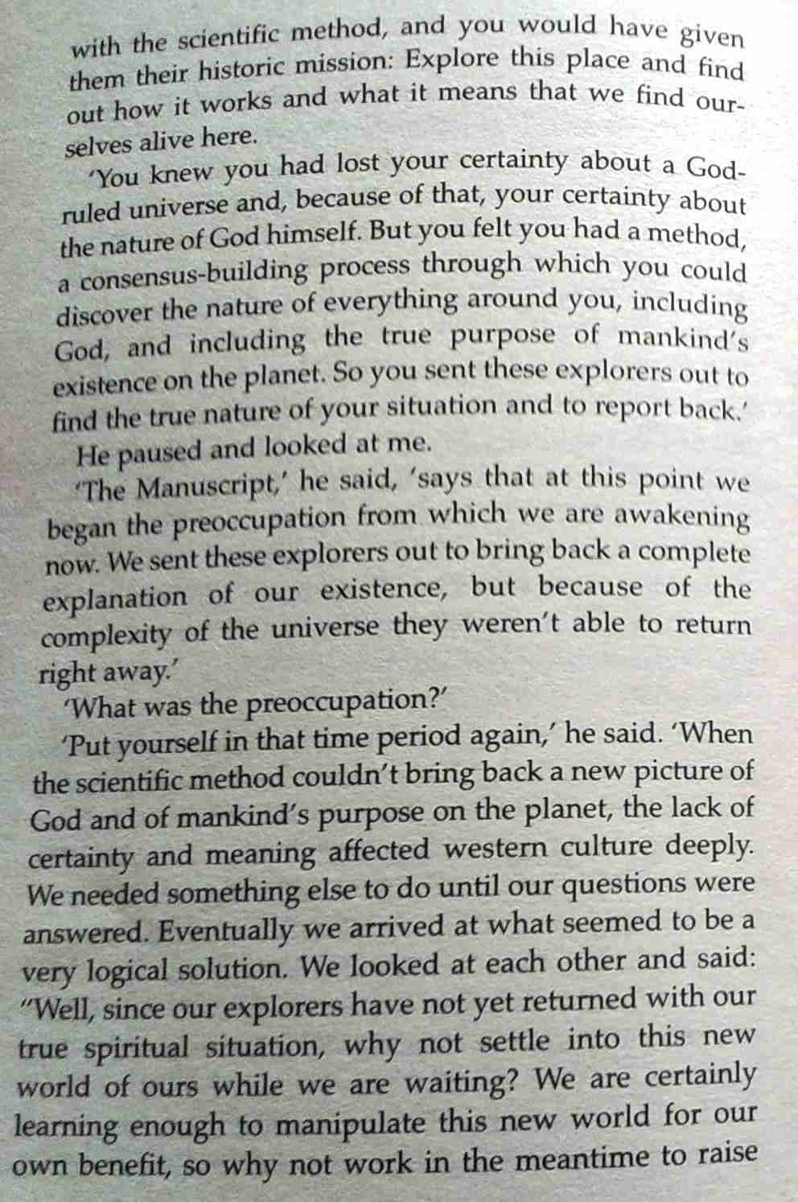

with the scientific method, and you would have given them their historic mission: Explore this place and find out how it works and what it means that we find our-selves alive here.  
 ‘You knew you had lost your certainty about a God-ruled universe and,

