•

ll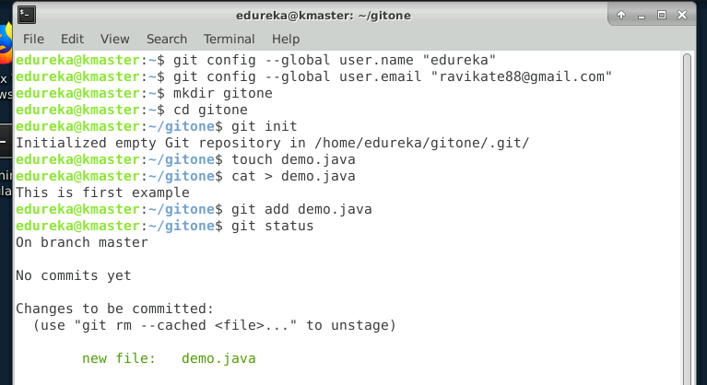

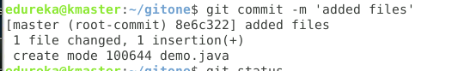

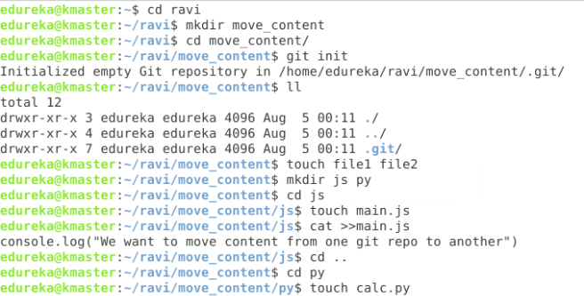

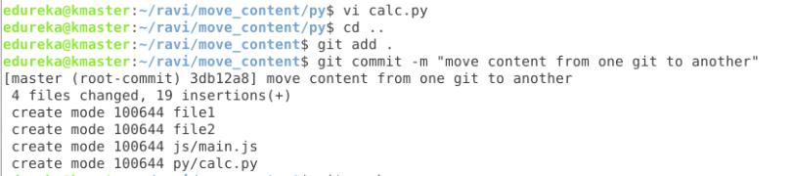

• Create a new branch for a new feature you want to add to the application

• Merge back the created branch with the master branch

• Create a remote repository

• Push the local repository to company’s remote repository