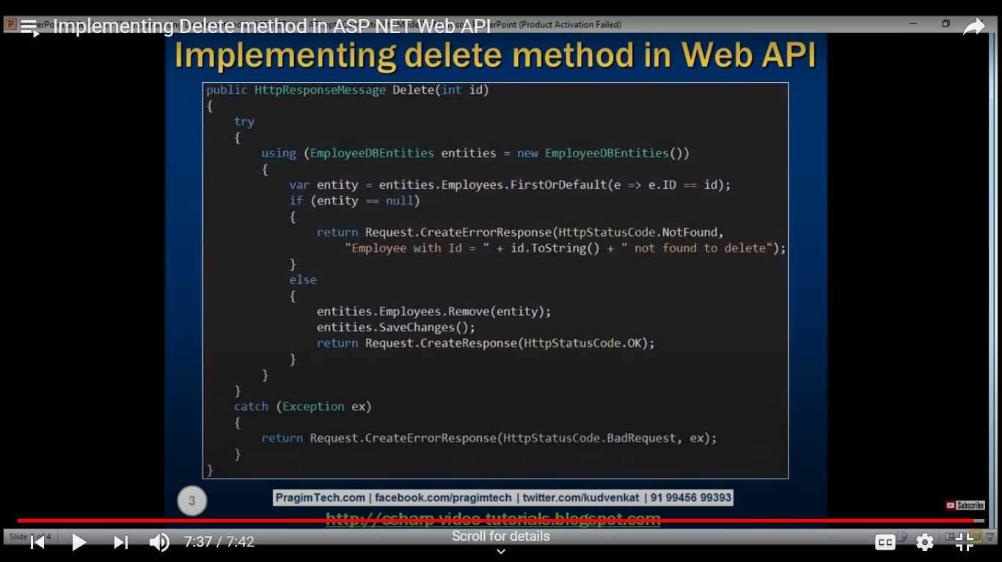

Implementing Post method in Web API For Inserting Patient details

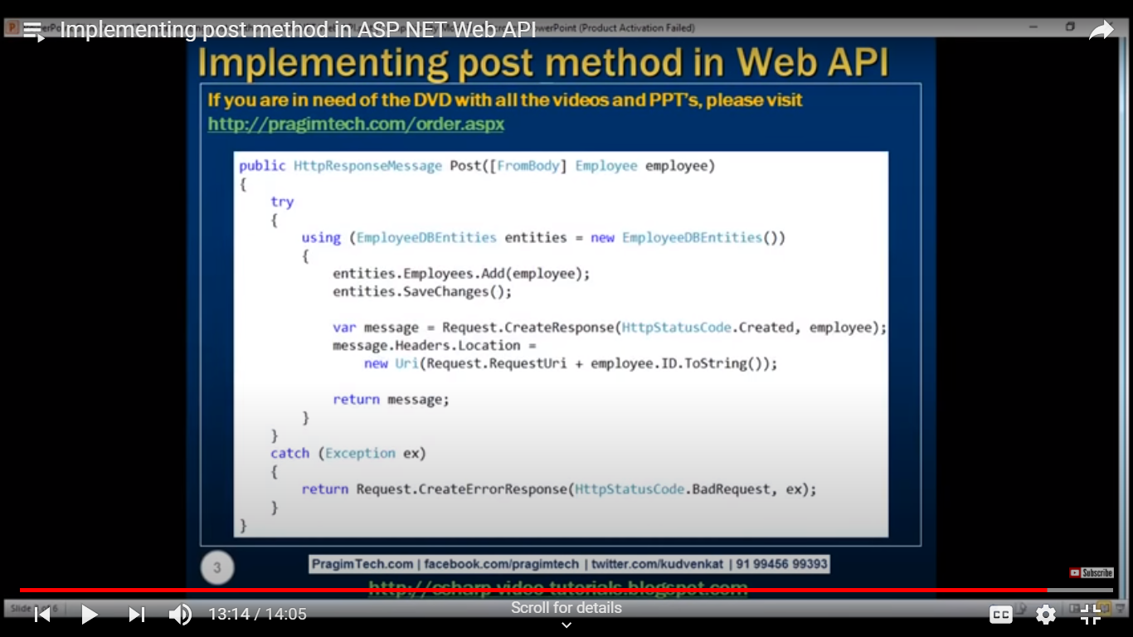

Implementing Get method in Web API For getting individual Patient details

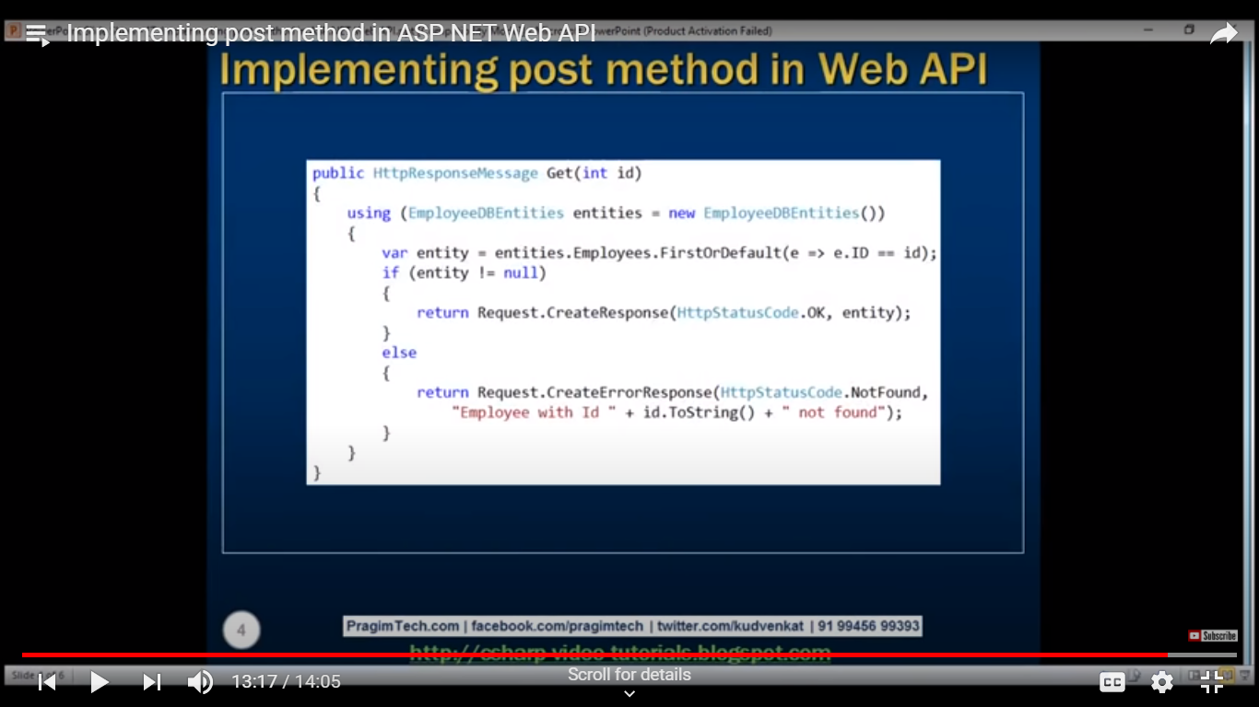

Implementing Get method in Web API For Getting All Patient details

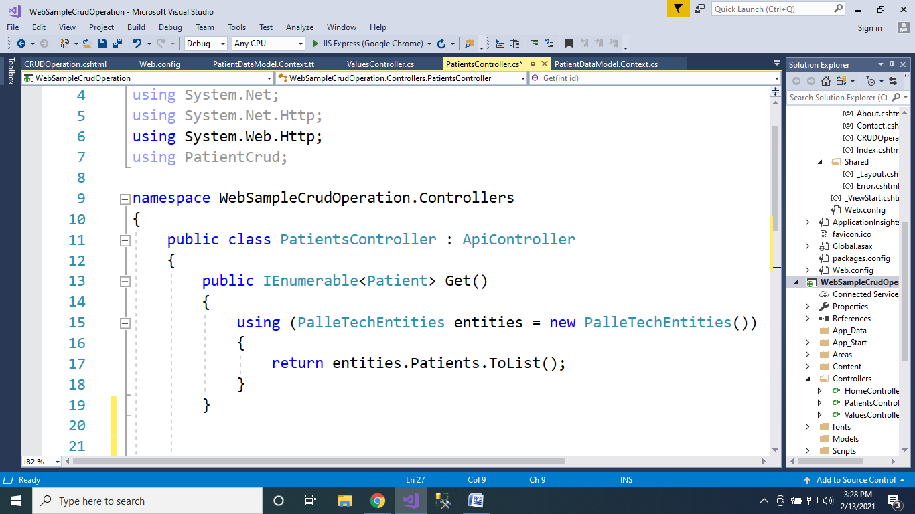

Implementing Put method in Web API For Updating All Patient details

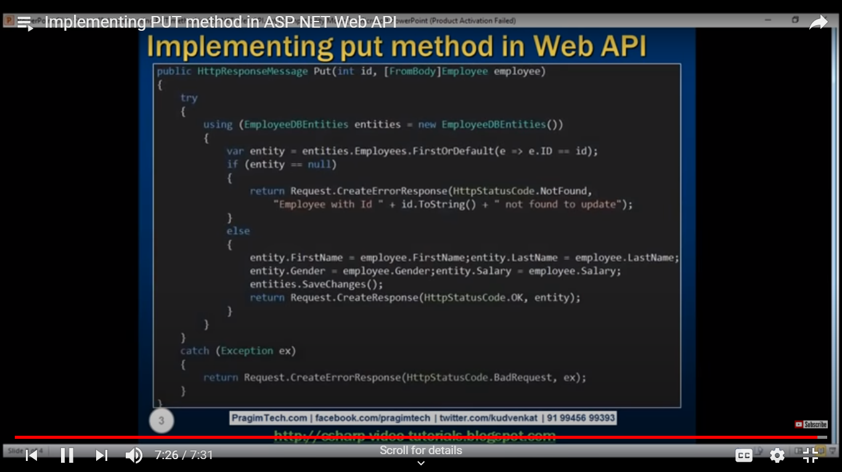

Implementing Web API Query String Parameters

