Machine Learning Classification
Complete Study Notes — Parts 1, 2 & 3
Sheryians AI School — Supervised Learning Series
Instructor: Akarsh Vyas

Topics Covered:
✓ Classification Fundamentals
✓ Logistic Regression (Sigmoid, Log Loss)
✓ K-Nearest Neighbors (Distance, Scaling)
✓ Support Vector Machines (Kernels, Margin)
✓ Decision Trees (Entropy, Gini, Pruning)
✓ Confusion Matrix & All Metrics
✓ 20 Interview Questions with Answers
✓ 20 Quiz Questions with Answers
✓ Complete Cheat Sheet & Revision Sheet
✓ Python Code for ALL Algorithms

This document includes graphs, formulas, code blocks, tip boxes, and comparison tables.

PART 1: Classification Fundamentals

1. What is Classification?
Definition: Classification is a type of Supervised Learning where the model learns from labeled data and predicts discrete categories/labels (not continuous values).

In Simple Words:
- You give the machine examples with answers (labeled data)
- The machine learns the pattern
- When new data comes, it predicts which category it belongs to

Real-World Examples:
Problem | Input | Output (Label)
Email Spam Detection | Email text | Spam / Not Spam
Disease Diagnosis | Patient symptoms | Disease / No Disease
Image Recognition | Pixel data | Cat / Dog / Bird
Loan Approval | Applicant details | Approved / Rejected
Sentiment Analysis | Customer review | Positive / Negative / Neutral

💡 Interview Tip: Always remember — Classification = Predicting categories. Regression = Predicting numbers.

2. Classification vs Regression
This is one of the most commonly asked questions in interviews!
Feature | Classification | Regression
Output Type | Discrete (Categories) | Continuous (Numbers)
Example Output | Yes/No, Cat/Dog | 25.5, 100000, 3.14
Goal | Predict a class/label | Predict a quantity
Algorithms | Logistic Reg, KNN, SVM, Decision Tree, Naive Bayes, Random Forest | Linear Reg, Polynomial, Ridge, Lasso
Evaluation Metrics | Accuracy, Precision, Recall, F1-Score | MSE, RMSE, MAE, R²
Use Case | Spam Detection | House Price Prediction
Loss Function | Log Loss (Cross Entropy) | Mean Squared Error

🔴 Exam Point: The key difference is the type of output — Classification predicts labels (discrete), Regression predicts values (continuous).

3. Types of Classification

3.1 Binary Classification
Only 2 possible outcomes
- Examples: Spam or Not Spam, Pass or Fail, 0 or 1

3.2 Multi-Class Classification
More than 2 possible outcomes
- Examples: Cat/Dog/Bird, A/B/C/D grades

3.3 Multi-Label Classification
Each instance can belong to multiple classes simultaneously
- Example: A movie can be Action + Comedy + Thriller
📝 Remember: Binary = 2 classes | Multi-class = Many classes, pick ONE | Multi-label = Many classes, pick MULTIPLE

4. The ML Pipeline for Classification
The complete end-to-end pipeline:
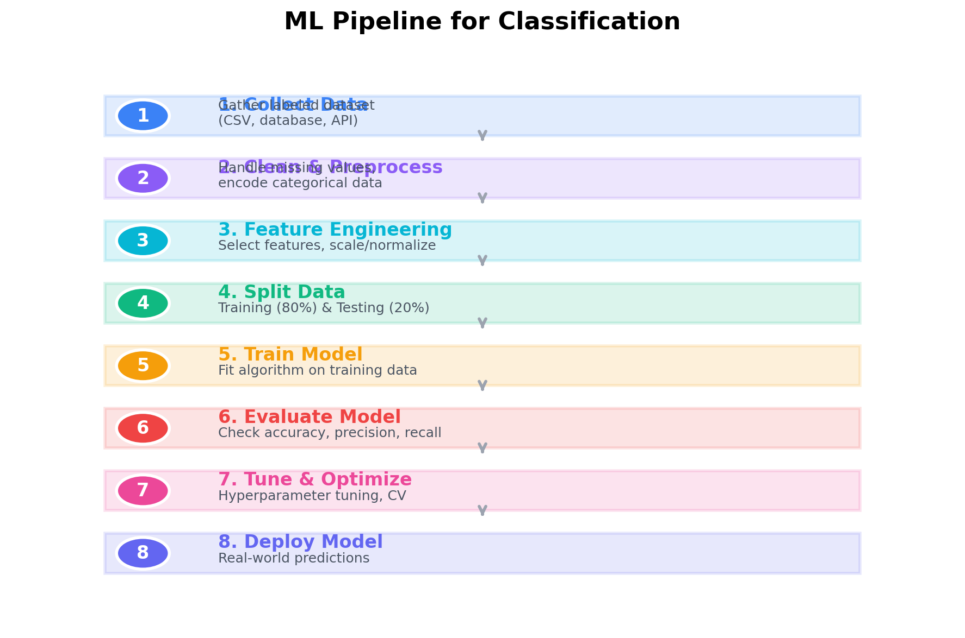
- 1. Collect Data: Gather labeled dataset (CSV, database, API)
- 2. Clean & Preprocess: Handle missing values, remove duplicates, encode categorical data
- 3. Feature Engineering: Select important features, create new features, scale/normalize
- 4. Split Data: Divide into Training set (80%) and Testing set (20%)
- 5. Train Model: Fit the classification algorithm on training data
- 6. Evaluate Model: Check accuracy, precision, recall on test data
- 7. Tune & Optimize: Hyperparameter tuning, cross-validation
- 8. Deploy Model: Make it available for real-world predictions
💡 Interview Tip: Always explain the complete ML pipeline when asked "How do you build a classification model?"

5. Logistic Regression
Definition: Logistic Regression is a linear classification algorithm used for binary classification problems. Despite its name containing "Regression," it is a classification algorithm!

Why "Regression" in the name?
- It uses a regression equation internally (linear combination of features)
- But the output is passed through a Sigmoid function to convert it into a probability (between 0 and 1)

5.1 The Sigmoid Function
This is the heart of Logistic Regression!
σ(z) = 1 / (1 + e^(-z))
Where: z = w₁x₁ + w₂x₂ + ... + wₙxₙ + b
e = Euler's number (≈ 2.718)
Output is always between 0 and 1

How it works:
- If σ(z) ≥ 0.5 → Predict Class 1 (Positive)
- If σ(z) < 0.5 → Predict Class 0 (Negative)
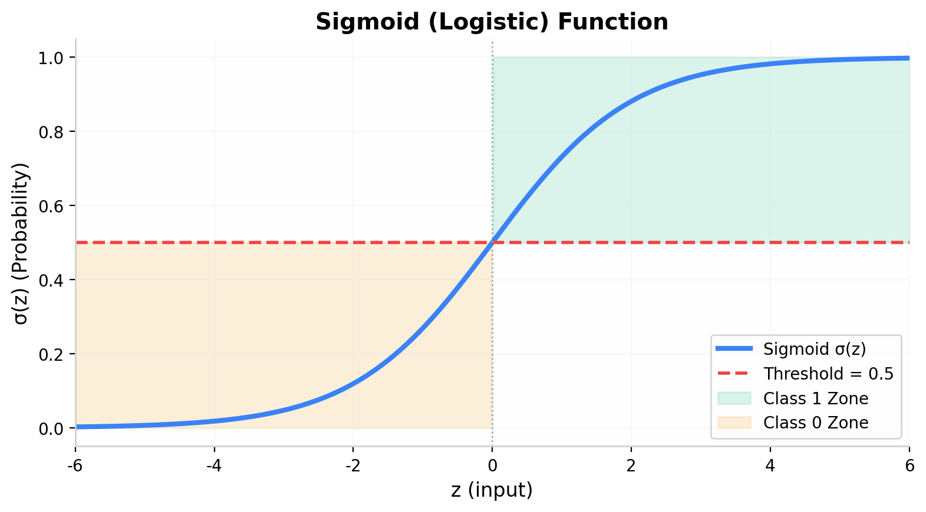
🔴 Exam Point: The sigmoid function squashes any real number into the range (0, 1), making it perfect for representing probabilities.

5.2 Decision Boundary
The line (or surface) that separates the two classes. In 2D, it's a straight line. In 3D, it's a flat plane. In higher dimensions, it's a hyperplane.
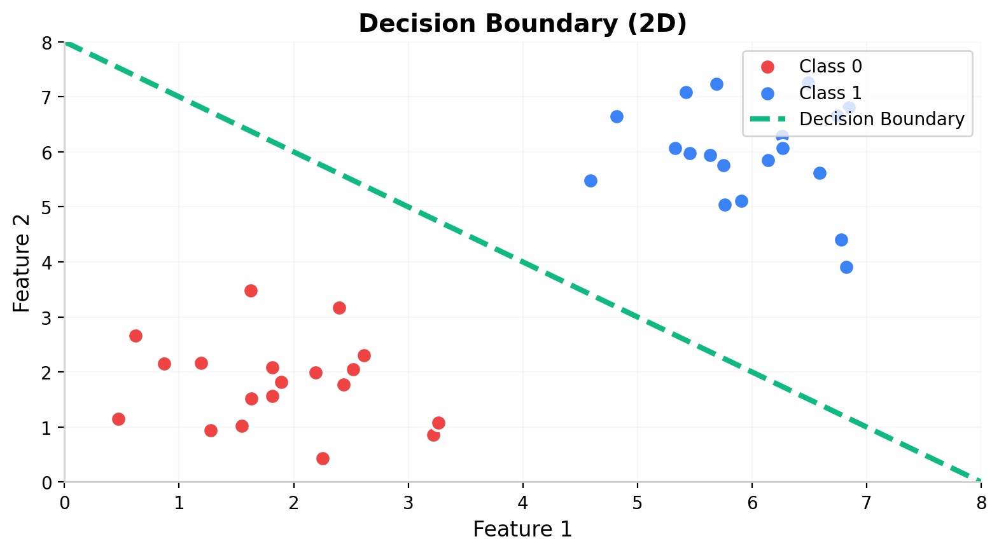

5.3 Cost Function (Log Loss)
J(θ) = -1/m Σ [ y⁽ⁱ⁾ log(ŷ⁽ⁱ⁾) + (1-y⁽ⁱ⁾) log(1-ŷ⁽ⁱ⁾) ]
Where: m = number of training examples, y = actual label, ŷ = predicted probability

Why not MSE (Mean Squared Error)?
- MSE creates a non-convex cost function for logistic regression
- Log Loss creates a convex function → guaranteed to find global minimum
- Gradient Descent works better with convex functions
⚠️ Common Mistake: Students often confuse Logistic Regression's loss function with MSE. Log Loss (Cross-Entropy) is the correct one for classification!

5.4 Logistic Regression — Python Code
# Step 1: Import Libraries
import numpy as np
import pandas as pd
from sklearn.model_selection import train_test_split
from sklearn.linear_model import LogisticRegression
from sklearn.metrics import accuracy_score, classification_report
# Step 2: Load Dataset
from sklearn.datasets import load_breast_cancer
data = load_breast_cancer()
X = data.data # Features
y = data.target # Labels (0 = malignant, 1 = benign)
# Step 3: Split Data
X_train, X_test, y_train, y_test = train_test_split(
X, y, test_size=0.2, random_state=42
)
# Step 4: Create and Train Model
model = LogisticRegression(max_iter=10000)
model.fit(X_train, y_train)
# Step 5: Make Predictions
y_pred = model.predict(X_test)
# Step 6: Evaluate Model
print("Accuracy:", accuracy_score(y_test, y_pred))
print("\nClassification Report:")
print(classification_report(y_test, y_pred))

Code Explanation:
Line | What it does
load_breast_cancer() | Loads a built-in sklearn dataset with 569 samples
train_test_split() | Splits data into 80% training, 20% testing
LogisticRegression() | Creates the logistic regression model
model.fit() | Trains the model on training data
model.predict() | Makes predictions on test data
accuracy_score() | Calculates what % of predictions were correct

5.5 Summary — Logistic Regression
Property | Details
Type | Linear Classification Algorithm
Best For | Binary Classification (2 classes)
Core | Uses Sigmoid function to output probability
Decision | Threshold at 0.5 (can be adjusted)
Loss | Log Loss (Binary Cross-Entropy)
Optimization | Gradient Descent
Assumption | Linear relationship between features and log-odds
Limitation | Cannot handle complex non-linear data
Limitation | Sensitive to outliers
💡 Interview Tip: When asked "Why is it called Logistic Regression if it's a classification algorithm?" — Answer: Because internally it uses a regression equation, but the output is converted to a probability using the sigmoid function, and then a threshold is applied to classify.

6. K-Nearest Neighbors (KNN)
Definition: KNN is a non-parametric, lazy learning algorithm that classifies a new data point based on the majority vote of its K nearest neighbors.

In Simple Words:
- "Tell me who your neighbors are, and I'll tell you who you are!"
- KNN looks at the K closest data points and assigns the class that appears most frequently among them

6.1 How KNN Works — Step by Step
- Step 1: Choose the value of K (number of neighbors)
- Step 2: Calculate the distance between the new point and ALL training points
- Step 3: Pick the K nearest (closest) points
- Step 4: Count which class appears most among these K neighbors
- Step 5: Assign that class to the new point (Majority Voting)

Visual Example (K = 3):
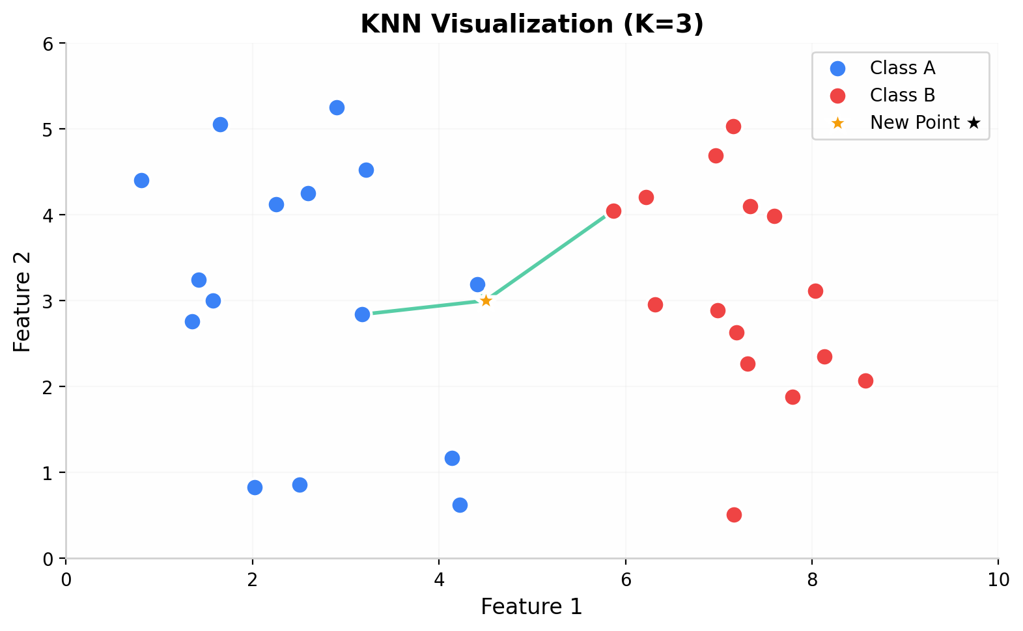

6.2 Distance Metrics

Euclidean Distance (Most Common):
d = √((x₂ - x₁)² + (y₂ - y₁)²)

Manhattan Distance:
d = |x₂ - x₁| + |y₂ - y₁|

Minkowski Distance (Generalization):
d = (Σ |xᵢ - yᵢ|ᵖ)^(1/p)
When p=2 → Euclidean | When p=1 → Manhattan

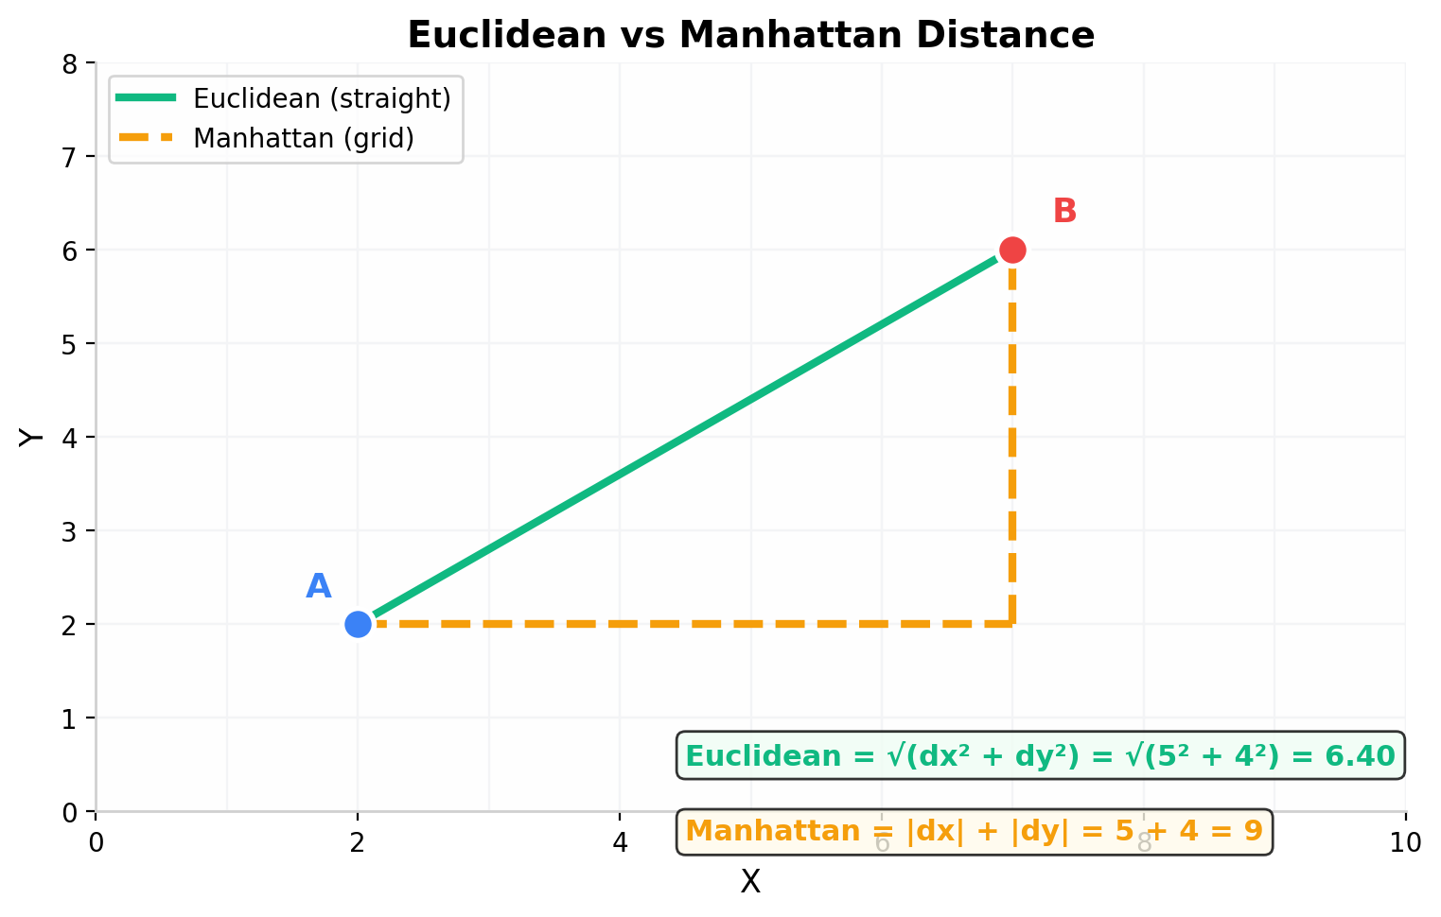
📝 Remember: Euclidean = "as the crow flies" (straight line). Manhattan = "walking on a grid" (city blocks).

6.3 Choosing the Value of K
K Value | Effect
K = 1 | Very sensitive to noise (overfitting)
K = 3 or 5 | Good starting point
K = large | Too smooth, loses details (underfitting)
K = even | Can cause ties (avoid if possible)

Best Practice:
- Start with K = √n (where n = total number of data points)
- Always use odd values of K for binary classification (to avoid ties)
- Use cross-validation to find the optimal K
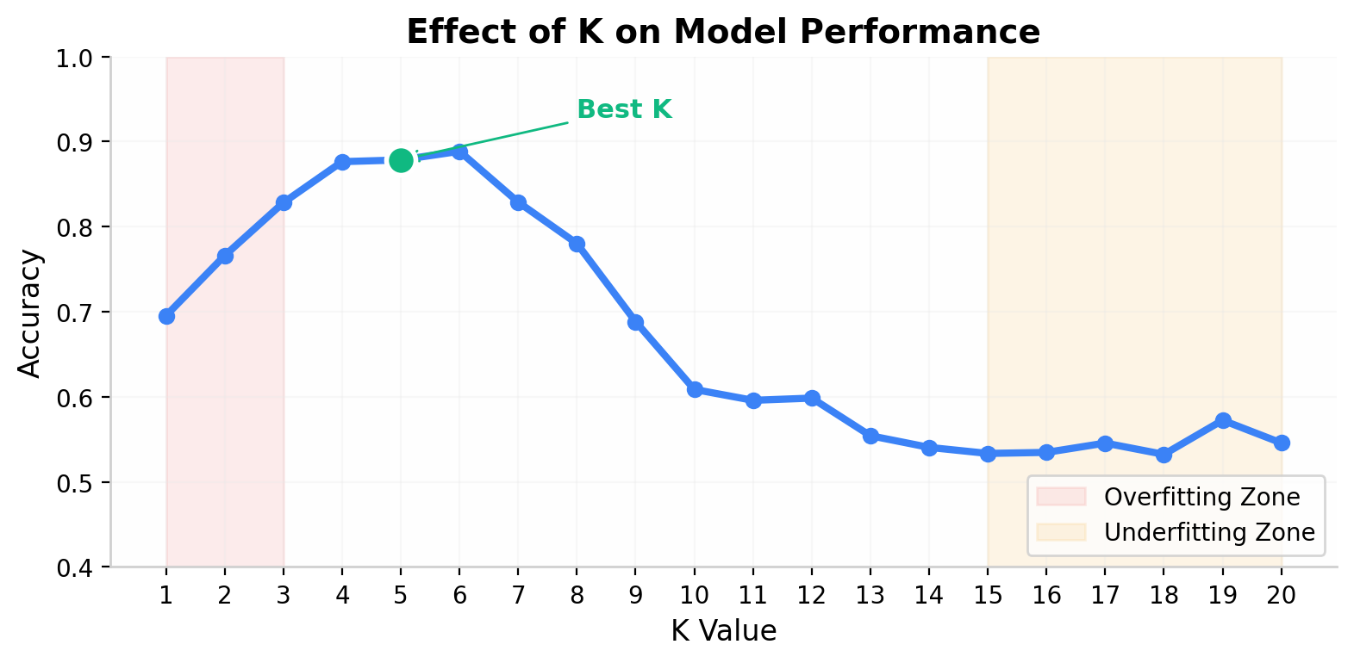
⚠️ Common Mistake: Using K=1 is almost always a bad idea because it's too sensitive to noisy data points. Use cross-validation to find the best K!

6.4 Feature Scaling is CRUCIAL for KNN!
Since KNN uses distance calculations, features with larger scales will dominate the distance.

Example WITHOUT Scaling:
- Feature: Salary (range: 30000-100000)
- Feature: Age (range: 20-60)
- Distance will be dominated by Salary because its values are much larger!

Solution: Standardization or Min-Max Scaling
from sklearn.preprocessing import StandardScaler
scaler = StandardScaler()
X_train_scaled = scaler.fit_transform(X_train)
X_test_scaled = scaler.transform(X_test)

🔴 Exam Point: ALWAYS scale your features before using KNN! This is one of the most commonly tested concepts.

6.5 KNN — Python Code
# Step 1: Import Libraries
from sklearn.neighbors import KNeighborsClassifier
from sklearn.preprocessing import StandardScaler
from sklearn.model_selection import train_test_split
from sklearn.metrics import accuracy_score
# Step 2: Load and Split Data
from sklearn.datasets import load_iris
data = load_iris()
X = data.data
y = data.target
X_train, X_test, y_train, y_test = train_test_split(
X, y, test_size=0.2, random_state=42
)
# Step 3: Scale Features (IMPORTANT!)
scaler = StandardScaler()
X_train_scaled = scaler.fit_transform(X_train)
X_test_scaled = scaler.transform(X_test)
# Step 4: Create and Train KNN Model
knn = KNeighborsClassifier(n_neighbors=5) # K = 5
knn.fit(X_train_scaled, y_train)
# Step 5: Predict and Evaluate
y_pred = knn.predict(X_test_scaled)
print("Accuracy:", accuracy_score(y_test, y_pred))

Code Explanation:
Line | What it does
KNeighborsClassifier(n_neighbors=5) | Creates KNN model with K=5
StandardScaler() | Standardizes features to mean=0, std=1
fit_transform() | Fits scaler on training data AND transforms it
transform() | Only transforms test data (using training stats)

⚠️ Common Mistake: Using fit_transform() on BOTH train and test data causes data leakage! You should only fit on training data, then transform the test data.

6.6 Advantages & Disadvantages of KNN
Advantages | Disadvantages
Simple and easy to understand | Slow prediction (computes distances every time)
No training phase (lazy learner) | Sensitive to irrelevant features
Works well with small datasets | Sensitive to the scale of features
No assumptions about data distribution | Doesn't work well with high-dimensional data
Can be used for both classification & regression | Requires feature scaling
 | Memory-intensive (stores all training data)

6.7 Summary — KNN
KNN in One Line: A lazy algorithm that classifies new data by looking at the K nearest neighbors and doing majority voting.
Property | Value
Type | Non-parametric, Instance-based, Lazy
Key Hyperparameter | K (number of neighbors)
Distance Metric | Euclidean (default), Manhattan, Minkowski
Feature Scaling | Required
Training Time | O(1) — no training!
Prediction Time | O(n × d) — slow!
Best For | Small datasets, low dimensions

PART 2: Advanced Algorithms

7. Support Vector Machines (SVM)
Definition: SVM (Support Vector Machine) is a powerful supervised learning algorithm that finds the optimal hyperplane to separate data into different classes with the maximum margin.

In Simple Words:
- SVM draws the best possible line (or plane) between two classes
- It tries to keep this line as far away as possible from the nearest points of each class
- Those nearest points are called Support Vectors

7.1 Key Concepts

Hyperplane
- A decision boundary that separates classes
- In 2D → a line | In 3D → a plane | In nD → a hyperplane

Margin
- The distance between the hyperplane and the nearest data points from each class
- SVM aims to maximize this margin

Support Vectors
- The data points that are closest to the hyperplane
- They literally "support" or define the position of the hyperplane
- If you remove them, the hyperplane changes!
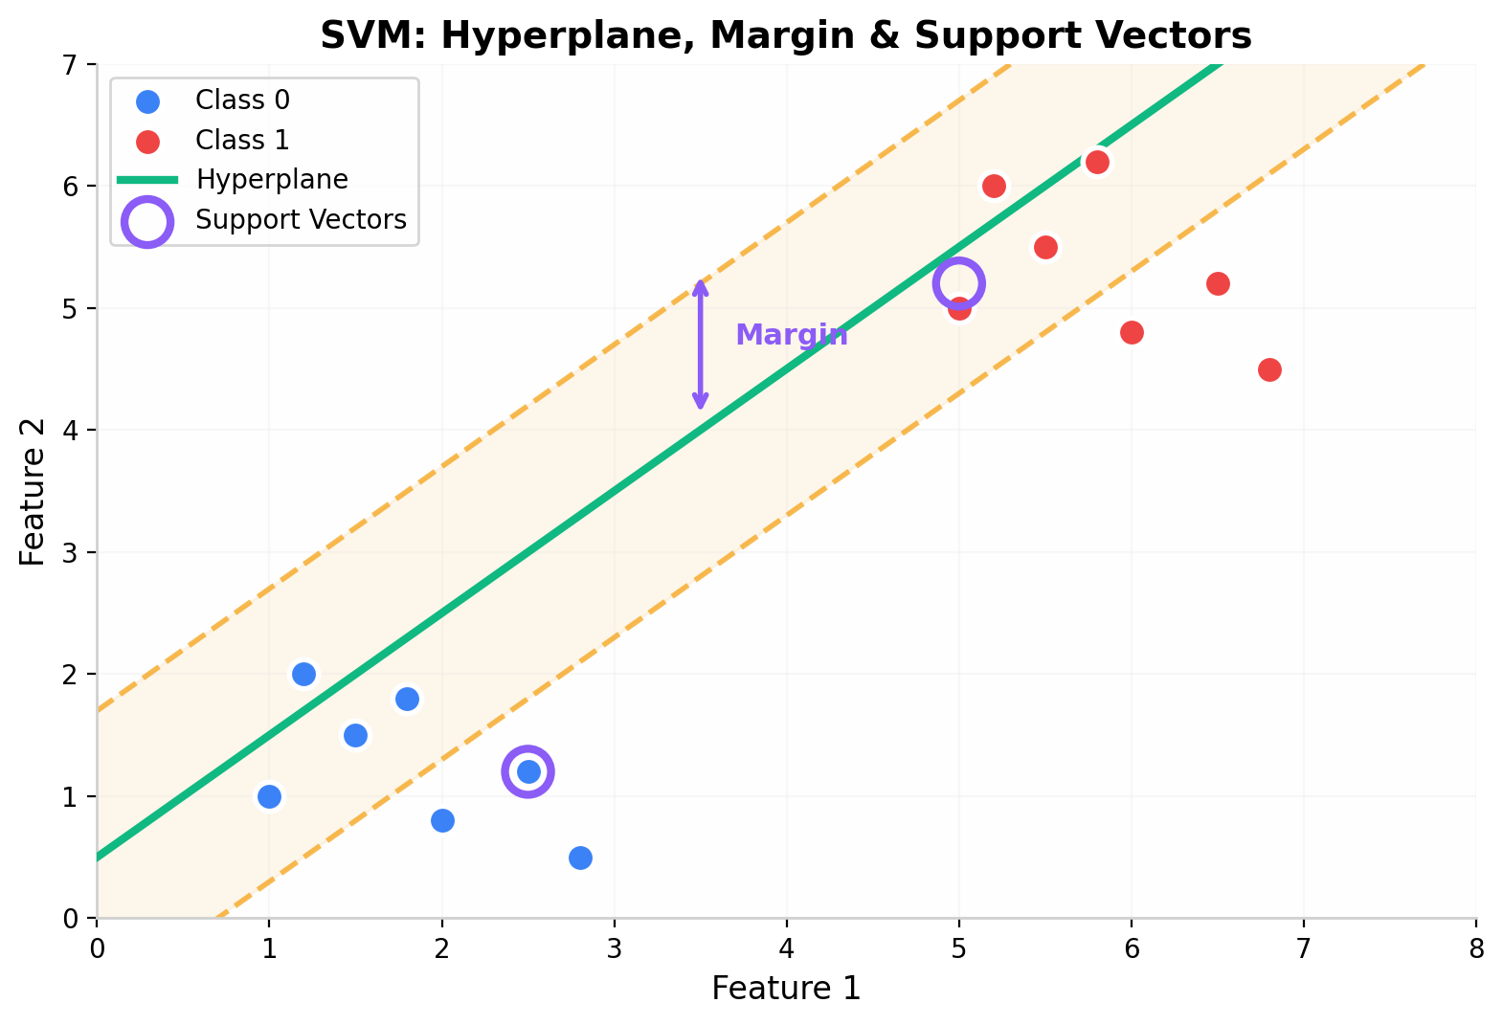

7.2 SVM — Mathematical Intuition

The Hyperplane Equation:
w · x + b = 0
Where: w = weight vector (perpendicular to hyperplane)
x = input feature vector
b = bias term

Decision Rule:
- If w · x + b > 0 → Predict Class 1
- If w · x + b < 0 → Predict Class 0

Margin Width:
Margin = 2 / ||w||
SVM minimizes ||w|| to maximize the margin.

🔴 Exam Point: SVM's objective is to find the hyperplane that maximizes the margin between the two classes. The data points on the margin boundaries are called Support Vectors.

7.3 Types of SVM

7.3.1 Linear SVM (Hard Margin)
- Works when data is perfectly linearly separable
- No misclassifications allowed

7.3.2 Soft Margin SVM (with C parameter)
- Works when data is not perfectly separable
- Allows some misclassifications
- C parameter controls the trade-off:
C Value | Margin | Misclassifications | Risk
Small (0.01) | Wide | More allowed | Underfitting
Medium (1.0) | Balanced | Some allowed | Balanced
Large (100) | Narrow | Very few allowed | Overfitting
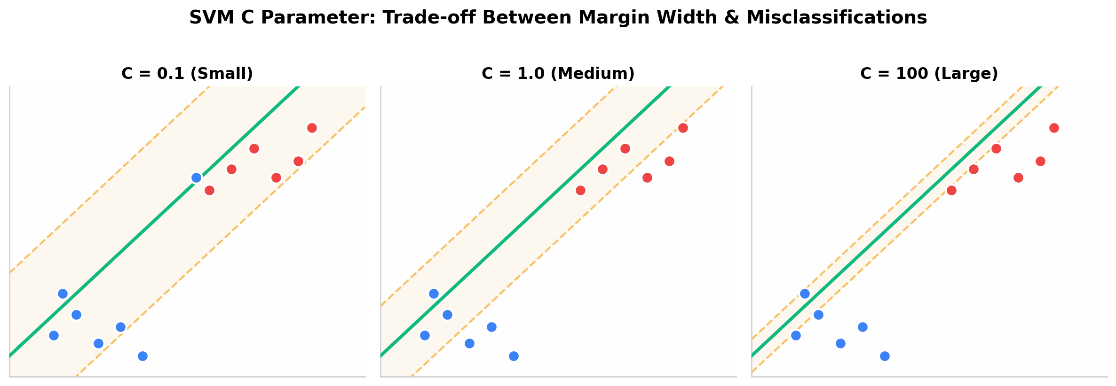

7.4 Kernel Trick — Handling Non-Linear Data
When data cannot be separated by a straight line, SVM uses the Kernel Trick to transform data into a higher dimension where it becomes separable.
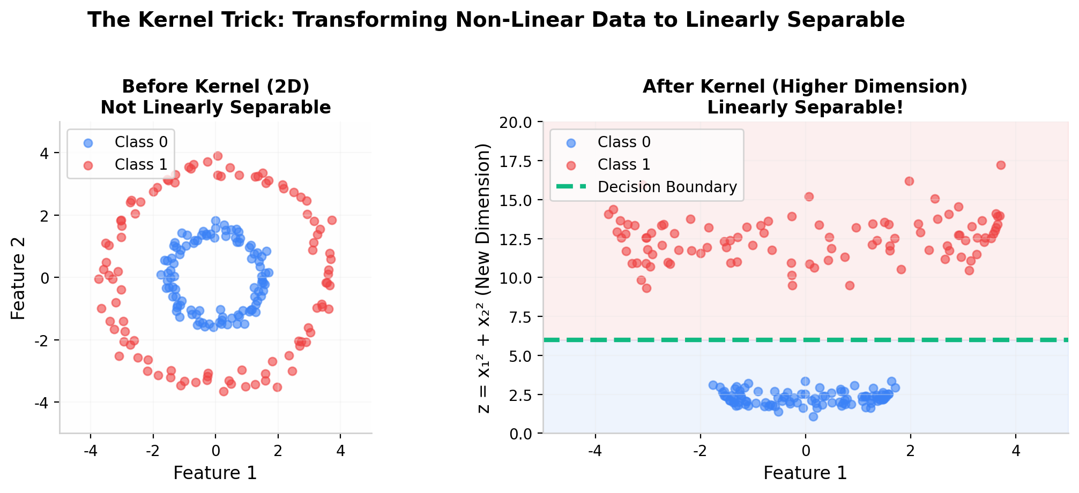

Common Kernels:
Kernel | Use Case | Formula
Linear | Linearly separable data | K(x, y) = x · y
Polynomial | Moderate non-linearity | K(x, y) = (x · y + c)^d
RBF (Gaussian) | Most common, complex patterns | K(x, y) = e^(-γ||x-y||²)
Sigmoid | Similar to neural network | K(x, y) = tanh(αx · y + c)
💡 Interview Tip: RBF (Radial Basis Function) kernel is the default and most commonly used kernel. It can handle most non-linear classification problems.

7.5 SVM — Python Code
# Step 1: Import Libraries
from sklearn.svm import SVC
from sklearn.preprocessing import StandardScaler
from sklearn.model_selection import train_test_split
from sklearn.metrics import accuracy_score, classification_report
# Step 2: Load Data
from sklearn.datasets import load_breast_cancer
data = load_breast_cancer()
X = data.data
y = data.target
# Step 3: Split Data
X_train, X_test, y_train, y_test = train_test_split(
X, y, test_size=0.2, random_state=42
)
# Step 4: Scale Features (IMPORTANT for SVM!)
scaler = StandardScaler()
X_train_scaled = scaler.fit_transform(X_train)
X_test_scaled = scaler.transform(X_test)
# Step 5: Create and Train SVM Model
svm_model = SVC(kernel='rbf', C=1.0, gamma='scale')
svm_model.fit(X_train_scaled, y_train)
# Step 6: Predict and Evaluate
y_pred = svm_model.predict(X_test_scaled)
print("Accuracy:", accuracy_score(y_test, y_pred))
print("\nClassification Report:")
print(classification_report(y_test, y_pred))

Important SVM Parameters:
Parameter | Meaning | Default
kernel | Type of kernel to use | rbf
C | Regularization (trade-off margin vs. accuracy) | 1.0
gamma | Kernel coefficient (how far influence reaches) | scale
⚠️ Common Mistake: Not scaling features before SVM! SVM is distance-based, so unscaled features will give poor results.

7.6 Summary — SVM
Property | Details
Type | Supervised Classification (can do Regression)
Goal | Maximize margin between classes
Core | Finds optimal hyperplane
Kernel Trick | Handles non-linear data
Works great in | High-dimensional spaces
Memory efficient | Uses only support vectors
Limitation | Slow on large datasets
Limitation | Sensitive to feature scaling
Limitation | Hard to interpret (black box)
Limitation | Doesn't perform well with noisy data

8. Decision Trees
Definition: Decision Tree is a tree-structured classification algorithm that makes decisions by splitting data based on feature conditions, creating a flowchart-like structure of if-else rules.

In Simple Words:
- It asks a series of yes/no questions about the data
- Each question splits the data into smaller groups
- At the end, you reach a leaf node with the final prediction

8.1 Structure of a Decision Tree
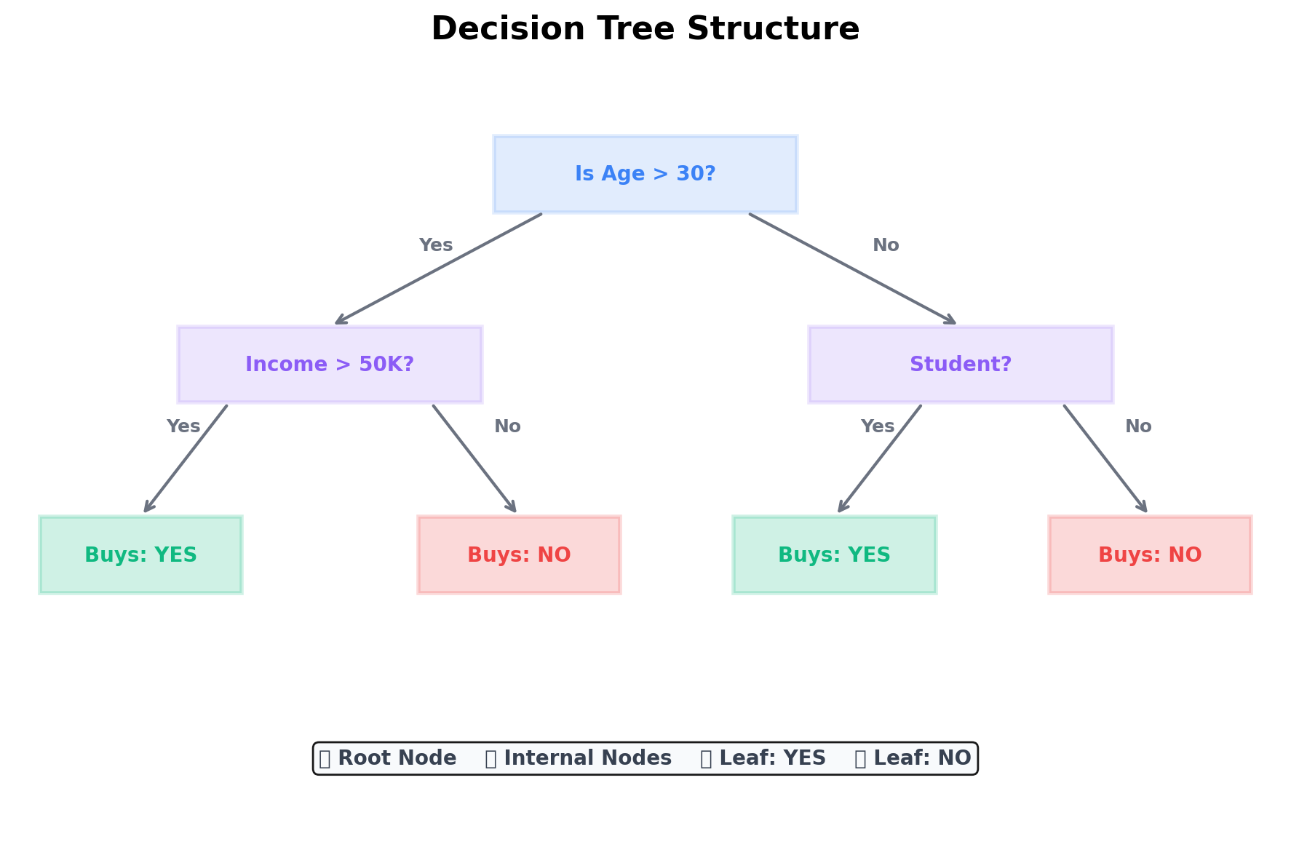

Key Terms:
Term | Meaning
Root Node | The topmost node; the first decision/split
Internal Node | A decision node that has children
Leaf Node | Terminal node; contains the final prediction
Branch | A connection between nodes (represents a condition)
Depth | Number of levels from root to deepest leaf
Splitting | Dividing data based on a feature condition

8.2 How Does the Tree Decide Which Feature to Split On?
The tree uses mathematical measures to find the best feature to split on — the one that creates the purest groups.

8.2.1 Entropy (Information Theory)
H(S) = -Σ pᵢ log₂(pᵢ)
Where: S = dataset, c = number of classes, pᵢ = proportion of class i

Entropy Values:
- Entropy = 0 → Pure set (all same class) BEST
- Entropy = 1 → Maximum impurity (50-50 split) WORST

Example:
- Dataset: [Yes, Yes, Yes, No, No]
- p(Yes) = 3/5 = 0.6, p(No) = 2/5 = 0.4
- H(S) = -(0.6 × log₂(0.6) + 0.4 × log₂(0.4)) = 0.971

8.2.2 Information Gain
IG(S, A) = H(S) - Σ (|Sᵥ|/|S|) · H(Sᵥ)
Information Gain = Entropy(before split) - Weighted average Entropy(after split)
The feature with the highest Information Gain is chosen for splitting.

8.2.3 Gini Impurity (Alternative to Entropy)
Gini(S) = 1 - Σ pᵢ²
Gini = 0 → Pure set | Gini = 0.5 → Maximum impurity (for binary)

Example:
- Dataset: [Yes, Yes, Yes, No, No]
- p(Yes) = 0.6, p(No) = 0.4
- Gini = 1 - (0.6² + 0.4²) = 1 - (0.36 + 0.16) = 0.48
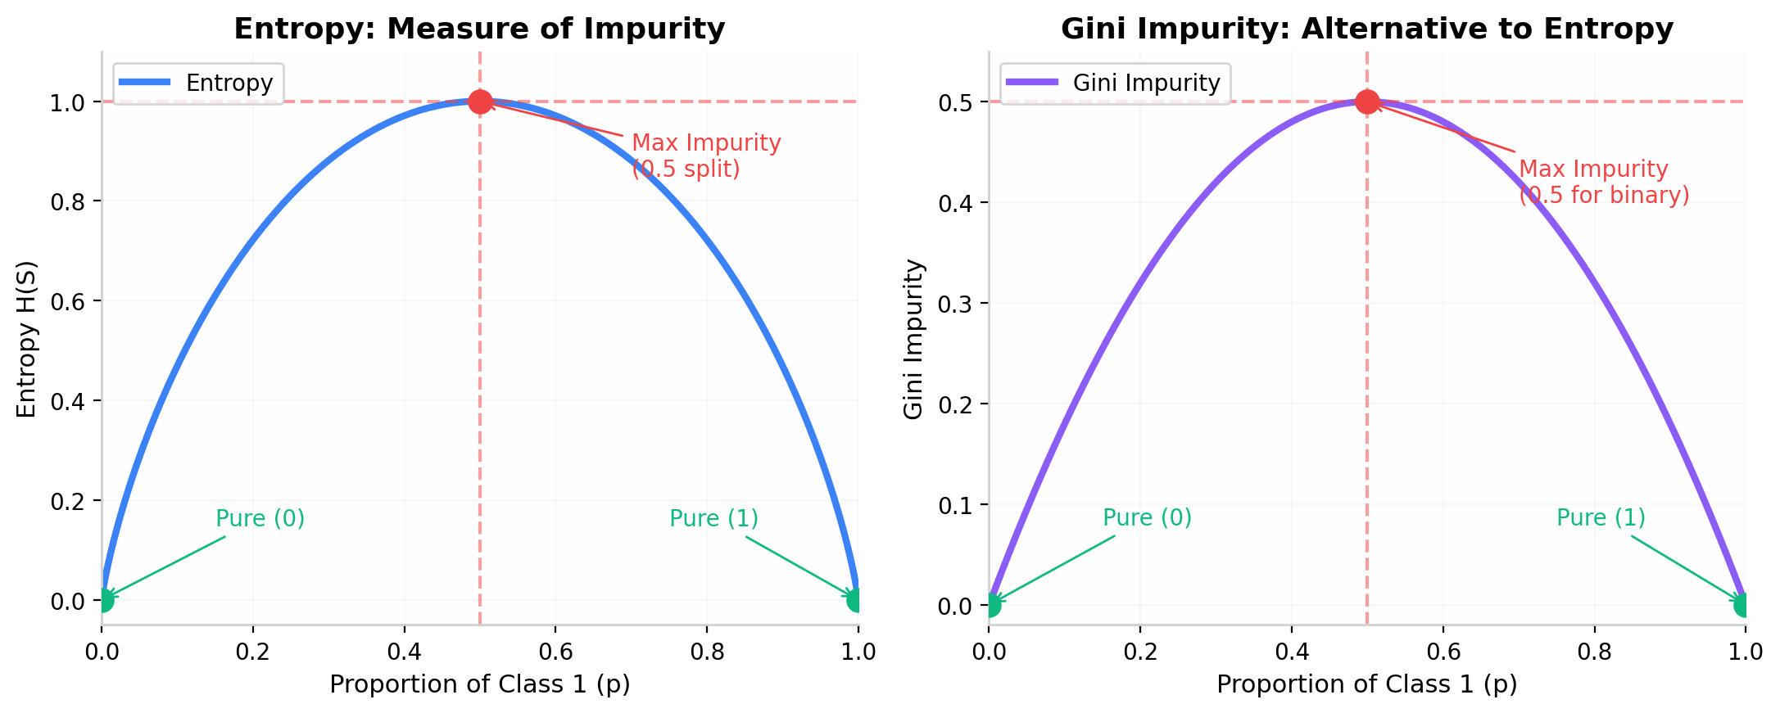
📝 Remember: Scikit-learn uses Gini Impurity by default. You can change it to criterion='entropy' if needed.

8.3 Overfitting in Decision Trees
Decision Trees can easily become very deep and overfit the training data.
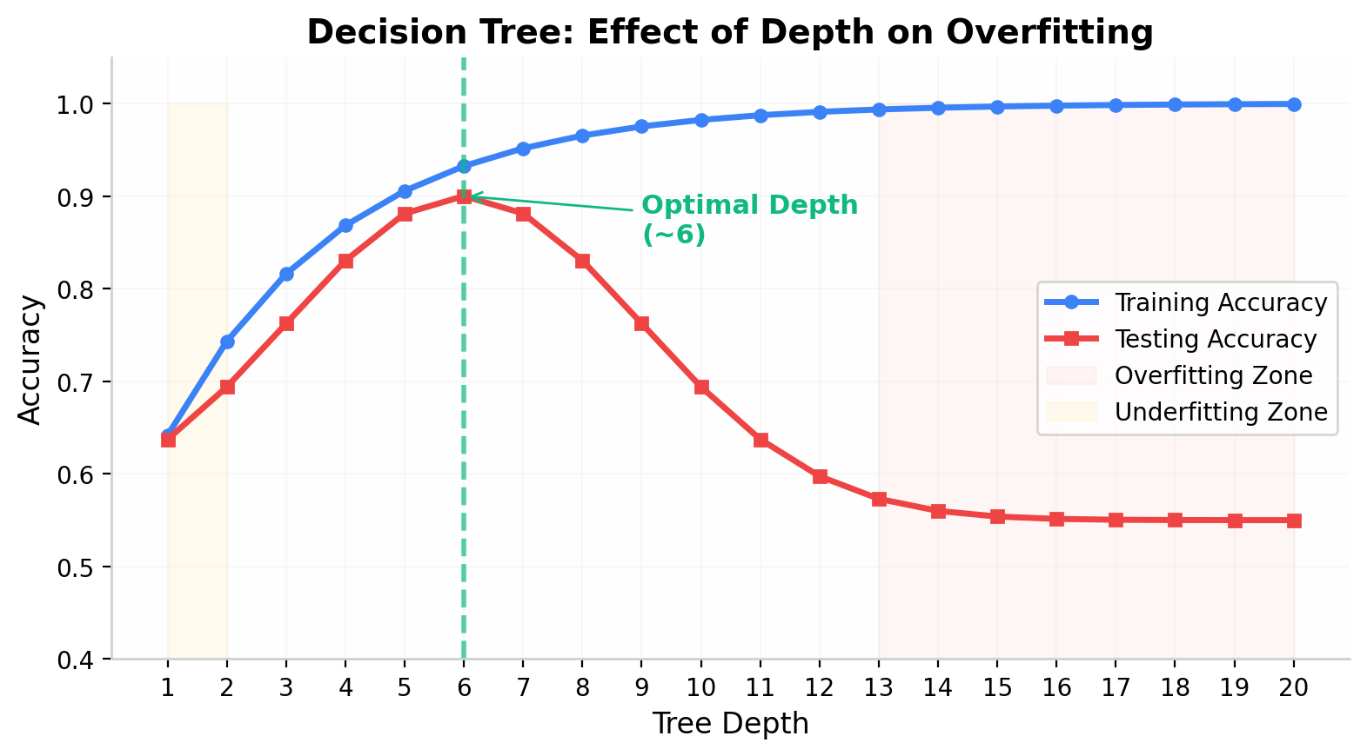

Solutions: Pruning
Technique | Description
Pre-pruning | Stop growing the tree early (set max_depth, min_samples_split)
Post-pruning | Grow full tree, then remove branches that don't help
max_depth | Maximum depth of the tree
min_samples_split | Minimum samples required to split a node
min_samples_leaf | Minimum samples required at a leaf node
max_features | Maximum features to consider for splitting
⚠️ Common Mistake: Not pruning your decision tree! Without pruning, the tree will memorize the training data (overfit) and perform poorly on new data.

8.4 Decision Tree — Python Code
# Step 1: Import Libraries
from sklearn.tree import DecisionTreeClassifier
from sklearn.model_selection import train_test_split
from sklearn.metrics import accuracy_score, classification_report
# Step 2: Load Data
from sklearn.datasets import load_iris
data = load_iris()
X = data.data
y = data.target
# Step 3: Split Data
X_train, X_test, y_train, y_test = train_test_split(
X, y, test_size=0.2, random_state=42
)
# Step 4: Create and Train Decision Tree
dt_model = DecisionTreeClassifier(
criterion='gini', # or 'entropy'
max_depth=5, # Prevent overfitting
min_samples_split=5, # Minimum samples to split
random_state=42
)
dt_model.fit(X_train, y_train)
# Step 5: Predict and Evaluate
y_pred = dt_model.predict(X_test)
print("Accuracy:", accuracy_score(y_test, y_pred))
print("\nClassification Report:")
print(classification_report(y_test, y_pred))
# Step 6: Visualize the Tree (Bonus!)
from sklearn.tree import export_text
tree_rules = export_text(dt_model, feature_names=data.feature_names.tolist())
print(tree_rules)

Important Parameters:
Parameter | Default | Meaning
criterion | gini | Splitting criterion (gini/entropy)
max_depth | None | Max tree depth (None = no limit)
min_samples_split | 2 | Min samples to split a node
min_samples_leaf | 1 | Min samples at a leaf node
💡 Interview Tip: Decision Trees do NOT require feature scaling! They are based on splitting rules, not distances.

8.5 Summary — Decision Trees
Property | Details
Type | Non-parametric, Tree-based classifier
Easy to understand | Interpretable (white box model)
No feature scaling | Required
Handles both numerical | and categorical data
Can capture non-linear | relationships
Feature importance | Can be extracted
Limitation | Prone to overfitting (needs pruning)
Limitation | Sensitive to small changes in data
Limitation | Can create biased trees if classes are imbalanced
Limitation | Greedy algorithm (may not find global optimum)

PART 3: Evaluation & Practice

9. Model Evaluation Metrics
Why Do We Need Metrics?
- Accuracy alone is NOT always enough to evaluate a classification model!

Example: Cancer Detection (Imbalanced Data)
- Dataset: 990 Healthy patients + 10 Cancer patients (Total: 1000)
- A dumb model that always predicts "Healthy": → 990/1000 = 99% Accuracy!
- But it MISSED all 10 cancer patients! → This is why we need more metrics!

10. Confusion Matrix Deep Dive
Definition: A Confusion Matrix is a table that describes the performance of a classification model by comparing actual labels vs predicted labels.

10.1 The 2×2 Confusion Matrix

For Binary Classification:
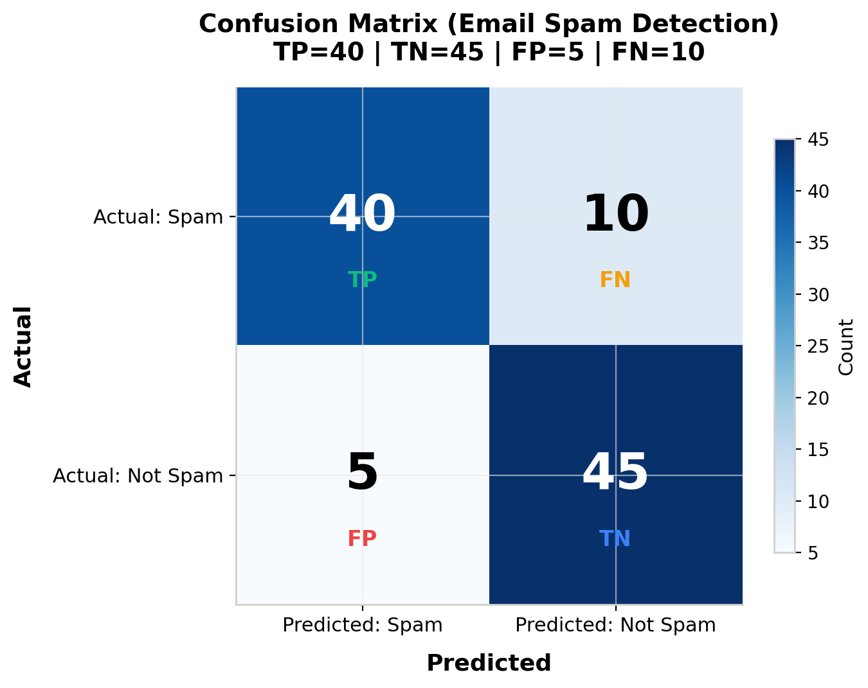

What Each Term Means:
Term | Full Name | Meaning | Example (Email Spam)
TP | True Positive | Correctly predicted as Positive | Spam email → Predicted Spam
TN | True Negative | Correctly predicted as Negative | Normal email → Predicted Normal
FP | False Positive | Incorrectly predicted as Positive (Type I Error) | Normal email → Predicted Spam
FN | False Negative | Incorrectly predicted as Negative (Type II Error) | Spam email → Predicted Normal
📝 Remember this trick: True/False = Was the prediction correct? Positive/Negative = What was the prediction? So: False Positive = Prediction is FALSE, but it predicted POSITIVE

10.2 Metrics Derived from Confusion Matrix

1. Accuracy
Accuracy = (TP + TN) / (TP + TN + FP + FN)

Meaning: Overall correctness of the model
When to use: Balanced datasets

2. Precision
Precision = TP / (TP + FP)

Meaning: Out of all predicted positives, how many were actually positive?
When to use: When False Positives are costly (e.g., spam filter)

3. Recall (Sensitivity)
Recall = TP / (TP + FN)

Meaning: Out of all actual positives, how many did we correctly identify?
When to use: When False Negatives are costly (e.g., cancer detection)

4. F1-Score
F1 = 2 × (Precision × Recall) / (Precision + Recall)

Meaning: Balance between Precision and Recall
When to use: When you need a single metric that balances both

5. Specificity
Specificity = TN / (TN + FP)

Meaning: Out of all actual negatives, how many did we correctly identify?
When to use: When you care about correctly identifying negatives

10.3 Numerical Example

Confusion Matrix:
- Predicted
- Spam | Not Spam
- Spam | 40 | 10 (50 actual spam)
- Not Spam | 5 | 45 (50 actual not spam)
- TP=40 FN=10 FP=5 TN=45

Calculations:
- Accuracy = (40+45)/(40+45+5+10) = 85/100 = 85%
- Precision = 40/(40+5) = 40/45 = 88.9%
- Recall = 40/(40+10) = 40/50 = 80%
- F1-Score = 2 × (0.889 × 0.80)/(0.889 + 0.80) = 84.2%
🔴 Exam Point: Know the difference between Precision and Recall. Think of it as: Precision → "How many of my PREDICTIONS were correct?" Recall → "How many of the ACTUAL positives did I catch?"

10.4 Precision vs Recall Trade-off
Increasing Recall usually decreases Precision (and vice versa). The F1-Score finds the balance.
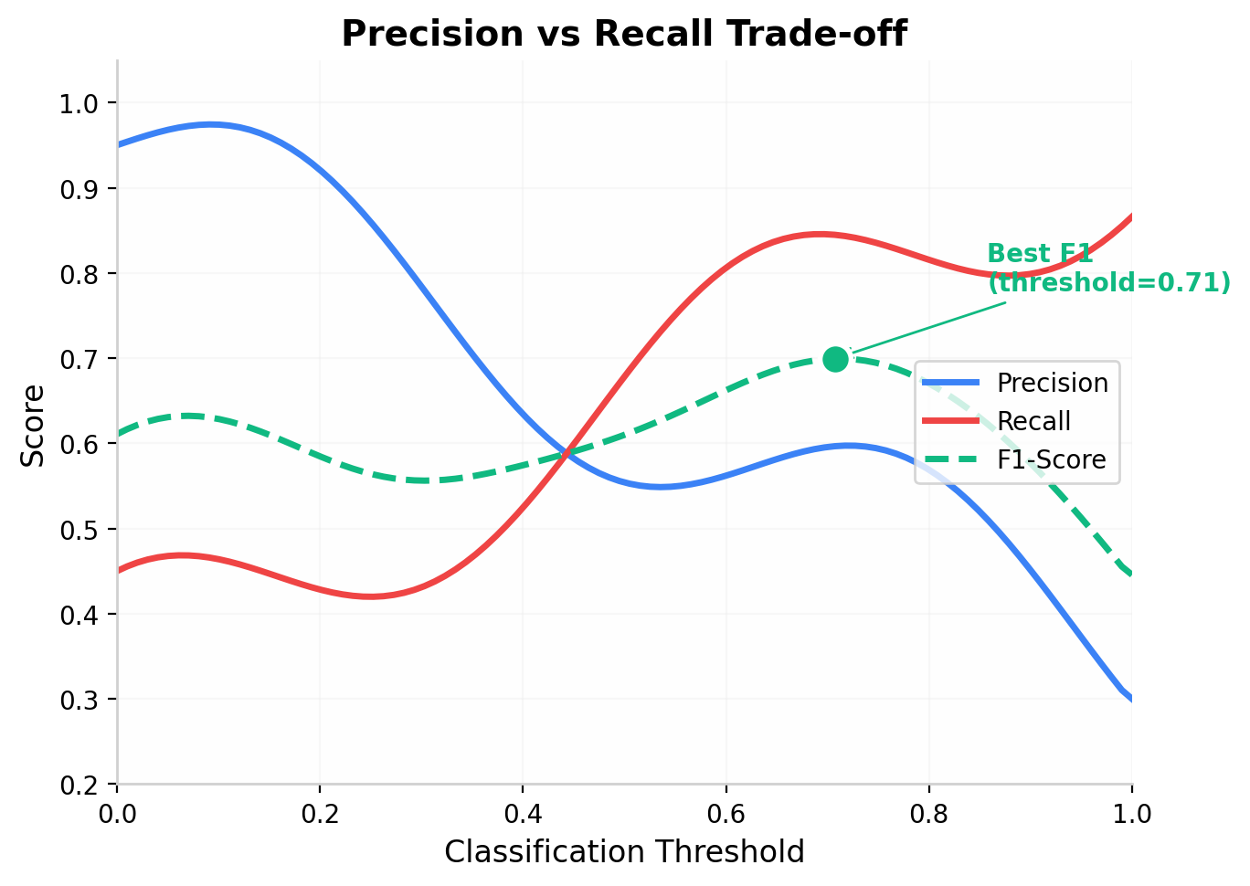

10.5 ROC Curve & AUC

ROC Curve (Receiver Operating Characteristic):
- Plots True Positive Rate (Recall) vs False Positive Rate
- FPR = FP / (FP + TN)
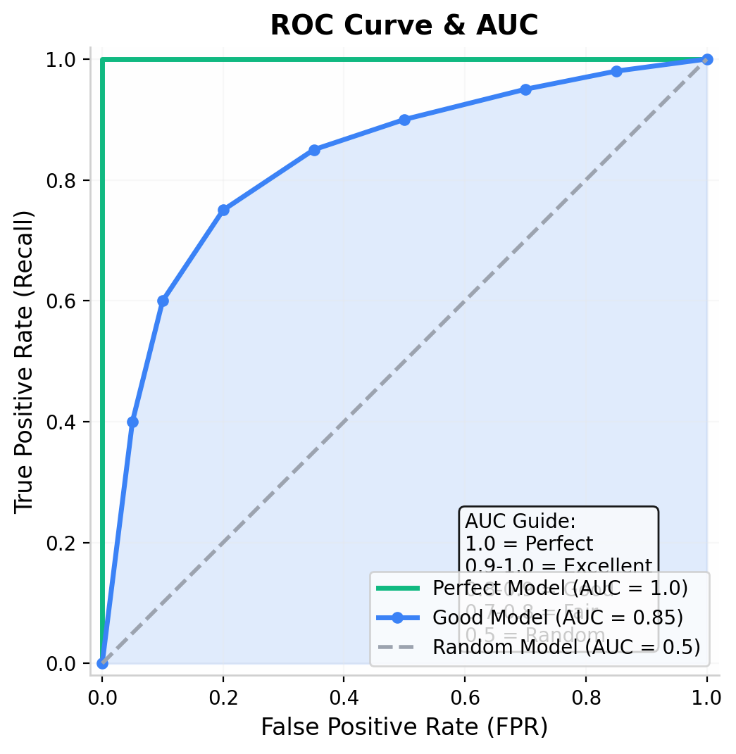

AUC (Area Under the Curve):
AUC Value | Model Quality
1.0 | Perfect
0.9 - 1.0 | Excellent
0.8 - 0.9 | Good
0.7 - 0.8 | Fair
0.5 | Random (useless)
< 0.5 | Worse than random

10.6 Evaluation Metrics — Python Code
from sklearn.metrics import (
confusion_matrix, accuracy_score, precision_score,
recall_score, f1_score, classification_report, roc_auc_score
)
# Assuming y_test and y_pred are already defined
# Confusion Matrix
cm = confusion_matrix(y_test, y_pred)
print("Confusion Matrix:")
print(cm)
# Individual Metrics
print(f"Accuracy: {accuracy_score(y_test, y_pred):.4f}")
print(f"Precision: {precision_score(y_test, y_pred):.4f}")
print(f"Recall: {recall_score(y_test, y_pred):.4f}")
print(f"F1-Score: {f1_score(y_test, y_pred):.4f}")
# Complete Report (BEST WAY!)
print("\nFull Classification Report:")
print(classification_report(y_test, y_pred))

💡 Interview Tip: Always use classification_report() — it gives you precision, recall, and F1-score for each class AND overall metrics in one command!

10.7 Which Metric to Use When?
Scenario | Best Metric
Balanced classes | Accuracy
Imbalanced classes | F1-Score, AUC
Spam Detection | Precision (avoid false spam)
Cancer Detection | Recall (don't miss patients)
Fraud Detection | Recall + F1-Score
Search Engine Results | Precision (show relevant results)
General purpose | F1-Score (balance P & R)

11. Complete Algorithm Comparison
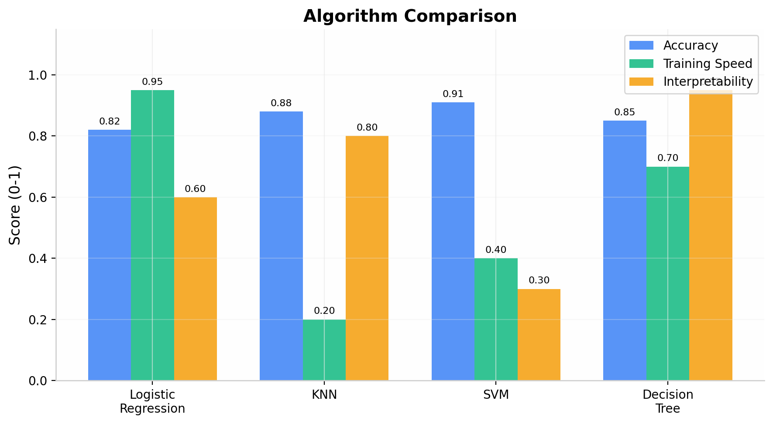
Feature | Logistic Reg | KNN | SVM | Decision Tree
Type | Linear | Non-parametric | Linear/Non-linear | Non-parametric
Learning | Eager | Lazy | Eager | Eager
Scaling Needed | No (recommended) | YES (mandatory) | YES (mandatory) | No
Training Speed | Fast | None (stores data) | Slow | Moderate
Predict Speed | Fast | Slow | Fast | Fast
Interpretable | Medium | Easy | Hard | Very Easy
Handles Non-Linear | No | Yes | Yes (kernels) | Yes
Overfitting | Low | Depends on K | Low (with C) | High (no prune)
Key Param | C, penalty | K, metric | C, kernel, gamma | max_depth, criterion
Best For | Binary, linear data | Small data | High-dim, medium data | Interpretable models

ONE-PAGE REVISION SHEET
CLASSIFICATION = Predicting DISCRETE labels (categories)
REGRESSION = Predicting CONTINUOUS values (numbers)
═══════════ LOGISTIC REGRESSION ═══════════
- Uses Sigmoid: σ(z) = 1 / (1 + e^(-z))
- Output: Probability (0 to 1), threshold at 0.5
- Loss: Log Loss (Binary Cross-Entropy)
- Linear classifier, best for binary classification
- sklearn: LogisticRegression()
═══════════ K-NEAREST NEIGHBORS ═══════════
- Lazy learner, no training phase
- Classifies by majority vote of K neighbors
- Distance: Euclidean (default), Manhattan, Minkowski
- REQUIRES feature scaling!
- Choose K: start with √n, use odd K, cross-validate
- sklearn: KNeighborsClassifier(n_neighbors=K)
═══════════ SUPPORT VECTOR MACHINE ═══════════
- Finds optimal hyperplane with maximum margin
- Support Vectors = closest points to hyperplane
- Kernel Trick: Linear, Polynomial, RBF (default)
- C parameter: small=wide margin, large=narrow margin
- REQUIRES feature scaling!
- sklearn: SVC(kernel='rbf', C=1.0)
═══════════ DECISION TREE ═══════════
- Tree of if-else rules, easy to interpret
- Splitting: Gini Impurity (default) or Entropy
- Gini = 1 - Σ(pi²) | Entropy = -Σ(pi × log₂(pi))
- Prone to OVERFITTING → use pruning (max_depth)
- Does NOT need feature scaling
- sklearn: DecisionTreeClassifier(max_depth=5)
═══════════ EVALUATION METRICS ═══════════
- Accuracy = (TP+TN) / (TP+TN+FP+FN)
- Precision = TP / (TP+FP) → "How pure are predictions?"
- Recall = TP / (TP+FN) → "How many actual + did I catch?"
- F1 = 2×(P×R)/(P+R) → Balance of Precision & Recall
- Use F1 for imbalanced data, Recall for disease detection
═══════════ CONFUSION MATRIX ═══════════
- Predicted → Pos | Neg
- Actual ↓ Pos | TP | FN
- Neg | FP | TN

20 INTERVIEW QUESTIONS WITH ANSWERS
Q1. What is the difference between Classification and Regression?
Answer: Classification predicts discrete labels/categories (e.g., Spam/Not Spam), while Regression predicts continuous numerical values (e.g., house price = Rs.50 lakhs). Classification uses metrics like Accuracy, Precision, Recall; Regression uses MSE, RMSE, R².

Q2. Why is Logistic Regression called "Regression" if it's a classification algorithm?
Answer: Because internally it uses a linear regression equation (z = wx + b) to compute a value. This value is then passed through the Sigmoid function to produce a probability between 0 and 1. A threshold (usually 0.5) converts this probability into a class label.

Q3. What is the Sigmoid function and why is it used?
Answer: The Sigmoid function σ(z) = 1/(1+e^(-z)) maps any real number to a value between 0 and 1. It's used in Logistic Regression to convert the linear output into a probability, which can then be thresholded to make a binary classification decision.

Q4. What is KNN and how does it work?
Answer: KNN (K-Nearest Neighbors) is a lazy, non-parametric algorithm. It stores all training data and, when a new point arrives, it calculates the distance to all training points, finds the K nearest ones, and assigns the class that has the majority vote among those K neighbors.

Q5. Why is feature scaling important for KNN?
Answer: KNN uses distance calculations (Euclidean, Manhattan). Features with larger ranges dominate the distance computation. For example, if Salary (30K-100K) and Age (20-60) are used without scaling, Salary differences will dominate and Age will barely matter. Scaling ensures all features contribute equally.

Q6. How do you choose the best K value for KNN?
Answer: Start with K = √n (where n is number of data points). Use odd values for binary classification to avoid ties. The best approach is cross-validation — try multiple K values and pick the one with the best validation accuracy. Plot accuracy vs. K to find the "elbow point."

Q7. What is the Kernel Trick in SVM?
Answer: When data is not linearly separable in the original space, the Kernel Trick maps data to a higher-dimensional space where it becomes separable. The "trick" is that it computes the dot product in this higher space without actually transforming the data, making it computationally efficient.

Q8. What are Support Vectors?
Answer: Support Vectors are the data points that are closest to the decision boundary (hyperplane). They are the most difficult to classify and literally define the position and orientation of the hyperplane. If you remove a support vector, the hyperplane changes. The SVM model only depends on these points.

Q9. What is the C parameter in SVM?
Answer: C is the regularization parameter that controls the trade-off between having a wide margin and correctly classifying training points. Small C → wider margin, allows more misclassifications (may underfit). Large C → narrower margin, tries to classify all points correctly (may overfit).

Q10. What is a Confusion Matrix?
Answer: A confusion matrix is a table that summarizes a classification model's performance by showing the counts of True Positives (TP), True Negatives (TN), False Positives (FP), and False Negatives (FN). It allows us to compute metrics like Accuracy, Precision, Recall, and F1-Score.

Q11. What is the difference between Precision and Recall?
Answer: Precision = TP/(TP+FP) — Of all predicted positives, how many were actually positive? Recall = TP/(TP+FN) — Of all actual positives, how many did we correctly identify? Use Precision when FP is costly (spam filter). Use Recall when FN is costly (cancer detection).

Q12. What is the F1-Score and when should you use it?
Answer: F1-Score is the harmonic mean of Precision and Recall: F1 = 2×(P×R)/(P+R). Use it when you need a single metric that balances both, especially with imbalanced datasets where accuracy is misleading.

Q13. Why can accuracy be misleading for imbalanced datasets?
Answer: If 95% of data belongs to Class A, a model that always predicts Class A achieves 95% accuracy but is completely useless. It fails to identify any Class B instances. Metrics like F1-Score, Precision, Recall, or AUC give a better picture.

Q14. What is Entropy and Information Gain in Decision Trees?
Answer: Entropy measures the impurity/disorder in a dataset: H(S) = -Σpᵢlog₂(pᵢ). Range: 0 (pure) to 1 (max impurity for binary). Information Gain = Entropy(before split) − weighted Entropy(after split). The feature with the highest IG is chosen for splitting.

Q15. What is the difference between Gini Impurity and Entropy?
Answer: Both measure impurity. Gini = 1−Σpᵢ² (range: 0 to 0.5 for binary). Entropy = −Σpᵢlog₂(pᵢ) (range: 0 to 1 for binary). Gini is computationally faster (no logarithm). Entropy sometimes gives more balanced trees. In practice, they produce very similar results.

Q16. How do you prevent overfitting in Decision Trees?
Answer: Use pruning techniques: (1) Pre-pruning — set max_depth, min_samples_split, min_samples_leaf, max_features. (2) Post-pruning — grow the full tree, then remove branches using cost-complexity pruning (ccp_alpha). Cross-validation helps find optimal parameters.

Q17. Which algorithms require feature scaling?
Answer: Algorithms that use distance calculations or gradient-based optimization require scaling: KNN, SVM, Logistic Regression (recommended), Neural Networks. Decision Trees and Random Forests do NOT require scaling because they use splitting rules based on feature thresholds.

Q18. What is the ROC-AUC curve?
Answer: The ROC curve plots True Positive Rate (Recall) vs False Positive Rate at different classification thresholds. AUC (Area Under the Curve) summarizes the ROC curve as a single number. AUC = 1.0 is perfect, AUC = 0.5 is random. It's threshold-independent and useful for comparing models.

Q19. What is the difference between eager and lazy learners?
Answer: Eager learners (Logistic Regression, SVM, Decision Trees) build a model during training and discard the training data. Lazy learners (KNN) store all training data and only process it when a prediction is needed. Eager learners have fast prediction but slow training; lazy learners have no training but slow prediction.

Q20. When would you choose SVM over Logistic Regression?
Answer: Choose SVM when: (1) Data is not linearly separable (use kernel trick). (2) You have high-dimensional data (SVM works well). (3) You need better margins/generalization. Choose Logistic Regression when: (1) You need probability outputs. (2) Data is linearly separable. (3) You need interpretability. (4) You have a very large dataset (SVM can be slow).

20 QUIZ QUESTIONS (Answers Marked)
Q1. Classification predicts ______ values.
- (a) Continuous
- (b) Discrete ✅
- (c) Random
- (d) Missing

Q2. Which function does Logistic Regression use?
- (a) ReLU
- (b) Tanh
- (c) Sigmoid ✅
- (d) Softmax

Q3. The output range of the Sigmoid function is:
- (a) (-∞, +∞)
- (b) (-1, 1)
- (c) (0, 1) ✅
- (d) (0, ∞)

Q4. KNN is a ______ learner.
- (a) Eager
- (b) Lazy ✅
- (c) Fast
- (d) Deep

Q5. Which distance metric is the default in sklearn's KNN?
- (a) Manhattan
- (b) Cosine
- (c) Minkowski (p=2, which equals Euclidean) ✅
- (d) Hamming

Q6. Feature scaling is mandatory for which algorithm?
- (a) Decision Tree
- (b) Random Forest
- (c) KNN ✅
- (d) Naive Bayes

Q7. In SVM, the data points closest to the hyperplane are called:
- (a) Anchor Points
- (b) Critical Points
- (c) Support Vectors ✅
- (d) Boundary Points

Q8. The RBF kernel in SVM stands for:
- (a) Random Basis Function
- (b) Radial Basis Function ✅
- (c) Recursive Basis Function
- (d) Relative Basis Function

Q9. A large C value in SVM leads to:
- (a) Wide margin, underfitting
- (b) Narrow margin, overfitting ✅
- (c) No effect
- (d) Balanced margin

Q10. Which splitting criterion does sklearn's DecisionTreeClassifier use by default?
- (a) Entropy
- (b) Information Gain
- (c) Gini Impurity ✅
- (d) Chi-Square

Q11. Entropy of a pure dataset is:
- (a) 1
- (b) 0.5
- (c) 0 ✅
- (d) Infinity

Q12. In a Confusion Matrix, False Positive (FP) is also called:
- (a) Type II Error
- (b) Type I Error ✅
- (c) True Error
- (d) Both a and b

Q13. Precision is defined as:
- (a) TP / (TP + FN)
- (b) TP / (TP + FP) ✅
- (c) TN / (TN + FP)
- (d) (TP + TN) / Total

Q14. For cancer detection, which metric is most important?
- (a) Accuracy
- (b) Precision
- (c) Recall ✅
- (d) Specificity

Q15. F1-Score is the ______ mean of Precision and Recall.
- (a) Arithmetic
- (b) Geometric
- (c) Harmonic ✅
- (d) Weighted

Q16. An AUC value of 0.5 indicates:
- (a) Perfect model
- (b) Good model
- (c) Random model (no discrimination) ✅
- (d) Terrible model

Q17. Which algorithm does NOT require feature scaling?
- (a) SVM
- (b) KNN
- (c) Decision Tree ✅
- (d) Logistic Regression

Q18. The loss function for Logistic Regression is:
- (a) Mean Squared Error
- (b) Mean Absolute Error
- (c) Binary Cross-Entropy (Log Loss) ✅
- (d) Hinge Loss

Q19. Overfitting in Decision Trees can be prevented by:
- (a) Increasing max_depth
- (b) Removing pruning
- (c) Setting max_depth and min_samples_split ✅
- (d) Using more features

Q20. If K = n (total samples) in KNN:
- (a) Perfect accuracy
- (b) Overfitting
- (c) Always predicts the majority class (underfitting) ✅
- (d) Model crashes

CHEAT SHEET — ALL COMMANDS & FORMULAS

Python Import Cheat Sheet
# ============= DATA HANDLING =============
import numpy as np
import pandas as pd
# ============= PREPROCESSING =============
from sklearn.model_selection import train_test_split
from sklearn.preprocessing import StandardScaler
from sklearn.preprocessing import LabelEncoder
# ============= CLASSIFICATION MODELS =============
from sklearn.linear_model import LogisticRegression
from sklearn.neighbors import KNeighborsClassifier
from sklearn.svm import SVC
from sklearn.tree import DecisionTreeClassifier
# ============= EVALUATION METRICS =============
from sklearn.metrics import (
accuracy_score, precision_score, recall_score,
f1_score, confusion_matrix, classification_report,
roc_auc_score, roc_curve
)
# ============= DATASETS =============
from sklearn.datasets import load_iris
from sklearn.datasets import load_breast_cancer

Quick Model Training Template
# 1. Load Data
X, y = data.data, data.target
# 2. Split
X_train, X_test, y_train, y_test = train_test_split(
X, y, test_size=0.2, random_state=42
)
# 3. Scale (if needed)
scaler = StandardScaler()
X_train = scaler.fit_transform(X_train)
X_test = scaler.transform(X_test)
# 4. Train
model = LogisticRegression() # or KNeighborsClassifier(n_neighbors=5)
# or SVC(kernel='rbf')
# or DecisionTreeClassifier(max_depth=5)
model.fit(X_train, y_train)
# 5. Predict & Evaluate
y_pred = model.predict(X_test)
print(classification_report(y_test, y_pred))

Formula Cheat Sheet
Sigmoid: σ(z) = 1 / (1 + e^(-z))
Log Loss: J = -(1/m) Σ[y·log(ŷ) + (1-y)·log(1-ŷ)]
Euclidean: d = √(Σ(xi - yi)²)
Manhattan: d = Σ|xi - yi|
Entropy: H(S) = -Σ(pi · log₂(pi))
Gini: Gini = 1 - Σ(pi²)
Info Gain: IG = H(S) - Σ(|Sv|/|S|) · H(Sv)
Accuracy: (TP + TN) / (TP + TN + FP + FN)
Precision: TP / (TP + FP)
Recall: TP / (TP + FN)
F1-Score: 2 × (P × R) / (P + R)
Specificity: TN / (TN + FP)
SVM Margin: 2 / ||w||

Sklearn Parameter Cheat Sheet
LogisticRegression(C=1.0, penalty='l2', max_iter=100, solver='lbfgs')
KNeighborsClassifier(n_neighbors=5, metric='minkowski', p=2, weights='uniform')
SVC(C=1.0, kernel='rbf', gamma='scale', degree=3)
DecisionTreeClassifier(criterion='gini', max_depth=None,
min_samples_split=2, min_samples_leaf=1)

Decision Flowchart — Which Algorithm to Choose?
START
|
┌───────────▼───────────┐
| Is your data linearly |
| separable? |
└───────────┬───────────┘
Yes | No
┌──────────┴──────────┐
▼ ▼
┌──────────────┐ ┌──────────────┐
| Small data? | | Need |
| | | interpretable|
| | | model? |
└──────┬───────┘ └──────┬───────┘
Yes | No Yes | No
┌───┴───┐ ┌───┴───┐
▼ ▼ ▼ ▼
Logistic Logistic Decision SVM
Reg Reg or Tree (with
SVM kernel)

FINAL TIPS

For Exams:
- Memorize the formulas — Sigmoid, Entropy, Gini, Confusion Matrix metrics
- Know when to use which algorithm and which metric
- Understand the Confusion Matrix inside out — TP, TN, FP, FN
- Remember: KNN & SVM need scaling, Decision Trees do NOT
- Practice writing code from memory — the 6-step template works for all algorithms

For Interviews:
- Explain concepts with real-world examples
- Know the pros and cons of each algorithm
- Be ready to explain Precision vs Recall trade-off
- Understand the Kernel Trick conceptually
- Know when accuracy is misleading (imbalanced data)

────────────────────────────────────────────────────────────
Notes Completed!
These notes cover EVERY important concept from:
Sheryians AI School — Part 3 Supervised Learning Classification Algorithms

