**Basic SQL Structure (SELECT, FROM, WHERE, etc.)**

# Topic 1: Basic SELECT with WHERE

Lab 1.1 – Retrieve the details of all users whose name starts with the letter 'S'.

**SELECT \***

**FROM user**

**WHERE name LIKE 'S%';**

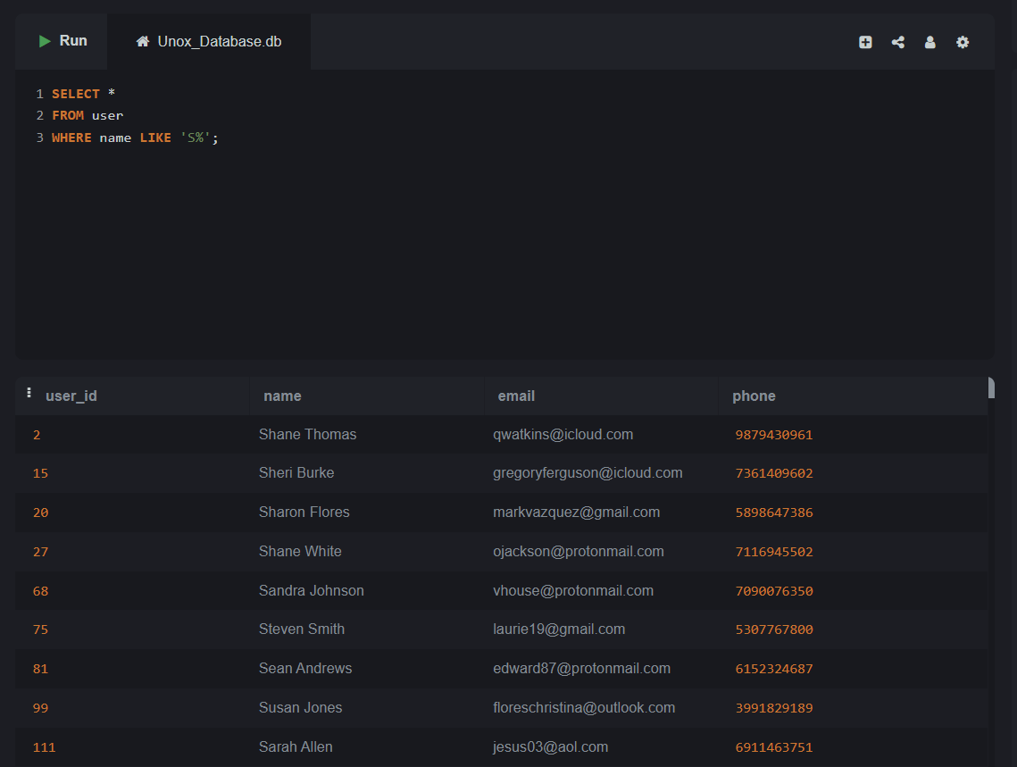

Lab 1.2 – Retrieve all movies where the genre is 'Comedy'.

**SELECT \***

**FROM movie**

**WHERE genre = 'Comedy';**

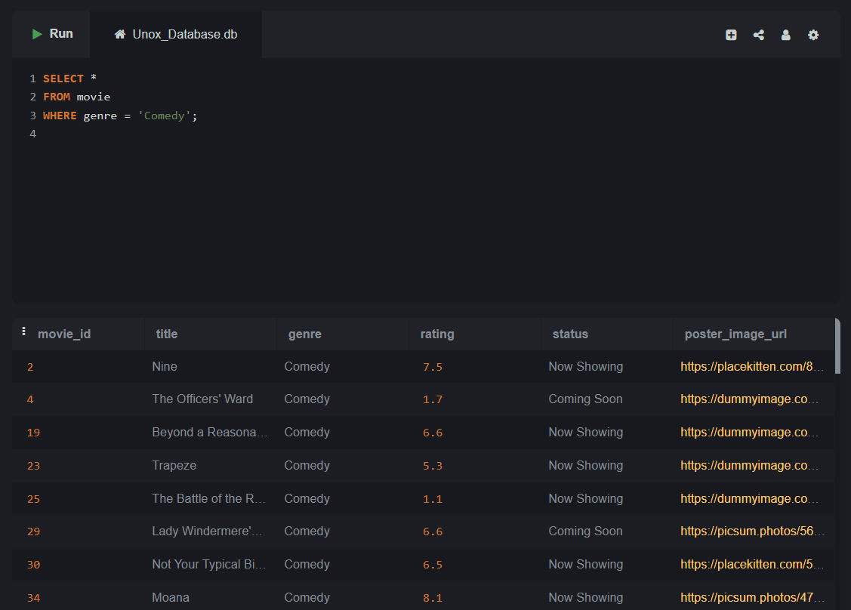

Lab 1.3 – Display the booking_id, user_id, and total_amount for bookings made by user with ID 102.

**SELECT booking_id, user_id, total_cost AS total_amount**

**FROM booking**

**WHERE user_id = 102;**

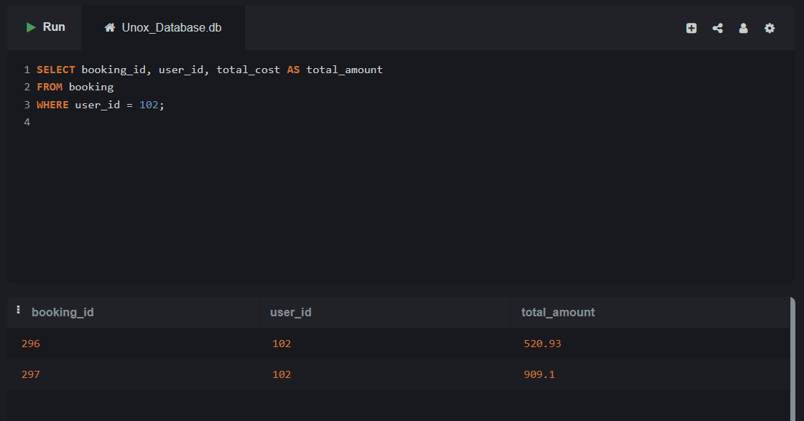

# Topic 2: SELECT with WHERE using Operators (=, >, <, !=)

Lab 2.1 – List all movie names where the rating is greater than 4.0.

**SELECT title**

**FROM movie**

**WHERE rating > 4.0;**

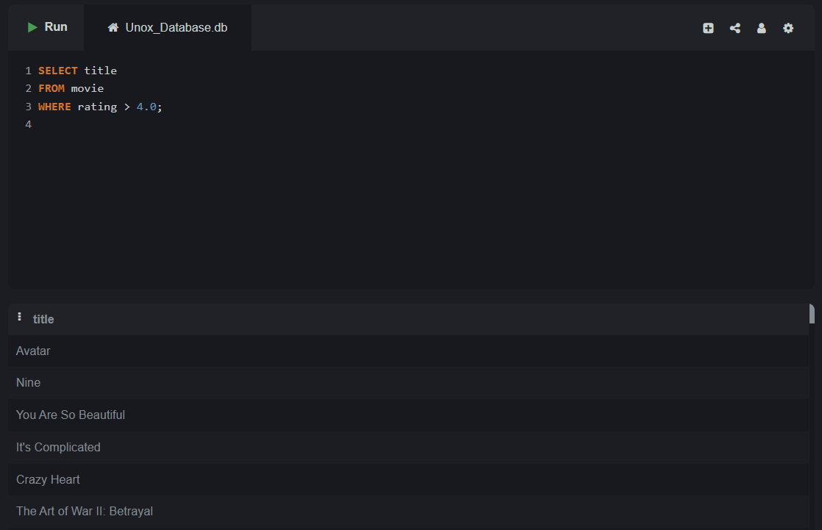

Lab 2.2 – List all bookings where the total amount is greater than ₹400.

**SELECT booking_id, user_id, total_cost**

**FROM booking**

**WHERE total_cost > 400;**

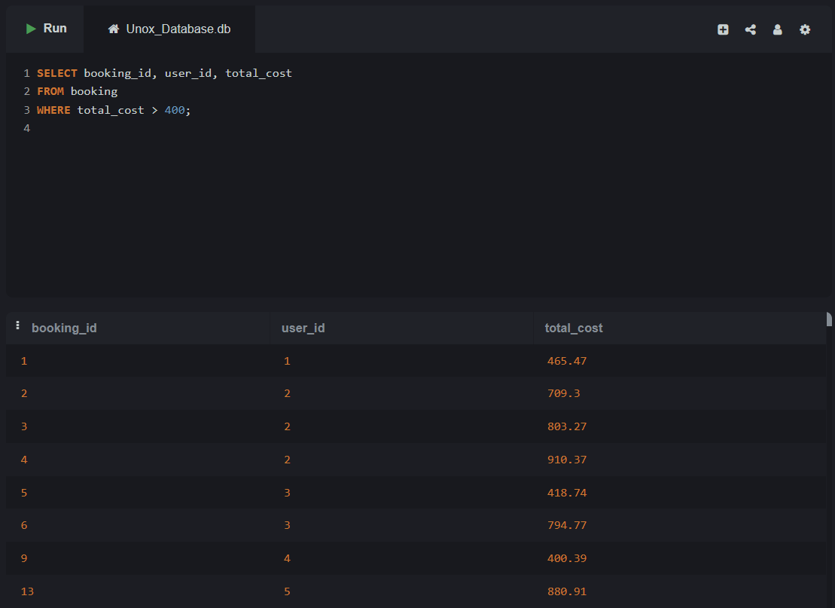

# Topic 3: SELECT with WHERE using AND/OR

Lab 3.1 – show details where movie ID is 3 and show datetime is after '2025-04-20'.

**SELECT \***

**FROM show**

**WHERE movie_id = 3 AND show_datetime > '2025-04-20';**

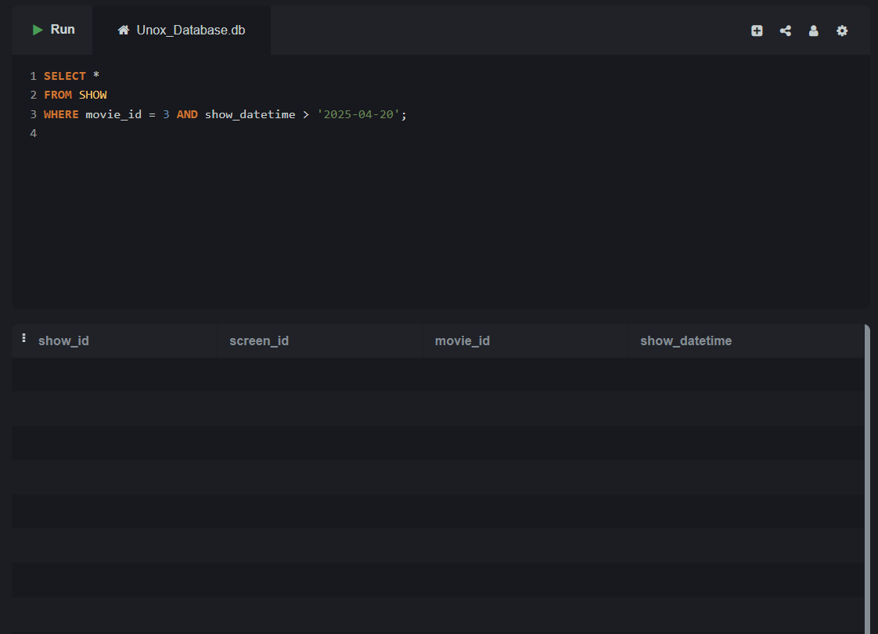

Lab 3.2 – List all bookings where the total cost is more than 500 OR the booking was made after '2025-04-01'.

**SELECT \***

**FROM booking**

**WHERE total_cost > 500 OR booking_datetime > '2025-04-01';**

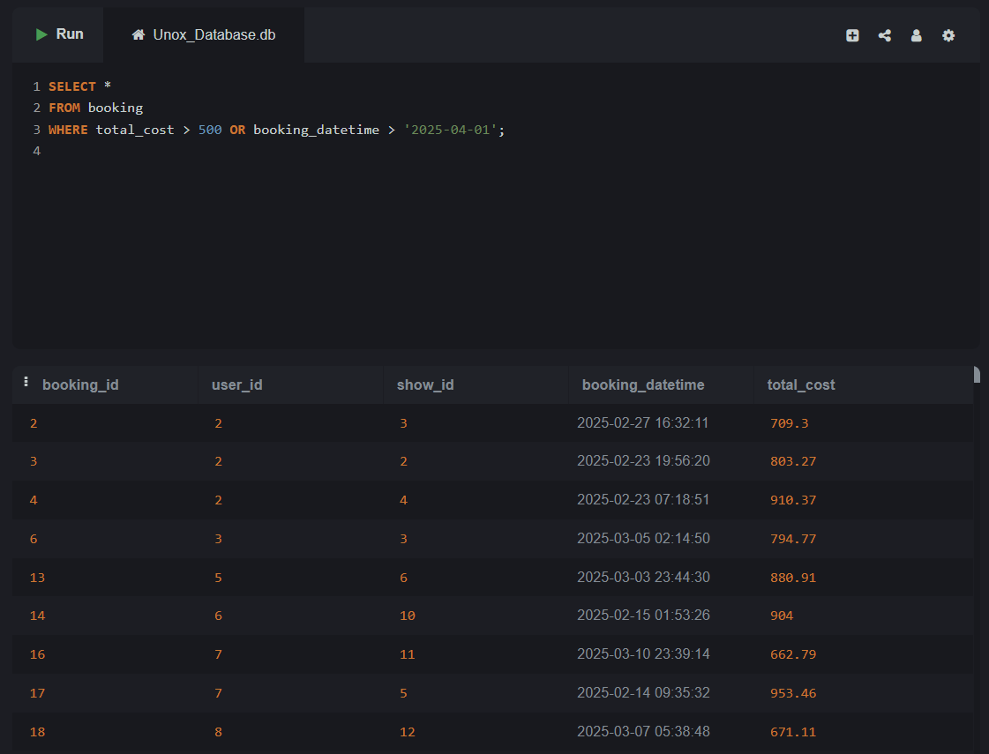

# Topic 4: SELECT with WHERE and NOT

Lab 4.1 –Show all food items which are not combos.

**SELECT \***

**FROM fooditem**

**WHERE NOT is_combo = 'TRUE';**

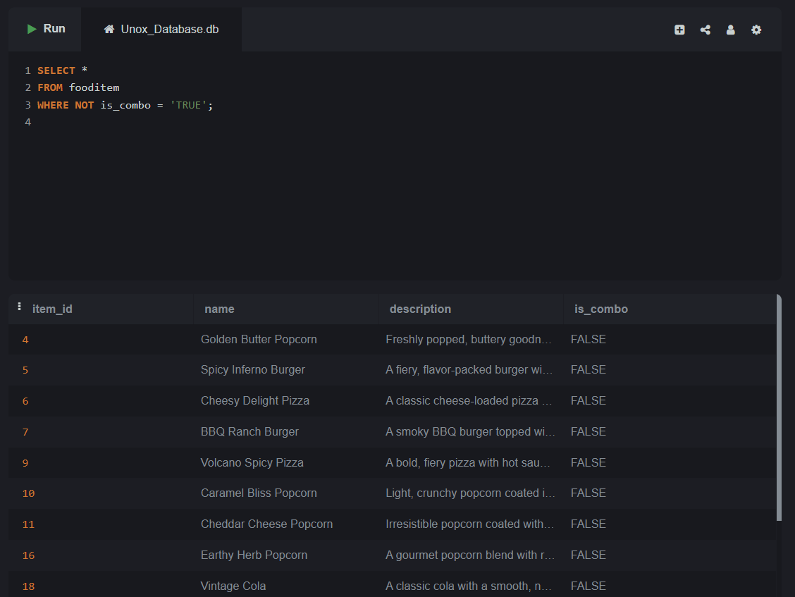

Lab 4.2 –Get all movie details that are not in status 'Inactive'.

**SELECT \***

**FROM movie**

**WHERE status != 'Inactive';**

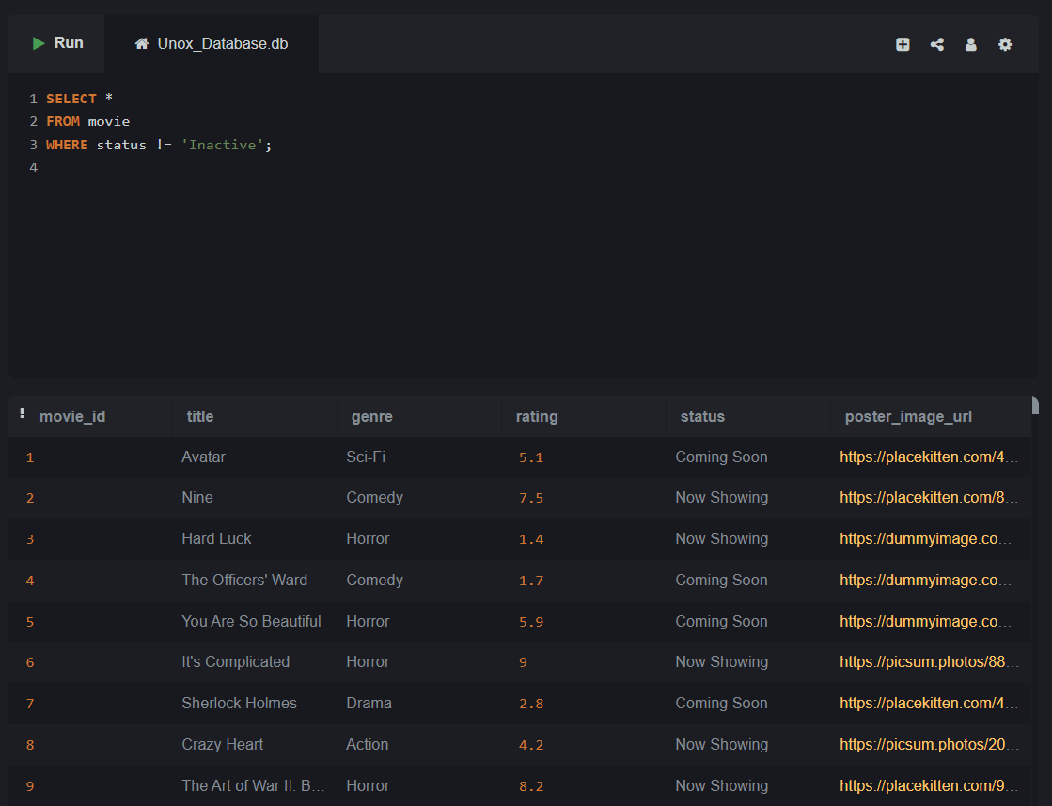

# Topic 5: SELECT with WHERE and BETWEEN

Lab 5.1 - List all food sizes where the rate is between 150 and 300.

**SELECT \***

**FROM FoodItemSize**

**WHERE rate BETWEEN 150 AND 300;**

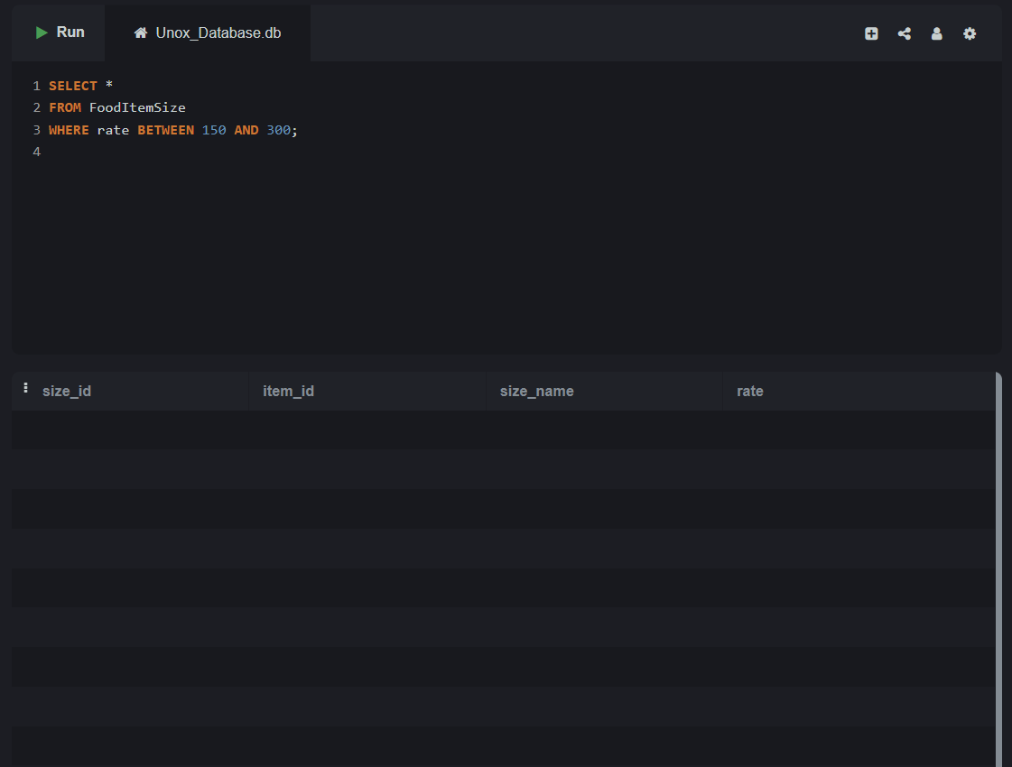

Lab 5.2 – Get all ticket bookings between '2025-04-01' and '202504-10'.

**SELECT \***

**FROM booking**

**WHERE booking_datetime BETWEEN '2025-04-01' AND '2025-04-10 23:59:59';**

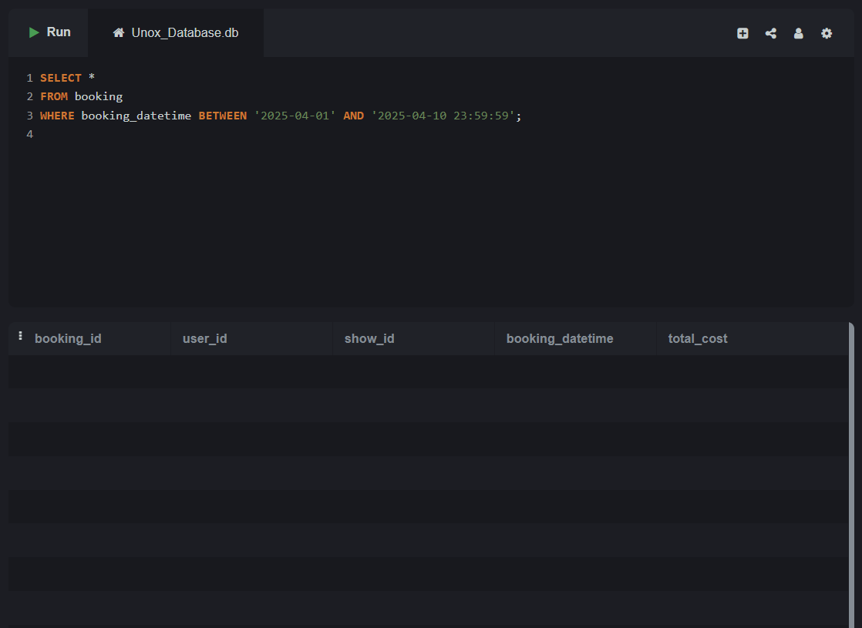

# Topic 6: SELECT with WHERE and IN

Lab 6.1 - Display food items whose names are either 'Vintage Cola', 'Sweet & Salty Popcorn', 'Fiesta Nachos'.

**SELECT \***

**FROM fooditem**

**WHERE name IN ('Vintage Cola', 'Sweet & Salty Popcorn', 'Fiesta Nachos');**

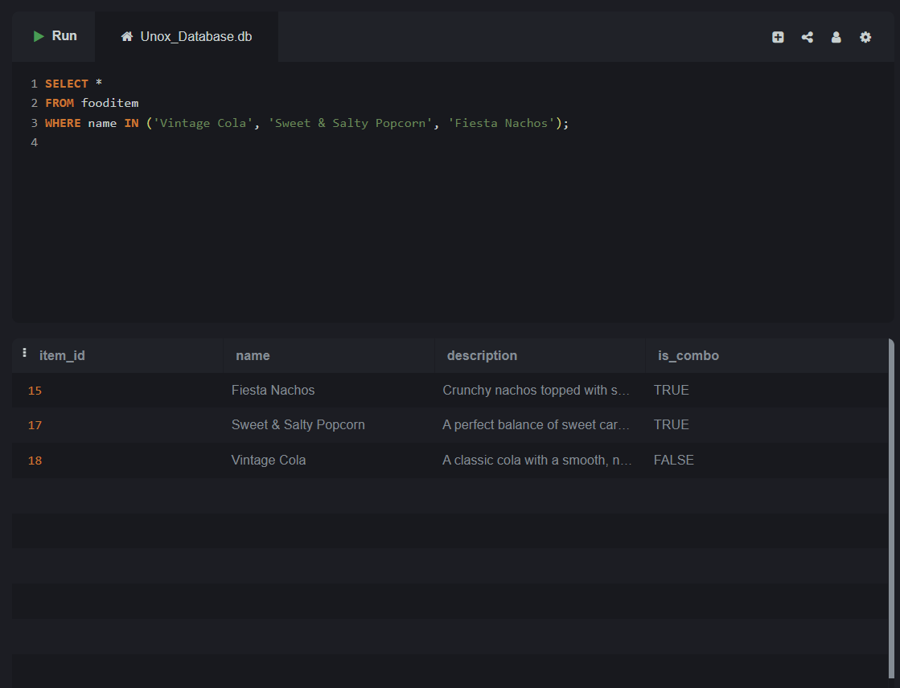

Lab 6.2 - List all bookings made by users with user IDs 101, 103, or 105.

**SELECT \***

**FROM booking**

**WHERE user_id IN (101, 103, 105);**

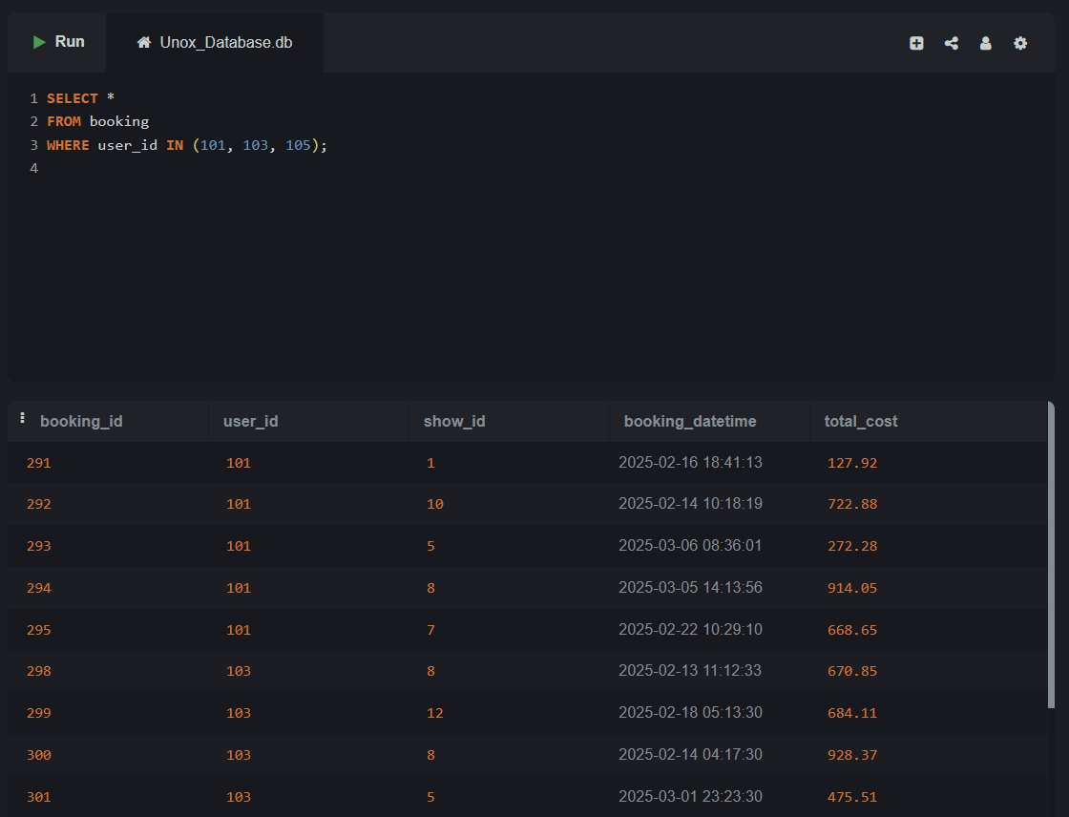

# Topic 7: SELECT with WHERE and LIKE

Lab 7.1 – Retrieve all user emails that contain the word 'yahoo'.

**SELECT email**

**FROM user**

**WHERE email LIKE '%yahoo%';**

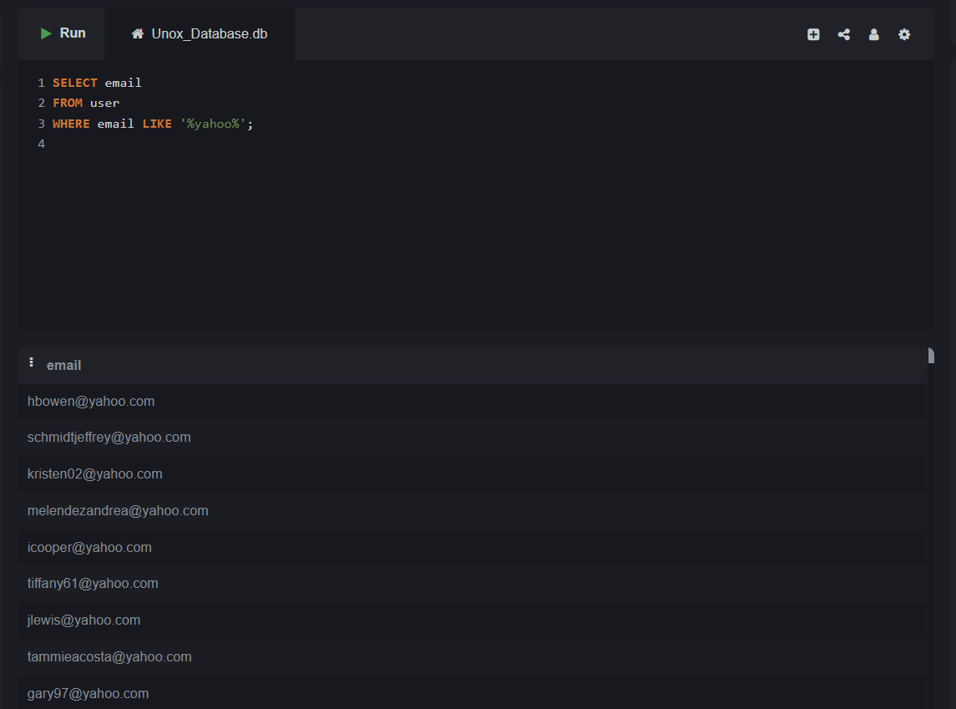

Lab 7.2 – Find all movies whose titles start with the letter 'T'.

**SELECT title**

**FROM Movie**

**WHERE title LIKE 'T%';**

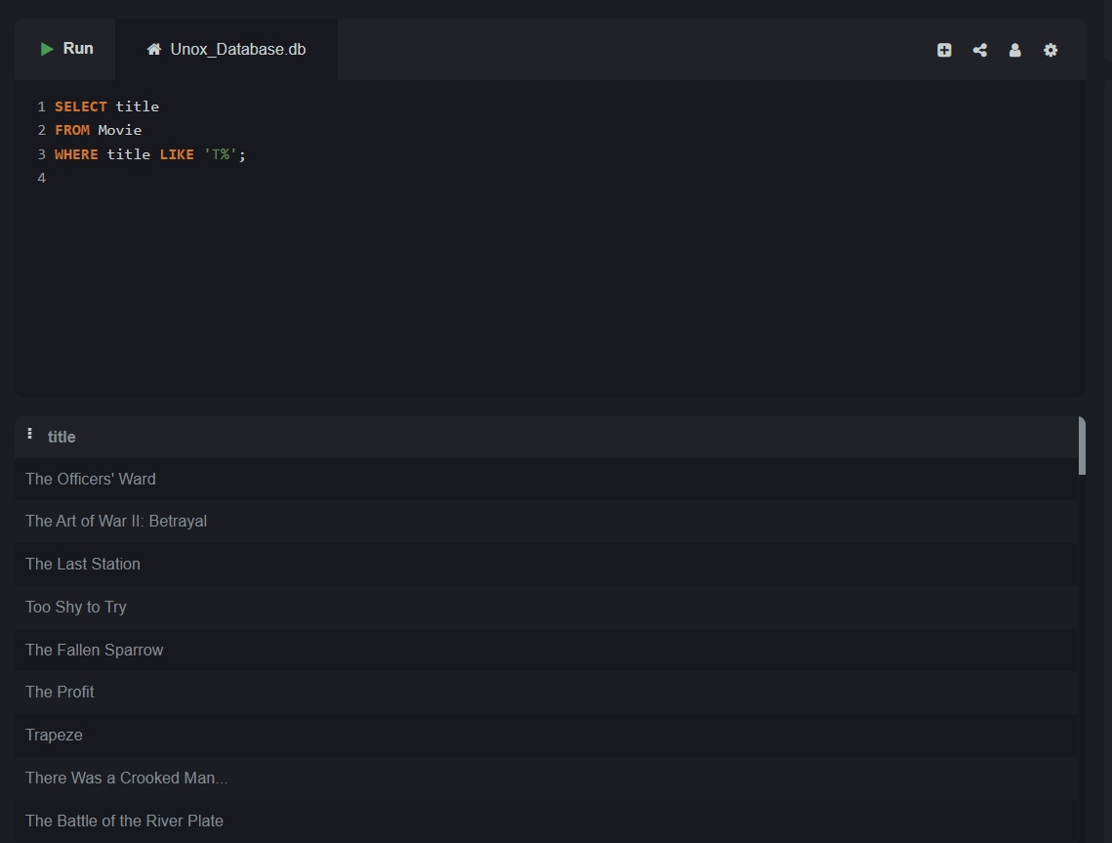

# Topic 8: SELECT with ORDER BY (ASC/DESC)

Lab 8.1 – List all movies ordered by their rating in descending order.

**SELECT \***

**FROM movie**

**ORDER BY rating DESC;**

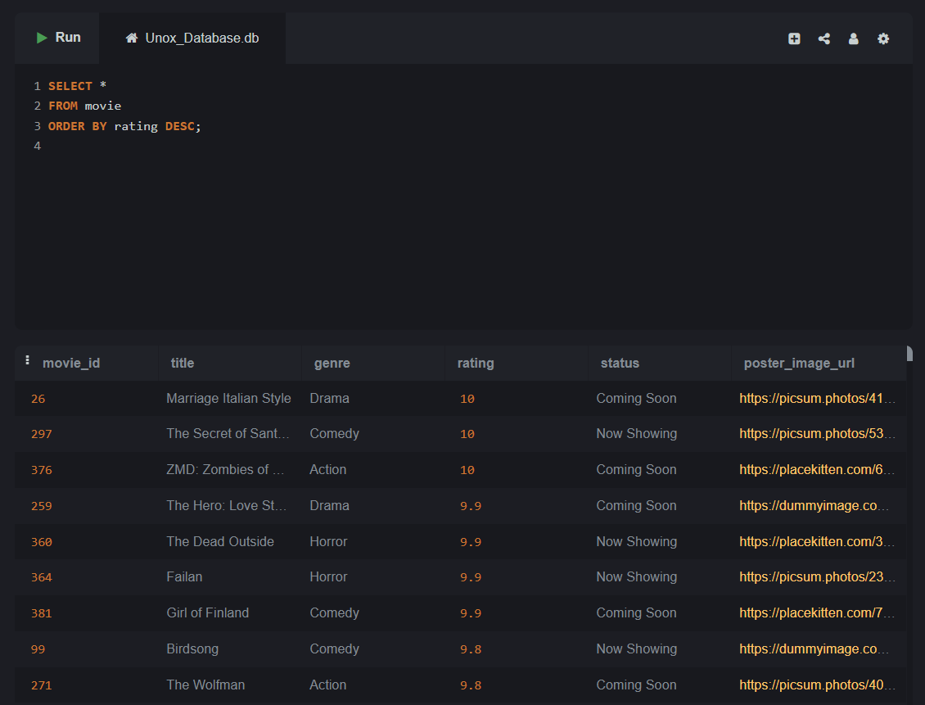

Lab 8.2 – List all shows ordered by show_datetime in ascending order.

**SELECT \***

**FROM show**

**ORDER BY show_datetime ASC;**

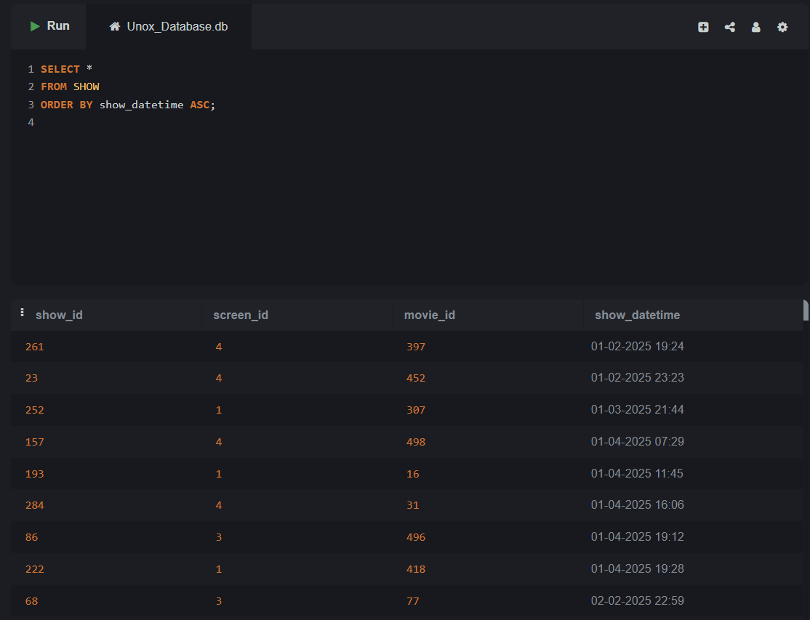

# Topic 9: SELECT with ALIAS (column and table aliases)

Lab 9.1 – Get the names and ratings of movies, but label the rating as 'Movie Rating'.

**SELECT title, rating AS "Movie Rating"**

**FROM Movie;**

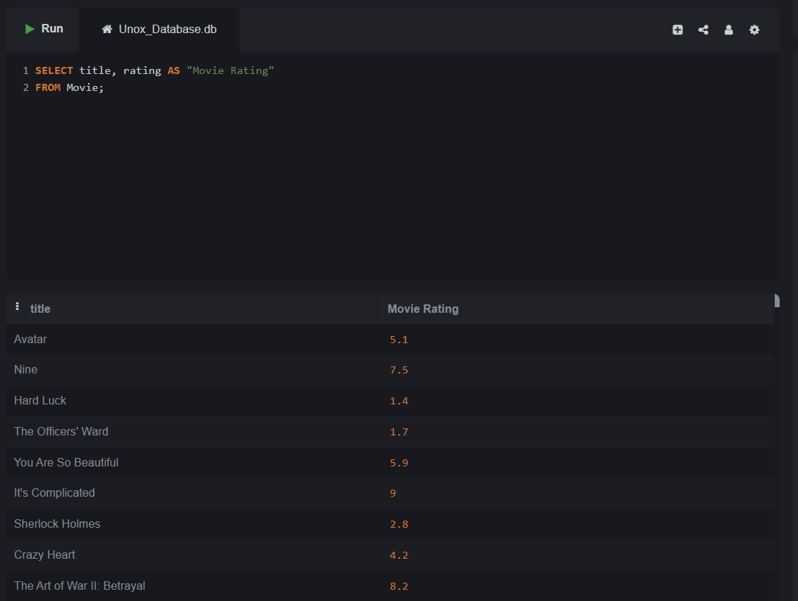

Lab 9.2 – Show screen names and their types, but alias class_type as "Screen Class".

**SELECT name, class_type AS "Screen Class"**

**FROM Screen;**

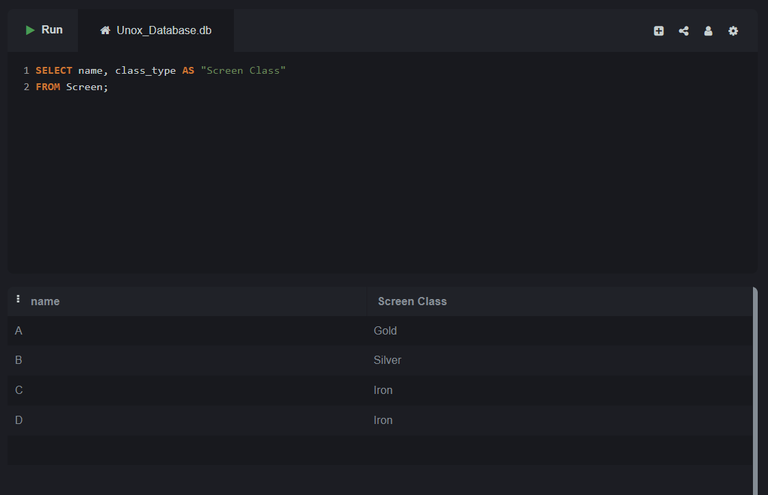

# Topic 10: SELECT with LIMIT and OFFSET

Lab 10.1 – Fetch the first 5 food items from the fooditem table.

**SELECT * FROM FoodItem LIMIT 5;**

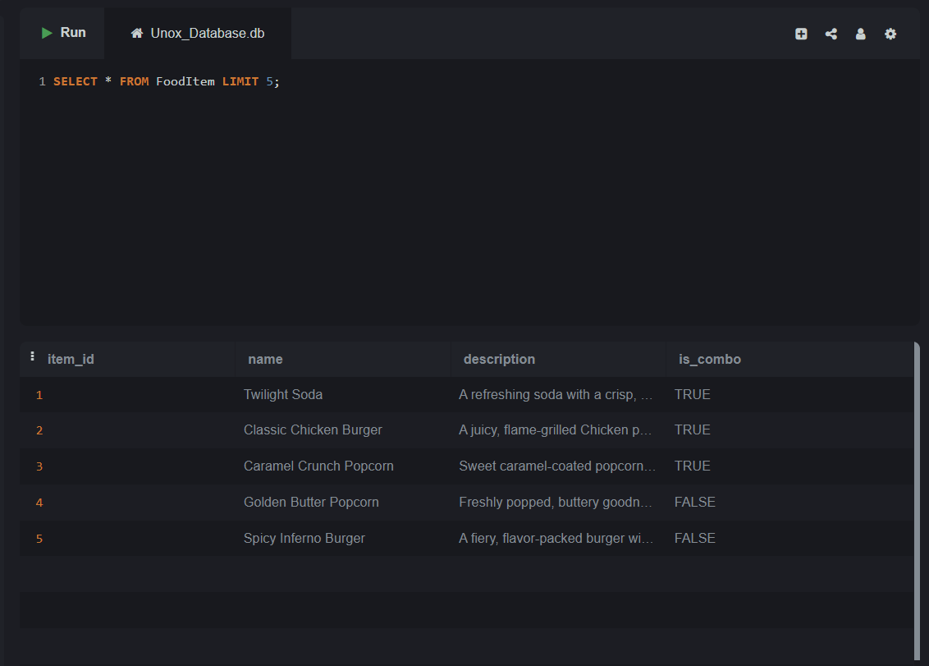

Lab 10.2 – Retrieve the 5 most recent bookings, skipping the latest 3.

**SELECT * FROM Booking**

**ORDER BY booking_datetime DESC LIMIT 5 OFFSET 3;**

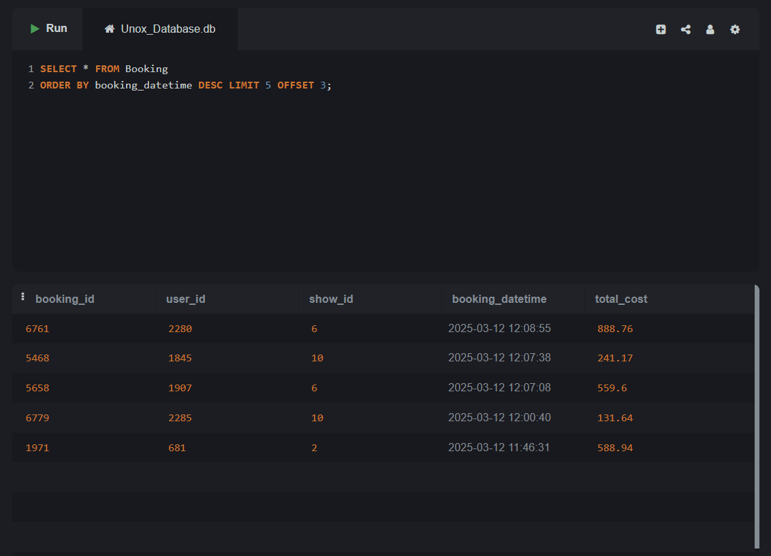

**Topic 11: SELECT with Aggregate Functions (SUM, AVG, COUNT, MIN, MAX)**

# 11.1: SELECT with Aggregate Function – COUNT

Lab 11.1.1 – Count how many bookings each user has made.

**SELECT user_id, COUNT(*) AS booking_count**

**FROM Booking GROUP BY user_id;**

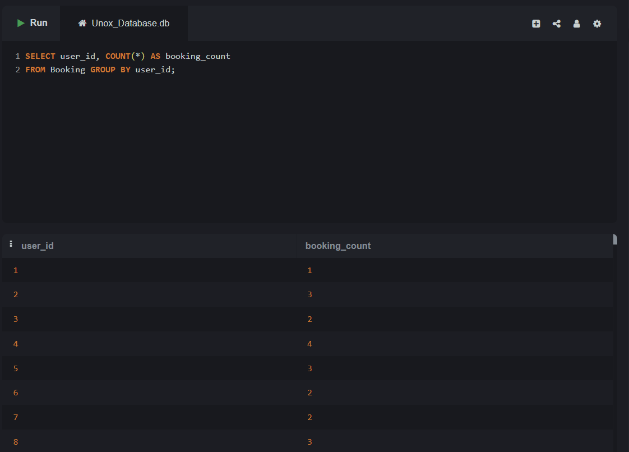

Lab 11.1.2 – Find the total number of food items marked as combo.

**SELECT COUNT(*)**

**FROM FoodItem WHERE is_combo = 1;**

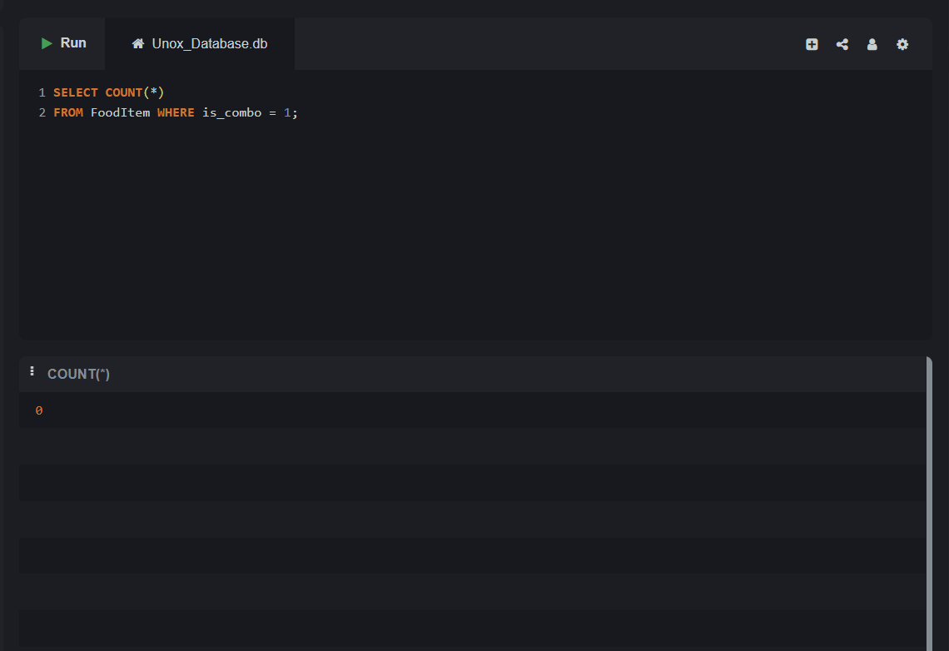

# 11.2: SELECT with Aggregate Function – SUM

Lab 11.2.1 – Find the total amount spent by each user on bookings.

**SELECT user_id, SUM(total_cost) AS total_spent FROM**

**Booking GROUP BY user_id;**

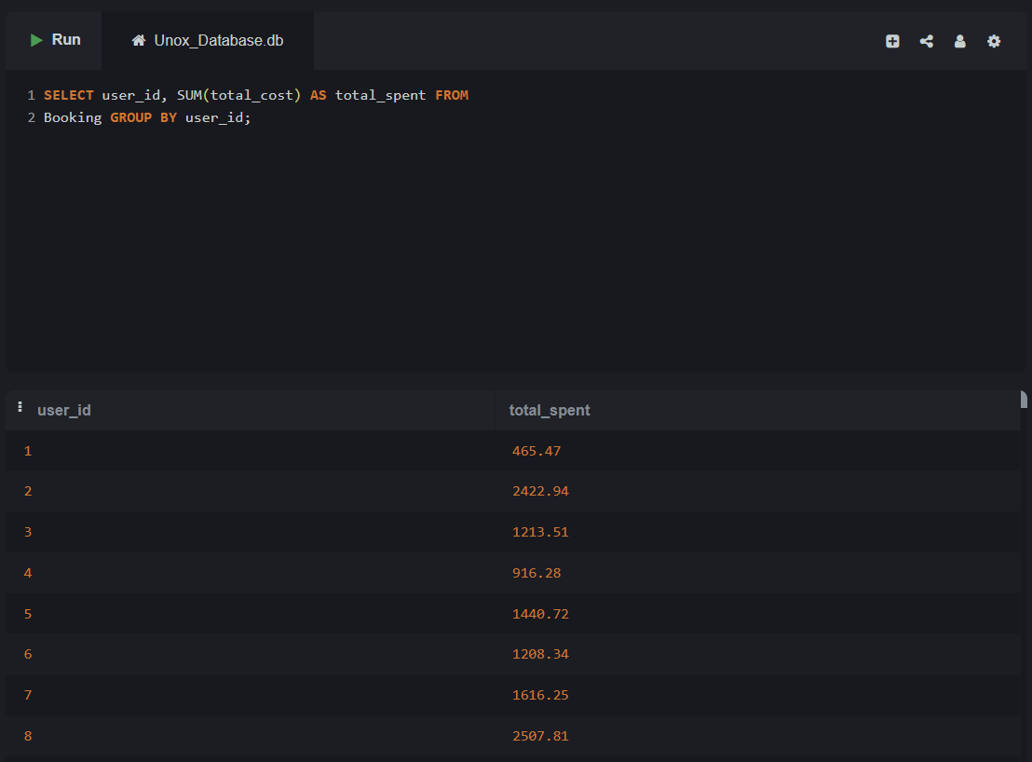

Lab 11.2.2 – Calculate the total loyalty points transactions done by each user.

**SELECT user_id, SUM(amount) AS total_loyalty_points**

**FROM PointsTransaction GROUP BY user_id;**

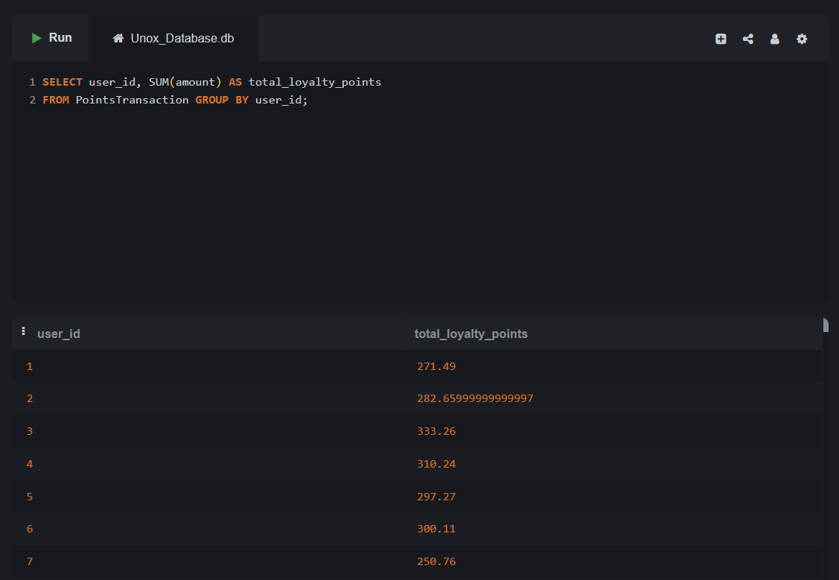

# 11.3: SELECT with Aggregate Function – AVG

Lab 11.3.1 – Find the average rating for each movie genre.

**SELECT genre, AVG(rating) AS avg_rating**

**FROM Movie GROUP BY genre;**

Lab 11.3.2 – Find the average amount of loyalty points used per transaction.

# 11.4: SELECT with Aggregate Function – MIN and MAX

Lab 11.4.1 – Find the highest and lowest rated movies for each genre.

Lab 11.4.2 – Find the earliest and latest show timings for each screen.

# Topic 12: GROUP BY with Aggregate Functions

Lab 12.1 – List the number of shows scheduled for each movie.

Lab 12.2 – Count the number of point transactions per user where the amount is greater than 60.

# Topic 13: GROUP BY with HAVING Clause

Lab 13.1 – Find screens that have more than 1 show scheduled.

Lab 13.2 – Find movie statuses with more than 2 movies.

# Topic 14: GROUP BY with WHERE and ORDER BY

Lab 14.1 – Find the total amount spent per user for bookings over ₹300, sorted in descending order of total.

Lab 14.2 – Group point transactions by user where amount is more than 50 and show only users with more than 3 such transactions.

# Topic 15: GROUP BY Multiple Columns

Lab 15.1 – Show the number of bookings per user per show.

Lab 15.2 – Get the number of shows scheduled per screen per movie.

# Topic16. INNER JOIN

Lab 16.1 – Write an SQL query to retrieve a list of all movies along with their cast members. Include the movie title, the name of the cast, and the role played by the cast.

Lab 16.2 – Write an SQL query to get a list of all shows, including the movie title, the screen name, and the show datetime.

# Topic 17: LEFT JOIN

Lab 17.1 – Write an SQL query to list all movies and their reviews, including movies that have no reviews. The result should include the movie title and the review content (if available).

Lab 17.2 – Write an SQL query to retrieve all movies and their associated movie casts, even if a movie does not have any cast associated with it.

# Topic 18: RIGHT JOIN

Lab 18.1 – Write an SQL query to get a list of all seats and their associated show details. Include all seats even if they have not been booked for any show.

Lab 18.2 – Write an SQL query to list all bookings, including the user name, the booking date, and the movie title, even if the booking has no payment details associated with it.

# Topic 19: FULL OUTER JOIN

Lab 19.1 – Write an SQL query to get a list of all movies and all reviews. Ensure that you include all movies even if they have no reviews and all reviews even if they do not correspond to any movie.

Lab 19.2 – Write an SQL query to list all users and the tickets they have booked. Ensure that all users are included, even those who have not booked any tickets, and include tickets that may not be associated with any user.

# Topic 20: JOIN with Multiple Tables

Lab 20.1 – Write an SQL query to list all food orders, including the food item name, the size of the food item, the quantity, and the total cost. The result should include orders from all bookings.

Lab 20.2 – Write an SQL query to list all food items ordered, including the item name, the quantity ordered, and the price at the time of order.

# Topic 21: JOIN with GROUP BY and Aggregate Functions

Lab 21.1 – Write an SQL query to retrieve the total number of bookings for each movie. Include the movie title and the total number of bookings.

Lab 21.2 – Write an SQL query to find the total number of seats booked per screen, along with the screen name and seat count.

# Topic 22: JOIN with WHERE and HAVING Clause

Lab 22.1 – Write an SQL query to list all movies that have a rating higher than 7.5, along with the number of reviews they have. Only include movies that have more than 3 reviews.

Lab 22.2 – Write an SQL query to list all shows, including the movie title and the screen name, but only include shows that occur after a specific date (e.g., 2025-05-01).

# Topic 23: JOIN with ORDER BY and LIMIT

Lab 23.1 – Write an SQL query to retrieve the 10 most expensive food items, including their name and price, sorted by price in descending order.

Lab 23.2 – Write an SQL query to get the top 3 most recent bookings (based on the booking_datetime), including the user name and total cost.

# Topic 24: JOIN with Aggregate + WHERE + Multiple Conditions

Lab 24.1 – Write an SQL query to find the total cost of all food orders for each screen where the total cost is greater than 30. Include the screen ID and the total cost.

Lab 24.2 – Write an SQL query to find the total cost of all bookings for each user, where the total cost is greater than 50, including the user's name and total booking cost.

# Topic 25: Complex JOINs involving 3+ Tables with Aggregation & Filtering

Lab 25.1 – Write an SQL query to list all food orders with their total cost and the corresponding user details. Only include users who have spent more than 100 on food. Join with the FoodOrder, User, and FoodOrderItem tables.