**SUMMER INTERNSHIP**

**Project Report**

**On**

# Network design proposal for an Organization

## Under the guidance of :

***Sir. Krishan Kumar Singh Yadav***

[*Junior Telecom Officer*

*Advanced Level Telecom Training Center, BSNL*

*Ghaziabad*. ]

## Submitted by:

***Ravi Ranjan***

*Jaypee Institute of Technology, Noida Sector-62*

*Computer Science and Engineering*



**CONTENTS**

* INTRODUCTION
* Networking
* Components of networking
* ABOUT
* PROJECT DETAILS
* SIGNIFICANCE OF PROJECT
* CONCLUSION

**Acknowledgement**

It is with profound gratitude that I express my deep in debtedness to all the employees of ALLTC., B.S.N.L. ,Ghazibad without whose support and guidance it would not have been possible for this training to have materialized and taken a concrete shape. I owe my personal thanks to my trainers in charge- Mr. K.K.S. Yadav, Mr. Dipankar Chakravaty, Mr. Neeraj Gupta, Mr Naresh Singh who extended their full support and co-operation at every stage of the training period. I would also like to acknowledge the HOD of Computer Science Engg. Dept. of our Institute for providing me the opportunity to undergo training at BSNL.

**PREFACE**

Organizations are made up of people and function through people. Without people, organizations cannot exist. The resources of men, money, material, machinery, and mechanism are connected, coordinated and utilized through people. Engineers need to concentrate more on mechanism and the way in which things have been made. The need of training arises for doing things yourself, understanding its way.

Practical exposure for doing things makes a person conversant to the technicalities involved in any job. In view of such benefits, imparting of vocational training has been made an integral part of any academic structure.

In B.S.N.L., training is given to Engineering Aspirants to secure future in the dynamic world of telecommunications. Today telecommunication industry is one of the very fastest growing industries in the world.

In this order I have taken FOUR week BSNL training. In my report I try to introduce IP basics, router and its configuration, switches and its configuration, routing protocol, different cables used in network formation, concept of VLAN and IVR, Concept of DHCP and DNS.

Also I present a project on “Organization Network” that has the implementation of some of the topics learned during the training.

**INTRODUCTION TO BSNL**



India is the fourth largest telecom market in Asia after China, Japan and South Korea. The Indian telecom network is the eighth largest in the world.

**1.1 HOW BSNL CAME IN TELECOM MARKET:**

The initial phase of telecom reforms began in 1984 with the creation of Center for Department of Telematics (C-DOT) for developing indigenous technologies and private manufacturing of customer premise equipment. Soon after, the Mahanagar Telephone Nigam Limited (MTNL) and Videsh Sanchar Nigam Limited (VSNL) were set up in 1986.The Telecom Commission was established in 1989. A crucial aspect of the institutional reform of the Indian telecom sector was setting up of an independent regulatory body in 1997 - the Telecom Regulatory Authority of India (TRAI), to assure investors that the sector would be regulated in a balanced and fair manner. In 2000, DoT corporatized its services wing and created Bharat Sanchar Nigam Limited.

**1.2 INSTITUTIONAL FRAMEWORK:**

It is defined as the system of formal laws, regulations, and procedures, and informal conventions, customs, and norms, that broaden, mold, and restrain socio-economic activity and behavior. The country has been divided into units called Circles, Metro Districts, Secondary Switching Areas (SSA), Long Distance Charging Area (LDCA) and Short Distance Charging Area (SDCA).

In India, DoT is the nodal agency for taking care of telecom sector on behalf of government.

Its basic functions are:

* Policy Formulation
* Review of performance
* Licensing
* Wireless spectrum management
* Administrative monitoring of PSUs
* Research & Development
* Standardization/Validation of Equipment

**1.3 BSNL CONTRIBUTION TO DEVELOPMENT OF TELECOM:**

Bharat Sanchar Nigam Limited was formed in year 2000 and took over the service

Provider’s role from DOT. BSNL's roadmap for providing customer with access to the latest telecommunications services without losing sight of universal service access has been by way of utilizing optimally the existing infrastructure and accelerating advances in technological component by innovative absorption.

**Introduction of Computer Networks**

**2.1 Need of Networking**

* To share Hardware resources
* To share Software Resources
* To share Information or Databases
* File sharing
* Program sharing
* For Communications :
  + Off Line: e-mail
  + On Line: e-commerce, video conferencing, chatting,etc.
* Multiplayer Gaming

**2.2What is a networking?**

In the world of computers, networking is the practice of interfacing two or more computing devices with each other for the purpose of sharing data. Computer networks are built with a combination of hardware and software.Network describes two or more connected computers that can share resources such as data, a printer, an internet connection, applications, or a combination of these

.

**2.3 Requirements of network**

* Network should be reliable. In computer networking, a reliable protocol provides reliability properties with respect to the delivery of data to the intended recipient(s), as opposed to an unreliable protocol, which does not provide notifications to the sender as to the delivery of transmitted data.
* Network should be fast. Proper network planning can save time and expense.
* Network should be accurate. It should send the data to the right destination.

**2.4 Design Considerations for a network**

* Physical Topologies**:-**Physical topology is the placement of the various components of a network, including device location and cable installation.It is important to note if the network is of bus,star,ring,mesh or hybrid types.
* Logical Topologies:**-**A logical topology is how devices appear connected to the user. It is to be noted whether it uses Ethernet, token ring, FDDI(fiber distributes interface) or ATM(asynchronous transfer mode).
* Network Protocols:**-**A network protocol defines rules and conventions for communication between network devices.We can use TCP/IP,IPX (Internetworking Protocol Suite),NetBIOS (Network Basic Input Output System), and NetBEUI (NetBIOS Extended User Interface).
* Logical Organisation:**-**the major components are functional units or subsystems that correspond to specific pieces of hardware built from the lower level building blocks.
* Geographical Extent:**-**The extent of the network and where it is required.

**2.5 Types of networks**

* **Depending on Geographical Coverage of Inter-connected Computers , Networks are Classified as**:

1. LAN-:Local Area Network connects networking devices with in short spam of area, i.e. small offices, home, internet cafes etc. LAN uses TCP/IP network protocol for communication between computers. It is often but not always implemented as a single IP subnet. Since LAN is operated in short area so it can be control and administrate by single person or organization.
2. WAN: -As “word” Wide implies, WAN, wide area network cover large distance for communication between computers. The Internet itself is the biggest example of Wide area network, WAN, which is covering the entire earth. WAN is distributed collection of geographically LANs. A network connecting device router connects LANs to WANs. WAN used network protocols like ATM, X.25, and Frame Relay for long distance connectivity.
3. Wireless LAN: -A LAN, local area networks based on wireless network technology mostly referred as Wi-Fi. Unlike LAN, in   WLAN no wires are used, but radio signals are the medium for communication. Wireless network cards are required to be installed in the systems for accessing any wireless network around. Mostly wireless cards connect to wireless routers for communication among computers or accessing WAN, internet.
4. MAN: -This kind of network is not mostly used but it has its own importance for some government bodies and organizations on larger scale. MAN, metropolitan area network falls in middle of LAN and WAN, It covers large span of physical area than LAN but smaller than WAN, such as a city.

* **Depending on the architecture of the network operating system software :**

1. Peer to peer:-In peer to peer networks, the connected computers have no centralised authority. Each computer in a peer-to-peer network can be both a client that requests resources and a server that provides resources.
2. Client Server: -client/server network uses a network operating system designed to manage the entire network from a centralized point, which is the server. Clients make requests to the server, and the server responds with the information or access to a resource.

**Basic Concepts Used :**

**VLAN**

A VLAN is a group of devices on one or more LANs that are configured to communicate as if they were attached to the same wire, when in fact they are located on a number of different LAN segments. Because VLANs are based on logical instead of physical connections, they are extremely flexible.

You can define one or many virtual bridges within a switch. Each virtual bridge you create in the switch defines a new broadcast domain (VLAN). Traffic cannot pass directly to another VLAN (between broadcast domains) within the switch or between two switches. To interconnect two different VLANs, you must use routers or Layer 3 switches.

**DHCP**

**D**ynamic **H**ost **C**onfiguration **P**rotocol (DHCP) is a protocol for assigning dynamic IP addresses to devices on a network. With dynamic addressing, a device can have a different IP address every time it connects to the network. In some systems, the device's IP address can even change while it is still connected. DHCP also supports a mix of static and dynamic IP addresses.

Dynamic addressing simplifies network administration because the software keeps track of IP addresses rather than requiring an administrator to manage the task. This means that a new computer can be added to a network without the hassle of manually assigning it a unique IP address. Many ISPs use dynamic IP addressing for Internet subscribers.

**DNS**

**D**omain **N**ame **S**ystem (or **S**ervice or **S**erver), an Internet service that translates domain names into IP addresses. Because domain names are alphabetic, they're easier to remember. The Internet however, is really based on IP addresses. Every time you use a domain name, therefore, a DNS service must translate the name into the corresponding IP address. For example, the domain name www.example.com might translate to 198.105.232.4.

The DNS system is, in fact, its own network. If one DNS server doesn't know how to translate a particular domain name, it asks another one, and so on, until the correct IP address is returned.

**WIFI**

Wi-Fi is the name of a popular wireless networking technology that uses radio waves to provide wireless high-speed Internet and network connections. A common misconception is that the term Wi-Fi is short for "wireless fidelity," however this is not the case. Wi-Fi is simply a trademarked phrase that means IEEE 802.11x.

**ROUTER**

A router is a device that forwards data packets along networks. A router is connected to at least two networks, commonly two LANs or WANs or a LAN and its ISP's network. Routers are located at gateways, the places where two or more networks connect.

Routers use headers and forwarding tables to determine the best path for forwarding the packets, and they use protocols such as ICMP to communicate with each other and configure the best route between any two hosts.

**SWITCHES**

A network switch is a computer networking device that connects devices together on a computer network, by using packet switching to receive, process and forward data to the destination device. Unlike less advanced network hubs, a network switch forwards data only to one or multiple devices that need to receive it, rather than broadcasting the same data out of each of its ports.

A network switch is a multiport network bridge that uses hardware addresses to process and forward data at the data link layer (layer 2) of the OSI model.

**NETWORKING CABLES**

Networking cables are networking hardware used to connect one network device to other network devices or to connect two or more computers to share printer, scanner etc. Different types of network cables like Coaxial cable, Optical fiber cable, Twisted Pair cables are used depending on the network's topology, protocol and size. The devices can be separated by a few meters (e.g. via Ethernet) or nearly unlimited distances (e.g. via the interconnections of the Internet).

While wireless networks are much easier deployed when total throughput is not an issue, most permanent larger computer networks use cables to transfer signals from one point to another.

**ACCESS POINTS**

Access Point, a hardware device or a computer's software that acts as a communication hub for users of a wireless device to connect to a wired LAN. APs are important for providing heightened wireless security and for extending the physical range of service a wireless user has access to.

# PROJECT: Network design proposal for an Organization

The project is to design a proposal for setting up a network in an Organization. The network is accessible by both guest users and the organization authority. This requires high security in the network so that only some part of the network is accessible to respective departments. It shows a network and the communication between different parts of a network.

**Project description**

The project is to design a proposal for setting up a network in an Organization. The Organization has four departments.

1. IT Department
2. Accounts
3. Marketing
4. Guest Users

The Organization maintains a two server .IT Department,Accounts and Marketing sections have access to only to the systems of their respective departments. The guest users should have wireless access to a high speed internet connection, protected by a password. The guest users do not have access to the other three departments. The guest users obtain IP addresses automatically through a login site available at the organization. We can have as many systems as possible in any of the departments, however the project demonstrates 4 systems for each organization departments and 4 guest users.

**Components used:**

The project is made in user friendly software by Cisco called “**Cisco packet tracer version 6.0.0.0045”.**Packet Tracer is a cross-platform visual simulation program designed by Cisco Systems that allows users to create network topologies and imitate modern computer networks. The software allows users to simulate the configuration of Cisco routers and switches using a simulated command line interface. It is free software that can be downloaded easily.

Components used in this project are:-

* 1 router
* 2 switches
* 1 laptops
* 2 servers
* 12 pc
* 2 smartphones
* 2 tablet
* 1 access point
* Cross wire to connect switches
* Copper straight wire for other wired connections

**Strategy of the project:**

* Firstly design a topology for the network. Network has four departments, where some systems of the IT Department,Accounts and Marketing are attached to two switches. Guest user’s access wireless network through an access point connected to switch two. It is important to note that two switches are connected through cross wire.
* Three departments are to be provided three different range of IP address. Systems of IT Department are provided IP of type 10.10.10.0/8,Systems of Marketing are provided with IP of type 20.20.20.0/8,Systems of Accounts are provided the IP of type 30.30.30.0/8 and Guest users have IP of type 40.0.0.0/8.
* Systems of IT Department ,Marketing and Accounts are allotted IP address statically whereas guest user acquire IP dynamically through DHCP server attached to switch 2.
* Configure switch one to make two VLAN representing two different department. Similarly configure switch two to make two VLAN. Note that VLAN representing a department have same IP gateway for both the switches.
* Ping the system to check connectivity. Packet from VLAN representing IT Dept. should not be able to go to packets from VLAN representing Accounts , whether the systems are connected to same switch or to a different switch. This is very important for security purpose.
* Configure DNS server and provide it IP statically. Provide IP and there corresponding name.
* Configure DHCP server to give IP address to guest users. Give a static IP to DHCP server and Connect to DNS server.
* Enable password facility in access point.
* Connect guest user to the access point by providing right password. Guest user then automatically obtain IP from the address pool of DHCP server.
* Ping one guest user to another to check connectivity.
* Open web browser in the guest user and try to search a site stored in DNS server.

**Network Topology**

Following is the network design that can easily be made in Packet tracer by dragging and dropping each of the different component

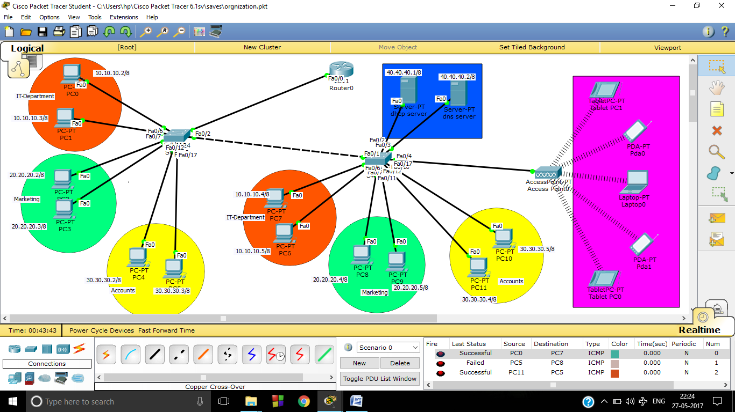

**Switch Configuration**

Following commands are used in both the switches to make two VLAN and to connect them

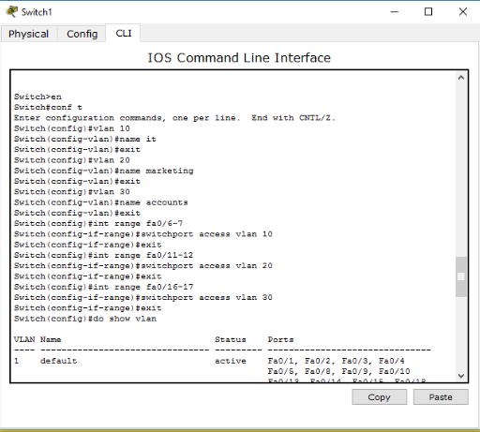

Similar steps are to be done for switch two to make VLAN for IT Department,Marketing and Accounts.

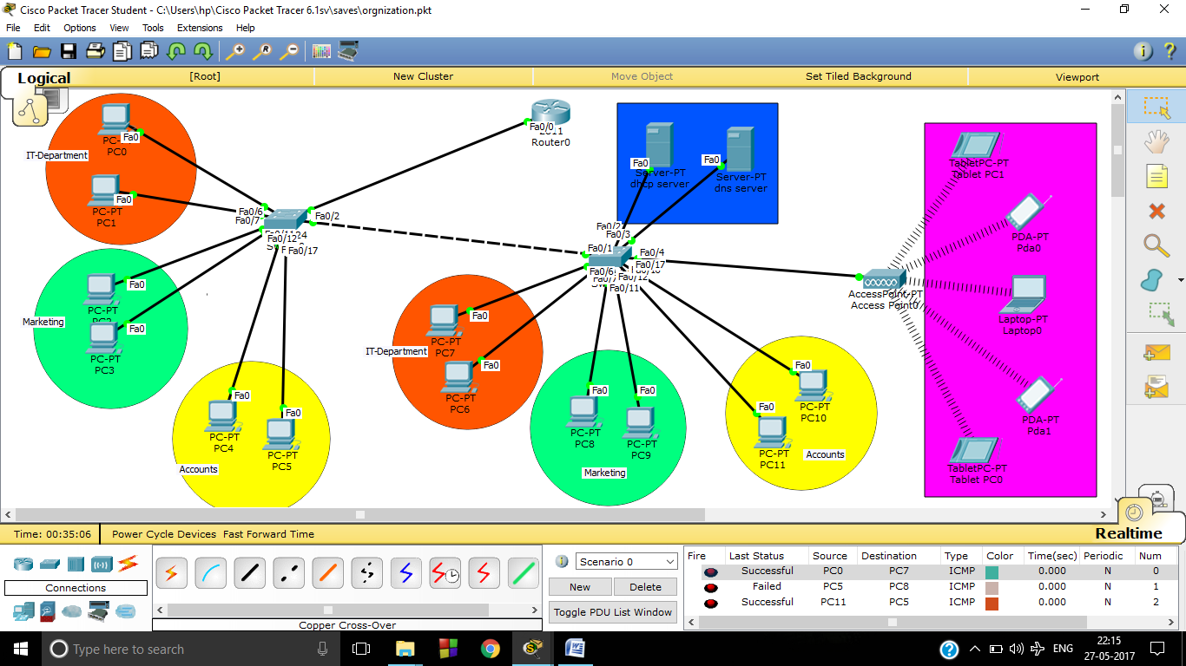

In this screenshot real time scenario of transfer of packets is shown. Packet is transferred from pc0 to pc7 and pc11 to pc5 but not from pc5 to pc8.

**DHCP CONFIGURATION**

Dynamic Host Configuration Protocol (DHCP) is a network protocol that enables as server to automatically assign an IP address to a computer from a defined range of numbers (i.e., a scope) configured for a given network. DHCP configuration can be done in two ways- using router or using server. Here configuration is done using DHCP server.Procedure is simple

1. Statically allot IP to DHCP server

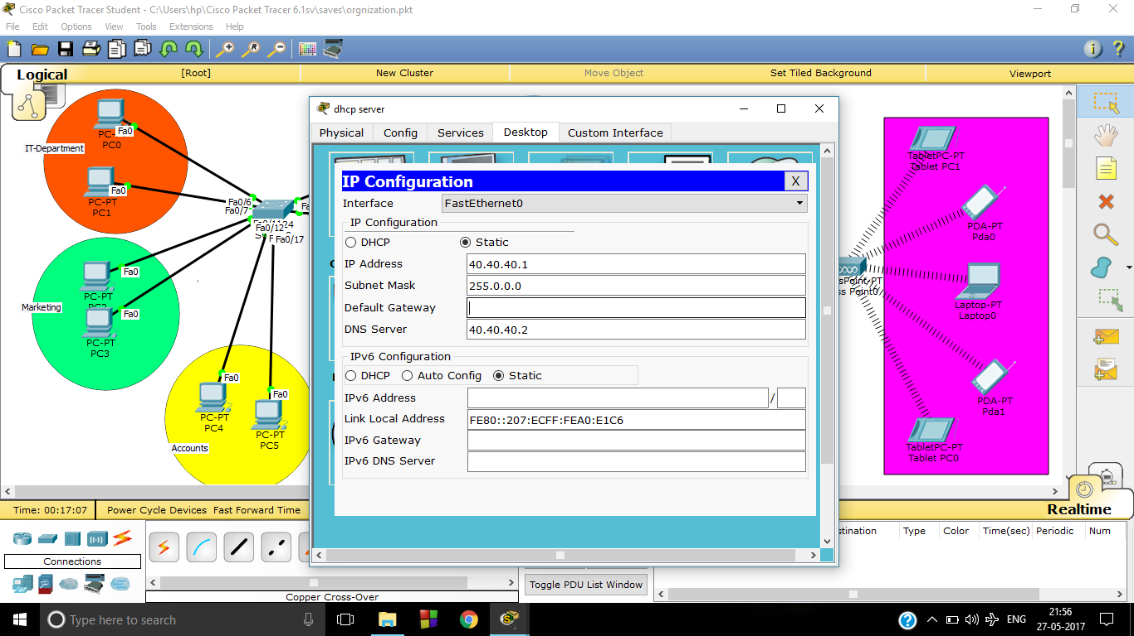

1. Configure DHCP accordingly

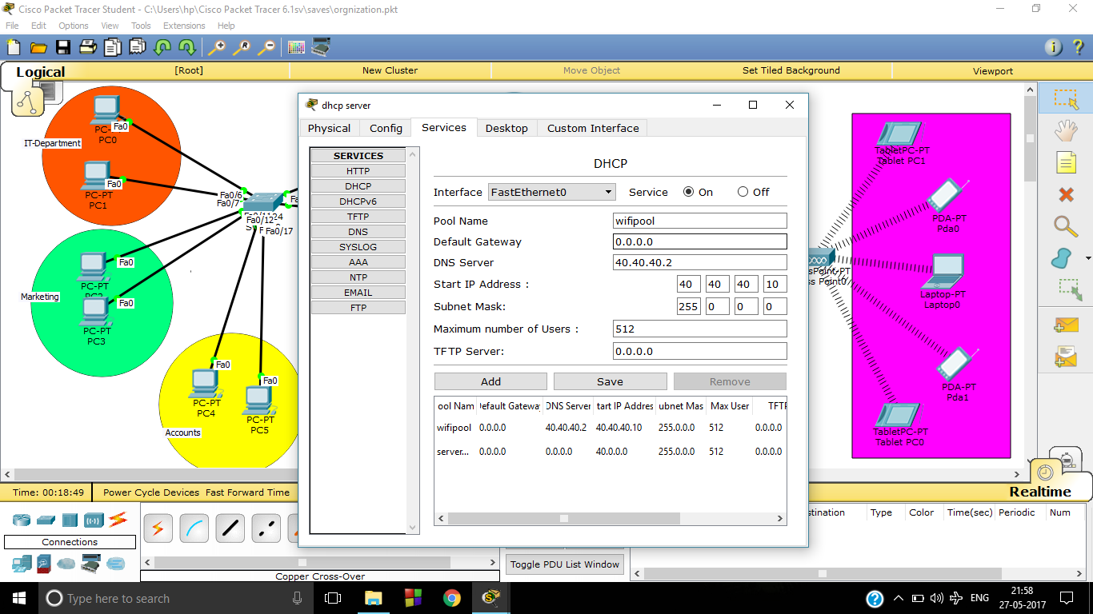

1. Using DHCP allot IP to the guest user

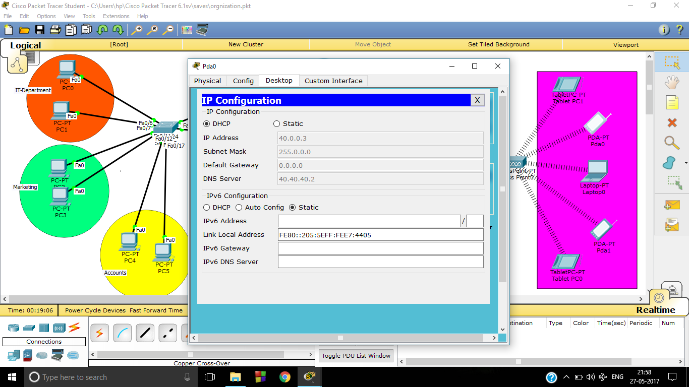

**DNS Server**

A DNS server is any computer registered to join the Domain Name System. A DNS server runs special-purpose networking software, features a public IP address, and contains a database of network names and addresses for other Internet hosts. Procedure to configure DNS server is almost same as DHCP server.

1. Allot IP statically to DNS server as done for DHCP server
2. Add name corresponding to the IP address in DNS server.

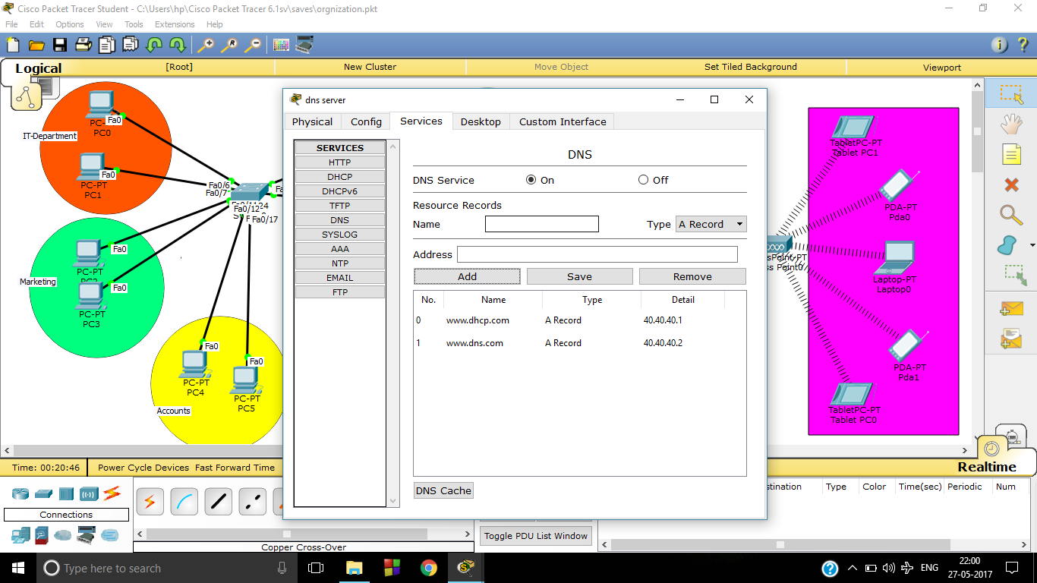

3.Open these pages in the web browser of the guest user

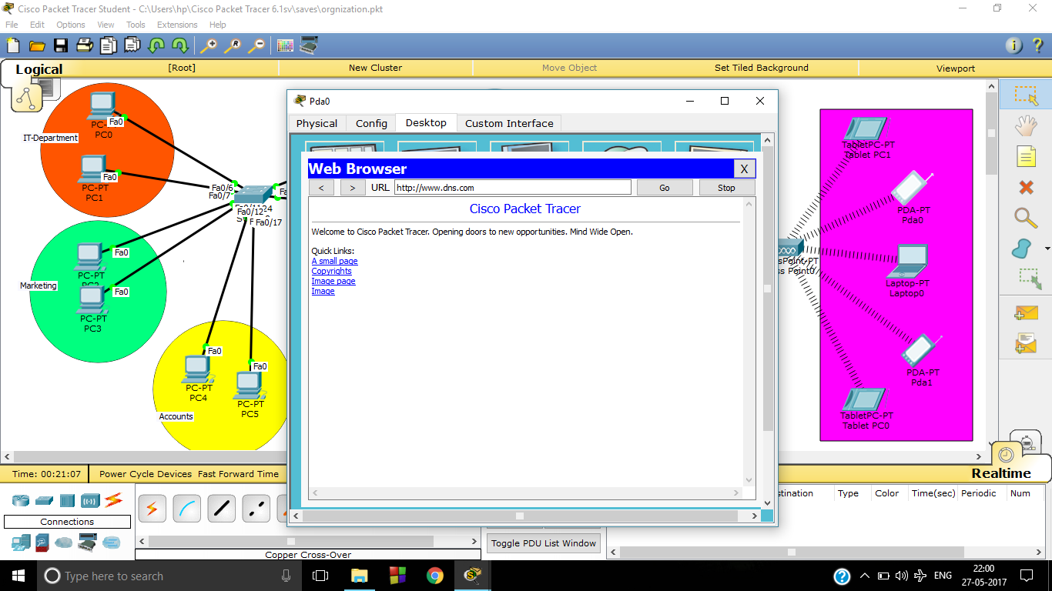

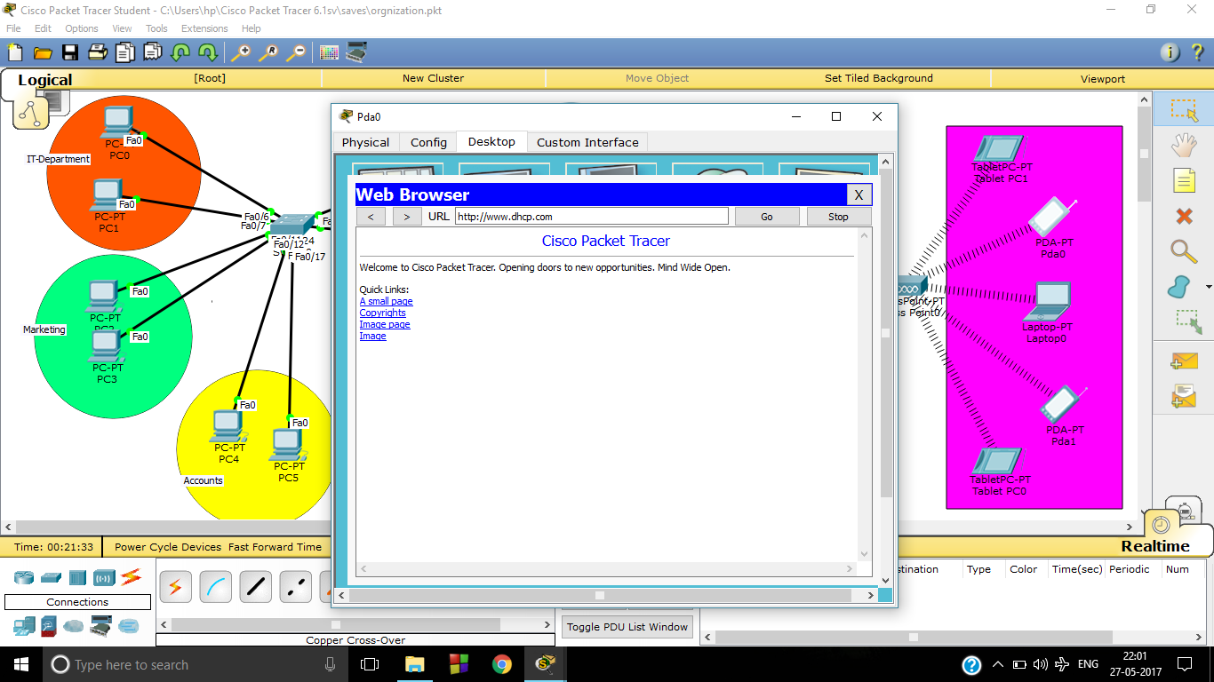

**Wireless connection establishment**

We can establish a wireless connection using a modem router or access point. An access point only provides an interface/portal for wireless clients to connect to your existing LAN. It does not route traffic between different networks, rather provides wireless access to an already existing local wired network. A Router has additional functions: It allows multiple clients to connect to the Internet by serving internal IP addresses, has NAT (Network Address Translation) capabilities, often a built-in switch as well. It 'routes' traffic between two different networks, usually the Internet on the WAN side, and your local area network on the LAN side.

In our project we use Access point. We also enable password facility in access point so that person outside the airport cannot access the free Wi-Fi facility.

After connecting to Wifi facility guest can transfer data between themselves but not to other departments of the airport.