1. Install Terraform on your PC

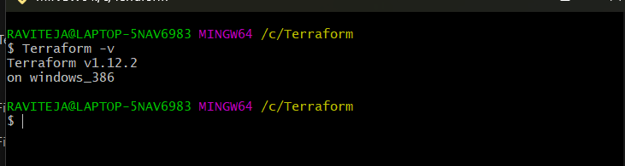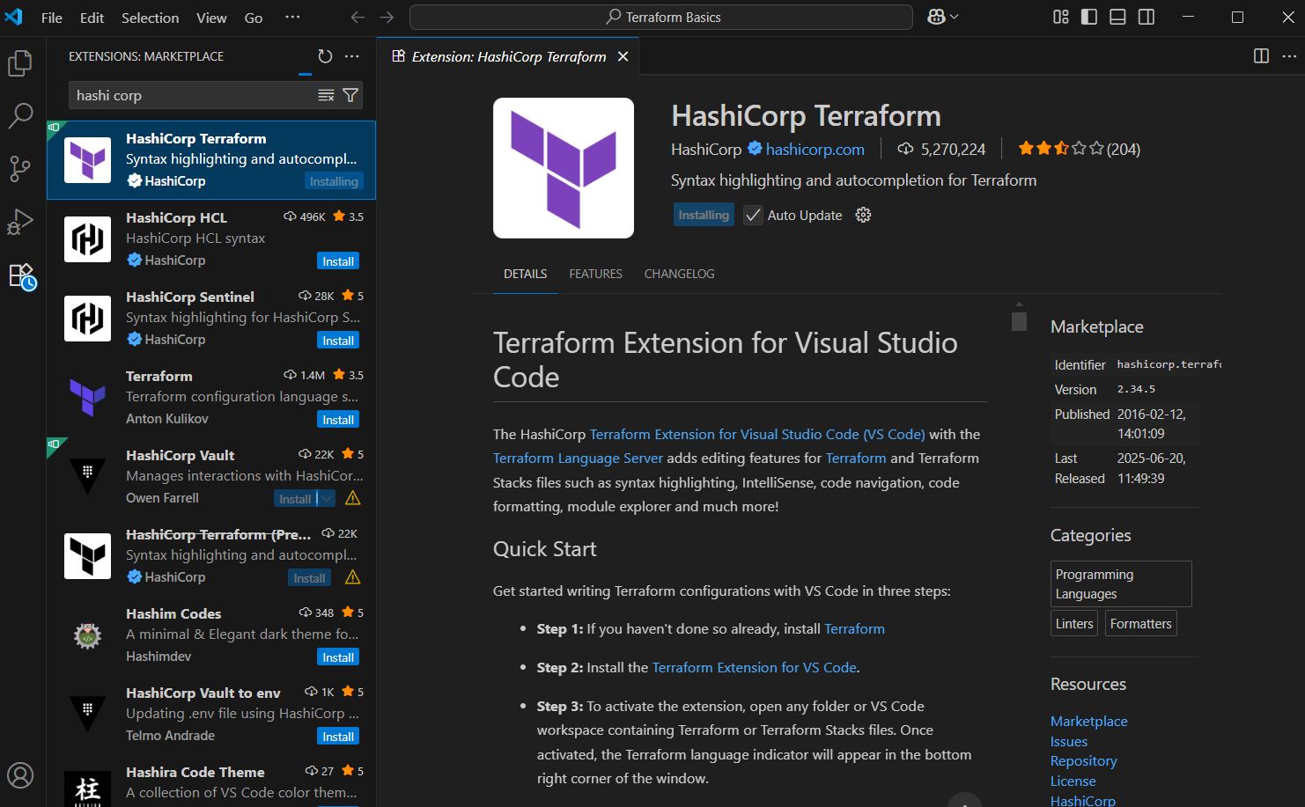

1. Execute all the templates shown in video.

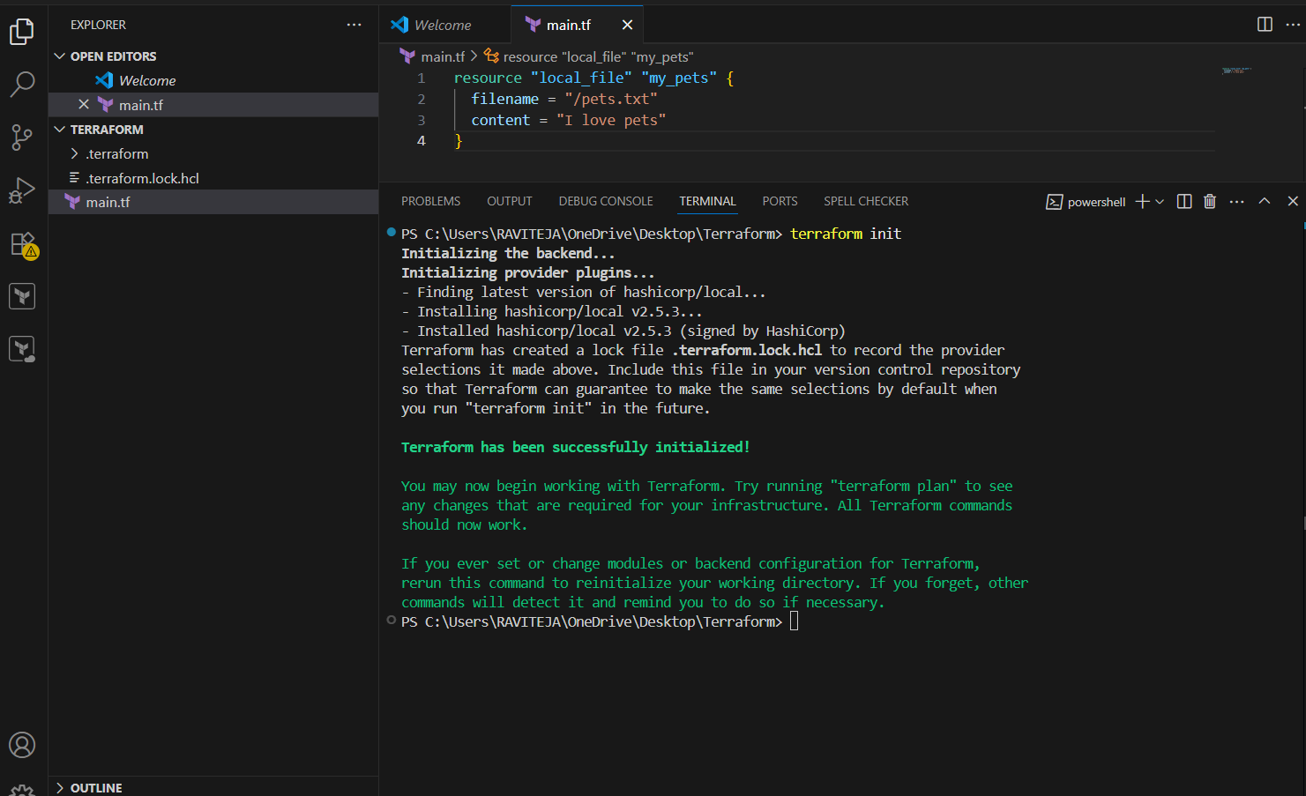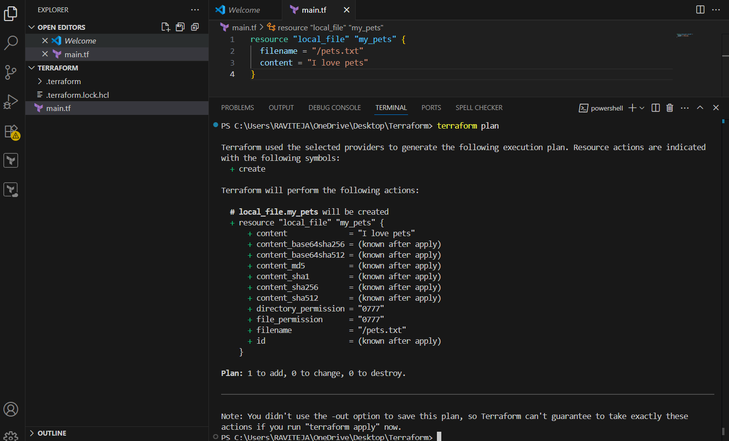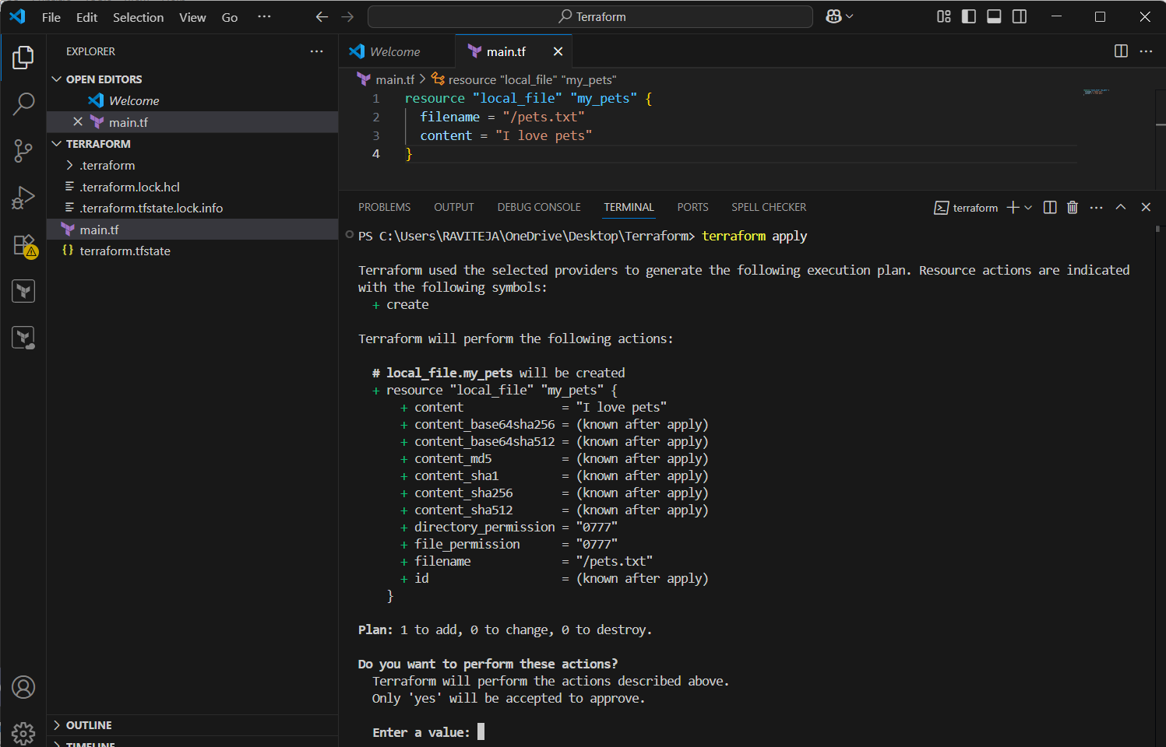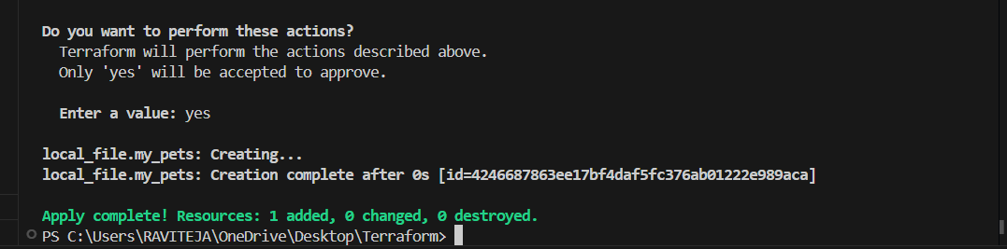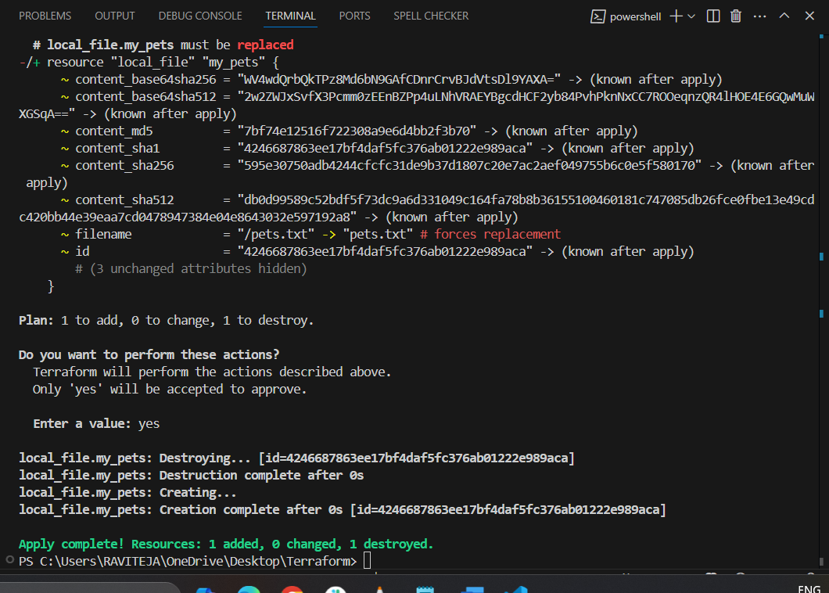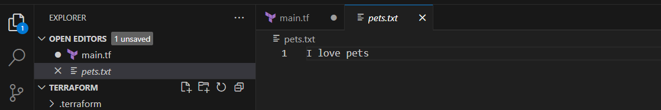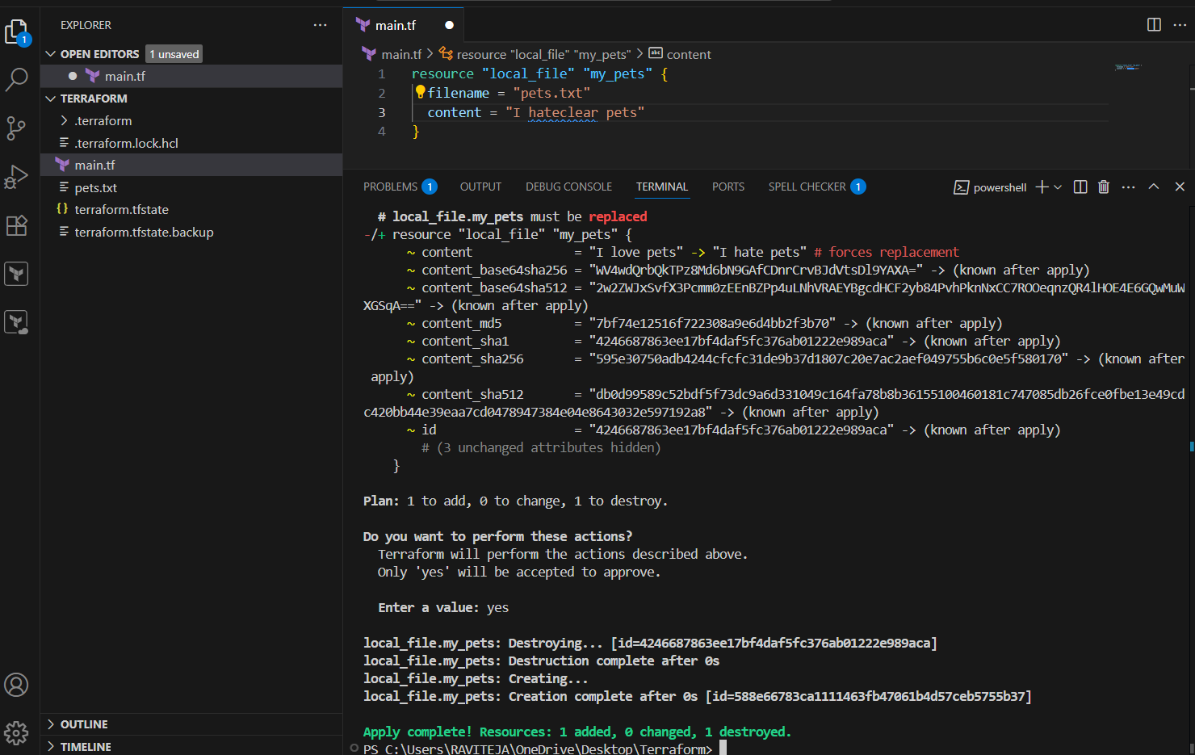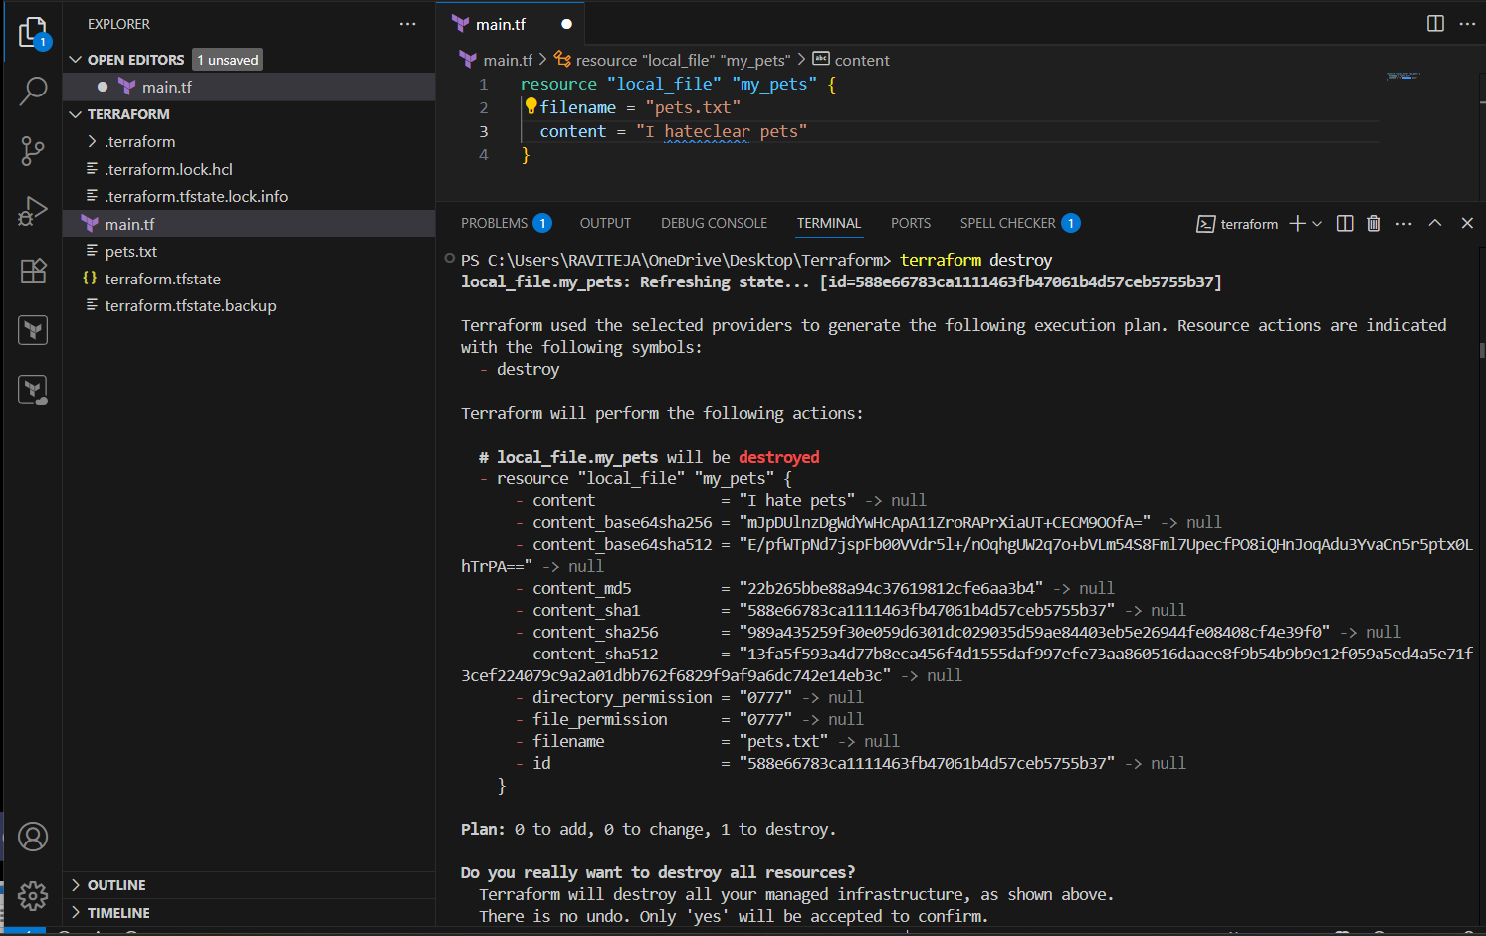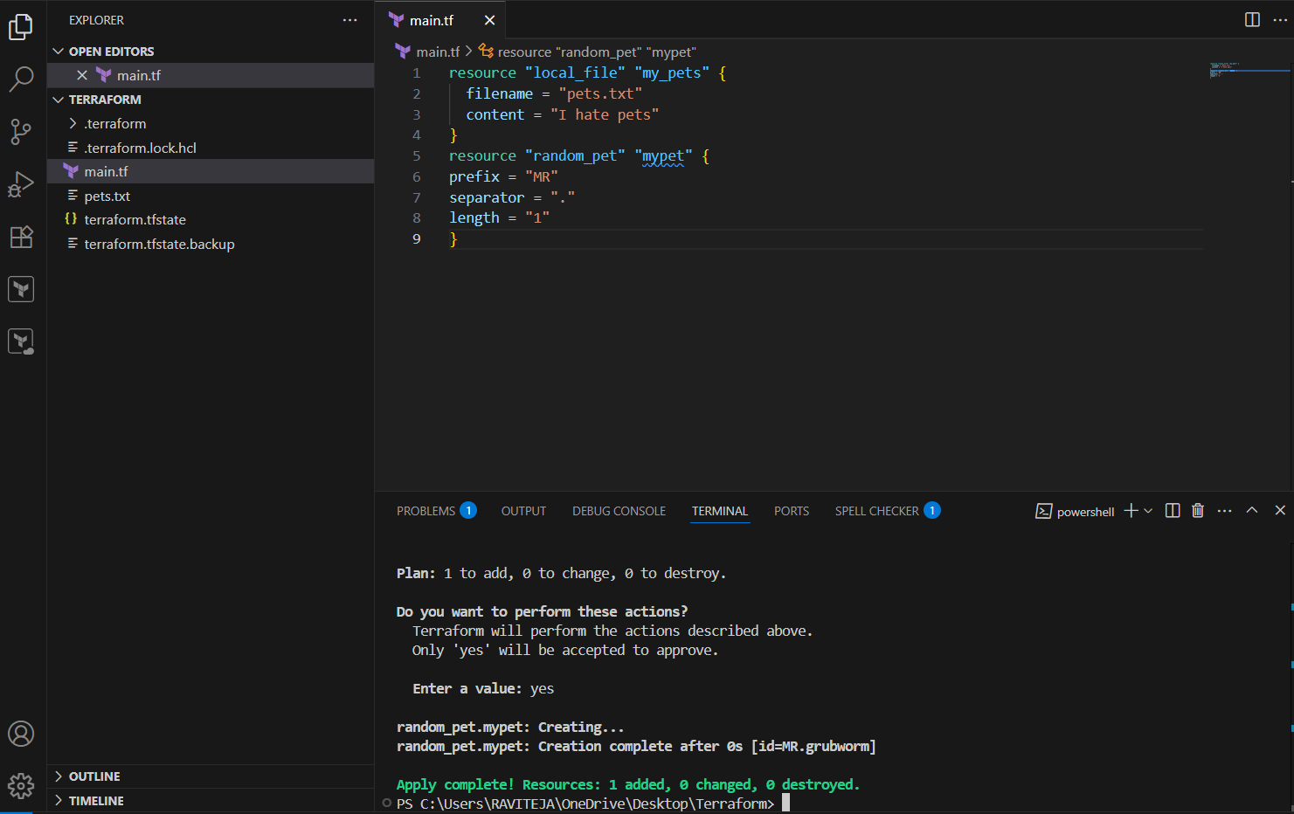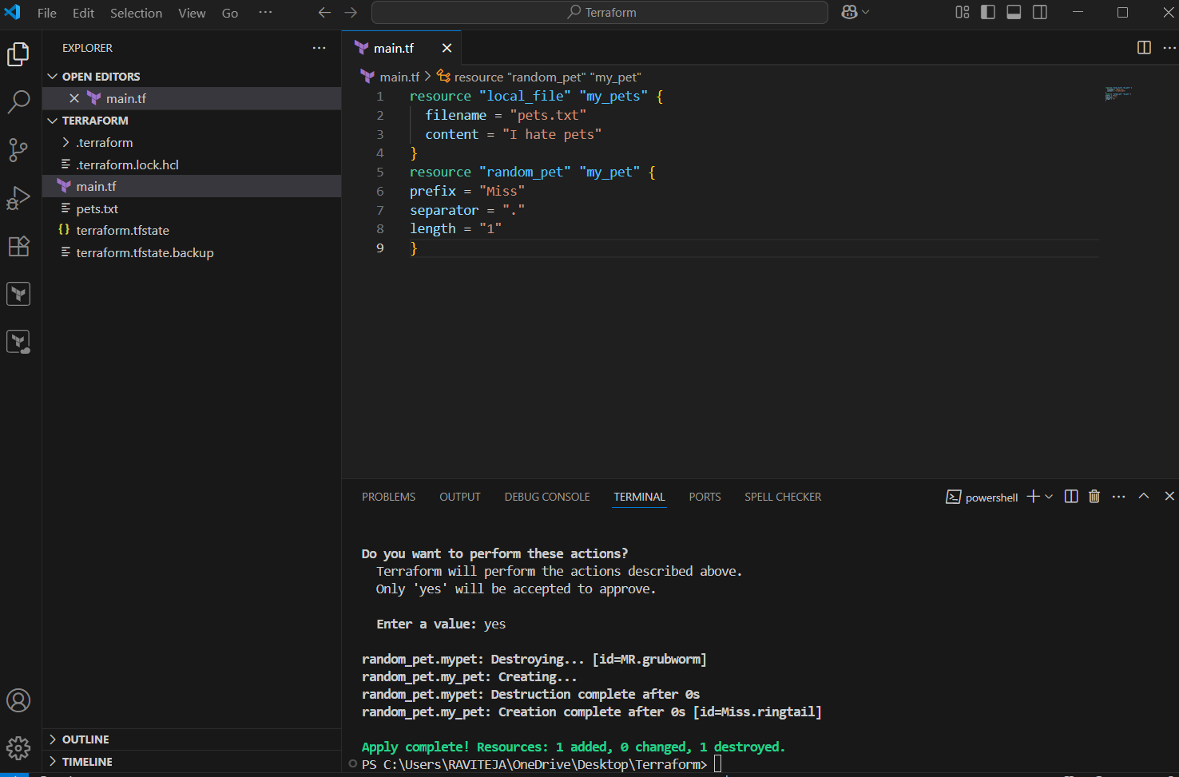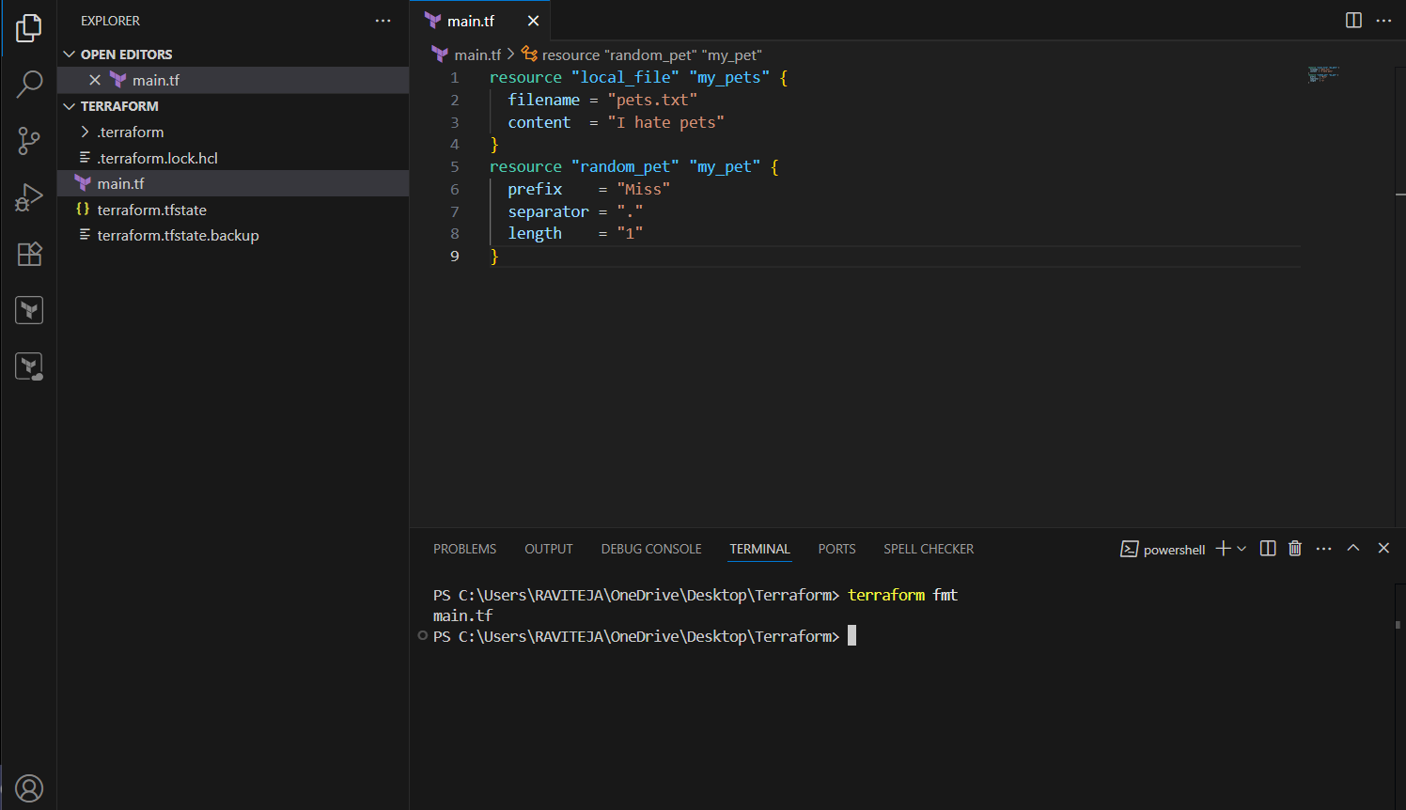

1. Note down below points, Terraform Init Terraform Plan Terraform Apply Terraform Provider.

**✅ 1. terraform init**

* **Purpose:** Initializes a new or existing Terraform configuration.
* **What it does:**
  + Downloads the provider plugins.
  + Initializes backend configuration (e.g., remote state).
  + Prepares the working directory for other Terraform commands.

📌 **Run it first** in any new Terraform project. 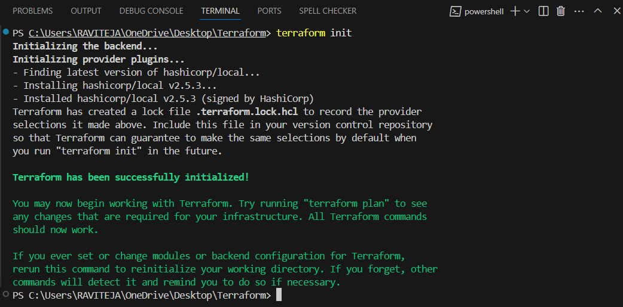

**✅ 2. terraform plan**

* **Purpose:** Creates an execution plan.
* **What it does:**
  + Shows what Terraform **will do** (add, change, or destroy resources) without making changes.
  + Compares your current configuration to the real infrastructure.

📌 Helps you **review changes** before applying them.



**✅ 3. terraform apply**

* **Purpose:** Applies the changes required to reach the desired state.
* **What it does:**
  + Executes the actions proposed by terraform plan.
  + Provisions or updates real infrastructure.

📌 Requires approval before proceeding unless you pass -auto-approve. 

**✅ 4. Terraform Provider**

* **Purpose:** Plugin that allows Terraform to interact with APIs and cloud services (e.g., AWS, Azure, GCP).
* **Examples:**
  + provider "aws" — manages AWS resources.
  + provider "azurerm" — manages Azure resources.

1. Integrate a sample Terraform template in jenkins.

