1) Watch terraform-03 video.

2) Execute the script shown in video.

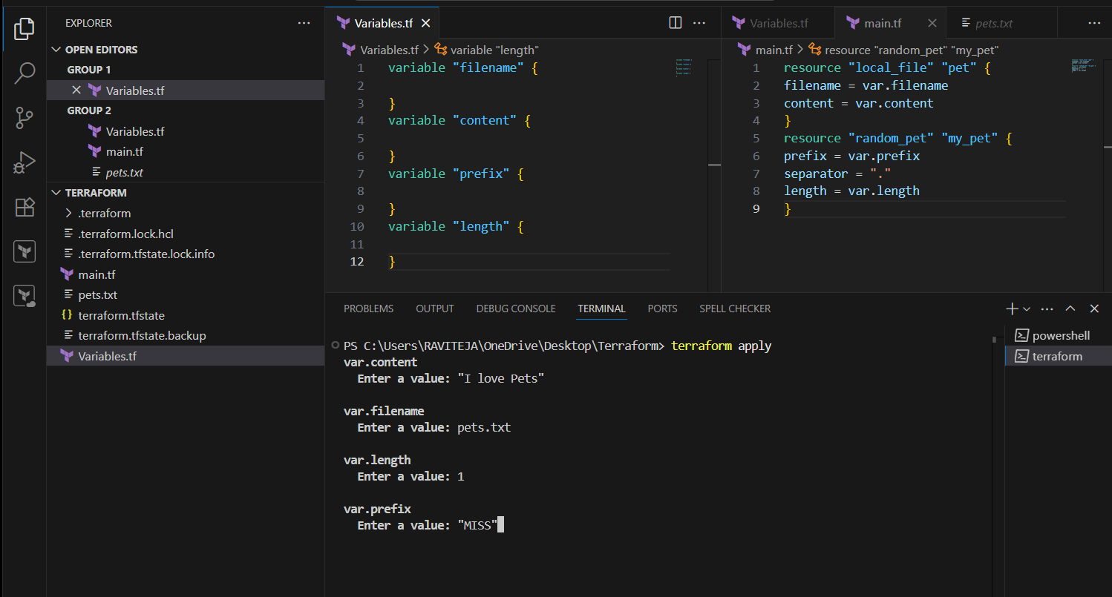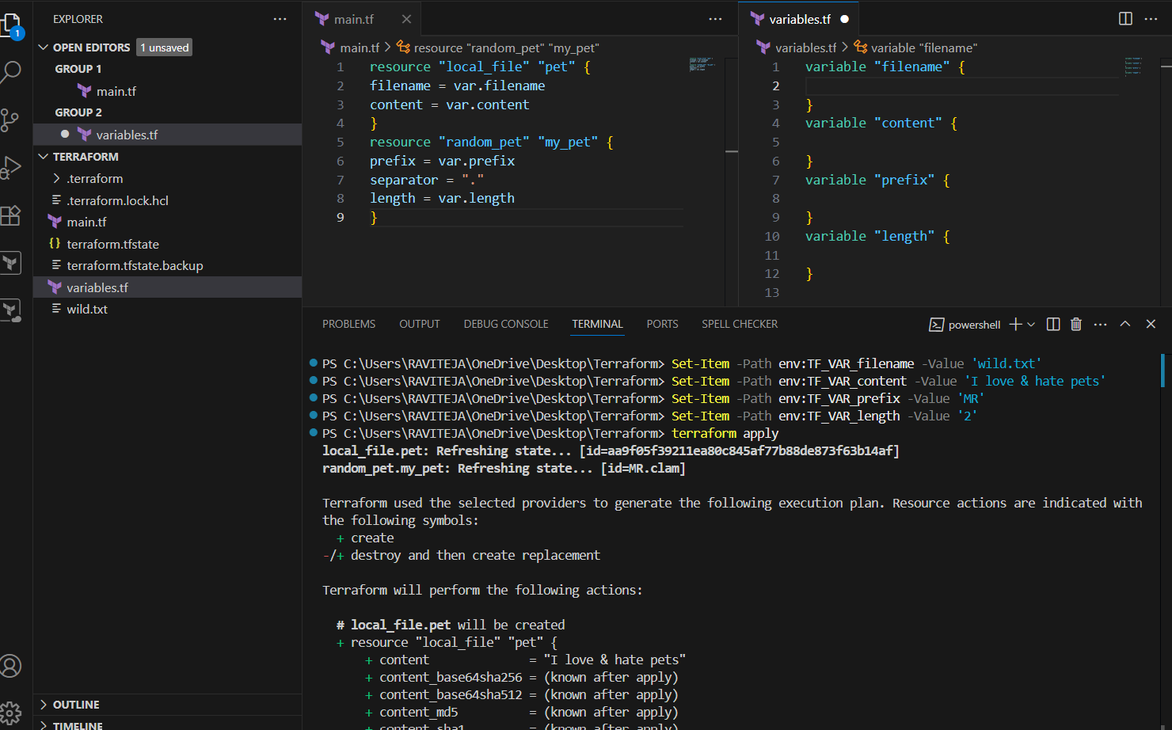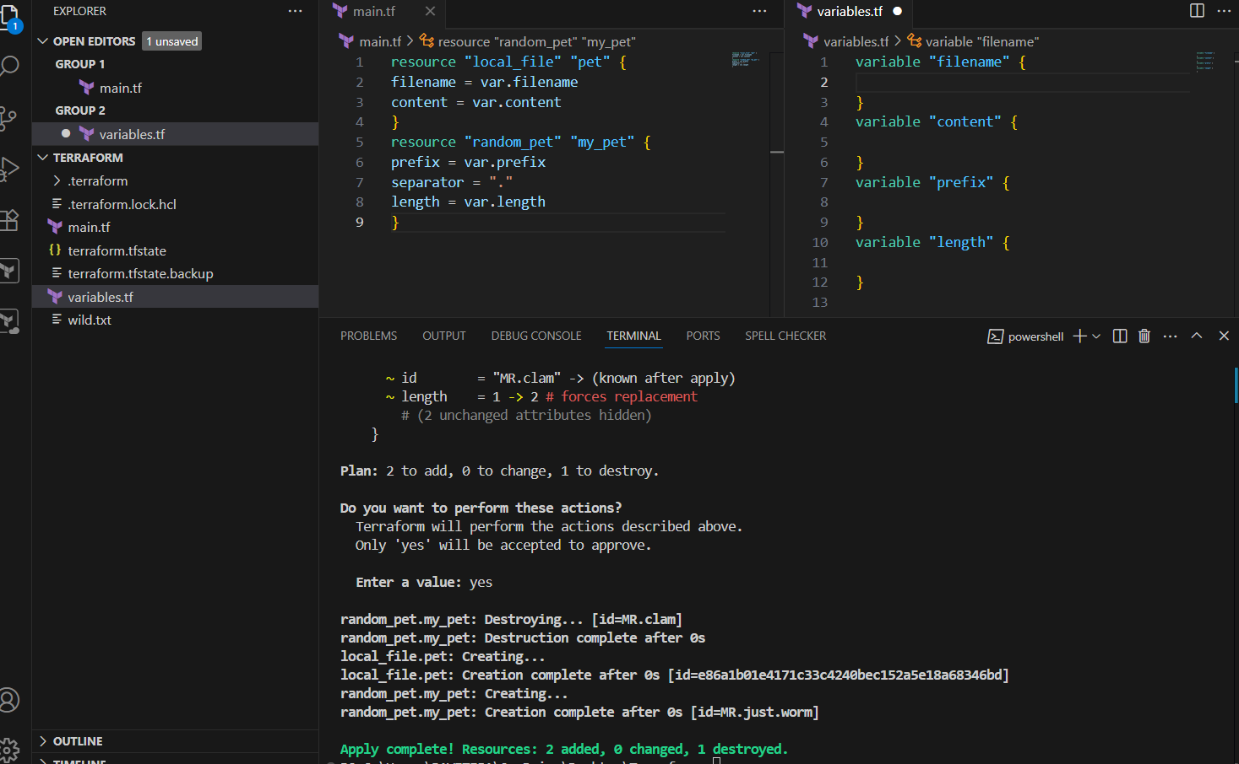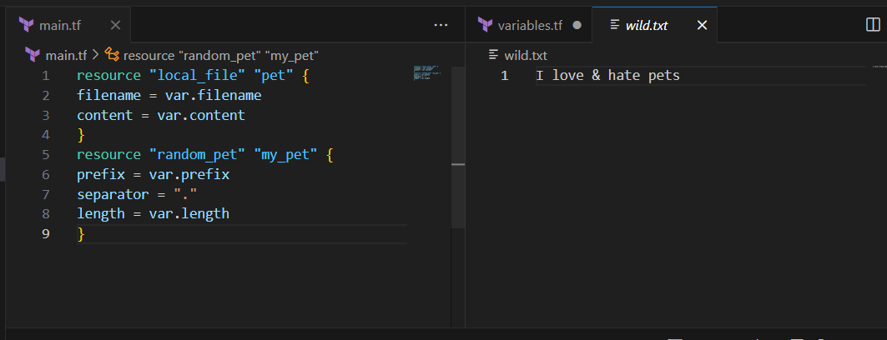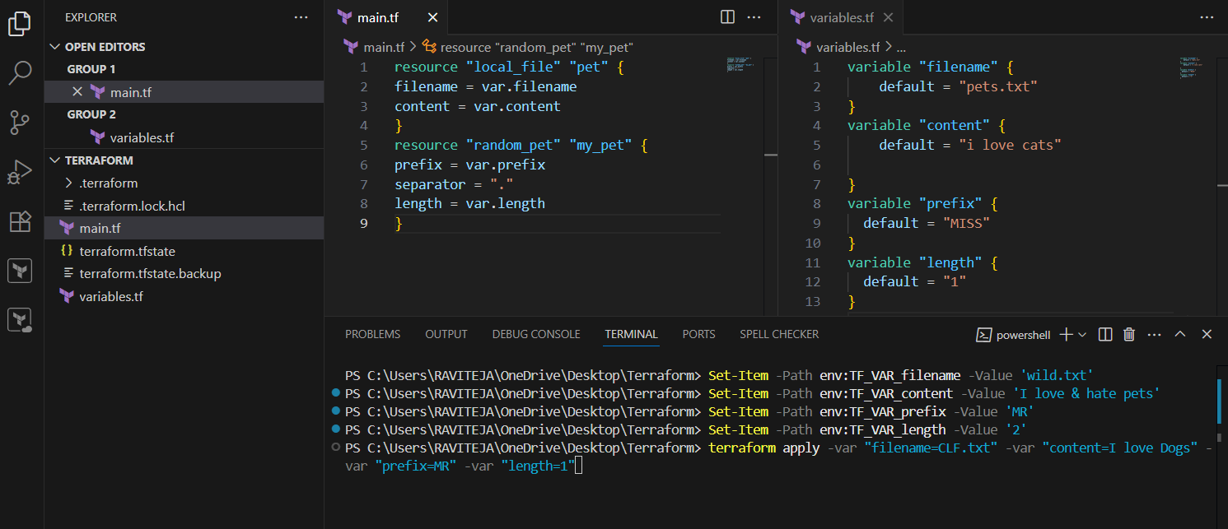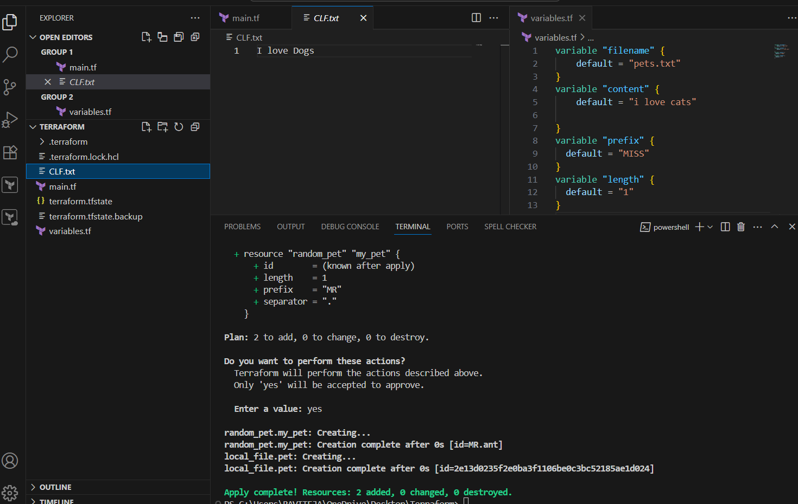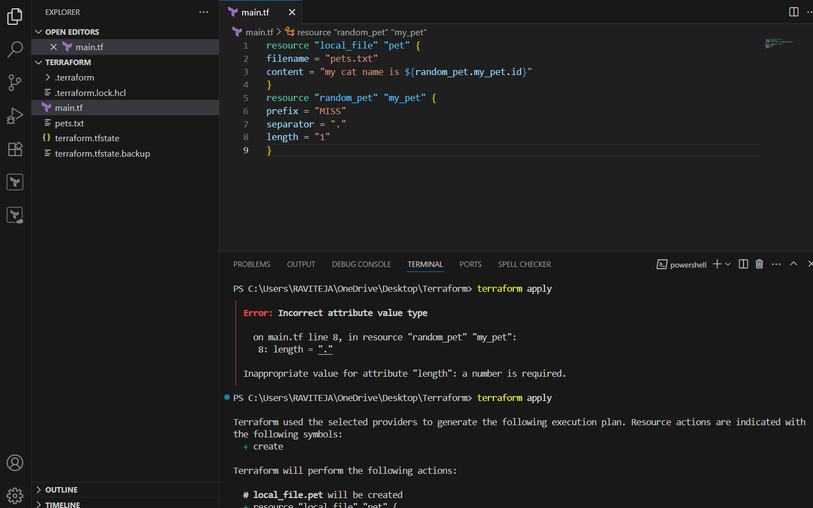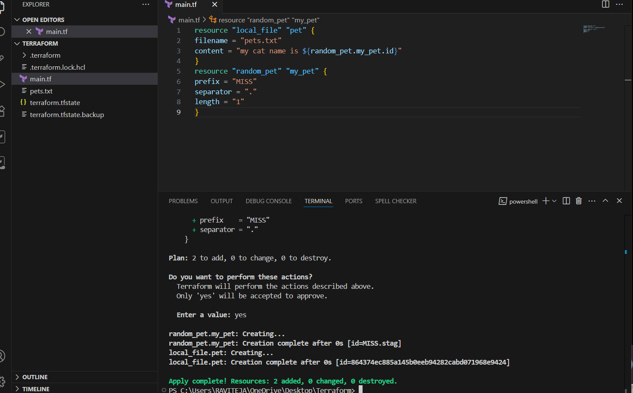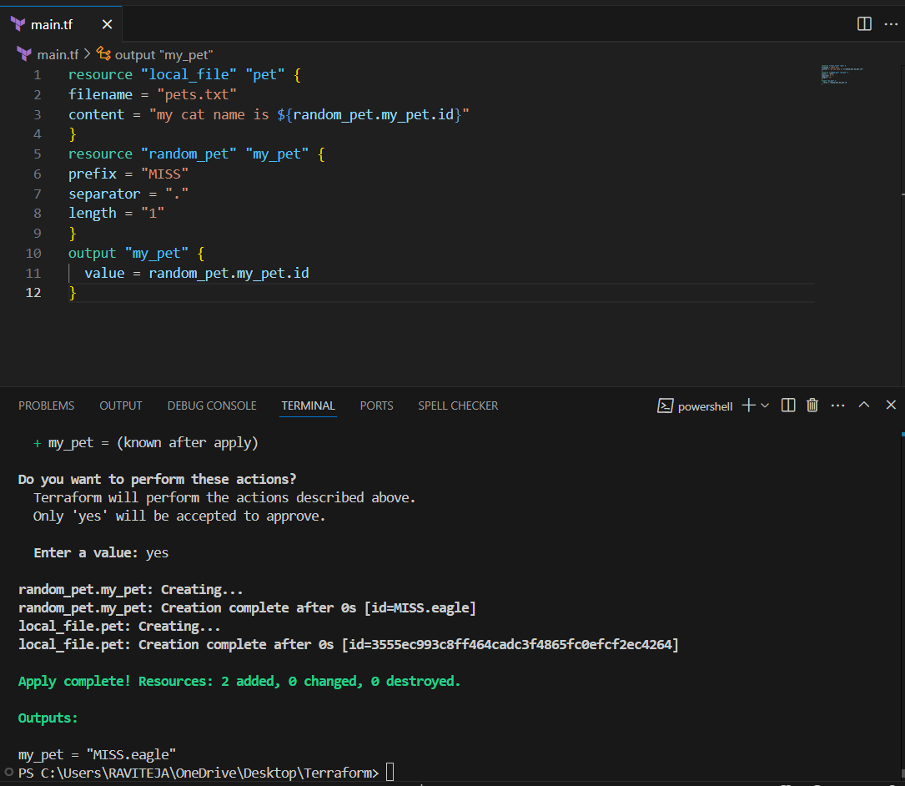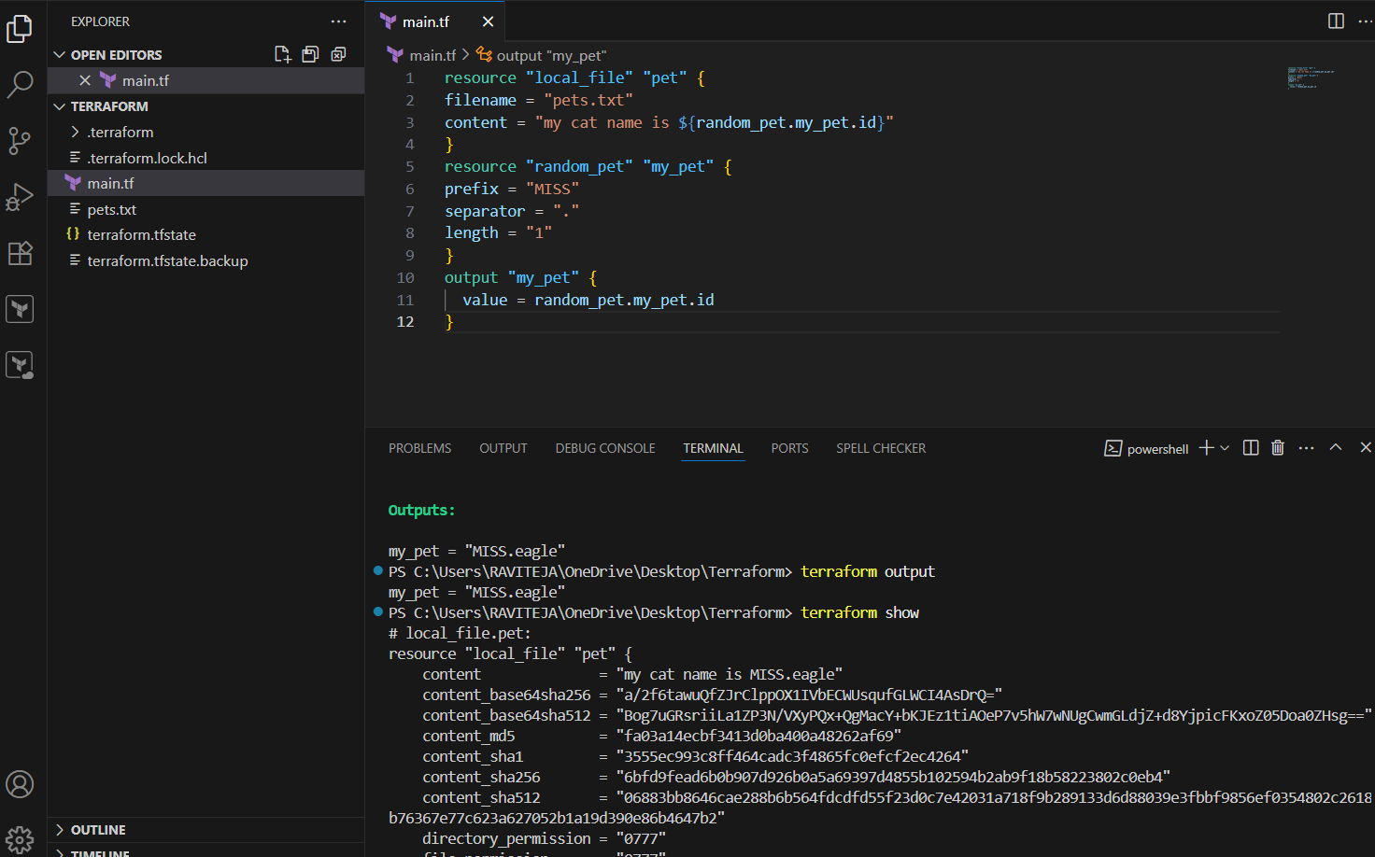

3) Intergrate terrafrom in jenkins using Terraform plugin.

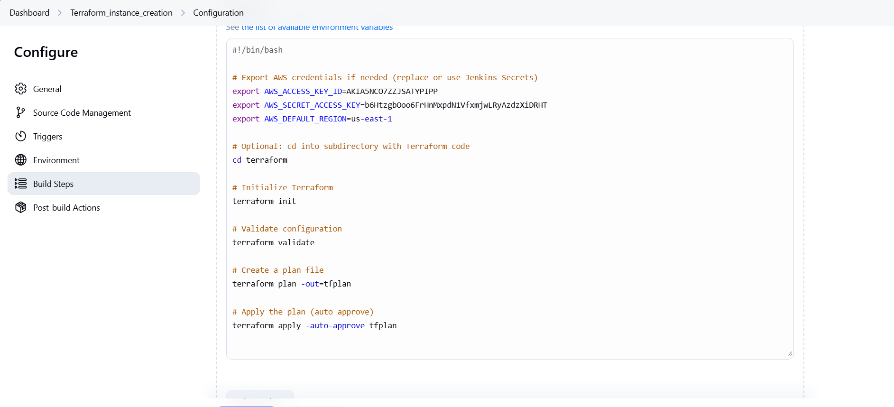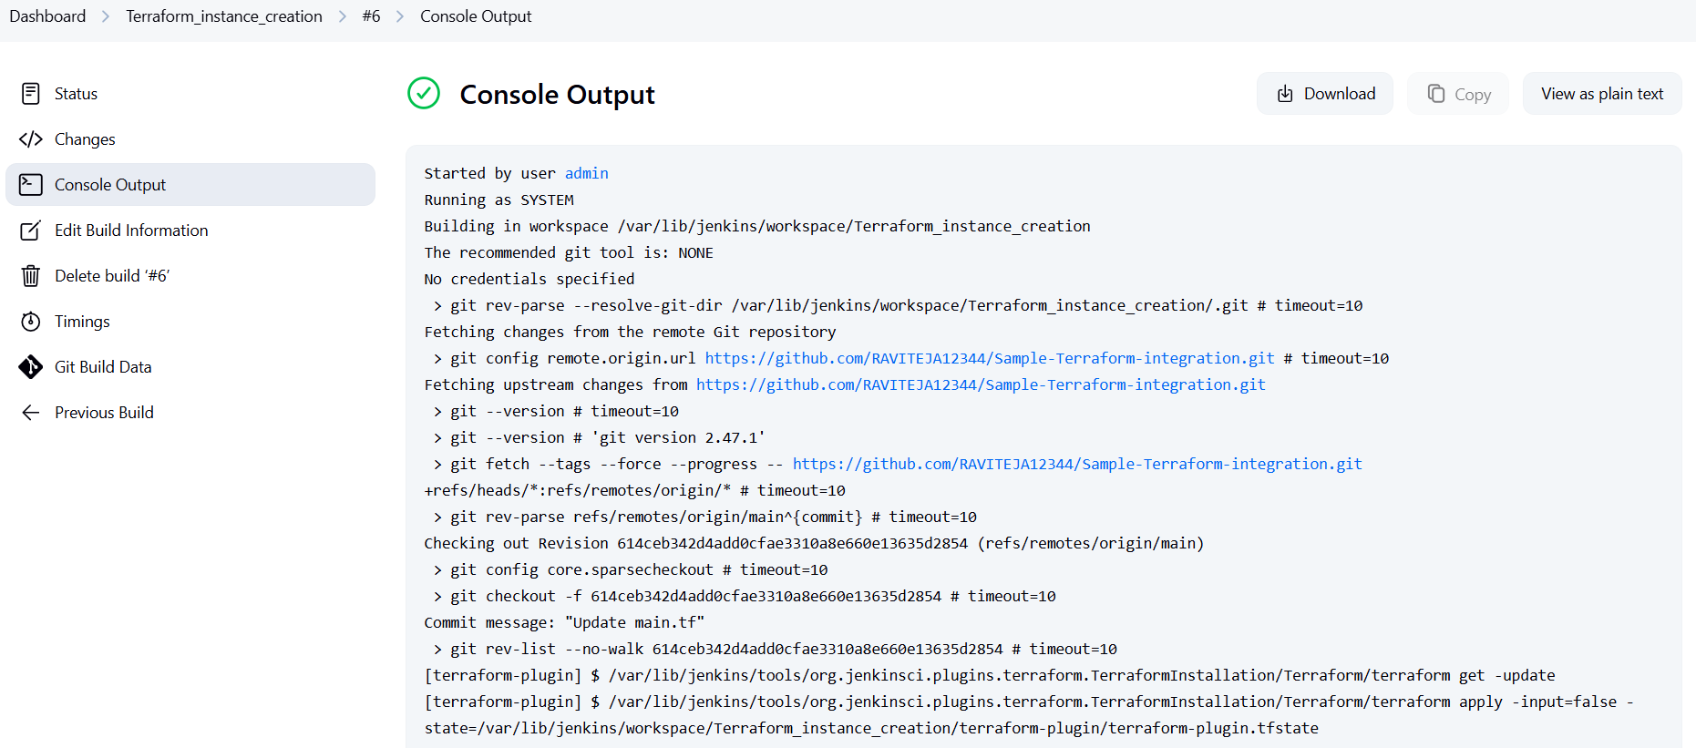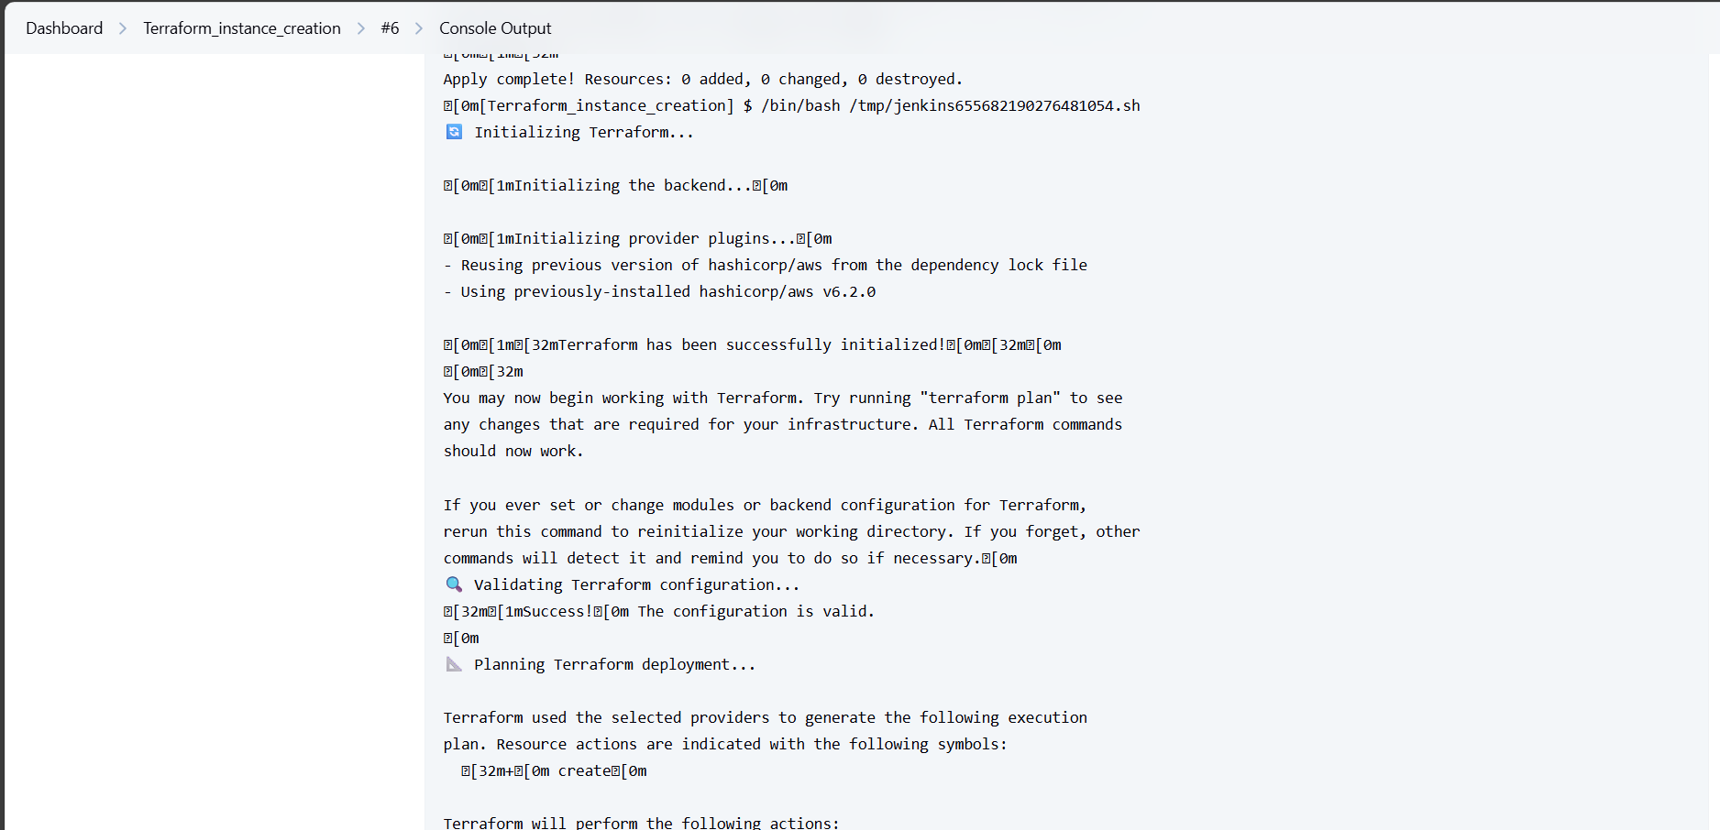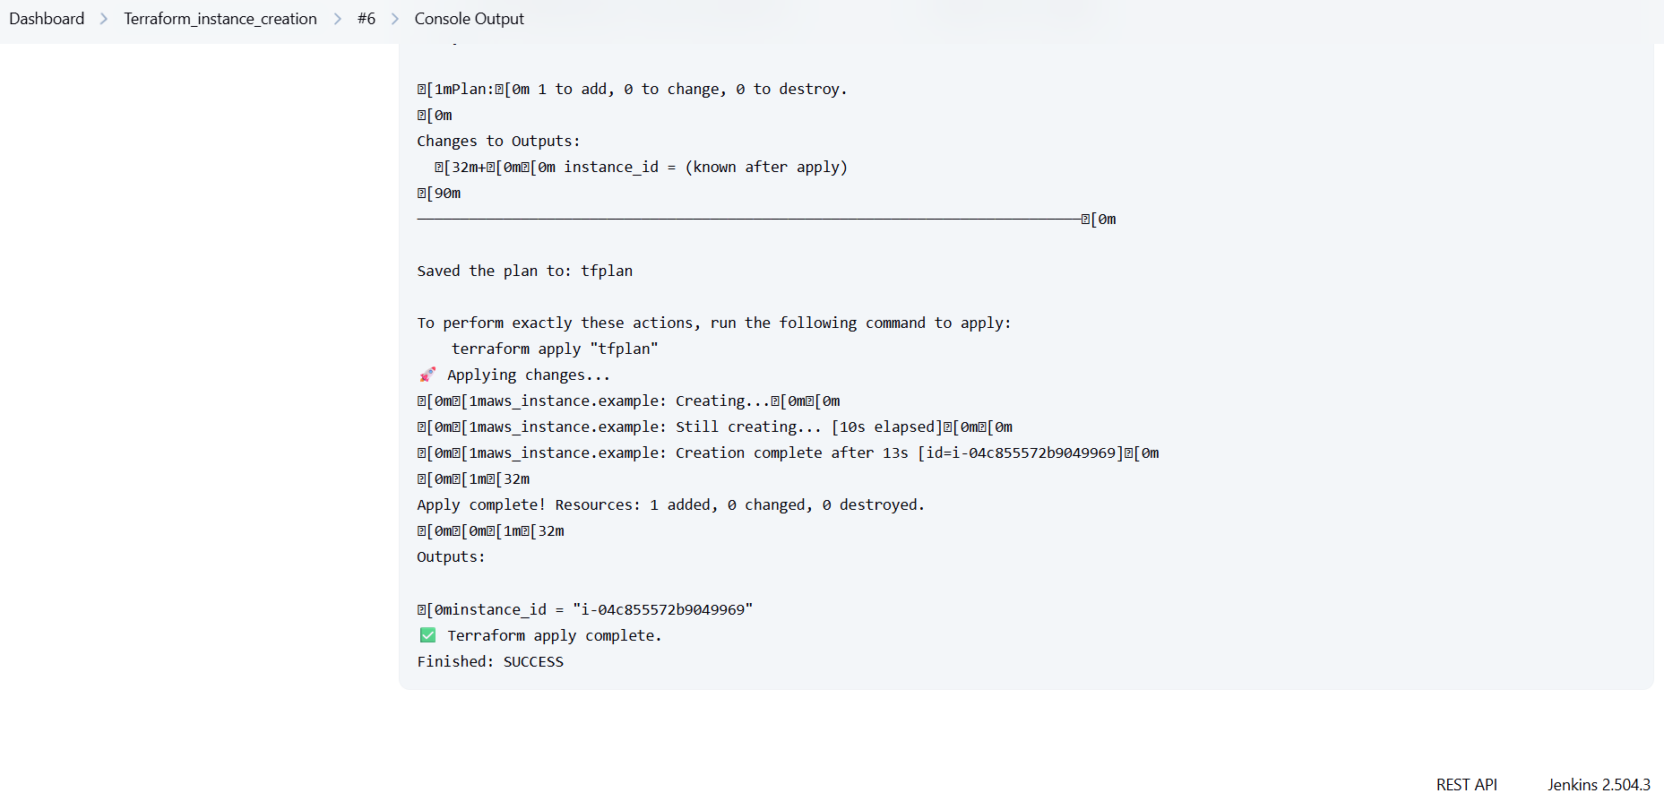

4) Create one jenkins job using MAVEN PROJECT for the below code with two stages.

stage 1: Git clone stage

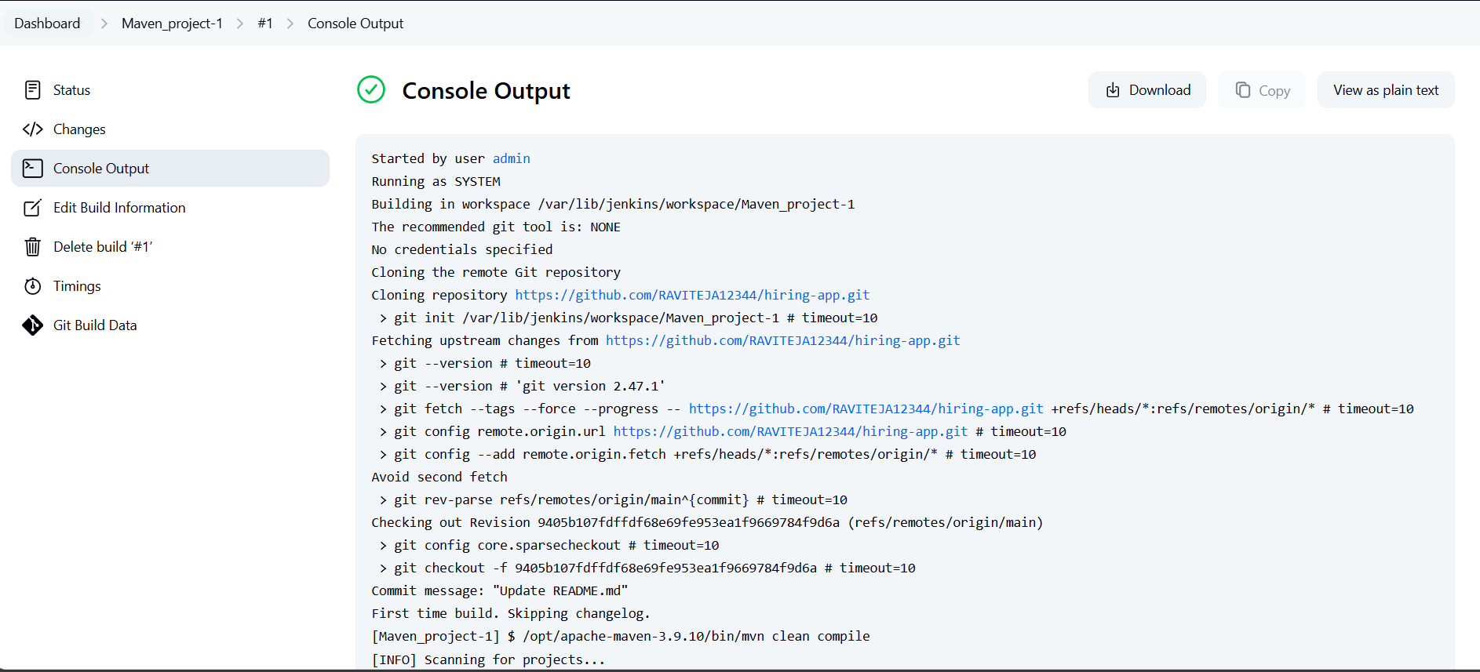

2: Maven Compilation 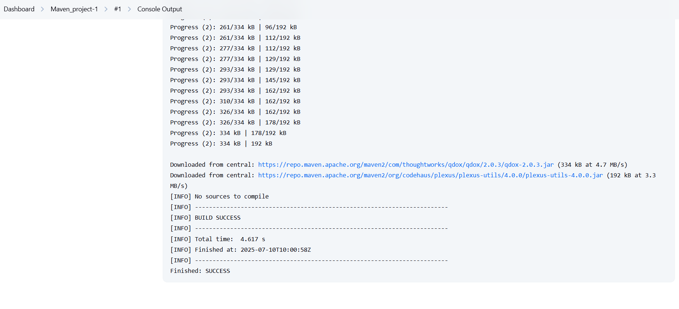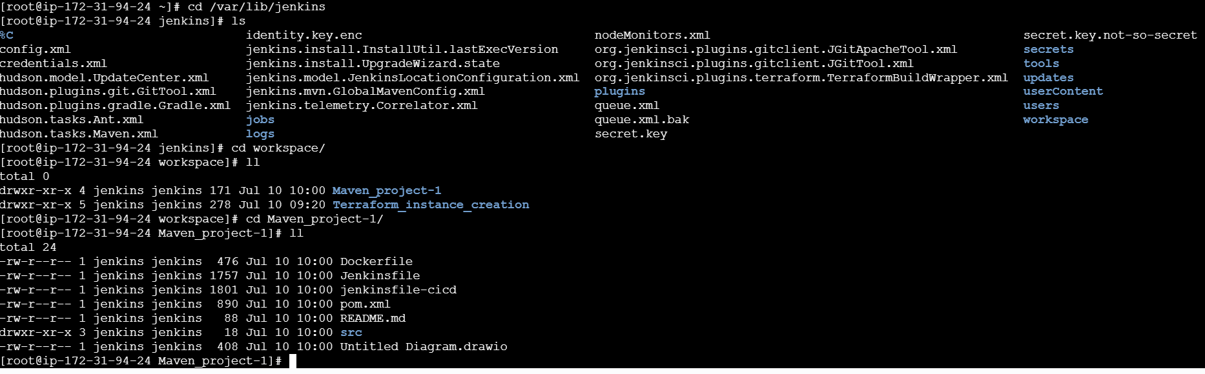

Code: <https://github.com/betawins/java-Working-app.git>

5) Use the below code and create a parameterized job in jenkins

stage 1: Git clone stage

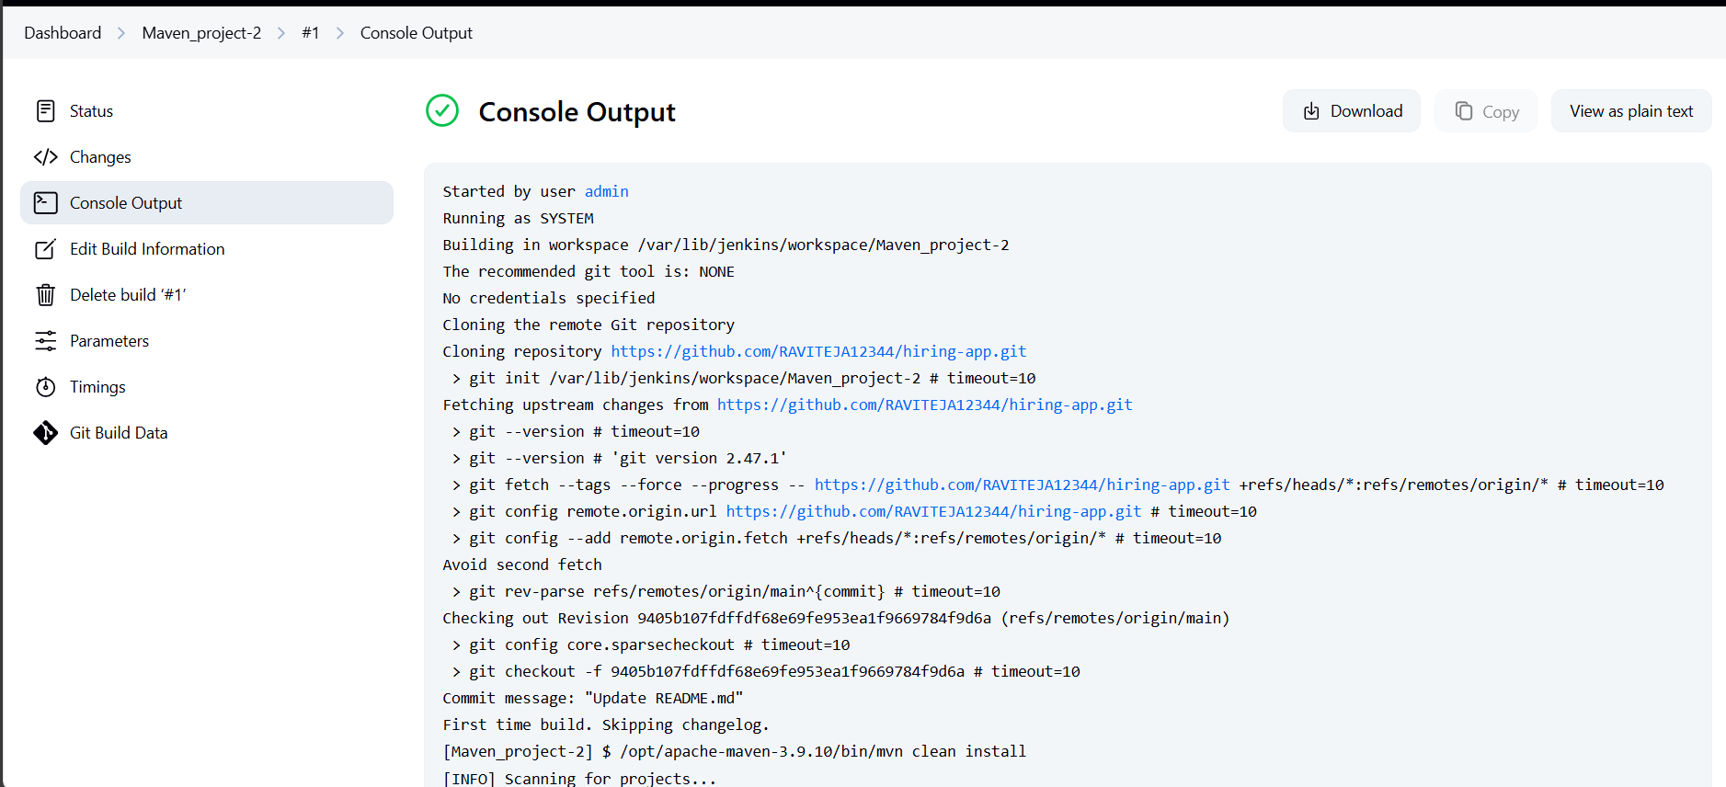

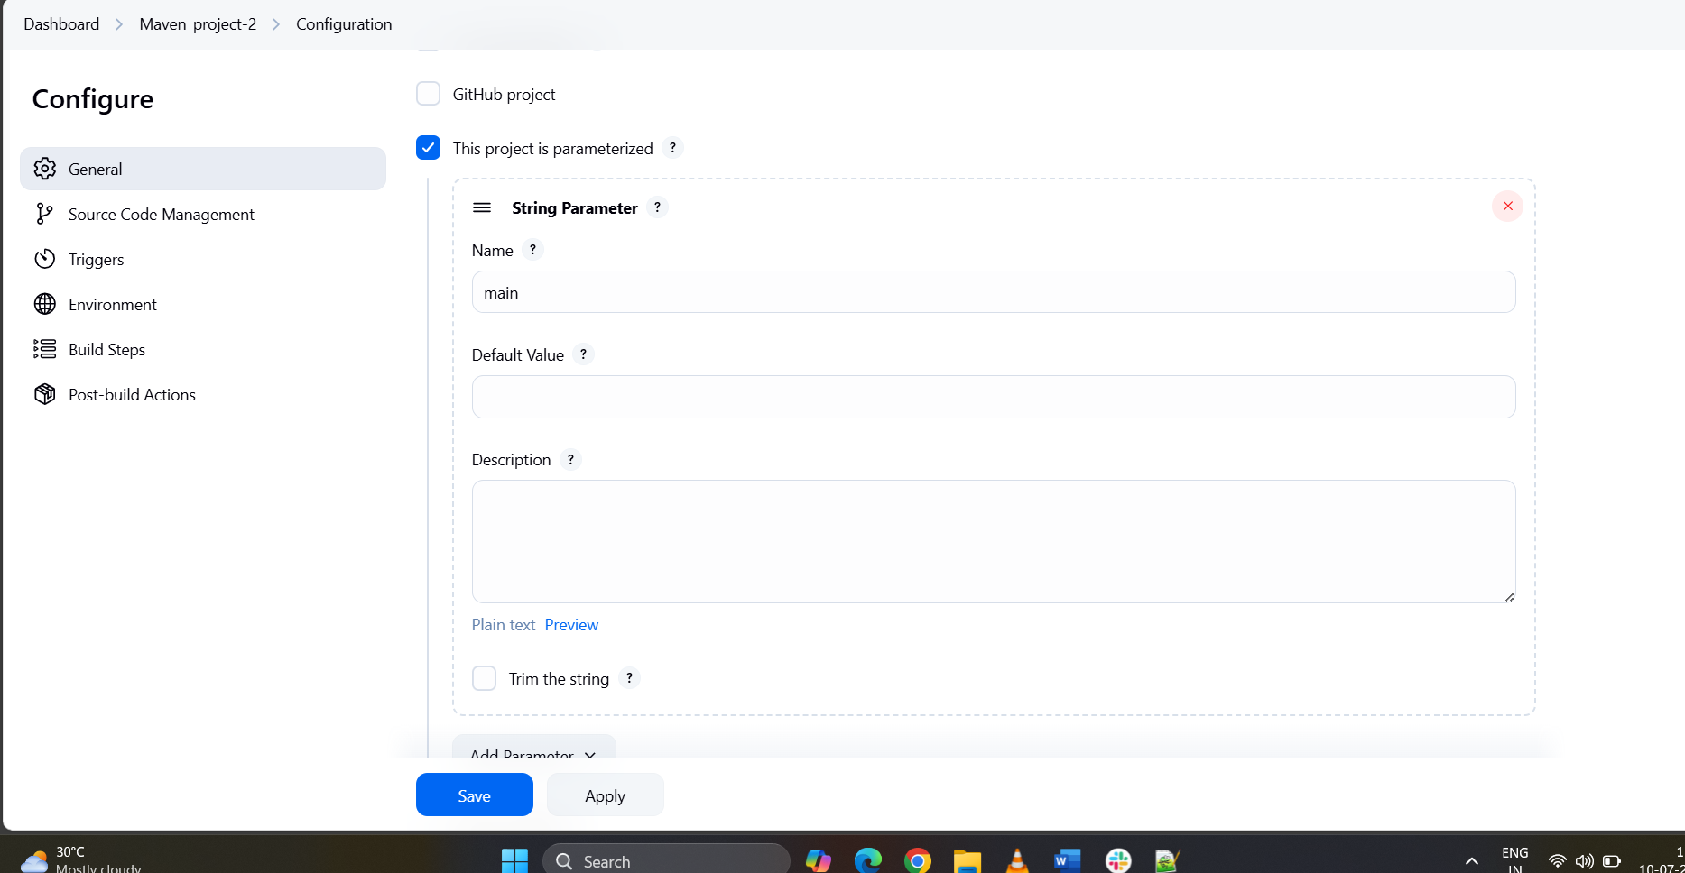

2: Maven Compilation Code: <https://github.com/betawins/java-Working-app.git>

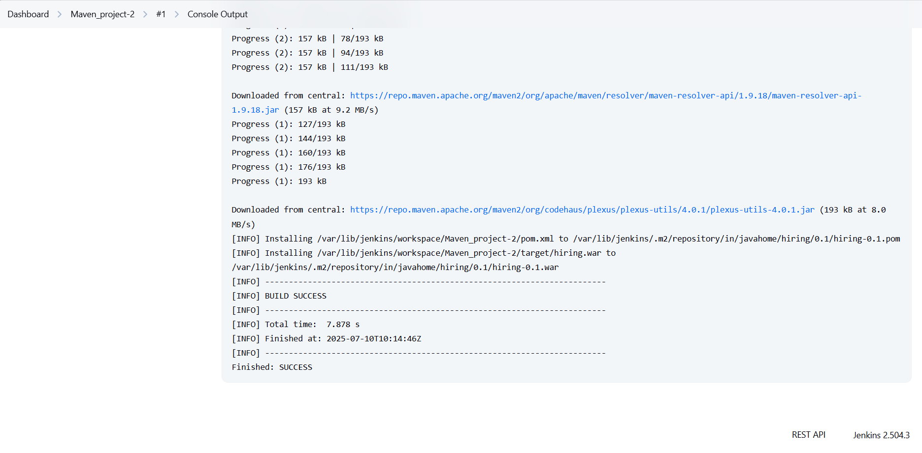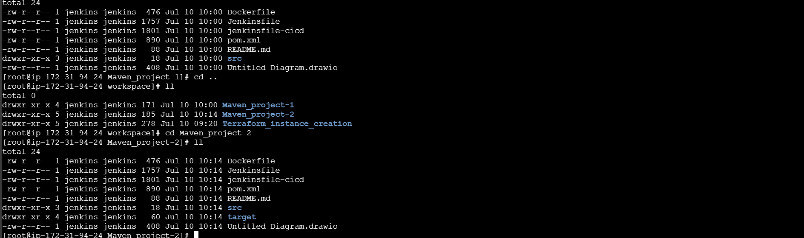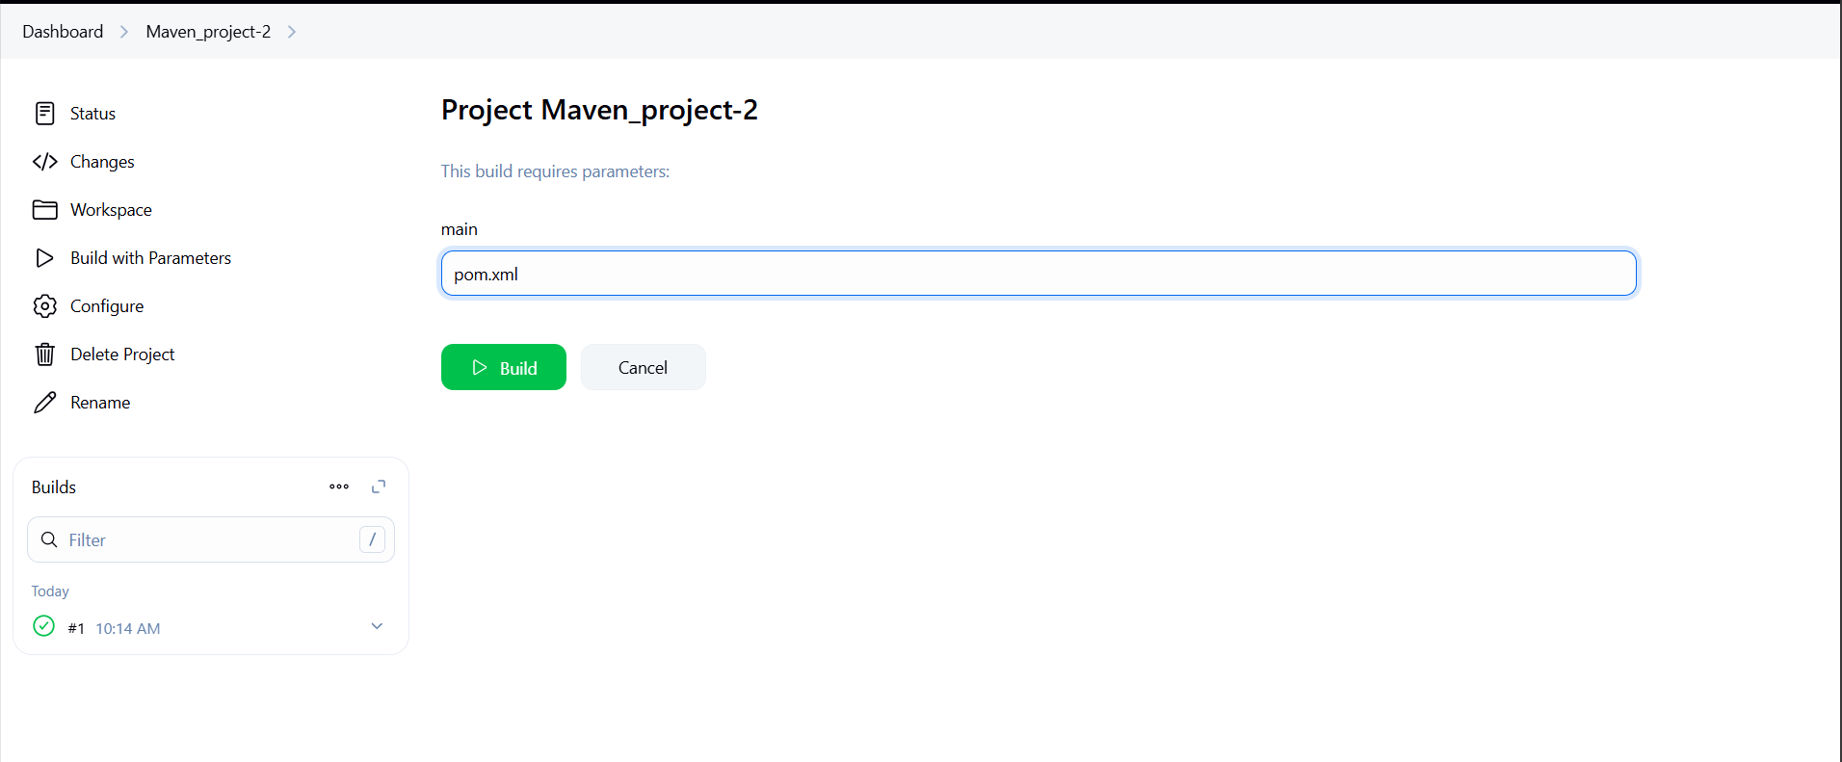 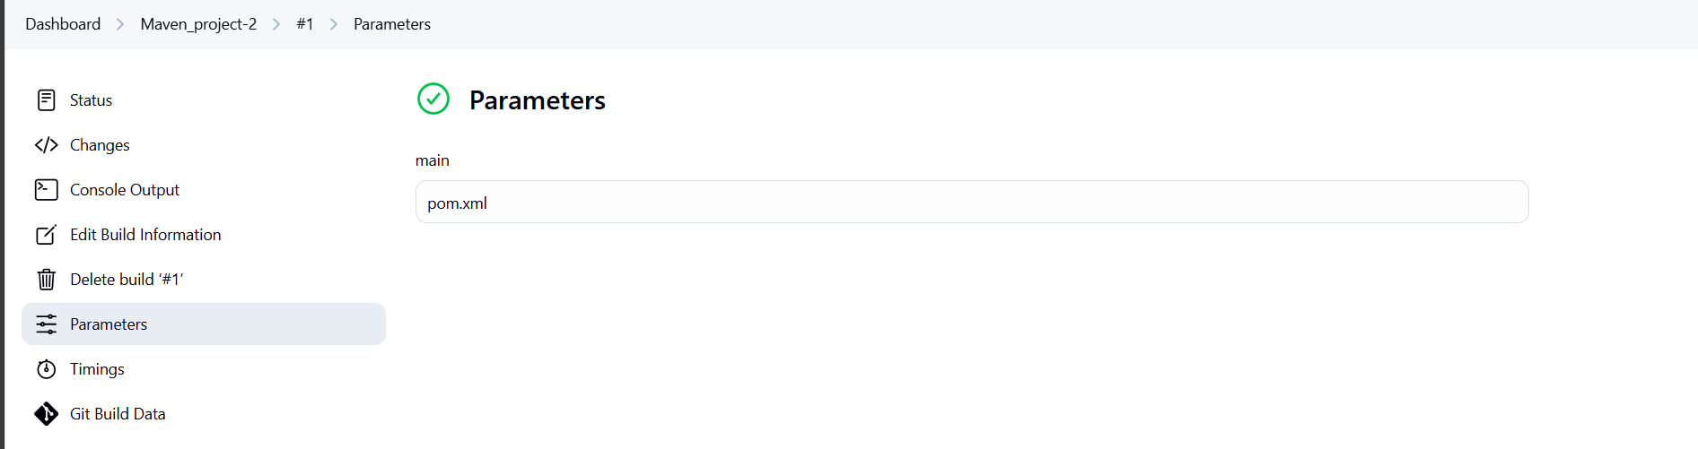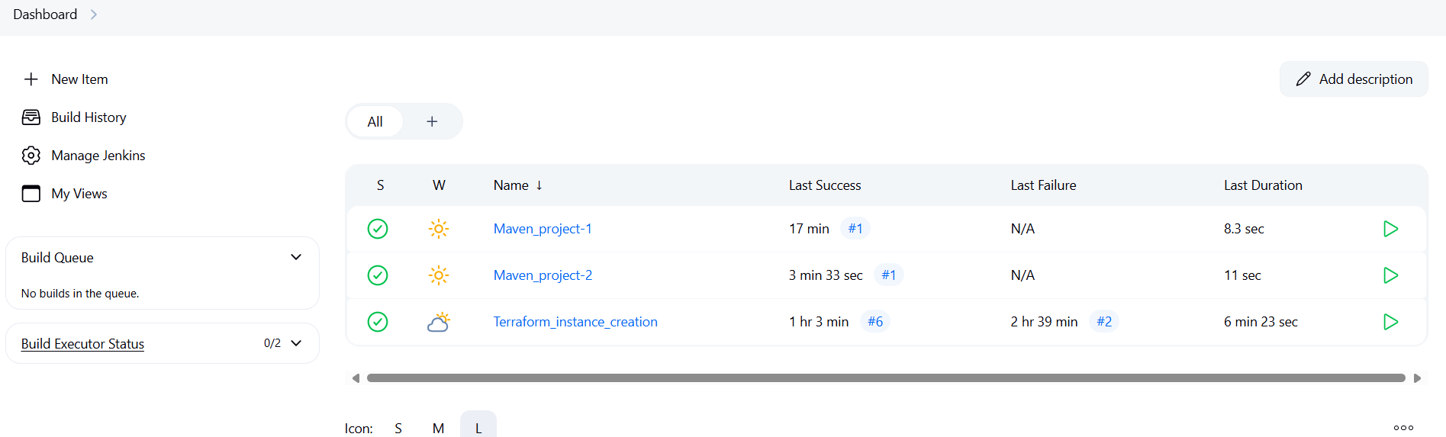

6) What are the global varaiables in jenkins?

[**Jenkins Global Variables**](https://www.bing.com/ck/a?!&&p=f4426d0d5835a763d5ce6daaea0259ee027204a9434b143c1f17e57e69a1371fJmltdHM9MTc1MjEwNTYwMA&ptn=3&ver=2&hsh=4&fclid=2c754098-b409-694c-066f-56bdb5e16818&psq=What+are+the+global+varaiables+in+jenkins%3f&u=a1aHR0cHM6Ly93d3cuamVua2lucy5pby9kb2MvcGlwZWxpbmUvdG91ci9lbnZpcm9ubWVudC8&ntb=1)

In Jenkins, global variables are predefined objects or values accessible throughout the entire pipeline script. These variables are essential for making pipeline scripts more dynamic and adaptable, providing valuable information such as build environment data, job parameters, and various aspects of the Jenkins system.

In Jenkins, **global variables** are built-in environment variables that are available across all jobs and pipelines. These are pre-defined by Jenkins and can be used in **Pipeline scripts (Declarative or Scripted)** or **Freestyle jobs**.

**Common Global Variables in Jenkins**

| **Variable** | **Description** |
| --- | --- |
| BUILD_ID | The unique ID of the current build (e.g., #25) |
| BUILD_NUMBER | The build number (e.g., 25) |
| BUILD_TAG | A unique name for the build, e.g., jenkins-MyJobName-25 |
| BUILD_URL | URL of the specific build |
| JOB_NAME | Name of the job (e.g., MyJobName) |
| JOB_BASE_NAME | Job name without folders (useful for multibranch or folders) |
| WORKSPACE | Full path to the workspace directory |
| JENKINS_HOME | Path to Jenkins installation directory |
| JENKINS_URL | Jenkins URL (e.g., http://localhost:8080/) |
| NODE_NAME | Name of the agent/node where the build is running |
| EXECUTOR_NUMBER | Number of the executor running the build |
| GIT_COMMIT | Git commit hash of the current checkout (if using Git plugin) |
| GIT_BRANCH | Git branch being built |
| GIT_URL | Git repository URL |
| BRANCH_NAME | For multibranch pipelines, the branch being built |