1) Watch terraform-04 video.

2) Execute the script shown in video.

**Below terraform code is used for initializing the specific version**

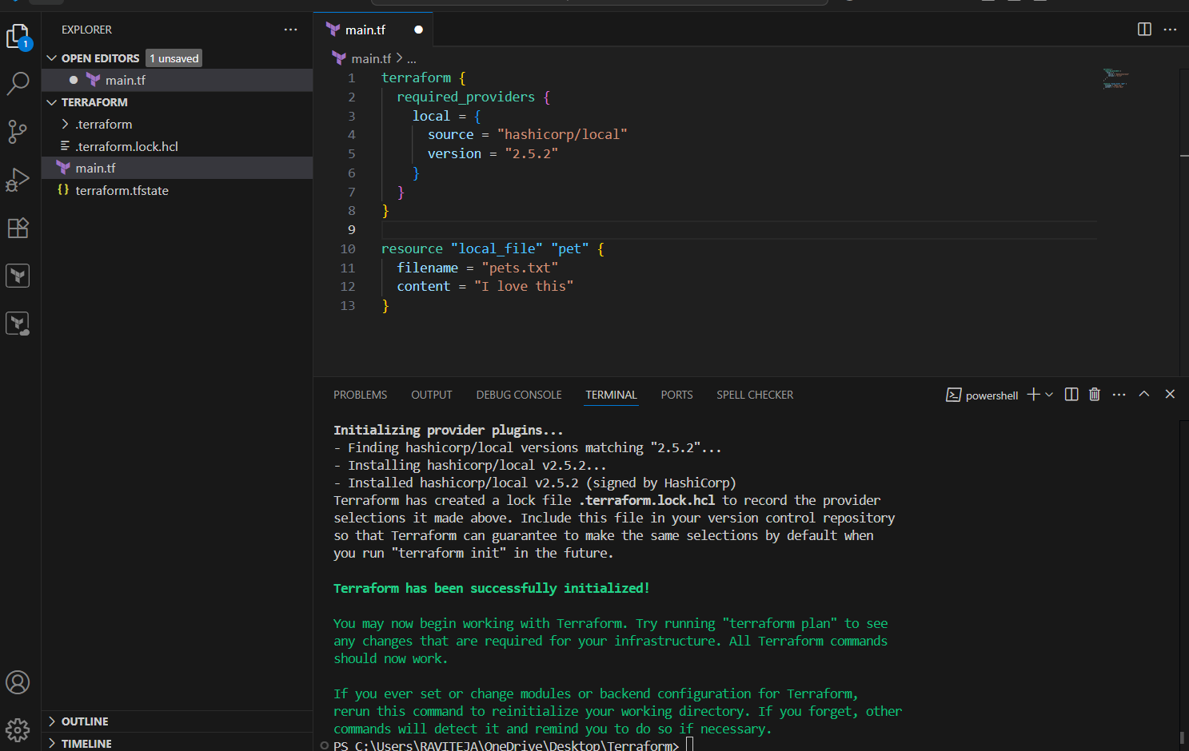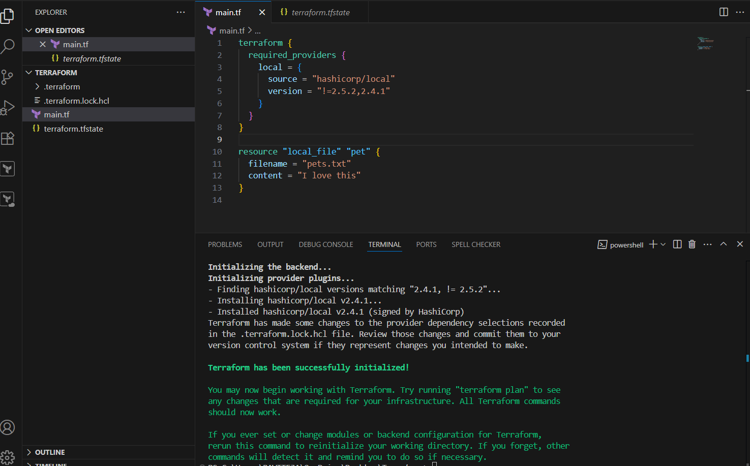

**Data Block file**

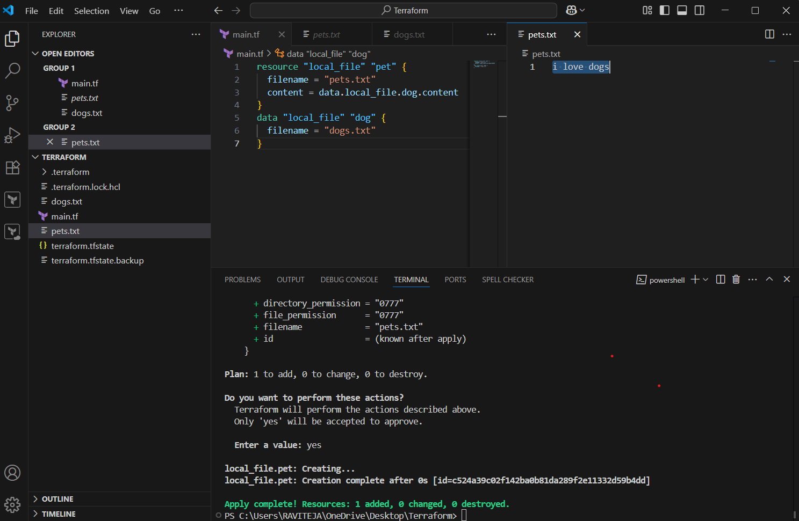

**Count -Arguments**

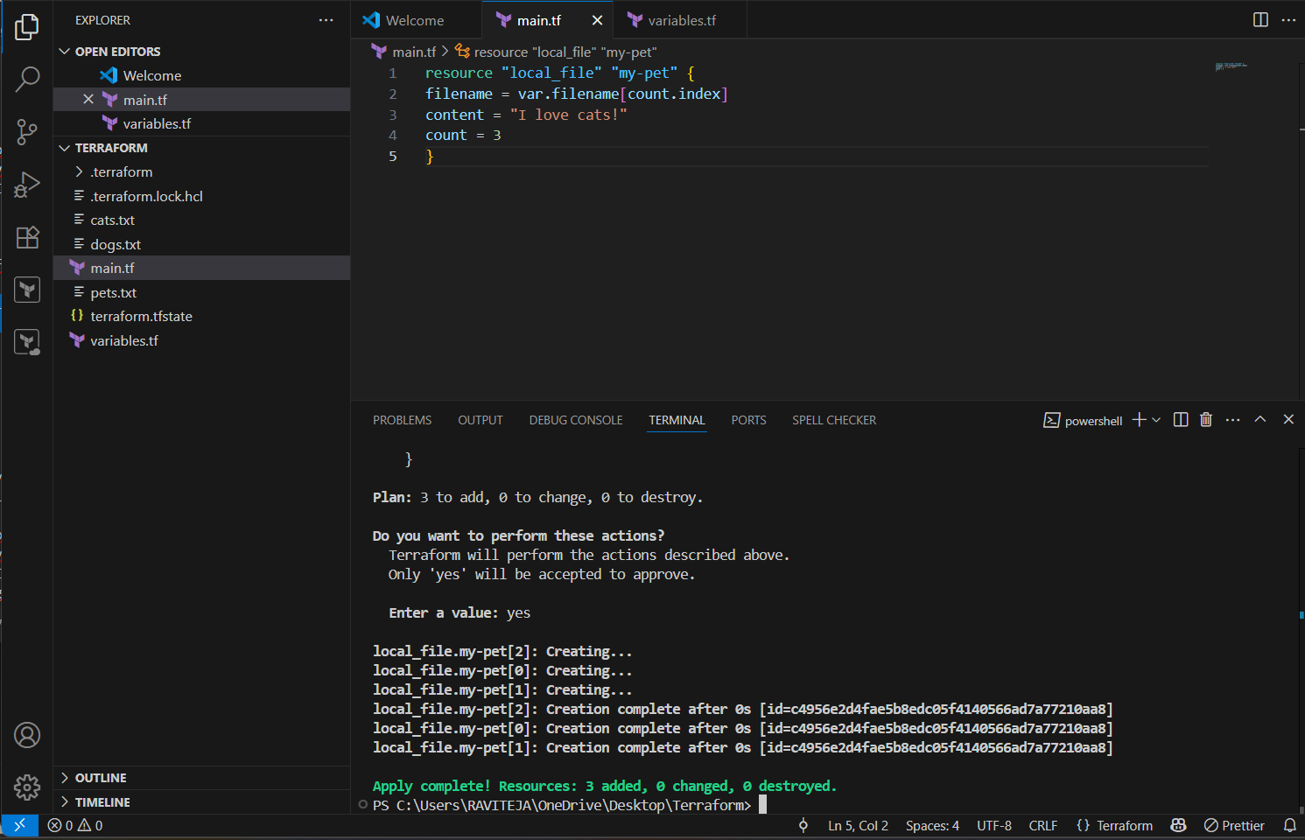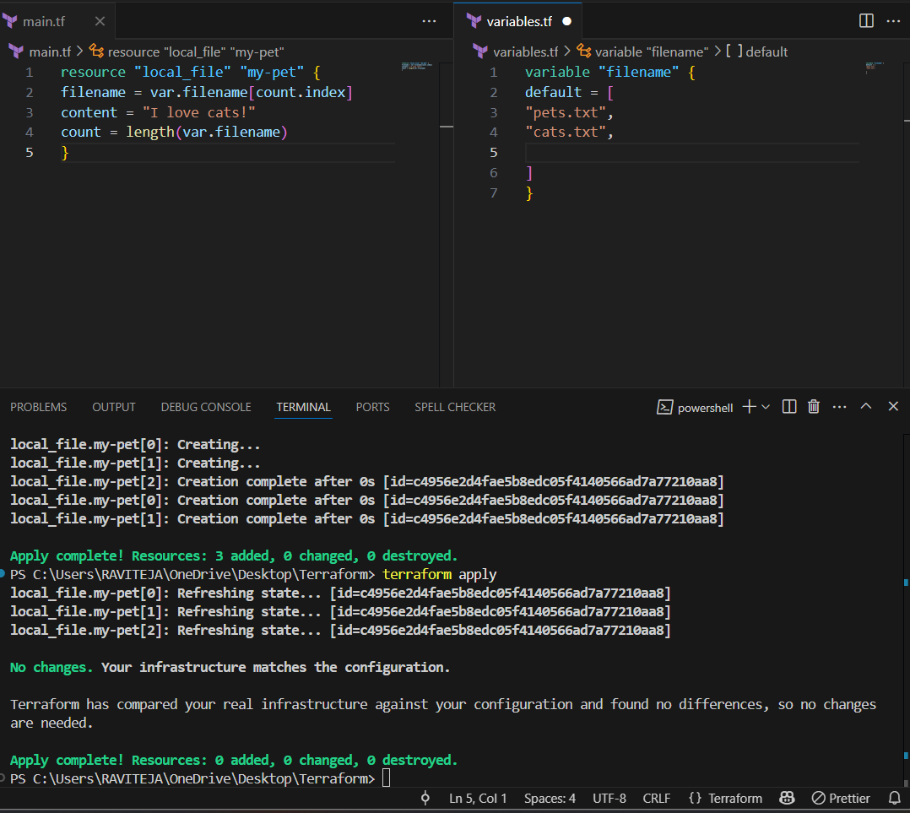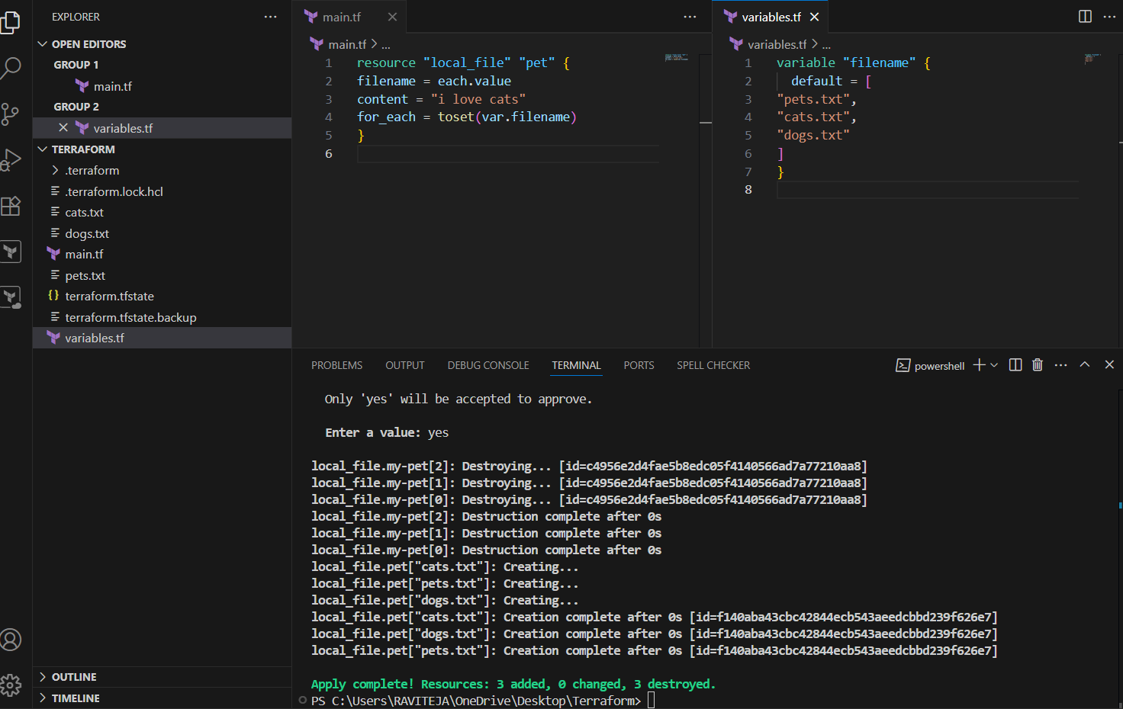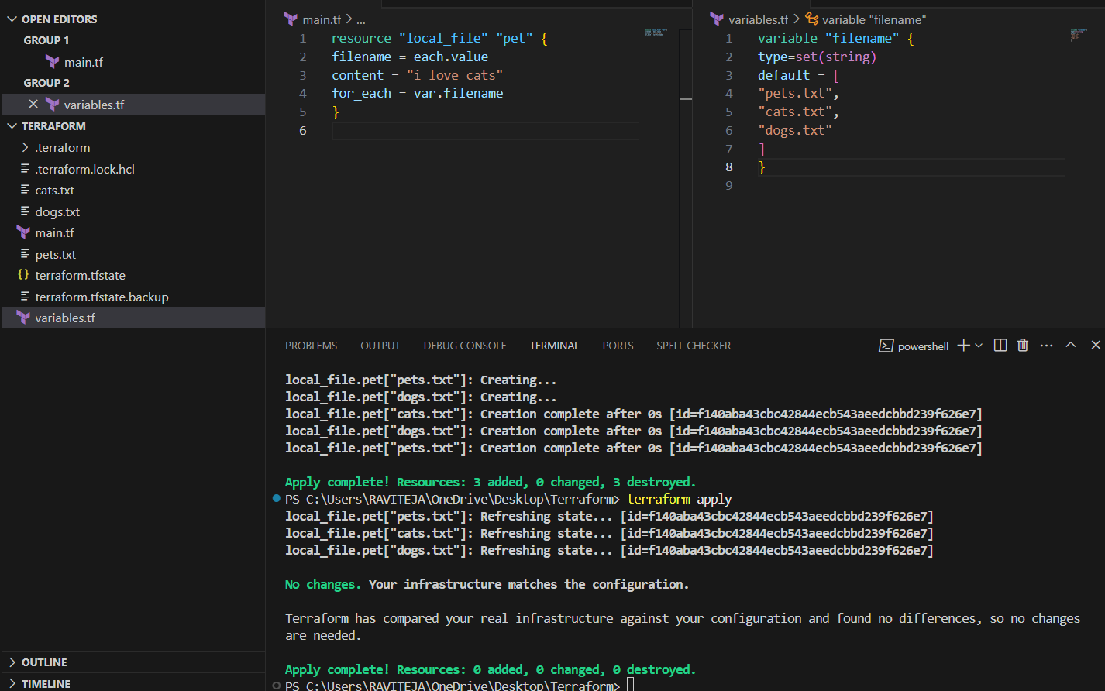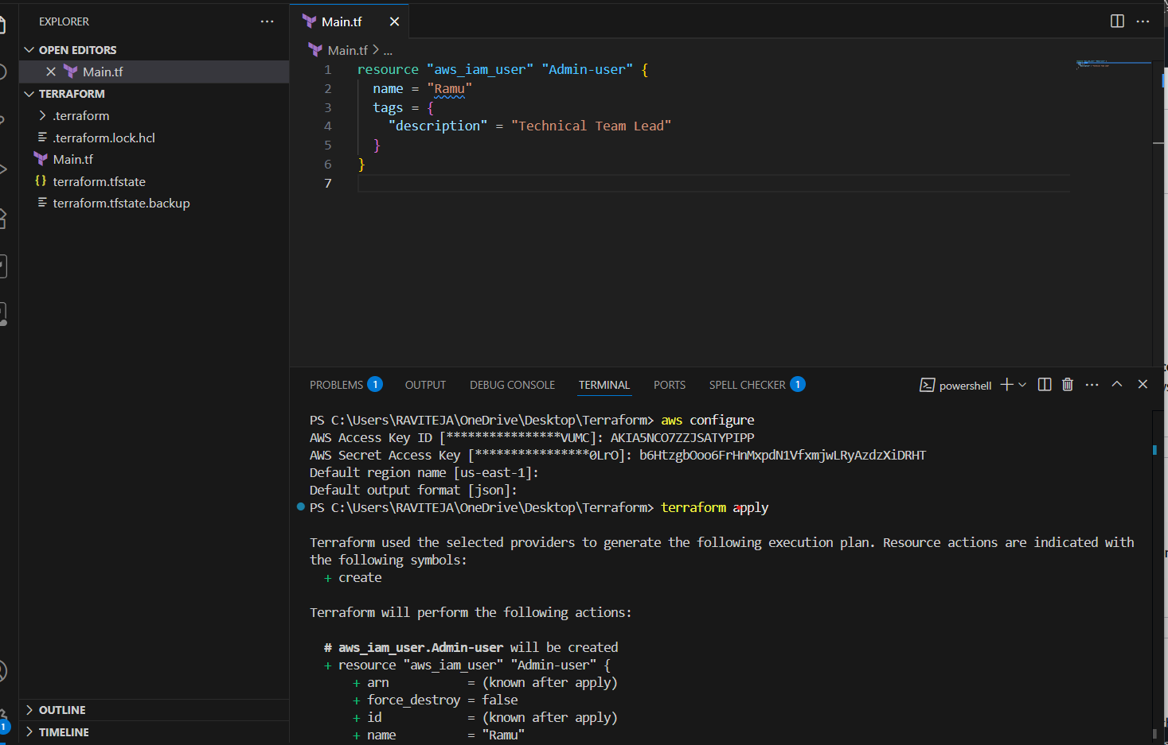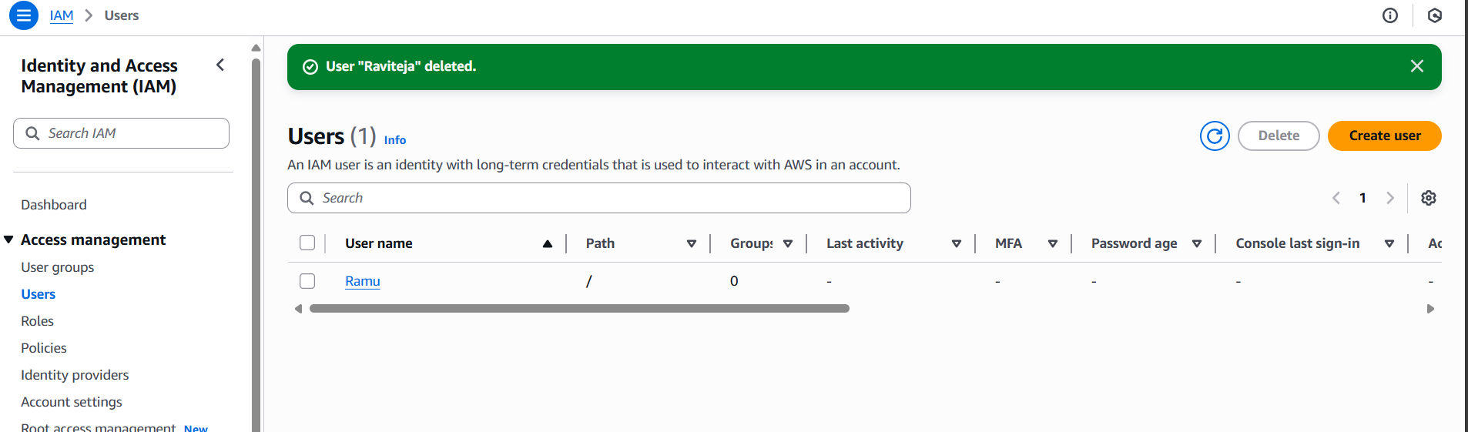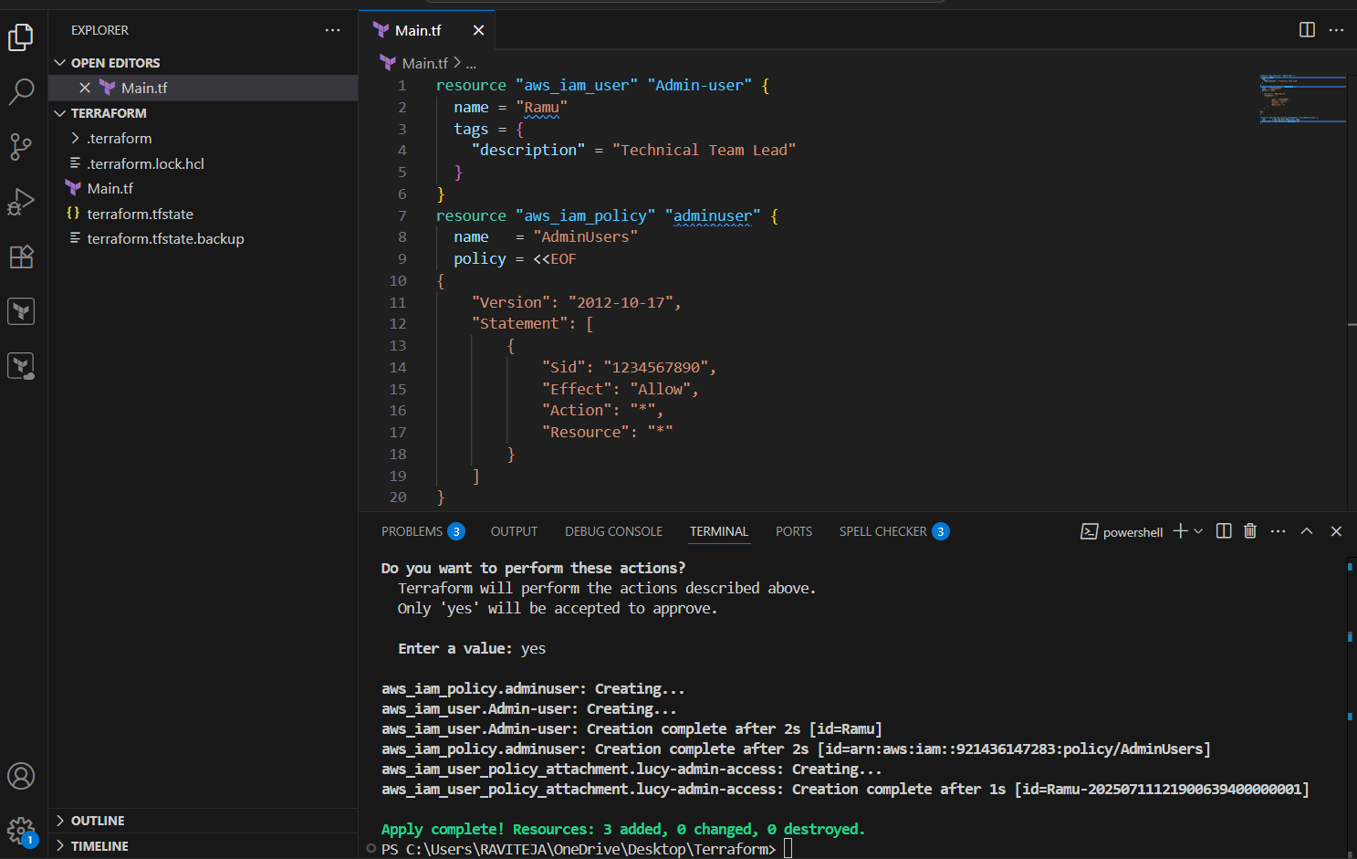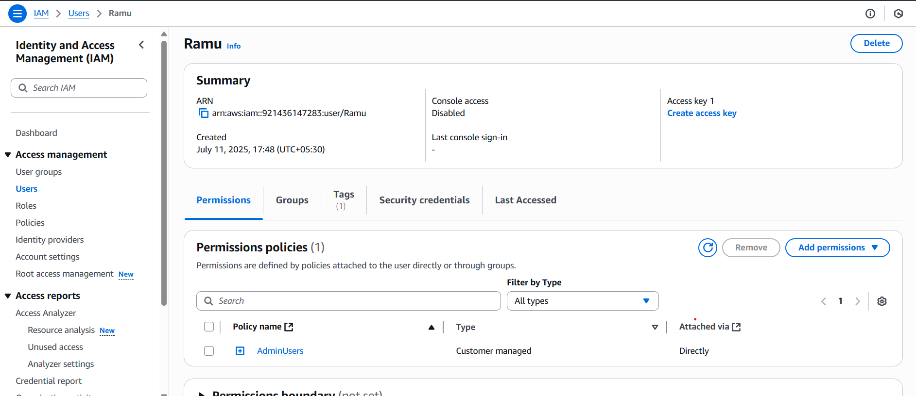

3) Integrate terrafrom in jenkins using Terraform plugin.

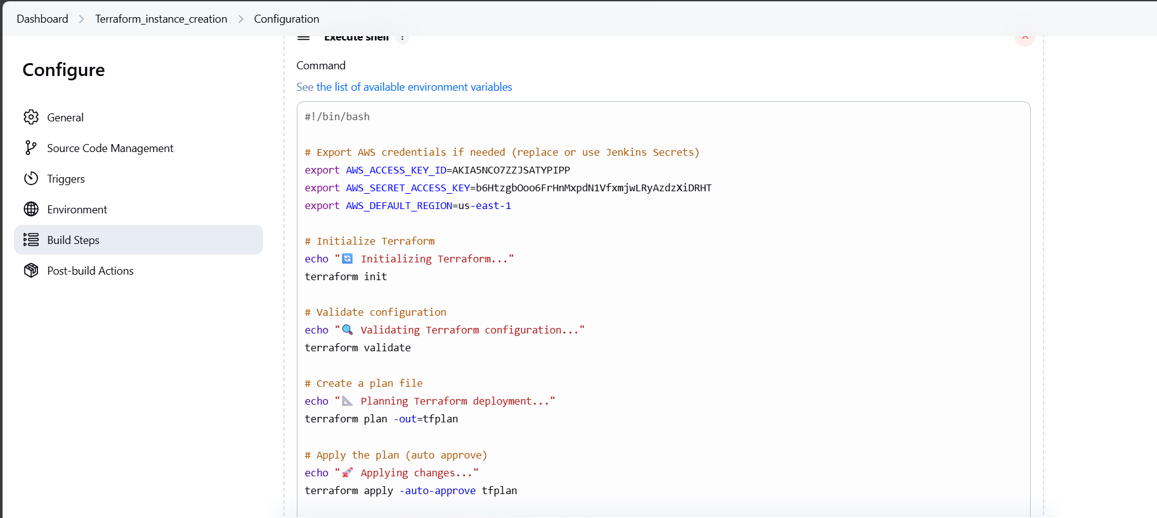

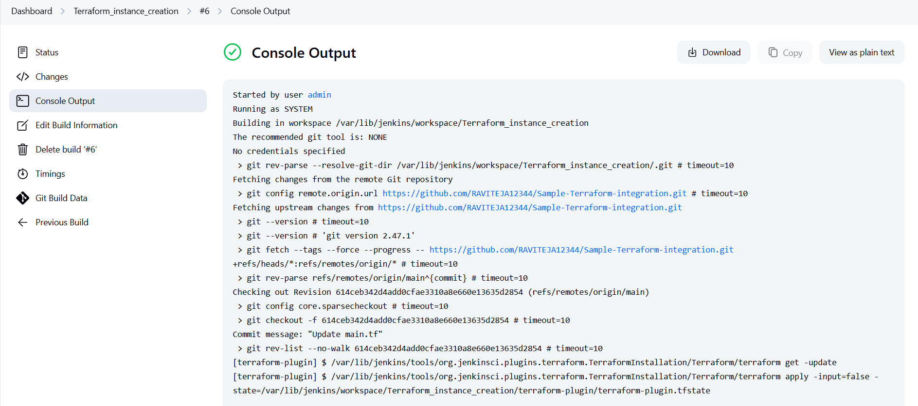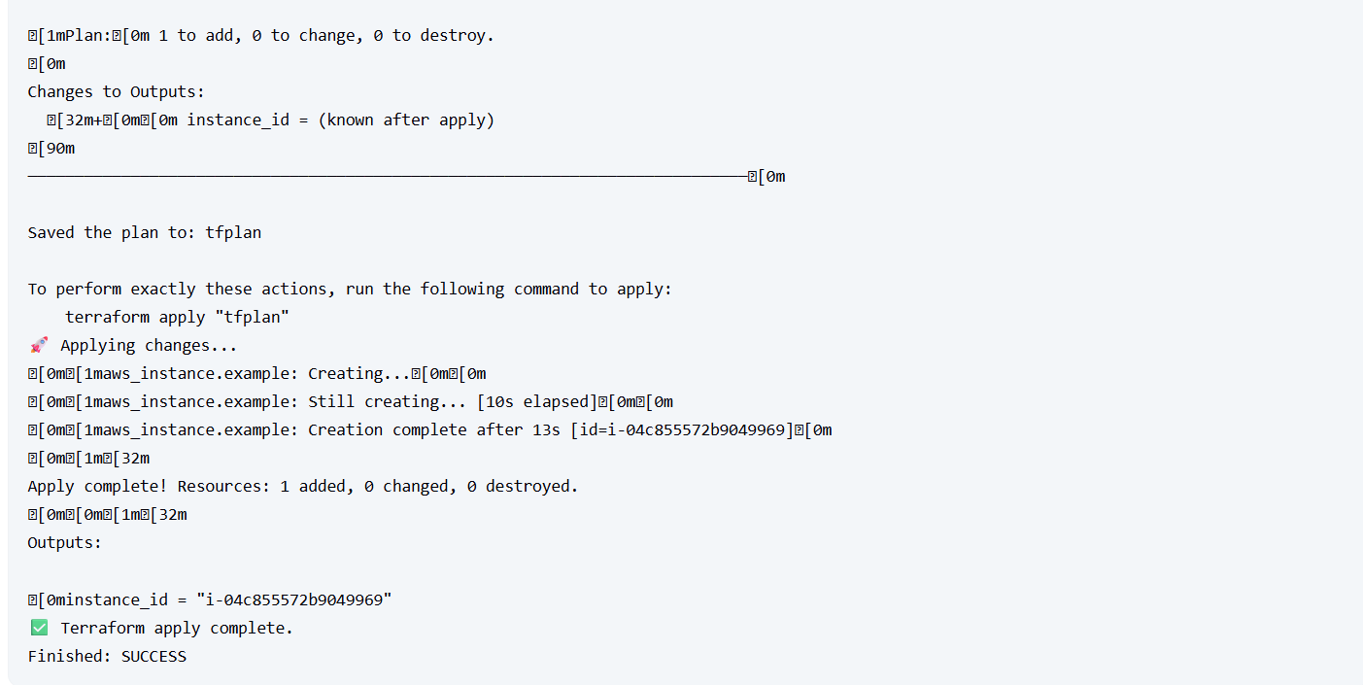

4) Create CICD pipeline for Nodejs Application. <https://github.com/betawins/Trading-UI.git>

**Installed Nodejs on Jenkins sever** 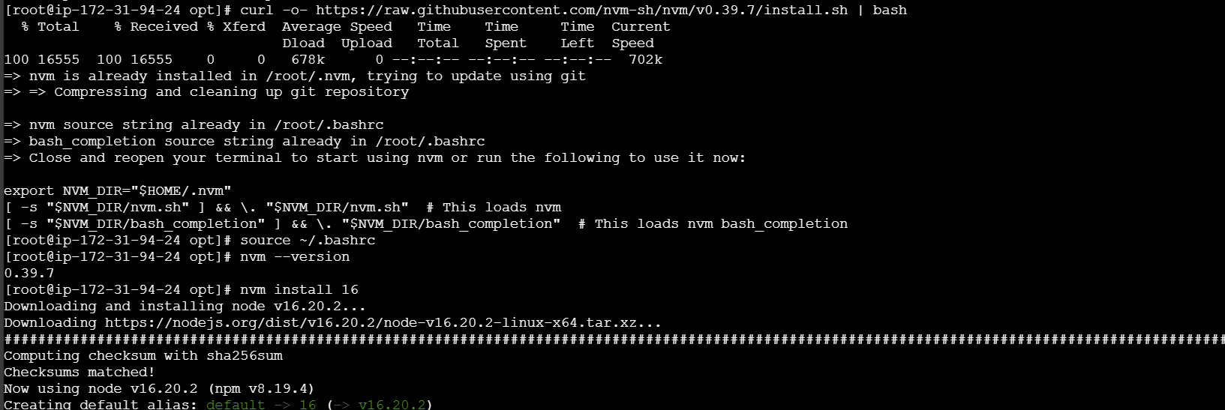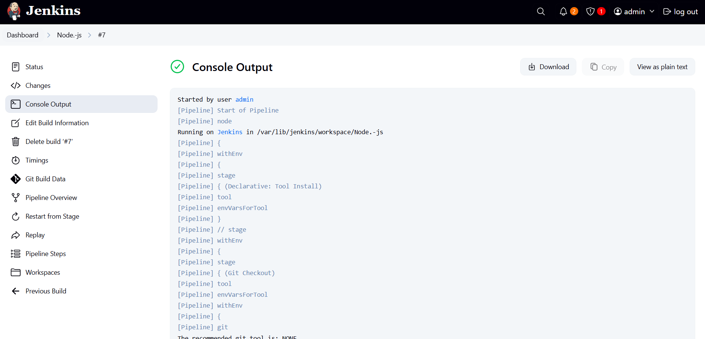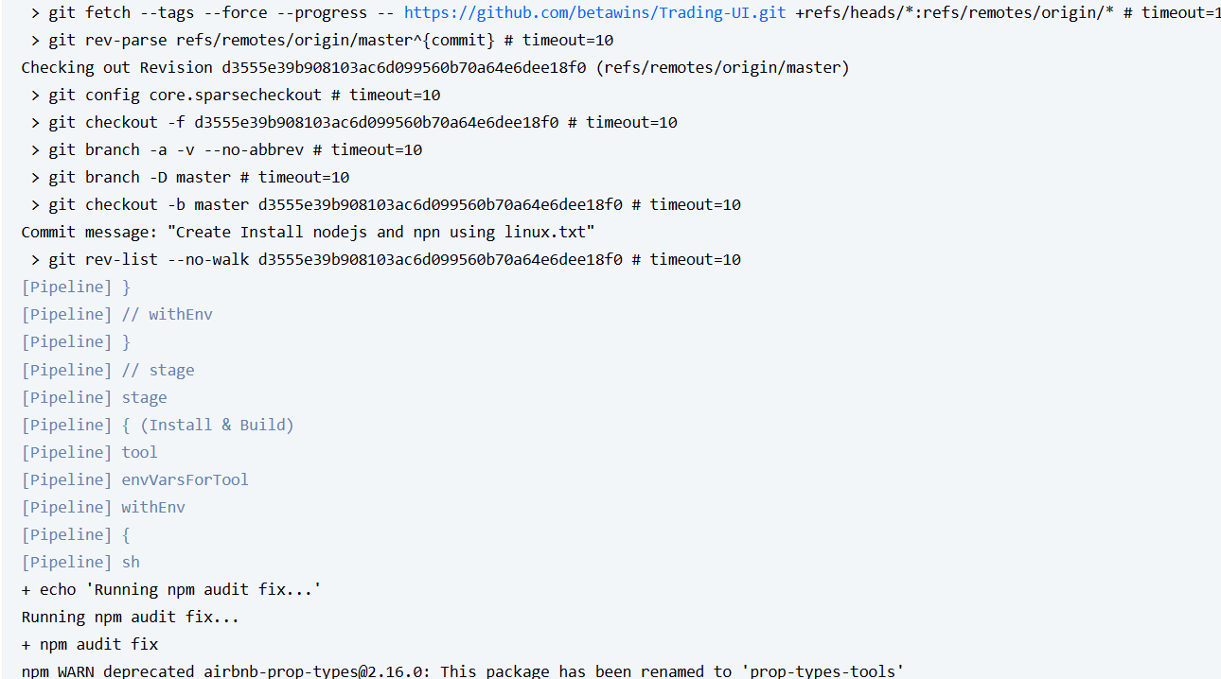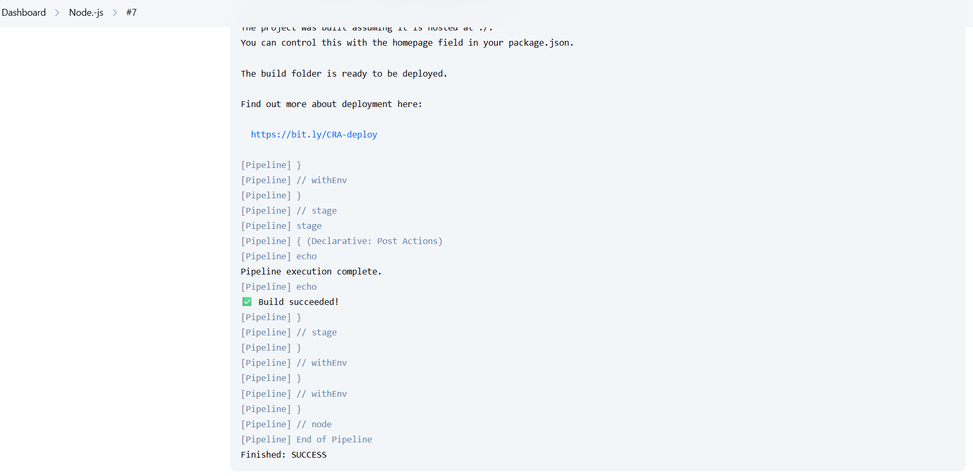

5) Explain 10 Maven commands.

**Top Maven Commands Explained**

| **Command** | **Description** |
| --- | --- |
| 1️⃣ mvn clean | **Cleans** the target/ directory where compiled files are stored. Useful before rebuilding. |
| 2️⃣ mvn compile | **Compiles** the source code of the project (under src/main/java). |
| 3️⃣ mvn test | Runs **unit tests** defined in src/test/java using frameworks like JUnit or TestNG. |
| 4️⃣ mvn package | **Packages** the compiled code into a JAR or WAR file, depending on the project type. |
| 5️⃣ mvn install | Installs the built artifact (JAR/WAR) to your local .m2 repository so other projects can use it. |
| 6️⃣ mvn deploy | Uploads the package to a **remote repository** (e.g., Nexus or Artifactory) for sharing with teams. |
| 7️⃣ mvn site | Generates a **project documentation site**, including reports like test coverage, dependency graphs, etc. |
| 8️⃣ mvn dependency:tree | Displays the **dependency hierarchy**, showing how libraries are related and if there's a conflict. |
| 9️⃣ mvn validate | Validates the pom.xml and project structure before any build steps. Checks if it's ready to build. |
| 🔟 mvn verify | Runs integration tests and checks if the project is valid and meets quality criteria before packaging. |

**Example Use Cases**

* **Before running a build**:

bash

CopyEdit

mvn clean compile

* **To run tests and package**:

bash

CopyEdit

mvn clean test package

* **To share a library with other teams**:

bash

CopyEdit

mvn deploy

* **To debug a dependency issue**:

bash

CopyEdit

mvn dependency:tree