1. Create VPC

Created VPC Name: MainVPC

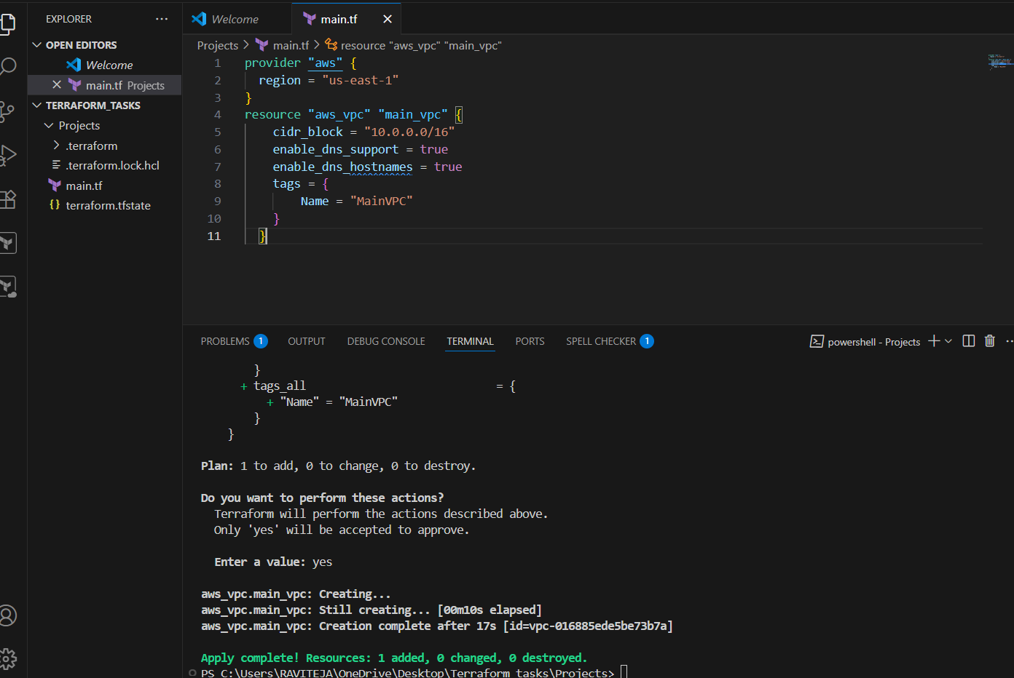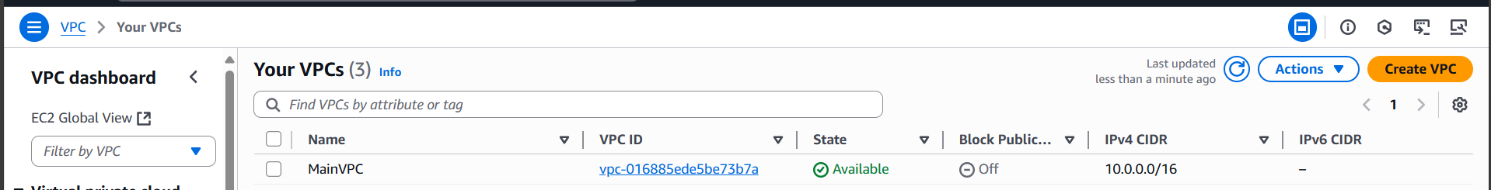

1. Create Internet gateway

Created IGW Name:MyIGW

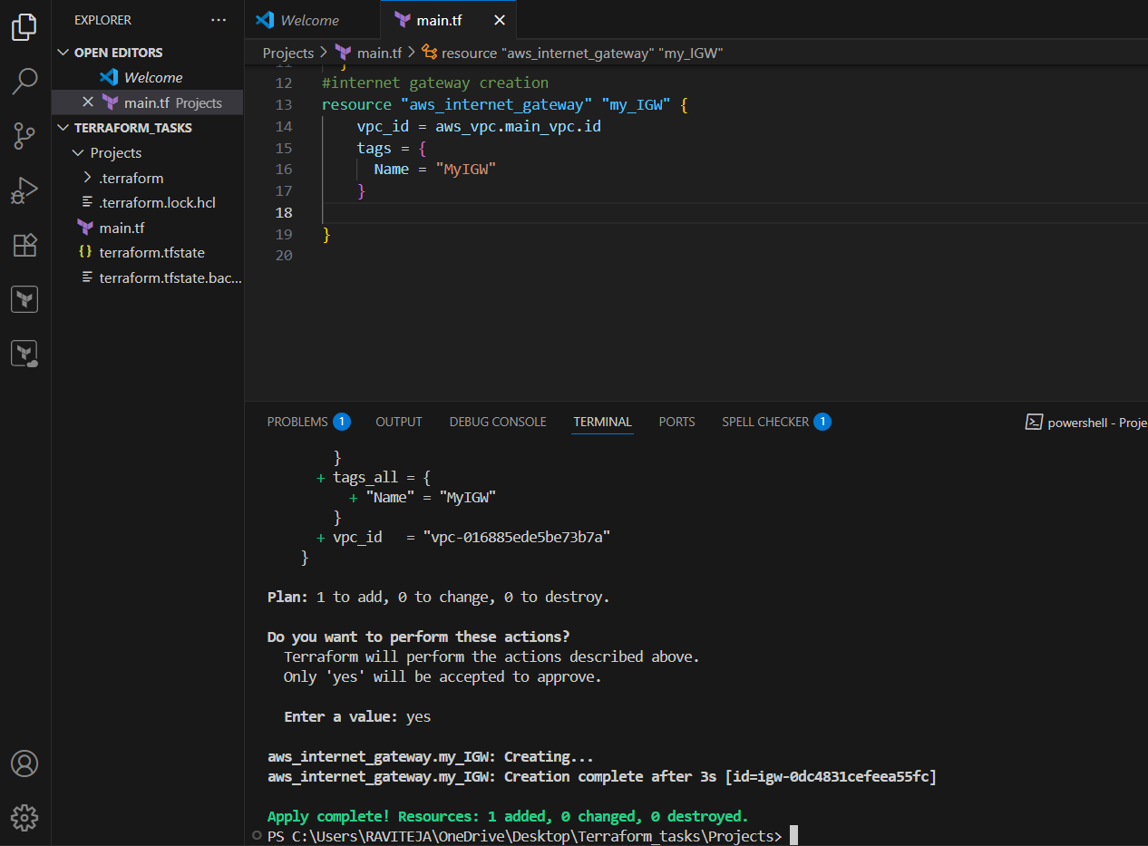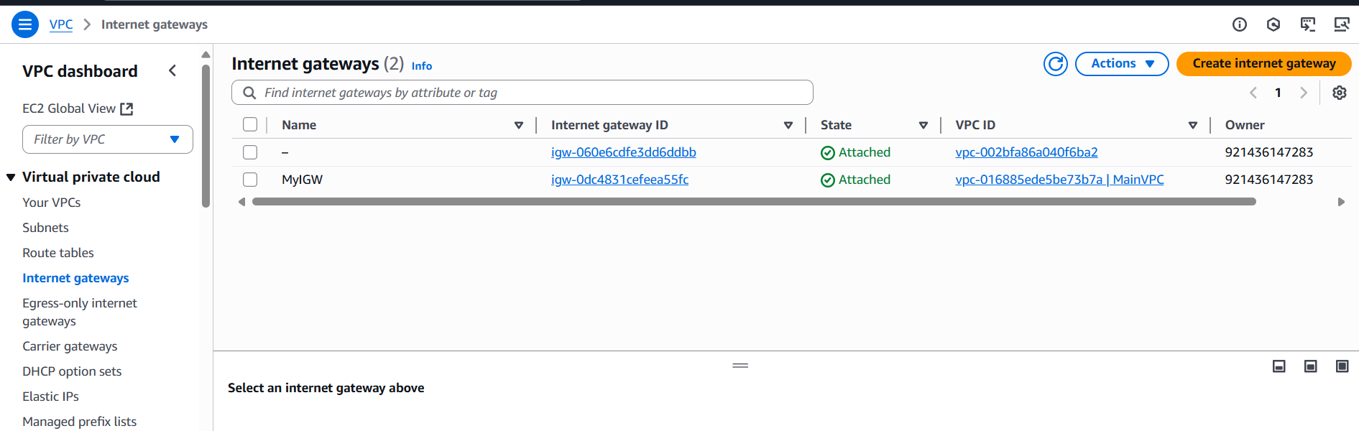

1. Create Custom Route Table

Custom route table Created

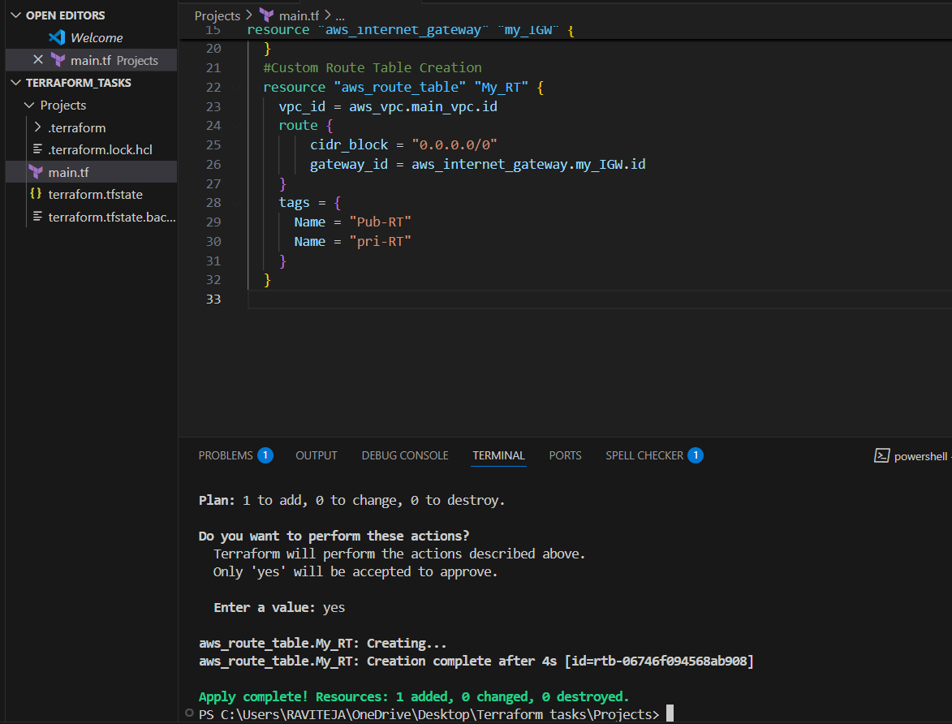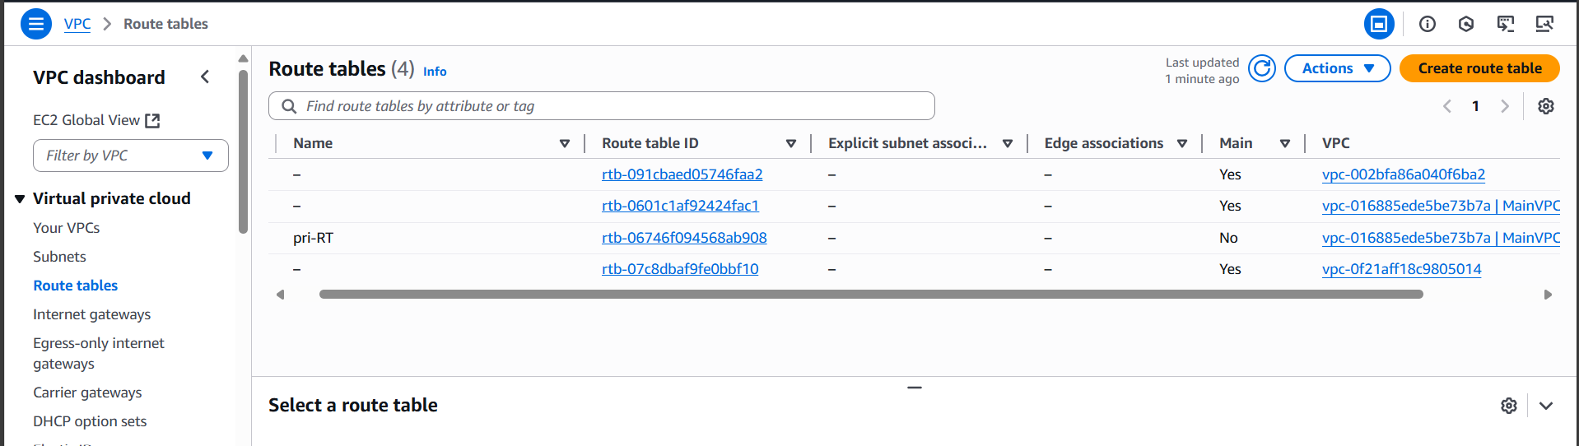

1. Create Subnet

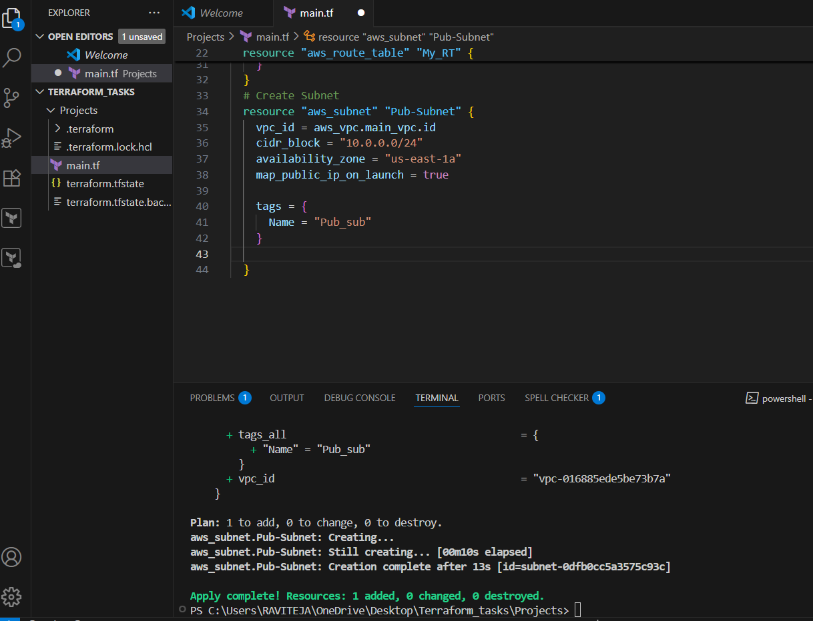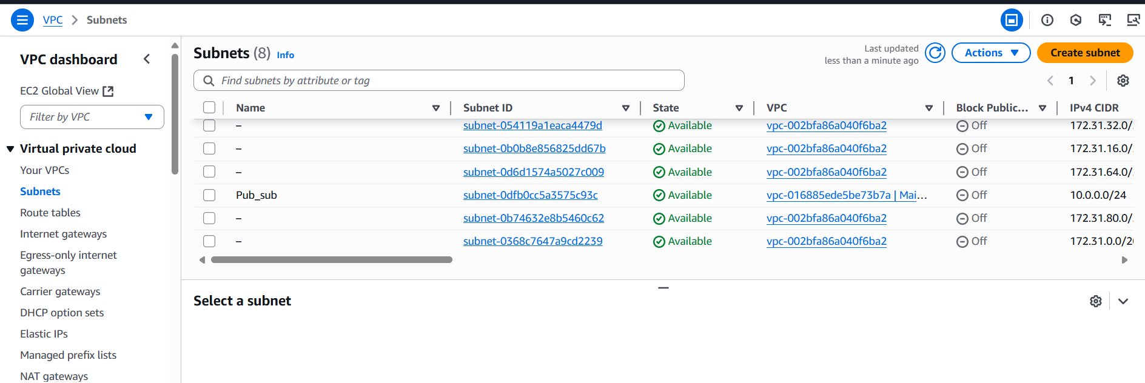

5) Associate subnet with Route Table

Route_table_subnet_association Created

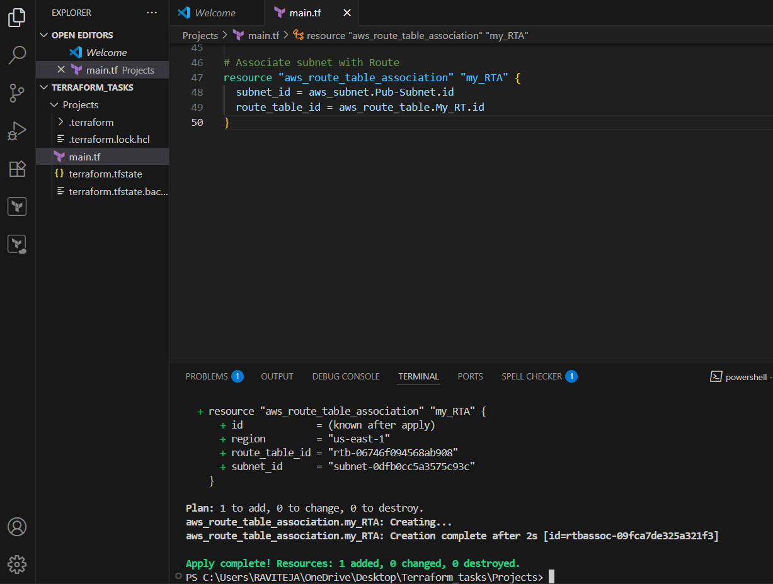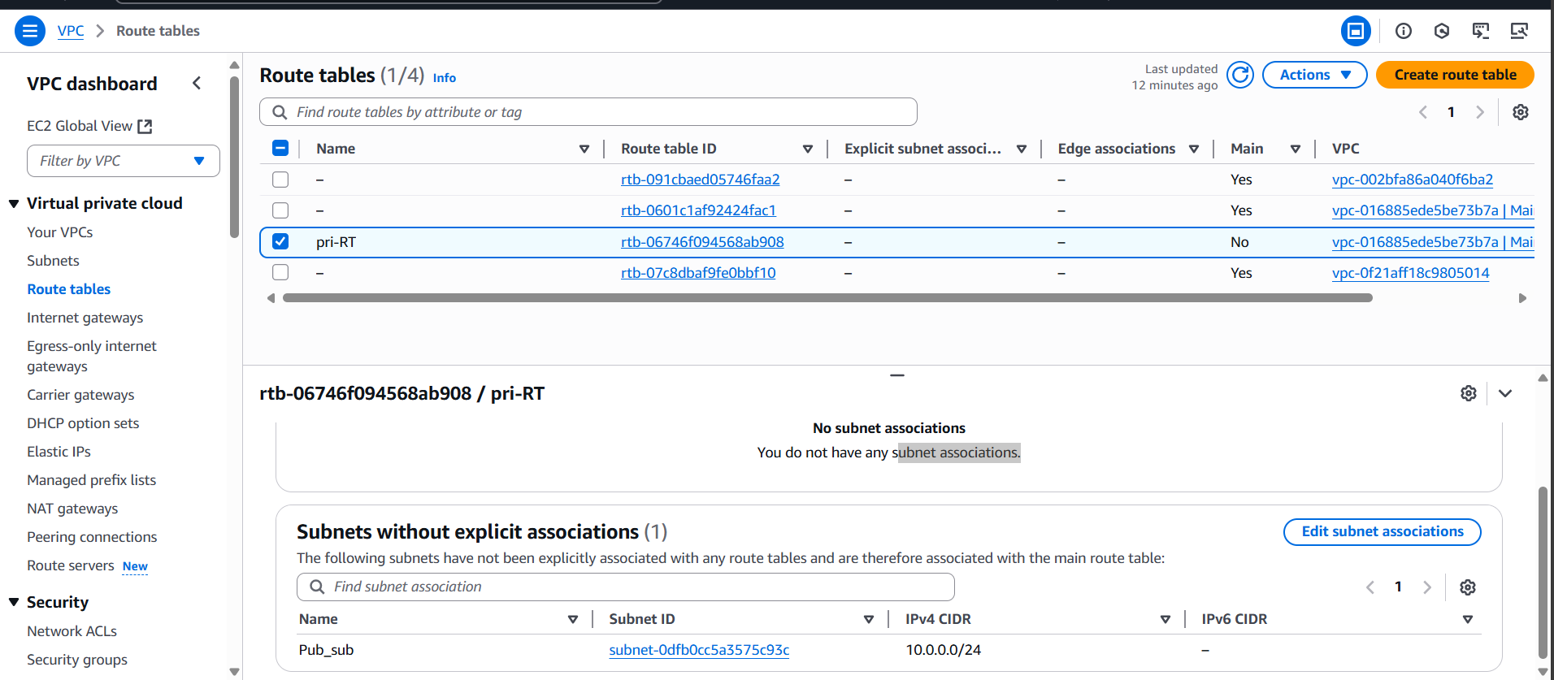

1. Create Security Group to allow port 22.80,443

Created Security Group to allow port 22.80 and 443

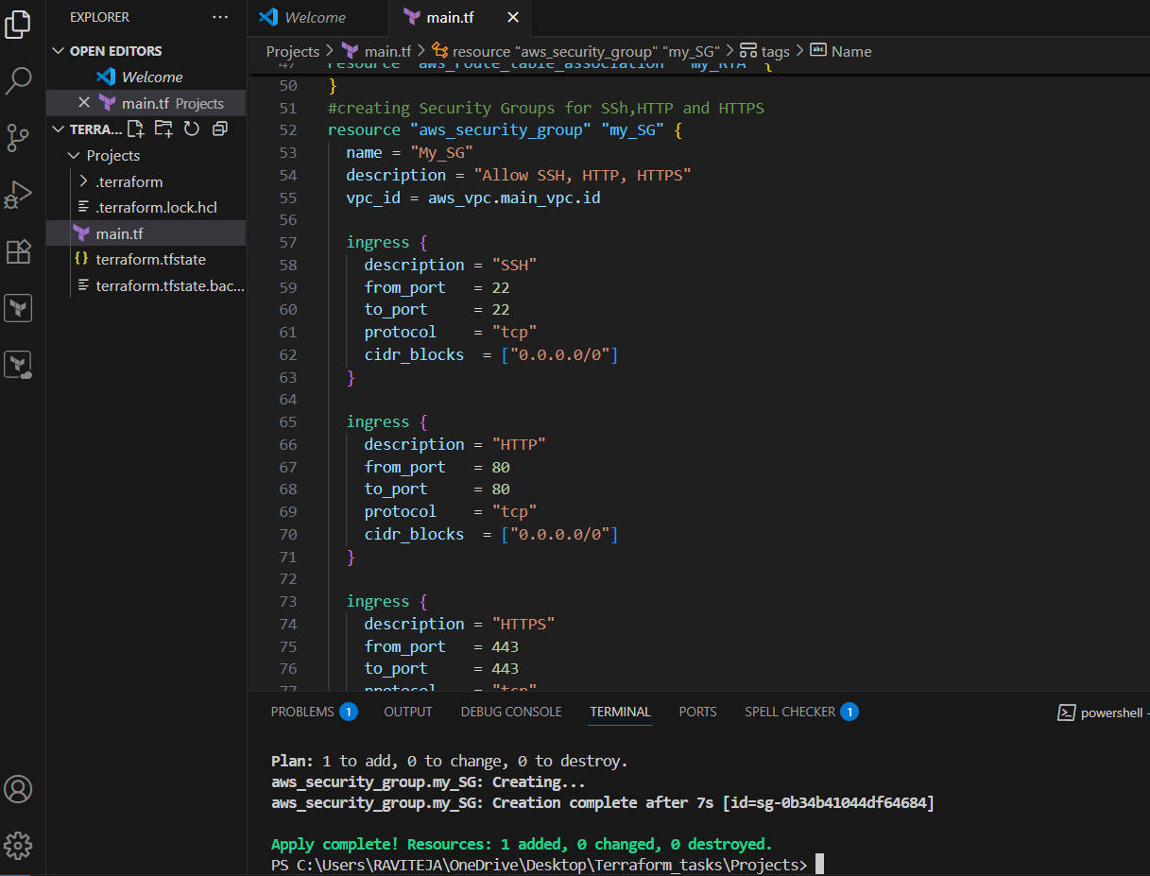 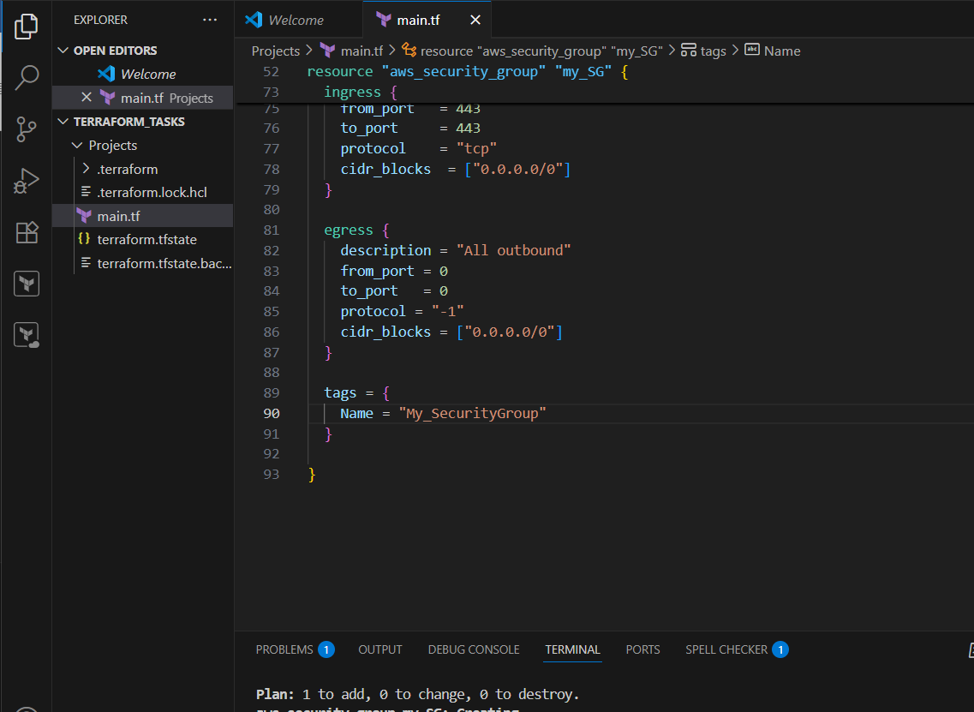

Inbound rules

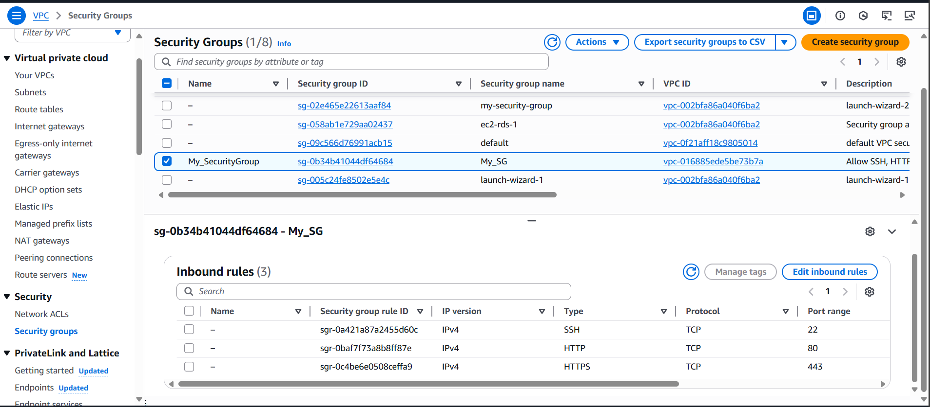

Outbound rules

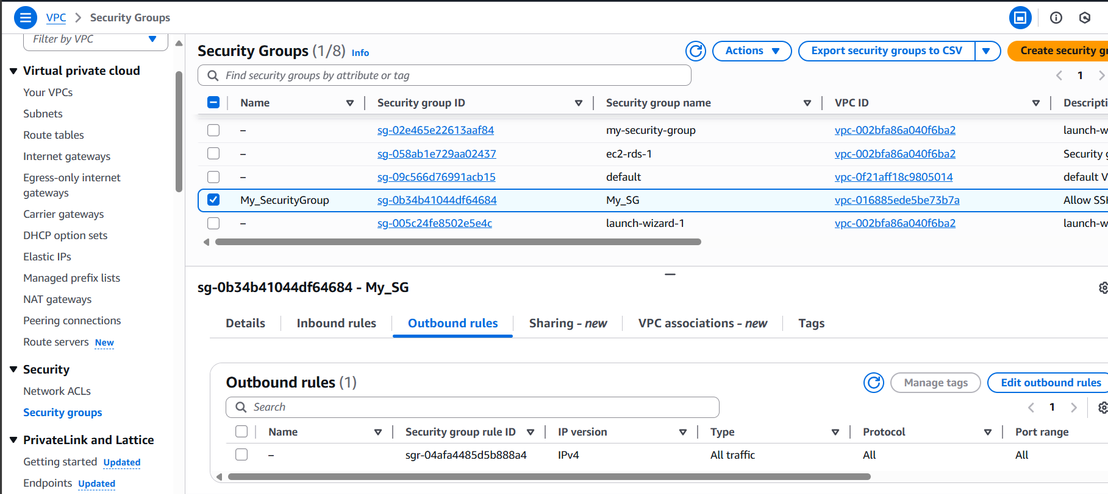

1. Create a network interface with an ip in the subnet that was created in step 4

Created “NETWORK INTERFACE WITH AN PRIVATE IP IN THE SUBNET”

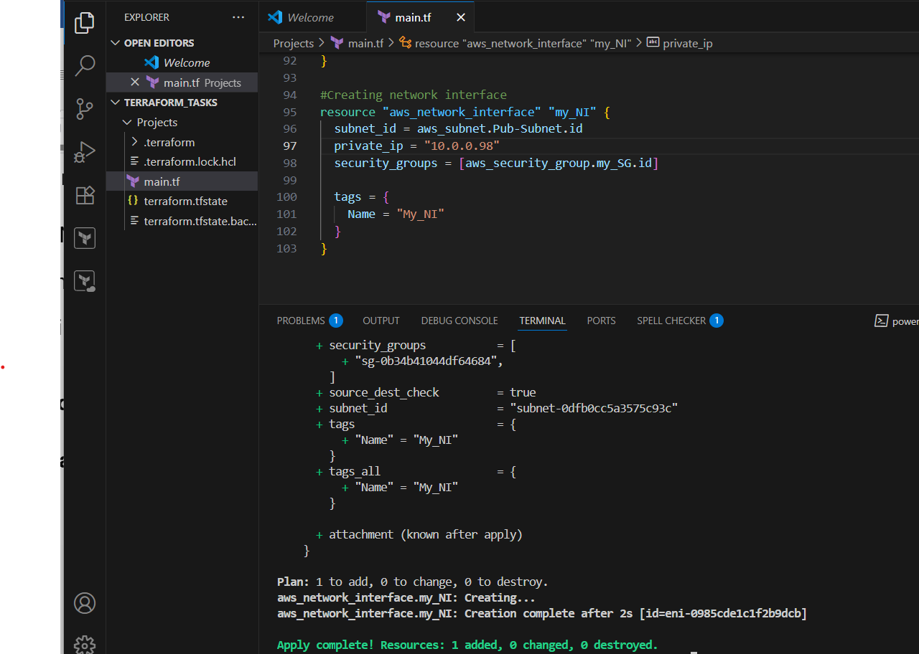

Network interface:

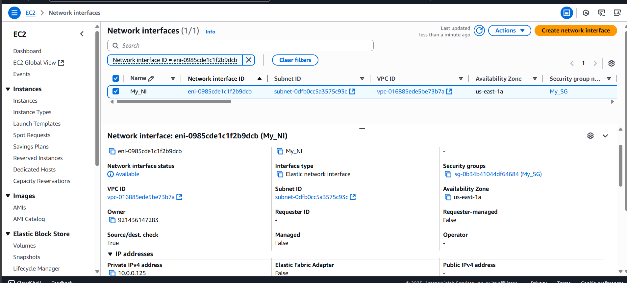

1. Assign an elastic IP to the network interface created in step 7

Assigned an elastic IP to network interfaces

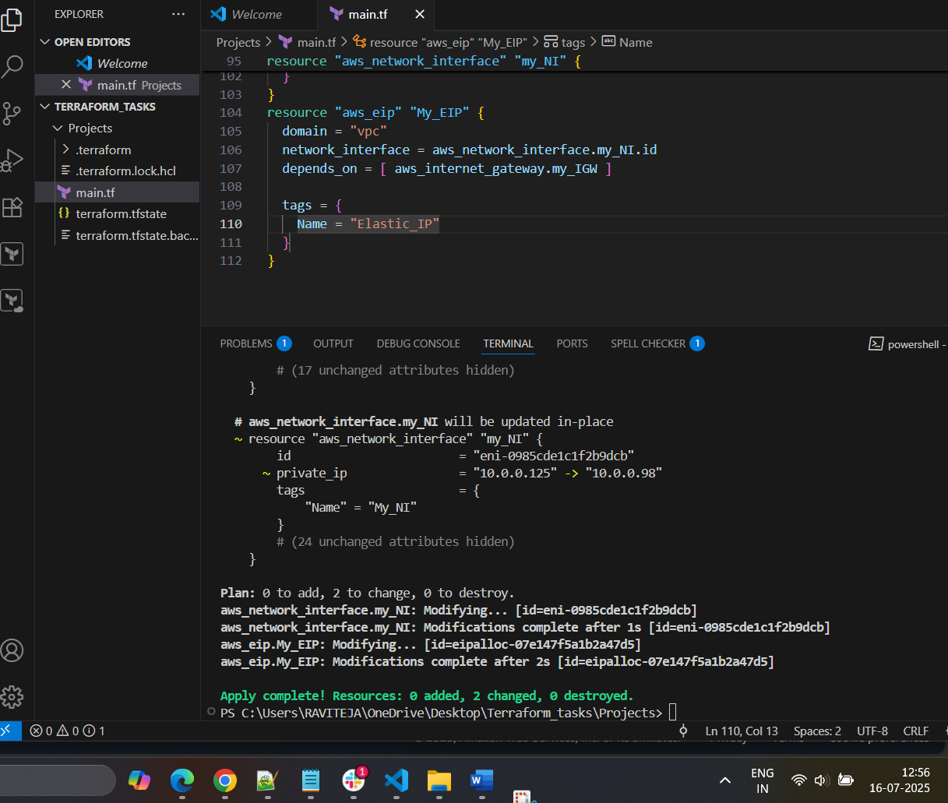 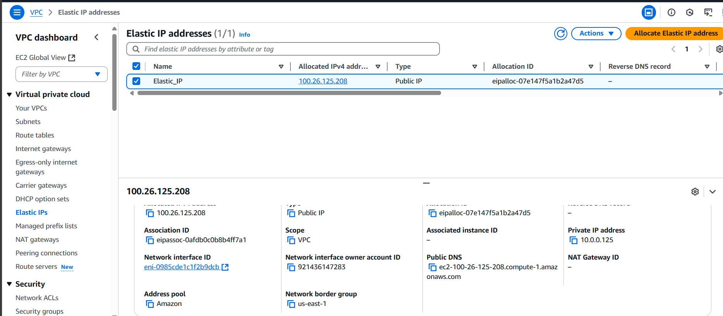

1. Create Ubuntu server and install/enable apache2

Created ec2 instace with Ubuntu server in apache2

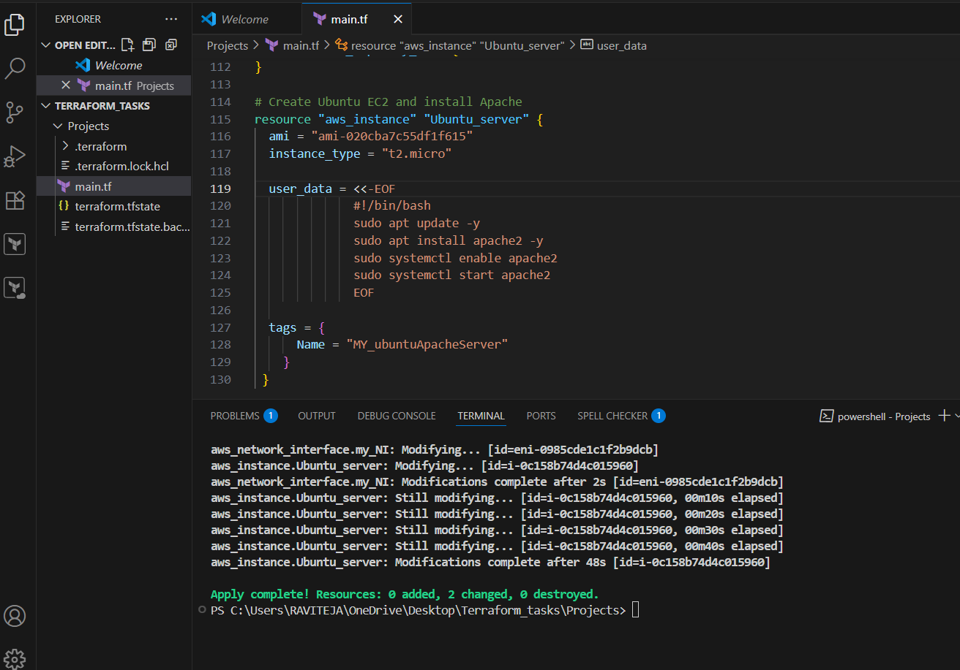

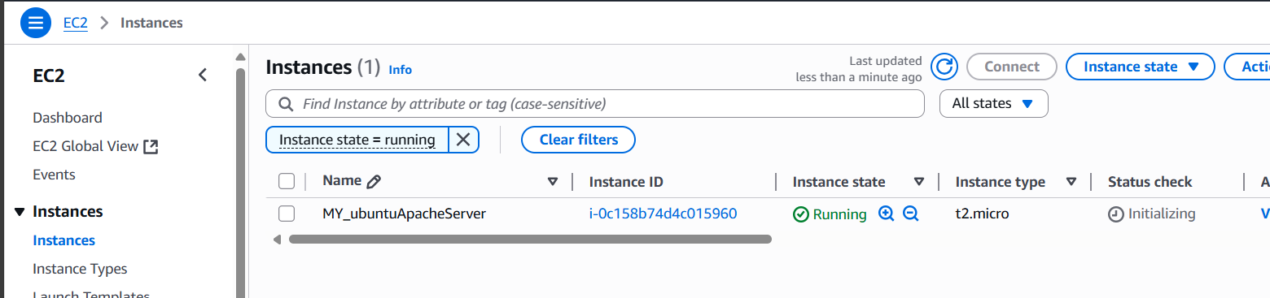 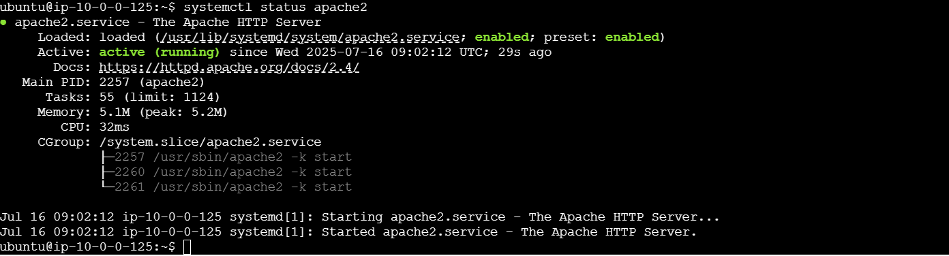 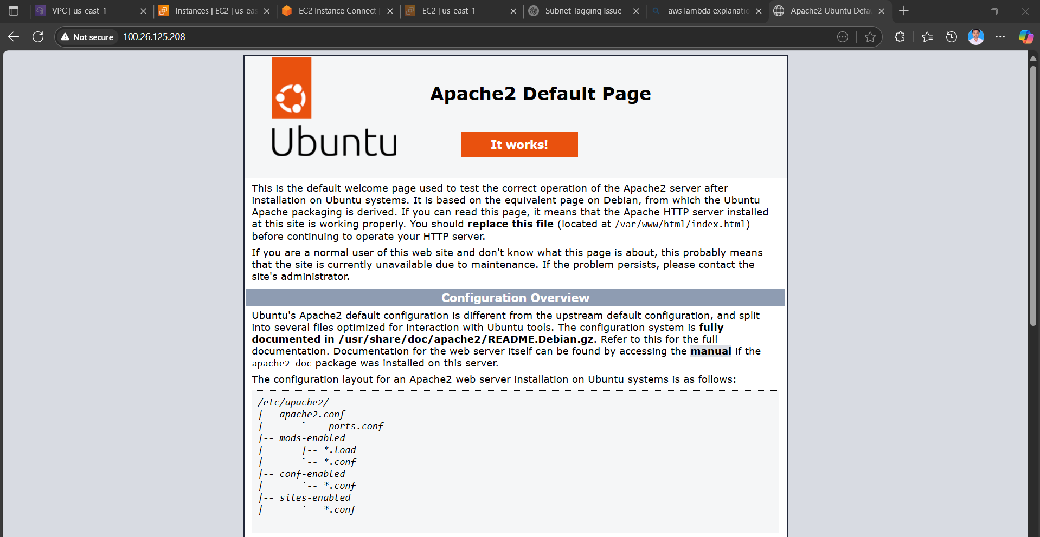

**Note:**  
**1) Create single main.tf which will be created the above resources and do not hardcode the id's.**

**2) Configure s3 as backend and dynamo db locking for multi user execution.**

**Created S3 bucket for store state lock**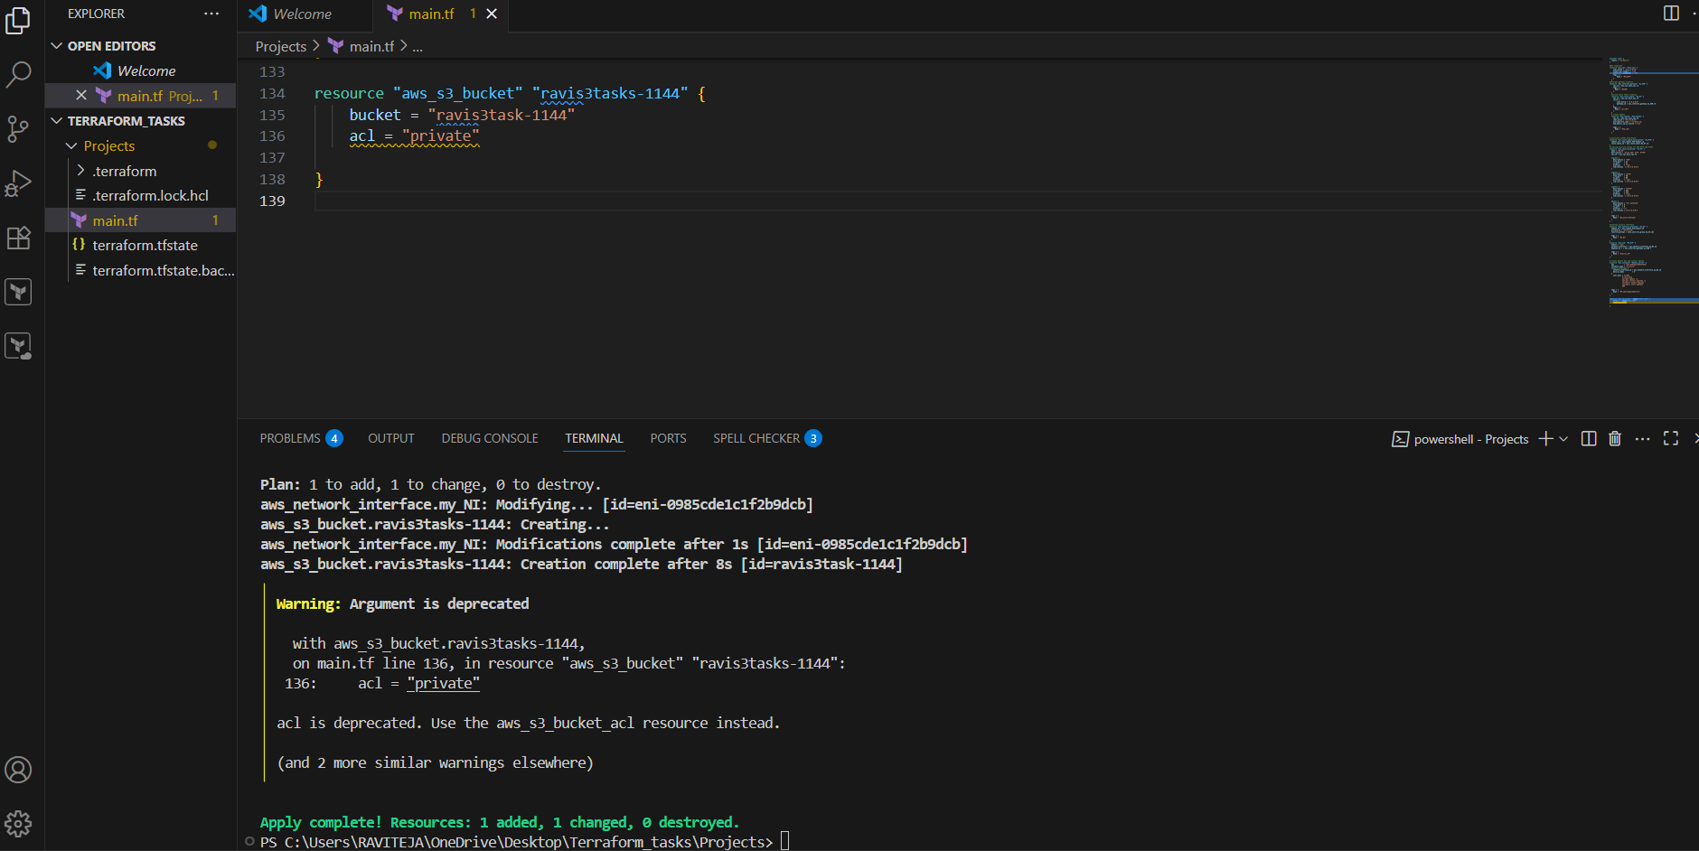 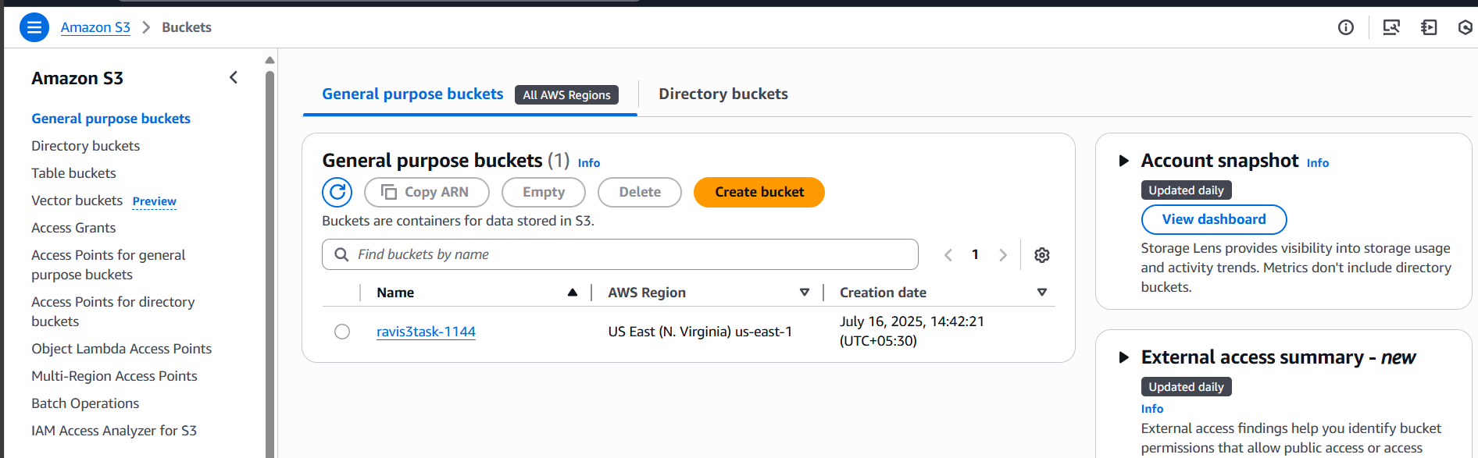

Created DynamoDB Table for Locking  
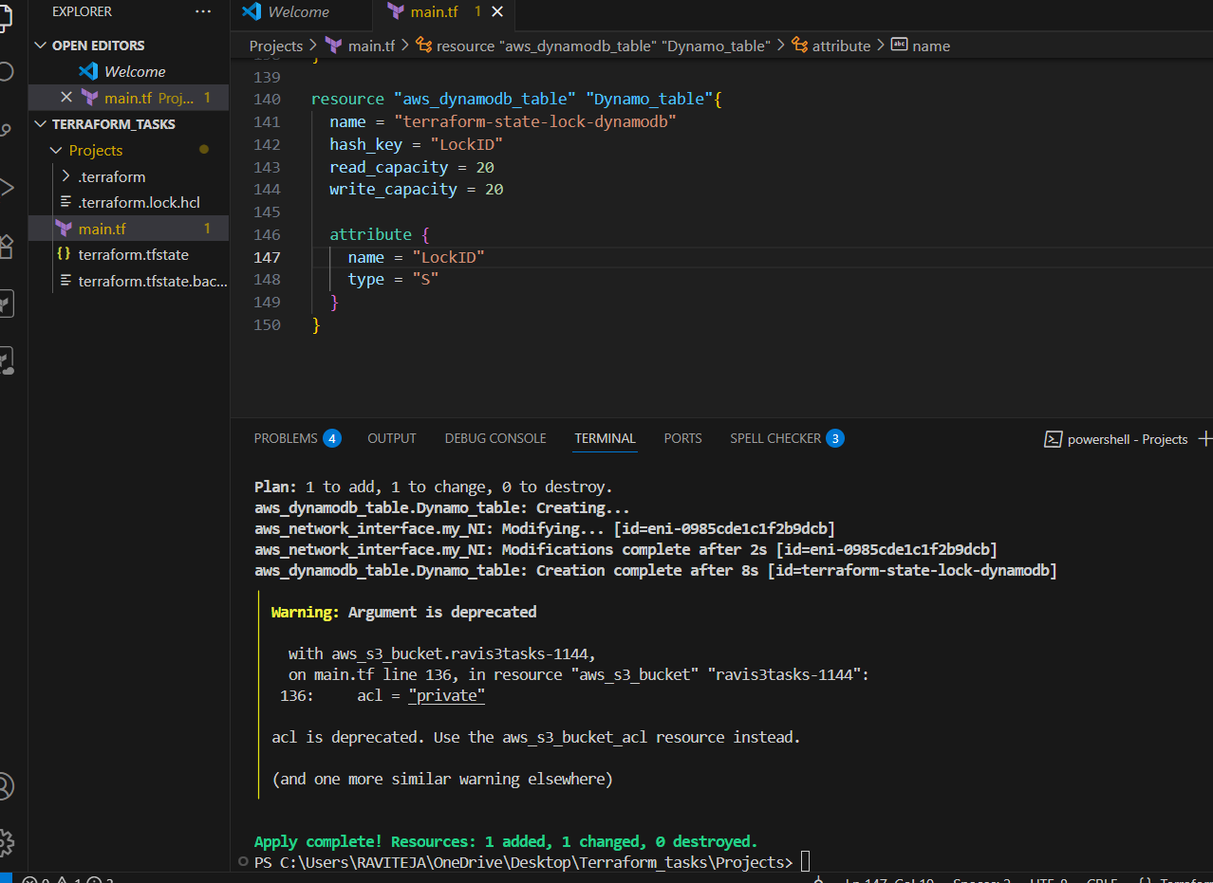 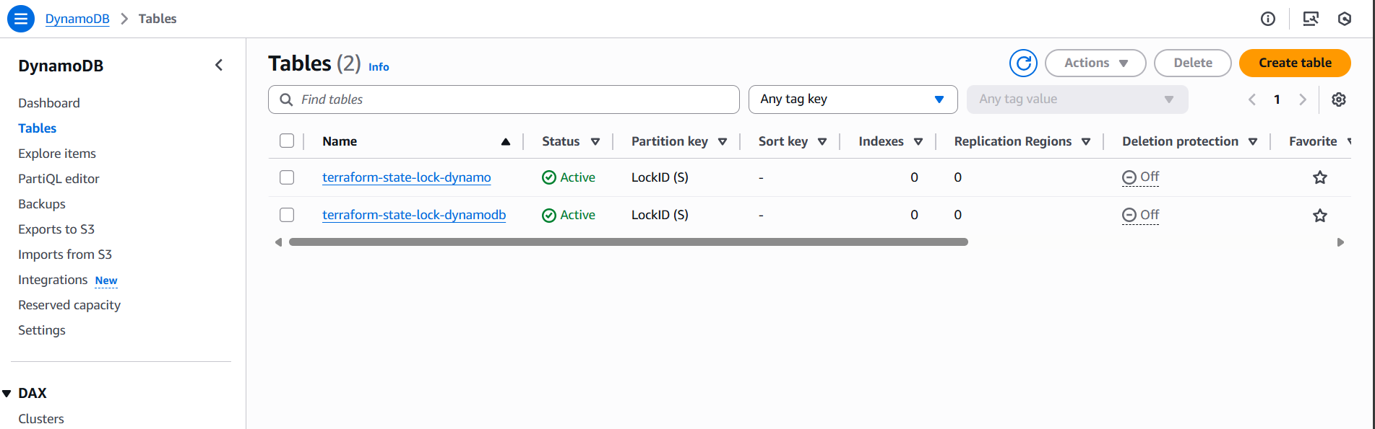

Created backed S3 to store the terraform.tfstate file

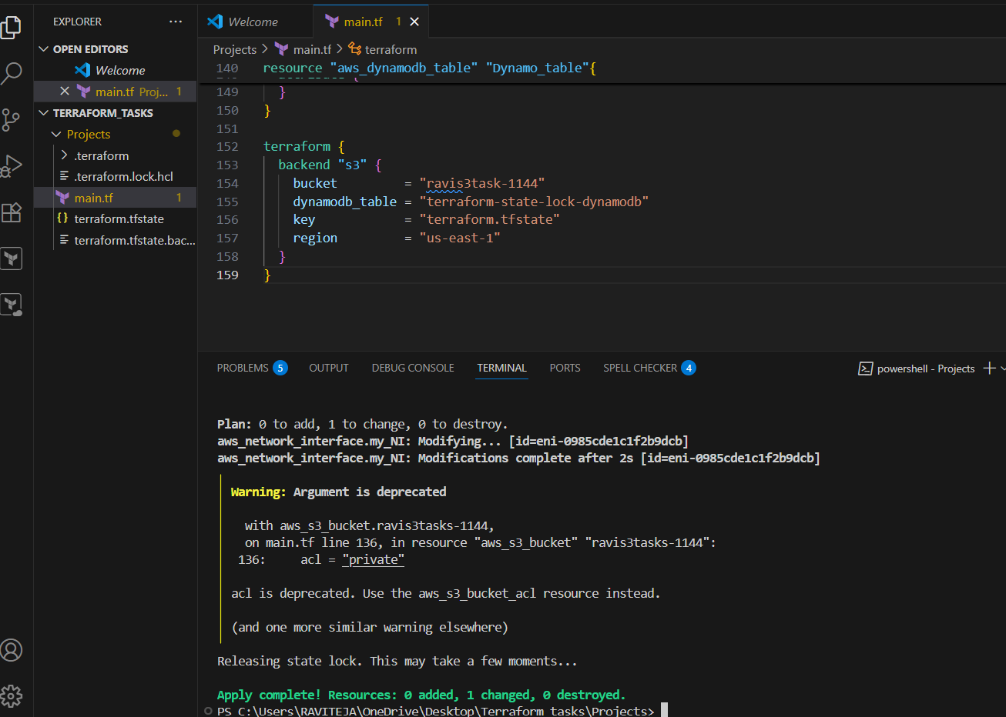

Stored in s3 bucket:

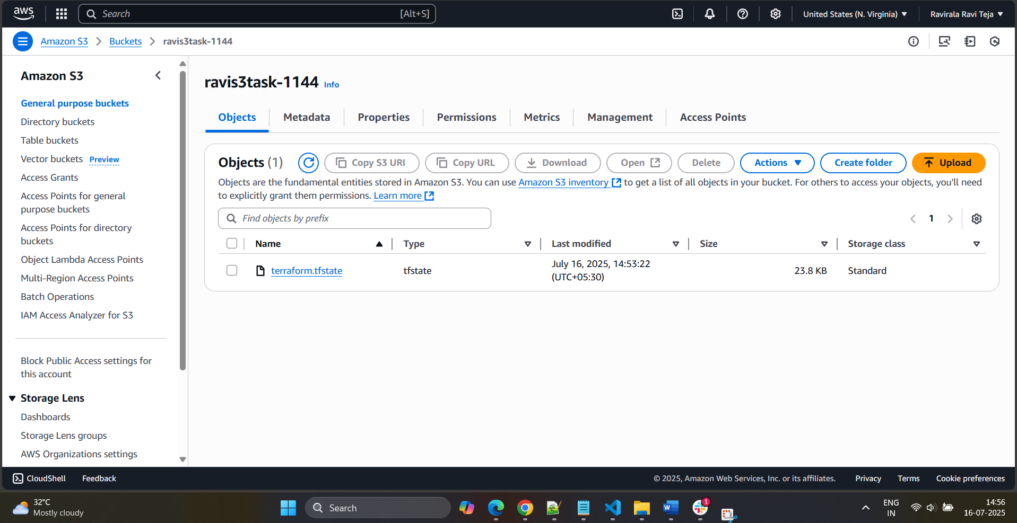

Terraform code for vpc,IGW,route tables,subnets,subnet association,network interface,elastic IP,created instance using ubuntu, s3 bucket,dynamodb table, terraform backend locked file to store s3

provider "aws" {

  region = "us-east-1"

}

#VPC CreationS

resource "aws_vpc" "main_vpc" {

  cidr_block           = "10.0.0.0/16"

  enable_dns_support   = true

  enable_dns_hostnames = true

  tags = {

    Name = "MainVPC"

  }

}

#internet gateway creation

resource "aws_internet_gateway" "my_IGW" {

  vpc_id = aws_vpc.main_vpc.id

  tags = {

    Name = "MyIGW"

  }

}

#Custom Route Table Creation

resource "aws_route_table" "My_RT" {

  vpc_id = aws_vpc.main_vpc.id

  route {

    cidr_block = "0.0.0.0/0"

    gateway_id = aws_internet_gateway.my_IGW.id

  }

  tags = {

    Name = "pri-RT"

  }

}

# Create Subnet

resource "aws_subnet" "Pub-Subnet" {

  vpc_id                  = aws_vpc.main_vpc.id

  cidr_block              = "10.0.0.0/24"

  availability_zone       = "us-east-1a"

  map_public_ip_on_launch = true

  tags = {

    Name = "Pub_sub"

  }

}

# Associate subnet with Route

resource "aws_route_table_association" "my_RTA" {

  subnet_id      = aws_subnet.Pub-Subnet.id

  route_table_id = aws_route_table.My_RT.id

}

#creating Security Groups for SSh,HTTP and HTTPS

resource "aws_security_group" "my_SG" {

  name        = "My_SG"

  description = "Allow SSH, HTTP, HTTPS"

  vpc_id      = aws_vpc.main_vpc.id

  ingress {

    description = "SSH"

    from_port   = 22

    to_port     = 22

    protocol    = "tcp"

    cidr_blocks = ["0.0.0.0/0"]

  }

  ingress {

    description = "HTTP"

    from_port   = 80

    to_port     = 80

    protocol    = "tcp"

    cidr_blocks = ["0.0.0.0/0"]

  }

  ingress {

    description = "HTTPS"

    from_port   = 443

    to_port     = 443

    protocol    = "tcp"

    cidr_blocks = ["0.0.0.0/0"]

  }

  egress {

    description = "All outbound"

    from_port   = 0

    to_port     = 0

    protocol    = "-1"

    cidr_blocks = ["0.0.0.0/0"]

  }

  tags = {

    Name = "My_SecurityGroup"

  }

}

#Creating network interface

resource "aws_network_interface" "my_NI" {

  subnet_id       = aws_subnet.Pub-Subnet.id

  private_ip      = "10.0.0.98"

  security_groups = [aws_security_group.my_SG.id]

  tags = {

    Name = "My_NI"

  }

}

resource "aws_eip" "My_EIP" {

  domain            = "vpc"

  network_interface = aws_network_interface.my_NI.id

  depends_on        = [aws_internet_gateway.my_IGW]

  tags = {

    Name = "Elastic_IP"

  }

}

# Create Ubuntu EC2 and install Apache

resource "aws_instance" "Ubuntu_server" {

  ami           = "ami-020cba7c55df1f615"

  instance_type = "t2.micro"

  network_interface {

    network_interface_id = aws_network_interface.my_NI.id

    device_index         = 0

  }

  user_data = <<-EOF

              #!/bin/bash

              apt-get update -y

              apt-get install apache2 -y

              systemctl enable apache2

              systemctl start apache2

              EOF

  tags = {

    Name = "MY_ubuntuApacheServer"

  }

}

resource "aws_s3_bucket" "ravis3tasks-1144" {

  bucket = "ravis3task-1144"

  acl    = "private"

}

resource "aws_dynamodb_table" "Dynamo_table" {

  name           = "terraform-state-lock-dynamodb"

  hash_key       = "LockID"

  read_capacity  = 20

  write_capacity = 20

  attribute {

    name = "LockID"

    type = "S"

  }

}

terraform {

  backend "s3" {

    bucket         = "ravis3task-1144"

    dynamodb_table = "terraform-state-lock-dynamodb"

    key            = "terraform.tfstate"

    region         = "us-east-1"

  }

}