1. Setup a virtual machine using Ubuntu image.

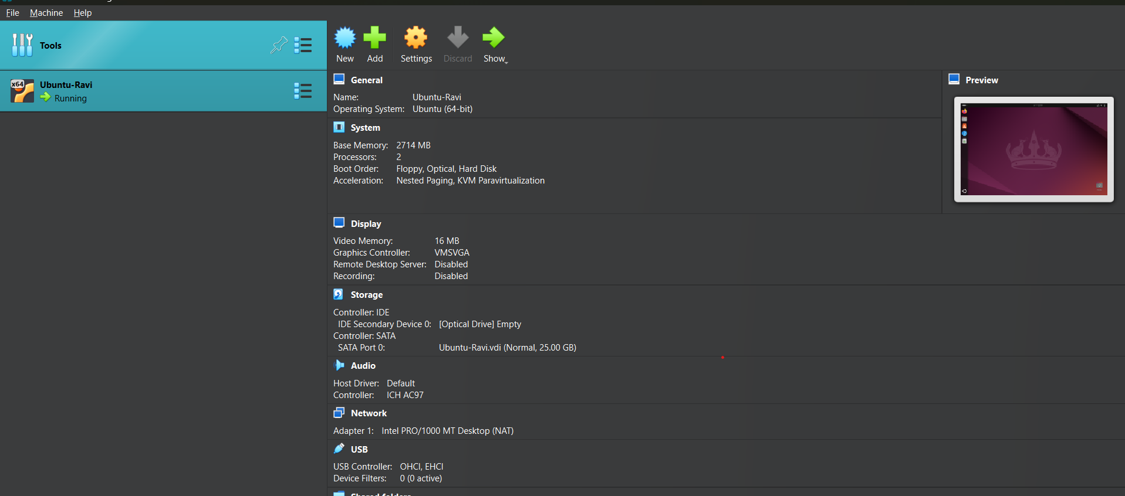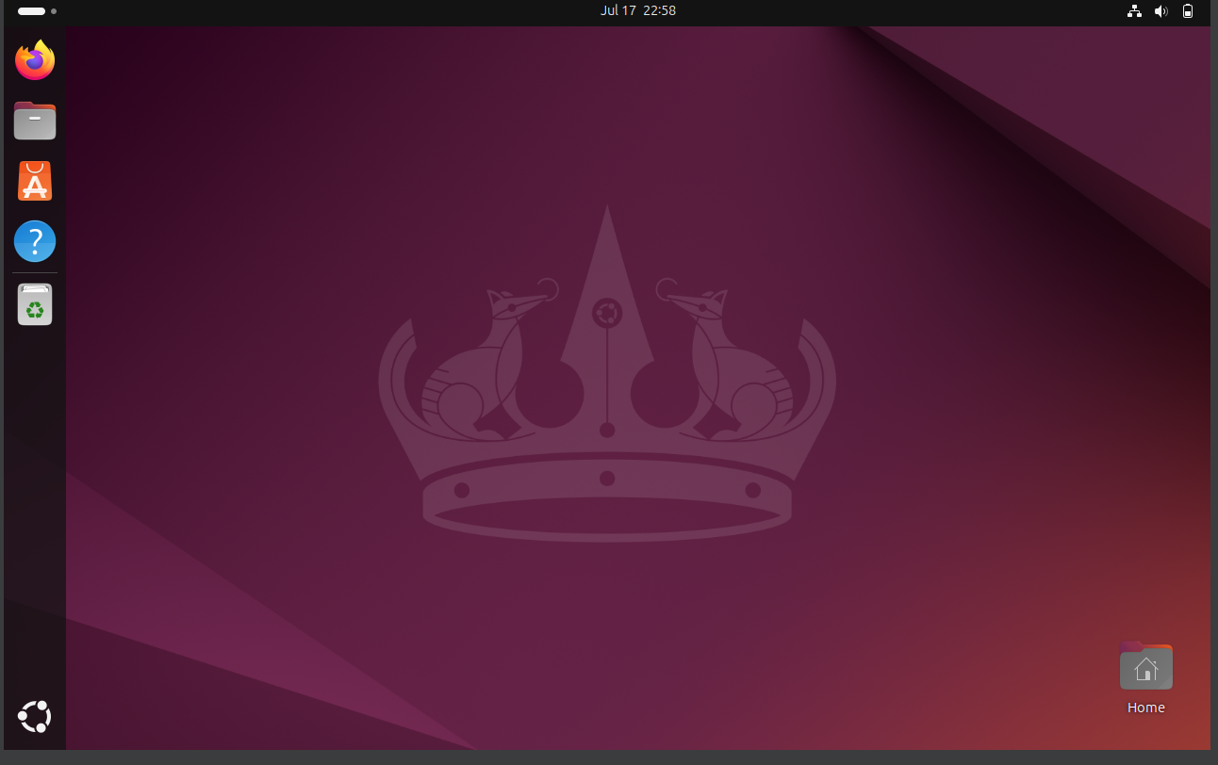

1. Install docker on ec2.

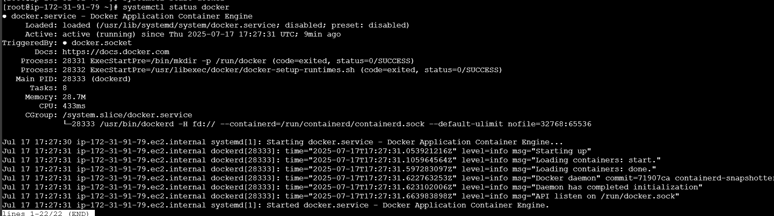

1. Pull 5 docker images.(nginx,apache tomcat,ubuntu,jenkins,sonarqube)

Docker pull nginx

Docker pull tomcat

Docker pull ubuntu

Docker pull Jenkins:2.60.3

Docker pull sonarqube

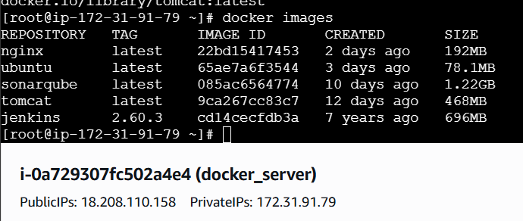

1. Run nginx container and expose on port 81.

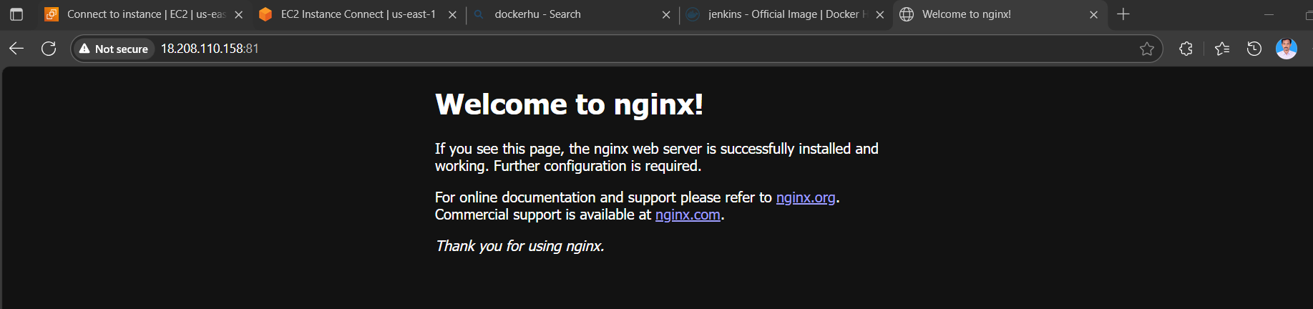

1. Delete the apache tomcat image from local.

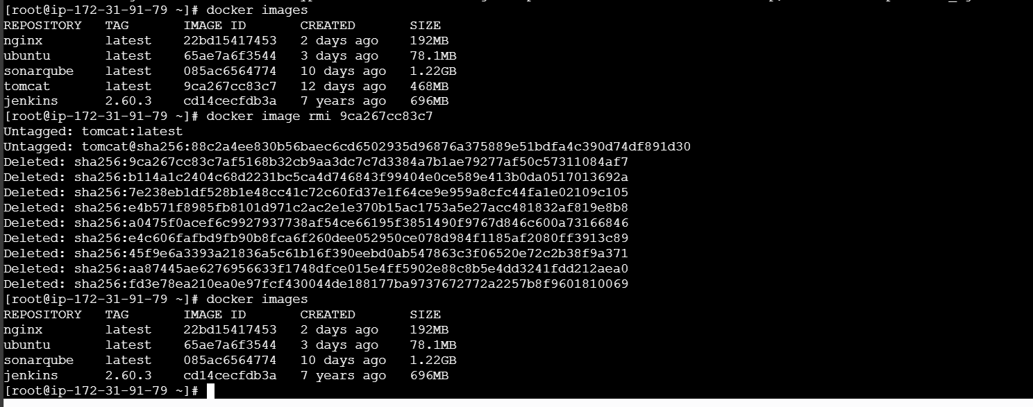

1. Inspect the jenkins image,sonarqube image.

For Jenkins:

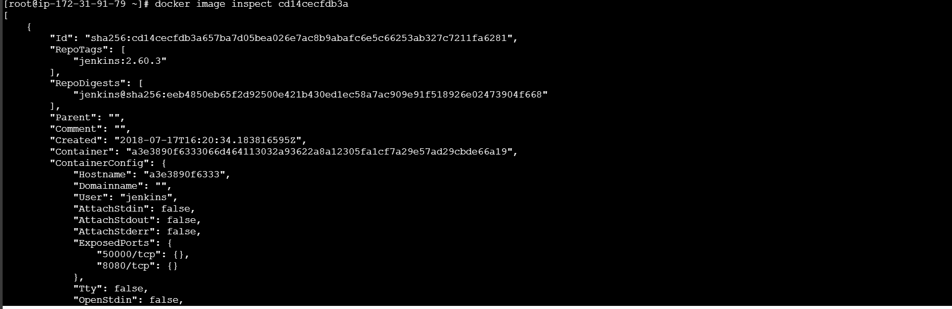

For sonarqube:

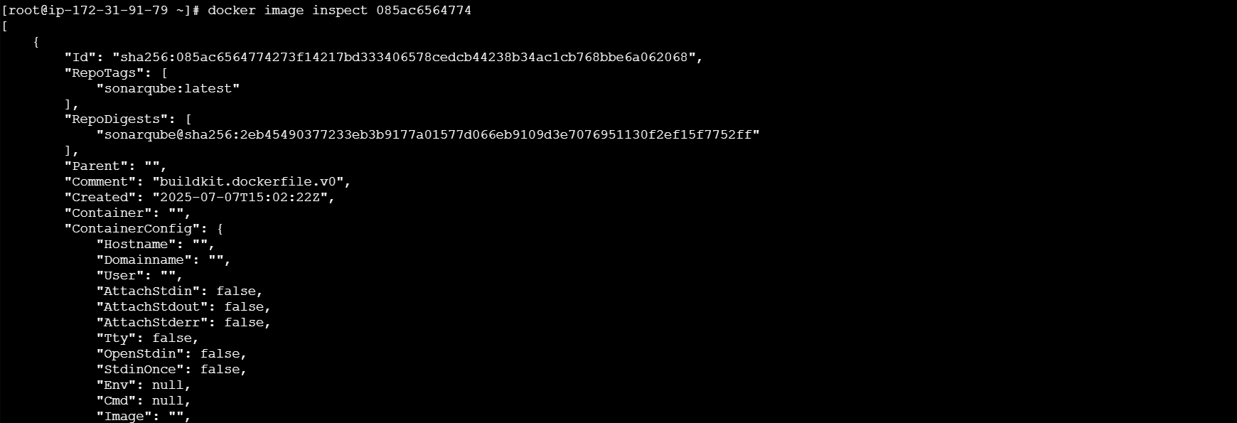

1. Run jenkins contianer and run one sample job.

