1. Setup Minikube in your local machine.

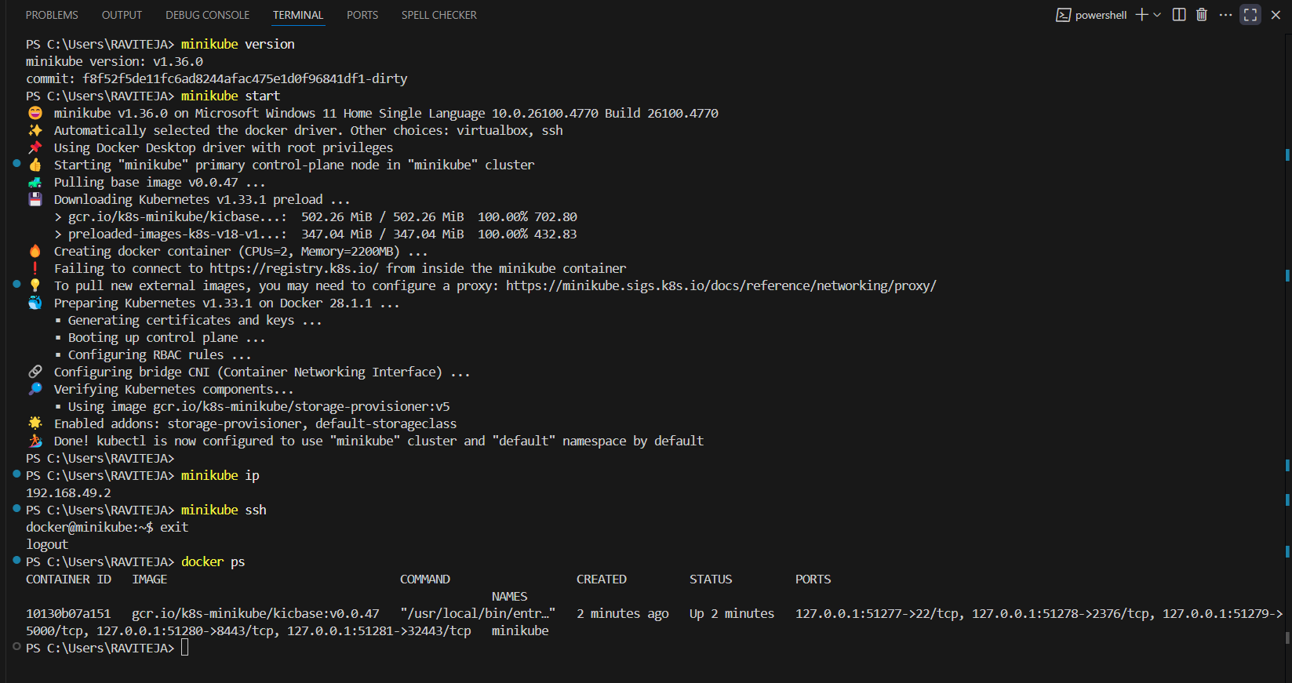

1. Setup k8s master and two worker nodes on ubuntu.

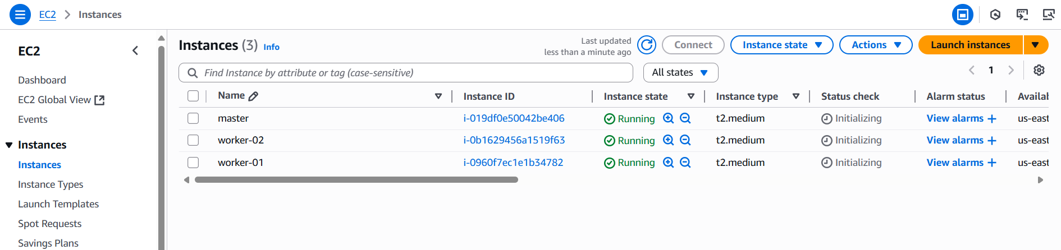 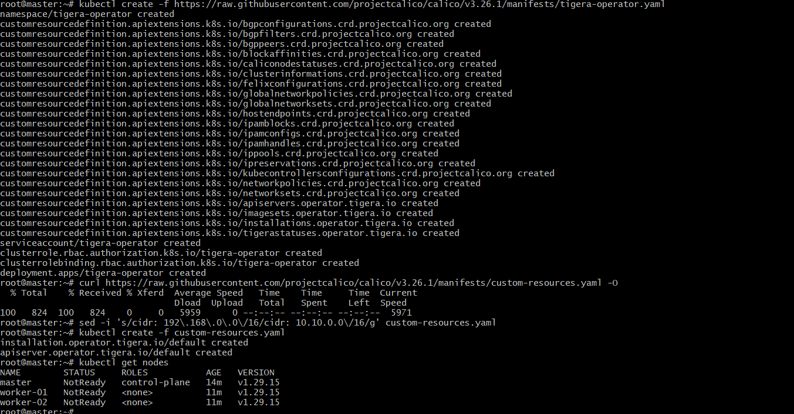 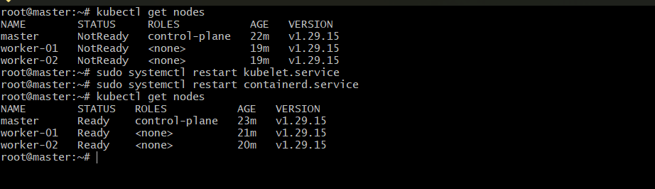 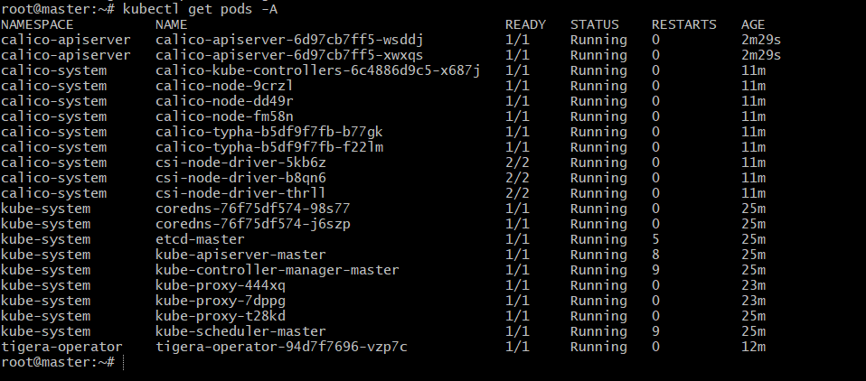

1. Run one nginx pod.

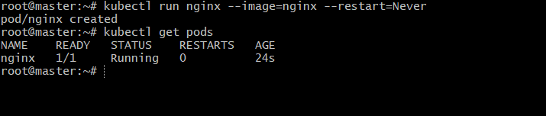 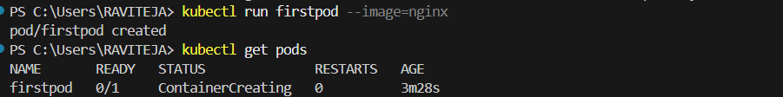 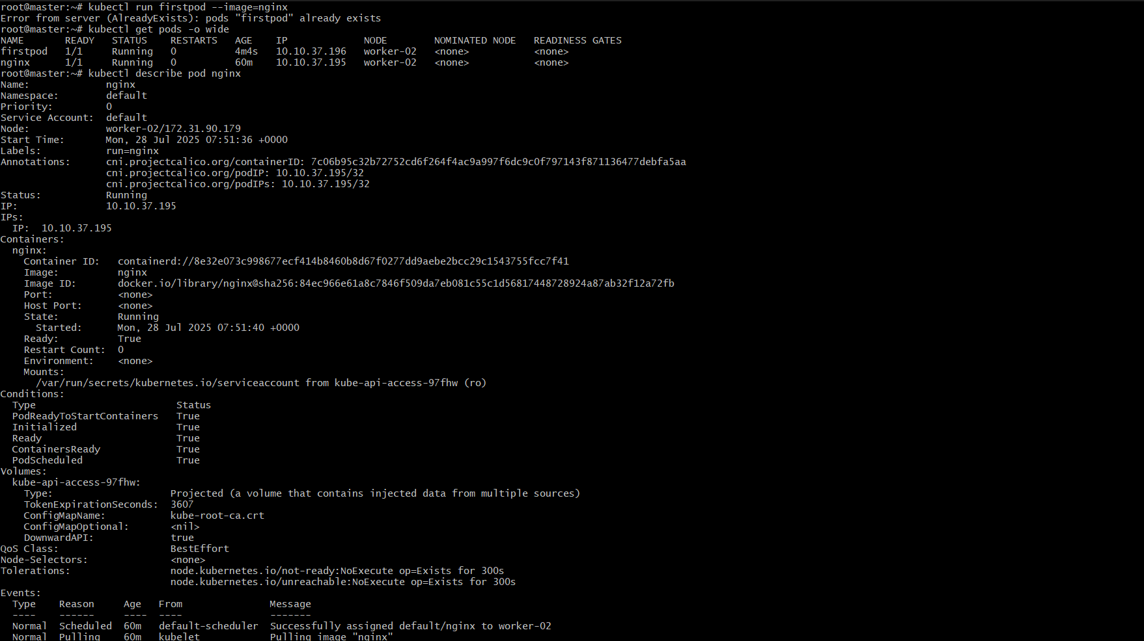 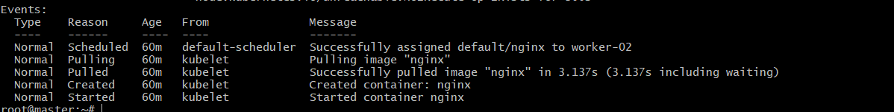

1. Mugup Master and slave components on k8s.

Kubernetes is built on a master-worker (formerly master-slave) architecture where the Control Plane (master components) manages the cluster and makes decisions, while the worker nodes (slave components) execute the workloads.

Master Components (Control Plane):

* **API Server:**

The primary communication interface for the cluster, handling requests from users, management devices, and command-line tools like kubectl.

* **Scheduler:**

Responsible for assigning Pods to worker nodes based on resource availability and other constraints.

* **Controller Manager:**

Contains various controllers that manage the desired state of the cluster, such as ensuring the correct number of replicas for a deployment.

* **etcd:**

A distributed key-value store that serves as the cluster's primary data store, holding all configuration data, state, and metadata.

Worker Components (Nodes):

* **Kubelet:**

An agent that runs on each worker node, ensuring that containers described in Pod specifications are running and healthy.

* **Container Runtime:**

The software responsible for running containers (e.g., Docker, containerd).

* **Kube-proxy:**

Maintains network rules on nodes and handles network communication for Pods.