1. Create a ClusterIP service for an Apache web server pod.

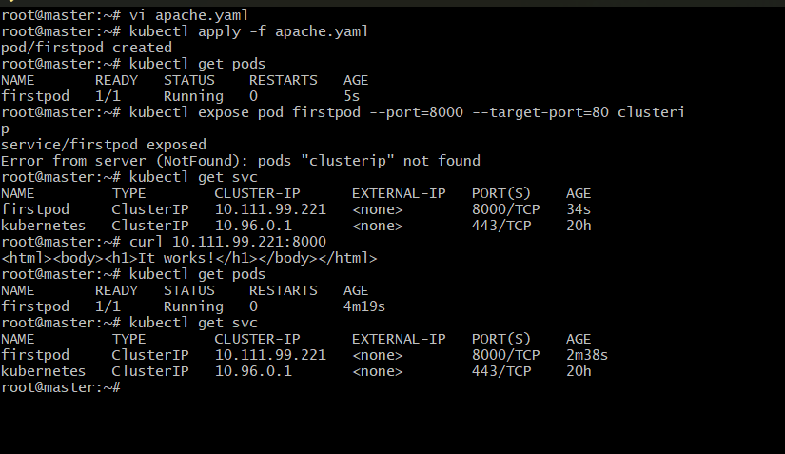

1. Expose an Nginx pod externally using a NodePort service.

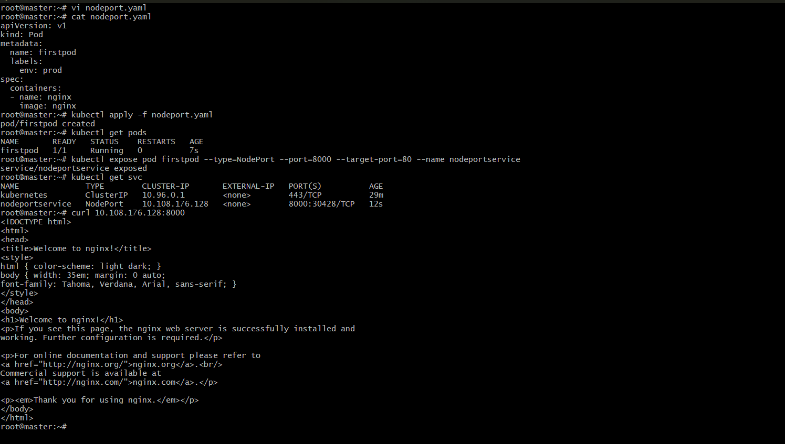

Public IP of master :30428

 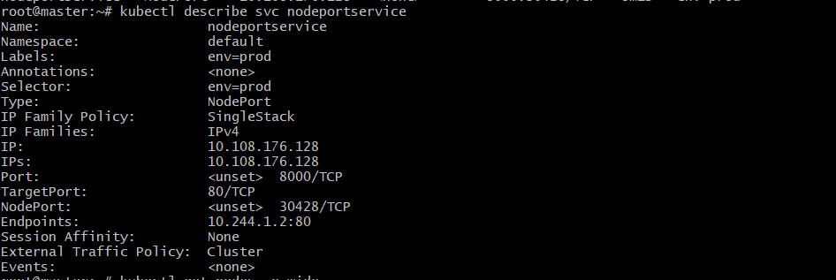

Public IP of Worker node-1:30428



Public IP of worker node-2



1. Deploy a ReplicationController to maintain 3 replicas of an Nginx pod.

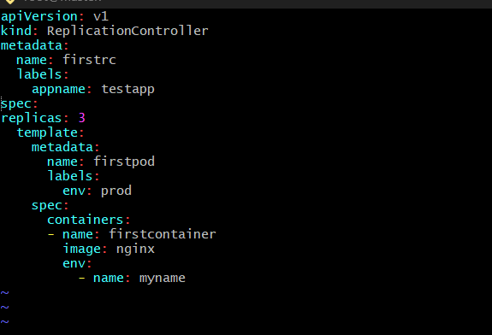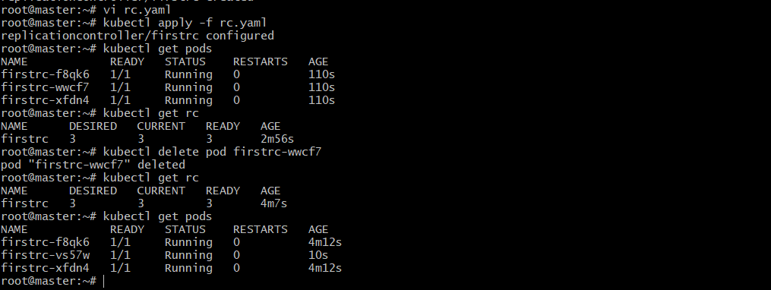

1. Scale the ReplicationController from 3 replicas to 5 replicas.

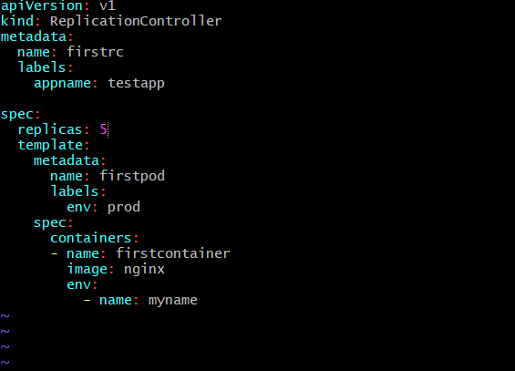 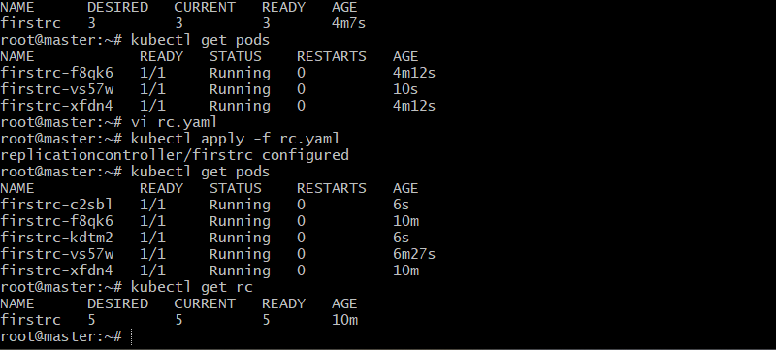 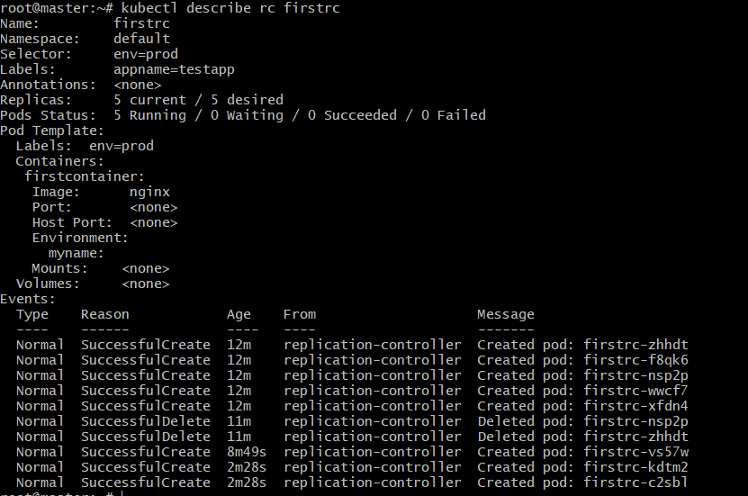

1. Create a ReplicaSet to manage pods based on multiple labels (prod and test).

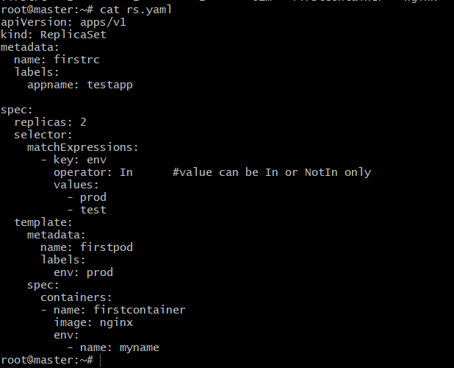  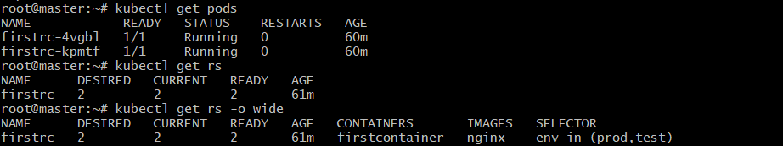

1. Deploy a ReplicaSet that excludes pods with the label backend.
2. 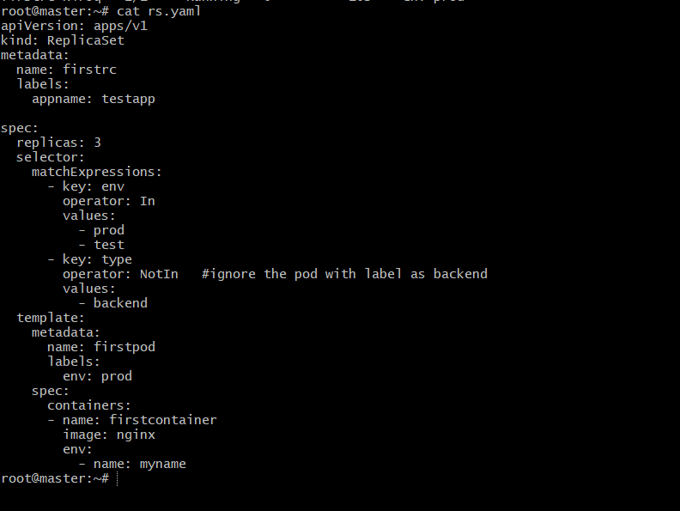

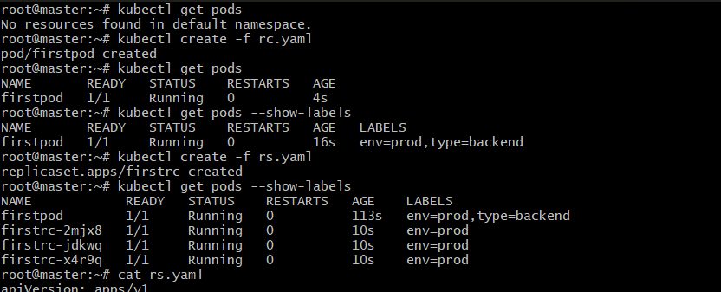

1. Test load balancing across multiple pods using a NodePort service.

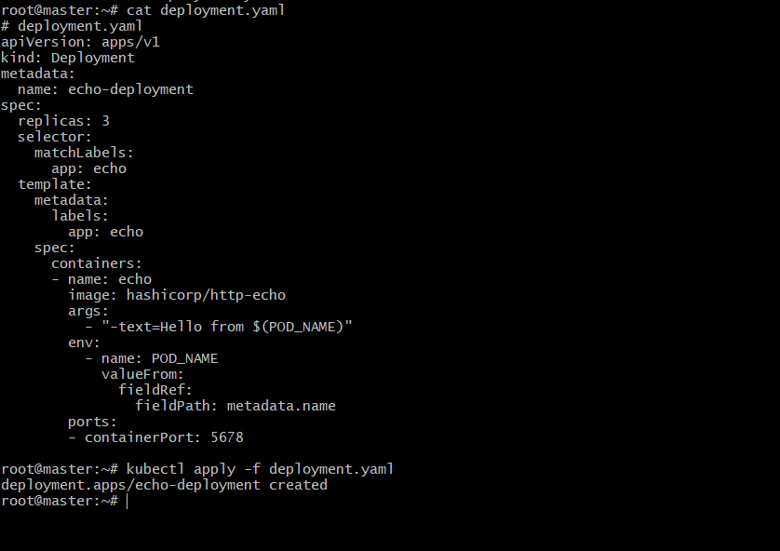 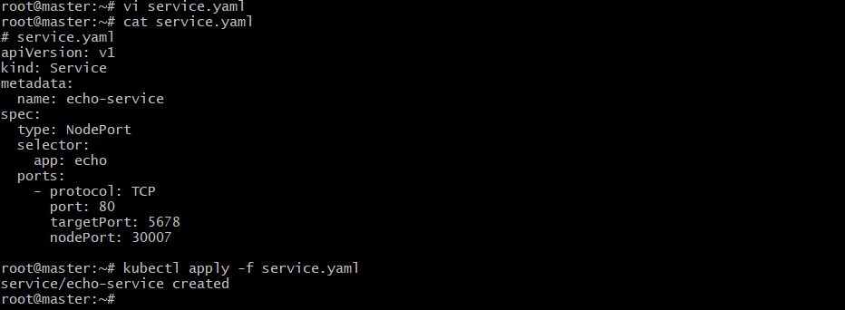 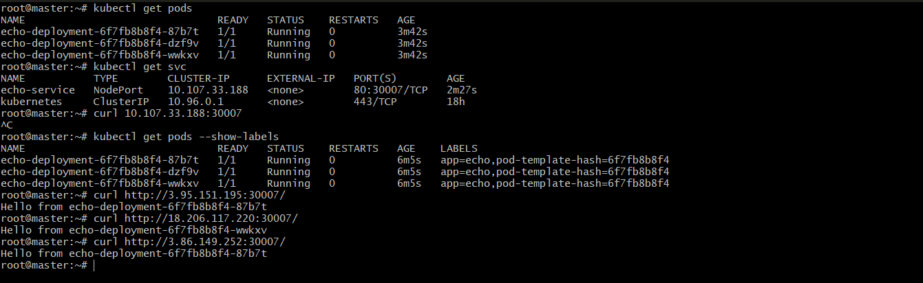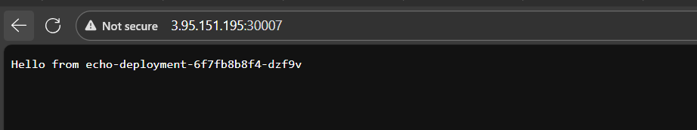 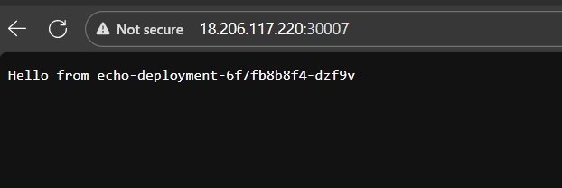 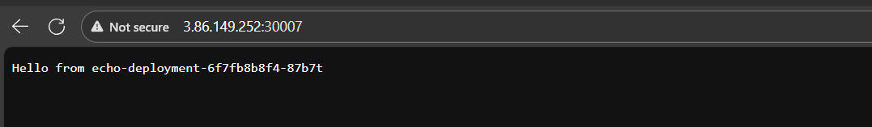

8) Delete a ReplicationController without affecting the running pods.

