1. Create a namespace dev-environment and apply a resource-based quota that restricts the number of pods to 3 and services to 2.



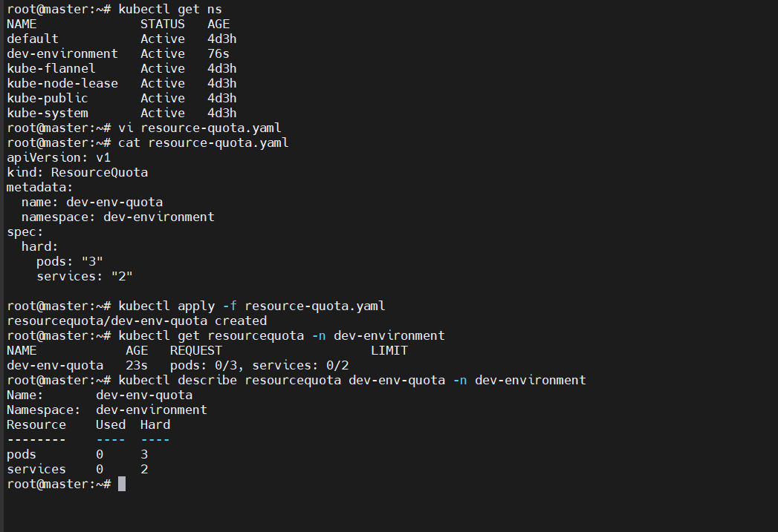

1. Create a pod in the prod-environment namespace with 0.2 CPU and 200Mi memory requests, and 0.5 CPU and 500Mi memory limits.

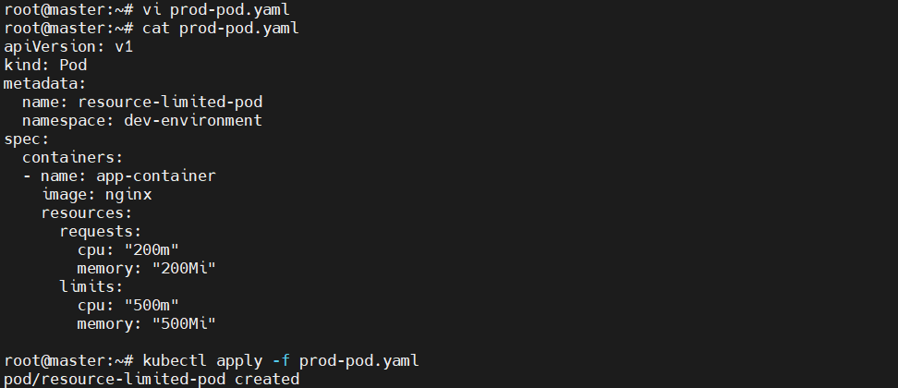 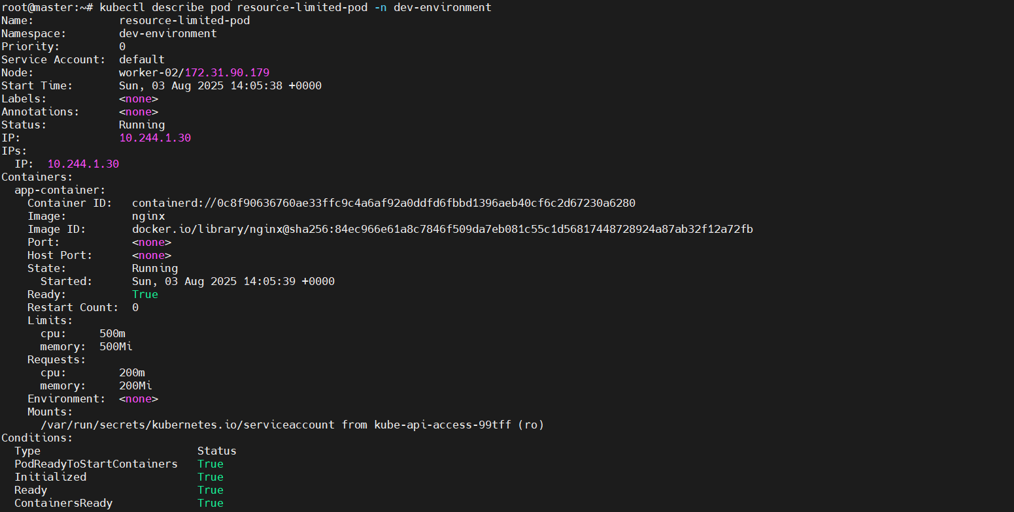 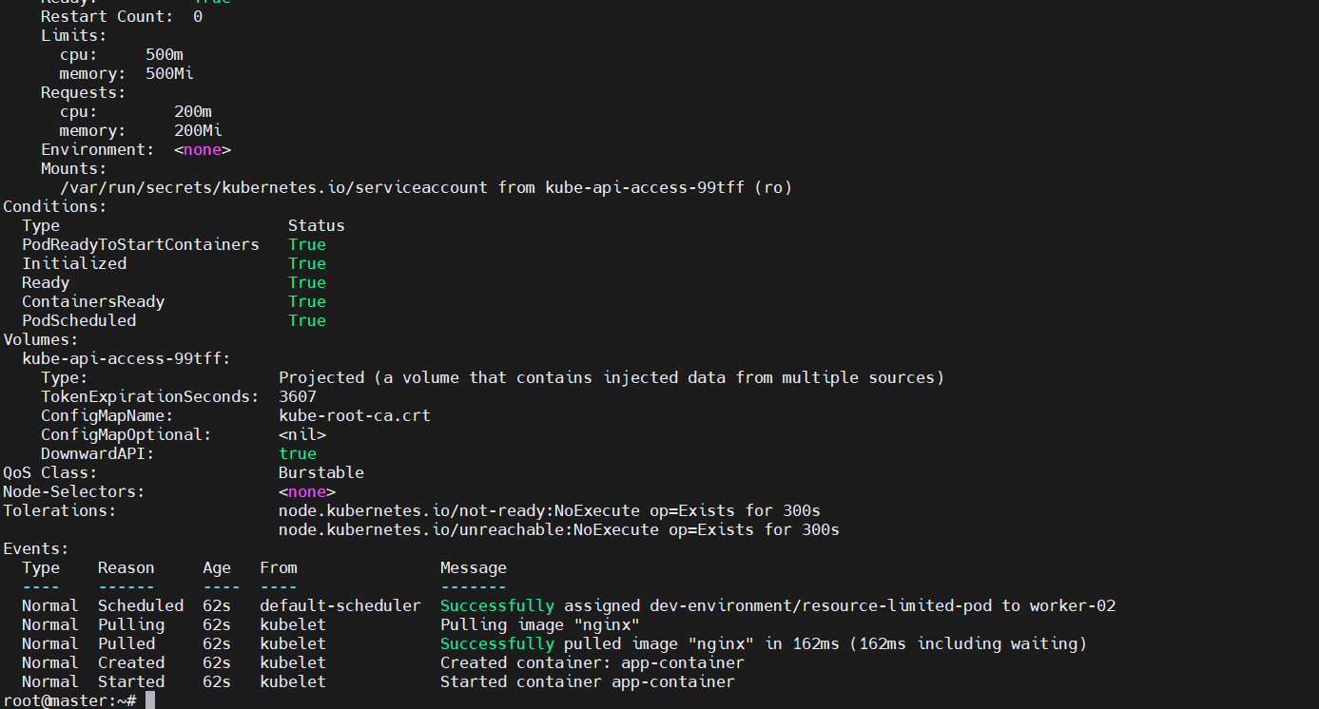

1. In the staging-environment namespace, set a LimitRange that assigns default CPU and memory limits (300m CPU, 600Mi memory) and applies a minimum and maximum CPU.

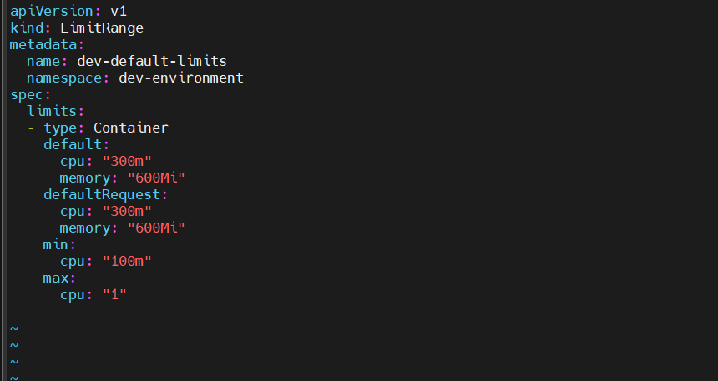 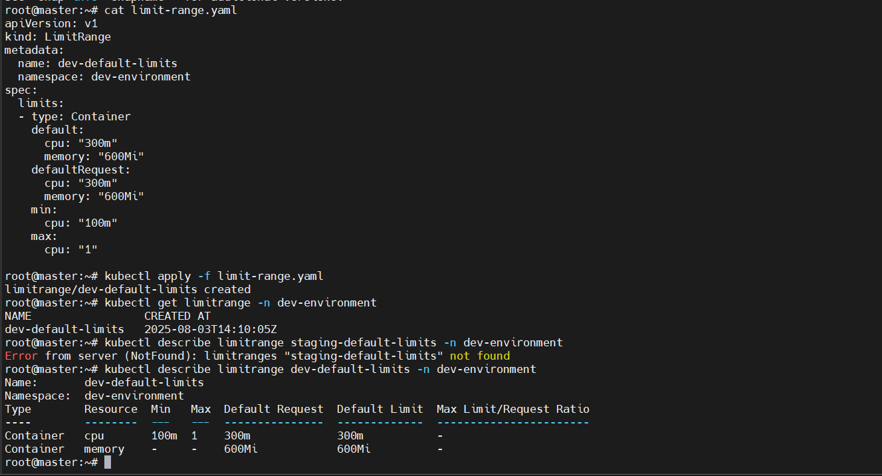

1. Create a pod and a NodePort service in the default namespace, then create another pod in the test namespace and communicate between them using Service DNS.

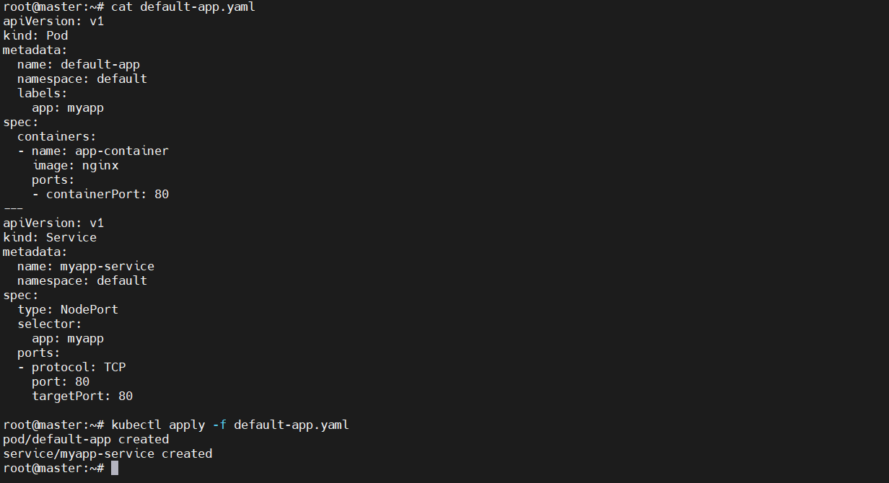 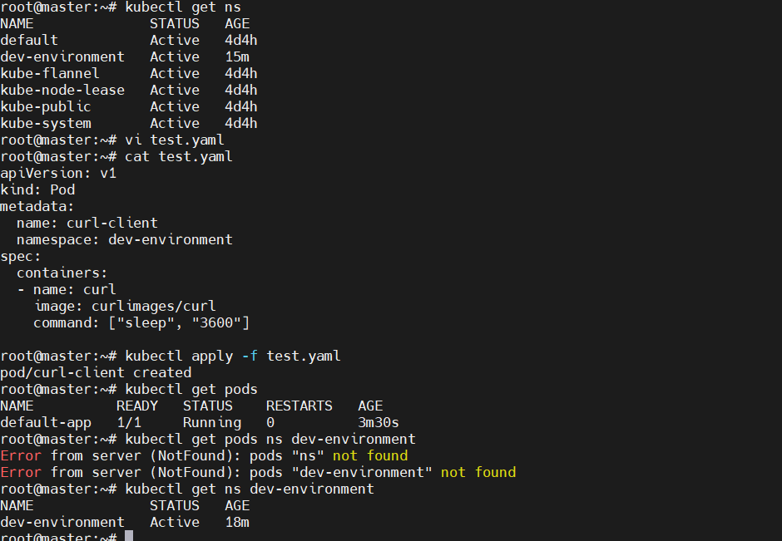 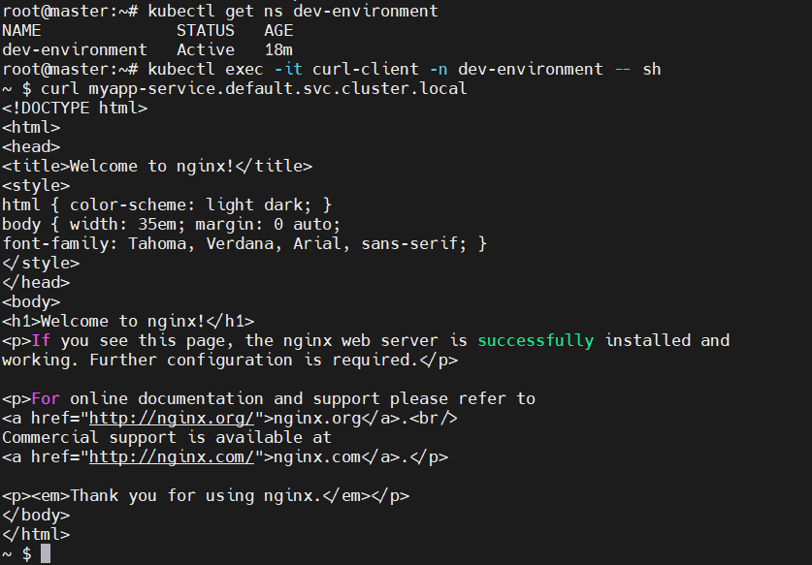

1. Apply a LimitRange with a max limit/request ratio of 2 for memory in the performance-environment namespace, and test by creating a pod with mismatched resource requests and limits.

