1. Create a ConfigMap from a directory containing multiple files and inject the variables into a pod as environment variables.

Two files

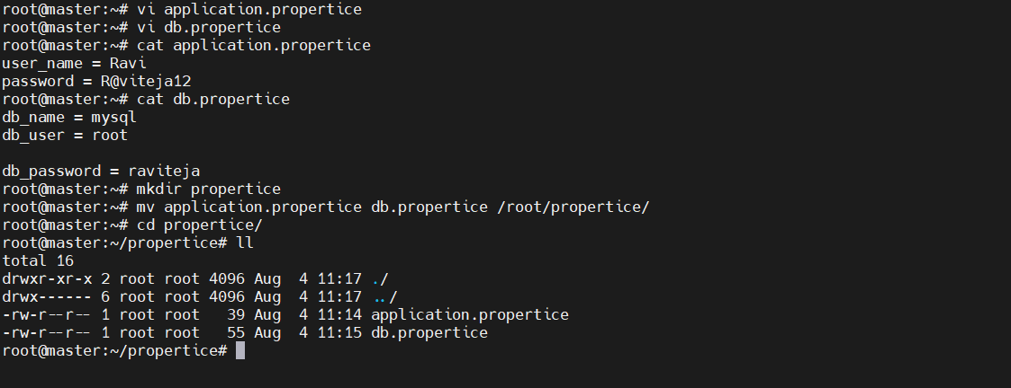 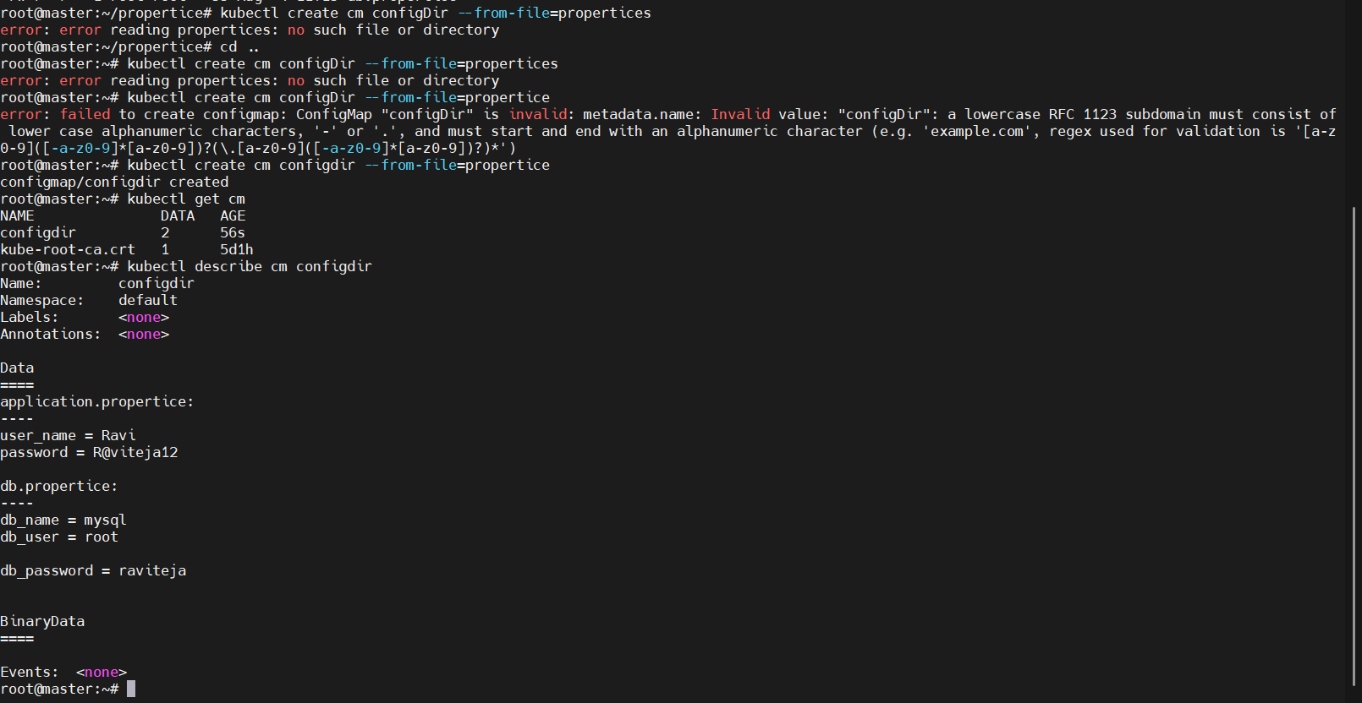 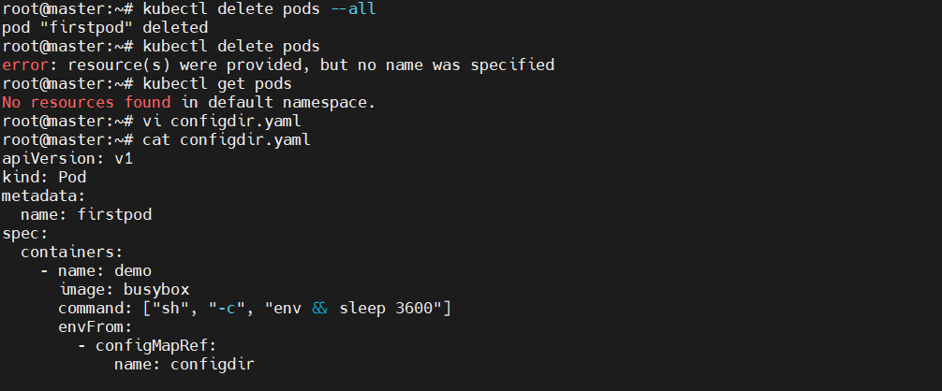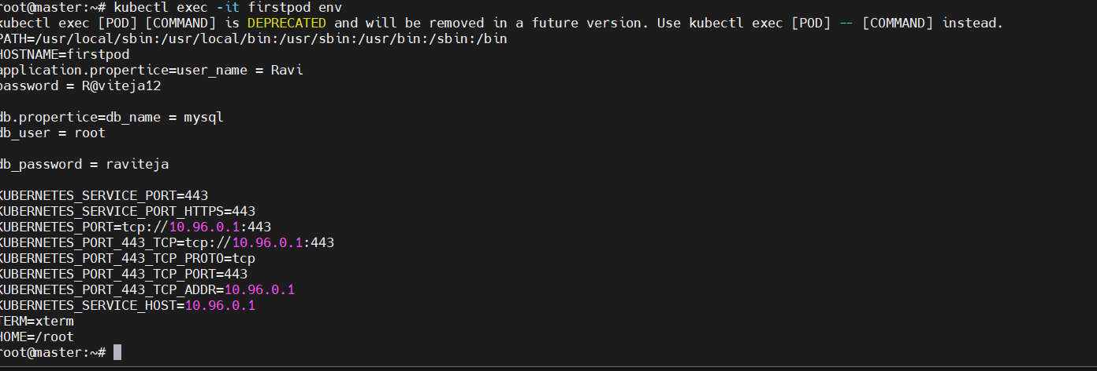

1. Create a ConfigMap from a file and mount it as a volume inside a pod, ensuring the configuration data is available as files.

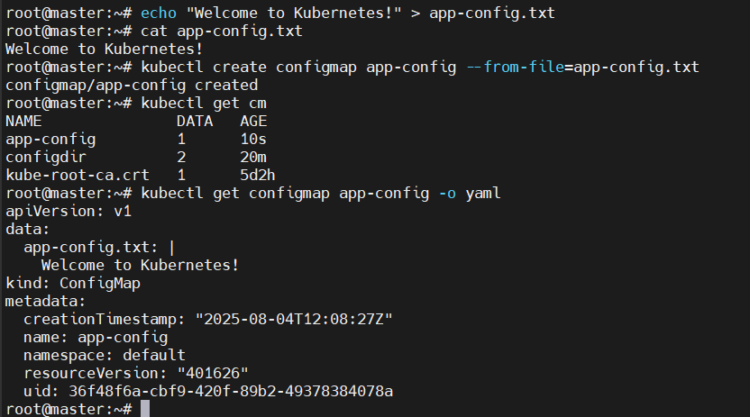 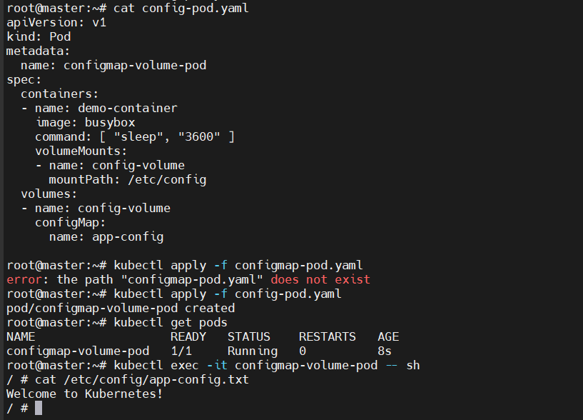

1. Create a Secret with sensitive information (username and password) and inject it into a pod as environment variables.

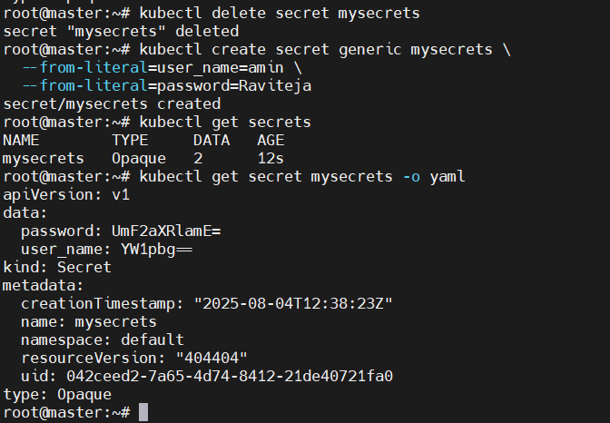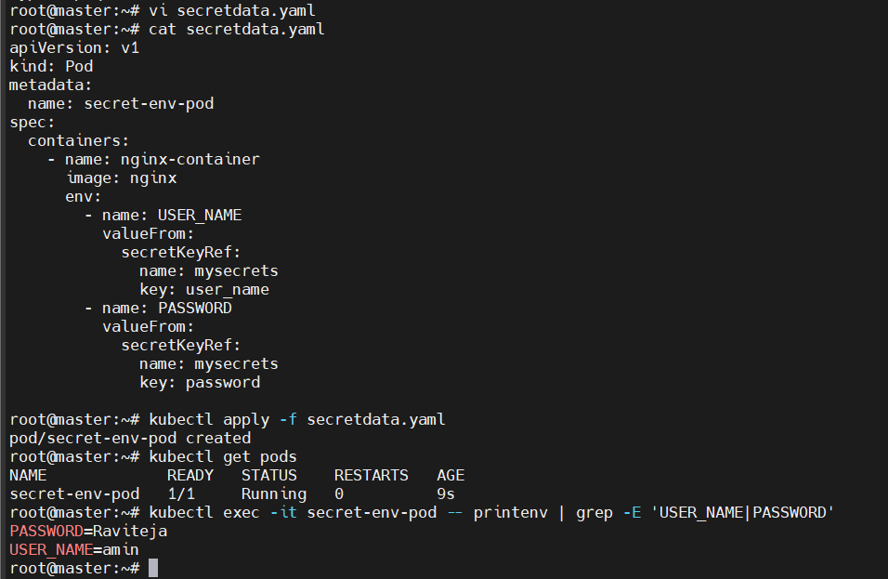

1. Create a Secret using a YAML file, mount it as a volume in a pod, and verify the specific Secret values are available as files.

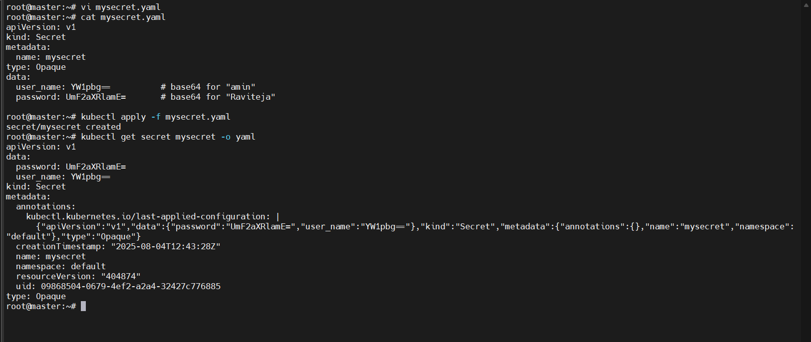 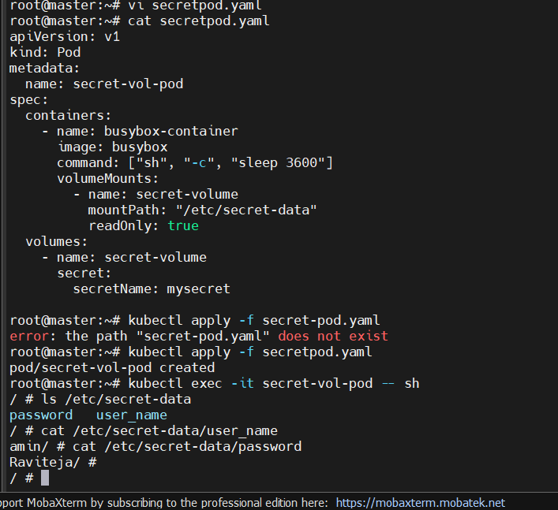

1. Inject a ConfigMap as environment variables and a Secret as files into the same pod, ensuring both are accessible within the pod.

