Task 1: Execute all yaml files shown in video.

Taint effect:NoSchedule

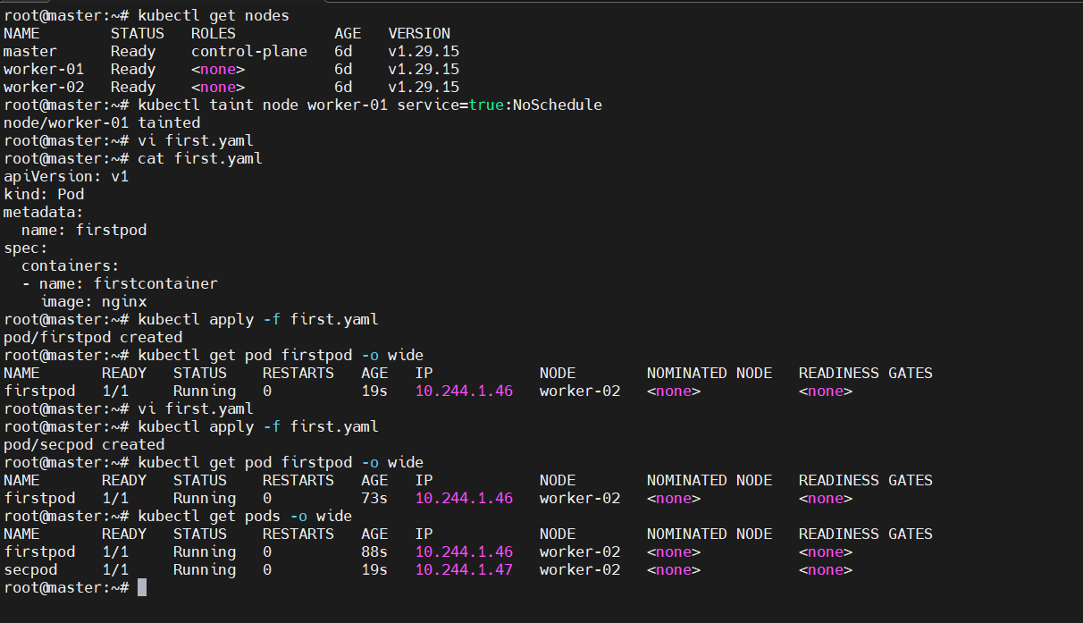

TaintEffect: NoExecute

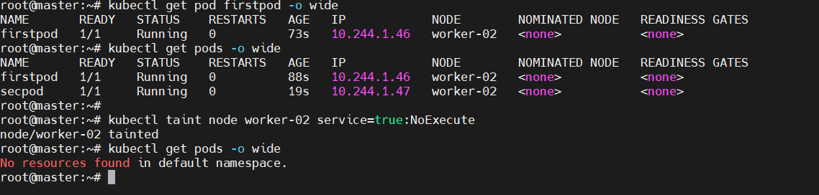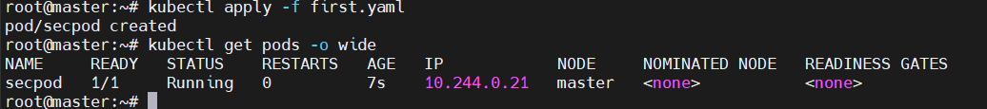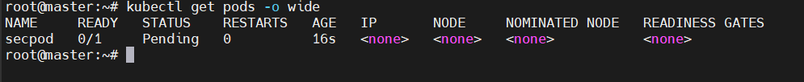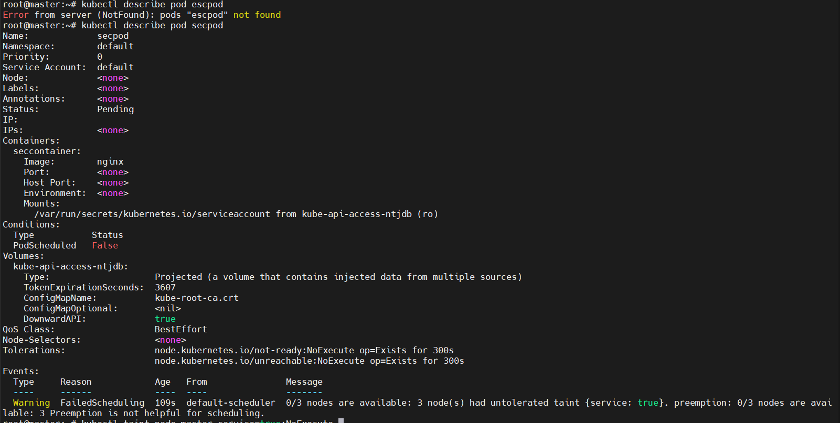

For untainted

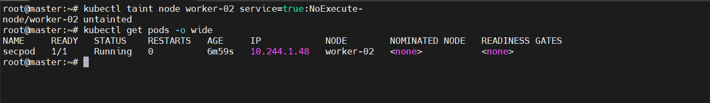

Taint effect : PreferNoSchedule

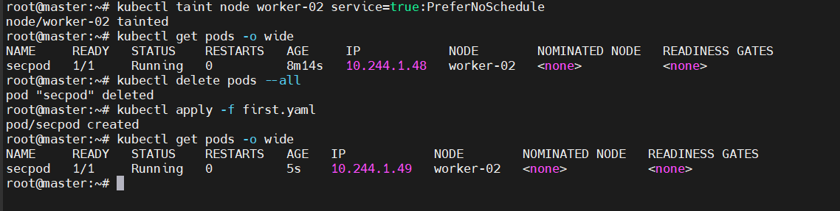

Using Tolerations

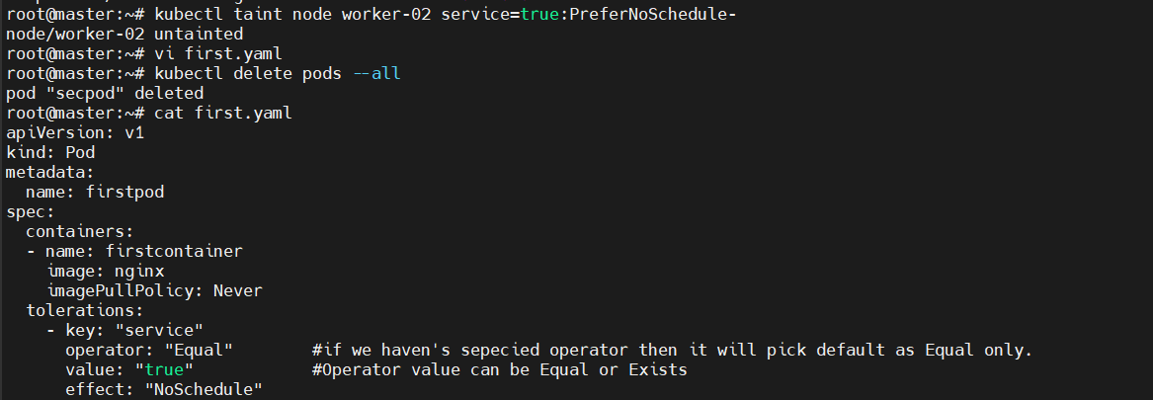

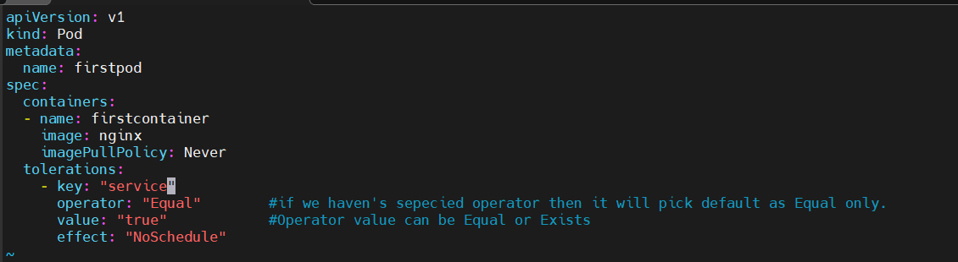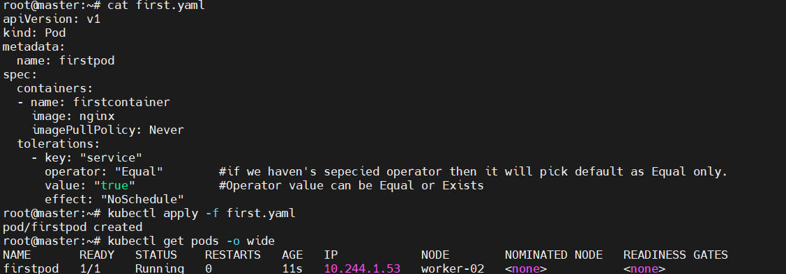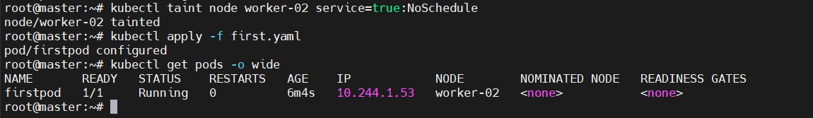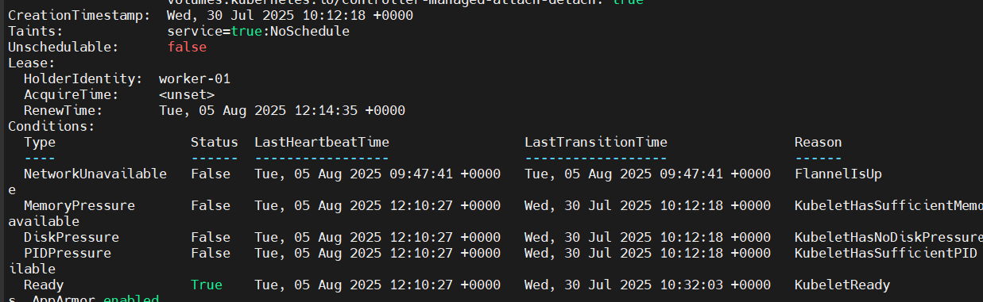

Tolerationseconds:60

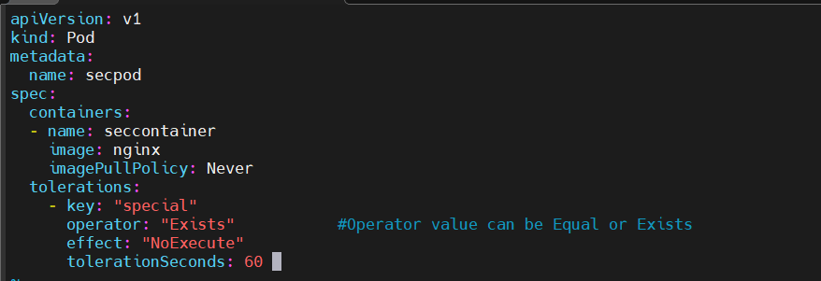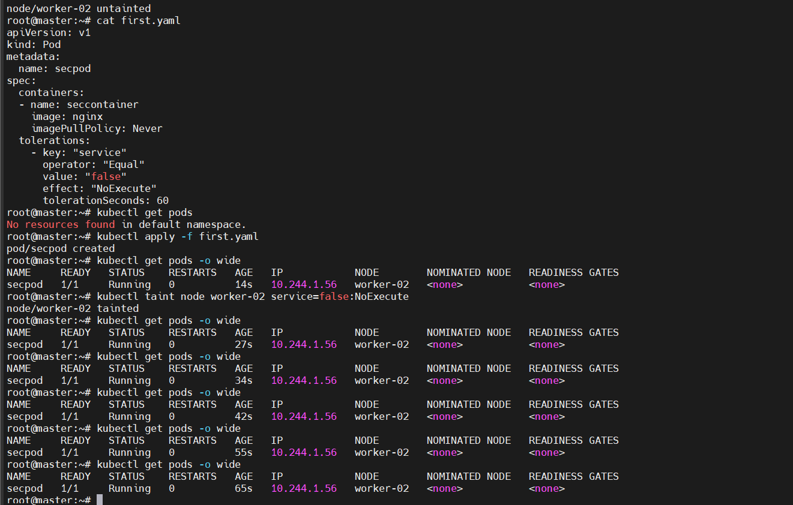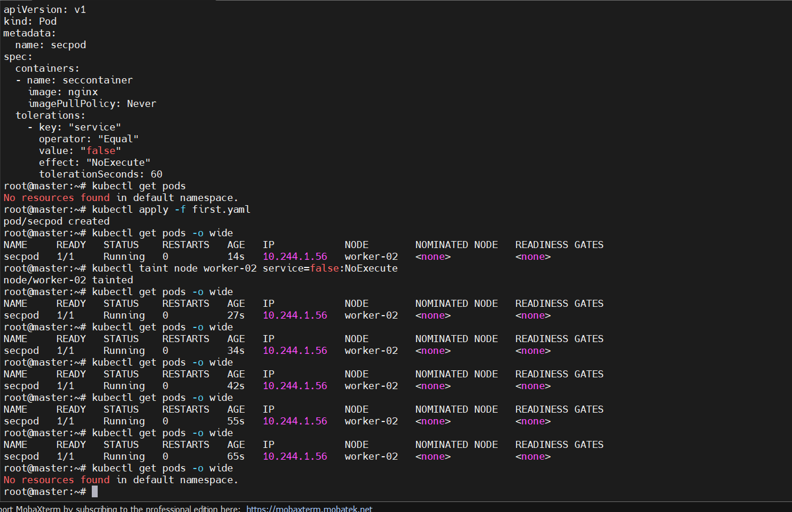

nodeSelector

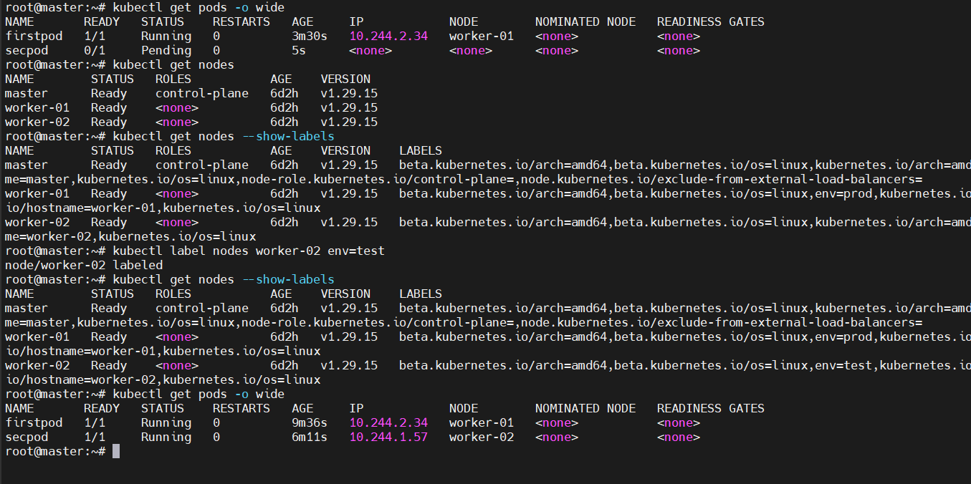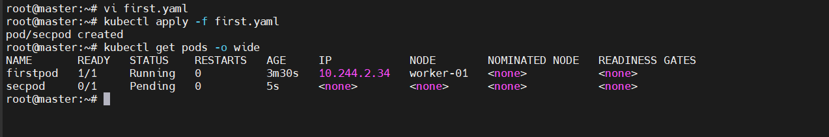



If I remove label to worker-02 still the pod is working, not deleted

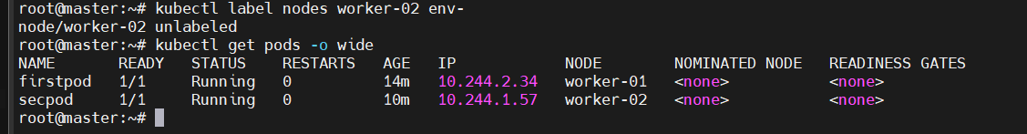

Node affinity:

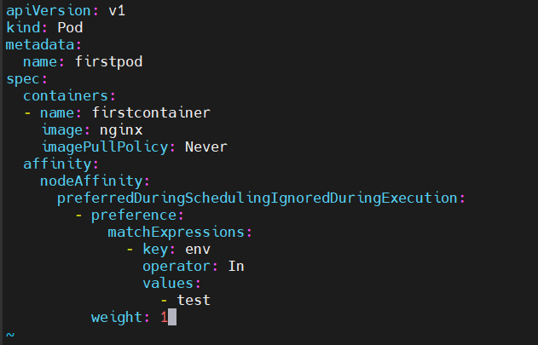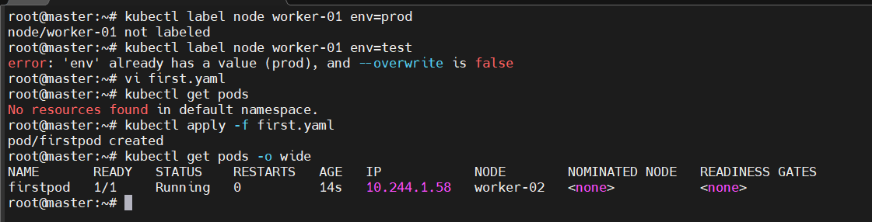

Node affinity unavailable labels:

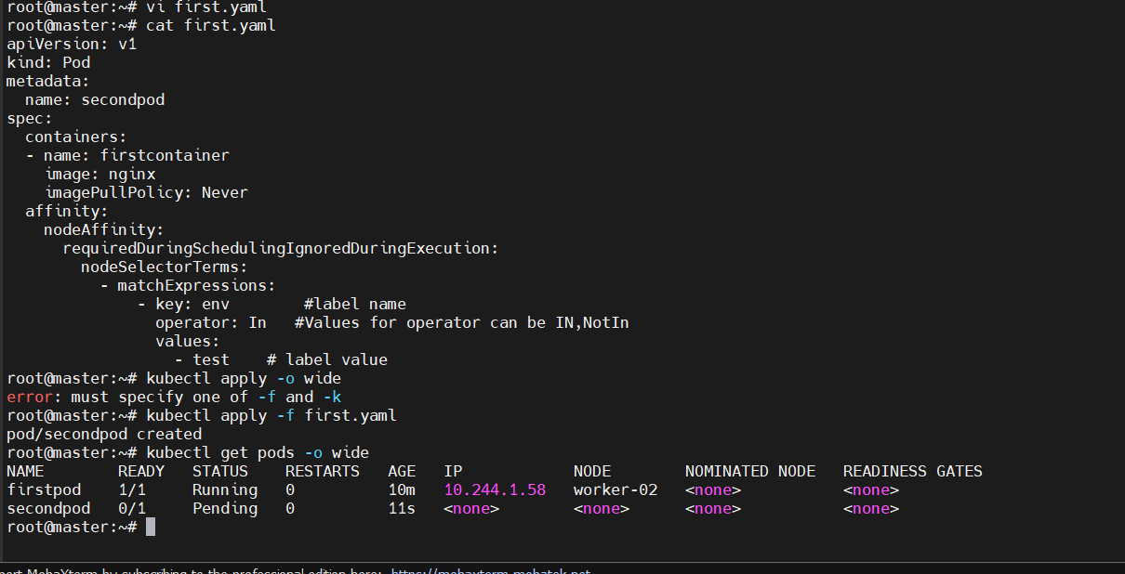

NotIn Opearator:

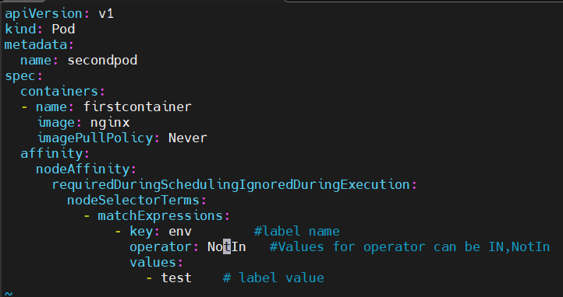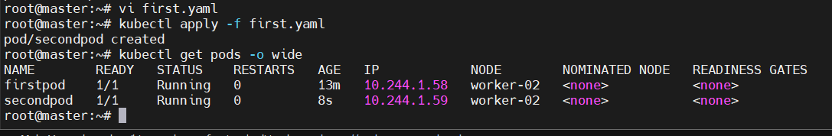

Env=prod

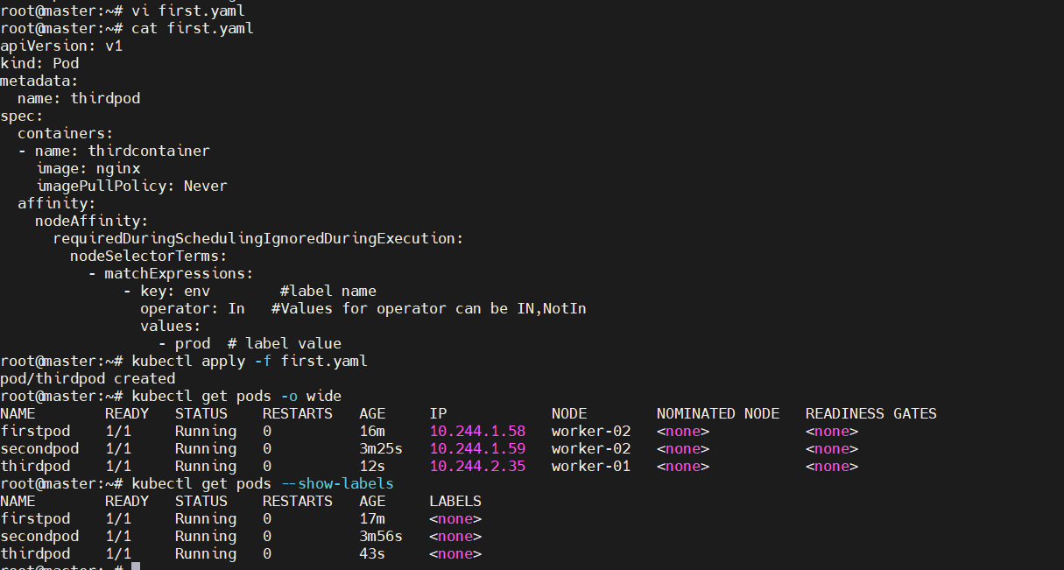  
Task 2: Taint a Node and Schedule a Tolerant Pod Taint a node with special=true:NoSchedule. Create a pod with a toleration that matches the taint, allowing it to be scheduled on the tainted node.

 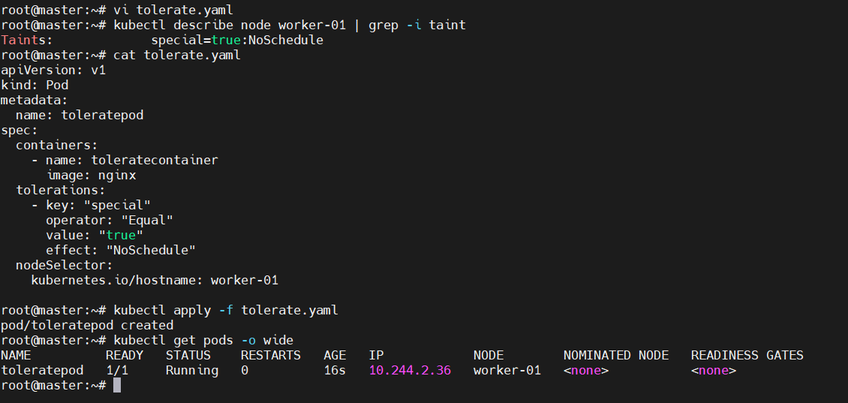  
Task 3: Use NodeSelector to Schedule a Pod on a Specific Node Label a node with env=dev. Create a pod with a nodeSelector that schedules it only on the node labeled env=dev.

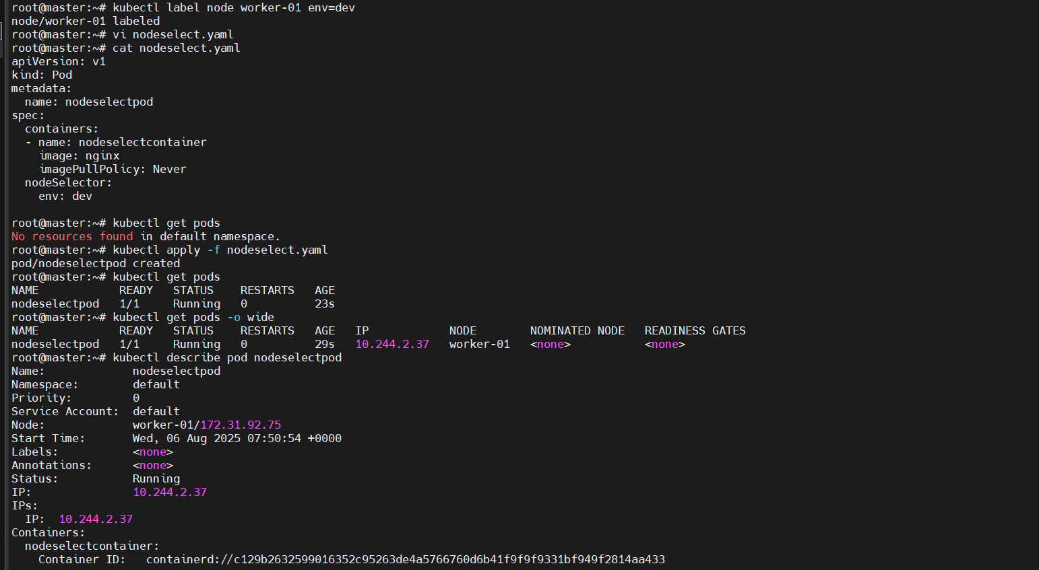 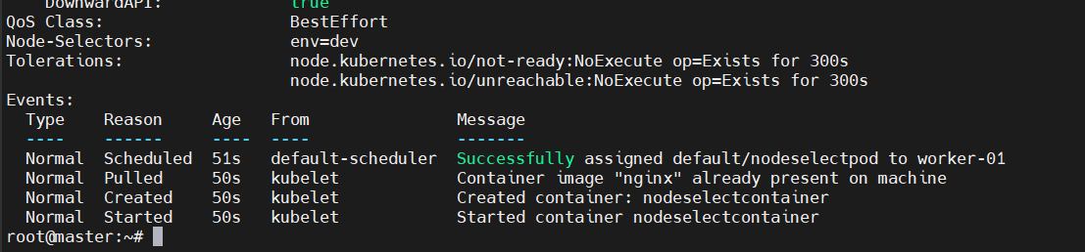

Task 4: Use Node Affinity with Soft Scheduling Label a node with env=test. Create a pod with PreferredDuringSchedulingIgnoredDuringExecution node affinity, preferring to schedule it on a node labeled env=test. Remove the label and verify the pod continues to run.

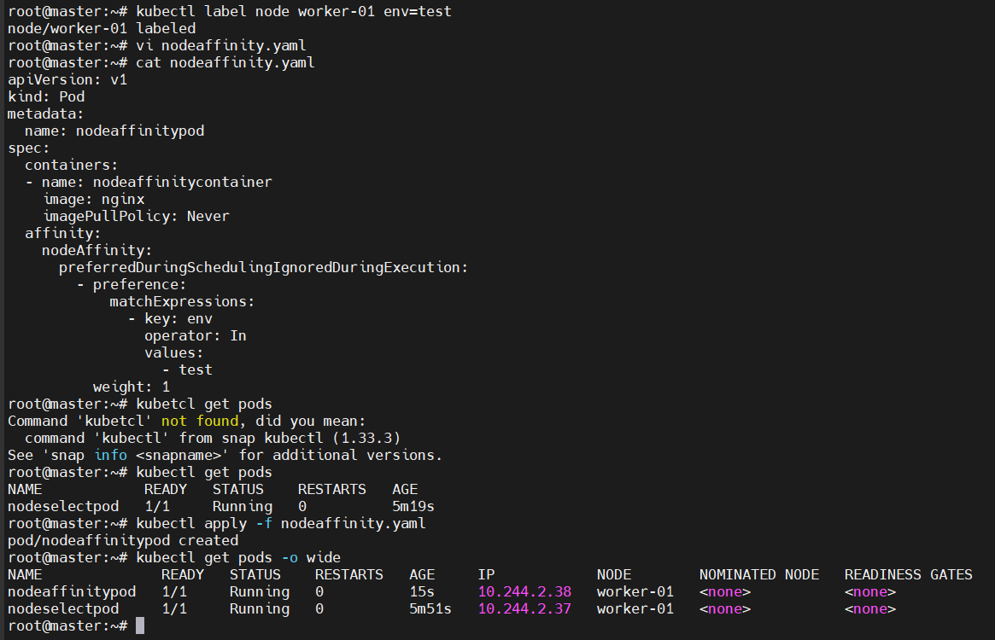

Remove the label and verify the pod continues to run.

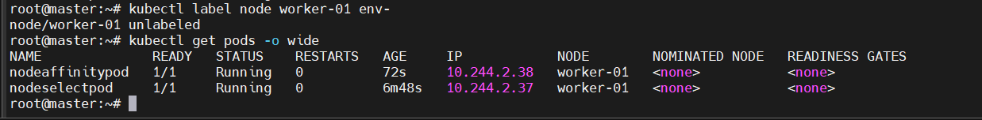  
Task 5: Implement Node Affinity with Hard Scheduling Create a pod with RequiredDuringSchedulingIgnoredDuringExecution node affinity, ensuring it will only be scheduled on a node labeled env=prod. Verify the pod cannot be scheduled if no node has the env=prod label.

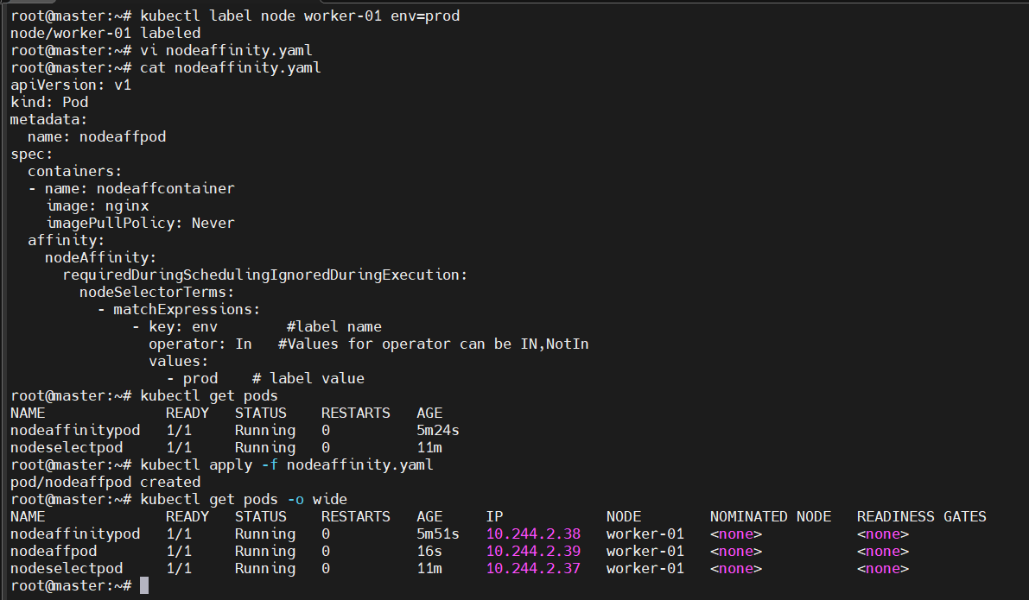 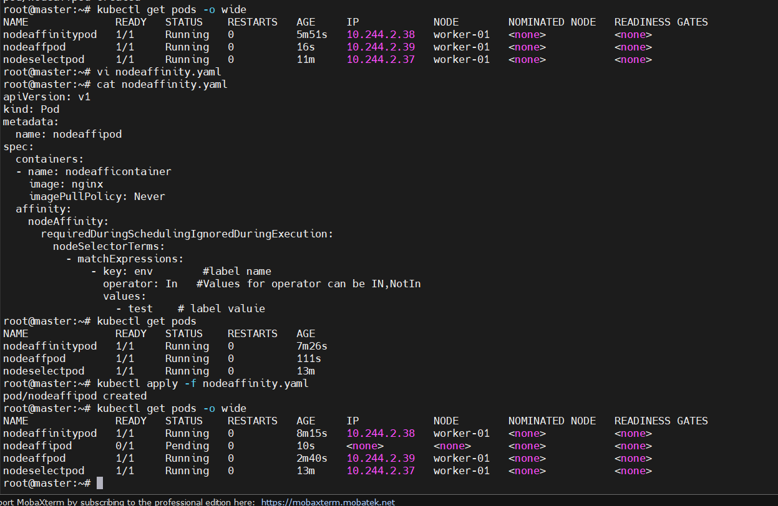  
Task 6: Taint a Node and Use NoExecute with Toleration Seconds Taint a node with special=true:NoExecute. Create a pod with a tolerationSeconds field (e.g., 60 seconds) and observe it gets evicted after 60 seconds on the tainted node.

 