1. Execute all the steps shown in video.

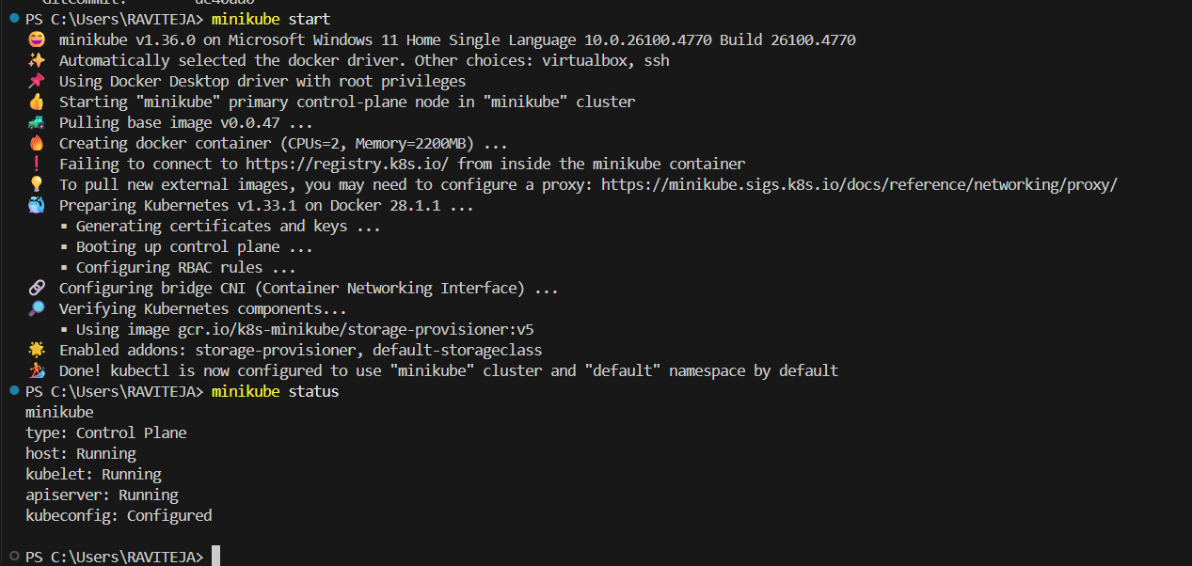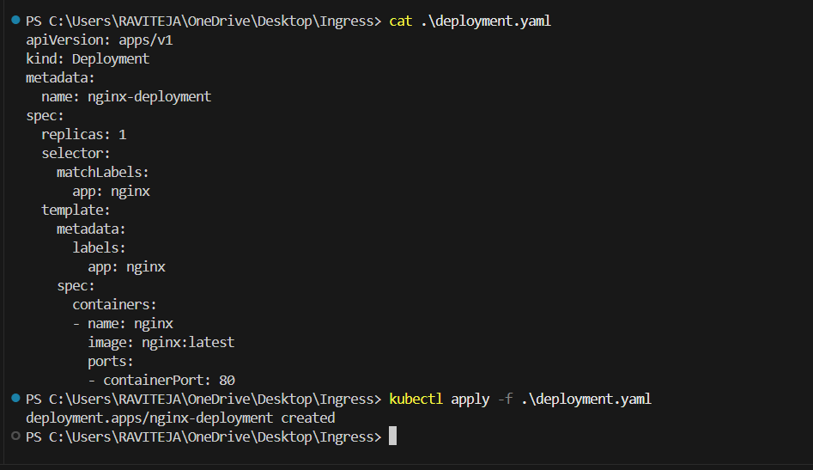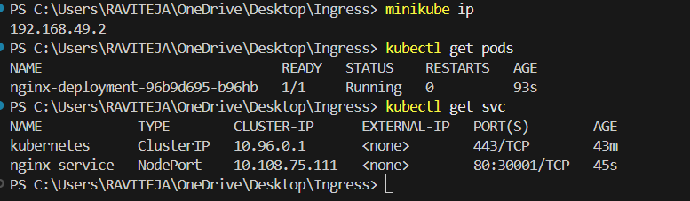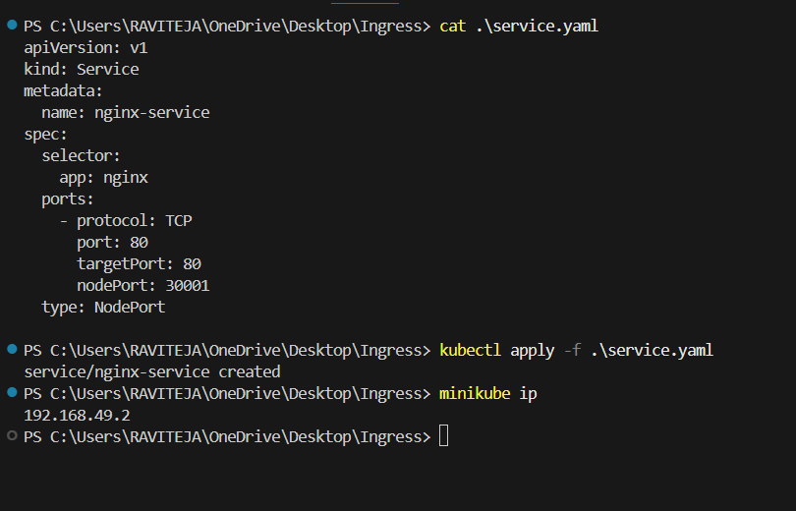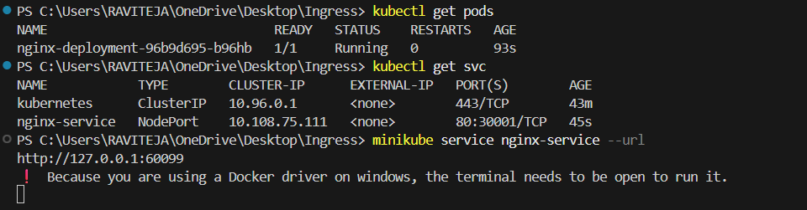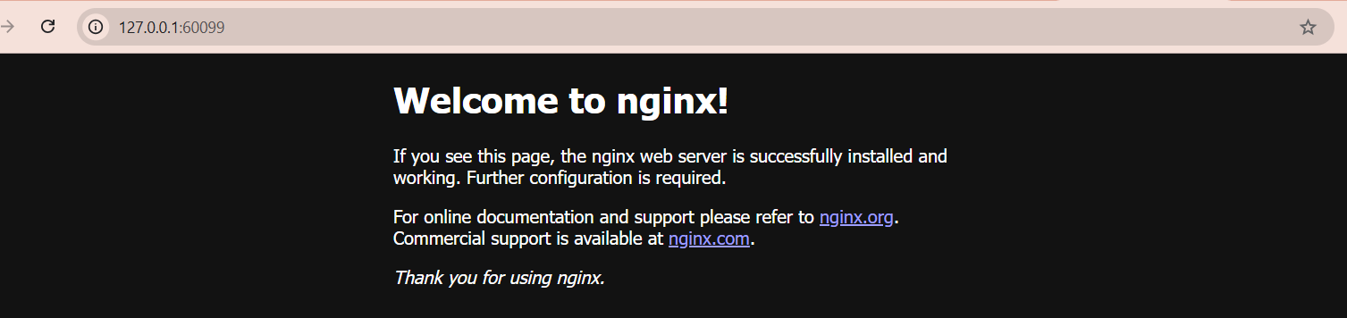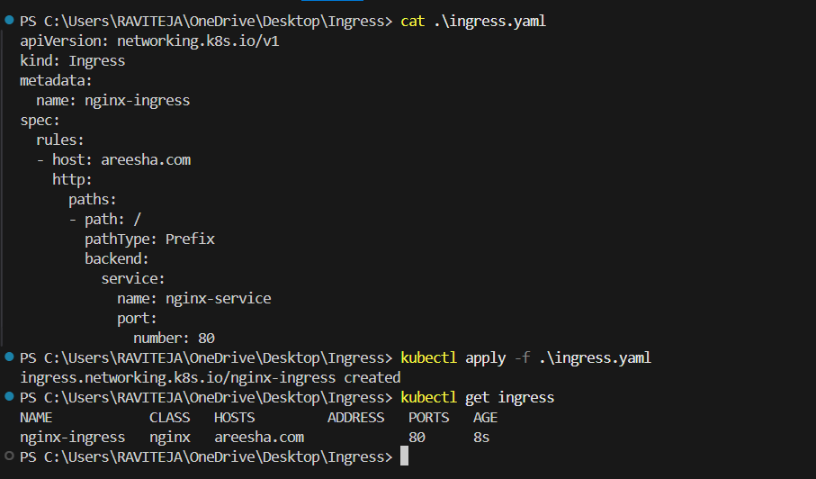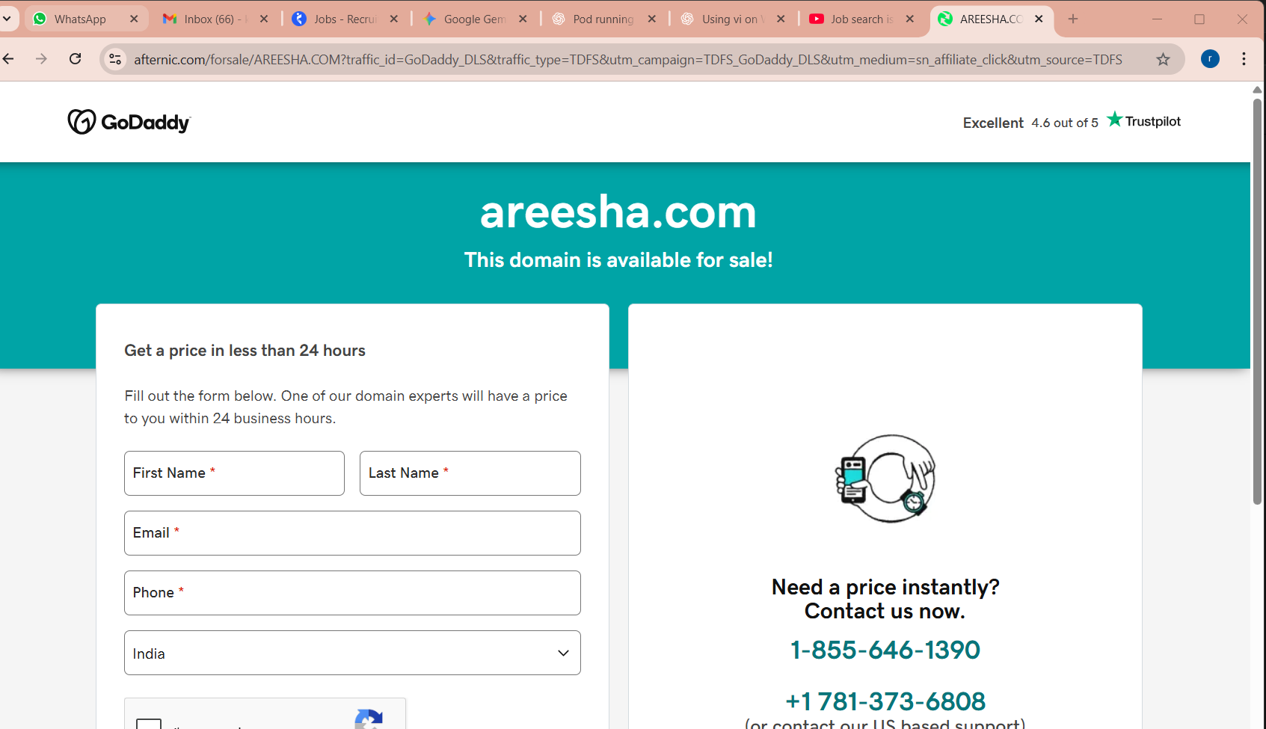

1. Upgrade k8s cluster from 1.26 to 1.28 Version.

Upgrading k8s cluster from 1.29.15 to 1.30.0 version

UPGRAING MASTER NODE:--

curl -fsSL https://pkgs.k8s.io/core:/stable:/v1.30/deb/Release.key | sudo gpg --dearmor -o /etc/apt/keyrings/kubernetes-apt-keyring.gpg

echo 'deb [signed-by=/etc/apt/keyrings/kubernetes-apt-keyring.gpg] https://pkgs.k8s.io/core:/stable:/v1.30/deb/ /' | sudo tee /etc/apt/sources.list.d/kubernetes.list

apt update

apt-cache madison kubeadm

apt-mark unhold kubeadm

apt-get update && sudo apt-get install -y kubeadm='1.30.0-1.1'

apt-mark hold kubeadm

kubeadm upgrade plan

kubeadm version -o json

apt-mark unhold kubelet kubectl

apt-get update && sudo apt-get install -y kubelet='1.30.0-1.1' kubectl='1.30.0-1.1'

apt-mark hold kubelet kubectl

systemctl daemon-reload

systemctl restart kubelet

UPGRAING WORKER_NODES:---

curl -fsSL https://pkgs.k8s.io/core:/stable:/v1.30/deb/Release.key | sudo gpg --dearmor -o /etc/apt/keyrings/kubernetes-apt-keyring.gpg

echo 'deb [signed-by=/etc/apt/keyrings/kubernetes-apt-keyring.gpg] https://pkgs.k8s.io/core:/stable:/v1.30/deb/ /' | sudo tee /etc/apt/sources.list.d/kubernetes.list

apt update

apt-mark unhold kubeadm

apt-get update && sudo apt-get install -y kubeadm='1.30.0-1.1'

apt-mark hold kubeadm

BELOW COMMANDS EXECUTE IN MASTER

kubectl drain worker-01 --ignore-daemonsets --delete-emptydir-data

kubectl drain worker-02 --ignore-daemonsets --delete-emptydir-data

or

kubectl drain worker-01 --ignore-daemonsets

kubectl drain worker-02 --ignore-daemonsets

EXECUTE BELOW COMMANDS IN WORKER-01&WORKER-02

apt-mark unhold kubelet kubectl

apt-get update && sudo apt-get install -y kubelet='1.30.0-1.1' kubectl='1.30.0-1.1'

apt-mark hold kubelet kubectl

systemctl daemon-reload

EXECUTE BELOW COMMANDS IN MASTER

kubectl uncordon worker-01

kubectl uncordon worker-02

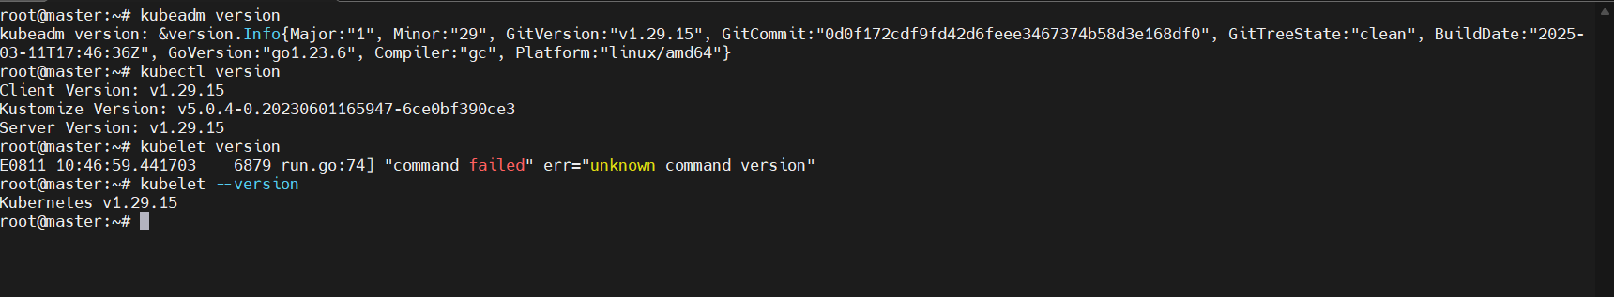 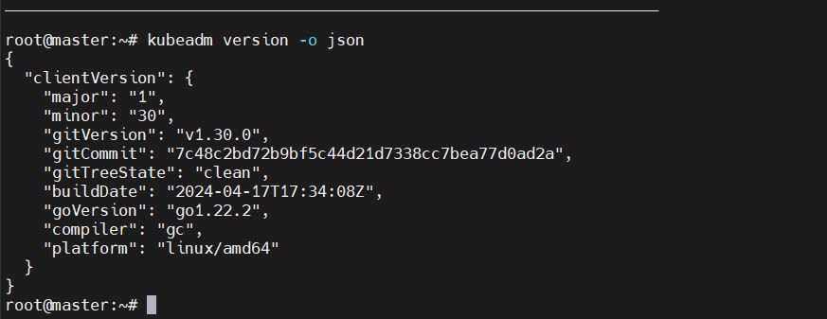 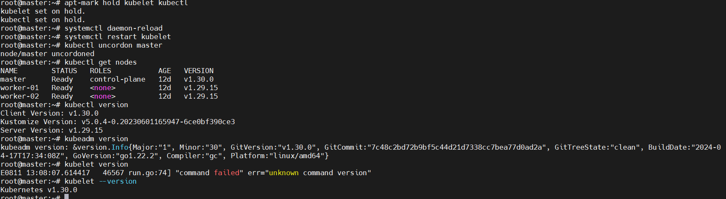 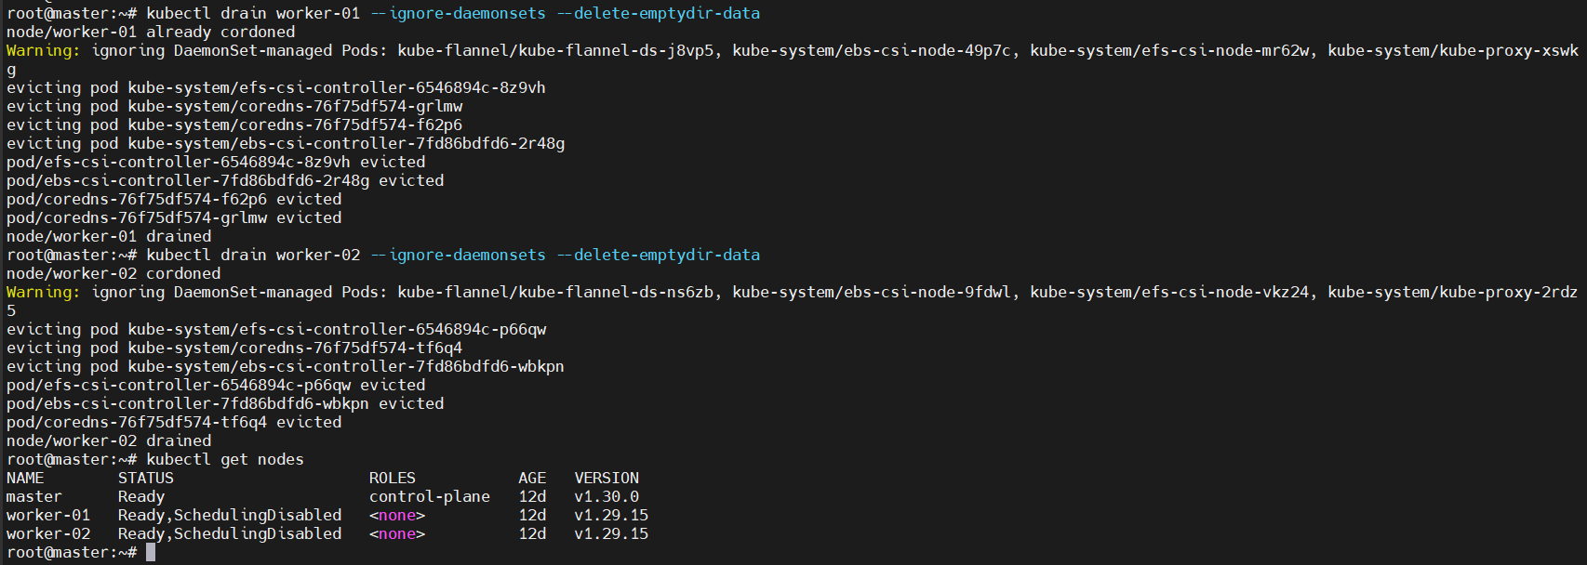 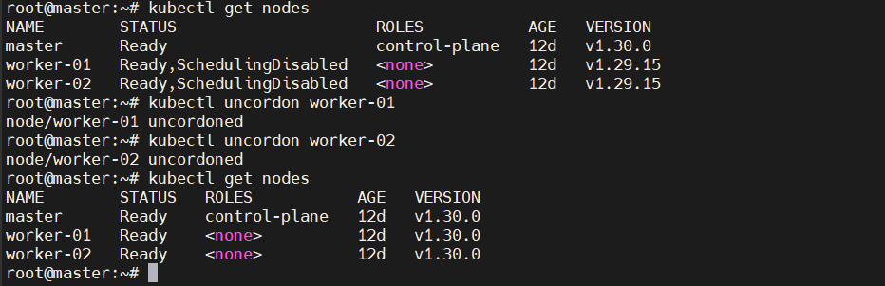  
Note: Document to upgrade cluster.  
<https://devopscube.com/upgrade-kubernetes-cluster-kubeadm/>

DevOpsCube – Easy DevOps, SRE Guides &amp; Reviews**DevOpsCube – Easy DevOps, SRE Guides & Reviews**

[**How to Upgrade Kubernetes Cluster Using Kubeadm?**](https://devopscube.com/upgrade-kubernetes-cluster-kubeadm/)

In this blog, I have added step-by-step guides to upgrade the Kubernetes cluster using Kubeadm. It is one of the important tasks in the CKA Exam.

**Written by**

Bibin Wilson

**Filed under**

HOW TO GUIDES, Kubernetes

Mar 17th, 2024 (6 kB)