1. Setup ARGO CD

Install argocd on master.

1. Install Argo CD

kubectl create namespace argocd

kubectl apply -n argocd -f <https://raw.githubusercontent.com/argoproj/argo-cd/stable/manifests/install.yaml>

Access The Argo CD API Server[¶](https://argo-cd.readthedocs.io/en/stable/getting_started/#3-access-the-argo-cd-api-server)

By default, the Argo CD API server is not exposed with an external IP. To access the API server, choose one of the following techniques to expose the Argo CD API server:

Service Type Load Balancer[¶](https://argo-cd.readthedocs.io/en/stable/getting_started/#service-type-load-balancer)

Change the argocd-server service type to LoadBalancer:

kubectl patch svc argocd-server -n argocd -p '{"spec": {"type": "LoadBalancer"}}'

After a short wait, your cloud provider will assign an external IP address to the service. You can retrieve this IP with:

kubectl get svc argocd-server -n argocd -o=jsonpath='{.status.loadBalancer.ingress[0].ip}'

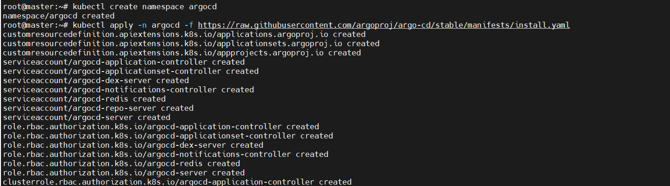 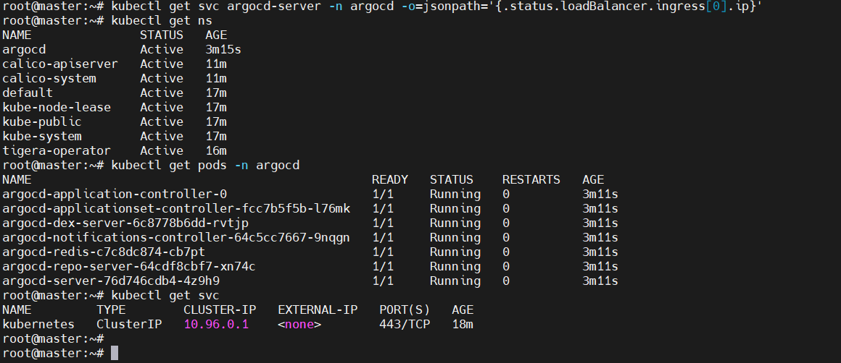

2) Create Jenkins job for CI.

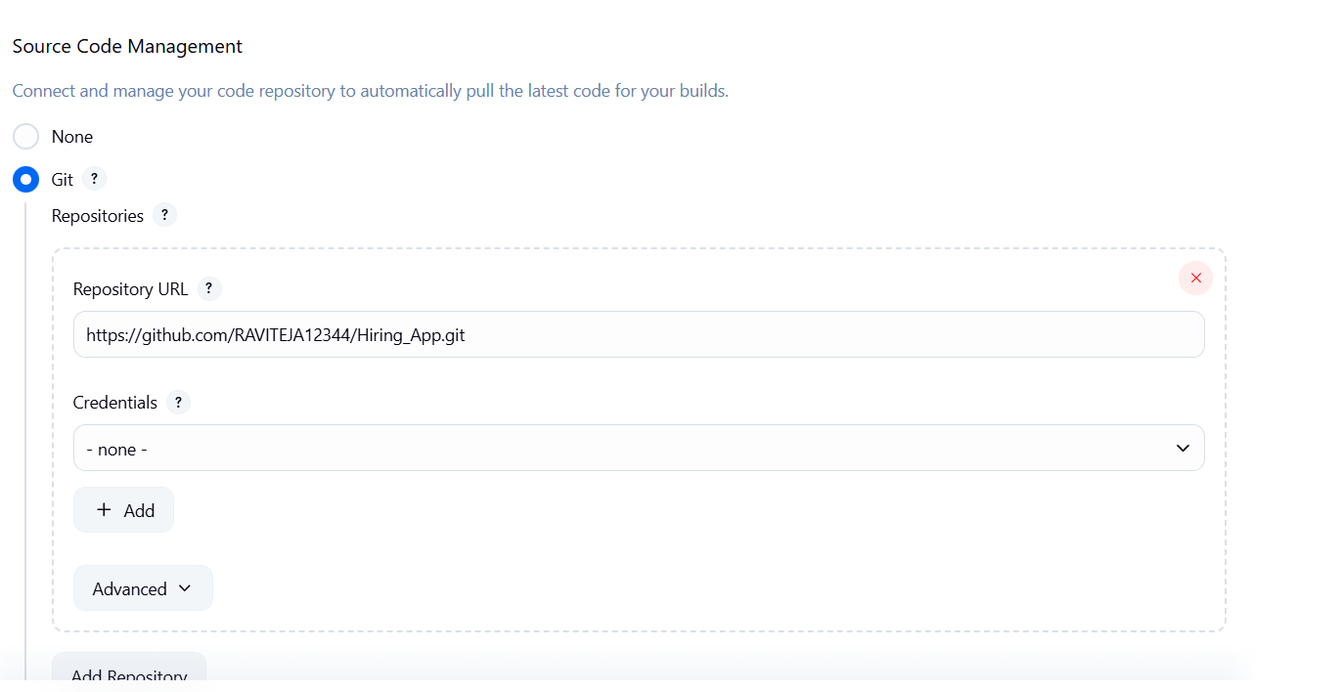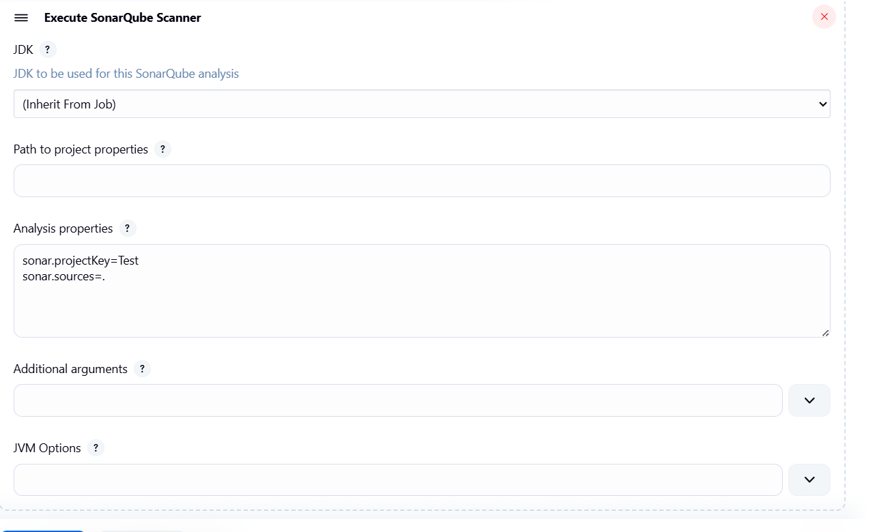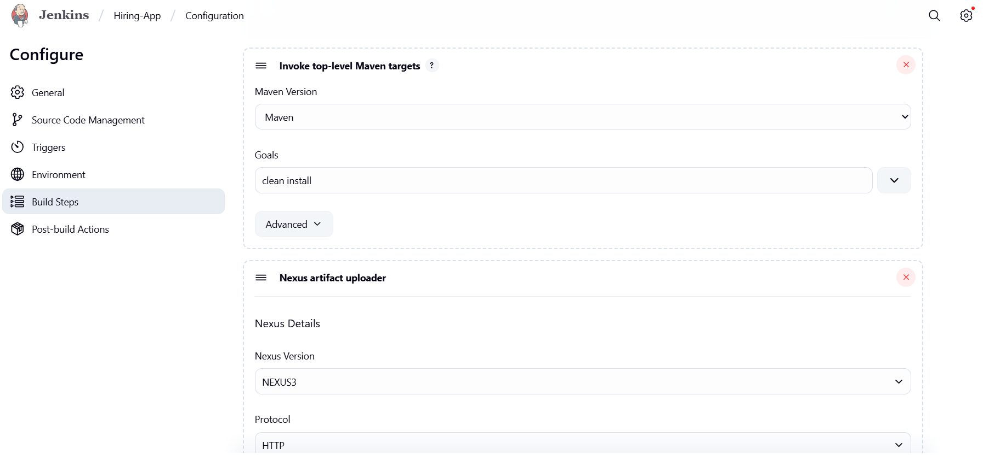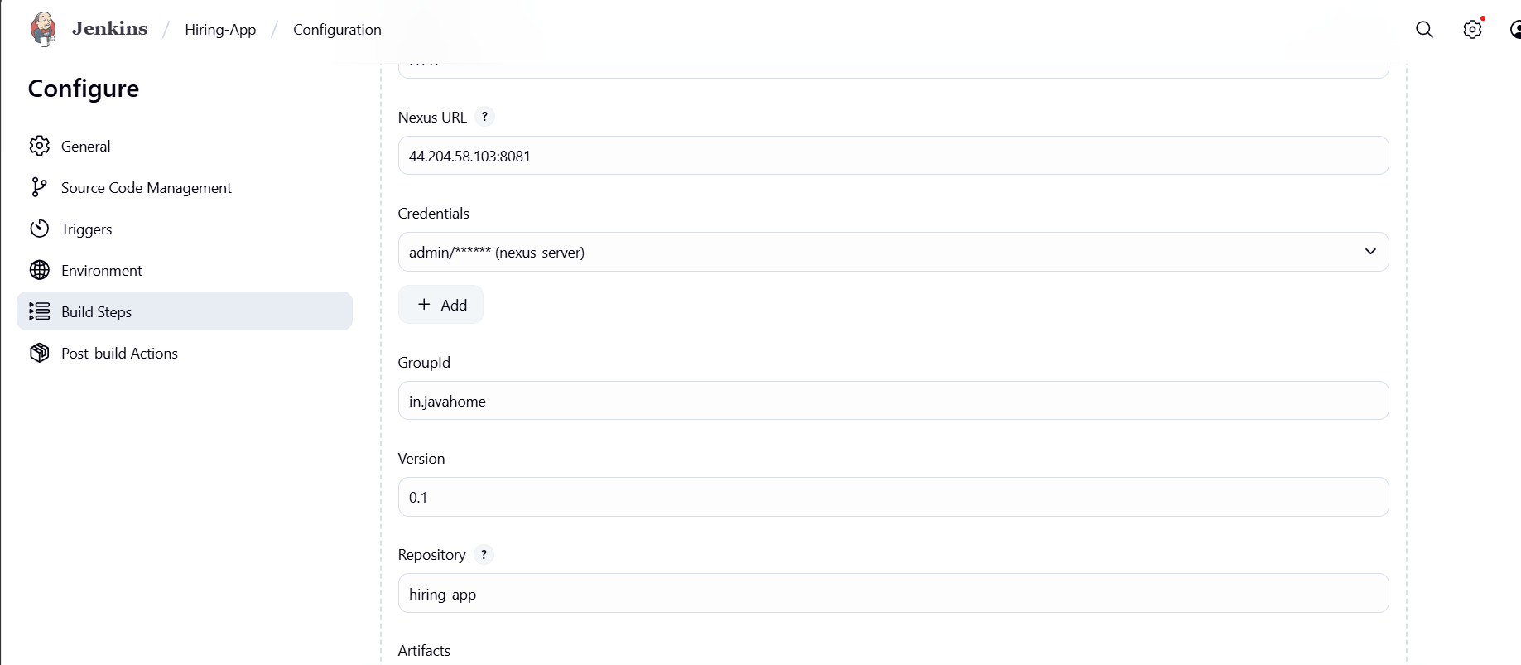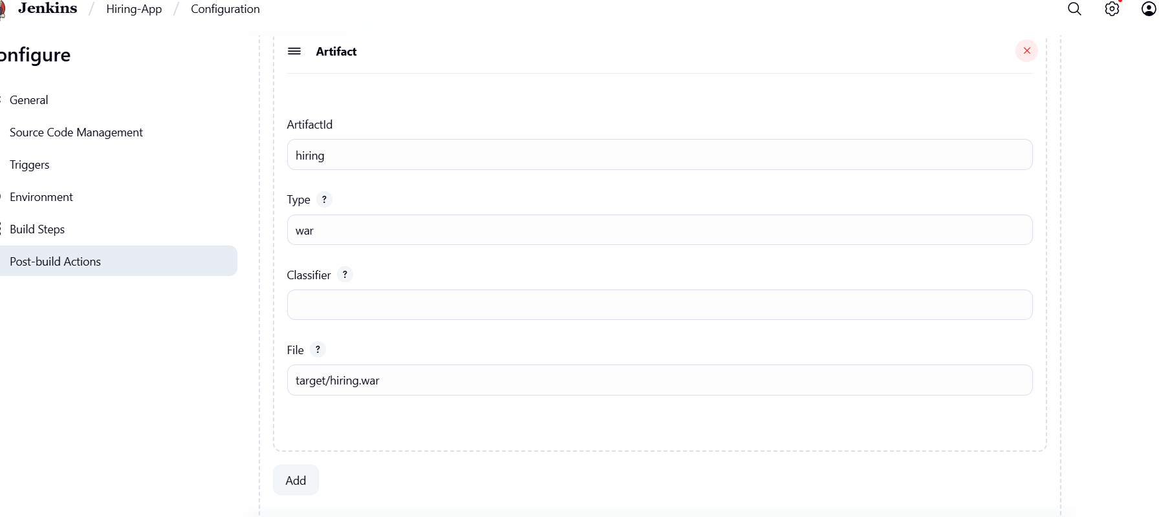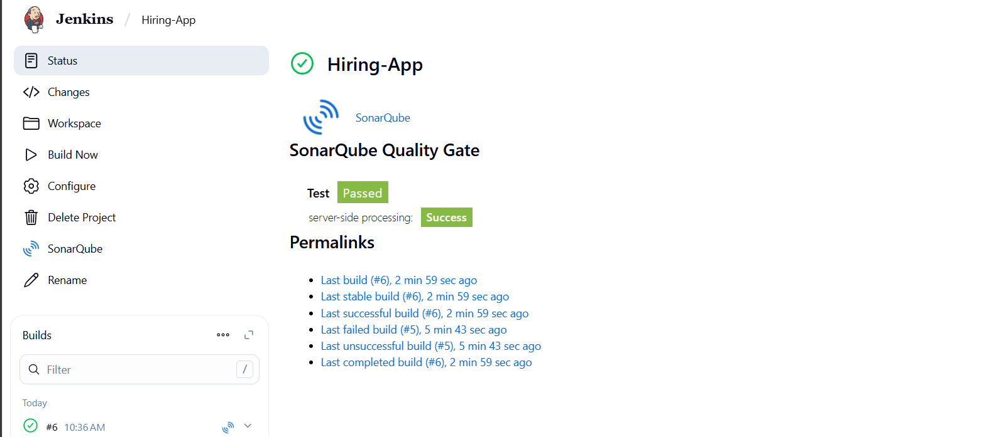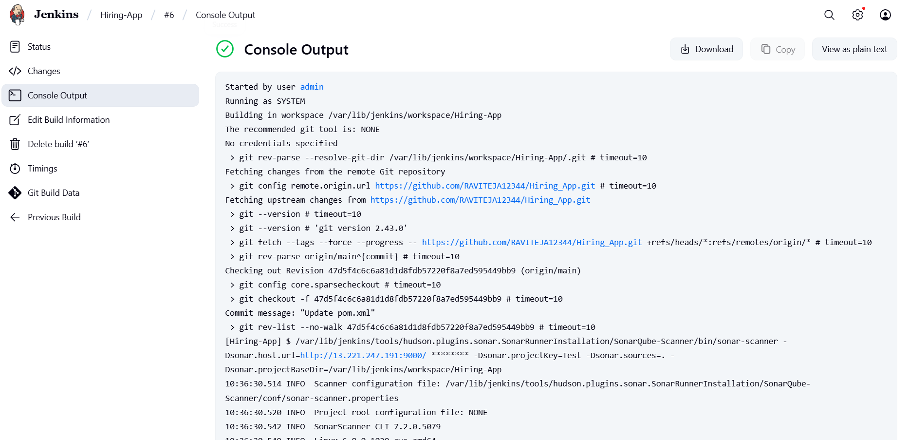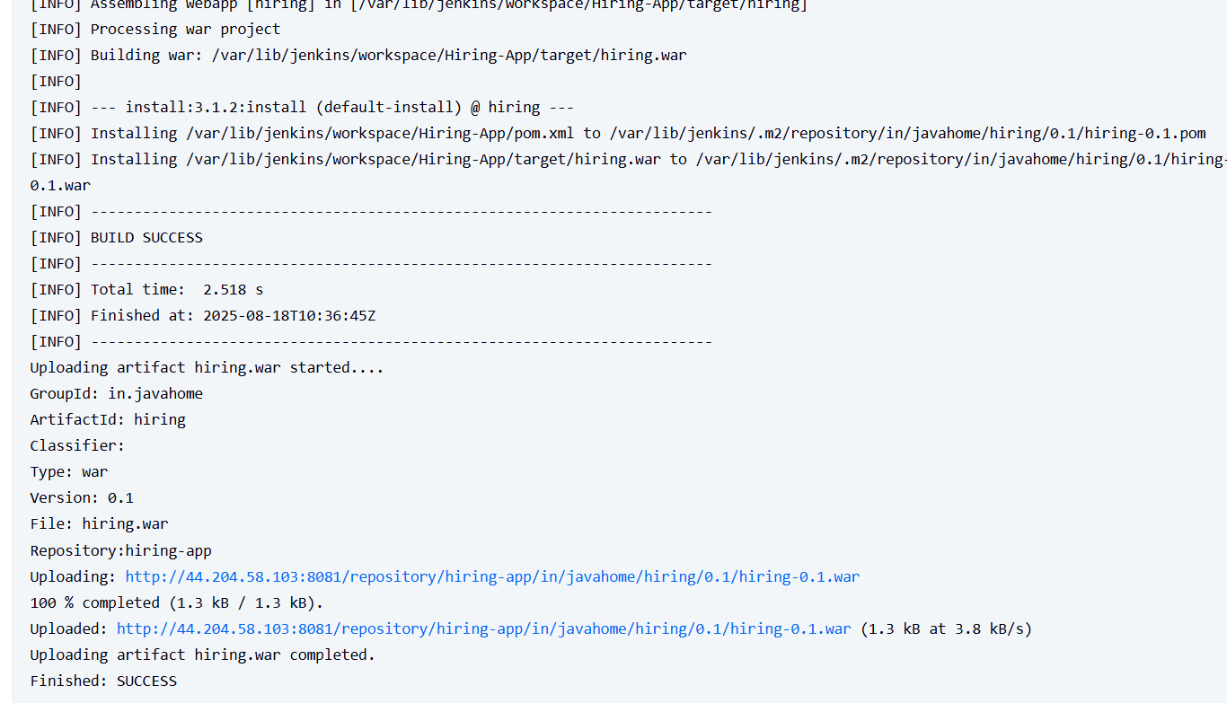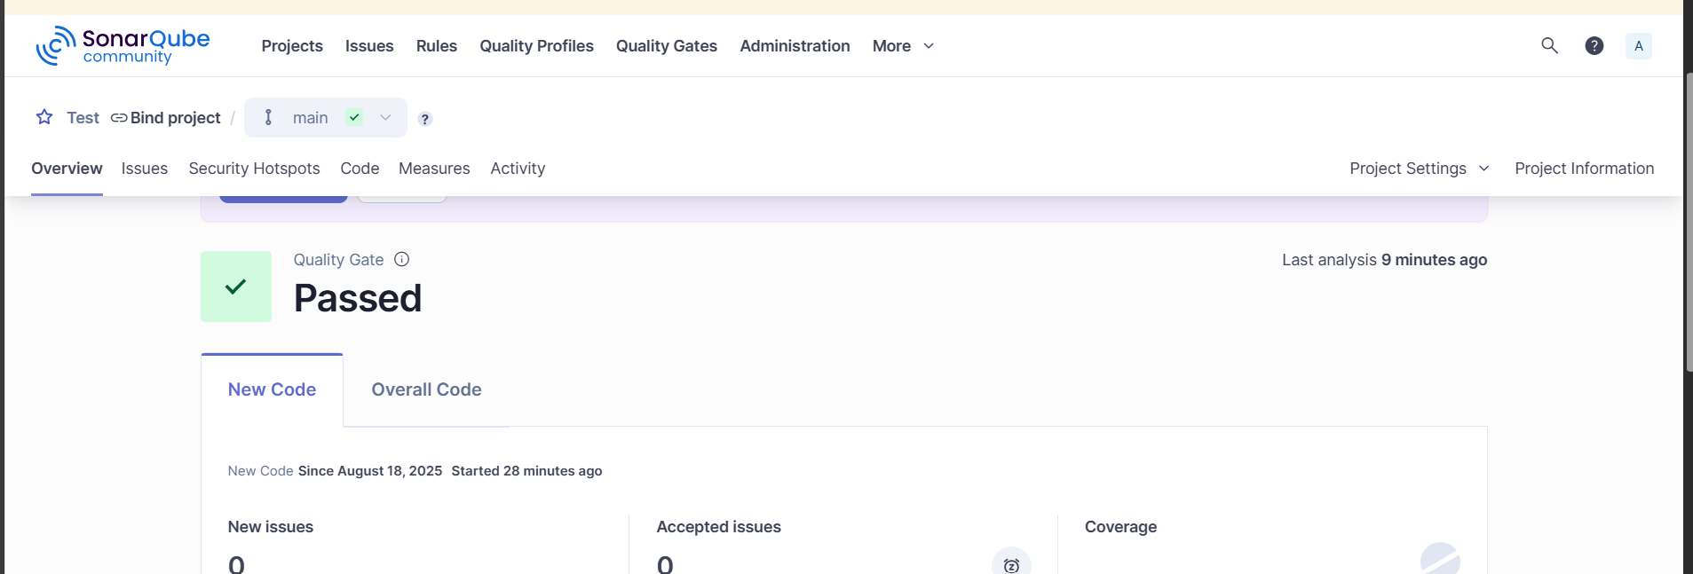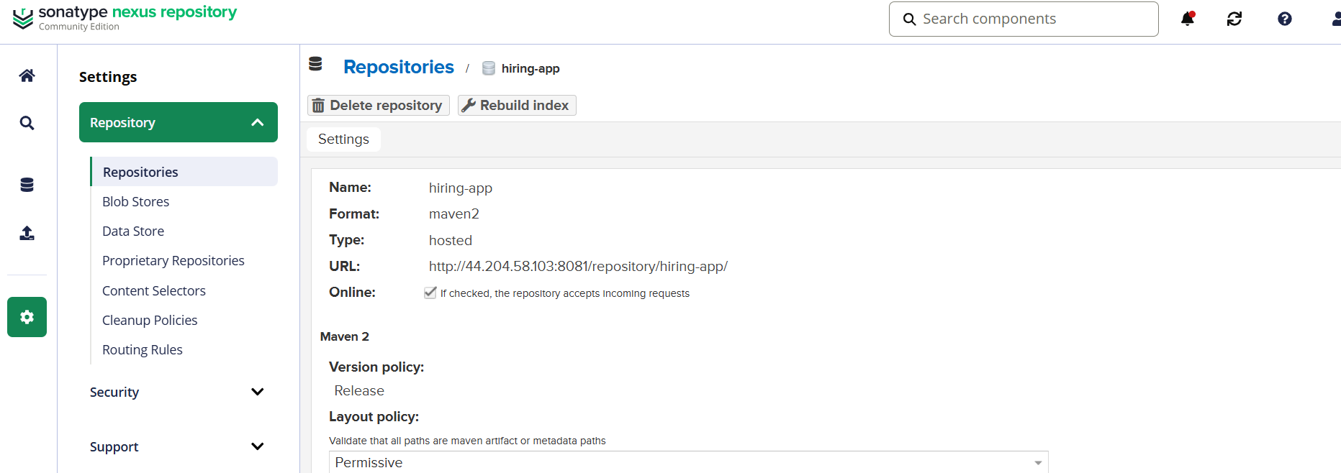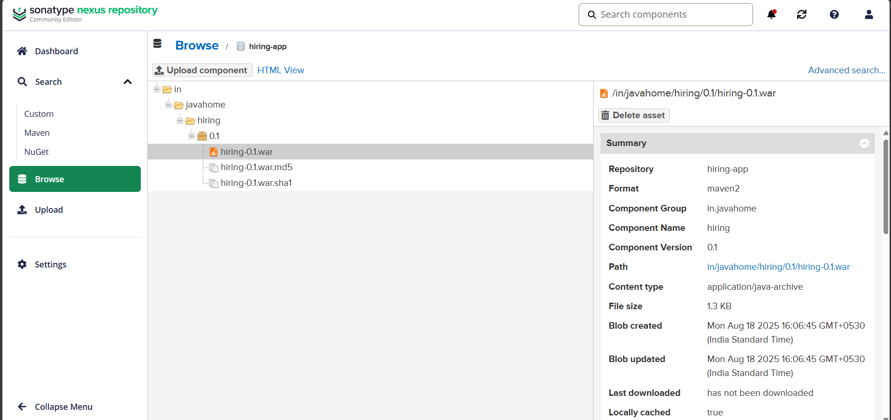  
3) Create Jenkins job to create docker image and build image.

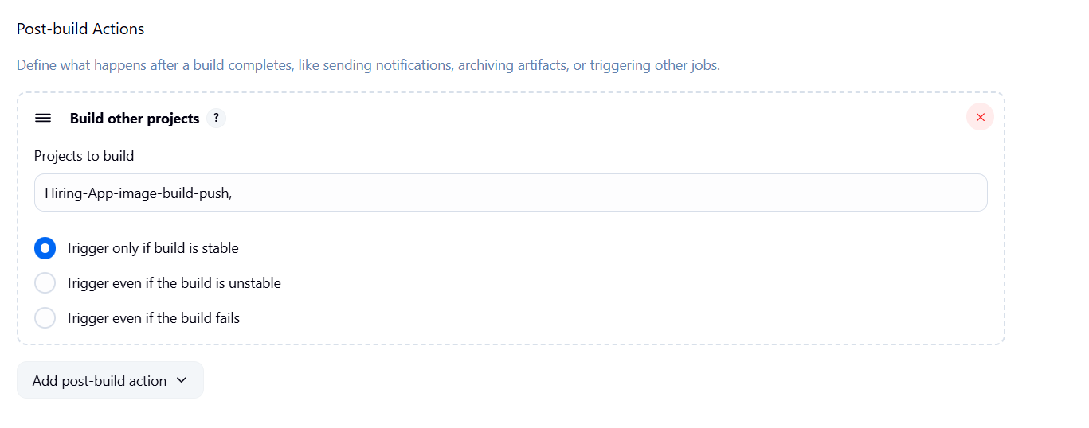

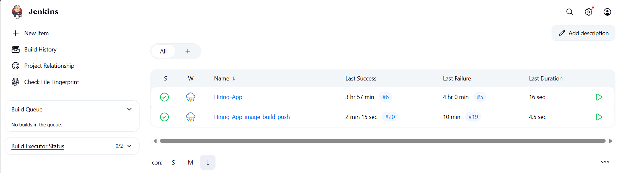 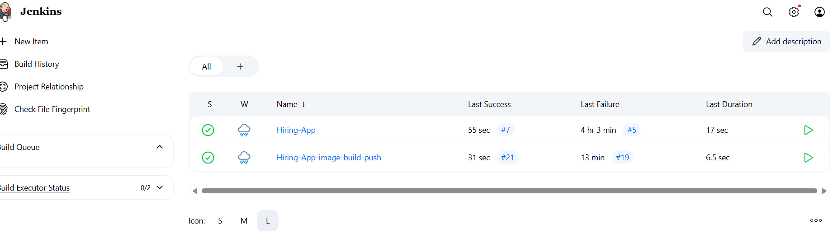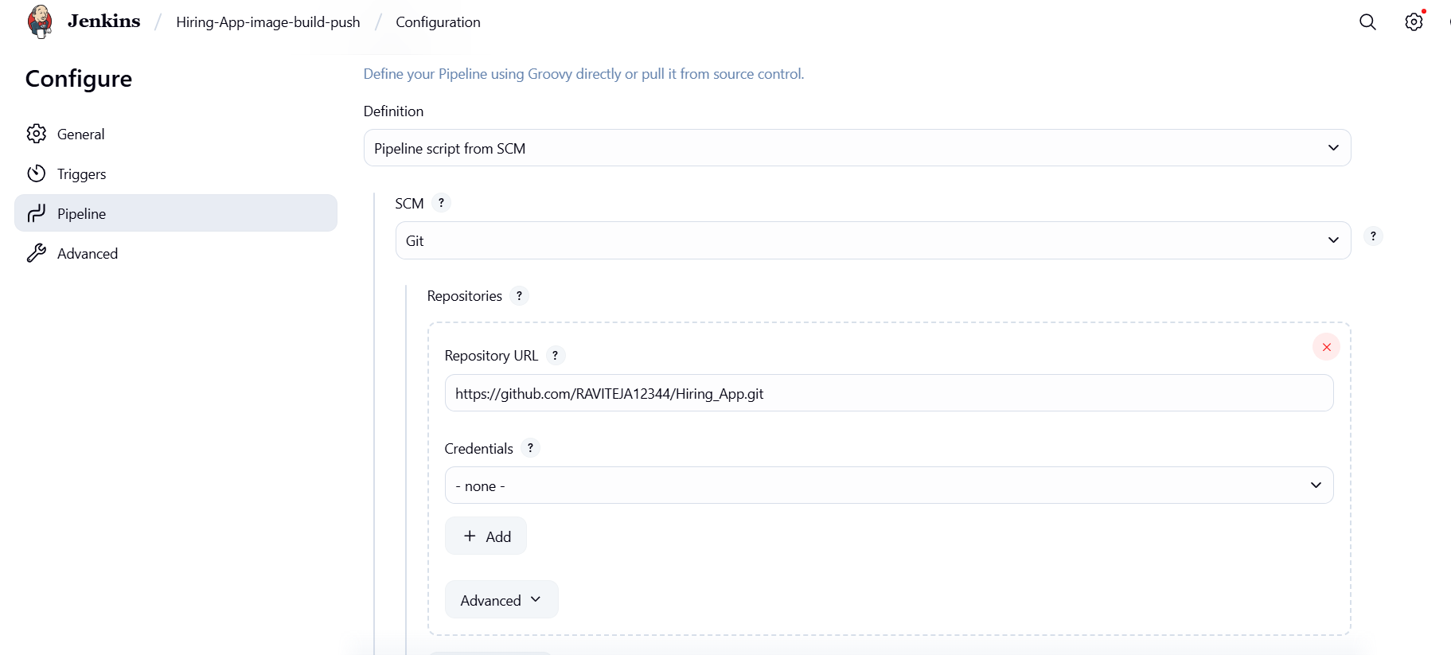

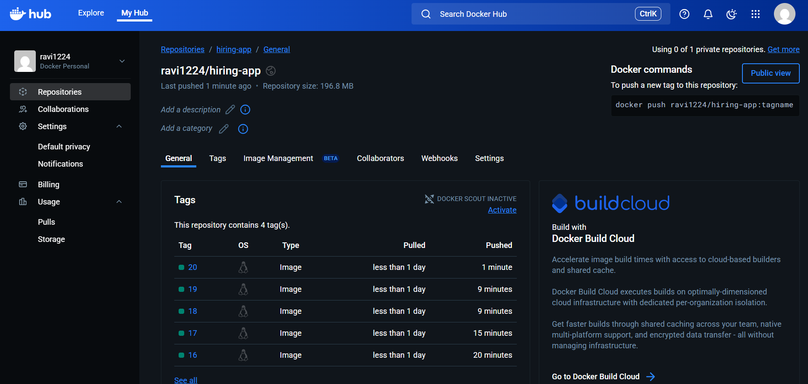 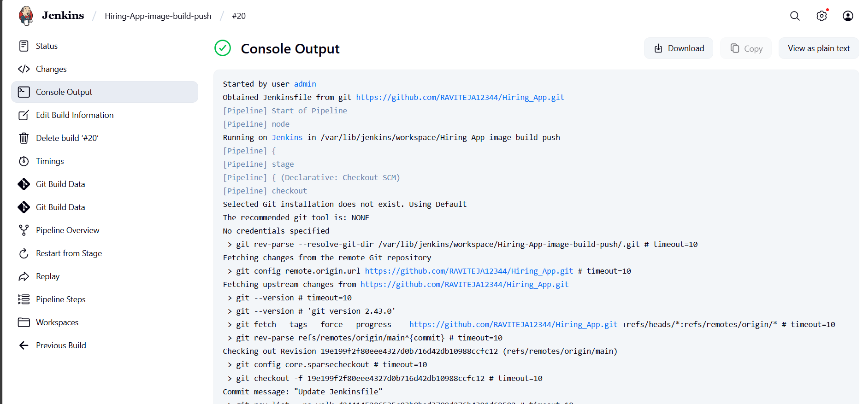 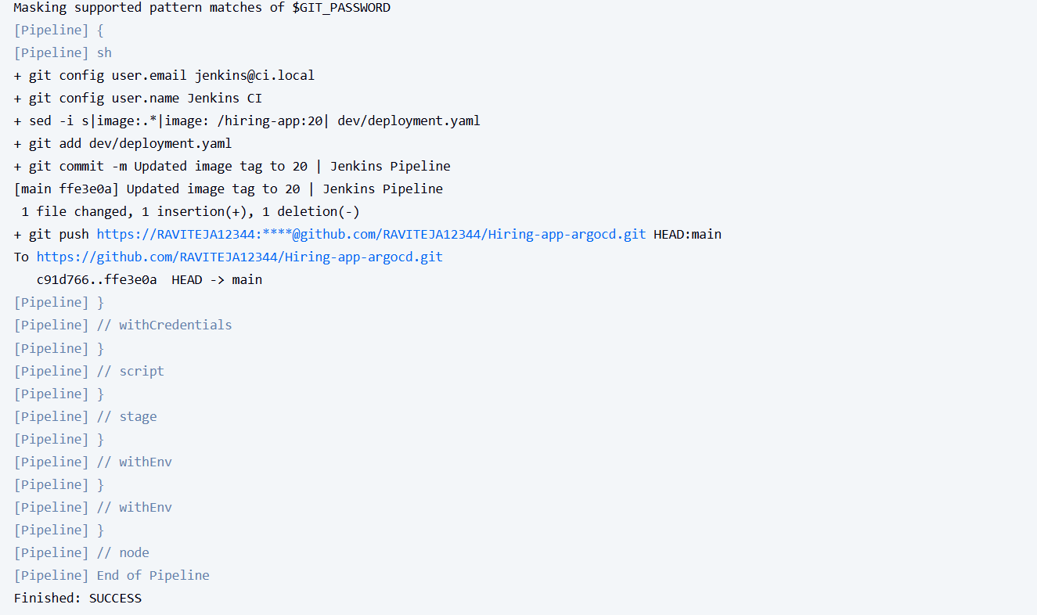  
4) Create ArgoCD job to deploy on ek8s cluster.