1. Watch ansible-01 video and write down notes.  
   2) Setup one master and two worker nodes in ansible.

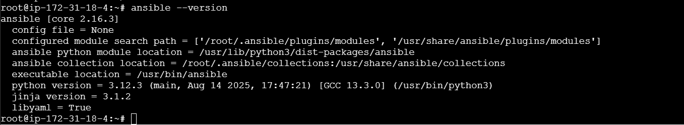

Genareated ssh-keygen and Copied the public key in the woeker-01&worker-02



Worker-01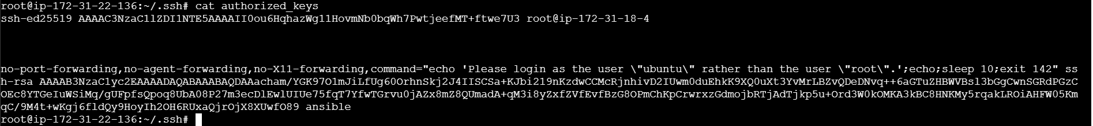

Worker-02

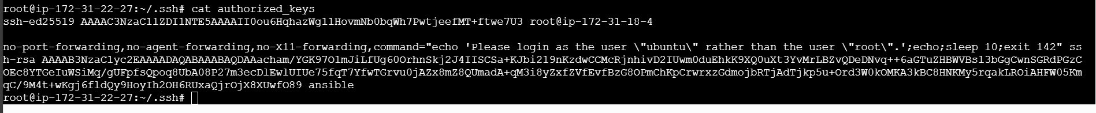

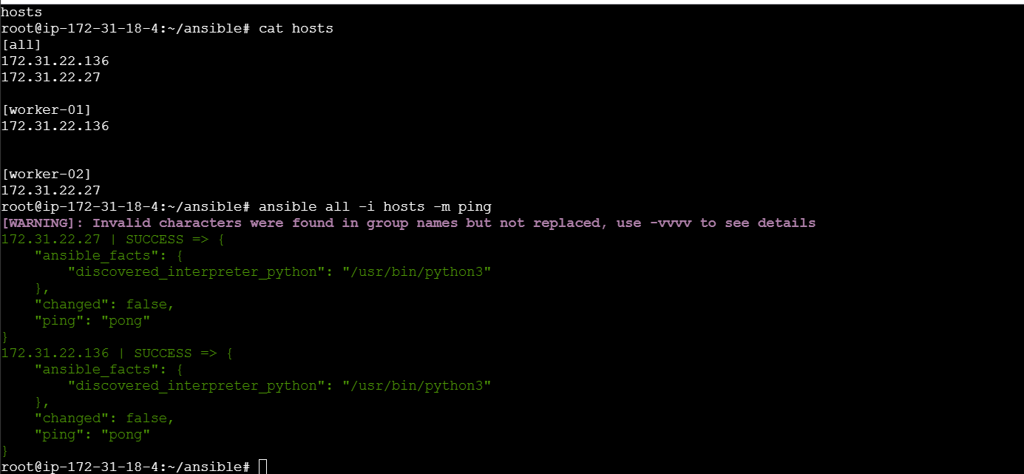

3) Execute the adhoc command shared in #dvps-cloud-documents-12 Channel.



