NAME: RAVITEJA KOMMALAPATI  
STUDENT ID: 012526358  
ASSIGNMENT: CMPE 281 - LAB #2 – Elastic Load Balancer

Auto Scaling group with Instances in Service. I have configured 2 desired instances and maximum to 3.

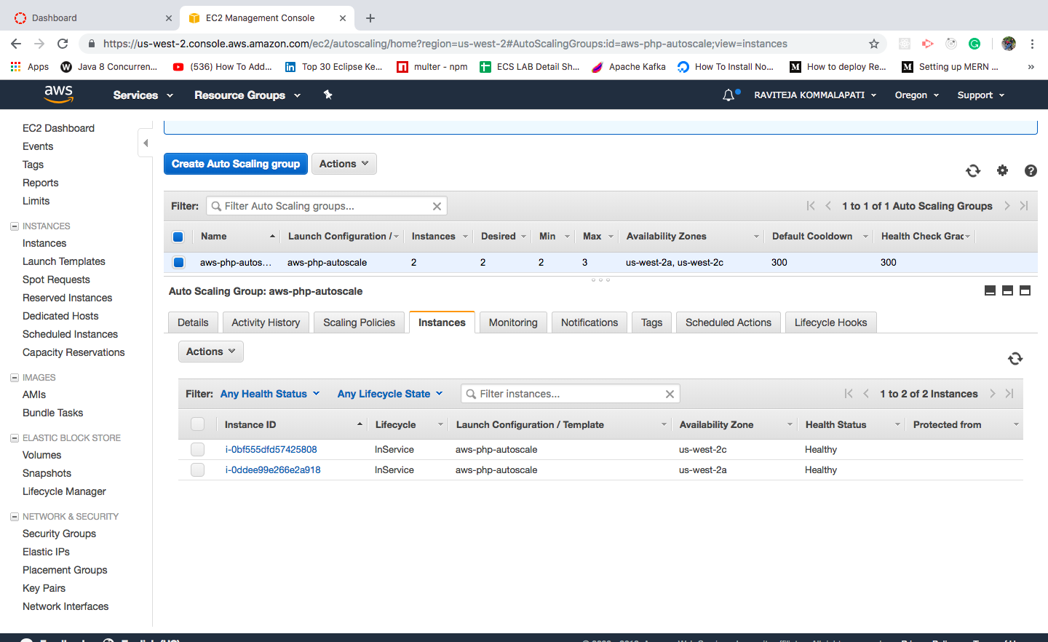

Created Classic Load balancer that takes the traffic and distribute to available instances in the running Scaling group.

As there are 2 instances up and running in the Scaling group we can see in the screen shot status 2 instances in service in 2 different Availability Zones us-west-2c and us-west-2a

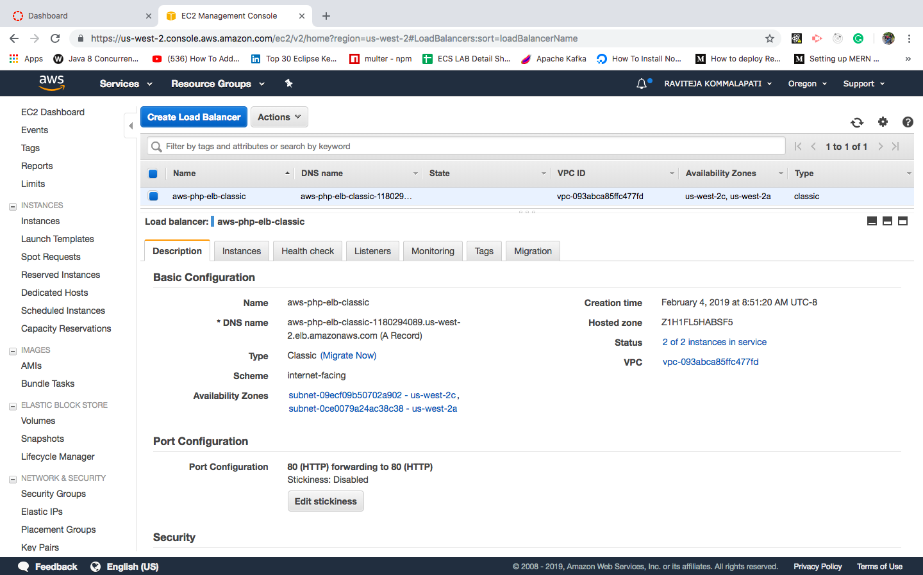

Instances screen shot in Load Balancer

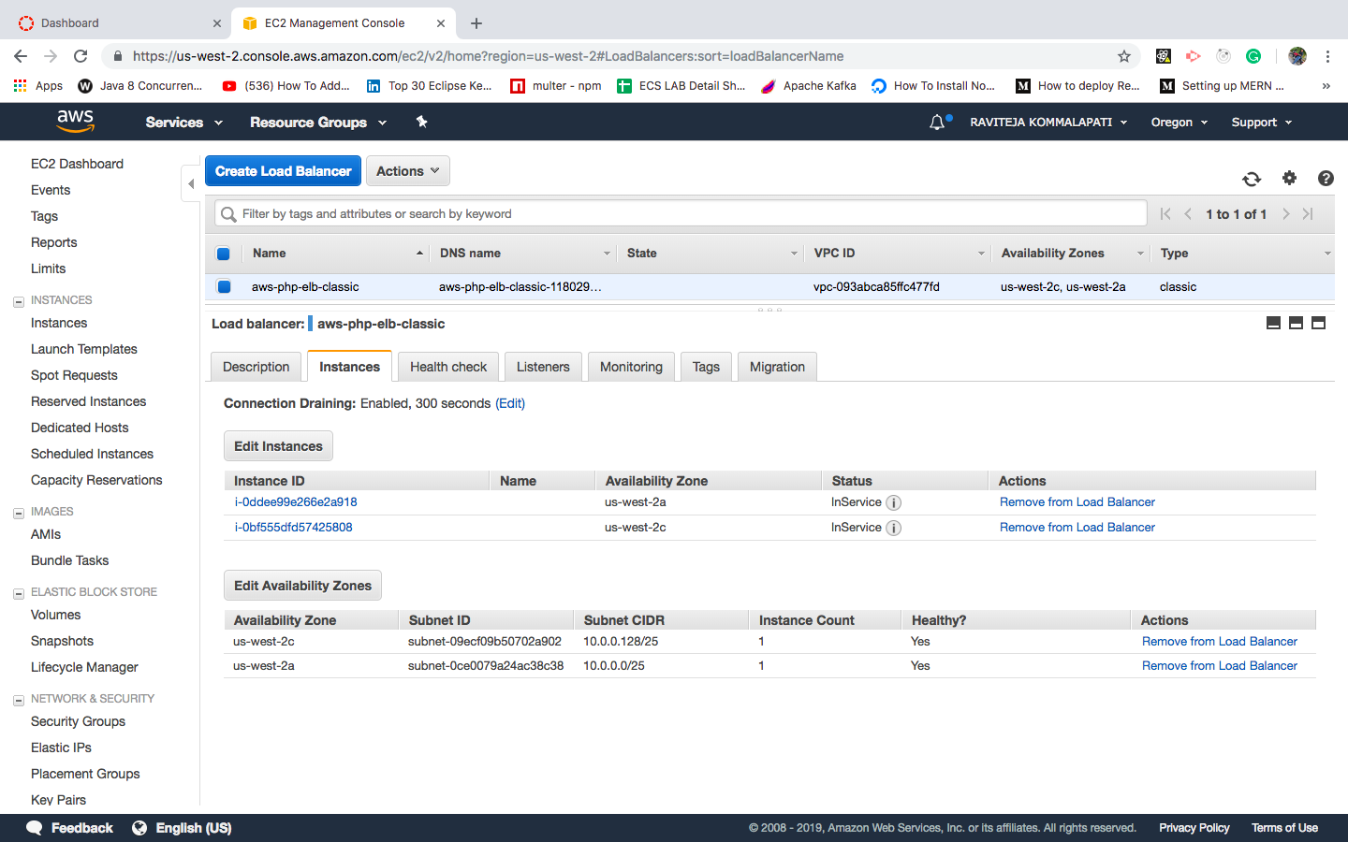

Health Check Screen Shot

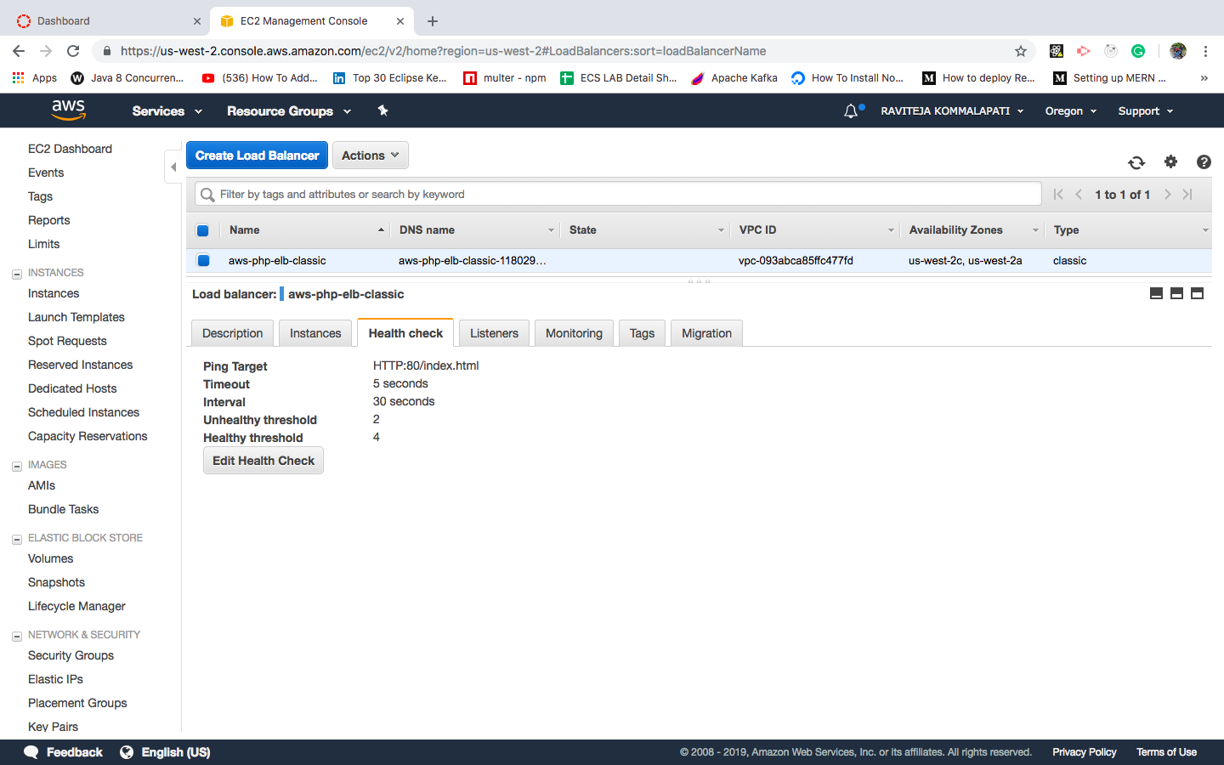

Auto Scale group configured to Load balancer and instances in 2 different zones

