Cryptography Key Management
To build a secure user authentication and cryptographic key management system that protects sensitive data from unauthorized access. The project focuses on secure registration/login, generating encryption keys for users, storing those keys safely, encrypting/decrypting user data, and managing the full key lifecycle (rotation, revocation, and destruction). This ensures confidentiality, integrity, and controlled access to protected information.
The project uses strong, standard security algorithms. For password security, we use bcrypt hashing, which protects passwords even if the database is compromised because passwords are never stored in plain text. For data protection, we use symmetric encryption (Fernet from the cryptography library) to encrypt and decrypt sensitive data. Fernet internally provides authenticated encryption (confidentiality + tamper detection). For key generation, we use secure random key generation (cryptographic-grade randomness) to create unique keys, and we use a master key to “wrap” (encrypt) and store user keys in the database safely (encrypted key storage).
Existing-system:
In the existing system, user authentication and data storage are often handled in a basic way where passwords may be stored in plain text or weak hashing methods, and encryption keys (if used) may be hardcoded, reused, or stored directly in the database without protection. Many systems do not implement key lifecycle management, meaning there is no proper rotation, revocation, or destruction. If an attacker gains database access, they may recover passwords easily and potentially decrypt sensitive data due to poor key handling.
Proposed-system:
In our proposed system, the entire flow is secured using modern cryptographic practices. Passwords are validated for strength and stored only as bcrypt hashes, making credential theft extremely difficult. After successful login, the system generates a new encryption key for each user and stores it in MySQL only after encrypting it using a master key (encrypted key storage). User data is encrypted before storage and decrypted only when the authenticated user requests it. The system also supports key rotation and re-encryption, ensuring that old keys can be safely disabled or destroyed without losing access to data, and includes key revocation and destruction to prevent reuse and reduce risk after compromise.

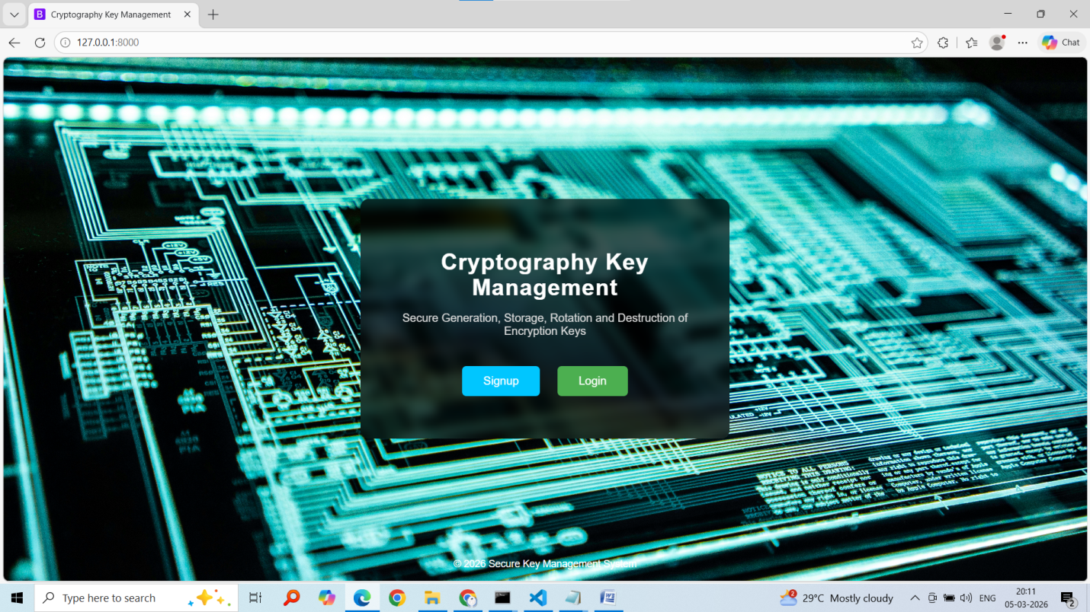
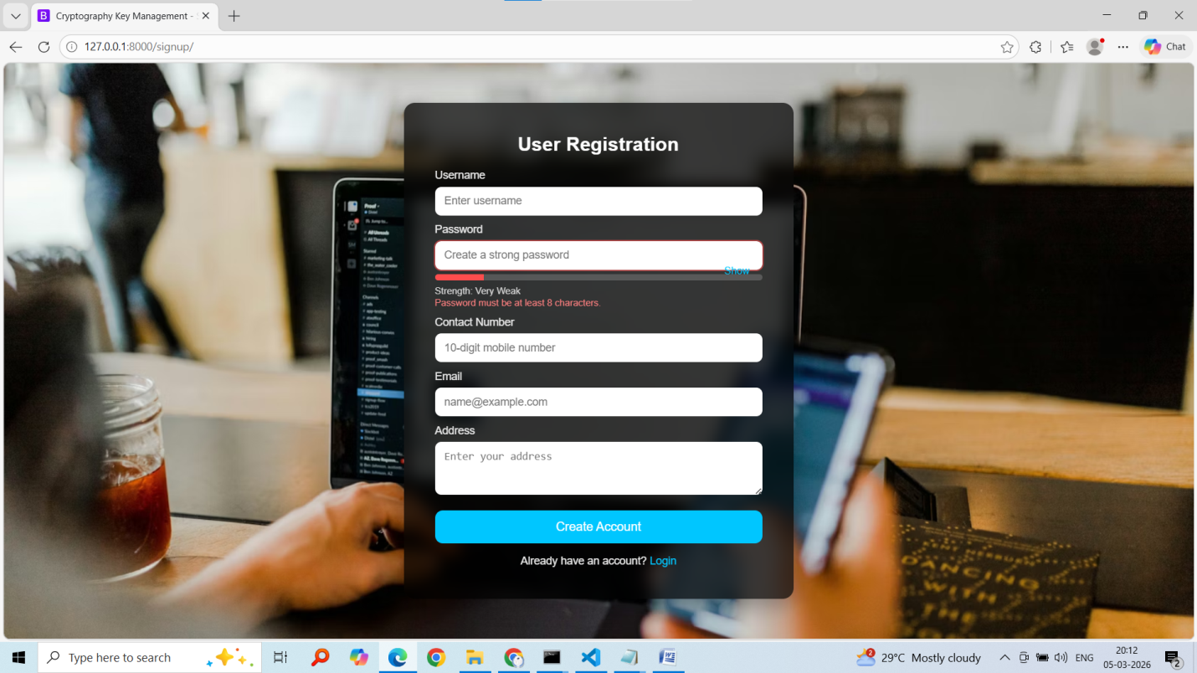
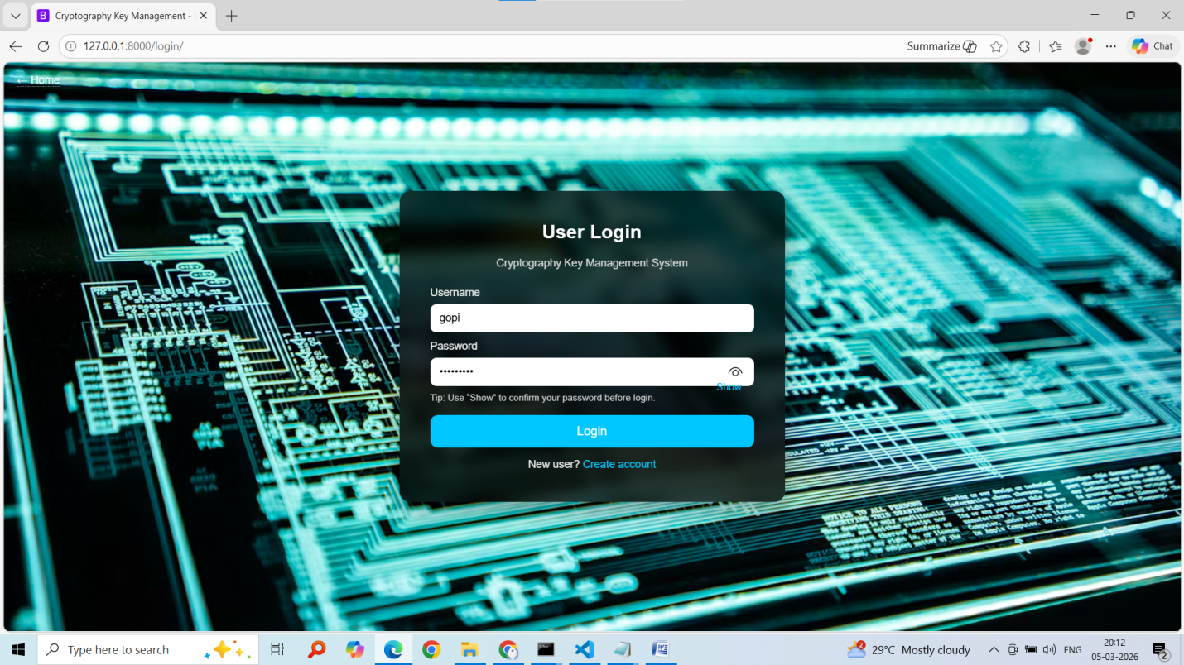
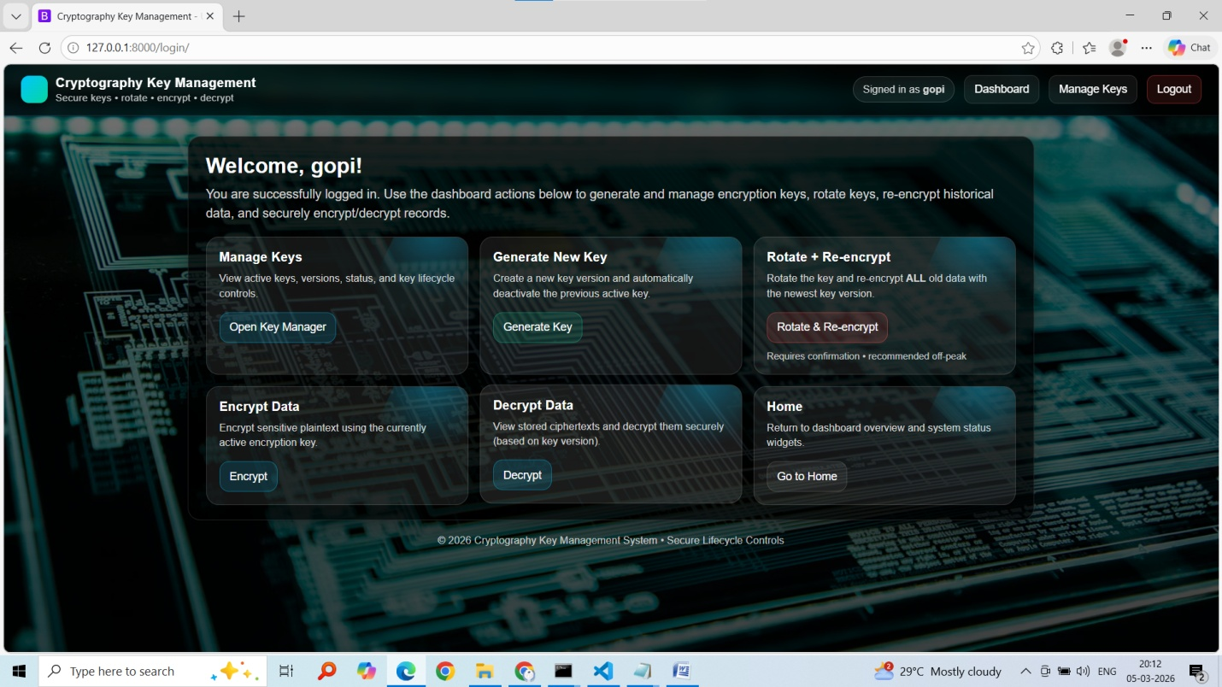
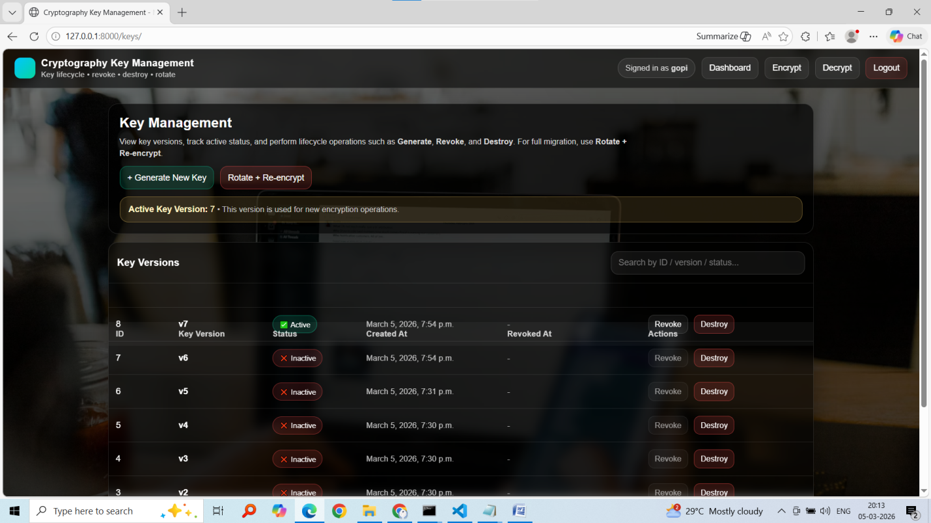
Click on generate new key if want to use old key click on rotate key.
