Agent-Based Game Analysis in Unity Based Upon Curiosity and RND Exploration Using PPO and SAC
Final Year Project Proposal
Session 2023–2027
A project submitted in partial fulfilment of the requirements
for the degree of
Bachelor of Science in Computer Science

Department of Computer Science
Namal University Mianwali
September 2026

Project Registration
Project ID (for office use)
Type of project |  |  | [ ] Traditional [X] Industrial (Inspired Square) [ ] Continuing
Nature of project |  |  | [ ] Development [ ] Research [X] R&D
Area of specialisation |  |  | Artificial Intelligence / Reinforcement Learning / Game AI
Project Group Members
Sr.# | Reg. # | Student Name |  | CGPA | Email ID | Phone # | Signature
(i) | NUM-BSCS23-28 | Raza Ullah Khan |  |  | bscs23f28@namal.edu.pk | +923065680546
Declaration: FYP group members have cleared all prerequisites courses (mentioned below) for FYP-I as per their degree requirements.

Plagiarism Free Certificate
This is to certify that, I am Raza Ullah Khan S/D/o Sana Ullah Khan, group member of FYP under registration no NUM-BSCS23-28 at Computer Science Department, Namal University. I declare that my FYP proposal is checked by my supervisor and the similarity index is 15% that is less than 20%, an acceptable limit by HEC. Report is attached herewith as Appendix A.
Date: ________________________
Name of Group Member 1: Raza Ullah Khan
Signature: __________________
Name of Supervisor: Dr. Malik M Ali Shahid
Signature: ___________________
Name of Co-Supervisor: Mr. Abdul Rafay
Signature: _____________________

Abstract
Reinforcement learning allows an agent to learn decision-making by interacting with the environment, making observations about the current state, performing actions, and receiving feedback through rewards. The success of a reinforcement learning agent might depend not only on the learning algorithm chosen for updating the policy but also on the exploration encouraged throughout the training process. The current project is devoted to investigating the impact of those two aspects using Unity ML-Agents in game environments.
The research would start with setting up a Unity-based Hummingbirds training environment and training agents using reinforcement learning algorithms as candidates including PPO (Proximal Policy Optimization) and SAC (Soft Actor-Critic). The learning algorithms would be compared under controlled training conditions. Besides, there would be three exploration conditions studied: no additional reward, curiosity based on next-state prediction and Random Network Distillation (RND). Thus, the learning algorithms and exploration strategies would be compared within the single environment.
The performance of the agents would mainly be estimated by means of extrinsic cumulative return that stands for the total reward gained through the actual game task. Task-specific progress metrics could be taken into account as well as exploration coverage in case when a proper metric could be introduced. The experiment would be conducted several times per each condition using different random seeds due to the variation that might occur because of the stochastic training process. Finally, some of the obtained results would be validated in a second Unity game environment.
The expected results would be the trained agents in Unity, the configurations of experiments and their source codes, performance data collected during the experiment, comparison graphs and a research report.

1 Introduction
Reinforcement learning (RL) is a machine learning method where an agent learns to make decisions through interaction with an environment. The agent observes the current state, takes an action, and gets a reward. By interacting repeatedly, it gradually refines its policy, which is the rule governing how it chooses actions.
In games and simulations, feedback is frequently sparse or delayed, so both how an agent learns and how it explores have a strong influence on its performance. The learning algorithm dictates how the policy is updated from experience, whereas the exploration strategy pushes the agent to try actions and states it has not yet experienced enough. Thus, balancing exploration and exploitation is essential to training.
This project examines these two factors with Unity ML-Agents (Juliani et al., 2018). A controlled Hummingbirds environment will first be built, in which Proximal Policy Optimization (PPO) (Schulman et al., 2017) and Soft Actor-Critic (SAC) (Pathak et al., 2017) will be tested under three exploration conditions: a baseline with no additional intrinsic reward, a next-state prediction-based curiosity method (Schulman et al., 2017), (Zhang et al., 2024) , and Random Network Distillation (RND) (Wang et al., 2023). The goal is to study how these combinations influence agent performance, without presupposing that any particular approach will do better.
To ensure the comparisons are meaningful, the experiments will be conducted under controlled conditions. Performance will mainly be measured by extrinsic cumulative return, backed by task-specific progress metrics and, where suitable, exploration coverage. Several random seeds will be used to account for variability in stochastic training. Following the primary comparison in Hummingbirds, chosen comparisons will be run in a second Unity game to verify whether the observed behavior also shows up in a different environment.
The project entails setting up the Unity environments, training the algorithms, applying the exploration strategies, gathering data, and analyzing the results. The final deliverables will be trained agents, source code and experiment configurations, performance data and comparison graphs, and a research report describing the methodology and findings.

2 Related Work
Reinforcement learning has been extensively explored as a means of acquiring decision-making policies through interaction with an environment. In games and other interactive scenarios, an agent's performance hinges not just on the algorithm it uses to update its policy, but also on how it explores. As a result, prior studies have investigated both policy optimization techniques and exploration strategies in order to enhance learning. TABLE I compares the pertinent literature, emphasizing the main contributions, methods, and the research gaps that this project seeks to address.
Table 1:literature Review Comparison
Study | Platform / Environment | Policies or Exploration Method | Evaluation Focus | Main Contribution / Finding | Gap Addressed by This FYP
Unity: A General Platform for Intelligent Agents (Juliani et al., 2018) [1] | Unity ML-Agents example environments including 3DBall, Crawler, FoodCollector, and Bouncer | PPO and SAC | Mean cumulative episodic reward across multiple training runs | Established Unity ML-Agents as a practical platform for training and comparing intelligent agents; showed that algorithm performance varies by environment. | Foundational study, but it predates current ML-Agents releases and does not systematically compare modern exploration strategies across a controlled FYP benchmark.
Automatic Intrinsic Reward Shaping for Exploration in Deep Reinforcement Learning (Technologies, 2020) [5] | Discrete and continuous-control benchmark tasks | AIRS and IDAAC intrinsic-reward shaping compared with vanilla PPO | Normalized training score and learning progress | Reports improved performance from automatic intrinsic-reward shaping over standard PPO across the evaluated tasks. | Uses general benchmark environments rather than a Unity game/simulation testbed; does not compare PPO and SAC under the same Unity conditions.
RLeXplore: Accelerating Research in Intrinsically-Motivated Reinforcement Learning (Wang et al., 2023)[8] | Sparse-reward continuous-control tasks such as Ant-UMaze and other RL benchmarks | Intrinsic rewards combined with PPO and SAC | Reproducibility, learning performance, and intrinsic-motivation experiments | Provides a research framework for testing intrinsic motivation with both on-policy PPO and off-policy SAC, making it highly relevant to controlled policy/exploration comparisons. | Not focused on Unity ML-Agents or a student-scale visual simulation suite; the proposed FYP translates the comparison into accessible Unity environments.
Reinforcement Learning in a Virtual World: A Study of PPO and SAC within Unity ML-Agents (Zhang et al., 2024) [6] | Unity3D virtual environment implemented with Unity ML-Agents | PPO and SAC | Learning behavior, reward progression, convergence, and stability | Directly compares PPO and SAC in a Unity ML-Agents virtual world; reports rapid initial learning for SAC but greater instability associated with excessive exploration, while PPO is more stable in the tested setting. | Closest prior work. This FYP extends it by adding a structured comparison of exploration strategies, repeated trials, learning-curve analysis, sample efficiency, variance, and environment difficulty.
Proposed FYP: Performance Analysis of Reinforcement Learning Policies and Exploration Strategies Using Unity ML-Agents | Controlled Unity ML-Agents environments, beginning with Hummingbirds followed by a second game environment | PPO and SAC baseline policies; baseline exploration compared with curiosity (next-state prediction) and RND | Extrinsic cumulative return, task progress, exploration coverage, convergence speed, sample efficiency, and stability across random seeds | Provides a reproducible student-scale experimental analysis of both policy choice and exploration strategy within the same unified Unity framework. | Directly bridges the gap by combining two dimensions typically analyzed in isolation: policy optimization (PPO vs SAC) and exploration mechanics (baseline vs curiosity vs RND).

2.1 Research Gap Statement
Earlier studies show that AI agents can be trained for games using Unity ML-Agents, and that different learning methods (PPO and SAC) and different ways of encouraging exploration, such as curiosity and RND, can lead agents to learn in different ways. However, these choices are often studied separately, and studies can differ in the game used, what the agent sees, the rewards, the training time and how results are measured. This makes the findings hard to compare directly, and studies that look at the choice of learning method and exploration style together, in one simple and repeatable setup, still appear to be limited. As a result, it remains difficult to see which combination works well for game agents.
This project aims to help narrow that gap by analyzing game agents in Unity under identical conditions. Here, identical conditions means that every experiment uses the same game and task, the same information for the agent (what it sees and the actions it can take), the same rewards, the same amount of training time, and the same way of measuring results (the score the agent earns from the game, with each experiment repeated several times). The analysis uses two Unity games: Hummingbirds, where the full comparison is carried out, and a second, different game, where selected comparisons are repeated to check whether the results are similar. Within this setup, it compares PPO and SAC with three exploration styles: no extra exploration reward (baseline), curiosity (next-state prediction), and RND (Random Network Distillation). The advantage of this is that any difference in results can be linked to the choice being tested, which gives developers a fairer way to choose between them.

2.2 Experimental Evaluation Protocol
In order to uphold standards of scientific rigor and replicability, the present investigation implements the evaluation framework outlined below:
• At minimum, two Unity ML-Agents environments should be employed, each differing in either task difficulty or the sparsity of reward signals.
• PPO and SAC are to be evaluated while holding constant the observation design, reward function, training budget, and random-seed protocol.
• Standard exploration baselines are to be assessed alongside two explicitly specified intrinsic reward approaches: next-state prediction curiosity and RND.
• For each experimental condition, several independent random seeds ought to be run, thereby avoiding dependence on any single stochastic training execution.
• Means and standard deviations must be provided for extrinsic cumulative return, task progress, sample efficiency, and training stability.
• Where the environment architecture permits quantification, exploration coverage or state diversity should be documented.
• Baseline training runs (PPO versus SAC, absent any intrinsic reward) must be established prior to the introduction and assessment of exploration enhancements.
3 Project Rationale
Using reinforcement learning, an agent is able to learn how to act in an environment. However, the quality of this learning depends on the chosen learning algorithm and how the exploration is incentivized. When an agent is playing a game or simulation, it might be difficult for him to find rewarding actions, which leads to different possible outcomes of the training.
Thus, this project experimentally investigates this problem within the context of controlled Unity ML-Agents environments. Proximal Policy Optimization and Soft Actor-Critic algorithms are being compared in terms of three different kinds of exploration methods, namely no intrinsic reward at all, next-state prediction based curiosity, and Random Network Distillation.
This project is important as it helps researchers and developers choose an optimal RL training approach that will provide the best outcome. Instead of using one training attempt, the approach uses controlled conditions and several random seeds, and quantitative measures. The first measure is the extrinsic cumulative return and the secondary measures are task-specific progress and exploration coverage.
The experiments will be conducted in the Hummingbirds environment, and after that, the comparison will continue in another Unity game in order to see whether the same behavior exists in other environments. The expected outcome is evidence-supported investigation of the effect of learning algorithms and exploration methods on RL agents' performance in the form of graphs and reproducible findings.

3.1 Aims and Objectives
The key objective of this study is to compare how different learning methods and exploration styles affect the performance of game agents in Unity, under identical conditions.
The goals of this project are:
- Set up identical test conditions in two Unity games. To prepare the Hummingbirds game in Unity ML-Agents as the main test game, and a second, different Unity game for selected comparisons. In both games, the task, what the agent sees, the actions it can take, the rewards, the training time and the way results are measured are kept the same for every experiment, so that results can be compared fairly.
- Compare learning methods and exploration styles together. To train agents with two learning methods, PPO and SAC, each combined with three exploration styles: a baseline with no extra exploration reward, curiosity (next-state prediction) and RND (Random Network Distillation). This gives six experiment conditions in Hummingbirds. Each condition is repeated several times with different random starts, and judged by the score the agent earns from the game itself (extrinsic cumulative return), supported by task progress, so that variation between runs can be observed. The size of the exploration bonus is also varied to see how it changes the results.
- Observe which combinations perform well and whether results carry over. To compare the results across the six conditions, see which combinations perform well in Hummingbirds, and repeat selected comparisons in the second game to observe whether the results are similar. The results will be reported as they are, without assuming in advance that any approach will do better.
- Deliverables: what this project will provide.
To provide the following:
  - the two Unity game environments, set up for training, together with the trained agents;
  - the source code and experiment settings, kept in a Git repository so the experiments can be repeated;
  - an online results dashboard (Weights & Biases) that collects the performance data and comparison graphs from all runs;
  - a final report documenting the method and findings.
3.2 Scope of the Project
This work will limit itself to the analysis of reinforcement learning algorithms and exploration strategies in Unity environments with the help of Unity ML-Agents. No development of the game will be carried out, just the creation and training of the AI agents themselves.
The majority of the experiments will be conducted in the Hummingbirds environment. Both PPO and SAC will be tested in three types of explorations: no exploration beyond baseline (without intrinsic rewards), curiosity based on next-state prediction and Random Network Distillation. That leads to six experimental conditions that will differ in neither the task being solved, nor in the reward structure nor in the budget allocated for their training. Several random seeds will be used to measure the variance.
Performance will be estimated through the means of extrinsic cumulative return, since the purpose of this work is to find out the performance of agents in solving the actual task. Progress of the agents in the task will be used as a secondary measurement, and exploration coverage – if it can be defined in some meaningful way.
Second Unity environment will also be used, however, in a select number of conditions rather than the entire six-condition matrix. It will be a different game, but its choice is still open and will depend on the feasibility and needs of the experiment.
The project does not aim at implementing any results into commercial games. It will be used in the games of the industrial partner in the future if such need arises.

3.3 Success Criterion
The Project success will depend on the ability to design, conduct, and assess the experiments with reinforcement learning algorithms as per the described scope. This project can be regarded as successful if the algorithms PPO and SAC can be assessed within the selected exploration settings in the Hummingbirds environment and the results of training can be measured accordingly.
The main proof of success will be the implementation of the six-condition experiment matrix with PPO and SAC being evaluated with the baseline, next-state prediction-based curiosity, and RND exploration settings. The experiments have to provide quantifiable results based on the performance metrics such as extrinsic cumulative return, along with task progress and exploration as required.
Using multiple random seeds will also be the proof of consistency and variance of the results obtained rather than focusing on only one training session. Moreover, some selected experiments should be conducted in the second Unity environment to evaluate if the results obtained in the first environment can be replicated in a new task environment.
Hence, the project can be considered successful if the designed experiments are implemented and the results obtained allow assessing the project aims and objectives.

3.4 Proposed Methodology and Architecture
The project follows a controlled experimental approach to study how reinforcement learning algorithms and exploration strategies affect agent performance in Unity. Unity ML-Agents is the main framework for building the environments, configuring the agents, and running the training experiments. The workflow has seven consecutive stages (Fig. 1), and the system architecture connecting the Unity environment to the Python training pipeline is shown in Fig. 2.
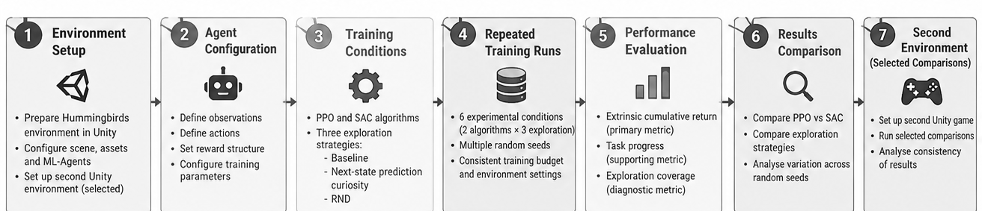
Figure 1: Overall methodology workflow across seven research stages.

The methodology starts with preparing the Hummingbirds environment. The agent is configured with the required observations, actions, and reward structure, and the training setup is built so that all experimental conditions can be compared under the same conditions.
The main experiment uses two algorithms, PPO and SAC, each tested under three exploration conditions: a baseline without additional intrinsic reward, a next-state prediction based curiosity approach, and RND. This produces six experimental conditions:
1. PPO with baseline exploration
2. PPO with next-state prediction based curiosity
3. PPO with Random Network Distillation (RND)
4. SAC with baseline exploration
5. SAC with next-state prediction based curiosity
6. SAC with Random Network Distillation (RND)
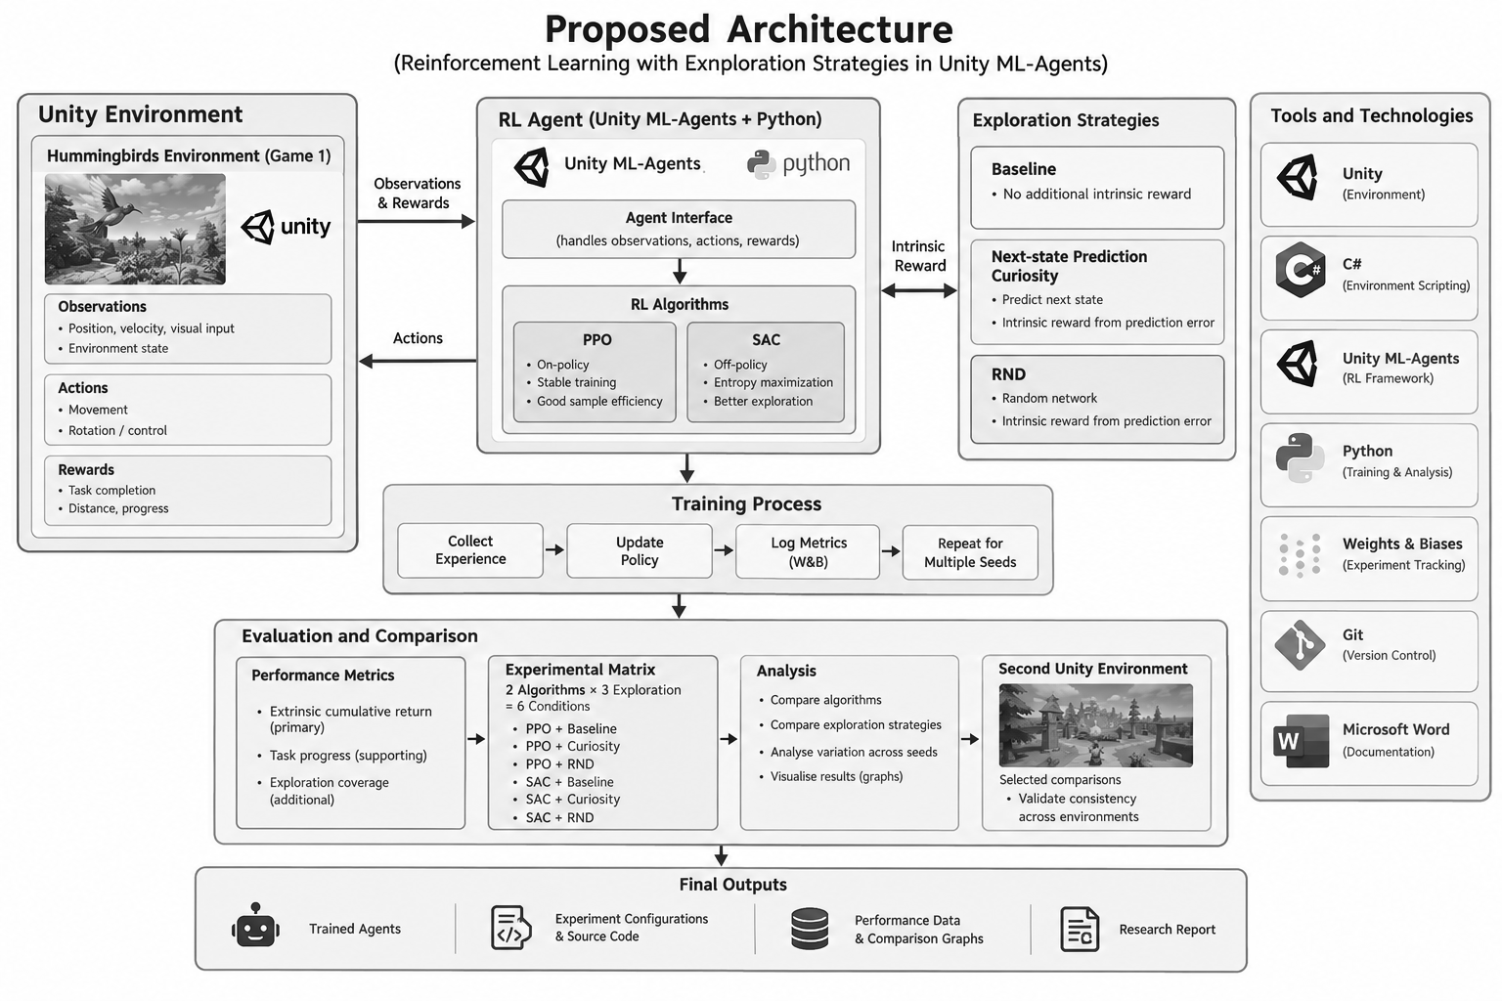
Figure 2: Proposed system architecture for reinforcement learning with exploration strategies in Unity ML-Agents.
As shown in Fig. 2, each condition will be trained with multiple random seeds where practical, so the variation between independent runs can be observed. Results will be evaluated mainly by extrinsic cumulative return, with task progress as a supporting measure and exploration coverage as an additional diagnostic where a suitable measurement can be defined.
The results will then be compared across algorithms and exploration conditions, focusing on observed performance and variation rather than assuming that any one approach is superior.
Finally, selected comparisons will be carried out in a second Unity environment to examine whether the Hummingbirds findings also hold under a different task structure. The overall methodology can be summarized as the following progression:
Environment Setup → Agent Configuration → Training Conditions → Repeated Training Runs → Performance Evaluation → Results Comparison → Selected Evaluation in Second Environment
This methodology provides a structured basis for implementing the project and collecting evidence that directly addresses the stated aims and objectives.

4 Individual Tasks
This is an individual Final Year Project, so all activities will be carried out by Raza Ullah Khan. The tasks are divided according to the stages of the research and development process, and the breakdown of responsibilities across the project duration is presented in TABLE II.
Table 2: INDIVIDUAL TASKS AND RESPONSIBILITIES
Sr. No. | Task Description | Individual Responsible
1 | Review relevant reinforcement learning concepts, algorithms, and exploration strategies required for the project. | Raza Ullah Khan
2 | Set up the Unity ML-Agents environment and prepare the Hummingbirds environment for experimentation. | Raza Ullah Khan
3 | Configure the RL agent, observations, actions, rewards, and training conditions for the experiments. | Raza Ullah Khan
4 | Implement and train the PPO and SAC baseline conditions. | Raza Ullah Khan
5 | Implement and evaluate the selected exploration approaches, including next-state prediction based curiosity and RND. | Raza Ullah Khan
6 | Conduct the six-condition experimental matrix in the Hummingbirds environment using multiple random seeds where practical. | Raza Ullah Khan
7 | Record and analyse training results using extrinsic cumulative return and supporting performance measures. | Raza Ullah Khan
8 | Prepare and evaluate selected comparisons in the second Unity environment. | Raza Ullah Khan
9 | Compare the experimental results and analyse the observed effects of the learning algorithms and exploration strategies. | Raza Ullah Khan
10 | Maintain the project code, experiment records, results, and documentation, and prepare the final report and presentation. | Raza Ullah Khan

5 Tools and Technologies
The following tools and technologies are planned for development, training, experimentation, evaluation, and documentation. TABLE III describes each one and its role in the research workflow.
Table 3: TOOLS AND TECHNOLOGIES
Sr. No. | Tool / Technology | Purpose in the Project
1 | Unity | Used to provide the game-based environments in which the reinforcement learning agents will be trained and evaluated.
2 | C# | Used for configuring and implementing the required Unity environment and agent-related components.
3 | Unity ML-Agents | Used as the main reinforcement learning framework for connecting the Unity environments with the training process and running the RL experiments.
4 | Python | Used for the reinforcement learning training process, experiment configuration, and analysis of training results through the ML-Agents workflow.
5 | Proximal Policy Optimization (PPO) | One of the selected reinforcement learning algorithms to be evaluated in the experimental study.
6 | Soft Actor-Critic (SAC) | The second selected reinforcement learning algorithm to be evaluated and compared with PPO.
7 | Weights & Biases (W&B) | Used for tracking training experiments, recording metrics, and supporting comparison of experimental runs.
8 | Git | Used for version control and maintaining the project source code and experiment-related changes.
9 | Microsoft Word | Used for preparing and formatting the project proposal, final report, and related documentation.
These tools will support the complete experimental workflow, from preparing the Unity environments and training the agents to recording, analysing, and documenting the experimental results.

6 Gantt Chart
The project will be completed over eight months. The work is organized into sequential and overlapping activities so that environment preparation, algorithm development, experimentation, evaluation, and documentation progress in a structured way. Git repository maintenance and documentation will continue throughout the project. The timeline and milestones are detailed in TABLE IV, and the schedule is illustrated in Fig. 3.

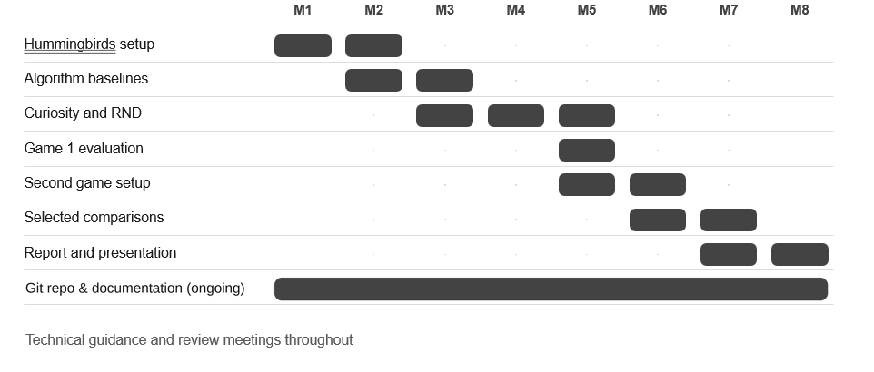
Figure 3 : Project Gantt chart representing the planned schedule across eight months.
The Gantt chart shows the planned sequence of activities. Hummingbirds is prepared first, followed by the baseline experiments and the exploration approaches. After evaluating the primary environment, the second environment is prepared for selected comparisons. The final months focus on analysis, the final report, and the presentation. Git-based version control and documentation continue throughout.

References
- Juliani, A., Berges, V.-P., Teng, E., Cohen, A., Harper, J., Elion, C., Goy, C., Gao, Y., Henry, H., Mattar, M., & Lange, D. (2018). Unity: A General Platform for Intelligent Agents. ArXiv Preprint ArXiv:1809.02627. https://arxiv.org/abs/1809.02627
- Pathak, D., Agrawal, P., Efros, A. A., & Darrell, T. (2017). Curiosity-Driven Exploration by Self-Supervised Prediction. Proceedings of the 34th International Conference on Machine Learning (ICML), 70, 2778–2787.
- Schulman, J., Wolski, F., Dhariwal, P., Radford, A., & Klimov, O. (2017). Proximal Policy Optimization Algorithms. ArXiv Preprint ArXiv:1707.06347. https://arxiv.org/abs/1707.06347
- Technologies, U. (2020). Solving Sparse-Reward Tasks with Curiosity. In Unity Technologies Blog. https://unity.com/blog/engine-platform/solving-sparse-reward-tasks-with-curiosity
- Wang, J., Liu, Y., Zhang, W., & Xu, C. (2023). Curiosity-Driven Exploration in Sparse-Reward Multi-Agent Reinforcement Learning. ArXiv Preprint ArXiv:2302.10825. https://arxiv.org/abs/2302.10825
- Zhang, Z., Zhao, M., Li, X., & Wang, H. (2024). RLeXplore: Accelerating Research in Intrinsically-Motivated Reinforcement Learning. ArXiv Preprint ArXiv:2405.19548. https://arxiv.org/abs/2405.19548

