**MINOR PROJECT- II**

**SECURITY ANALYSIS OF METASPLOITABLE 2 USING NMAP AND NESSUS**

1. **INTRODUCTION**

The purpose of this report is to present the activities conducted during Week 02 of the Cybersecurity Internship. The focus of this week's project was to set up and analyze the security of Metasploitable 2, a deliberately vulnerable virtual machine. We were tasked with installing Metasploitable 2, performing a network scan using Nmap, conducting a vulnerability assessment using Nessus, and generating a comprehensive report outlining the identified vulnerabilities and recommended remediation actions.

1. **PROJECT OBJECTIVES AND METHODOLOGY**

The objectives of this project were to set up Metasploitable 2, perform a network scan using Nmap to identify open ports, running services, and potential vulnerabilities, conduct a vulnerability assessment using Nessus, and generate a comprehensive report. The methodology involved the following steps:

1. Downloading and installing Metasploitable 2 on a virtualization platform such as VMware or VirtualBox.
2. Executing a network scan using Nmap to identify open ports, running services, and potential vulnerabilities.
3. Utilizing Nmap scripts to gather additional information about the identified services and potential vulnerabilities.
4. Installing and configuring Nessus, a vulnerability scanner, on the host machine.
5. Conducting a comprehensive vulnerability assessment of Metasploitable 2 using Nessus.
6. Analyzing the Nessus scan results, including identified vulnerabilities, severity levels, and potential impacts.
7. Preparing a comprehensive report documenting the project findings, including an overview of the project objectives and methodology, the installation process and network configuration of Metasploitable 2, Nmap scan results, Nessus vulnerability assessment findings, recommended remediation actions for each identified vulnerability, and a conclusion with recommendations for improving the security posture of Metasploitable 2.
8. **METASPLOITABLE 2 INSTALLATION AND NETWORK CONFIGURATION**

The installation process of Metasploitable 2 involves the following steps:

1. **Download the Metasploitable 2 VM:** Metasploitable 2 is available for download as a pre-configured virtual machine. You can obtain the VM image from reliable sources such as the Metasploit website or trusted online repositories.
2. **Choose a Virtualization Platform:** Metasploitable 2 can be run on popular virtualization platforms such as VMware or VirtualBox. Select the platform of your choice and ensure it is installed on your system.
3. **Import Metasploitable 2 into the Virtualization Software:** Open the virtualization software (VMware or VirtualBox) and import the Metasploitable 2 VM image into the software. This process typically involves selecting the option to import an existing virtual machine and providing the path to the downloaded Metasploitable 2 VM image.
4. **Configure Network Settings:** Once the VM is imported, you need to configure the network settings to establish connectivity. Metasploitable 2 is usually set up with a default network configuration, but it's essential to ensure that it aligns with your virtualization software's networking setup.
5. **Start the Metasploitable 2 VM:** After the network settings are configured, you can start the Metasploitable 2 virtual machine within your virtualization software. The VM will boot up, and you will be provided with the login credentials for accessing the system.

Regarding network configuration, Metasploitable 2 is typically set up with a default network configuration that allows it to connect to the network and communicate with the host machine and other virtual machines. By default, Metasploitable 2 is configured with a single network interface and may use NAT (Network Address Translation) or Bridged mode to establish connectivity.

NAT mode allows the virtual machine to access the network through the host machine's network interface, using the host's IP address for external communication. In Bridged mode, the virtual machine is directly connected to the network, obtaining its IP address and network connectivity independently.

It's crucial to ensure that the virtualization software's network settings are properly configured to establish connectivity between the host machine and the Metasploitable 2 VM. This will enable network scanning using tools like Nmap and conducting vulnerability assessments using Nessus as discussed in the project objectives.

1. **NETWORK SCANNING USING NMAP**

Nmap, a network scanning tool, was used to perform a network scan of Metasploitable 2. The objective was to identify open ports, running services, and potential vulnerabilities.

**NMAP SCAN RESULTS**

The Nmap scan yielded the following results:

Open Ports: List the open ports discovered during the scan and their associated services.

Running Services: Identify the services running on the open ports.

**Finding the Ip address of linux machines**

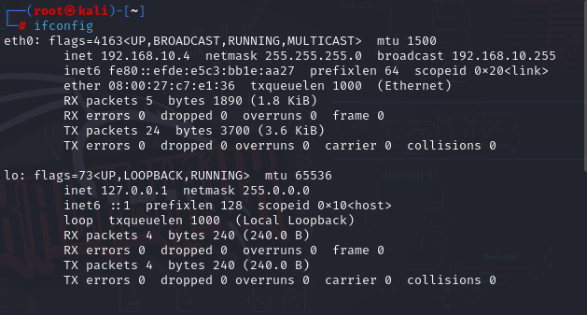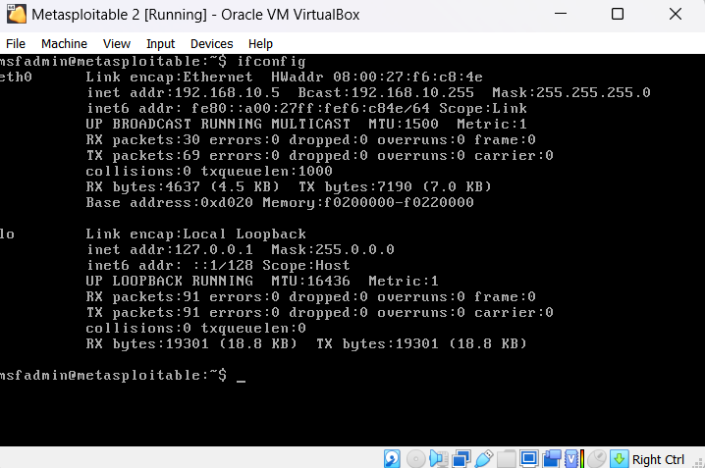

**Using nmap in kali linux to find the open ports, running services,**

**and potential vulnerabilities**

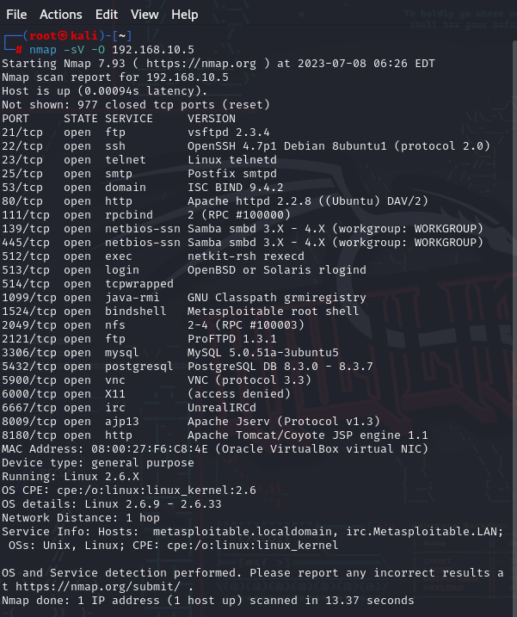

**Default scan**

|  |
| --- |
| **nmap -sV -script=default 192.168.10.5 Starting Nmap 7.93 ( https://nmap.org ) at 2023-07-09 00:52 EDT Nmap scan report for 192.168.10.5 Host is up (0.00017s latency). Not shown: 977 closed tcp ports (reset) PORT STATE SERVICE VERSION 21/tcp open ftp vsftpd 2.3.4 | ftp-syst:  | STAT:  | FTP server status: | Connected to 192.168.10.4 | Logged in as ftp | TYPE: ASCII | No session bandwidth limit | Session timeout in seconds is 300 | Control connection is plain text | Data connections will be plain text | vsFTPd 2.3.4 - secure, fast, stable |_End of status |_ftp-anon: Anonymous FTP login allowed (FTP code 230) 22/tcp open ssh OpenSSH 4.7p1 Debian 8ubuntu1 (protocol 2.0) | ssh-hostkey:  | 1024 600fcfe1c05f6a74d69024fac4d56ccd (DSA) |_ 2048 5656240f211ddea72bae61b1243de8f3 (RSA) 23/tcp open telnet Linux telnetd 25/tcp open smtp Postfix smtpd |_smtp-commands: metasploitable.localdomain, PIPELINING, SIZE 10240000, VRFY, ETRN, STARTTLS, ENHANCEDSTATUSCODES, 8BITMIME, DSN | ssl-cert: Subject: commonName=ubuntu804-base.localdomain/organizationName=OCOSA/stateOrProvinceName=There is no such thing outside US/countryName=XX | Not valid before: 2010-03-17T14:07:45 |_Not valid after: 2010-04-16T14:07:45 |_ssl-date: 2023-07-09T04:52:33+00:00; +1s from scanner time. | sslv2:  | SSLv2 supported | ciphers:  | SSL2_RC2_128_CBC_WITH_MD5 | SSL2_DES_64_CBC_WITH_MD5 | SSL2_RC4_128_EXPORT40_WITH_MD5 | SSL2_DES_192_EDE3_CBC_WITH_MD5 | SSL2_RC2_128_CBC_EXPORT40_WITH_MD5 |_ SSL2_RC4_128_WITH_MD5 53/tcp open domain ISC BIND 9.4.2 | dns-nsid:  |_ bind.version: 9.4.2 80/tcp open http Apache httpd 2.2.8 ((Ubuntu) DAV/2) |_http-title: Metasploitable2 - Linux |_http-server-header: Apache/2.2.8 (Ubuntu) DAV/2 111/tcp open rpcbind 2 (RPC #100000) | rpcinfo:  | program version port/proto service | 100000 2 111/tcp rpcbind | 100000 2 111/udp rpcbind | 100003 2,3,4 2049/tcp nfs | 100003 2,3,4 2049/udp nfs | 100005 1,2,3 40281/udp mountd | 100005 1,2,3 55892/tcp mountd | 100021 1,3,4 41604/udp nlockmgr | 100021 1,3,4 46082/tcp nlockmgr | 100024 1 44922/tcp status |_ 100024 1 52448/udp status 139/tcp open netbios-ssn Samba smbd 3.X - 4.X (workgroup: WORKGROUP) 445/tcp open netbios-ssn Samba smbd 3.0.20-Debian (workgroup: WORKGROUP) 512/tcp open exec netkit-rsh rexecd 513/tcp open login 514/tcp open tcpwrapped 1099/tcp open java-rmi GNU Classpath grmiregistry 1524/tcp open bindshell Metasploitable root shell 2049/tcp open nfs 2-4 (RPC #100003) 2121/tcp open ftp ProFTPD 1.3.1 3306/tcp open mysql MySQL 5.0.51a-3ubuntu5 | mysql-info:  | Protocol: 10 | Version: 5.0.51a-3ubuntu5 | Thread ID: 8 | Capabilities flags: 43564 | Some Capabilities: Support41Auth, ConnectWithDatabase, SupportsCompression, SupportsTransactions, SwitchToSSLAfterHandshake, Speaks41ProtocolNew, LongColumnFlag | Status: Autocommit |_ Salt: '3i:$DjiR=zo@/h@E|_G 5432/tcp open postgresql PostgreSQL DB 8.3.0 - 8.3.7 |_ssl-date: 2023-07-09T04:52:33+00:00; +1s from scanner time. | ssl-cert: Subject: commonName=ubuntu804-base.localdomain/organizationName=OCOSA/stateOrProvinceName=There is no such thing outside US/countryName=XX | Not valid before: 2010-03-17T14:07:45 |_Not valid after: 2010-04-16T14:07:45 5900/tcp open vnc VNC (protocol 3.3) | vnc-info:  | Protocol version: 3.3 | Security types:  |_ VNC Authentication (2) 6000/tcp open X11 (access denied) 6667/tcp open irc UnrealIRCd | irc-info:  | users: 1 | servers: 1 | lusers: 1 | lservers: 0 | server: irc.Metasploitable.LAN | version: Unreal3.2.8.1. irc.Metasploitable.LAN  | uptime: 0 days, 0:03:49 | source ident: nmap | source host: BAAF933C.554FE7D2.FFFA6D49.IP |_ error: Closing Link: kqnepylav[192.168.10.4] (Quit: kqnepylav) 8009/tcp open ajp13 Apache Jserv (Protocol v1.3) |_ajp-methods: Failed to get a valid response for the OPTION request 8180/tcp open http Apache Tomcat/Coyote JSP engine 1.1 |_http-title: Apache Tomcat/5.5 |_http-favicon: Apache Tomcat |_http-server-header: Apache-Coyote/1.1 MAC Address: 08:00:27:F6:C8:4E (Oracle VirtualBox virtual NIC) Service Info: Hosts: metasploitable.localdomain, irc.Metasploitable.LAN; OSs: Unix, Linux; CPE: cpe:/o:linux:linux_kernel  Host script results: |_clock-skew: mean: 1h00m01s, deviation: 2h00m01s, median: 0s | smb-os-discovery:  | OS: Unix (Samba 3.0.20-Debian) | Computer name: metasploitable | NetBIOS computer name:  | Domain name: localdomain | FQDN: metasploitable.localdomain |_ System time: 2023-07-09T00:52:26-04:00 | smb-security-mode:  | account_used: guest | authentication_level: user | challenge_response: supported |_ message_signing: disabled (dangerous, but default) |_nbstat: NetBIOS name: METASPLOITABLE, NetBIOS user: <unknown>, NetBIOS MAC: 000000000000 (Xerox) |_smb2-time: Protocol negotiation failed (SMB2)  Service detection performed. Please report any incorrect results at https://nmap.org/submit/ . Nmap done: 1 IP address (1 host up) scanned in 20.89 second** |

**Vulnerability Scan**

|  |
| --- |
| **nmap --script=vuln -sV 192.168.10.5  Starting Nmap 7.93 ( https://nmap.org ) at 2023-07-09 09:04 IST Stats: 0:00:16 elapsed; 0 hosts completed (1 up), 1 undergoing Service Scan Service scan Timing: About 8.70% done; ETC: 09:04 (0:00:00 remaining) Nmap scan report for 192.168.14.191 Host is up (0.054s latency). Not shown: 977 filtered tcp ports (no-response) PORT STATE SERVICE VERSION 21/tcp open ftp vsftpd 2.3.4 22/tcp open ssh OpenSSH 4.7p1 Debian 8ubuntu1 (protocol 2.0) 23/tcp open telnet Linux telnetd 25/tcp open smtp Postfix smtpd | ssl-dh-params:  | VULNERABLE: | Anonymous Diffie-Hellman Key Exchange MitM Vulnerability | State: VULNERABLE | Transport Layer Security (TLS) services that use anonymous | Diffie-Hellman key exchange only provide protection against passive | eavesdropping, and are vulnerable to active man-in-the-middle attacks | which could completely compromise the confidentiality and integrity | of any data exchanged over the resulting session. | Check results: | ANONYMOUS DH GROUP 1 | Cipher Suite: TLS_DH_anon_WITH_RC4_128_MD5 | Modulus Type: Safe prime | Modulus Source: postfix builtin | Modulus Length: 1024 | Generator Length: 8 | Public Key Length: 1024 | References: | https://www.ietf.org/rfc/rfc2246.txt |  | Transport Layer Security (TLS) Protocol DHE_EXPORT Ciphers Downgrade MitM (Logjam) | State: VULNERABLE | IDs: BID:74733 CVE:CVE-2015-4000 | The Transport Layer Security (TLS) protocol contains a flaw that is | triggered when handling Diffie-Hellman key exchanges defined with | the DHE_EXPORT cipher. This may allow a man-in-the-middle attacker | to downgrade the security of a TLS session to 512-bit export-grade | cryptography, which is significantly weaker, allowing the attacker | to more easily break the encryption and monitor or tamper with | the encrypted stream. | Disclosure date: 2015-5-19 | Check results: | EXPORT-GRADE DH GROUP 1 | Cipher Suite: TLS_DHE_RSA_EXPORT_WITH_DES40_CBC_SHA | Modulus Type: Safe prime | Modulus Source: Unknown/Custom-generated | Modulus Length: 512 | Generator Length: 8 | Public Key Length: 512 | References: | https://weakdh.org | https://cve.mitre.org/cgi-bin/cvename.cgi?name=CVE-2015-4000 | https://www.securityfocus.com/bid/74733 |  | Diffie-Hellman Key Exchange Insufficient Group Strength | State: VULNERABLE | Transport Layer Security (TLS) services that use Diffie-Hellman groups | of insufficient strength, especially those using one of a few commonly | shared groups, may be susceptible to passive eavesdropping attacks. | Check results: | WEAK DH GROUP 1 | Cipher Suite: TLS_DHE_RSA_WITH_3DES_EDE_CBC_SHA | Modulus Type: Safe prime | Modulus Source: postfix builtin | Modulus Length: 1024 | Generator Length: 8 | Public Key Length: 1024 | References: |_ https://weakdh.org | ssl-poodle:  | VULNERABLE: | SSL POODLE information leak | State: VULNERABLE | IDs: BID:70574 CVE:CVE-2014-3566 | The SSL protocol 3.0, as used in OpenSSL through 1.0.1i and other | products, uses nondeterministic CBC padding, which makes it easier | for man-in-the-middle attackers to obtain cleartext data via a | padding-oracle attack, aka the "POODLE" issue. | Disclosure date: 2014-10-14 | Check results: | TLS_RSA_WITH_AES_128_CBC_SHA | References: | https://www.imperialviolet.org/2014/10/14/poodle.html | https://www.securityfocus.com/bid/70574 | https://www.openssl.org/~bodo/ssl-poodle.pdf |_ https://cve.mitre.org/cgi-bin/cvename.cgi?name=CVE-2014-3566 53/tcp open domain ISC BIND 9.4.2 80/tcp open http Apache httpd 2.2.8 ((Ubuntu) DAV/2) |_http-server-header: Apache/2.2.8 (Ubuntu) DAV/2 |_http-stored-xss: Couldn't find any stored XSS vulnerabilities. |_http-vuln-cve2014-3704: ERROR: Script execution failed (use -d to debug) |_http-csrf: Couldn't find any CSRF vulnerabilities. |_http-dombased-xss: Couldn't find any DOM based XSS. |_http-aspnet-debug: ERROR: Script execution failed (use -d to debug) 111/tcp open rpcbind 2 (RPC #100000) 139/tcp open netbios-ssn Samba smbd 3.X - 4.X (workgroup: WORKGROUP) 445/tcp open netbios-ssn Samba smbd 3.X - 4.X (workgroup: WORKGROUP) 512/tcp open exec netkit-rsh rexecd 513/tcp open login? 514/tcp open tcpwrapped 1099/tcp open java-rmi GNU Classpath grmiregistry |_rmi-vuln-classloader: ERROR: Script execution failed (use -d to debug) 1524/tcp open bindshell Metasploitable root shell 2049/tcp open nfs 2-4 (RPC #100003) 2121/tcp open ccproxy-ftp? 3306/tcp open mysql MySQL 5.0.51a-3ubuntu5 |_ssl-ccs-injection: No reply from server (TIMEOUT) 5432/tcp open postgresql PostgreSQL DB 8.3.0 - 8.3.7 | ssl-ccs-injection:  | VULNERABLE: | SSL/TLS MITM vulnerability (CCS Injection) | State: VULNERABLE | Risk factor: High | OpenSSL before 0.9.8za, 1.0.0 before 1.0.0m, and 1.0.1 before 1.0.1h | does not properly restrict processing of ChangeCipherSpec messages, | which allows man-in-the-middle attackers to trigger use of a zero | length master key in certain OpenSSL-to-OpenSSL communications, and | consequently hijack sessions or obtain sensitive information, via | a crafted TLS handshake, aka the "CCS Injection" vulnerability. |  | References: | http://www.openssl.org/news/secadv_20140605.txt | http://www.cvedetails.com/cve/2014-0224 |_ https://cve.mitre.org/cgi-bin/cvename.cgi?name=CVE-2014-0224 | ssl-poodle:  | VULNERABLE: | SSL POODLE information leak | State: VULNERABLE | IDs: BID:70574 CVE:CVE-2014-3566 | The SSL protocol 3.0, as used in OpenSSL through 1.0.1i and other | products, uses nondeterministic CBC padding, which makes it easier | for man-in-the-middle attackers to obtain cleartext data via a | padding-oracle attack, aka the "POODLE" issue. | Disclosure date: 2014-10-14 | Check results: | TLS_RSA_WITH_AES_128_CBC_SHA | References: | https://www.imperialviolet.org/2014/10/14/poodle.html | https://www.securityfocus.com/bid/70574 | https://www.openssl.org/~bodo/ssl-poodle.pdf |_ https://cve.mitre.org/cgi-bin/cvename.cgi?name=CVE-2014-3566 | ssl-dh-params:  | VULNERABLE: | Diffie-Hellman Key Exchange Insufficient Group Strength | State: VULNERABLE | Transport Layer Security (TLS) services that use Diffie-Hellman groups | of insufficient strength, especially those using one of a few commonly | shared groups, may be susceptible to passive eavesdropping attacks. | Check results: | WEAK DH GROUP 1 | Cipher Suite: TLS_DHE_RSA_WITH_3DES_EDE_CBC_SHA | Modulus Type: Safe prime | Modulus Source: Unknown/Custom-generated | Modulus Length: 1024 | Generator Length: 8 | Public Key Length: 1024 | References: |_ https://weakdh.org 5900/tcp open vnc VNC (protocol 3.3) 6000/tcp open X11 (access denied) 6667/tcp open irc UnrealIRCd 8009/tcp open ajp13 Apache Jserv (Protocol v1.3) 8180/tcp open http Apache Tomcat/Coyote JSP engine 1.1 |_http-dombased-xss: Couldn't find any DOM based XSS. |_http-server-header: Apache-Coyote/1.1 |_http-vuln-cve2014-3704: ERROR: Script execution failed (use -d to debug) |_http-aspnet-debug: ERROR: Script execution failed (use -d to debug) | http-csrf:  | Spidering limited to: maxdepth=3; maxpagecount=20; withinhost=192.168.14.191 | Found the following possible CSRF vulnerabilities:  |  | Path: http://192.168.14.191:8180/admin/ | Form id: username |_ Form action: j_security_check;jsessionid=843D54076336BF45FCD215D3D6231BA2 |_http-stored-xss: Couldn't find any stored XSS vulnerabilities. Service Info: Hosts: metasploitable.localdomain, irc.Metasploitable.LAN; OSs: Unix, Linux; CPE: cpe:/o:linux:linux_kernel  Host script results: |_samba-vuln-cve-2012-1182: Could not negotiate a connection:SMB: Failed to receive bytes: EOF |_smb-vuln-ms10-061: Could not negotiate a connection:SMB: Failed to receive bytes: EOF |_smb-vuln-regsvc-dos: ERROR: Script execution failed (use -d to debug) |_smb-vuln-ms10-054: false | smb-vuln-cve2009-3103:  | VULNERABLE: | SMBv2 exploit (CVE-2009-3103, Microsoft Security Advisory 975497) | State: VULNERABLE | IDs: CVE:CVE-2009-3103 | Array index error in the SMBv2 protocol implementation in srv2.sys in Microsoft Windows Vista Gold, SP1, and SP2, | Windows Server 2008 Gold and SP2, and Windows 7 RC allows remote attackers to execute arbitrary code or cause a | denial of service (system crash) via an & (ampersand) character in a Process ID High header field in a NEGOTIATE | PROTOCOL REQUEST packet, which triggers an attempted dereference of an out-of-bounds memory location, | aka "SMBv2 Negotiation Vulnerability." |  | Disclosure date: 2009-09-08 | References: | http://www.cve.mitre.org/cgi-bin/cvename.cgi?name=CVE-2009-3103 |_ https://cve.mitre.org/cgi-bin/cvename.cgi?name=CVE-2009-3103  Service detection performed. Please report any incorrect results at https://nmap.org/submit/ . Nmap done: 1 IP address (1 host up) scanned in 152.78 seconds** |

**NMAP SCRIPT RESULTS**

Nmap scripts were employed to gather additional information about the identified services and potential vulnerabilities. The following Nmap scripts were executed:

Script 1: The Metasploitable 2 machine has several open and vulnerable services, including an open FTP server (vsftpd 2.3.4) with anonymous login allowed, an outdated OpenSSH server (4.7p1 Debian 8ubuntu1), and an open Telnet service (Linux telnetd). These services could pose significant security risks if not properly secured and updated.

Script 2: The presence of open NetBIOS services (Samba smbd 3.X - 4.X) on ports 139 and 445 suggests potential vulnerabilities that could be exploited by attackers. It is crucial to ensure that proper security measures are implemented to protect against unauthorized access and data breaches.

1. **VULNERABILITY ASSESSMENT USING NESSUS**

Nessus, a vulnerability scanner, was installed and configured on the host machine. A comprehensive vulnerability assessment of Metasploitable 2 was conducted using Nessus.

1. **NESSUS SCAN RESULTS**

The Nessus scan generated detailed results, including identified vulnerabilities, severity levels, and potential impacts. Notable findings include**:**

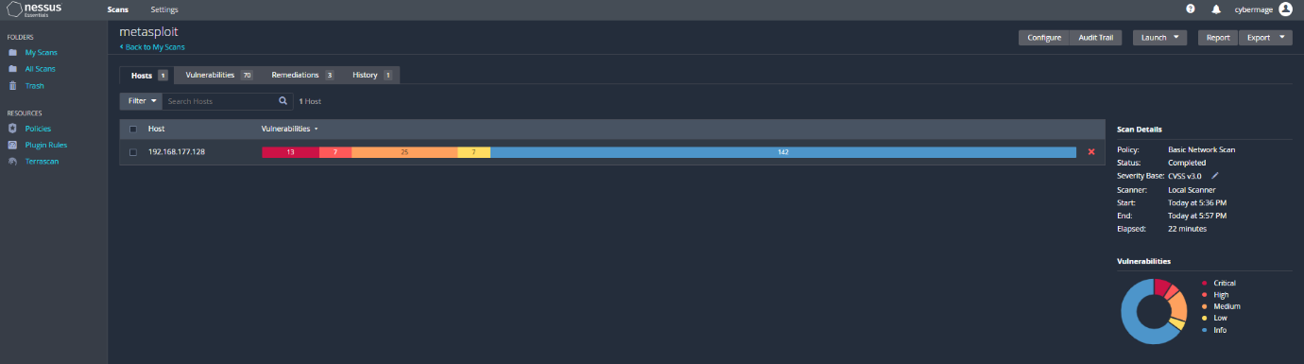

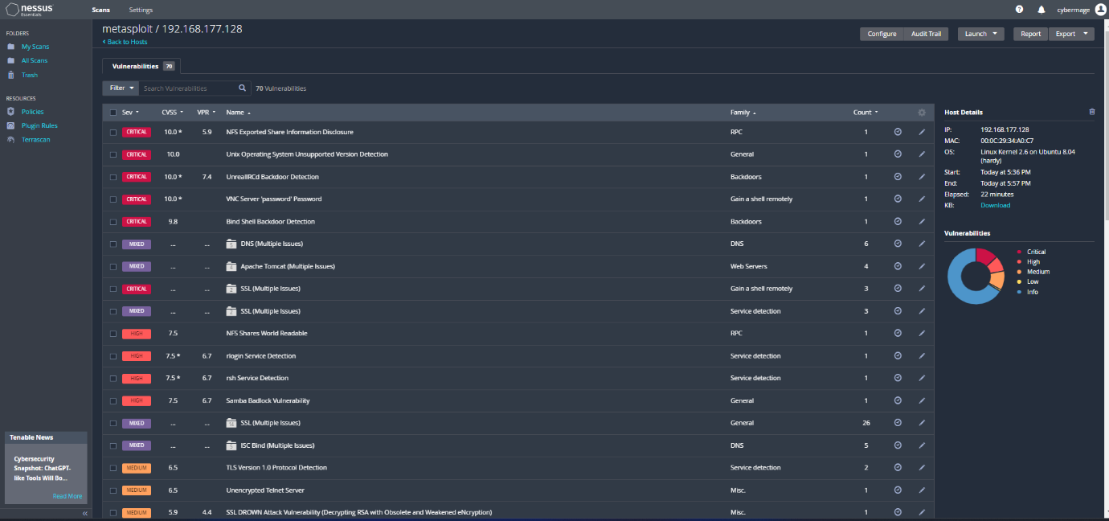

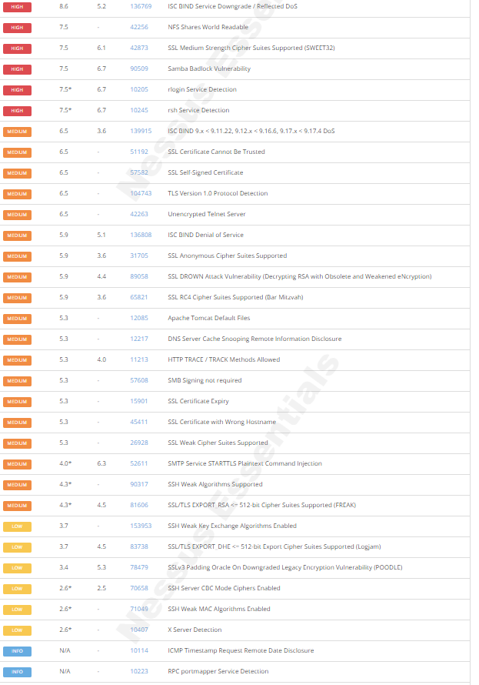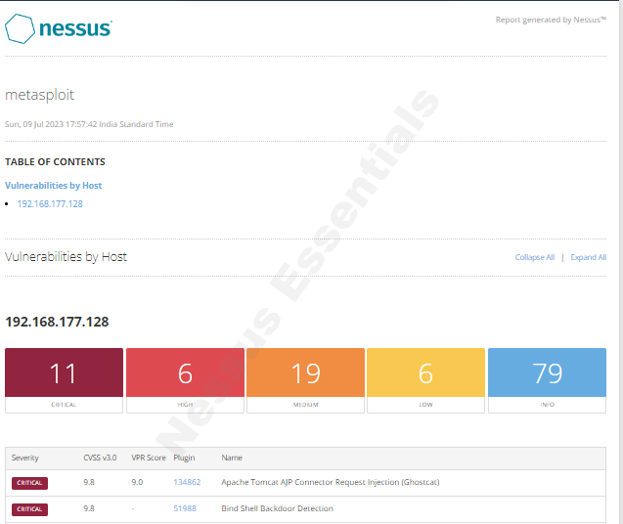



1. **Vulnerability :** Unix OS Unsupported Version Detection

**Description:** This vulnerability refers to the detection of an outdated and unsupported version of the Unix operating system on the target system.

**Severity Level**: CRITICAL

**Potential Impact:**

Lack of security updates

Exploitation of known vulnerabilities

Compliance violations

1. **Vulnerability :** rlogin Service Detection

**Description:** The rlogin service is detected on the target system, which poses security risks due to its lack of encryption and weak authentication.

**Severity Level**: MEDIUM

**Potential Impact:**

Unauthorized access

Data interception

Credential compromise

1. **Vulnerability :** X Server Detection

**Description:** The presence of Xserver, a component of the X Window System, is detected on the target system.

**Severity Level**: LOW

**Potential Impact:**

Unauthorized access

Session hijacking

Information disclosure

1. **RECOMMENDED REMEDIATION ACTIONS**

* Upgrade the unsupported Unix OS version.
* Disable rlogin service and switch to SSH.
* Secure Xserver with proper configurations.
* Regularly update software and services.
* Implement network segmentation and access controls.
* Conduct regular security assessments.
* Provide training on secure practices.

**These actions will help mitigate the identified vulnerabilities and enhance the overall security of the system.**

1. **CONCLUSION AND RECOMMENDATIONS**

In conclusion, the network scan using Nmap and vulnerability assessment using Nessus on Metasploitable 2 identified several vulnerabilities. It is crucial to address these vulnerabilities promptly to enhance the security posture of Metasploitable 2. The report concludes with recommendations for improving the security posture of Metasploitable 2, including implementing the recommended remediation actions and regularly conducting vulnerability assessments.