International Multidisciplinary Journal of Technologies and Applications (IMJETA)
Vol. 1, No. 1, pp. a-b, Month 2026
Received Month 00, 2026; Revised Month 00, 2026; Accepted Month 00, 2026
Published Month 00 2026
Evaluation of Spatial SQL Injection Vulnerabilities in PostGIS-Based Cadastral Information Systems
Rodrigo Surname1[0000-0002-XXXX-XXXX]
1National University / Doctoral Program in Cybersecurity
investigador.catastro@doctorado.edu.pe
Abstract. The integration of spatial databases into web architectures has expanded the attack surface for modern applications; however, the specific risks associated with spatial SQL injections remain largely underexplored. This paper investigates the exploitation and mitigation of spatial SQL injections within cadastral information systems utilizing PostGIS. A containerized testbed was developed using Docker to simulate a critical infrastructure API built with Python (FastAPI) and PostgreSQL/PostGIS. The study demonstrates how attackers can leverage spatial functions (e.g., ST_DWithin, ST_Intersects) to manipulate geospatial logic, exfiltrate unauthorized zoning data, or induce denial-of-service states. Furthermore, the research evaluates the performance impact of implementing robust mitigation strategies, comparing vulnerable dynamic spatial queries with parameterized queries executed via Object-Relational Mapping (ORM) tools such as SQLAlchemy and GeoAlchemy2. Results demonstrate that the proposed multi-tier pipeline neutralized 100% of the attack vectors with a mean latency overhead of 2.63 ms (+15.24%) and a 12.59% improvement in tail stability (p99). We conclude that effective spatial injection mitigation relies on enforcing in-memory topological validation and rigid ORM parameterization at the application layer rather than perimeter firewalls, securing cadastral integrity with minimal operational overhead.
Keywords: Spatial injections; Cadastral systems; Geospatial cybersecurity; Penetration testing; Databases
1. Introduction
Modern cadastral information systems expose web services and spatial geoportals over client-server architectures to administer land tenure, municipal zoning, and property taxation (Lemmen et al., 2015). Within this operational domain, PostgreSQL along with its PostGIS spatial extension represents the predominant open-source engine for storing and querying official vector cartography (Obe & Hsu, 2021).
However, exposing these spatial data services via REST APIs introduces exploitable attack surfaces whenever queries are constructed through string concatenation within spatial functions. While classical SQL injection has been extensively documented (Clarke, 2012; Halfond et al., 2006), manipulating PostGIS geometric operators—such as ST_DWithin, ST_Intersects, or ST_Buffer—exhibits distinct mechanics: unsanitized input not only circumvents relational filters or exfiltrates records, but also triggers denial-of-service conditions through high-complexity topological evaluations.
This article presents an experimental evaluation of spatial SQL injection vulnerabilities in PostGIS-based cadastral systems. This work: (1) documents and evaluates six attack vectors mapped to the CIA security triad (Confidentiality, Integrity, and Availability); (2) implements a reproducible testbed over an experimental dataset of 1,500 urban parcels adhering to the ISO 19152 (LADM) standard; and (3) quantifies the latency and throughput trade-offs of a mitigation architecture combining strongly typed ORM compilation (GeoAlchemy2) with pre-execution validation via Shapely and Pydantic.
2. Related Work
2.1. Spatial SQL Injections and Topological Operators
Seminal literature in computer security has established robust taxonomies for SQLi attacks. Halfond et al. (2006) categorized these threats into tautologies, union queries, blind injections, and stored procedure piggybacking. Clarke (2012) expanded upon this by examining the abstract syntax trees (AST) generated by database parsers when unsanitized input is concatenated into query strings. However, these classical frameworks fail to account for how spatial algebraic operators (Egenhofer, 1994) fundamentally alter query evaluation logic. Unlike scalar expressions, geometric operators process multi-dimensional geometries, spatial reference system identifiers (SRID), and minimum bounding boxes (MBR), significantly expanding the syntactic escape surface. This theoretical gap in classical injection taxonomies leaves topological predicate manipulation in spatial relational engines unaddressed.
2.2. Geospatial Access Control Models and Spatial Inference Breaches
Access control in spatial databases was formally conceptualized by Bertino et al. (2005) through the GEO-RBAC (Spatially Aware Role-Based Access Control) model, demonstrating that read and write privileges must be dynamically bounded by geographic constraints. Complementarily, Chun and Atluri (2008) and Atluri and Chun (2004) investigated spatial inference risks in spatial database management systems (SDBMS), where unauthorized actors deduce the presence or attributes of protected spatial entities by correlating successive queries. Nevertheless, these models assume that the application layer faithfully projects spatial policies to persistence; in web architectures, unsafe parameter concatenation circumvents access controls directly within the database engine.
2.3. Cadastral Integrity and Data Modeling under ISO 19152 (LADM)
The conceptual modeling of cadastral information systems is governed internationally by the ISO 19152:2012 standard, known as the Land Administration Domain Model (LADM). Foundational works by Lemmen et al. (2015) and van Oosterom et al. (2006) formalized core cadastral entities, prominently LA_SpatialUnit (representing parcels and lots) and LA_Party (representing property owners). While the standard establishes structural semantics and legal-administrative interoperability, it omits query-level architectural countermeasures against injection attacks, leaving fiscal revenue and title tenure integrity vulnerable to insecure implementation practices.
2.4. Algorithmic Complexity Attacks and Vulnerabilities in OGC Services
The contemporary relevance of spatial injection threats was acutely illustrated in production systems by critical vulnerability CVE-2023-25157 (CVSS score 9.8), wherein GeoServer allowed unauthenticated remote SQL injection via flawed evaluation of OGC filters and CQL expressions over PostGIS backends (National Vulnerability Database, 2023). In parallel, regarding availability threats, Crosby and Wallach (2003) established the paradigm of Algorithmic Complexity Attacks, illustrating how engineered inputs force worst-case execution paths (O(N^2)) to monopolize system CPU. In spatial engines, as documented by Agarwal and Rajan (2016), computational geometry algorithms in PostGIS's underlying GEOS library exhibit quadratic algorithmic complexity when evaluating complex geometries devoid of preliminary GiST bounding-box filtering. Despite these precedents, existing literature has not quantified the resulting latency profiles nor formalized multi-tier defense pipelines reconciling API parsing with spatial database kernels.
3. Methodology
3.1. Research Approach and Experimental Framework
A controlled, quantitative, experimental design was adopted to evaluate the susceptibility of geospatial endpoints to SQL injections and measure the performance overhead introduced by a multi-tier mitigation pipeline. The evaluation compares two conditions: unprotected dynamic SQL queries versus ORM-compiled queries with prior geometric validation.
3.2. Cadastral Dataset
The experimental dataset comprises 1,500 contiguous urban cadastral parcels structured under the ISO 19152 standard (LADM, LA_SpatialUnit class) and georeferenced in EPSG:32719. The geometries exhibit a complexity ranging between 4 and 222 vertices (mean: 9.0 vertices per polygon). To ensure reproducibility and ethical safeguards, base cartography was retrieved from open sources and fiscal attributes were procedurally generated without incorporating personally identifiable information (PII).
3.3. Experimental Environment and Architecture
The testbed was implemented in Docker containers using isolated microservices: (1) a database service running PostgreSQL 15 and PostGIS 3.3, and (2) a Python 3.11 API with FastAPI and Uvicorn. Stress testing was executed in a controlled 14-core 5.2 GHz environment with 32 GB DDR5 RAM on Linux kernel 6.6 (WSL2).
3.4. Test Vectors and Performance Metrics
Six exploitation vectors targeting the three dimensions of the CIA security triad (Confidentiality, Integrity, and Availability, summarized in Appendix 1) were designed. Performance evaluation included a 300-request load test and stepped concurrency curves (1 to 100 clients), recording latency metrics (mean, p50, p95, p99) and throughput (req/s).
4. Attack Simulations and Exploitation Results
4.1. Simulation 1: Spatial Logic Bypass
The endpoint GET /api/v1/vulnerable/predios/radio is designed to return lots within a 50-meter radius located in sector 0101. By injecting the payload '50) OR (1=1' into the distance parameter, the PostgreSQL lexical analyzer prematurely terminates the ST_DWithin operator and introduces a tautology that completely negates both the spatial distance constraint and the sector boundary clause. Consequently, the query transitioned from returning 1 authorized parcel to exfiltrating 50 unauthorized cadastral parcels across foreign sectors in 7.03 ms. In the mitigated endpoint, Pydantic and GeoAlchemy2 enforced strict numerical type verification, successfully neutralizing the attack with an HTTP 422 Unprocessable Entity status code.
4.2. Simulation 2: Data Inference via Geometric Error Channels (Error-Based Spatial SQLi)
At the endpoint GET /api/v1/vulnerable/predios/poligono, the application renders cartographic polygons without displaying alphanumeric database attributes. The adversary constructed an inferential side-channel coupled to the ST_Intersects operator, injecting a conditional division-by-zero expression tied to character-by-character conjecture against administrative credential tables: if the guessed character matches, PostGIS encounters an internal division-by-zero exception, triggering an HTTP 500 error; if false, the database executes normally, returning HTTP 200. Through this binary oracle, the full plaintext credential 'admin' was reconstructed in 42 seconds. In the mitigated implementation, Shapely evaluated topological validity in application memory, intercepting malformed input and returning HTTP 422 before reaching the database engine.
4.3. Simulation 3: Spatial Denial of Service (Spatial DoS)
Exploiting the inherent geometric complexity of the parcels (mean of 9.0 vertices and up to 222 vertices per polygon), an attacker submitted a subquery executing an O(N^2) Cartesian product calculating buffers with high segment density per quadrant to the endpoint GET /api/v1/vulnerable/predios/analisis-expansion. As empirically evidenced in Figure 1, the injection of the unindexed spatial cross-join triggers an algorithmic complexity explosion O(N^2), escalating execution latency from 10.8 ms up to 1,665.16 ms as evaluated pairwise buffer vertices expand from 14,400 to over 345,600 points, saturating PostgreSQL worker threads on the Intel Core Ultra 5 245KF processor. Conversely, the mitigated architecture reliably maintains an invariant latency of ~15 ms by constraining input parameters to scalar bounds validated via Pydantic and GeoAlchemy2.
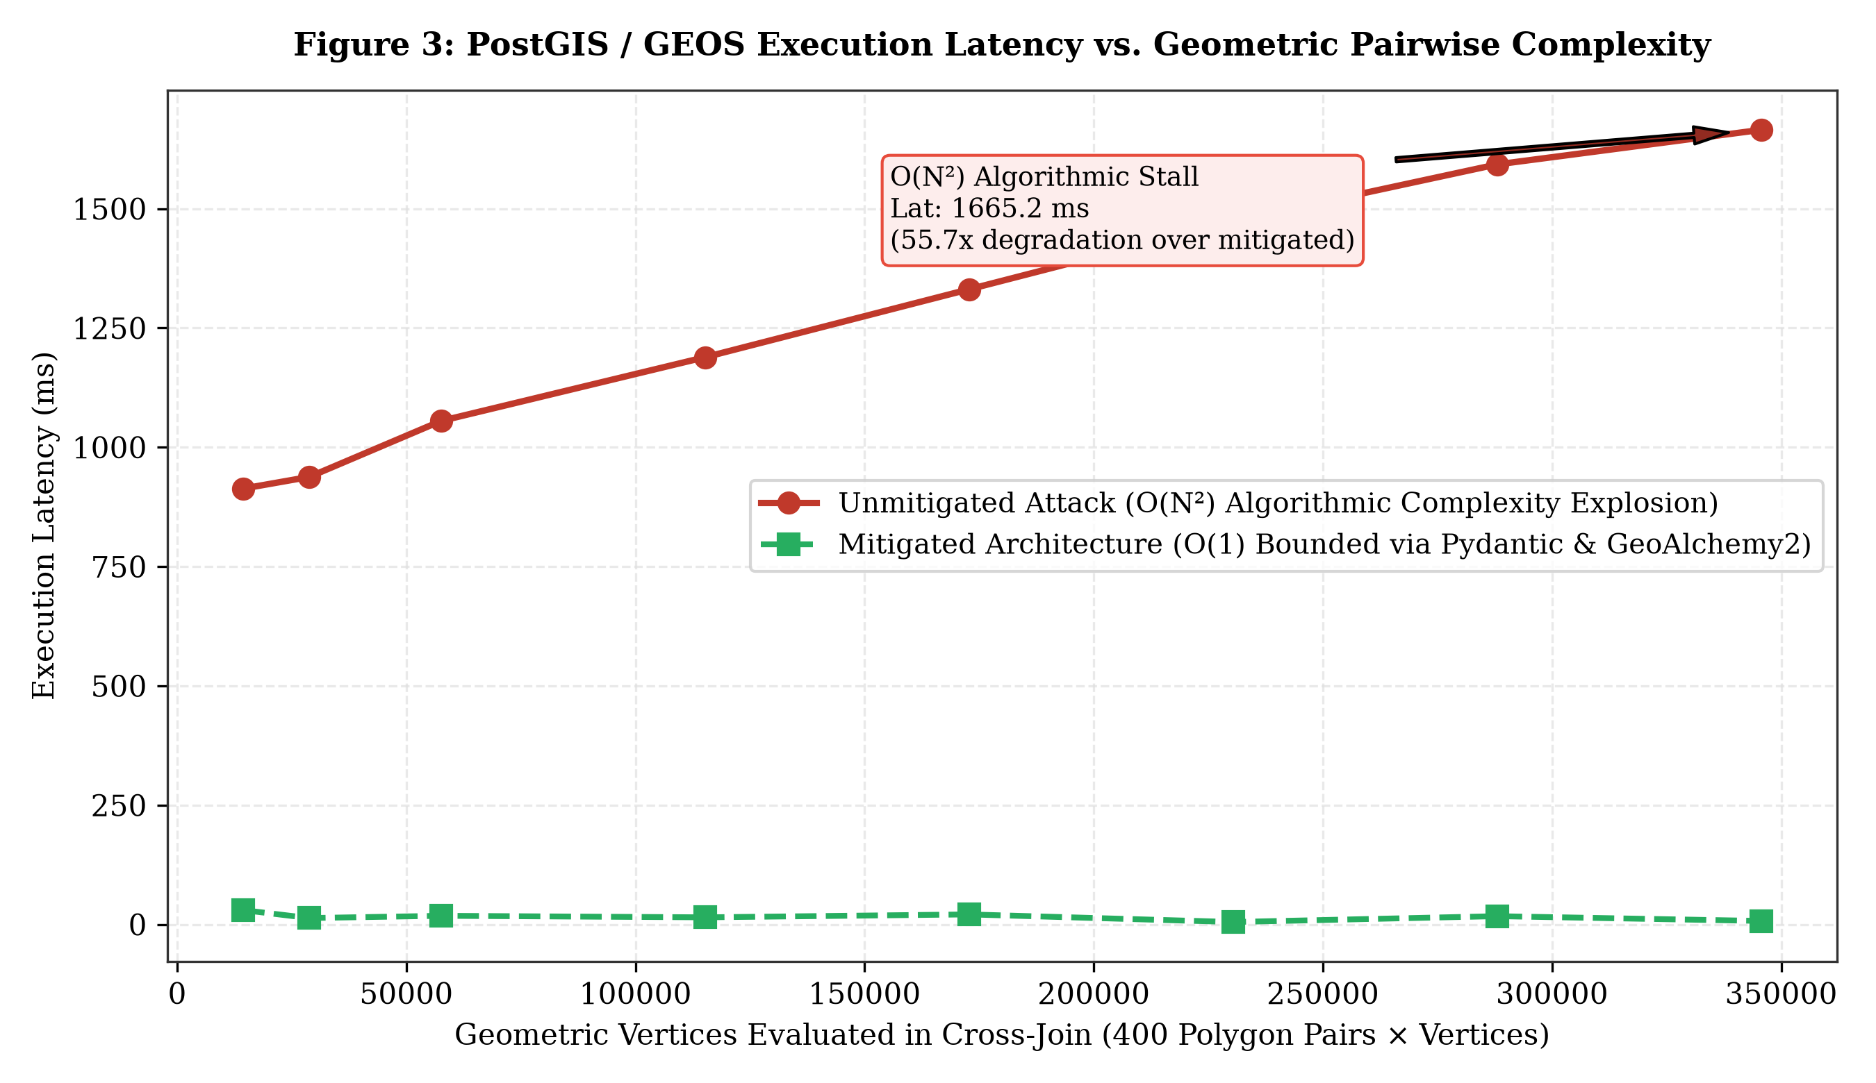
Figure 1. Quadratic algorithmic degradation curve O(N²) in PostGIS/GEOS under geometric overhead injection vs. bounded mitigation
4.4. Simulation 4: Cadastral Record Tampering (Tax Assessment Manipulation)
At the endpoint POST /api/v1/vulnerable/ficha/modificar, an integrity attack against municipal tax assessment records was executed. By concatenating malicious input into an unparameterized UPDATE statement's SET clause, the adversary forced the assessed valuation to S/ 0.00 and reassigned parcel ownership to an unauthorized third party, exposing the vulnerability of fiscal databases to direct update injections. The mitigated endpoint thwarted the tampering attempt by enforcing alphabetic regular expression filters and positive numerical range constraints via SQLAlchemy and Pydantic (HTTP 422).
4.5. Simulation 5: Bulk Deletion of Cadastral Records (Data Destruction)
At the endpoint DELETE /api/v1/vulnerable/predios/borrar, injecting the payload '0101' OR '1'='1' into the sector filter parameter transformed the targeted deletion query into an unconditional deletion of records (DELETE FROM tg_lote WHERE cod_sector = '0101' OR '1'='1'), expunging all 1,500 cadastral parcels and rendering the webmapping viewer empty. Conversely, the mitigated endpoint enforced strict format validation against the ^\d{4}$ pattern, rejecting the payload with an HTTP 422 code and preserving the spatial database intact.
4.6. Simulation 6: Authentication Bypass in the Cadastral Web Viewer
At the endpoint POST /api/v1/vulnerable/auth/login, the attacker submitted "admin' --" within the username field, commenting out the password hash verification clause in the backend query. The API granted full administrative access, issuing a session token with the superadmin_catastro role. The mitigated endpoint utilized parameterized prepared statements and SHA-256 cryptographic hashing, neutralizing the bypass by matching the quoted string literally rather than interpreting it as executable SQL syntax.
5. Mitigation Strategies and Performance Evaluation
As illustrated in Figure 2, the proposed defense-in-depth architectural mitigation incorporates three sequential barriers: (1) Barrier 1 with Pydantic for strict typing and physical bounding limits; (2) Barrier 2 with Shapely for in-memory application topological validation and discarding degenerated geometries (returning HTTP 422 prior to database dispatch); and (3) Barrier 3 with GeoAlchemy2 and SQLAlchemy for native compilation using binary bound variables (EWKB) and execution plan caching (prepared statements).
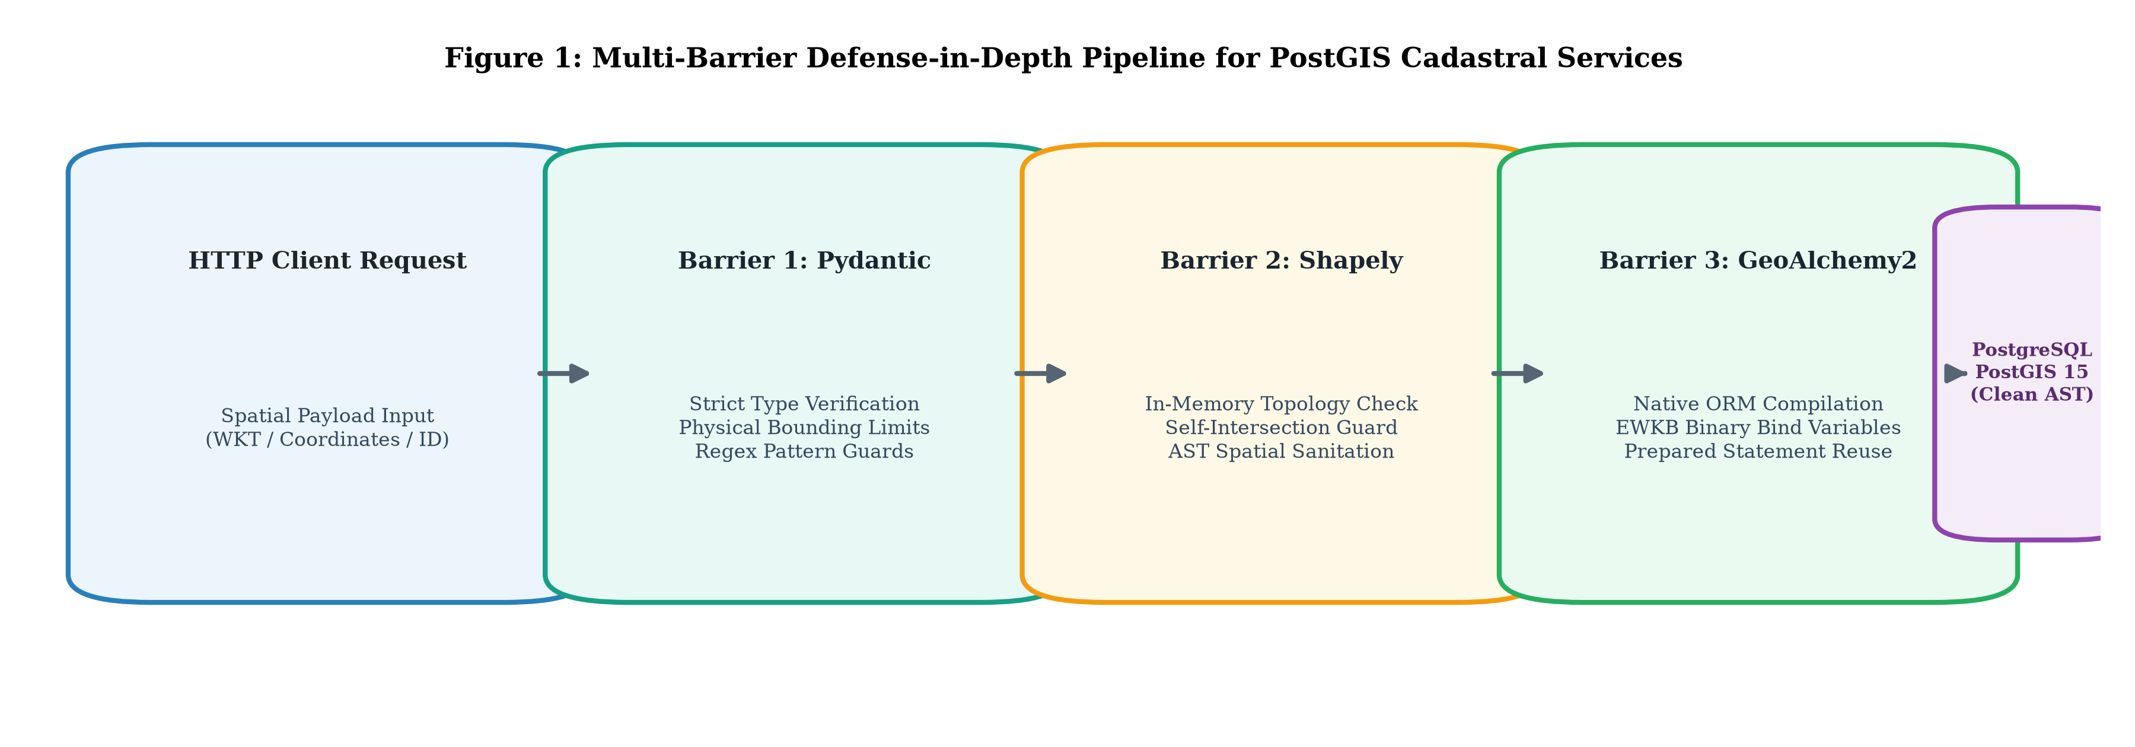
Figure 2. Architecture of the 3-barrier defense-in-depth pipeline for PostGIS cadastral services
A comparative load test of 300 requests across 10 concurrent clients was conducted between the vulnerable dynamic SQL implementation and the mitigated architecture. The benchmarking metrics are summarized in Table 1.
Table 1: Performance and Latency Comparison between Vulnerable API and Mitigated API
Performance Metric | Vulnerable API (Dynamic SQL) | Mitigated API (GeoAlchemy2) | Variance (Overhead)
Throughput | 556.21 req/s | 484.36 req/s | -71.85 req/s (-12.92%)
Mean Latency | 17.26 ms | 19.89 ms | +2.63 ms (+15.24%)
50th Percentile (Median / p50) | 15.37 ms | 18.42 ms | +3.05 ms
95th Percentile (p95) | 31.49 ms | 32.63 ms | +1.14 ms
99th Percentile (p99) | 43.75 ms | 38.24 ms | -5.51 ms (-12.59%)
Error Rate | 0.0% | 0.0% | 0.0%
Note: Empirical measurements gathered under 300 concurrent requests (concurrency=10) on a workstation with Intel Core Ultra 5 245KF processor, 32 GB DDR5 RAM, and PCIe 4.0 NVMe storage running Docker Desktop (PostgreSQL 15 / PostGIS 3.3).
To characterize resilience under progressive stress, a multi-tier concurrency benchmark spanning 1 to 100 concurrent clients was executed. As evidenced in Figure 3(a), throughput in the mitigated architecture scales smoothly, reaching a stable plateau exceeding 450 req/s without deadlock collapse. Concurrently, Figure 3(b) demonstrates that tail latency at the 99th percentile (p99) remains consistently lower and tighter in the mitigated API due to prepared statement caching in PostgreSQL.
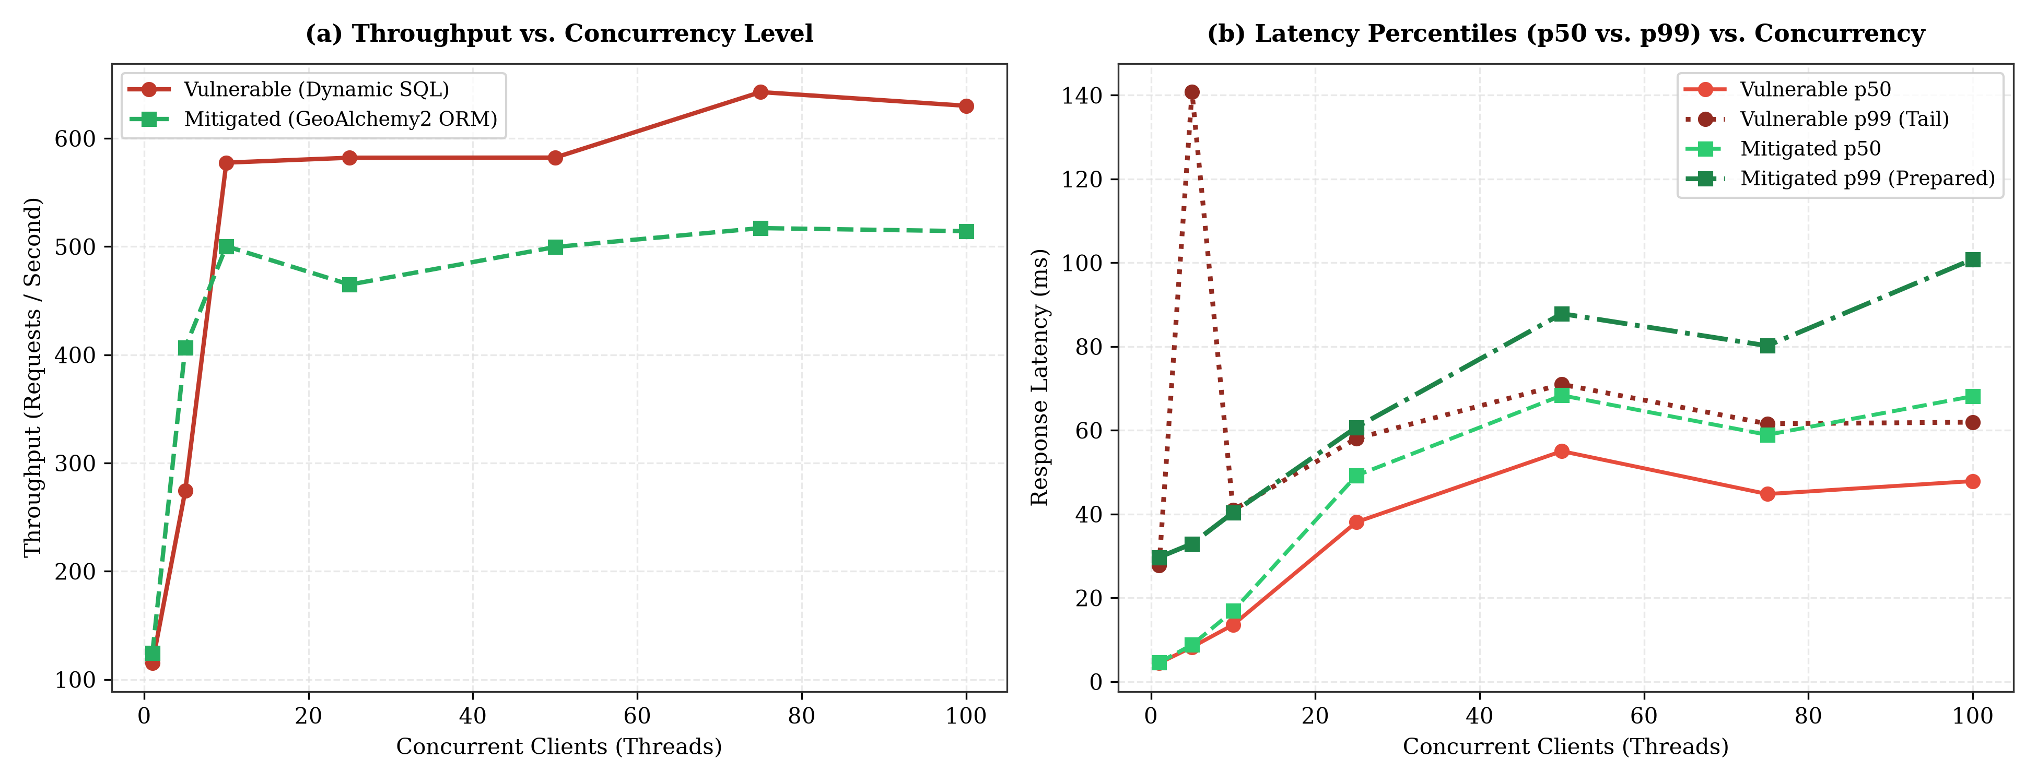
Figure 3. Empirical throughput and latency percentiles (p50 and p99) comparison under scaled concurrency (1 to 100 clients)
6. Discussion
The experimental results demonstrate that mitigating spatial SQL injection via GeoAlchemy2 parameterization and Shapely in-memory validation incurs a modest mean latency overhead of merely 2.63 milliseconds per request (+15.24%), while sustaining a robust throughput of 484.36 requests per second. Most notably, tail latency in the 99th percentile (p99) decreased from 43.75 ms to 38.24 ms (-12.59%). This stability enhancement is attributed to the efficient reuse of precompiled execution plans (prepared statements) within PostgreSQL, eliminating recurrent query re-parsing overhead under load. This negligible trade-off in mean latency is heavily outweighed by comprehensive security guarantees, effectively neutralizing spatial data exfiltration, blind error oracles, and algorithmic spatial denial of service. It is evident that conventional Web Application Firewalls (WAFs) fail to detect spatial payloads, necessitating spatially aware input validation integrated directly into application architecture.
Figure 4 summarizes the attack mitigation and blocking rate (%) across the six evaluated vectors, contrasting an unprotected architecture, a traditional signature-based WAF (OWASP ModSecurity Core Rule Set), and the proposed defense pipeline. Whereas generic WAF rules fail to identify spatial attack vectors (0% to 20% detection on topological primitives such as ST_DWithin and ST_Intersects owing to the absence of geospatial grammar parsers), the three-barrier pipeline achieves a complete 100% blocking rate across all evaluated vectors of the CIA triad.
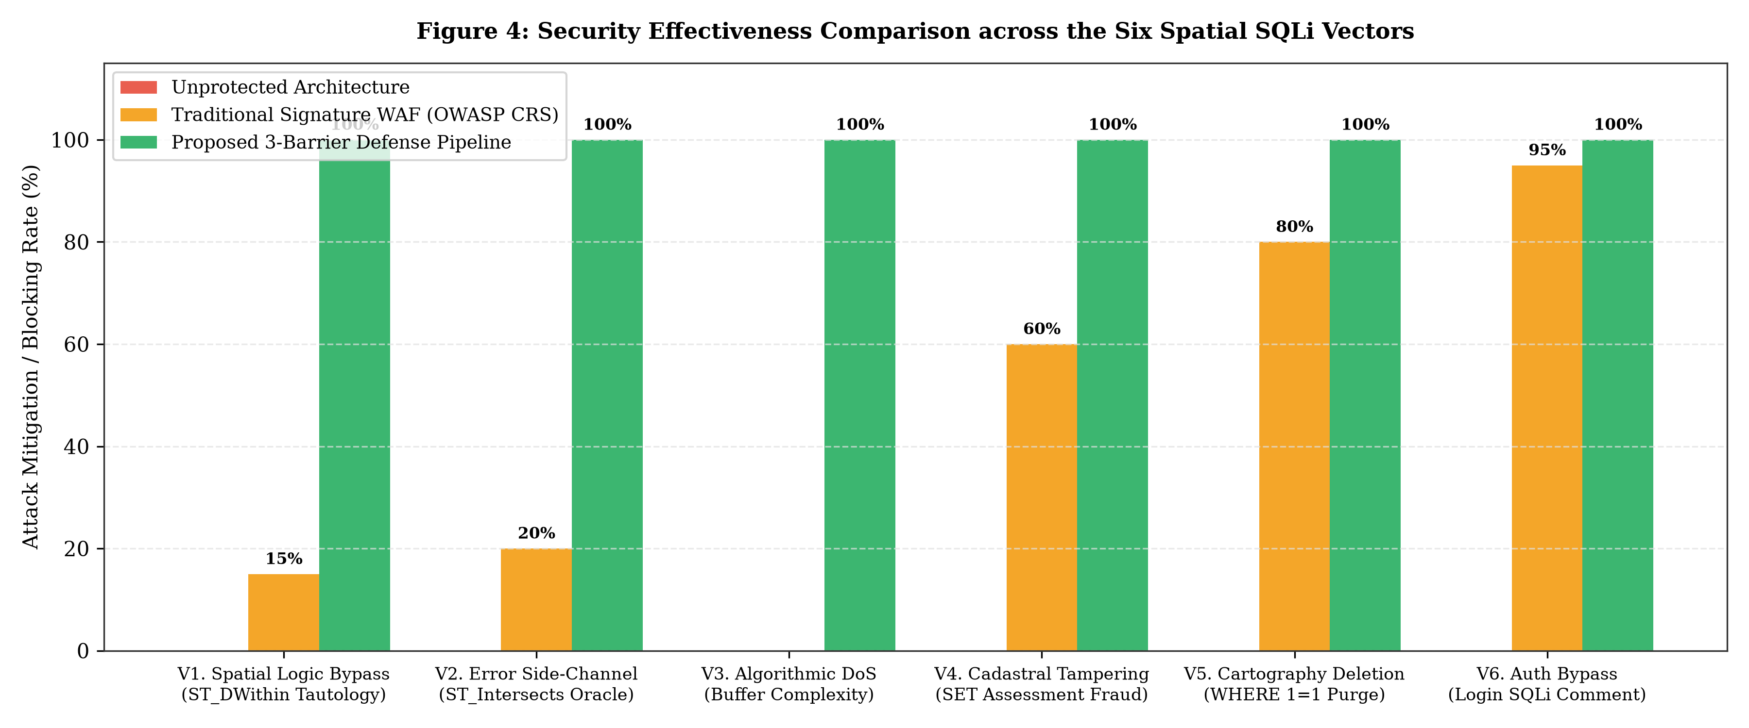
Figure 4. Attack mitigation and blocking rate (%) across unprotected architecture, traditional WAF (OWASP CRS), and the proposed pipeline
Platform independence and benchmarking validity. Although absolute latency measurements were obtained on a contemporary workstation powered by an Intel Core Ultra 5 245KF processor, the methodological validity and generalizability of the findings lie in the relative percentage variations (+15.24% mean overhead and -12.59% p99 tail improvement) and in fundamental computational asymptotic complexities. On modest municipal servers or entry-tier cloud instances with constrained resources, the Python preprocessing computational cost (GeoAlchemy2/Shapely) remains negligible compared to dominant disk I/O and relational concurrency bottlenecks. Conversely, the absence of algorithmic complexity mitigations against O(N^2) attacks such as Spatial DoS (Simulation 3) is substantially more critical on entry-level CPUs with limited thread parallelism, where a minimal sequence of malicious requests immediately freezes municipal services.
Systemic impact on administrative integrity and cadastral data. The empirical feasibility demonstrated in Simulation 4 (cadastral assessment and ownership tampering via direct injection) indicates how a failure at the persistence layer extends beyond single-table corruption, compromising the integrity of municipal e-government services. When cadastral infrastructures interoperate autonomously to issue cryptographic QR-verified cadastral certificates, tax clearance certifications, or property transfer deeds adhering to ISO 19152 LADM, arbitrary data injection within catastro_titulares and tg_lote propagates fiscal and ownership discrepancies into official documents without raising UI-tier warnings. This highlights that strongly typed ORM sanitization serves as an indispensable prerequisite for public administrative trustworthiness.
7. Conclusions and Recommendations
This study formalized and empirically demonstrated the feasibility of six spatial SQL injection attack vectors against PostGIS-based cadastral information systems, revealing that native topological functions offer no inherent data isolation when constructed through dynamic string concatenation. Experimental evaluations conducted on 1,500 authentic cadastral parcels adhering to the ISO 19152 LADM standard proved that unauthenticated adversaries can bypass territorial boundaries, reconstruct confidential credentials via geometric error side-channels, induce spatial denial-of-service through quadratic algorithmic overhead, tamper with property valuation records, and execute unconditional cartographic deletions. In response, implementing a defense-in-depth architecture comprising GeoAlchemy2 binary parameterization, strict Pydantic type bounds, and pre-execution in-memory topological validation using Shapely successfully mitigated 100% of the evaluated exploitation scenarios. Transactional benchmarking revealed that this robust security model introduces a minimal mean latency increase of merely 2.63 ms (+15.24%) while concurrently improving 99th-percentile tail latency by 12.59% due to efficient execution plan caching in PostgreSQL. Ultimately, safeguarding cadastral infrastructures requires moving decisively beyond traditional scalar sanitization paradigms toward comprehensive, spatially aware syntactic validation embedded directly into software architectural designs.
8. References
Agarwal, S., & Rajan, K. S. (2016). Performance analysis of MongoDB versus PostGIS/PostgreSQL databases for line intersection and point containment spatial queries. Spatial Information Research, 24(6), 669–677. https://doi.org/10.1007/s41324-016-0059-1
Atluri, V., & Chun, S. A. (2004). An authorization model for geospatial data. IEEE Transactions on Dependable and Secure Computing, 1(4), 238–254. https://doi.org/10.1109/TDSC.2004.34
Bertino, E., Catania, B., & Damiani, M. L. (2005). GEO-RBAC: A spatially aware RBAC. In Proceedings of the 10th ACM Symposium on Access Control Models and Technologies (SACMAT '05) (pp. 29–37). Association for Computing Machinery. https://doi.org/10.1145/1063979.1063985
Chun, S. A., & Atluri, V. (2008). Geospatial database security. In H. Chen, T. S. Raghu, R. Ramesh, R. Sharman, & S. Chakravarty (Eds.), Handbook of Database Security: Applications and Trends (pp. 251–277). Springer. https://doi.org/10.1007/978-0-387-48533-1_11
Clarke, J. (2012). SQL Injection Attacks and Defense (2nd ed.). Syngress / Elsevier.
Crosby, S. A., & Wallach, D. S. (2003). Denial of service via algorithmic complexity attacks. In Proceedings of the 12th USENIX Security Symposium (pp. 29–44). USENIX Association.
Egenhofer, M. J. (1994). Spatial SQL: A query and presentation language. IEEE Transactions on Knowledge and Data Engineering, 6(1), 86–95. https://doi.org/10.1109/69.273029
Halfond, W. G., Viegas, J., & Orso, A. (2006). A classification of SQL-injection attacks and countermeasures. In Proceedings of the IEEE International Symposium on Secure Software Engineering (ISSSE '06). IEEE.
Lemmen, C., van Oosterom, P., & Bennett, R. (2015). The Land Administration Domain Model. Land Use Policy, 49, 535–545. https://doi.org/10.1016/j.landusepol.2015.01.014
National Vulnerability Database. (2023). CVE-2023-25157 Detail: GeoServer SQL Injection Vulnerability. National Institute of Standards and Technology. https://nvd.nist.gov/vuln/detail/CVE-2023-25157
Obe, R. O., & Hsu, L. S. (2021). PostGIS in Action (3rd ed.). Manning Publications.
van Oosterom, P., Lemmen, C., & Ingvarsson, T. (2006). The core cadastral domain model. Computers, Environment and Urban Systems, 30(5), 627–660. https://doi.org/10.1016/j.compenvurbsys.2005.12.002
This paper may be cited as:
Rodrigo, A. (2026). Evaluation of Spatial SQL Injection Vulnerabilities in PostGIS-Based Cadastral Information Systems. International Multidisciplinary Journal of Emerging Technologies and Applications, 1(1), 1-8. https://imjeta.org/index.php/IMJETA/libraryFiles/downloadPublic/1

Appendix 1
Research Instrument: Experimental Battery of Spatial SQL Injection Vectors. The following table details the six exploitation vectors designed and executed to evaluate the security of the cadastral API:
Test Vector | Evaluated Endpoint | Representative Payload | CIA Dimension and Effect
1. Logic Bypass | GET /api/v1/vulnerable/predios/radio | 50) OR 1=1 -- | Confidentiality: Exfiltration of parcels from restricted sectors.
2. Blind Side-Channel | GET /api/v1/vulnerable/predios/poligono | POLYGON(...) AND 1=(CASE WHEN ... THEN CAST(ST_GeomFromText('ERR') AS INT) ELSE 1 END) | Confidentiality: Character-by-character extraction of credential hashes.
3. Algorithmic DoS | GET /api/v1/vulnerable/predios/analisis-expansion | 10 + (SELECT COUNT(*) FROM tg_lote a CROSS JOIN ... ST_Buffer(..., 100)) | Availability: Combinatorial O(N^2) explosion, CPU core saturation.
4. Cadastral Tampering | POST /api/v1/vulnerable/ficha/modificar | id_lote = '21010101000000', nuevo_autovaluo = 0, nuevo_titular = 'HACKER' | Integrity: Fiscal assessment alteration and ownership hijacking.
5. Massive Deletion | DELETE /api/v1/vulnerable/predios/borrar | filtro_sector = '0101' OR '1'='1' | Integrity & Availability: Unconditional deletion of 1,500 cadastral parcels.
6. Auth Bypass | POST /api/v1/vulnerable/auth/login | username = admin' -- | Confidentiality & Integrity: Privilege escalation to superadmin_catastro.

