**ELAM Mesh Data Format Guide**

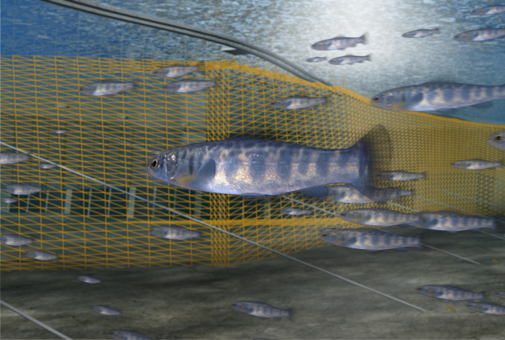

The Eulerian-Lagrangian-agent method (ELAM) uses sensory ecology, computational neuroscience, and cognitive modeling to analyze the movement behavior of animals in complex environments. ELAMs for terrestrial and urban environments (to analyze animal or human movements) are covered separately. The aquatic-based ELAM works with *any* type of mesh data that can be imported into [Tecplot 360](http://www.tecplot.com/support/360/docs.aspx), including spreadsheet data that can come from laboratory measurements.

Only a single Tecplot-formatted binary (.plt) file is needed. The Tecplot (.plt) format allows the ELAM model to take advantage of compression and multi-threaded routines significantly enhancing I/O execution. We surveyed a variety of mesh data storage and retrieval tools/formats and discerned this path as affording the greatest yield regarding ELAM algorithms. The [Tecplot 360](http://www.tecplot.com/support/360/docs.aspx) Data Format Guide can be found here:

<http://www.tecplot.com/support/360/docs.aspx>

In this ELAM Mesh Data Format Guide, words in red are searchable in the Tecplot Data Format Guide. The Tecplot guide will point you to source code and pre-compiled TecIO libraries that can be downloaded and used, for free, to call functions directly from within your code to output solution data directly to a Tecplot-formatted binary (.plt) file.

If using a non-Intel processor-based computer, you must use the TECFOREIGN112 function to create the binary file with an Intel byte order. Functionality described in the ASCII Data section of the Tecplot guide has equivalents in the functions you can call from within your code (linked to TecIO libraries) for outputting solution data directly to a Tecplot-formatted binary (.plt) file.

**ELAM-compatible Meshes**

ELAM mesh data may be any of the following, either static or adaptive moving meshes:

3-D (any combination of any element type)

2-D (laterally-averaged, xz-only)

2-D (depth-averaged, xy-only)

**Mesh Variable Data**

Hydraulic, water quality, and/or any other type of *field variable* (FV) can be stored at either nodes or cell-centers, except Node No, Node BC, and WSC that must be node-based. Use the VARLOCATION variable in the Zone Header to indicate where each *field variable* is stored. The only required variables are in **bold**:

**FV = 1 X x-position (m) of mesh node**

**FV = 2 Y y-position (m) of mesh node**

**FV = 3 Z z-position (m) of mesh node**

**FV = 4 U velocity vector (m/sec) in the mesh-based x-direction**

**FV = 5 V velocity vector (m/sec) in the mesh-based y-direction**

**FV = 6 W velocity vector (m/sec) in the mesh-based z-direction**

FV = 7 PR total pressure (Pa)

FV = 8 TK turbulent kinetic energy (m2/sec2)

FV = 9 AcclM acceleration magnitude (m/sec2)

FV = 10 STRXYZUVW spatial velocity gradient magnitude (sec-1)

**FV = 11 Node No node’s unique global node number**

**FV = 12 Node BC node’s permeable/impermeable (flux/no-flux) property**

**FV = 13 WSC identifies the free water surface**

FV = 14 Ax acceleration vector (m/sec2) in the mesh-based x-direction

FV = 15 Ay acceleration vector (m/sec2) in the mesh-based y-direction

FV = 16 Az acceleration vector (m/sec2) in the mesh-based z-direction

FV = 17 Optional *field variable*: Depth (m) → useful for 2-D depth-averaged data

FV = 18 Optional *field variable*: Temperature (ºC)

FV = 19 Optional *field variable*: Dissolved Oxygen (mg/L)

FV = 20 Optional *field variable*

. .

**Time / Date Information**

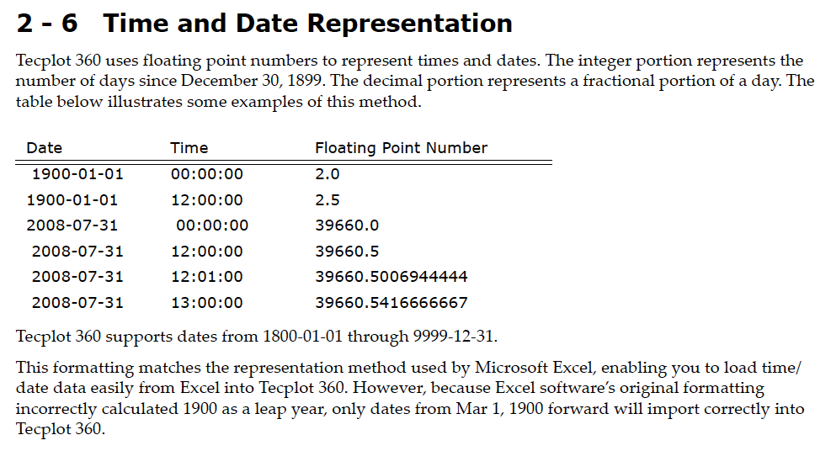Time/date information is recorded in the mesh data (.plt) file as described in this screenshot of the [Tecplot 360](http://www.tecplot.com/support/360/docs.aspx) Data Format Guide:

Set Time and Date Representation in the .plt file through the SOLUTIONTIME variable in the Zone Header. If mesh node locations (x,y,z) do not change with time, Data Sharing (Variable Sharing) should be used with the VARSHARELIST variable in the Zone Header so xyz-node locations are only output once to the .plt file. Also consider using Connectivity List Sharing.

If hydraulic and water quality variables do not change appreciably with time for parts of the mesh, consider breaking the mesh volume into multiple zones and only updating the solution with time for zones where hydraulics and/or water quality are changing (*see* how this works in the “Time Aware” section in the [Tecplot 360](http://www.tecplot.com/support/360/docs.aspx) User's Manual. Set the StrandID variable in the Zone Header for each zone such that StrandID=0 for static zones (mesh and conditions do not change with time) and StrandID>0 for time-varying zones (do change with time). Order zones as follows (note: the below is a requirement beyond the normal Tecplot requirements):

1) all static zones (StrandID=0) appear first and only once in mesh data (.plt) file;

2) each non-static StrandID has a zone in each time step (each unique solution time);

3) non-static zones appear in the same order in each time step.

*Time-varying, moving/adaptive mesh with multiple zones (not all change w/time):*

Static zone #1 (StrandID=0)

.

Doesn’t have to start at *t* = 0.0, but each time-varying zone must be listed each time step *t*.

Static zone #n (StrandID=0)

Time-varying zone # 1 (StrandID=1), time *t* = 0.0

. 2 (StrandID=2), time *t* = 0.0

. 3 (StrandID=3), time *t* = 0.0

. 1 (StrandID=1), time *t* = 2.5

. 2 (StrandID=2), time *t* = 2.5

. 3 (StrandID=3), time *t* = 2.5

. .

. 1 (StrandID=1), time *t* = end of time cycle

. 2 (StrandID=2), time *t* = end of time cycle

. 3 (StrandID=3), time *t* = end of time cycle

**Multiple-zone Meshes**

If the physical geometry of the system volume is tessellated (imported) as a compilation of multiple Tecplot zones (e.g., structured meshes that have to fit complex bathymetries), set Face Neighbor connections between cells in adjacent zones (global connections) in the Zone Footer through the FACENEIGHBORMODE and FACENEIGHBORCONNECTIONS options or, if polygonal/polyhedral elements are used, through the Facemap Data and Boundary Map Data options. Reference the TECFACE112 function for how to output this information directly to a binary (.plt) file.

**Hanging Nodes**

For cell faces associated with a hanging node, set Face Neighbor connections (FACENEIGHBORMODE and FACENEIGHBORCONNECTIONS in the Zone Footer) or, if polygonal/polyhedral elements are used, the Facemap Data and Boundary Map Data options.

**Face Neighbor Connections**

Visually check the Face Neighbor connections by loading the mesh data into [Tecplot 360](http://www.tecplot.com/support/360/docs.aspx) and ensure the following settings:

2-D mesh data: → *Mesh* plot layer toggle (in left sidebar) is off, and

→ *Edge* plot layer toggle (in left sidebar) is on.

3-D mesh data: → *Mesh* plot layer toggle (in left sidebar) is off,

→ *Shade* plot layer toggle (in left sidebar) is on,

*→ Lighting* plot layer toggle (in left sidebar) is on,

→ *Translucency* plot layer toggle (in left sidebar) is on, and

→ *Zone Style* (in left sidebar)→*Surfaces*→*Surfaces To Plot*→*Boundary Cell Faces* (for all zones).

With these settings, ensure that no interior permeable cell faces are plotted (edges for 2-D mesh data or shaded faces for 3-D mesh data), including zone boundary faces that connect to other zones via face neighbors.

**Boundary Conditions**

Two attributes in the mesh data will control where fish particles can move within the mesh:

* Node BC variable provided for each cell *node* in the mesh, and
* Face Neighbor connections for each cell *face* in the mesh.

All nodes in the mesh will have Node BC = -3 except where you want to allow fish particles to exit the system domain (mesh); at these available exits Node BC must be > 0 with each unique exit having its own distinct positive integer of Node BC. For special (unusual) circumstances where there are Face Neighbor connections in the mesh at cell interfaces where you do *not* want to allow fish particles to pass through (these cell faces), you can set Node BC = 0 for all nodes of a cell face and this will make the cell face impermeable to fish particles (i.e., that cell face will block the movement of fish particles).

Table of how Node BC and Face Neighbor connections influence fish particle movement:

Face Neighbor Node BC values Fish particle

exists? at nodes of cell face include action at cell face

(+ means same #>0)

Yes -3 → passes

Yes 0 → blocked

Yes + → extracted

Yes -3,0 → passes

Yes -3 + → passes

Yes 0,+ → extracted

Yes -3,0,+ → passes

No -3 → blocked

No 0 → blocked

No + → extracted

No -3,0 → blocked

No -3 + → extracted

No 0,+ → extracted

No -3,0,+ → extracted

Not allowed is a cell edge/face with nodes having more than one (same) unique positive Node BC value. For instance, in a mesh tessellating the reservoir behind a hydropower dam, face nodes composing the exit of turbine 1 have the same unique positive Node BC value while face nodes composing the exit of turbine 2 have the same unique positive Node BC value, but different than that for turbine 1. Similarly, in a mesh tessellating a river, face nodes composing the upstream boundary have the same unique positive Node BC value, but different from the same unique positive Node BC value identifying the downstream boundary.

Note if there are no face neighbors that among 3-D tetrahedral elements a minimum of 3 cell faces will be opened for a single node having Node BC > 0 because a single node adjoins at least 3 triangular cell faces. Among 3-D hexahedral elements a minimum of 4 cell faces will be opened because a single node adjoins at least 4 quadrilateral cell faces.

**Free Water Surface (3-D Meshes Only)**

The free water surface is sometimes not trivial to discern in complex 3-D meshes such as at a hydropower dam where the top of the water domain may be inside a powerhouse turbine intake. Therefore, for all 3-D meshes the WSC variable is populated as follows:

WSC = -1 → Free water surface

WSC = 0 → Not the free water surface