1#TASK DESCRIPTION
USE COPILOT TO GENERATE A IS_PRIME() PYTHON FUNCTION
EXPECTED OUTPUT:
FUNCTION TO CHECK PRIMALITY WITH CORRECT LOGIC
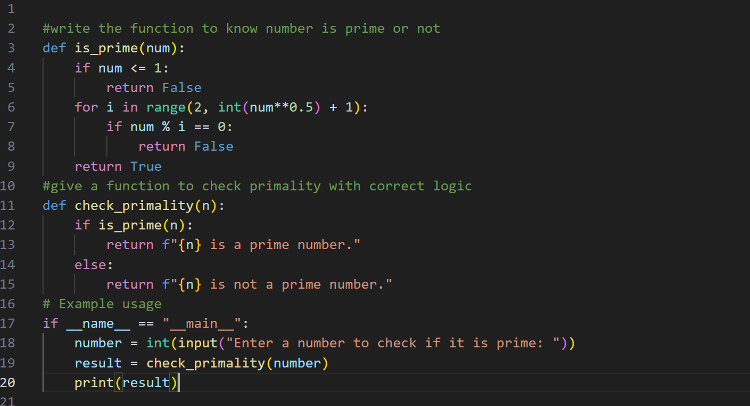
OUTPUT:
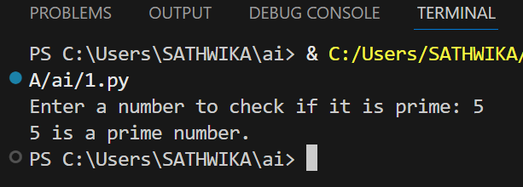

2#TASK DESCRIPTION
WRITE A COMMENT LINE #FUNCTION TO REVERSE A STRING AND USE COPILOT TO GENERATE THE FUNCTION.
EXPECTED OUTPUT:
AUTO COMPLETED REVERSE FUNCTION
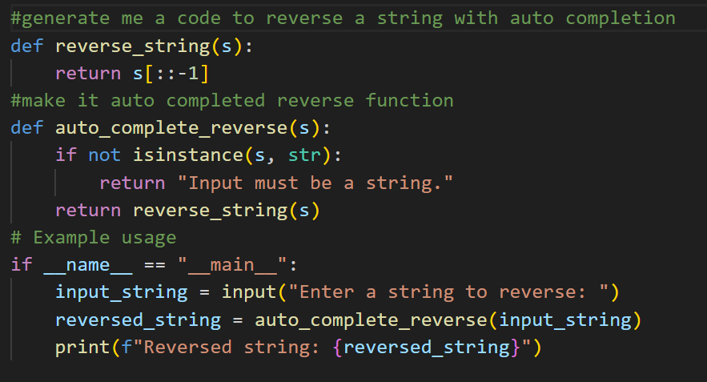
OUTPUT:
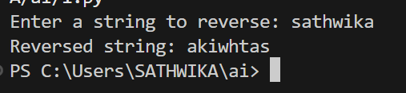

3#TASK DESCRIPTION
GENERATE BOTH RECURSIVE AND ITERATIVE VERSIONS OF A FACTORIAL FUNCTION COMMENTS
EXPECTED OUTPUT:
TWO WORKING FACTORIAL IMPLEMENTATIONS

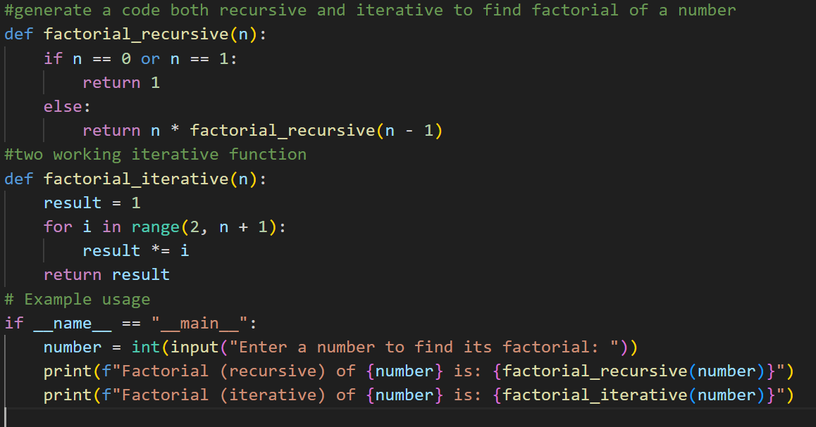
OUTPUT:
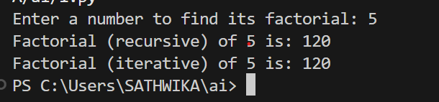

4#TASK DESCRIPTION
USE COPILOT TO FIND THE LARGEST NUMBER IN A LIST .ASSESS CODE QUALITY AND EFFICIENCY
EXPECTED OUTPUT:
A VALID FUNCTION WITH YOUR REVIEW
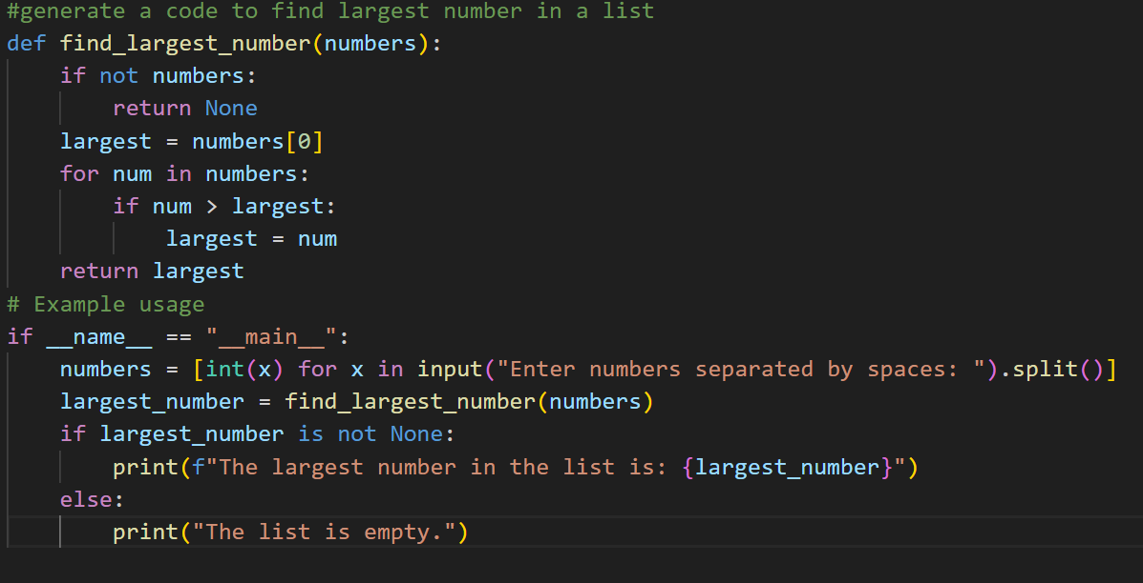
OUTPUT:
