ASSIGNMENT-8.3
Task Description#1
Use AI to generate test cases for is_valid_email(email) and then implement the
validator function.
Requirements:
• Must contain @ and . characters.
• Must not start or end with special characters.
• Should not allow multiple @
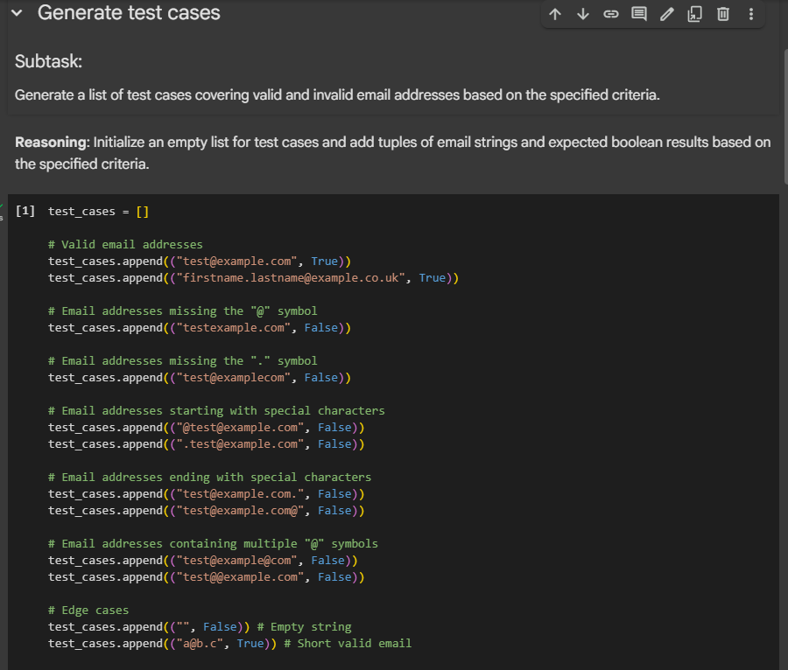
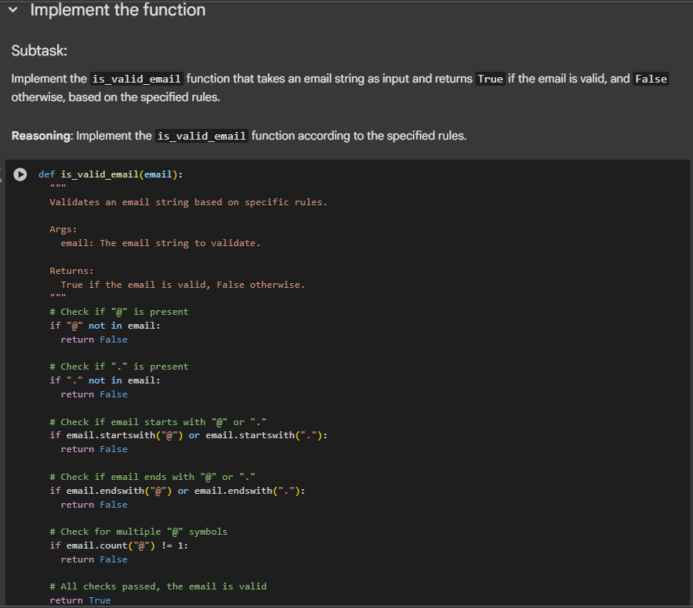
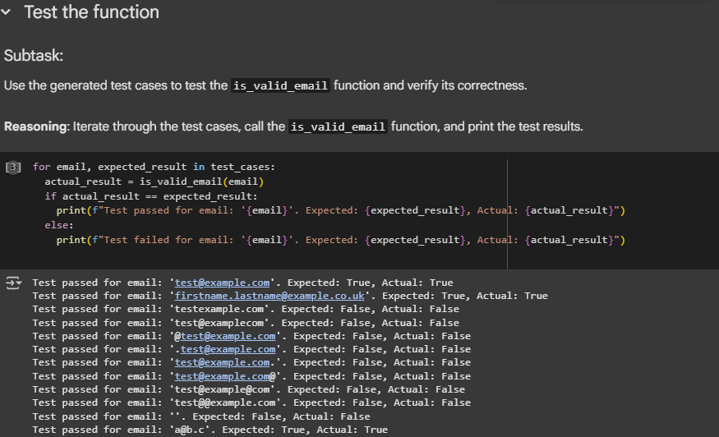
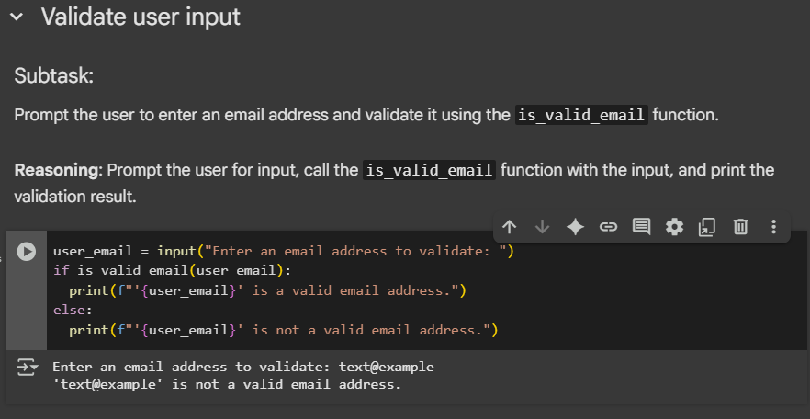
Task Description#2 (Loops)
• Ask AI to generate test cases for assign_grade(score) function. Handle boundary and
invalid inputs.
Requirements
• AI should generate test cases for assign_grade(score) where: 90-100: A, 80-89: B, 70-
79: C, 60-69: D, <60: F
• Include boundary values and invalid inputs (e.g., -5, 105, "eighty")
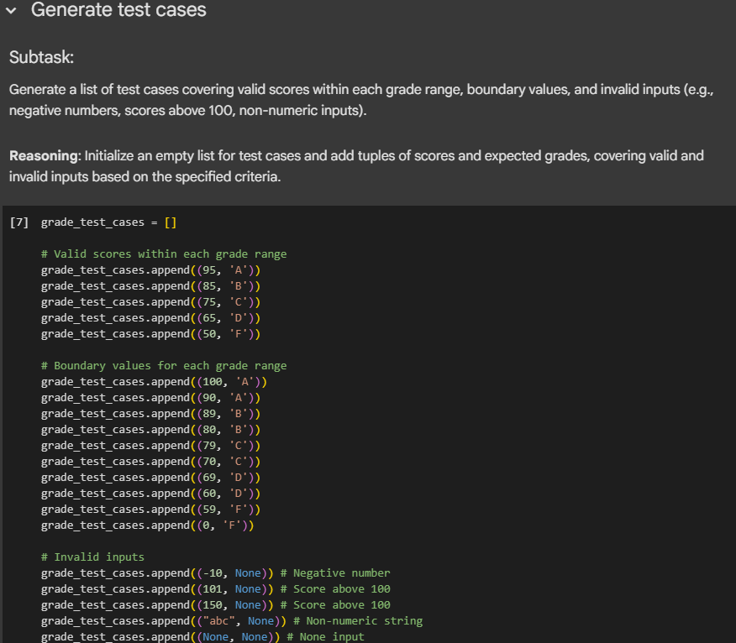
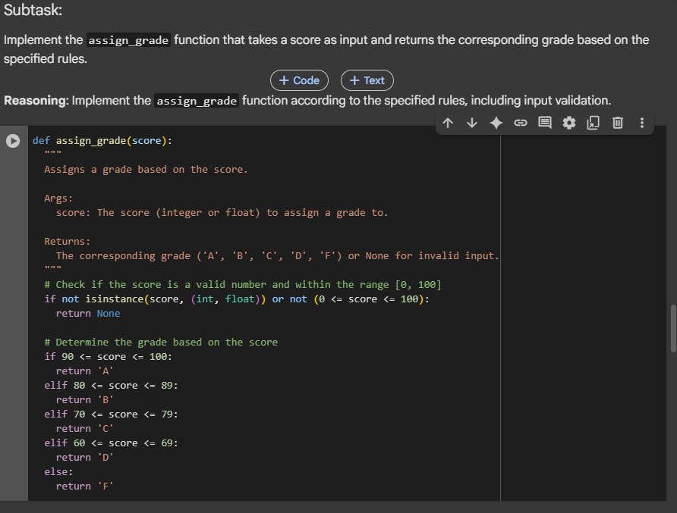
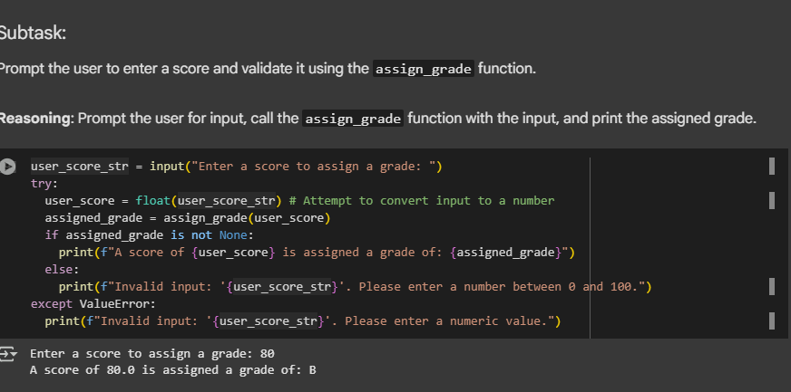
Task Description#3
• Generate test cases using AI for is_sentence_palindrome(sentence). Ignore case,
punctuation, and spaces
Requirement
• Ask AI to create test cases for is_sentence_palindrome(sentence)
(ignores case, spaces, and punctuation).
• Example:
"A man a plan a canal Panama" → True
