Task Description #1 – Stack Implementation
Task: Use AI to generate a Stack class with push, pop, peek, and is_empty methods.
Sample Input Code:
class Stack:
pass
Expected Output:
A functional stack implementation with all required methods and docstrings.
prompts :.
Create a Python class named Stack with methods: push, pop, peek, and is_empty. Include docstrings and make it interactive to take user inputs for push operations
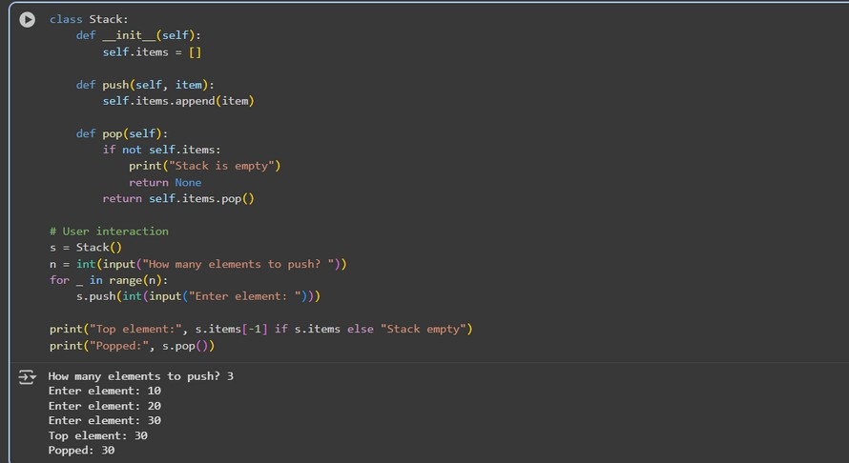

observations and code expalnation
Defined Stack class with a list to store elements. push(item) → adds an element to the top of stack.
pop() → removes and returns the top element; handles empty stack. peek() → shows top element without removing it.
is_empty() → checks if stack is empty.
Interactive code asks for number of elements → pushes elements from user input.

Task Description #2 – Queue Implementation
Task: Use AI to implement a Queue using Python lists.
Sample Input Code:
class Queue:
pass
Expected Output:
• FIFO-based queue class with enqueue, dequeue, peek, and size methods.
prompts :
Create a Python class named Queue using list. Include methods: enqueue, dequeue,
peek, and size. Make it interactive for user input.

code:
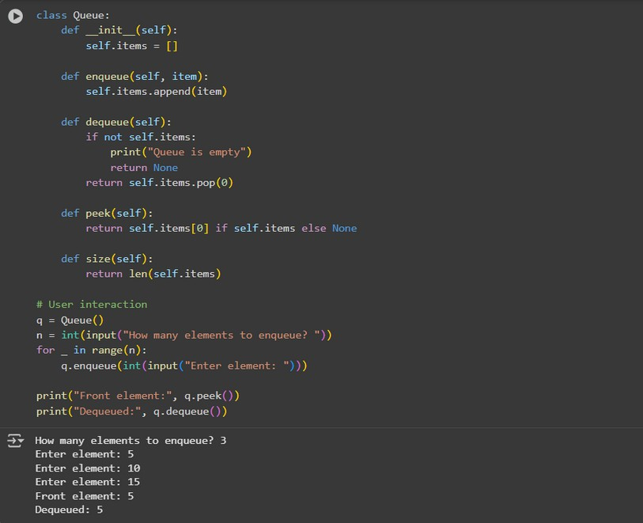

observations and code expalnation :
Queue class stores elements in a list.
enqueue(item) → adds element at the rear.
dequeue() → removes element from front; prints message if empty. peek() → shows front element.
size() → returns number of elements.
User input used to enqueue multiple elements; then displays front and dequeued element.
Task Description #3 – Linked List
Task: Use AI to generate a Singly Linked List with insert and display methods.
Sample Input Code:
class Node:
pass

class LinkedList:
pass
Expected Output:
A working linked list implementation with clear method documentation
Prompts :
Create a Python Singly Linked List with Node class. Include insert and display methods. Make it interactive for user input.
Code:
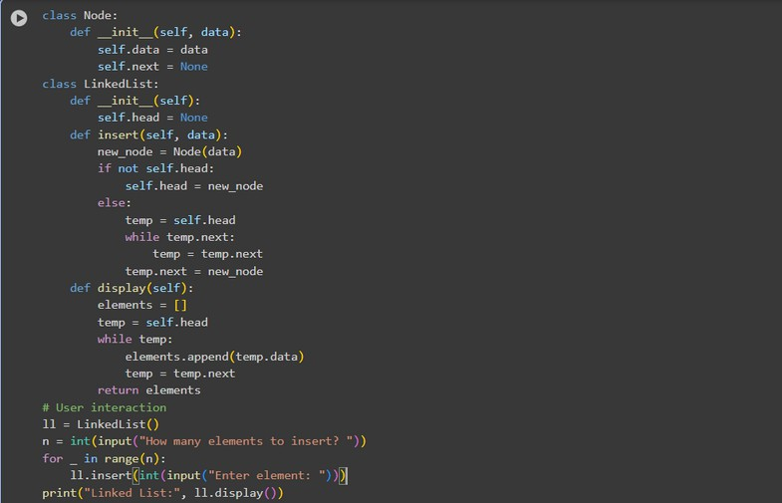

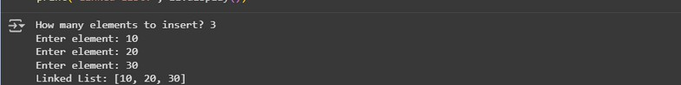

Code explanation and observations :
Node class stores data and next pointer. LinkedList class has head pointer.
insert(data) → adds new node at end. display() → prints all nodes in order.
User inputs number of nodes → program inserts each one and displays list.
Task Description #4 – Binary Search Tree (BST)
Task: Use AI to create a BST with insert and in-order traversal methods.
Sample Input Code:
class BST:
pass
Expected Output:
BST implementation with recursive insert and traversal methods
Prompts :
Create a Python BST class with insert and inorder traversal methods. Make it interactive for user input.
Code :
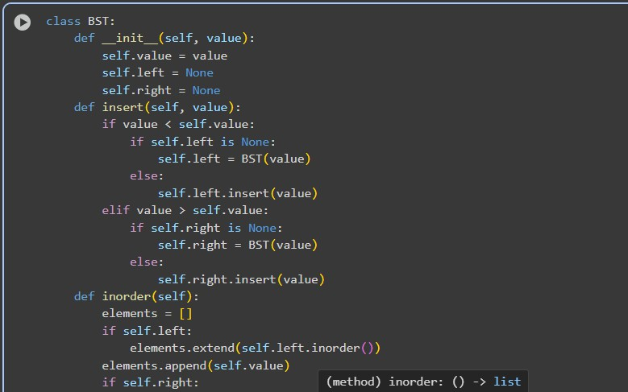

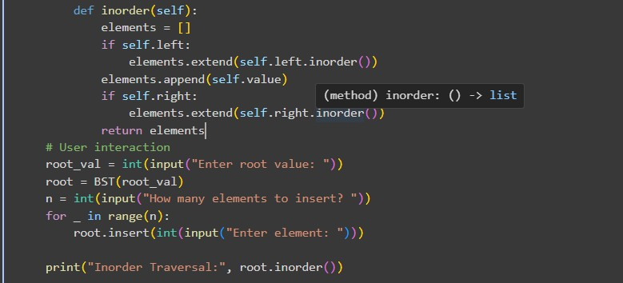

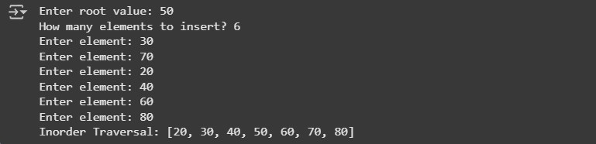
observations and code expalnation
BST node has data, left, right.
insert(data) → recursively places node in correct position. inorder() → returns elements in sorted order.
Program asks for root, then number of elements → inserts each. Prints inorder traversal to verify BST structure.
Task Description #5 – Hash Table
Task: Use AI to implement a hash table with basic insert, search, and delete methods.
Sample Input Code:
class HashTable:
pass
Expected Output:
Collision handling using chaining, with well-commented methods

Prompts :
Create a Python Hash Table class with insert, search, and delete methods. Handle collisions using chaining. Include docstrings and user input.
Code:
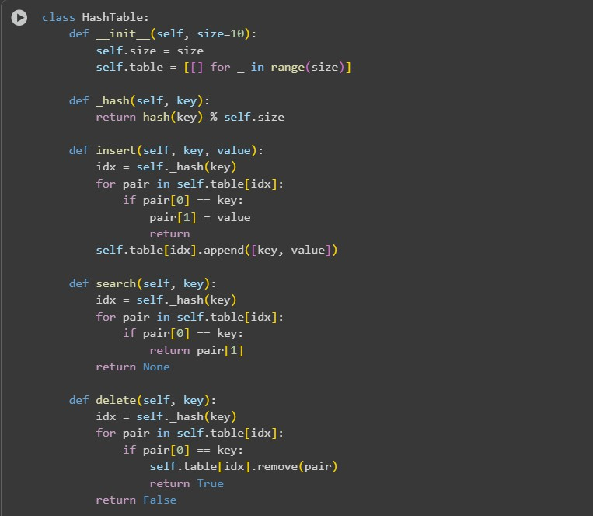
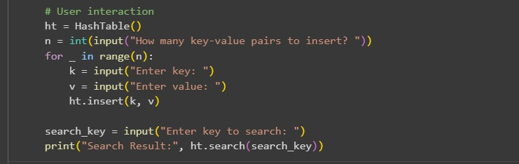

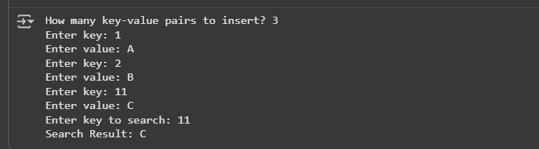

Observation and code explanation
Uses a list of lists (buckets) for collision chaining. insert(key, value) → hashes key → appends to bucket.
search(key) → looks for key in bucket → returns value or None. delete(key) → removes key-value pair if exists.
User enters number of key-value pairs → program inserts → searches and prints result.
Task Description #6 – Graph Representation
Task: Use AI to implement a graph using an adjacency list.
Sample Input Code:
class Graph:
pass
Expected Output:
Graph with methods to add vertices, add edges, and display connections
Prompt :
Create a Python Graph class using adjacency list. Include methods: add_vertex, add_edge, display. Make it interactive.
Code
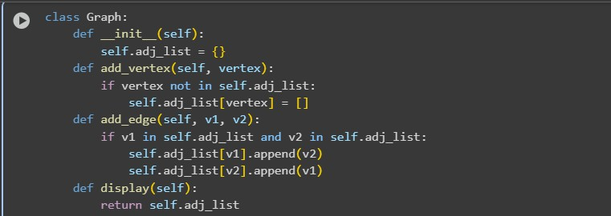

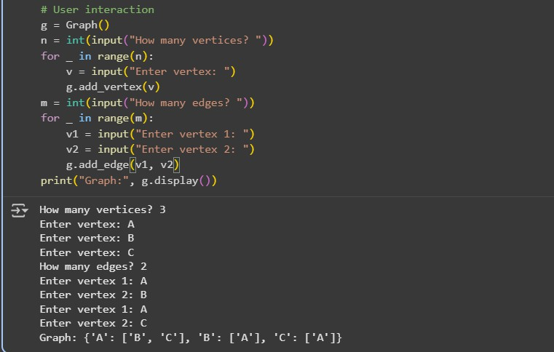
Code explanation and Observation :
Dictionary stores adjacency list.
add_vertex(v) → adds vertex if not exist.
add_edge(v1, v2) → adds edge (undirected) between two vertices. display() → prints adjacency list.
Program asks number of vertices and edges → user enters each → displays graph.
Task Description #7 – Priority Queue
Task: Use AI to implement a priority queue using Python’s heapq module.
Sample Input Code:
class PriorityQueue:
pass
Expected Output:
Implementation with enqueue (priority), dequeue (highest priority), and display methods.
Prompt :
Create a Python Priority Queue class using heapq. Include enqueue (priority), dequeue (highest priority), and display methods. Interactive user input.

Code :
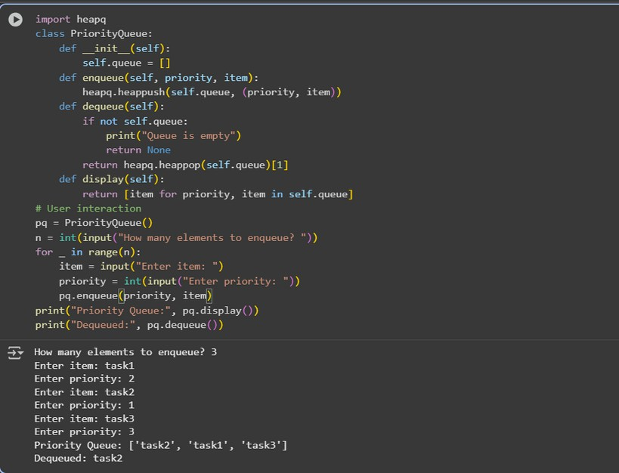
Observation and code explanation:
Uses heapq for priority management. enqueue(priority, item) → pushes tuple (priority, item). dequeue() → pops element with smallest priority value. display() → shows queue.
User enters items with priority → program enqueues → dequeues highest priority → displays queue.
Task Description #8 – Deque
Task: Use AI to implement a double-ended queue using collections.deque.
Sample Input Code:
class DequeDS:
pass
Expected Output:
Insert and remove from both ends with docstrings

Prompt :
Create a Python Deque class using collections.deque. Include methods: insert_front, insert_rear, remove_front, remove_rear, display. Interactive input.
Code :
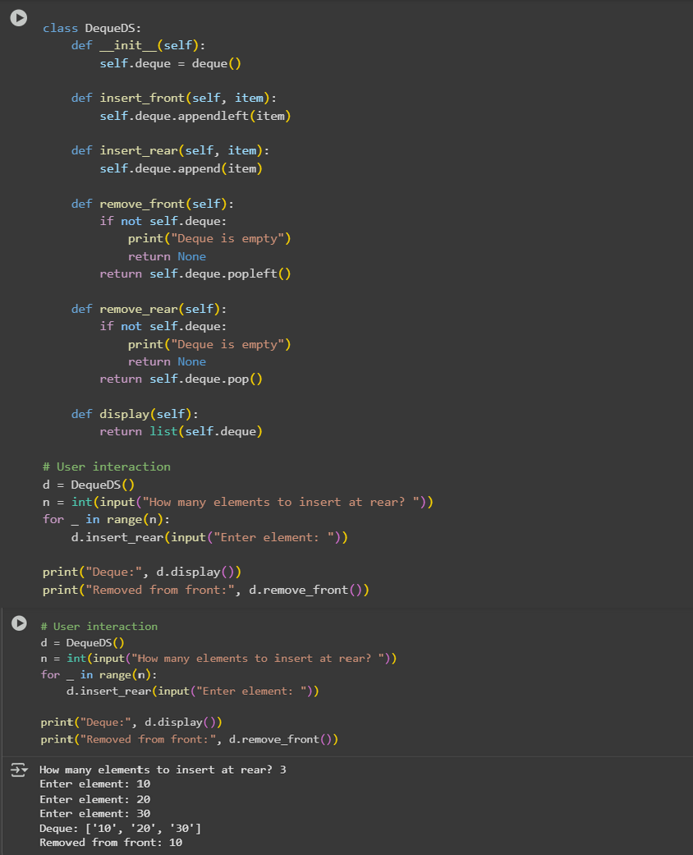

Observation and code explation
collections.deque allows fast insertion/removal at both ends. insert_front(item) → adds to front.
insert_rear(item) → adds to rear.
remove_front() / remove_rear() → removes from respective end. display() → prints deque.
User inputs number of elements → inserts → removes → displays deque.
Task Description #9 – AI-Generated Data Structure Comparisons
Task: Use AI to generate a comparison table of different data structures (stack, queue, linked list, etc.) including time
complexities.
Sample Input Code:
# No code, prompt AI for a data structure comparison table
Expected Output:
A markdown table with structure names, operations, and complexities

Prompt :
Generate a markdown table comparing Stack, Queue, Linked List, BST, Hash Table, Graph, Priority Queue, Deque with their time complexities for insertion, deletion, search, access. Using pandas
Code :
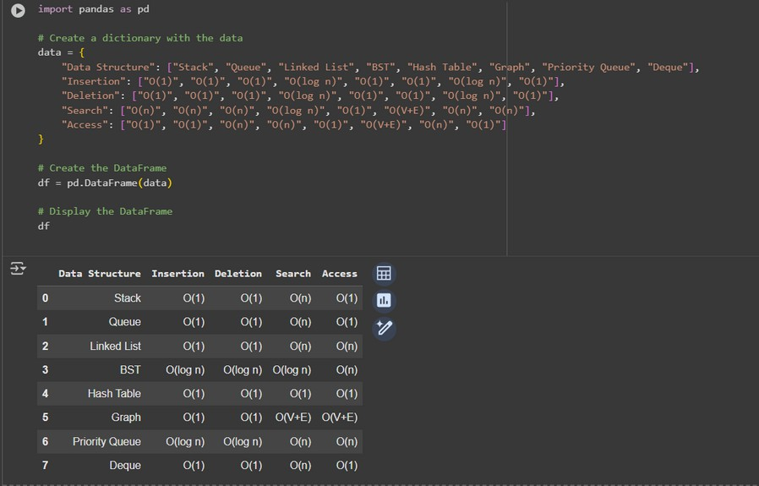

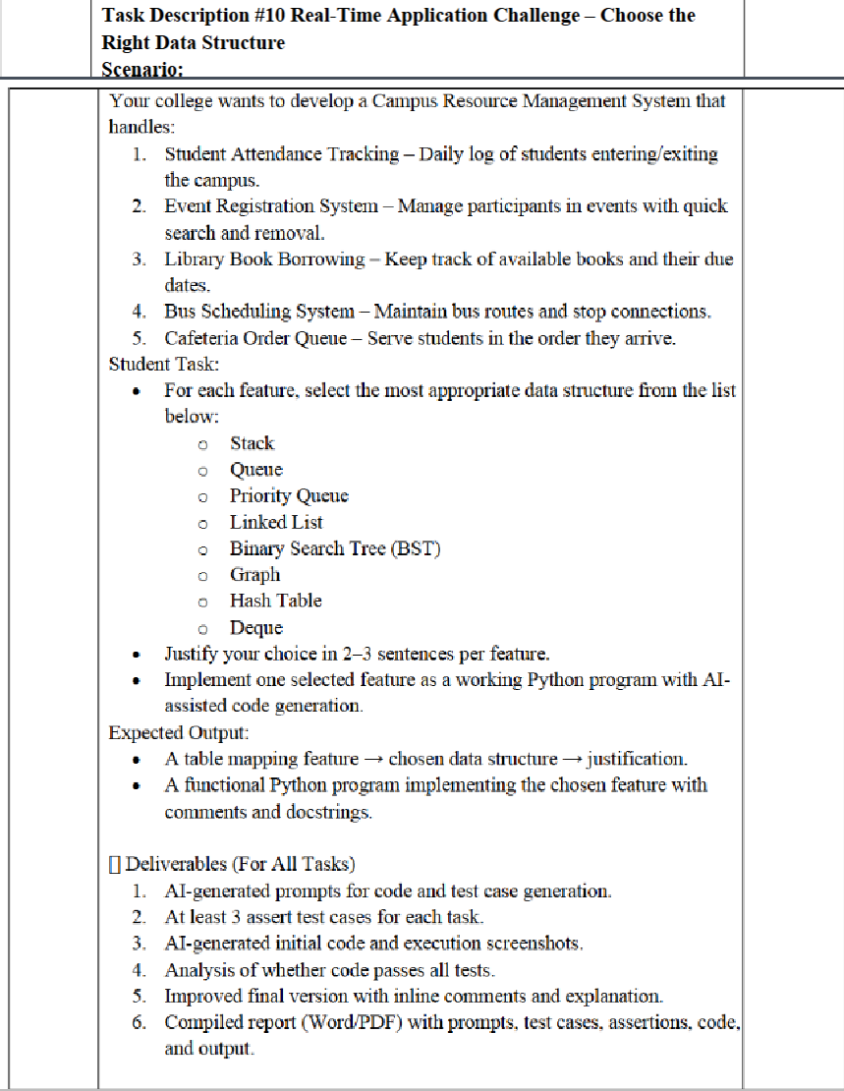

Prompt :
Create a Python menu-driven Queue for cafeteria orders. Include methods: place_order, serve_order, next_order, queue_size. Use user input to interact.
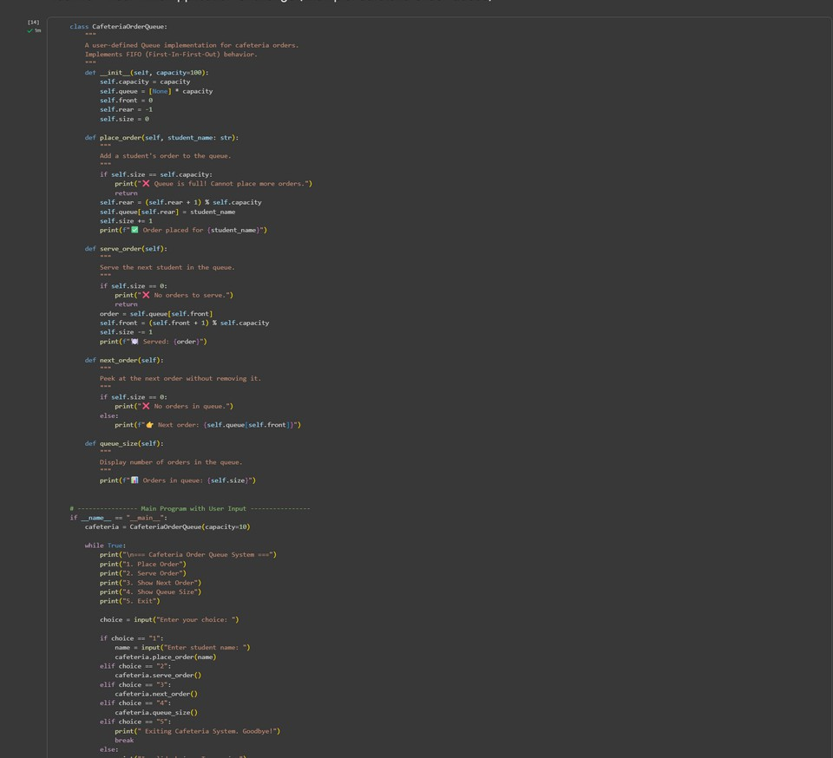

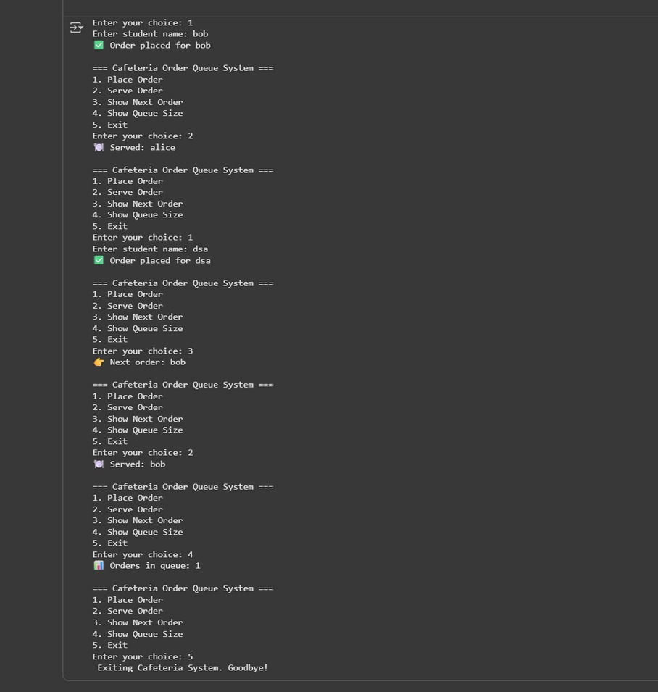
Observations and Code Explanation
CafeteriaOrderQueue uses circular queue array.
place_order(student_name) → adds student; handles full queue. serve_order() → serves front student; handles empty queue. next_order() → shows next order without removing. queue_size() → displays number of orders.
Menu allows user to place, serve, peek, check size, exit interactively.

