**Step 1)** Download & set up Java JDK 8

**Step 2)** Download apache-maven-3.5.4 package

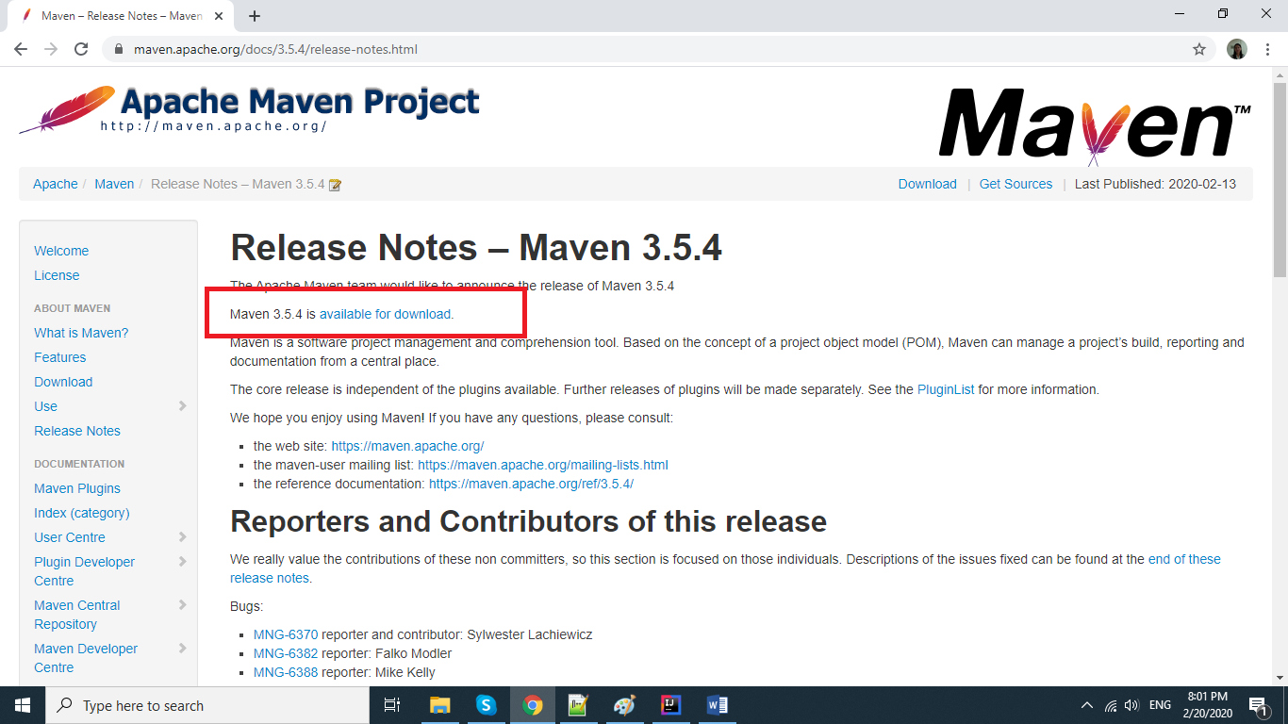

and save in the folder path D:\TheInternet\apache-maven-3.5.4

**Step 3)** Download Rapid Environment Editor & then create variables for JAVA_PATH, MAVEN_PATH

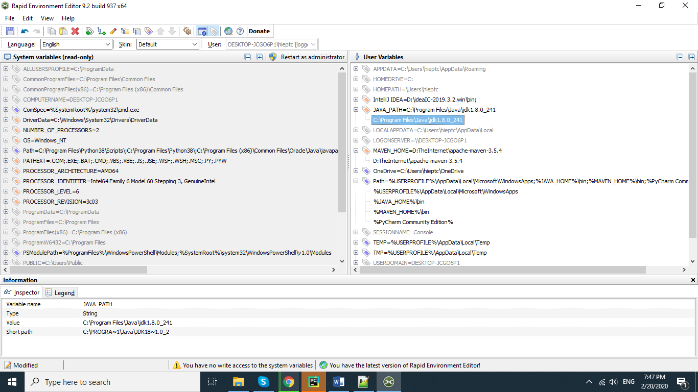

**Step 4)** Download [IntelliJ](https://www.jetbrains.com/idea/download/) "Community" Version, example it will save as in the path D:\ideaIC-2019.3.2.win

**Step 5)** Double click on the application idea64 to open Intellij IDE

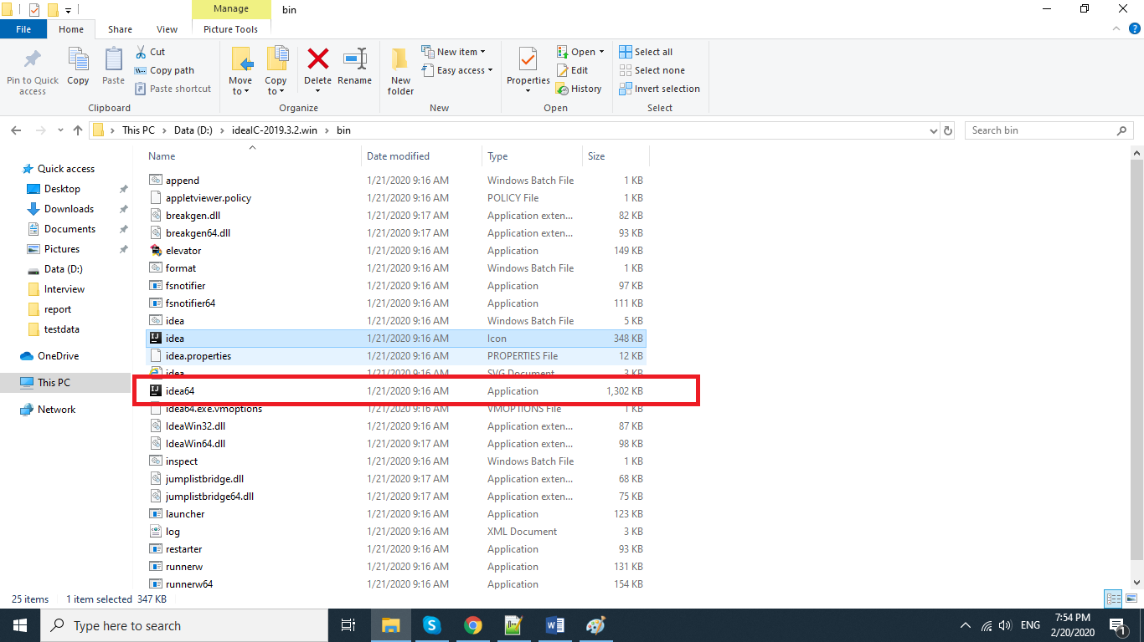

**Step 5)** Click Import Project as image:

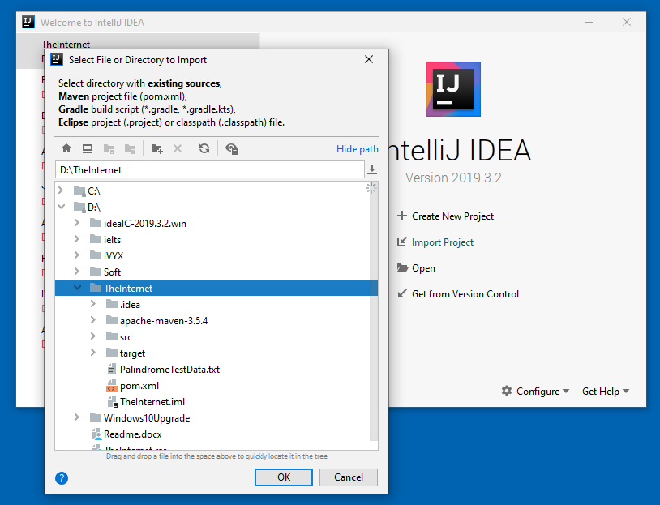

**Step 6)** Click OK

**Step 7)** Click Create project from existing sources, then click Next

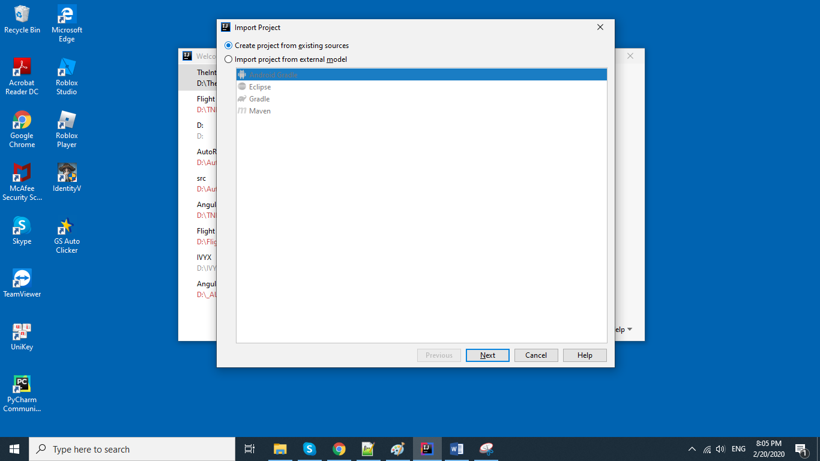

**Step 8)** Click Next

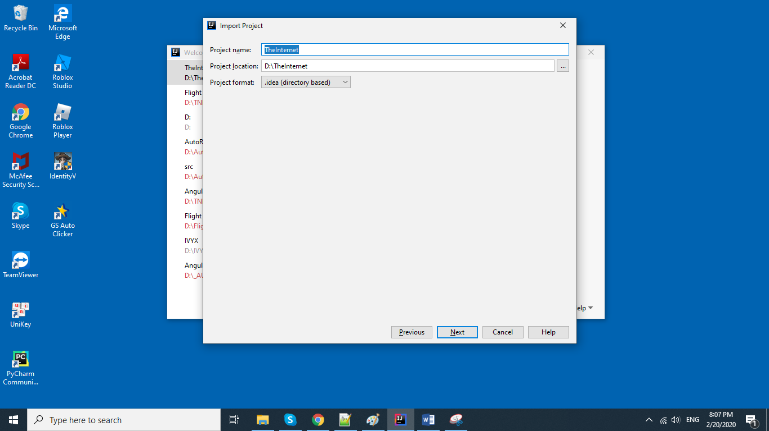

**Step 9)** Click Yes

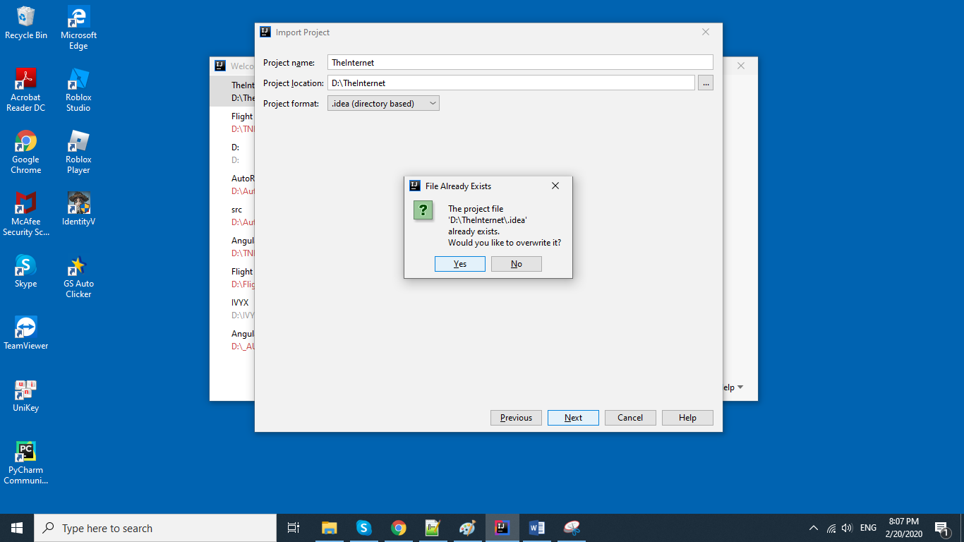

**Step 10)** Click Next

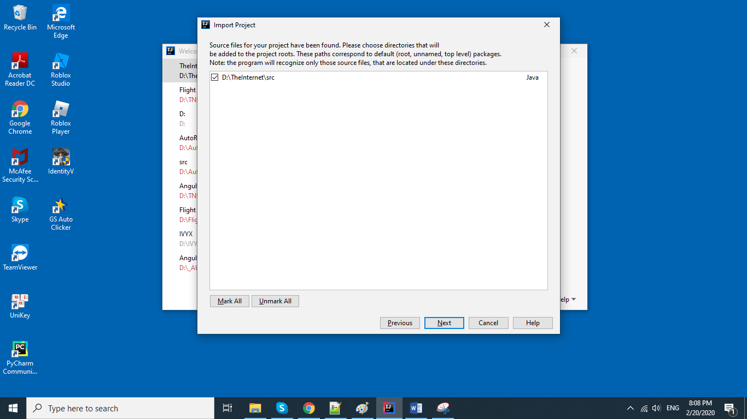

**Step 11)** Click Next

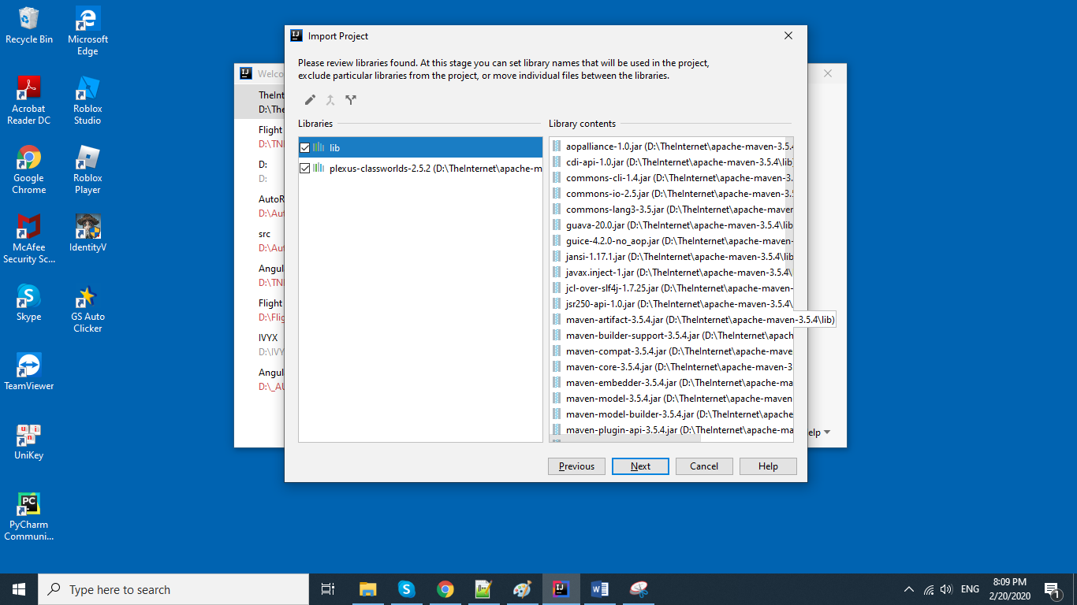

**Step 12)** Click Next

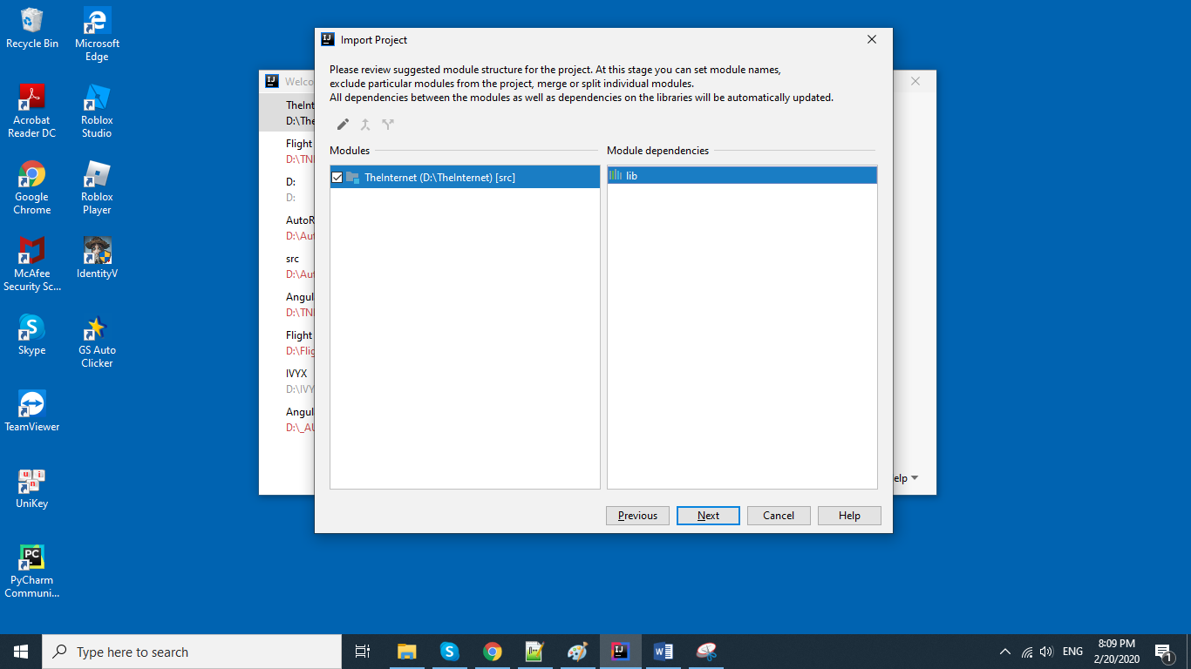

**Step 13)** Click Overwrite

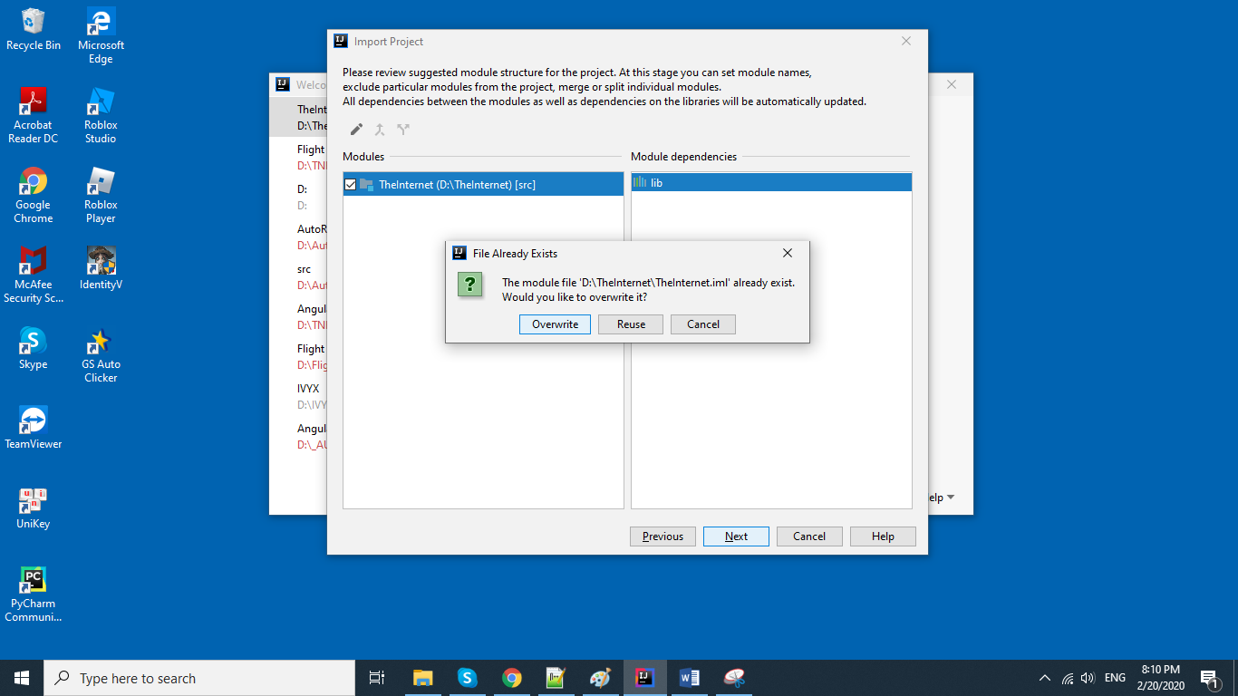

**Step 14)** Add Java JDK 8 as image

C:\Program Files\Java\jdk1.8.0_241

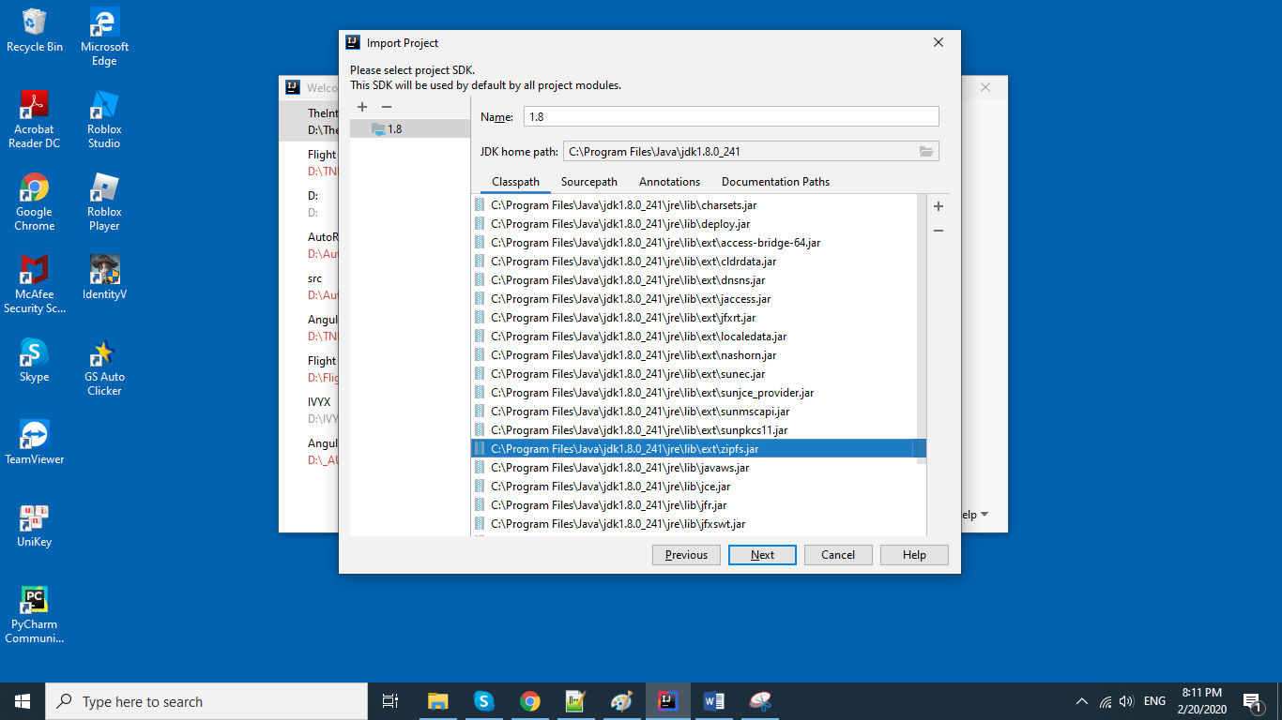

**Step 15)** Click Finish

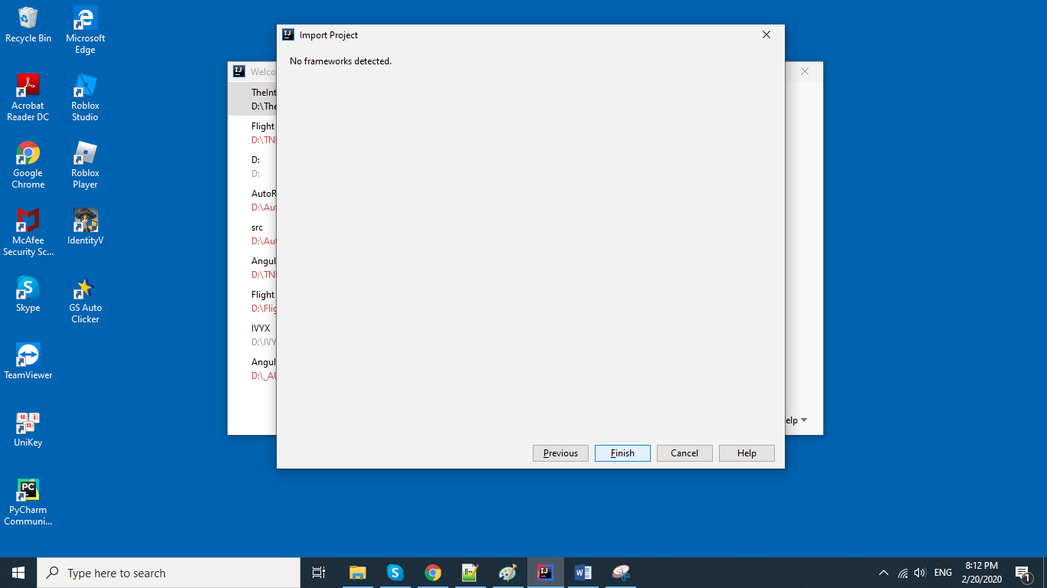

**Step 16)** It will open the project as image, remember click ‘Add as Maven project’:

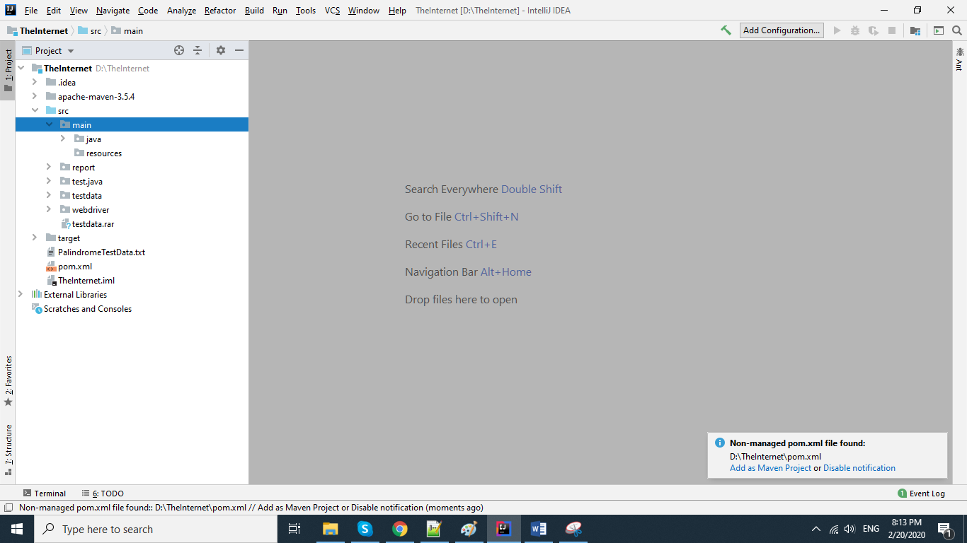

**Step 17)** It will take 15 minutes for auto downloading maven dependencies which will be keep as default as: C:\Users\hieptc\.m2\repository

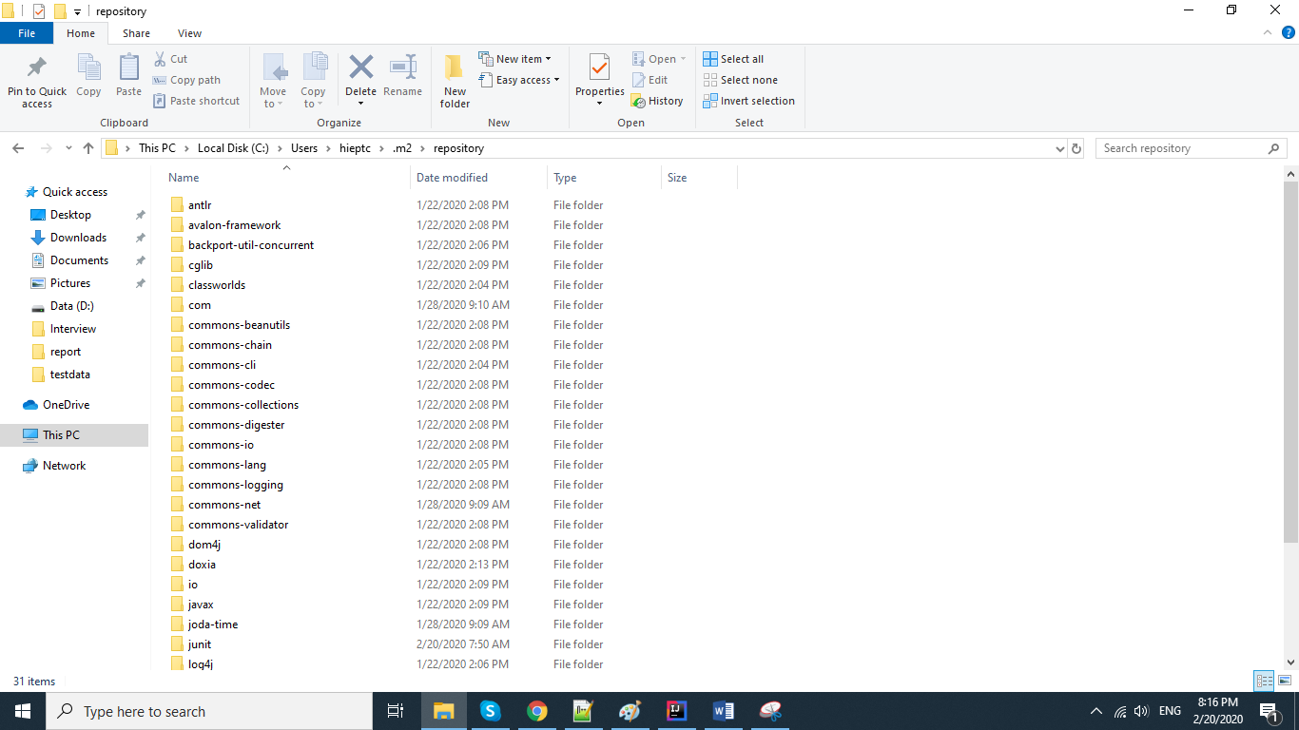

**Step 18)** There are 4 main folders: main, test, testdata, report

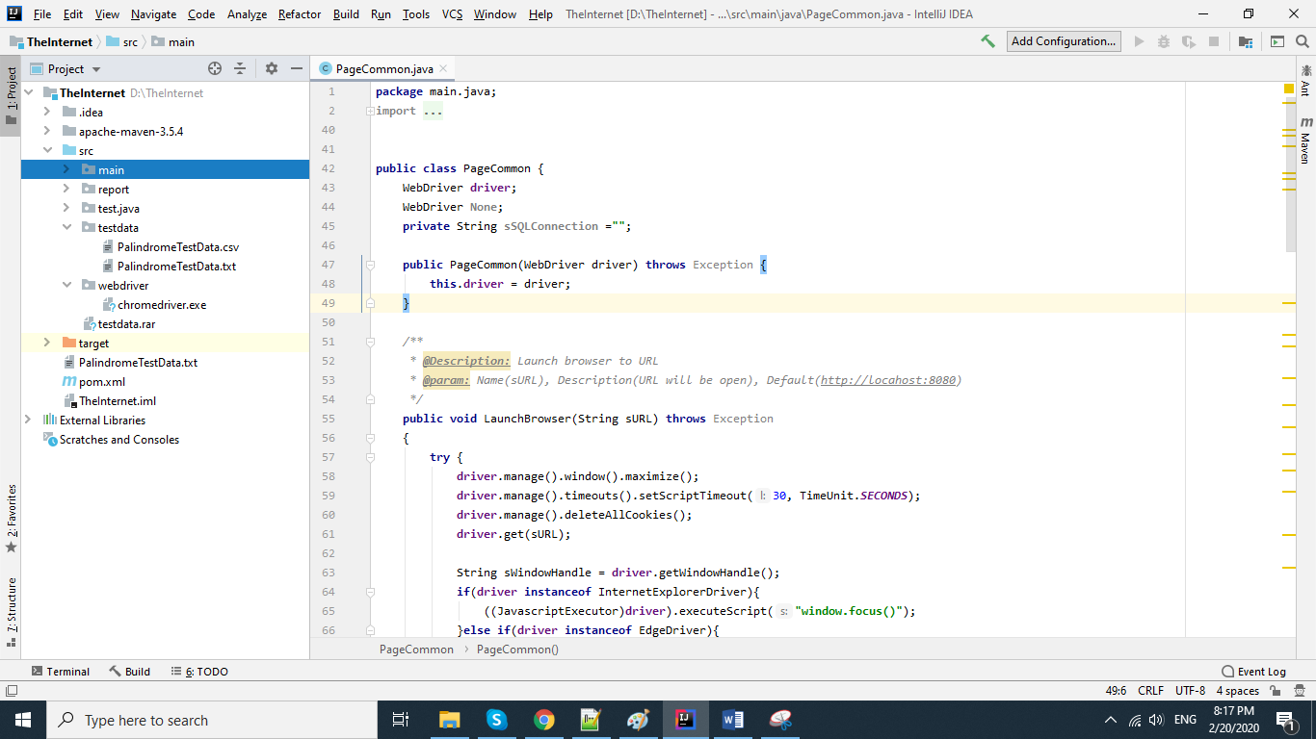

Main: keep java files which operate UI operations such as open webform, click button, send keys into a text fields

Test: keep test cases which be execute

Testdata: create test data file in csv file and save to this folder

Report: will auto generate after running a test

Running a test:

Run PalindromeCheckerTest: Click on PalindromeCheckerTest.java file in the folder test, then right click and click menu Run PalindromeCheckerTest, then it will run all test data which defined in the D:\TheInternet\src\testdata\ PalindromeTestData.txt

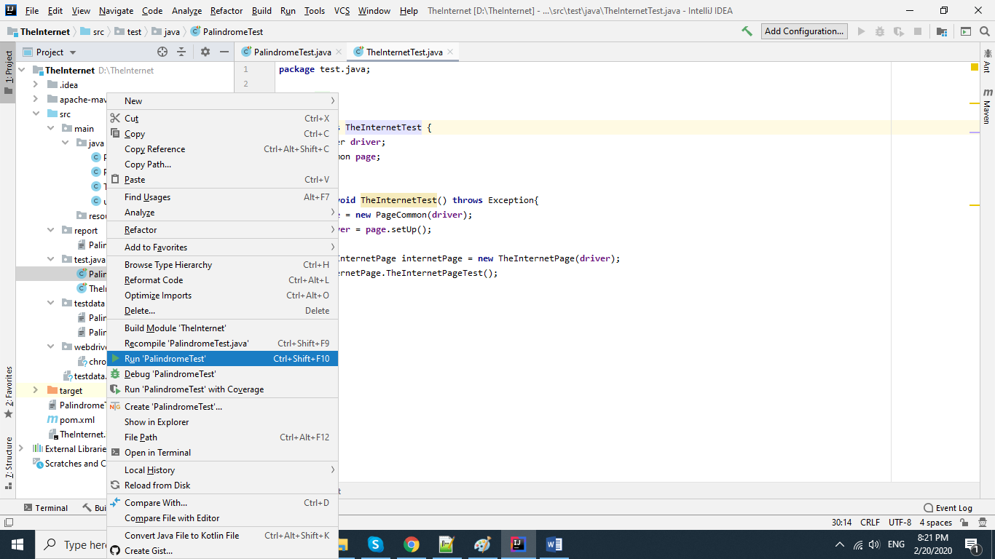

When running it looks like: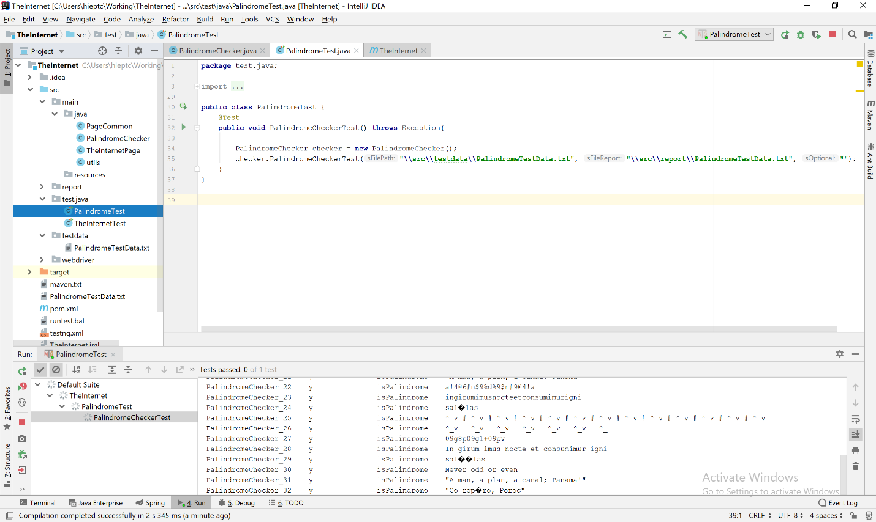

After running, it will display green result in the bottom panel

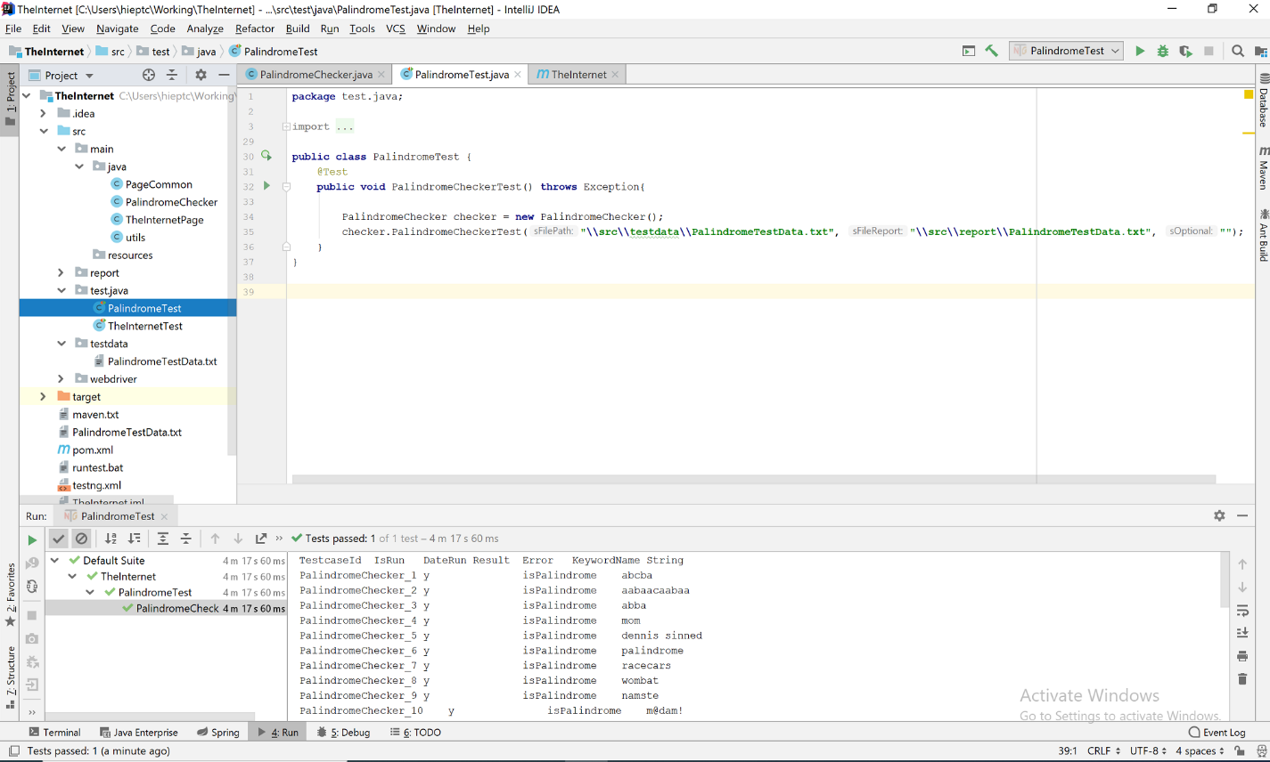

Then go to D:\TheInternet\src\report\ PalindromeTestData.txt to review result

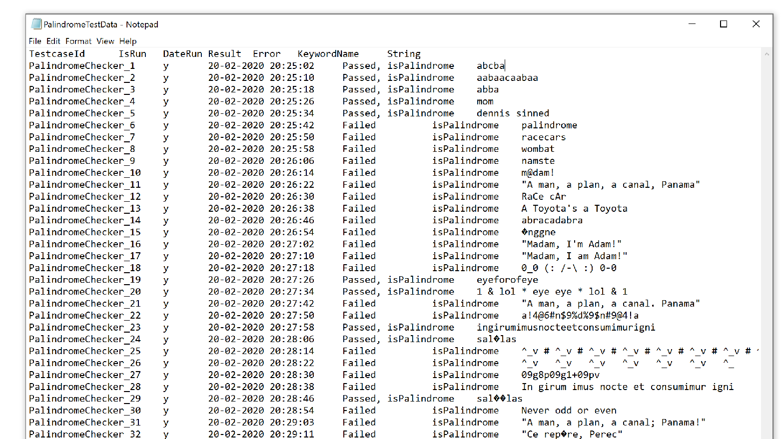

Run TheInternetTest: Click on TheInternetTest.java file in the folder test, then right click and click menu Run TheInternetTest, then it will run the function TheInternetTest()

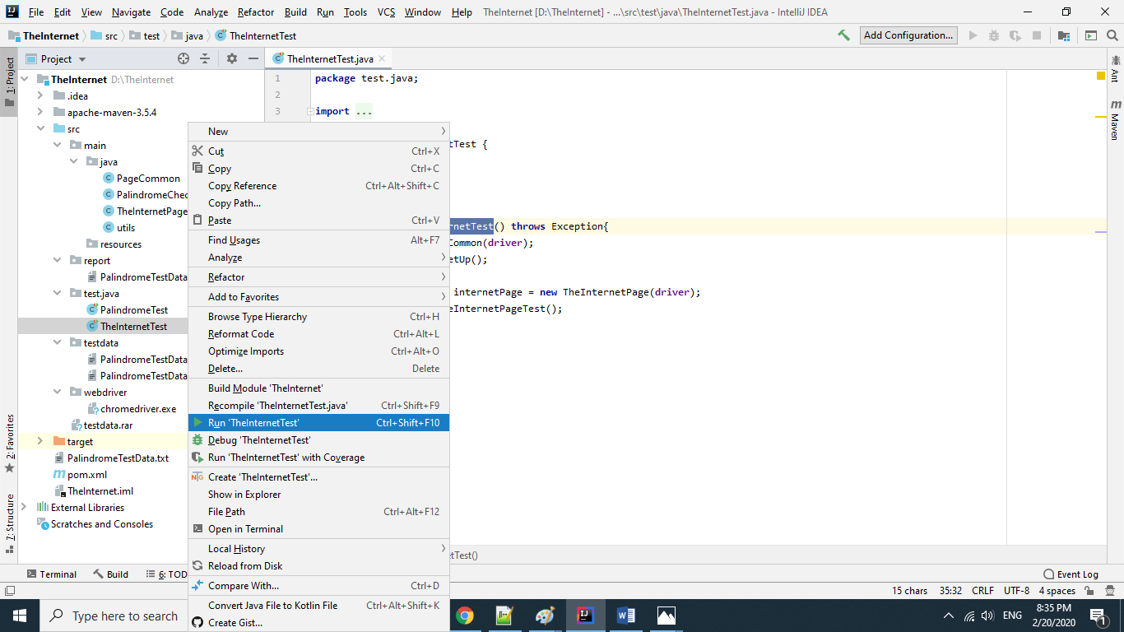

Notes:

You can double click the runtest.bat (D:\TheInternet\runtest.bat) to run all test suites without using Intellij IDE

File D:\TheInternet\runtest.bat

cd D:\TheInternet\

mvn package -DskipTests=false

Remember to edit cd D:\TheInternet\ by the project TheInternet path you save in your machine