

rapport technique
PRÉSENTÉ À L’ÉCOLE DE TECHNOLOGIE SUPÉRIEURE
DANS LE CADRE DU COURS LOG792 Projet de fin d'études en génie logiciel

Yarn
A Speculative Multithreading System

Rémi Attab
ATTR05098501

Département de génie logiciel et des TI

Professeur superviseur
ÉRIC PAQUETTE

MONTRÉAL, 8 août 2011
Été 2011

Yarn
A Speculative Multithreading System

Rémi Attab
ATTR05098501

SUMMARY

This document describes a solution for solving some of the problems associated with parallelizing sequential programs. It uses a speculative multithreading scheme that leverages runtime information in order to simplify the parallelization process. The proposed solution is composed of a runtime kernel and an instrumentation tool. The runtime kernel is used to execute the program in parallel while keeping the results coherent. The instrumentation tool is used to automatically instrument a target program with calls to the runtime kernel. In order to measure the performance of the system, a benchmarking tool was created. This tool demonstrated that a software-only speculative multithreading could achieve an interesting speedup when presented with a sufficient workload per iteration. This document then describes several ways that can be used to improve the system in order to fix some lingering issues as well as improve the flexibility and performances.

TABLE OF CONTENTS

Page
INTRODUCTION 1
CHAPTER 1 Context 2
1.1 General Context 2
1.2 Traditional Parallelisation 2
1.2.1 Manual Parallelisation 3
1.2.2 Automatic Parallelisation 3
1.3 Speculative Multithreading 4
1.3.1 Loop-Based Speculation 4
1.3.2 Function-Based Speculation 5
CHAPTER 2 Objectives 6
2.1 General Objectives 6
2.2 Runtime Kernel Objectives 6
2.3 Instrumentation Tool Objectives 7
2.4 Objective Summary 7
CHAPTER 3 Methodology 8
3.1 General Methodology 8
3.2 Runtime Kernel Development Methodology 8
3.3 Instrumentation Tool Development Methodology 9
3.4 Documentation Process 10
CHAPTER 4 Solution 11
4.1 General Description 11
4.2 Runtime Kernel 11
4.2.1 Implementation 12
4.2.2 Performance Testing 14
4.3 Instrumentation Tool 16
4.3.1 LLVM 16
4.3.2 Instrumentation Process 17
4.3.3 Implementation 18
4.3.4 Functionality Tests 20
CHAPTER 5 Results 21
5.1 General Objectives 21
5.2 Runtime Kernel Objectives 21
5.3 Instrumentation Tool Objectives 22
CHAPTER 6 Recomendations 23
6.1 General Recommendations 23
6.2 Runtime Kernel Recommendations 23
6.3 Benchmark Tool Recommendations 25
6.4 Instrumentation Tool Recommendations 25
CONCLUSION 27
BIBLIOGRAPHIE 28
ANNEXE I Vision 29
ANNEXE II Architecture 30
ANNEXE III Algorithms 31
ANNEXE IV Tests 32
ANNEXE V Source Code 33

LISTE OF FIGURES

Page

Figure i - Runtime kernel overview 12
Figure ii - Performance graph 15
Figure iii - Instrumentation process 17
Figure iv - Instrumentation Tool Implementation 18
Figure v - Pass dependencies 20

LIST OF ABREVIATIONS AND ACRONYMS

SMT | Speculative Multithreading
CPU | Central Processing Unit
yarn | The name of the project
libyarn | The name of the runtime kernel
yarnb | The name of the benchmarking tool
yarnc | The name of the instrumentation tool
LLVM | Low-Level Virtual Machine. It's a versatile compiler infrastructure.
clang | The name of the C, C++ and Objective-C frontend for LLVM.

INTRODUCTION

The yarn project was developed to implement a generic software-only speculative multithreading system. This document is a technical report which aims to describe the conception, development and outcome of the yarn project.

CHAPTER 1 begins with a brief overview of the current state of program parallelization and its associated problems. CHAPTER 2 states the objectives that were determined for the proposed solution and is followed by a description of how these objectives would be achieved in CHAPTER 3. CHAPTER 4 provides the details of the proposed solution and is followed by an analysis of the outcome in CHAPTER 5. A series of recommendations are proposed in CHAPTER 6.

Context

General Context
With the recent widespread availability of multi-core processors, there has been an increasing demand for software that can make full use of the hardware that it’s running on. To meet this demand, multiple tools have been created to help programmers design and implement parallel code. Unfortunately, there is a large number of existing programs that were not designed to work in a parallel environment. These programs are generally difficult to parallelize due to their size and complexity.

The following sections briefly describe the current state of the techniques and tools used to parallelize a program and the various problems associated with them. The first section describes the traditional parallelisation techniques and the second section explores the main speculative parallelisation techniques.

Traditional Parallelisation
In this section we will describe the current state of transforming a sequential program into a parallel program using traditional methods. The first section describes the various steps that have to be undertaken in order to parallelize a sequential program manually. The second section describes how these steps can then be automated using various automatic parallelization tools.

Manual Parallelisation
The first method is to do the parallelisation by hand. This involves the following steps:

- Finding a section of code that is inherently parallelizable and involves a bottleneck.
- Split the section of code into separate tasks that can be executed in parallel.
- Use the primitives provided by the current platform to run the tasks in parallel.
- Synchronize the communications between the different threads running these tasks.

Each of these steps can be difficult to implement correctly. For example, a bottleneck that is inherently not parallelizable will usually contain a lot of dependencies in its computation. In order to parallelize this bottleneck and keep its computation coherent, a large amount of synchronization would need to be introduced. This would negate most, if not all, of the benefits of the parallelization. Since it's not always obvious if the bottleneck is inherently parallelizable, a programmer could waste a lot of his time. The extra complexity could also introduce defects in the programs which can be difficult to detect and correct. Tools like OpenMP have been created to alleviate some of these problems. Nevertheless, they still require a considerable amount of human intervention because they can't solve all the steps involved in parallelizing a program.

Automatic Parallelisation
Because of all the difficulties associated with manual parallelization, another type of tool has been developed with the aim of automatically finding and parallelizing bottlenecks. These are usually part of a compiler and are implemented as optimization passes [1]. During the compilation process most of the developer's intent is lost which forces the optimisation process to be conservative in nature to keep the program coherent. By being conservative, the process could miss some good parallelization opportunities.

Speculative Multithreading
In this section we will explore an alternative to parallelize a sequential program which relies on the concept of speculation. Speculation is defined as making a bet on the future in the hopes of making a gain. This also means that if the bet is incorrect, there is a loss. There are two approaches that can be used to marry parallelization and speculation: loop-based speculation and function-based speculation. Both of these are detailed below.

The main advantage of speculative multithreading is that it enables us to easily automate the parallelisation of the program because we make the bet that it can run in parallel without any added synchronisation primitives. In order to confirm our bets, a runtime component is used to validate the coherence of the execution. If a violation is detected then the incoherent work is thrown out and we take a loss.

The downside is that this is a scheme that only exists in research papers and doesn't have any real world implementations. Furthermore, the majority of these research papers rely on specialized hardware to implement their speculative scheme [2][3] which severely limits its adoption. Most research papers also rely on simplifications in order to make their implementation performant. For example, an implementation that only tracks data that are part of a vector [7] while most programs often access memory locations that can't be determined until runtime. The net effect is that we simply don't know whether a software-only speculative multithreading system is a viable solution in a real-world scenario.

Loop-Based Speculation
Loops are natural bottlenecks within a program and they describe a sequence of similar tasks that all have to be executed. A loop can therefore be easily parallelized with a speculative scheme by executing each iteration in parallel. In order to ensure coherence, each reads and writes made to a memory location are tracked by the runtime component. If an iteration makes a premature read that leads to incoherent calculations, the work made by that iteration and any subsequent iterations are thrown out and recalculated.

This scheme has the advantage that it is simple to implement and is intuitive for the user of the system. The downside is that it adds a large amount of overhead to the loop which makes it more difficult to obtain a significant speedup.

Function-Based Speculation
The idea of this scheme is to fork the execution of the program when attempting to call a function. In order for the main thread to continue its execution, it must first make a prediction on the return value of the function [4]. While the main thread is executing, the function call is executed in parallel in order to confirm the prediction that was made. When the return value of the function is available, it is used to validate the initial prediction. If the prediction is correct then the main thread can continue executing. If the prediction is incorrect then the modifications made by the main thread are rolled-back and it resumes execution after the function call with the correct return value.

This scheme is analogous to the branch prediction schemes used by most modern CPUs. It has the advantage that it is more widely applicable then loop-based speculation and introduces significantly less overhead. The downside is that it is considerably more difficult to implement and since most functions have side-effects that could affect the coherence of the work done by the main thread. To take this into account, it is necessary to implement a read-write tracking mechanism that is used in loop-based speculation.

Objectives

General Objectives
The overall goal of this project is to provide a robust foundation for a speculative multithreading system which doesn't rely on any specialised hardware. The project will require the development of a runtime kernel as well as an instrumentation tool. These components will be used to automatically parallelize a program with minimal user intervention. Because of time constraints, this project will only focus on loop-based speculation. The resulting system must be portable to any popular operating systems (eg. Windows, Linux, Mac...) and run on both 32 bit and 64 bit CPU architecture.

Runtime Kernel Objectives
The goal of the runtime kernel will be to run a loop in parallel while keeping its computation coherent. The coherence of the computation will be achieved by tracking every read and write made to the memory locations identified by the compiler component. In order to determine the usability of this kind of scheme in the real world, the runtime kernel must also achieve a speedup of at least 2 using a machine with 8 physical processors.

The runtime kernel will be generic and works with any program types. This means that it can't assume anything about the layout of the data it is tracking or rely on special hardware support. The runtime component can only take advantage of these special scenarios if instructed by the instrumentation tool.

As a secondary goal, the runtime kernel should also scale. For the runtime kernel, scalability is defined as being able to maintain some kind of speedup growth when increasing the number of speculative threads.

Instrumentation Tool Objectives
The instrumentation tool should be able to analyse a loop, detect any memory accesses and instrument them with the required calls to the runtime kernel. Because the main focus for this component is to simplify the parallelisation process, the instrumentation tool should be able to instrument a target program with little or no user intervention and should be easy to integrate to any existing projects. The instrumentation tool should also be generic in nature in order to support as many input programs as possible.

Objective Summary
In summary, the main objective of the project is:
- To parallelize a sequential program using a speculative multithreading scheme.

The objectives for the runtime kernel are:
  - To run a loop in parallel while keeping its computation coherent.
  - Achieve a speedup of at least 2 using a machine with 8 physical processors.
  - Create a generic component that works with any program types.
  - Scalable and portable.

The objectives for the instrumentation tool are:
  - The ability to analyse a loop, detect any relevant memory accesses and instrument them with the required calls to the runtime kernel.
  - To process the target program with little or no user intervention.
  - Create a generic component that works with any types of input programs.

Methodology

General Methodology
This section describes the development methodology that will be used during the course of the project. The project is separated into three different processes: the documentation process, the development of the runtime kernel and the development of the instrumentation tool. The development of the instrumentation tool can only start once all the requirements for the runtime kernel have been met. The documentation process will be done in parallel with the development activities.

All development and documentation activities will be versioned using git as the versioning software and github as the remote repository. The source code and the documents produced during this project will be open sourced under the FreeBSD license.

Runtime Kernel Development Methodology
The development of the runtime kernel will focus on its performance. This focus should be reflected in the conception of the architecture which is documented in the Architecture document. Caches and shortcuts should be introduced to keep the load and store operations as small as possible. The synchronisation schemes should also be implemented as lock-free algorithms [6] where possible to avoid concurrency bottlenecks. The entire source code for this component will follow the C99 [5] standard with the exception of the public headers which will follow the Clean C [5] standard. For every module that is developed, a series of sequential and parallel tests will be created to ensure that the program works as expected and that there are no major synchronisation issues. The testing procedure will be codified in the Tests document.

To achieve the performance goals, a benchmark program will be created in order to gather a large number of performance measurements. These measurements should contain the workload required to achieve a given speedup using a given number of speculative threads. A strict timing methodology will be established to ensure that the results are correct and consistent. This methodology will be documented in the Tests document. This benchmark program should be executed on hardware that matches a real world scenario. Before doing any optimization, a bottleneck should first be identified using the profiling tool gprof.

Instrumentation Tool Development Methodology
The development of the instrumentation tool will require an initial research phase to learn the available tools provided by LLVM. The architecture which will be documented in the Architecture document, should aim to reuse the tools provided by LLVM and clang as much as possible. The implementation of any additional algorithms will be integrated as much as possible within the LLVM. The entire source code for this component will follow the conventions defined by the LLVM. For every module that is developed, a series of tests will be created to ensure that the program works as expected. The testing procedure will be documented in the Test and performance document.

Documentation Process
The documentation process will start by the creation of a Vision document which will guide future developments once this project is finished. The Architecture document will be progressively constructed every time a component is completed. It will describe not only the current implementation but also how future features will be added. Finally the Algorithms documents will be progressively constructed to reflect the development activities of the current iteration and will describe all the main algorithms of the system with enough details to allow for another party to re-create the entire system.

Solution

General Description
This chapter details the solution that was implemented during the 15 weeks allocated to the yarn project. In order to fulfill our objectives set at the beginning of the project, the solution was divided into two major components: the runtime kernel named libyarn and the instrumentation tool named yarnc. The following two sections describe each of these components in details.

Runtime Kernel
The runtime kernel is responsible for running a given loop in parallel and ensuring the coherence of the resulting execution. While the user should never use this component directly, the interfaces are still designed to be simple and easy to use. This has the advantage of making the functionality tests much easier to write and maintain.

Because the code base for this component is relatively small, the scheme used to organize the various functionalities is fairly simple and straight forward: one functionality per module. Note that the small size of the code is counter-weighted by the complexity of the algorithms. In order to manage this extra complexity and keep the code robust, it is important that any non-obvious behaviours or side-effect be well documented within the code.

In order to increase the robustness of the component, it is important that each functionality has an associated sequential and parallel test suite which must be executed and maintained regularly. The component also has a well defined protocol for dealing with errors and failure recovery. This protocol is then re-used by the instrumentation tool in order to ensure that the host program recovers gracefully from any non-fatal errors.

Implementation
This section gives a brief overview of a typical execution flow when executing a loop in parallel using the runtime kernel. Figure i gives an overview of the main modules that compose the runtime kernel. The discussion that follows will reference this figure.
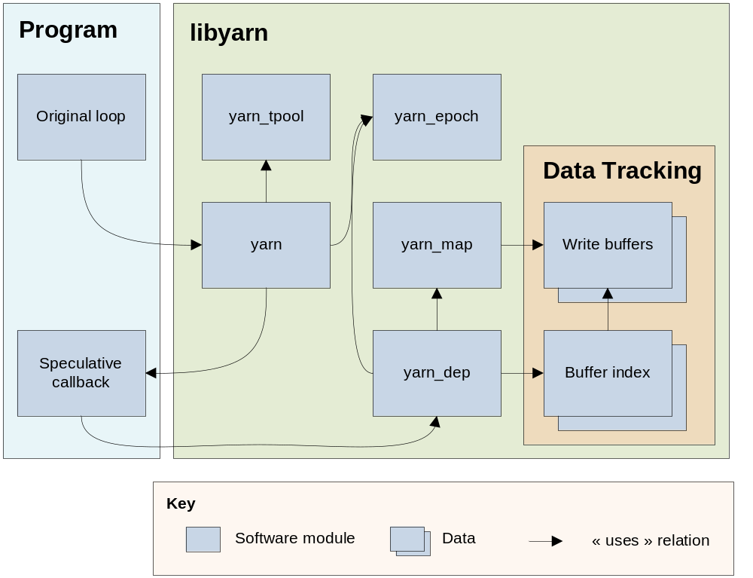
Figure i - Runtime kernel overview

Before executing a loop, a program that has been instrumented using the yarnc tool will first call the yarn module to execute the loop in parallel using the speculative callback function (a by-product of the instrumentation tool) as an argument.

The yarn module acts as the main interface for the runtime kernel and is responsible for driving the speculative execution. It first uses the yarn_tpool module to initiate the threads used to execute each iterations of the loop in parallel. It then uses the yarn_epoch module to assign an iteration to execute to each thread. The yarn_epoch module acts as the scheduler for the system and is responsible for correctly sequencing the iterations in time and re-executing iterations that might have been rolled-back.

To execute the iteration, the yarn module then calls the speculative callback function. This callback contains a copy of the loop where each read and write made to a memory location are replaced with calls to the yarn_dep module.

The yarn_dep module is responsible for tracking all the reads and writes made to a given memory location and detecting any violations. When a violation is detected, it triggers a rollback using the yarn_epoch module. To make the association from memory location to its tracking data, it uses the yarn_map module. This module makes no assumption about the data layout in memory which allows the runtime kernel to track all types of memory read-write operations. Note that since accessing the tracking data through the yarn_map module is costly, the yarn_dep module also has a shortcut to the tracking data which can be used with an index id. During the instrumentation process, it is possible to be able to reliably associate a variable with a single memory location. In these cases, we assign that variable an id which is then used to access the shortcut. Note that even if a memory location can be accessed through the shortcut, it is still available through the yarn_map module in case it is accessed by another variable.

Once the speculative execution terminates, it returns to the program. If no errors were detected during the speculative execution, then the original sequential loop can be safely skipped. If a non-fatal error was detected, then the program should recover by re-reading the values committed during speculative execution and execute the sequential loop using the newly read values. This error recovery scheme ensures that even when non-fatal errors occur, the program still behaves as expected.

Performance Testing
The yarnb benchmarking tool was created to determine whether the runtime kernel is capable of producing a sufficient speedup in real world scenarios. It is used to measure the workload required per iterations in order to achieve a given speedup with a given number of processor. For this component, the workload is defined as being an amount of time (in nanoseconds) per iterations that simulates the execution of a task.

Note that currently yarnb is only capable of handling the ideal case where the number of rollbacks is kept at a minimum. We were unable to implement any more cases because we determined that yarnb would have to be completely rewritten in order to support this which was impractical because of time constraints. This means that the result obtained from this benchmark are incomplete because they don't give a complete and accurate picture. The yarnb tool is nevertheless useful to determine whether the yarn project has enough potential and can be used as a temporary justification to continue the project.

Executing the yarnb program with a possibility of 24 speculative threads, we obtain the graph in Figure ii.
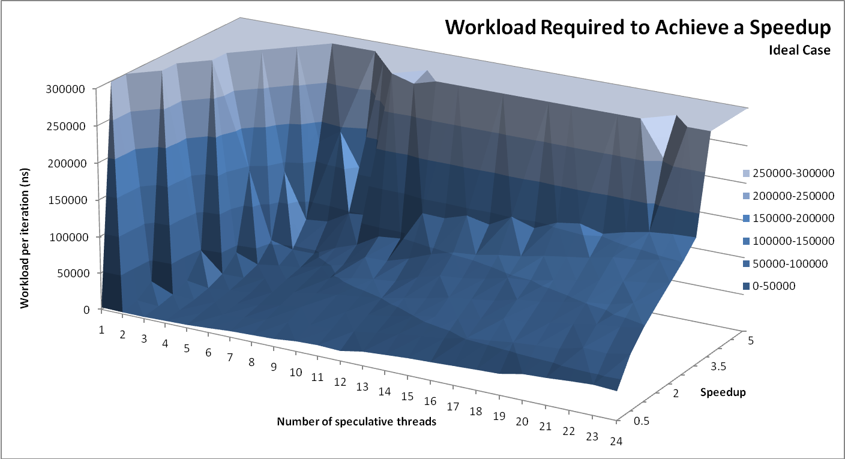
Figure ii - Performance graph

The results demonstrate that we can't expect to achieve any speedup with a workload that is under 10μs. A quick test tells us that this corresponds to approximately 10 to 100 floating point divisions. While this is a non-trivial workload, it does match the types of programs that we are targeting with our system. This test demonstrates that the yarn project is at least worth pursuing and developing further.

Another interesting trend that can be seen in the graph is that, beyond 8 speculative threads, the speedup growth stagnates at 5. This issue has been tracked down to a bottleneck within the yarn_epoch module. A solution is planned for a future release and, once implemented, should restore the growth of the speedup.

Instrumentation Tool
The instrumentation tool is responsible for analyzing a loop, detecting any relevant memory accesses and instrumenting them with the required calls to the runtime kernel. In order to do this with a minimum of user intervention, this component was implemented as part of the compilation process. This has the advantage that it fits naturally within a user's workflow and would require no maintenance beyond the initial setup. The use of a good compiler tool will also allow the component to be very robust and handle a large variety of input programs. Our choice of compiling tool is described in the next section which is followed by a description of the instrumentation process and implementation details.

LLVM
We chose to use the LLVM compiler infrastructure in order to implement the instrumentation tool. The main advantage of LLVM is its intermediate representation (IR) code which allows a program to easily manipulate the code of a program.

An intermediate representation code is generated using a frontend that translates a source program. For example, the clang front end is capable of translating a C, C++ and Objective-C program into its equivalent IR code. The IR code is completely independent from the original source program and can manipulate in a variety of formats (serialized binary, human readable text and a programming interface). This means that any program that manipulates IR code, automatically supports all the programming languages that are supported by the LLVM ecosystem.

In order to be easily integrated within the LLVM infrastructure, the instrumentation tool was implemented as two optimization passes. This allows the implementation to access a wide variety of analyses and transformation tools that are provided by LLVM. These mature tools will allow the yarnc component to handle a much wider range of input programs while also significantly reducing the effort required to implement the instrumentation process.

The main downside of implementing our tool as an LLVM optimization pass is that we introduce a strong dependency between yarn project and LLVM. This means that in order to use our tools, a user must have the LLVM compiler. This can hinder the deployment of the yarn project because the LLVM compiler is not as widely distributed as the gcc or the Visual Studio compilers. Note that the LLVM compiler does provide a C back-end which could be used to output the instrumentation result in a format that can be re-used by other compilers. Making use of this feature would require too much effort and, for this reason, is postponed to a future release.

Instrumentation Process
In this section we describe the instrumentation process from the point of view of the user. Figure iii provides an example of this process.
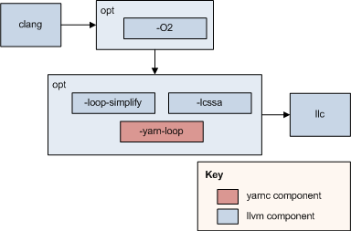
Figure iii - Instrumentation process

The compilation process begins with a call to one of the LLVM front-ends. In the above example, this is represented by clang. The output is then passed to the LLVM optimizer opt with the user provided optimizations. This step is important in order to simplify the code to analyze and avoid false positives during the instrumentation's analysis phase.

The output of the first optimization step is then sent again to the LLVM optimizer with the -loop-simplify, -lcssa and -yarn-loop options. The first two are used to standardize the loops within the program in order to make them easier to manipulate and analyze. These two passes should normally be specified as dependencies of the third pass within the code but a bug in LLVM is currently preventing this. The third option is used to initiate the instrumentation process by invoking the two yarnc optimization passes. Note that this step of the compilation process is the only setup required by the user in order to generate a parallel program.

The output of the second optimization step is then sent to one of the LLVM backends in order to generate the machine code. This code can then finally be transformed in a binary used to execute the instrumented program.

Implementation
In this section we will describe how the two optimization passes are used to instrument a loop. Figure iv illustrates this process.
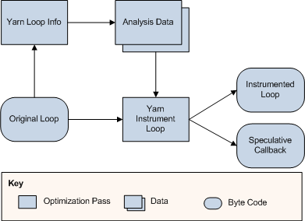
Figure iv - Instrumentation Tool Implementation

The process begins by passing the loop to the analysis pass named Yarn Loop Info. The analysis pass must first determine whether the loop can be instrumented. This means checking whether it contains calls to other functions or whether the types manipulated are compatible with the runtime kernel. If no problems were detected, the pass proceeds to detecting all reads and writes memory locations within the loop. These accesses are then converted into instrumentation points which indicates where and what type of instrumentations are required within the loop. These instrumentation points are then used within a heuristic to determine whether the loop is worth instrumenting. If the heuristic returns a positive, the compilation process can continue to the transformation pass.

The transformation pass YarnInstrumentLoop is responsible for generating the speculative callback as well as adding the required calls to the yarn_dep module of the runtime kernel. The insertion of the calls into the speculative callback is guided by the instrumentation points generated by the analysis pass. A header is also added before the original loop which calls the yarn module to initiate the speculative execution. The return is checked and, if no errors were detected, execution resumes after the original loop. If an error was detected the original loop is executed as part of the error recovery mechanism which is described in section 1.13.1.

Note that this process relies on a number of LLVM analyses and transformation passes which are displayed in Figure v.
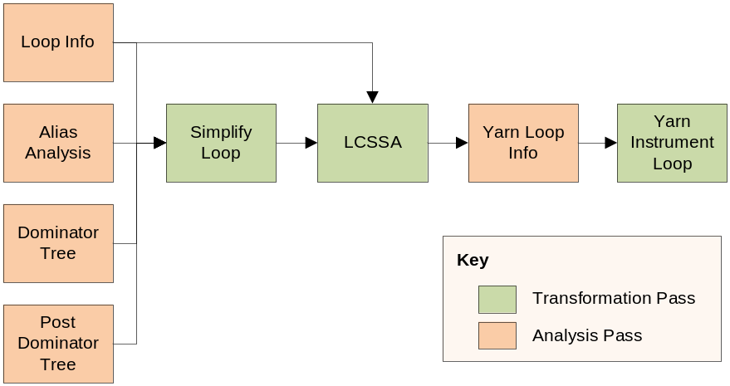
Figure v - Pass dependencies

These passes are used to either help the instrumentation process or ensure that certain properties hold true within the target loop. The details of each passes are detailed within the Architecture document.

Functionality Tests
This section describes the tests that were conducted in order to ensure the robustness of the instrumentation tool. Unfortunately, time constraint restricted our ability to create a thorough suite of test for this component. Instead, testing relied on a sample C program that contained a large variety of constructs and loops. We consider these samples to be sufficient to determine whether the objectives for this component have been met. Future release should place a high priority on creating a comprehensive test suite using the LLVM testing tools.

Results

General Objectives
The yarn project contains two sample programs that can be automatically parallelized. When run, these two programs will run in parallel and will yield behaviours that are coherent with their sequential counterpart. The yarn project is therefore considered an overall success because it meets the main objective of the project. The following two sections will describe the specific objectives that were initially set for the two major components of the project in order to accurately quantify our success.

Runtime Kernel Objectives
The runtime kernel is capable of executing a given loop in parallel while keeping its resulting behaviour coherent. This can be demonstrated executing the various tests that were developed for this component or by automatically parallelizing one of the two sample programs bundled with the project.

In order to meet the generic objective, the runtime kernel uses the yarn_map module described in section 1.13.1 to track memory read-writes. The runtime kernel ensures that every touched memory accesses are indexed by this module and it also makes no assumption regarding the memory layout of the data being tracked. This ensures that the implementation is capable of handling all types of data structures which fulfills the objective of being generic.

While the design of the library should also work on 32-bit systems and requires minimal modification to function on Windows, the runtime kernel was only tested on a Linux 64-bit environment. This means that the project didn't meet its secondary portability objective.

Furthermore, using the benchmarking tool described in section 1.13.2 we were able to determine that the runtime kernel was capable of achieving a speedup of at least 2 using 8 speculative threads. The speedup was largely dependent of the program's workload. This means that it is possible to achieve a speedup higher than 2 by using a big enough workload within the parallelized loop. The benchmarking tool also revealed that there were scalability issues in the runtime kernel. This means that the project didn't meet its secondary scalability objective.

Instrumentation Tool Objectives
The instrumentation tool is capable of automatically analysing a loop, detect any memory access and instrument them with calls to the runtime kernel. The process is explained in section 1.14.3 and can be demonstrated by building the two sample programs provided by the yarn project with our instrumentation tool. Once they are built, the user can inspect the intermediary representation to confirm that the instrumentation took place and that it is correct. The runtime kernel log outputs can also be enabled to confirm the runtime behaviour.

The instrumentation process described in section 1.14.2 only adds a single command line to the typical user's workflow which only requires a onetime setup within the build process. This means the component requires very little user intervention and meets the usability objective.

The implementation of the instrumentation tool described in section 1.14.3 relies heavily on the LLVM IR code. Because the LLVM IR code is a standardized simplification of the original source code, the instrumentation tool can rely on properties to correctly manipulate any types of programs. These properties are enforced by the fully tested and mature LLVM passes. This means that the instrumentation tool meets its objective of being generic because it only depends on properties that are guaranteed to be enforced by LLVM.

Recomendations

General Recommendations
Because the yarn project has met all its primary objectives in the allocated 15 weeks, we recommend that its development should continue. Any future development should prioritize the improvement of the performance tests for the runtime kernel and the functionality tests for the instrumentation tool. The following sections describe important features that should be addressed in future releases.

Runtime Kernel Recommendations
The priority for this component is to fix the yarn_epoch bottleneck that was discussed in section 1.13.2. Until this is fixed, it is difficult to get an accurate picture of the performances and scalability of the system. The fix will involve replacing a temporary lock by a lock-free algorithm. This will involve a lot of functionality tests which will focus on the parallel aspects.

Another problematic area of the runtime kernel is its large memory footprint. For each word that is tracked by the yarn_dep module, the component can require up to 64 times the size of that memory location. This excessive memory usage is problematic because it can harm performances by polluting the processor's cache and triggering page faults. It is possible to reduce this amount by at least half without breaking any existing concurrent algorithms. Further reductions will affect the concurrent algorithms and their performances.

Currently, the runtime kernel has no special behaviour for induction variables. Because the value of induction variables can easily be determined for any iteration, it would be possible to allow the yarn_epoch scheduler to generate these automatically for each iteration. This would allow the instrumentation tool to ignore induction variables which would reduce the overall overhead of the runtime kernel. It would also allow for dynamic scheduling of iterations. This means that it would be possible to execute more than one iteration within a single epoch or scheduling unit. This would also allow the runtime kernel to more effectively handle loops that execute a large amount of iterations.

Another interesting feature would be to gather statistics on the memory accesses. It would provide information on how the various memory accesses interact between each other and which pair is responsible for triggering rollbacks. This could be used by the user in order to better understand his program. It would also play a central role to an profiler guided optimization scheme that could eventually be added to the instrumentation tool.

This project was focused on providing a loop-based speculative scheme (see section 1.3.1) but a future release could also add support for function-based speculation (see section 1.3.2). This would allow the yarn project to be able to parallelize a wider range of input programs but would require substantial modifications to the current architecture.

Finally, the runtime kernel only tracks reads and writes to individual memory locations. This is a limiting factor because most programs have a much wider array of memory manipulation tools. For example, modifying an entire array in a predictable sequence or accessing external resources such as files. Supporting these memory manipulation tools would render the runtime kernel more flexible. It would also require substantial modifications to the current architecture.

Benchmark Tool Recommendations
The benchmarking tool described in section 1.13.2 is only capable of handling a single ideal scenario. In order to get a more accurate picture of the performances of the yarn project, it would be useful to add support for various scenarios. For example, the number of rollbacks could be scaled at different frequencies in order to determine a breakeven point.

Any modifications to the yarnb program are dependent on the successful correction of the bottleneck within the yarn_epoch module. Furthermore, it was determined that the yarnb program would have to be completely re-written in order to accommodate these modifications and the resulting architecture would have to be much more flexible.

Instrumentation Tool Recommendations
The priority for this component is to implement an extensive suite of functionality tests. The current sample programs are simply insufficient to ensure a high level of reliability in the component. The new tests could be written using the set of testing tools provided by LLVM.

The analysis pass would also have to be augmented with an algorithm to validate the types of the instrumented variables in order to determine whether the loop can be safely instrumented. No type validation currently takes place and this can lead to issues when running on 32 bit systems. For example, a variable of type double will take 64 bits of memory while the runtime kernel is only capable of handling types of up to 32 bits. This can lead to severe problems during execution.

Another major overhaul that is required within the analysis pass is the heuristic used to determine whether the loop is worth instrumenting. The current heuristic was intentionally made weak in order to facilitate the testing process of the component. Improvements to this heuristic could take various shapes:
- Better loop analysis. This could mean that the heuristic would detect the presence of nested loops or function calls in order to adjust its scoring.
- The user could be allowed to guide the analysis pass by providing a set of rules in an external file.
- Incorporating the performance data generated by the yarnb benchmarking tool.
- Incorporating runtime statistics that could be eventually added to the runtime kernel. This scheme is analogous to the profiler guided optimizations scheme used by most major compilers.

Another problematic area of the instrumentation tool is its inability to do any analysis and instrumentation beyond the function boundary. This means that any loops that contain function calls with side-effects will have to be discarded. Because this is a frequent scenario in the real world, being able to instrument functions as well as loops would greatly increase the number of programs that could be parallelized. The modifications needed to implement this feature would require some refactoring in order to re-use the algorithms developed for loops. Note that this feature could be improved further by crossing module boundaries during link-time optimizations. This would have the downside of complicating the build process.

CONCLUSION

To conclude this document, the yarn project was successfully capable of automatically parallelizing a sequential program with minimal user intervention. The instrumented program behaves coherently and has potential for producing an interesting speedup. Given a reasonable workload, a program could achieve a speedup of up to 5 using 8 speculative threads. The yarn project also provides a solid foundation on which we can expand to increase the robustness, flexibility and performances of the system. While there are still some issues in the solution implemented because of the time constraints, we still are confident that they can be fixed.

It is worth noting that the current solution is not yet ready to be used in a production environment. In order to make this happen we are confident that by implementing the planned features described in the sections 1.19 and 1.21 the yarn project should be flexible and robust enough to handle any large scale code base.

BIBLIOGRAPHIE
1 | Aho, Alfred V., Lam, Modica S., Sethi, Ravi, and Ullman, Jeffrey D. Compilers: Principles Techniques, & Tools. Addison Wesley, Boston, 2007.
2 | Porter, Leo, Choi, Bumyong, and Tullsen, Dean M. Mapping Out a Path from Hardware Transactional Memory to Speculative Multithreading. In Proceedings of the 2009 18th International Conference on Parallel Architectures and Compilation Techniques (PACT '09) (Washington, DC 2009), IEEE Computer Society, 313-324.
3 | Prabhu, Manohar K. and Olukotun, Kunle. Using thread-level speculation to simplify manual parallelization. In Proceedings of the ninth ACM SIGPLAN symposium on Principles and practice of parallel programming (PPoPP '03) (New York, NY, USA 2003), ACM, 1-12.
4 | Hu, Shiwen, Bhargava, Ravi, and John, Lizy Kurian. The Role of Return Value Prediction in Exploiting Speculative Method-Level Parallelism. Journal of Instruction-Level Parallelism, 5 (2003), 1-21.
5 | Steele Jr., Guy L. and Harbison III, Samuel P. C: A Reference Manual. Prentice Hall, Upper Saddle River, NJ, USA, 2002.
6 | Herlihy, Maurice and Shavit, Nir. The Art of Multiprocessor Programming. Morgan Kaufmann, Burlington, MA, USA, 2008.
7 | Steffan, J. Greggory, Colohan, Christopher B., Zhai, Antonia, and Mowry, Todd C. A scalable approach to thread-level speculation. In Proceedings of the 27th annual international symposium on Computer architecture (ISCA '00) (New York, NY, USA 2000), ACM, 1-12.

- Vision
See the document titled Vision that should have been provided with this document.

- Architecture
See the document titled Architecture that should have been provided with this document.

- Algorithms
See the document titled Algorithms that should have been provided with this document.

- Tests
See the document titled Tests that should have been provided with this document.

- Source Code
The source code is available for download at the URL:
https://github.com/RAttab/yarn

http://openmp.org/
Git is a distributed version control system (http://git-scm.com/).
Github provides free hosting for open source projects (https://github.com/RAttab/yarn).
FreedBSD is a permissive open source license (http://www.freebsd.org/copyright/freebsd-license.html).
LLVM is a versatile and user-friendly compiler infrastructure (http://llvm.org/).
The inaccurate number range is due to the difficulty of accurately measuring instruction count when fighting compiler optimizations. In order to get a more accurate number range we would have to use a standardized benchmarking program. Unfortunately, time constraints for the project would not allow this.
Function calls are problematic because, in the scope of this project, the instrumentation tool can't instrument the function. Any side-effects of the function can therefore not be tracked by the runtime kernel. This might lead to incoherence within the calculations.
Induction variables are variables that enter the loop with the value of zero and are incremented by 1 on each iteration.
An epoch is a unit of work that we want to execute in parallel. When parallelizing loops, an epoch is equivalent to an iteration. Note that the rest of this document doesn't make a distinction between an epoch and an iteration because in the current solution they are essentially the same.

