ASSIGNMENT 2 - USE CASE DIAGRAM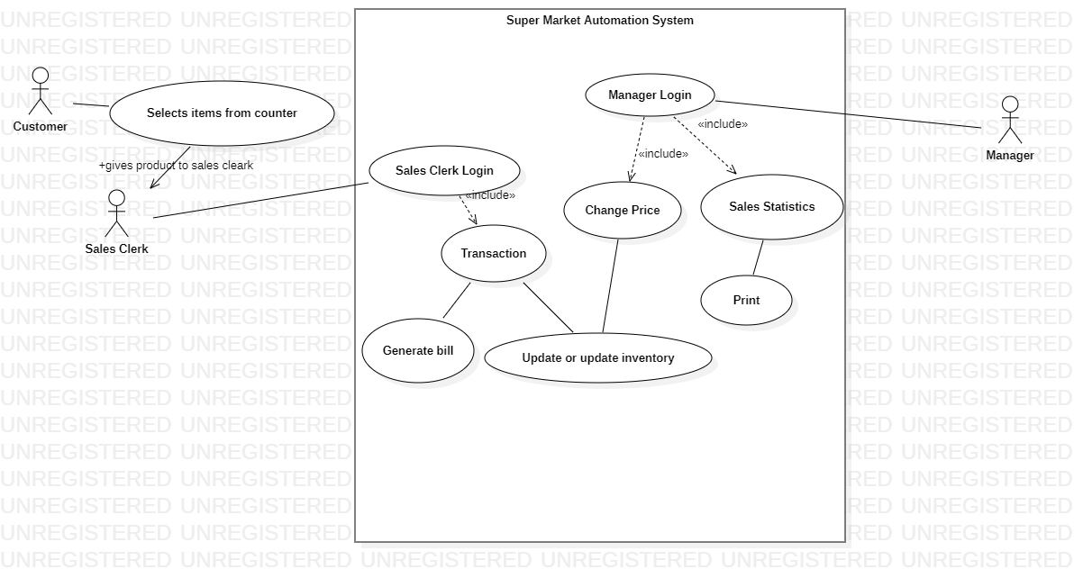

ASSIGNMENT 3 ACTIVITY DIAGRAM

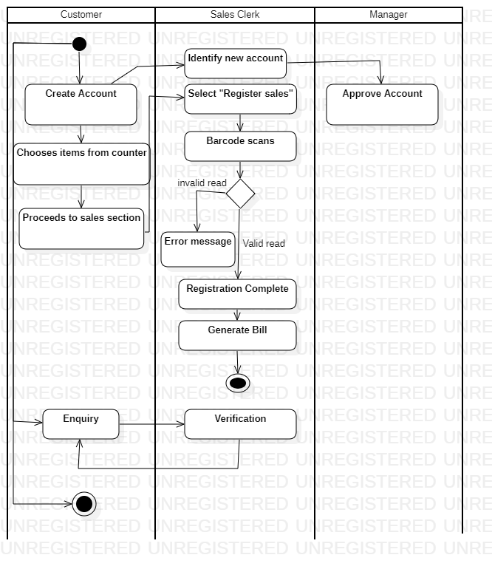

ASSIGNMENT 4

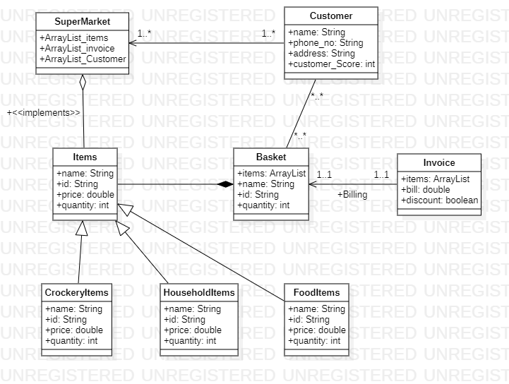

ASSIGNMENT 5

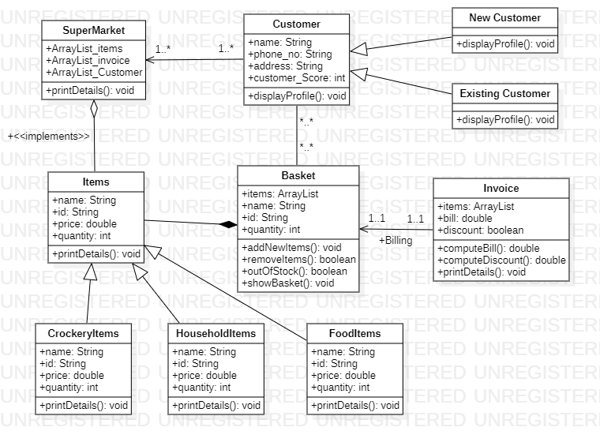

ASSIGNMENT 6  
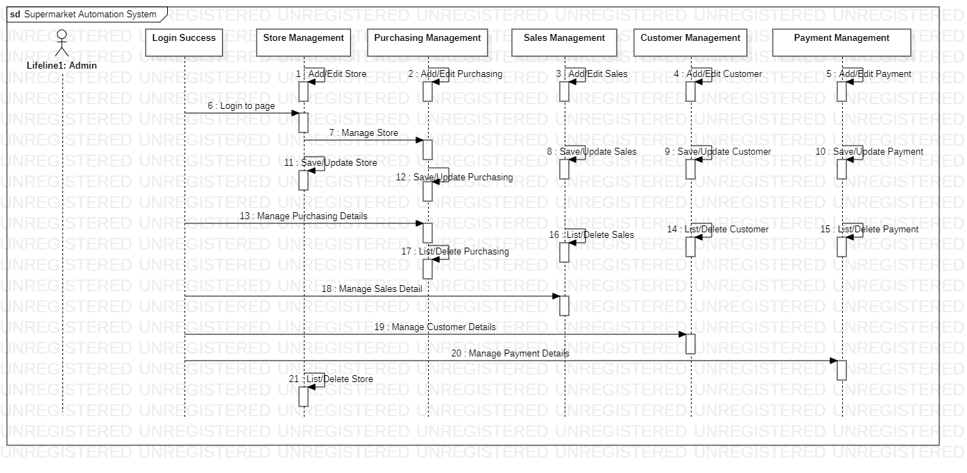

ASSIGNMENT 7

