Multiple Linear Regression

Author : Rose Ellison

I will be building a multiple linear regression model based off the ‘50_Startups’ data and using the forward elimination model. In this dataset there are five columns $Profit$, $R.D.Spend$, $Administration$, $Marketing$, and $State$. Profit is our dependent variable while the other four are our independent variables. We want to determine if there are any correlations between the profit and expenditures, such as r&d, admin, and marketing. Additionally, is there any correlation between profit and which state the company is operating?

$$MultipleLinearRegressionFormula:$$

$$y=b_{0}+b_{1}x_{1}+b_{2}x_{2}+b_{3}x_{3}+b_{4}x_{4}$$

## Preparing the data

For this step, I need to read in the csv file, deal with categorical data, and then split the data into training and test sets.

# Importing the dataset  
startups <- read.csv('../data/50_Startups.csv')  
  
  
# Dealing with categorical data - 'State'  
# Encoding  
startups$State <- factor(startups$State,  
 levels <- c('New York', 'California', 'Florida'),  
 labels <- c(1, 2, 3))  
  
  
# Splitting the data into test and training sets  
set.seed(1)  
split <- sample.split(startups$Profit, SplitRatio = .8)  
training.set <- subset(startups, split == TRUE)  
test.set <- subset(startups, split == FALSE)

## Fitting Multiple Linear Regression to the Training Set

The Independent variable, Profit, is going to be a linear combination of all the dependent variables.

# Regressor with all dependent variables  
regressor <- lm(Profit ~ ., training.set)  
summary(regressor)

##   
## Call:  
## lm(formula = Profit ~ ., data = training.set)  
##   
## Residuals:  
## Min 1Q Median 3Q Max   
## -30230.1 -3255.0 606.6 6683.7 13424.8   
##   
## Coefficients:  
## Estimate Std. Error t value Pr(>|t|)   
## (Intercept) 5.203e+04 7.535e+03 6.905 5.9e-08 ***  
## R.D.Spend 8.612e-01 5.468e-02 15.749 < 2e-16 ***  
## Administration -7.261e-02 5.923e-02 -1.226 0.229   
## Marketing.Spend 1.893e-02 1.926e-02 0.983 0.332   
## State2 5.173e+02 3.688e+03 0.140 0.889   
## State3 -1.967e+02 3.728e+03 -0.053 0.958   
## ---  
## Signif. codes: 0 '***' 0.001 '**' 0.01 '*' 0.05 '.' 0.1 ' ' 1  
##   
## Residual standard error: 9365 on 34 degrees of freedom  
## Multiple R-squared: 0.955, Adjusted R-squared: 0.9483   
## F-statistic: 144.2 on 5 and 34 DF, p-value: < 2.2e-16

According to the data, the only strong predictor in profit is the r&d spend. Due to this, we could rewrite our regressor with only one dependent variable and we should still get the same results.

# Regressor with only the R.D.Spend dependent variable  
regressor <- lm(Profit ~ R.D.Spend, training.set)  
summary(regressor)

##   
## Call:  
## lm(formula = Profit ~ R.D.Spend, data = training.set)  
##   
## Residuals:  
## Min 1Q Median 3Q Max   
## -31194.8 -4500.5 58.8 5638.2 17478.7   
##   
## Coefficients:  
## Estimate Std. Error t value Pr(>|t|)   
## (Intercept) 4.588e+04 2.823e+03 16.25 <2e-16 ***  
## R.D.Spend 8.836e-01 3.283e-02 26.91 <2e-16 ***  
## ---  
## Signif. codes: 0 '***' 0.001 '**' 0.01 '*' 0.05 '.' 0.1 ' ' 1  
##   
## Residual standard error: 9318 on 38 degrees of freedom  
## Multiple R-squared: 0.9502, Adjusted R-squared: 0.9488   
## F-statistic: 724.4 on 1 and 38 DF, p-value: < 2.2e-16

Although we changed the regressor to only using the R.D.Spend variable, the p-value remains the same. This is another indication that R.D.Spend is the only strong dependent variable predictor.

## Predicting the Test Set Results

y.pred <- predict(regressor, newdata = test.set)

## Visualizing the training set

# Visualizing the training set results  
ggplot() +   
 geom_point(aes(x = training.set$R.D.Spend, y = training.set$Profit), col = 'lightblue', lw = 4) +   
 geom_line(aes(x = training.set$R.D.Spend, y = predict(regressor, newdata = training.set)), col = 'darkblue') +   
 theme_bw() +   
 ggtitle('Profit VS R.D.Spend (Training Set)') +   
 xlab('Research and Development Spend') +   
 ylab('Profit')

## Warning: Ignoring unknown parameters: lw

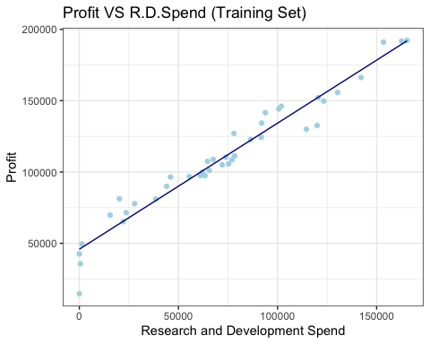

## Visualizing the test set results

ggplot() +   
 geom_point(aes(x = test.set$R.D.Spend, y = test.set$Profit), col = 'lightblue', lw = 4) +   
 geom_line(aes(x = training.set$R.D.Spend, y = predict(regressor, newdata = training.set)), col = 'darkblue') +   
 theme_bw() +   
 ggtitle('Profit VS R.D.Spend (Test Set)') +   
 xlab('Research and Development Spend') +   
 ylab('Profit')

## Warning: Ignoring unknown parameters: lw

