# VISVESVARAYA TECHNOLOGICAL UNIVERSITY

## BELAGAVI–590018

## Karnataka

## INTERNSHIP REPORT

#### ON

“Book-my-show gift card”

## BACHELOR OF ENGINEERING IN

## Information Science and Engineering

***Submitted by:***

RB Manasa (1KI19IS035)



Varcons Technology Pvt Ltd

Bangalore , Karnataka



# Kalpataru Institute of Technology, Tiptur

(Affiliated to Visvesvaraya Technological University and Approved by AICTE, New Delhi)

Accredited By NAAC with ‘A’ Grade ISO 9001-2015 and 14001-2015 certified Institute

**Bengaluru, Karnataka 560057**

2022-2023

# 

**CERTIFICATE**

This is to certify that the Internship titled **“BOOK-MY-SHOW GIFT CARD”** carried out by **“RB Manasa”** a bonafide student of Kalpataru Institute of Technology, impartial fulfillment for the award of **Bachelor of Engineering**, in **Information Science and Engineering** under Visvesvaraya Technological University, Belagavi, during the year 2022-2023. It is certified that all corrections/suggestions indicated have been in corporate in the report.

The project report has been approved as it satisfies the academic requirements in respect of Internship prescribed for the course Internship/Professional Practice (18ISI85)

#### Signature of Guide Signature of HOD Signature of Principal

**External Viva:**

Name of the Examiner Signature with Date

1)

2)

# 

# DECLARATION

I RB Manasa final year student of Information Science and Engineering, Kalpataru Institute of Technology - 572201, declare that the Internship has been successfully completed, in **Varcons Technologies Pvt Ltd**. This report is submitted in partial fulfillment of the requirements for award of Bachelor Degree in ISE, during the academic year 2022-2023.

Date: 02/09/2022

Place: Tiptur

USN: 1KI19IS035

NAME: RB Manasa

**OFFER LETTER PROVIDED BY THE COMPANY**





Date: **2nd September, 2022**

Name: **RB Manasa**

USN: **1KI19IS035**

## Dear Student,

We would like to congratulate you on being selected for the **Full Stack Web Development** Internship position with **Varcons Technologies Pvt Ltd**, effective Start Date **02nd September, 2022**, All of us are excited about this opportunity provided to you!

This internship is viewed as being an educational opportunity for you, rather than a part-time job. As such, your internship will include training/orientation and focus primarily on learning and developing new skills and gaining a deeper understanding of concepts of **Full Stack Web Development** through hands-on application of the knowledge you learn while you train with the senior developers. You will be bound to follow the rules and regulations of the company during your internship duration.

Again, congratulations and we look forward to working with you!. Sincerely,

Spoorthi H C

## Director

Varcons Technologies Pvt Ltd

*213, 2st Floor,*

*18 M G Road, Ulsoor, Bangalore-560001*

# ACKNOWLEDGEMENT

This Internship is a result of accumulated guidance, direction and support of several important

persons. We take this opportunity to express our gratitude to all who have helped us to complete

the Internship.

We express our sincere thanks to our Principal Prof. Dr. Gurumurthy G D for providing us

adequate facilities to undertake this Internship.

We would like to thank our Head of the Department Prof. Rajashekar K J, for providing us an

opportunity to carry our internship and for his valuable guidance and support.

We express our deep and profound gratitude to our guide Spoorthi H C, for her keen interest and

encouragement at every step in completing the Internship.

We would like to thank all the faculty members of our department for the support extended

during the course of Internship.

We would like to thank the non-teaching members of our dept, for helping us during the

Internship.

Last but not the least, we would like to thank our parents and friends without whose constant

help, the completion of Internship would have not been possible.

RB MANASA

(1KI19IS035)

# ABSTRACT

Gift cards cannot be used to purchase another Gift Card.

Gift cards are valid for a period of twelve months from the date on which the recipient will

receive the gift card.

Gift cards on Book-My-Show can be purchased by Net Banking, Credit/Debit Card, and UPI on

Book-My-Show.

Gift Card(s) once bought online, shall be considered as sold and cannot be Cancelled, Exchanged

or refunded.

If lost/misused, the Gift Card(s) cannot be replaced. Gift cards are void if resold, and cannot be

exchanged for point(s) or cash and cannot be re-validated once past expiry date.

In addition to these Terms and Conditions, Book-My-Show Gift Card(s) and their use on our

website are also subject to Book-My-Show's general Terms of Use & Book-My-Show's decision

will be final in case of any dispute.

Book-My-Show may change (add to, delete, or amend) these terms from time to time. Unless

stated otherwise, the changes will apply to any new Book-My-Show. Any gift cards that you

purchase is for personal, non-commercial use and enjoyment only. The same may be shared

with family and friends, but may not be advertised, sold or used as promotional items by the

purchaser or anyone else without Book-My-Show's prior written consent.

# TABLE OF CONTENTS

|  |  |  |
| --- | --- | --- |
| **Chapters** | **Description** | **Page**  **No** |
| Chapter 1 | Company Profile | 1 |
| Chapter 2 | About the Company | 2 |
| Chapter 3 | Introduction | 4 |
| Chapter 4 | System Analysis | 5 |
| Chapter 5  5.1  5.2 | Requirement Analysis  Software Requirement  Hardware Requirement | 6 |
| Chapter 6 | Design Analysis | 7 |
| Chapter 7  7.1  7.2  7.3  7.4 | Implementation  Advanced Workout  Create your views here  @login_required  Create your models here | 8    9  10  11  13 |
| Chapter 8  Fig 8.1  Fig 8.2  Fig 8.3  Fig 8.4 | Snapshots  Book tickets  Confirm Show  Movie Information  Signup portal | 15  16 |
| Chapter 9 | Future Scope | 17 |
| Chapter 10 | Conclusion | 18 |
|  | References | 19 |

[**CHAPTER**](https://1.bp.blogspot.com/-dODuK8N5h1Q/Wlnyb3V9HFI/AAAAAAAACL4/WxQtCJ1pM5wccDABg4wIrTBUB0vlikXQQCLcBGAs/s1600/poly1.jpg) **1**

# COMPANY PROFILE

**VARCONS TECHNOLOGIES PRIVATE LIMITED** is a **KARNATAKA** based **PRIVATE**

**ltd.** Company Registered at dated 2022-07-11 12:00:00 AM on Ministry of Corporate

Affairs(MCA), The Corporate Identification Number (CIN) of VARCONS TECHNOLOGIES

PRIVATE LIMITED is **U72900KA2022PTC163646** and registration number

is **U72900KA2022PTC163646 It has been classified as COMPANY LIMITED BY SHARES**

**and is registered under Registrar of Companies BANGALORE India.** Authorized share

capital of VARCONS TECHNOLOGIES PRIVATE LIMITED is Rs. 1000000 and its paid up

capital is Rs. 10000. It aspire to serve in **COMPUTER AND RELATED**

**ACTIVITIES** activities across the India.

Its Annual General Meeting (AGM) was lastly conducted on and as per the

records of Ministry of Corporate Affairs (MCA), its balance sheet was last filed on .

Varcons Technologies Private Limited has two directors – Chikaegowdana Doddi Kariyappa Somalatha and Haralahalli Chandraiah Spoorthi.

The Corporate Identification Number (CIN) of Varcons Technologies Private Limited is

U72900KA2022PTC163646. The registered office of Varcons Technologies Private Limited is at #8/9, 5th Main, 3rd Cross road, Beside Sachidananada Nagar, R R Nagar Bangalore, Karnataka

# [CHAPTER](https://1.bp.blogspot.com/-dODuK8N5h1Q/Wlnyb3V9HFI/AAAAAAAACL4/WxQtCJ1pM5wccDABg4wIrTBUB0vlikXQQCLcBGAs/s1600/poly1.jpg) 2

**ABOUT THE COMPANY**

Varcons Inc. is a Certified Economically Disadvantaged

Women-owned Small Business based out of Virginia. Varcons offers a wide range of IT

Professional Services, providing innovative, customized, and cost-effective End-to-end Product

support to the Commercial and Public sector clients. Our certified experts have decades of

experience delivering IT solutions to the Public Sector and enterprise. We are not only the cloud-

native solution provider; we are successfully stabilizing and modernizing the legacy applications.

We provide a proven cloud journey from governance, security, and risk to automated

deployments. We focus on results, as we help our customers to uncover new possibilities to put

them on the leading edge of cloud innovation in their industry.

Website

[https://varcons.com](https://varcons.com/)

Varcons Technologies Private Limited's Annual General Meeting (AGM) was last held on N/A and as per records from Ministry of Corporate Affairs (MCA), its balance sheet was last filed on N/A.

Smart solutions are at the core of all that we do at VCT. Our main goal is to find smart ways of using technology that will help build a better tomorrow for everyone, everywhere. As offers a variety of advantages over traditional software licensing models and we here at VCT tend to include the key features of as in everything we build.

**OD services we provide:**

**Website as Software**: We develop websites that behave and interact similar to sophisticated software. Information + Functionality = WAS.

**Analytics and Research**: Let us analyze the way your users/customers interact with you/your business by gathering, studying, and understanding the consumer voice and their perception of the product/service to generate a report to help you make better market decisions.

**Comprehensive Customer Support**: With a comprehensive range of services, we n guarantee your technology needs are not just met, but exceeded. We shall work with your Customers/users closely to understand the way your users/customers use/make use of Products/Services.

**Smart Automation Tools**: We create API's and tools that help you automate any process with a host

[**CHAPTER**](https://1.bp.blogspot.com/-dODuK8N5h1Q/Wlnyb3V9HFI/AAAAAAAACL4/WxQtCJ1pM5wccDABg4wIrTBUB0vlikXQQCLcBGAs/s1600/poly1.jpg) **3**

**INTRODUCTION**

#### The "Book-my-show gift card" is a new way of gifting movies, plays, concerts or sports tickets to

#### your loved ones and each gift card has a predefined amount loaded on it which can be used to buy

#### tickets.

#### There are different categories of Gift Cards: Birthdays, Anniversaries, Festivals, Speciaoccasions, etc.

#### Price ranges from INR 250, 500, 1000, 2000, 2,500, 5,000 & 10,000/- are valid till 12 months from

#### the date of delivery of gift card and is ideal as an hr incentive tool, gift it to business partners,

#### clients or for someone just to send as an individual gift employee.

#### This gift card is suitable for all gifting purposes and can be redeemed on book-my-show only.

On the payment page, click on the tab "Gift Voucher" and enter your Gift Card code for

redemption.

Gift Card(s) can be redeemed ONLY on in.bookmyshow.com and BMS Mobile Apps (iOS,

Android). They cannot be redeemed directly at the cinema/venue box office.

Gift Card(s) can be redeemed on the purchase of tickets for Movies/ Plays/ Concerts/ Sports/

Experiences Or Merchandise (if any) available on Book-My-Show website.

Multiple Gift Card(s) can be used in a single transaction. Gift Card(s) can be combined with any

other payment type on Book-My-Show. Gift cards can also be redeemed partially, as many times

as a user wishes to, till its balance is consumed or it expires.

[**CHAPTER**](https://1.bp.blogspot.com/-dODuK8N5h1Q/Wlnyb3V9HFI/AAAAAAAACL4/WxQtCJ1pM5wccDABg4wIrTBUB0vlikXQQCLcBGAs/s1600/poly1.jpg) **4**

**SYSTEM ANALYSIS**

A system analysis is a method for identifying and solving problems that looks at each component in the overall system for the purpose of achieving specific goals.

The systematic analysis will answer the question, "What does the integrated whole look like and how is it functioning?" Based on this system analysis definition, the overall framework of steps will provide knowledge of interdependencies between people, structure, objects, tasks, and goals. This information can inform the decision-making process or enhance efficient use of time, money, and resources in business.

[**CHAPTER**](https://1.bp.blogspot.com/-dODuK8N5h1Q/Wlnyb3V9HFI/AAAAAAAACL4/WxQtCJ1pM5wccDABg4wIrTBUB0vlikXQQCLcBGAs/s1600/poly1.jpg) **5**

**REQUIREMENT ANALYSIS**

**5.1 Software Requirements:**

Software Requirements deal with defining software resource requirements and pre-requisites that need to

be installed on a computer to provide optimal functioning of an application. These requirements or prerequisites are generally not included in the software installation package and need to be installed separately

before the software installation package and need to be installed separately before the software is installed.

• Operating system: Windows 10

• Visual Studio Code

• Notepad ++

• Google Chrome, Microsoft Edge

**5.2 Hardware Requirements:**

The most common set of requirements defined by any operating system or software application is the

physical computer resources, also known as hardware. A hardware requirements list is often accompanied

by a hardware compatibility and sometimes incompatible hardware devices for a particular operating

system or application. The following sub-sections discuss the various aspects of hardware requirements.

• Processor: Intel core i3

• RAM: 8GB

• Hard disk: 1TB

[**CHAPTER**](https://1.bp.blogspot.com/-dODuK8N5h1Q/Wlnyb3V9HFI/AAAAAAAACL4/WxQtCJ1pM5wccDABg4wIrTBUB0vlikXQQCLcBGAs/s1600/poly1.jpg) **6**

**DESIGN ANALYSIS**

We have implemented this Online Book-my-show gift card by the Visual Studio code and as well as Notepad++

**6.1 Visual Studio Code:**

Visual Studio Code is a source-code editor that can be used with the variety of programming languages. Including Java, JavaScript, Go, Node.js, Python, C++, C, Rust and Fortran. It is based on the Electron Framework. Which is used to develop Node js Web applications that run on the Blink layout engine? Visual Studio Code employs the same editor component used in Azure Develops. Out of the box; Visual Studio Code includes basic support for most common programming languages. This basic support includes syntax highlighting, bracket matching, code folding, and configurable snippets. Visual Studio Code also ships with intelligence for JavaScript, TypeScript, JSON, CSS, and HTML, as well as Debugging support for Node.js. Support for additional languages can be provided freely available extensions On the VS Code Marketplace.

**6.2 Notepad ++ :**

Notepad is a generic text editor included with all versions of Microsoft windows that lets you create, open, and read plain text file with a .txt file extension. If the file contains special formatting or is not a plaintext file, it cannot be read in Notepad**.**

Notepad++ has a very active community behind it and is thus available in a multitude of languages. Once on your hard drive, the editor only takes up about 4MB.

[**CHAPTER**](https://1.bp.blogspot.com/-dODuK8N5h1Q/Wlnyb3V9HFI/AAAAAAAACL4/WxQtCJ1pM5wccDABg4wIrTBUB0vlikXQQCLcBGAs/s1600/poly1.jpg) **7**

**IMPLEMENTATION**

Implementation is the stage where the theoretical design is turned into a working system. The most crucial stage in achieving a new successful system and in giving confidence on the new system for the users that it will work efficiently and effectively.

The system can be implemented only after thorough testing is done and if it is found to work according to the specification. It involves careful planning, investigation of the current system and it constraints on implementation, design of methods to achieve the change over and an evaluation of change over methods a part from planning.

Two major tasks of preparing the implementation are education and training of the users and testing of the system. The more complex the system being implemented, the more involved will be the system analysis and design effort required just for implementation.

The implementation phase comprises of several activities. The required hardware and software acquisition is carried out. The system may require some software to be developed. For this, programs are written and tested. The user then changes over to his new fully tested system and the old system is discontinued.

## TESTING

The testing phase is an important part of software development. It is the Information zed system will help in automate process of finding errors and missing operations and also a complete verification to determine whether the objectives are met and the user requirements are satisfied. Software testing is carried out in three steps:

1. The first includes unit testing, where in each module is tested to provide its correctness, validity and also determine any missing operations and to verify whether the objectives have been met. Errors are noted down and corrected immediately.
2. Unit testing is the important and major part of the project. So errors are rectified easily in particular module and program clarity is increased. In this project entire system is divided into several modules and is developed individually. So unit testing is conducted to individual modules.
3. The second step includes Integration testing. It need not be the case, the software whose modules when run individually and showing perfect results, will also show perfect results when run as a whole.
4. **7.1 Advanced Workout**

from django.urls import path,include,re_path

from main import views

app_name = 'main'

urlpatterns = [

path('', views.index, name='index'),

path('signup/',views.user_signup,name="signup"),

path('movies/', views.movies.as_view(), name='movies'),

path('search/', views.search, name='search'),

re_path(r'^accounts/(?P<pk>\d+)/(?P<user>\w+)/',views.account.as_view(),name="accounts"),

re_path(r'^accounts-update/(?P<pk>\d+)/',views.account_update.as_view(),name="accounts-update"),

re_path(r'^accounts-delete/(?P<pk>\d+)/',views.account_delete.as_view(),name="accounts-delete"),

re_path(r'^movie-detail/(?P<pk>\d+)/',views.movie_detail_view.as_view(),name="movie-detail-view"),

re_path(r'^theatre-list/(?P<pk>\d+)/',views.movie_booking_theatre.as_view(),name="movie-booking-theatre"),

re_path(r'^booking/(?P<pk>\d+)/',views.show_details.as_view(),name="movie-booking"),

re_path(r'^booking/(?P<pk>\d+)/',views.booking,name="booking"),

re_path(r'^book-ticket/(?P<pk>\d+)/(?P<id>\d+)',views.book_ticket,name="book-ticket"),

re_path(r'^booked/(?P<pk>\d+)/',views.booked.as_view(),name="booked"),

re_path(r'^cancel/(?P<pk>\d+)/',views.cancel_ticket,name="cancel_ticket"),

]

from django.shortcuts import render,redirect

from django.http import HttpResponse,HttpResponseForbidden,HttpResponseRedirect,HttpResponseBadRequest

from dashboard import models

from dashboard.models import movie,show,theatre,screen,User

from django.views.generic import DetailView,ListView,TemplateView,UpdateView,DeleteView

from django.db import connection

from django.contrib.auth.forms import UserCreationForm

from django.urls import reverse_lazy

from django.contrib.auth.mixins import LoginRequiredMixin,PermissionRequiredMixin

from django.db.models import Q

from django.contrib import messages

from main.models import TicketsForm,booking

from datetime import datetime, timedelta

from django.contrib.auth.decorators import login_required

# Create your views here.

def index(request) :

slider_images = movie.objects.raw('SELECT id,slideshow_image FROM dashboard_movie ORDER BY id DESC LIMIT 4')

thumbnail_images = movie.objects.raw('SELECT id,thumbnail_image FROM dashboard_movie ORDER BY id DESC LIMIT 8')

trailer = movie.objects.raw('SELECT id,trailer FROM dashboard_movie ORDER BY id DESC LIMIT 6')

return render(request,'main/index.html',{ 'slider_images':slider_images,'thumbnail_images' : thumbnail_images,'trailer' : trailer })

class movies(ListView) :

context_object_name = 'movie'

model = models.movie

template_name = 'main/movie-view.html'

class movie_detail_view(DetailView) :

context_object_name = 'movie'

model = models.movie

template_name = 'main/movie-detail-view.html'

class movie_booking_theatre(DetailView) :

context_object_name = 'movie'

model = models.movie

template_name = 'main/movie-booking-theatre.html'

class show_details(LoginRequiredMixin,DetailView) :

def get_context_data(self, **kwargs):

context = super().get_context_data(**kwargs)

context['form'] = TicketsForm

show_id = self.kwargs['pk']

Show = show.objects.get(pk=show_id)

context['tickets_booked'] = booking.objects.filter(show=Show)

return context

context_object_name = 'show'

model = models.show

template_name = 'main/booking-page.html'

@login_required

def book_ticket(request,pk=None,id=None):

data = TicketsForm(request.POST)

Booking = data.save(commit=False)

Show = show.objects.get(pk=pk)

user = User.objects.get(pk=id)

Booking.show = Show

Booking.user = user

if Booking.row_num == 0 or Booking.col_num == 0 or Booking.row_num > Show.screen.no_of_rows or Booking.col_num > Show.screen.no_of_columns:

return HttpResponseBadRequest("Invalid ticket number")

if not request.session.session_key:

request.session.save()

Booking.session = request.session.session_key

try:

existing_tix = booking.objects.get(row_num=Booking.row_num, col_num=Booking.col_num, show=Show)

if existing_tix.session == Booking.session and existing_tix.status == 1:

if existing_tix.status == 1:

existing_tix.delete()

else:

Booking = existing_tix

else:

return HttpResponseBadRequest("This ticket has already been reserved")

except booking.DoesNotExist:

pass

Booking.save()

return redirect('main:booked',pk=pk)

class account(LoginRequiredMixin,DetailView) :

def get_context_data(self, **kwargs):

context = super().get_context_data(**kwargs)

user_id = self.kwargs['pk']

username = self.kwargs['user']

u = User.objects.get(pk=user_id)

context['tickets_booked'] = booking.objects.filter(user=u)

if u.username == username :

context['test'] = username

return context

context_object_name = 'user'

model = models.User

template_name = 'main/account.html'

class account_update(LoginRequiredMixin,UpdateView) :

context_object_name = 'user'

model = models.User

fields = ['username','first_name','last_name','email',]

template_name = 'main/account_form.html'

success_url = reverse_lazy('main:index')

class account_delete(LoginRequiredMixin,DeleteView) :

context_object_name = 'user'

model = models.User

template_name = 'main/user_confirm_delete.html'

success_url = reverse_lazy('main:index')

def user_signup(request) :

if request.method == 'POST' :

form = UserCreationForm(request.POST)

if form.is_valid() :

user = form.save()

return redirect('main:index')

else :

form = UserCreationForm()

return render(request,'main/signup.html',{'form':form})

def search(request) :

if request.method == 'POST' :

search_query = request.POST['search']

if search_query :

result = movie.objects.filter(Q(name_icontains=search_query) | Q(heroicontains=search_query) | Q(heroine_icontains=search_query))

if result :

return render(request,'main/search.html',{'results':result,'search_query' : search_query})

else :

messages.error(request,'Sorry no results found')

else :

return HttpResponseRedirect('/')

return render(request,'main/search.html')

class booked(LoginRequiredMixin,DetailView) :

context_object_name = 'show'

model = models.show

template_name = 'main/confirm_movie.html'

def cancel_ticket(request,pk=None) :

Ticket = booking.objects.get(pk=pk)

Ticket.delete()

return redirect('main:index')

from django.db import models

from django.forms import ModelForm

from dashboard.models import show

from django.contrib.auth.models import User

# Create your models here.

TICKET_STATUS_CHOICES = (

(1, 'AVAILABLE'),

(2, 'BLOCKED'),

(3, 'BOOKED')

)

class booking(models.Model):

name = models.CharField(max_length=50)

age = models.PositiveSmallIntegerField(null=False)

created_at = models.DateTimeField(auto_now_add=True, db_index=True)

updated_at = models.DateTimeField(auto_now=True)

row_num = models.PositiveSmallIntegerField(null=False, blank=False)

col_num = models.PositiveSmallIntegerField(null=False, blank=False)

show = models.ForeignKey(show,related_name="booking_show",null=False,on_delete=models.CASCADE)

user = models.ForeignKey(User,related_name="booking_user",null=False,default=None, on_delete=models.CASCADE)

status = models.IntegerField(choices=TICKET_STATUS_CHOICES, default=1)

session = models.CharField(blank=False, null=False, max_length=200)

class Meta:

unique_together = ('show', 'row_num', 'col_num')

class TicketsForm(ModelForm):

class Meta:

model = booking

fields = ['name','age','row_num', 'col_num',]

from django.apps import AppConfig

class MainConfig(AppConfig):

name = 'main'

I’m

[**CHAPTER**](https://1.bp.blogspot.com/-dODuK8N5h1Q/Wlnyb3V9HFI/AAAAAAAACL4/WxQtCJ1pM5wccDABg4wIrTBUB0vlikXQQCLcBGAs/s1600/poly1.jpg) **8**

**SNAPSHOTS**

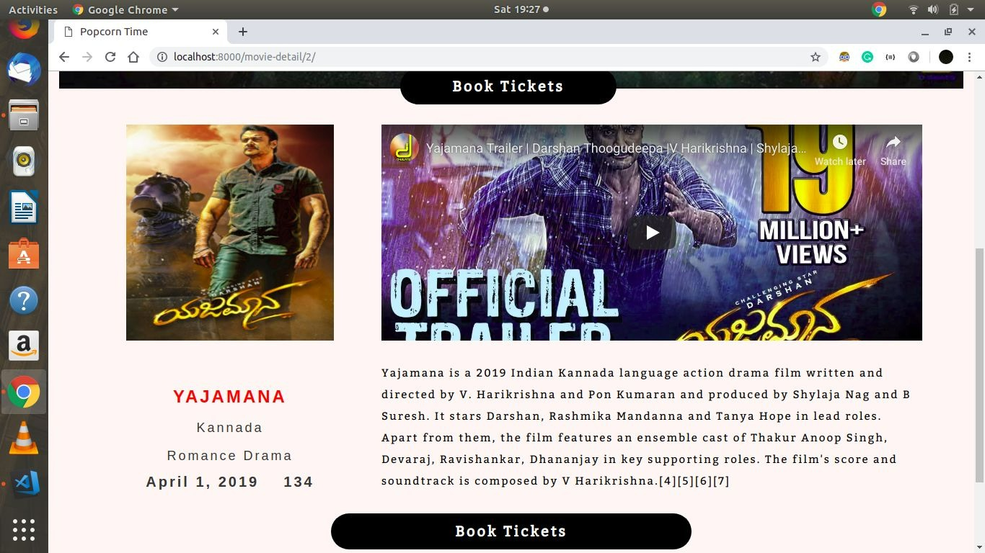

**Fig 8.1 Book ticket**

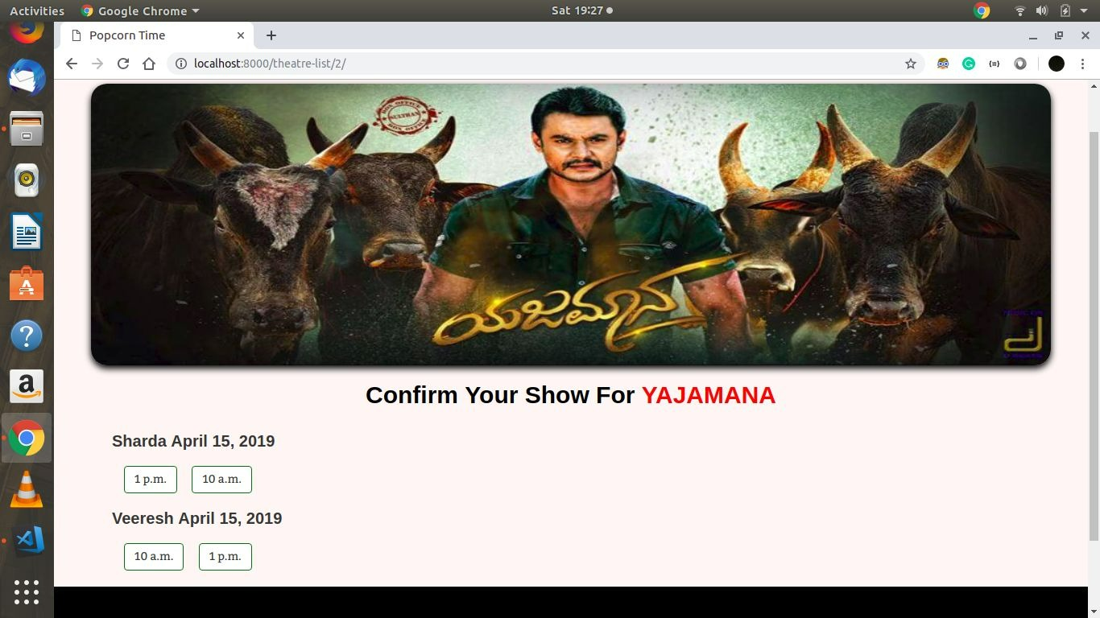

**Fig 8.2 Confirm show**

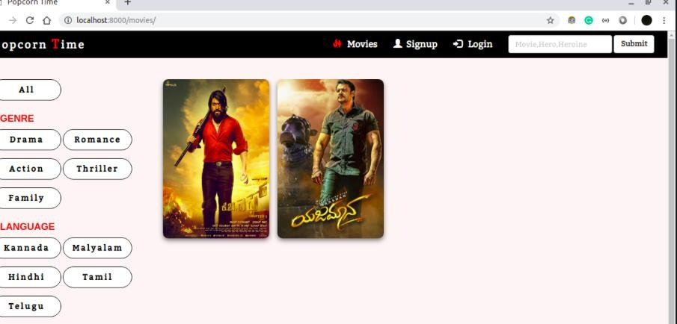

**Fig 8.3 Movie Information**

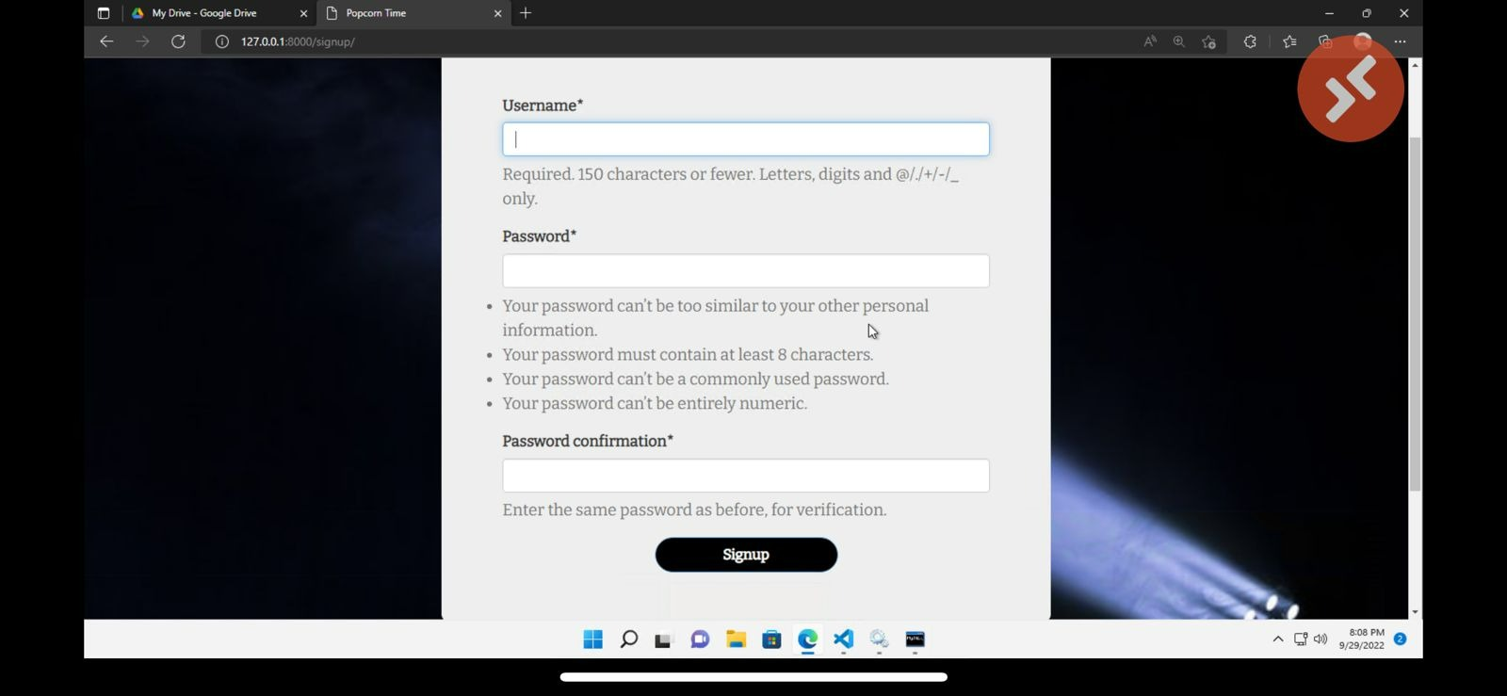

**Fig 8.4 Signup portal**

**CHAPTER 9**

**FUTURE SCOPE**

* The customers can buy ticket online and cancel the seats at a suitable time.
* All the customers have to login and become a member before buying tickets.
* Customers cancelling tickets will not be given money back; instead the amount of money will be
* recorded in the customer amount for further use.
* To make the system more user friendly, the customer need not enter lots of data.
* Customer will first choose the film, time and venue.
* Customer will login to the system.
* Customers will choose the seat positions.
* Customers need a credit card to complete a buying transaction.
* Confirm and show the transaction number to the customer.
* In addition to creating a member account, the customer can modify his/her own data.

**CHAPTER 10**

**CONCLUSION**

The package was designed in such a way that future modifications can be done easily. The following conclusions can be deduced from the development of the project:

* Automation of the entire system improves the efficiency
* It provides a friendly graphical user interface which proves to be better when compared to the existing system.
* It gives appropriate access to the authorized users depending on their permissions.
* It effectively overcomes the delay in communications.
* Updating of information becomes so easier
* System security, data security and reliability are the striking features.
* The System has adequate scope for modification in future if it is necessary.

**CHAPTER 11**

**REFERENCES**

<https://www.w3schools.com>

 <https://www.takeiteasyengineers.com>

 <https://www.geeksforgeeks.org>