Which products generate the highest and lowest revenue?
Querry for Lowest revenue:
select p.productid, p.productName, sum(od.unitPrice * od.quantity * (1 - od.discount)) as total_revenue
from product p
join orderdetail od
on p.productid = od.productid
group by p.productName, p.productid
order by total_revenue limit 1;
Result:
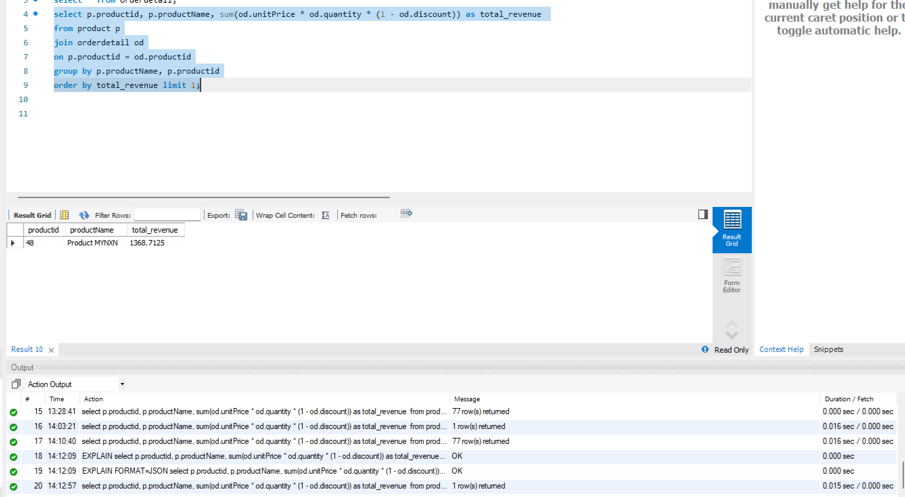

Querry for Highest Revenue:
select p.productid, p.productName, sum(od.unitPrice * od.quantity * (1 - od.discount)) as total_revenue
from product p
join orderdetail od
on p.productid = od.productid
group by p.productName, p.productid
order by total_revenue limit 1;
Result:
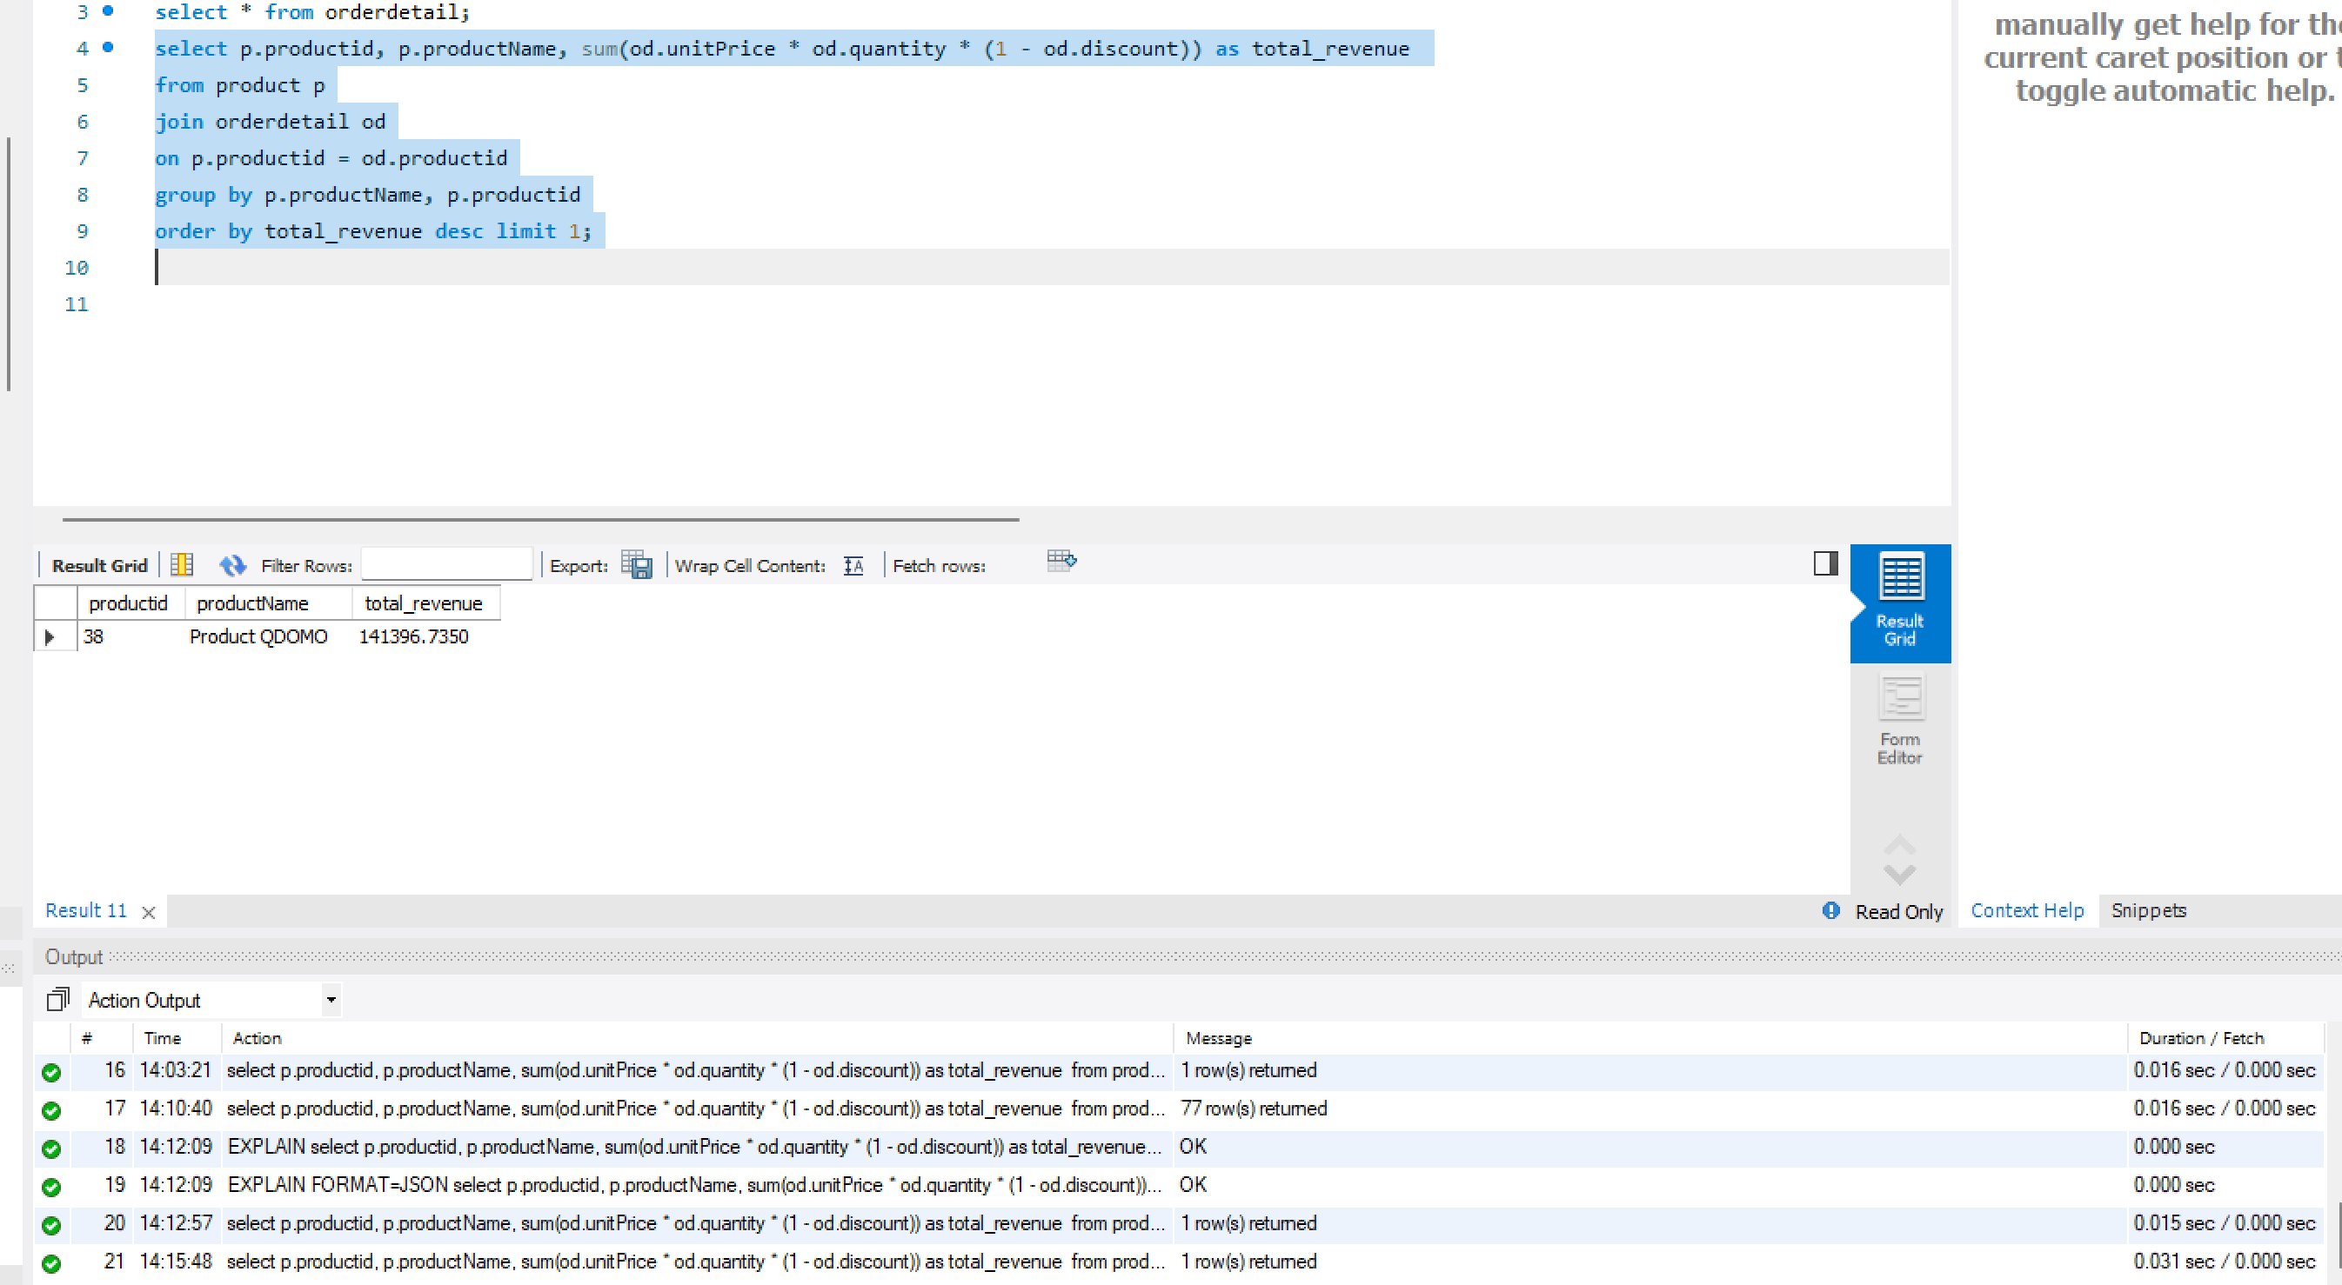

Insights: There is a huge gap between the highest and the lowest which suggests that the company mainly depends on highest contributors for its income. The lowest contributing Product 48 Product MYNXN contributes only 1368.7125 compared to highest contributing Product 38 Product QDOMO contributing 141396.7350. Overall, the Revenue is not evenly distributed.

Strategy: The Company should focus on expanding, promoting, advertising much more on high revenue generating products so that many sales happen in this product. And coming to low revenue products company should first analyze the reasons for low performance/revenue and act accordingly. Also, company should give discounts and offers on them so that more sales happen and thereby result in increasing the revenue for the particular product. And at last, if the revenue is not increase or decrease or show no affect even after taking necessary steps company may take decision to terminate/ not continuing the product.
==========================================================
Which product lines result in highest revenue? ( Category wise Highest)
Querry:
select c.categoryid, c.categoryName, sum(od.unitPrice * od.quantity * (1 - od.discount)) as total_revenue
from product p
join orderdetail od
on p.productid = od.productid
join category c
on c.categoryid = p.categoryId
group by c.categoryid, c.categoryName
order by total_revenue desc;
Result:
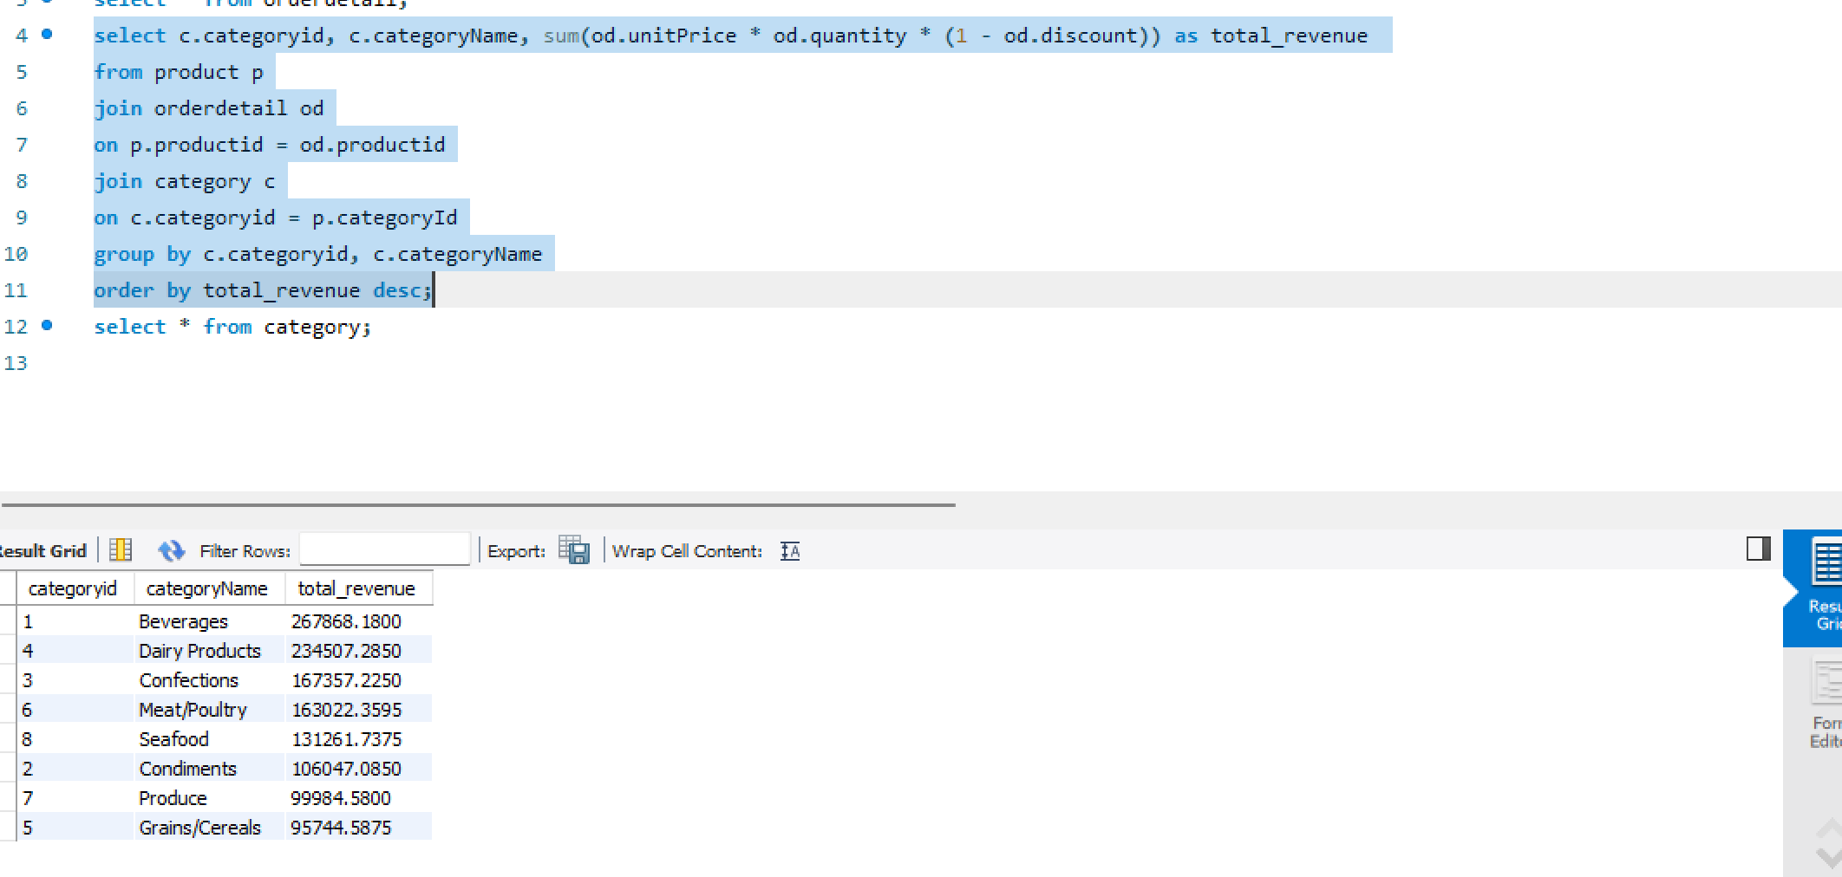

Insights: From the output we can know that the Category Beverages contribute highest 267868.1800 to the revenue. It is followed by Dairy Products and Confections. The above analysis indicate that the above said products have strong Customer demand. It also indicate that the company’s revenue is mostly driven by these products’ sales.
The least contributing product is Grains/Cereals with 95744.5875 which may indicate weaker demand from customers.
Strategy: The Company should prioritize high revenue giving category and encourage them more by keeping stocks always available, more promotions etc. For Low revenue products like grains/cereals the company should rethink of its strategies towards them like pricing, placement, supply and for increasing the revenue from this category Company should keep more offers on this type and also combos with other high selling products. Finally, even after all the strategies/ideas of company towards the low revenue category are not working the company can stop/discontinue the Category if necessary.
============================================================Who are the top customers, and what are their purchasing behaviors?
Querry:
select c.custId, c.companyName, c.city, count(distinct s.orderId) as total_orders,
sum(od.unitPrice * od.quantity * (1 - od.discount)) as total_purchasing_value,
sum(od.unitPrice * od.quantity * (1 - od.discount))/count(distinct s.orderId) as average_purchase_value
from customer c
join salesorder s
on c.custId = s.custId
join orderdetail od
on s.orderId = od.orderId
group by c.custId, c.companyName, c.city
order by total_purchasing_value desc;
Result:
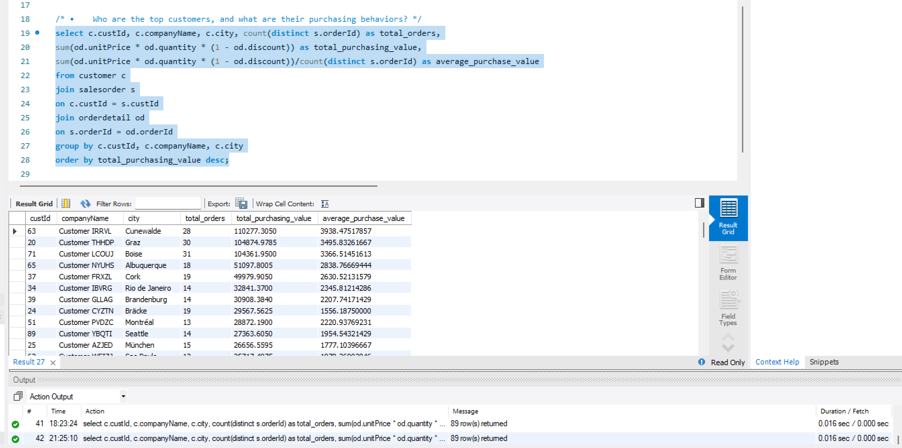
Overall average purchase value is 1525.05185 ( For Insights purpose)
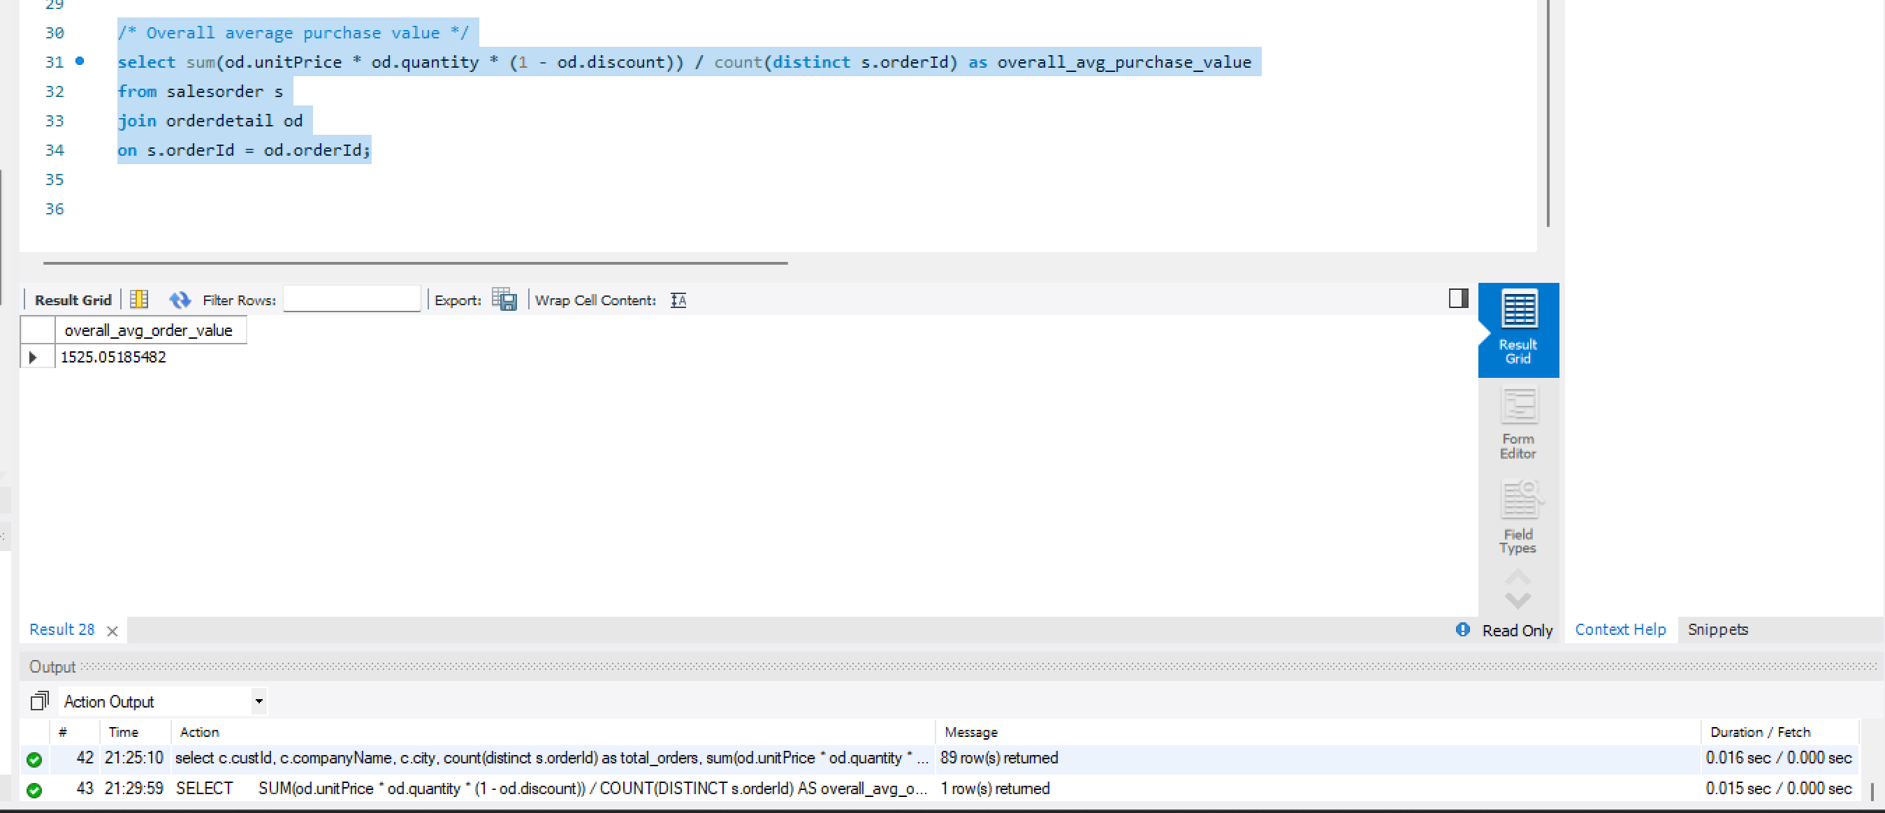
Insights: The Analysis shows that there is a vast variation in customer purchasing behaviour. A small group of customers contribute to maximum amount of overall Revenue which indicates that Business relies much on these customers. Also, we can confirm that these are the customers who place frequent orders/maximum no of orders. The overall average purchase value of all customers come down to 1525 which can be taken as benchmark and customers who spend more than the overall average can be considered as Premium customers while below average customers can be treated/considered as an opportunity to get more from them. Also from the count of orders, we can note that some customers place few orders but the worth is high compared to others who order more but overall value is less comparatively. And Finally there is a huge gap between top and bottom customers like top 3 contribute around 319510 and bottom 3 contribute around 1000.
Strategy: Company should take good care of the big spending customers by offering Royalties, Rewards, Special exclusive offers etc there by they can engage them more and not losing them, On the other side to encourage customers who spend less they should be offered with discounts, Offers, Combo and any other special products at reasonable rates should be introduced to attract them. Separate strategies should be implemented for high value and low value customers taking the overall purchase value 1525 as base and format different strategies for both.
============================================================
How do seasonal trends and order volumes vary over time?
Querry:
select year(s.orderDate) as year, month(s.orderDate) as month, count(distinct s.orderId) as total_orders,
sum(od.unitPrice * od.quantity * (1 - od.discount)) as total_revenue
from salesorder s
join orderdetail od
on s.orderId = od.orderId
group by year(s.orderDate), month(s.orderDate)
order by year, month;
Result:
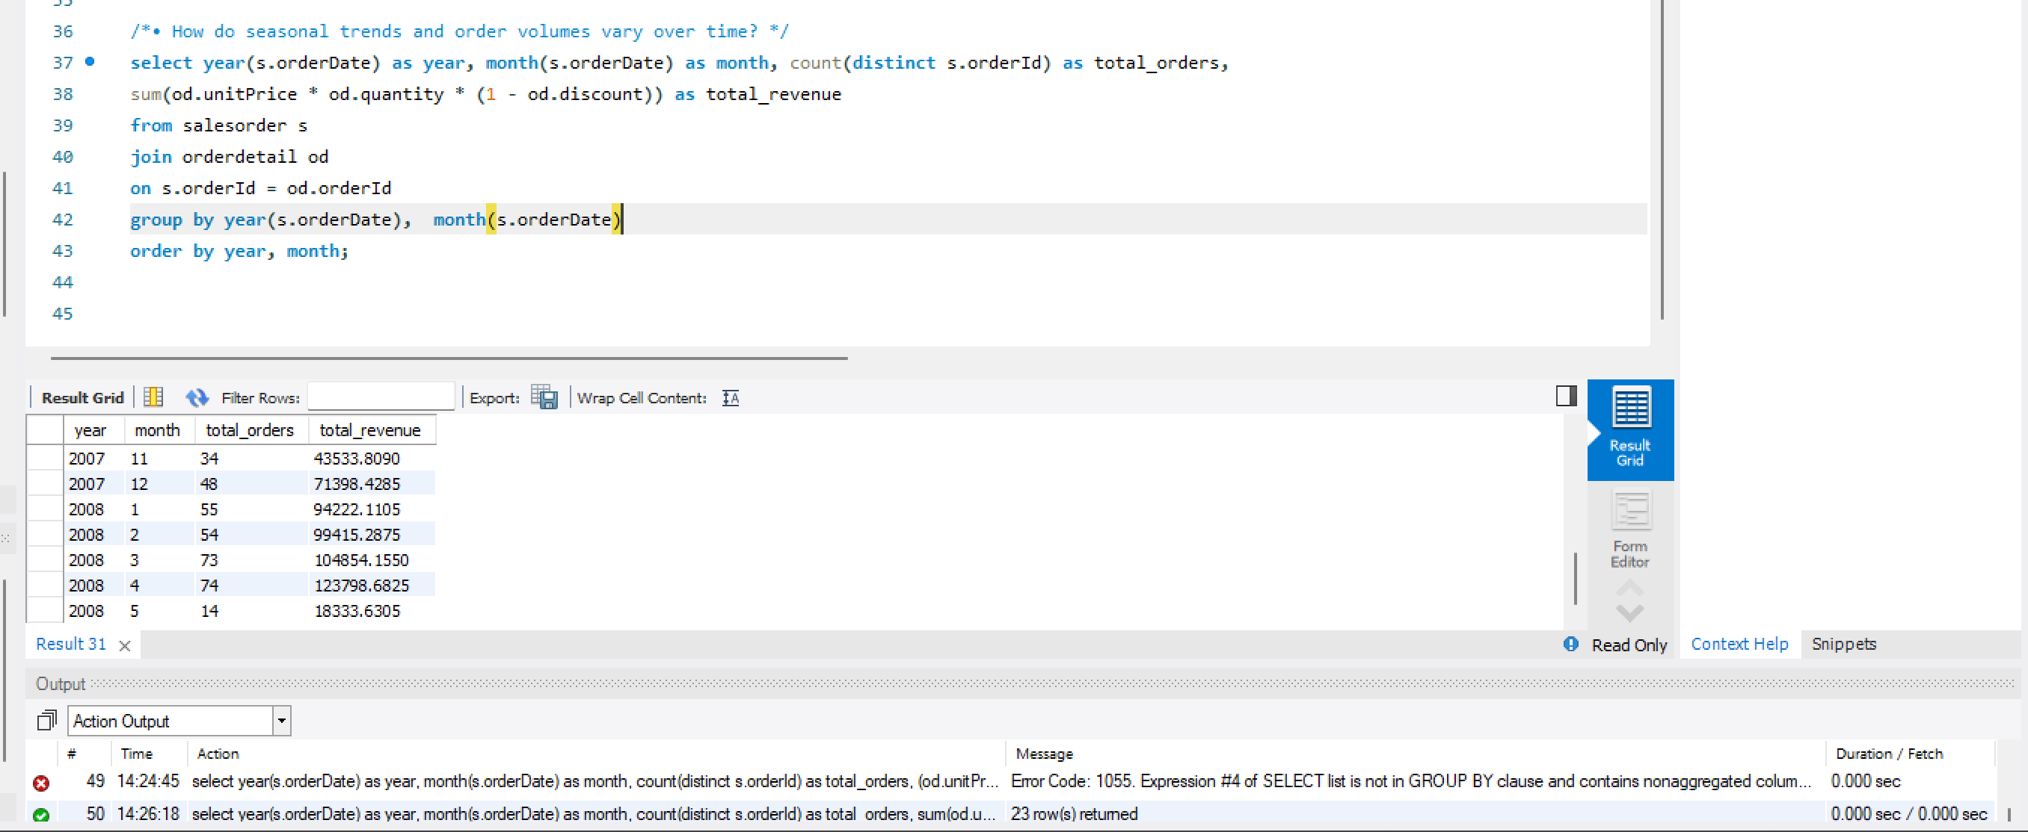
Insights: The data shows there is a steady increase in both no of orders and also total revenue, which indicates a positive steady growth. We can also infer it as increased sales performance and customer satisfaction. The highest revenue recorded was in April 2008 with total orders being 74 and revenue being 123798. While the lowest was immediately preceding May 2008. But there can be missing data for the May or it can be that the records for the month has not yet been completely entered. Overall the trend indicates that the company’s sales performance has improved consistently over time and peak period being the 2008.
Strategy: Since the company is growing in both Orders and also Revenue it can cnow consider expanding its business by opening new branches especially considering areas where it gets more customers from. It can also consider starting online oerdering and delivery services to attract more customers and sales.
============================================================
How status of orders affecting purchases? (Here I took Required date, order date, shipped date and if shipped date is greater than Required date then delayed and if shipped date is null then consider it as pending or else Intime. For this Im using Case Statement)
Querry:
select
case
when s.shippedDate > s.requiredDate then "Delayed"
when s.shippedDate < s.requiredDate or s.shippedDate = s.requiredDate then "Ontime"
when s.shippedDate is null then "Pending"
end as Shipping_Status,
count(distinct s.orderId) as total_orders,
sum(od.unitPrice * od.quantity * (1 - od.discount)) as total_revenue
from salesorder s
join orderdetail od
on s.orderId = od.orderId
group by Shipping_Status
order by total_revenue desc;

Result:
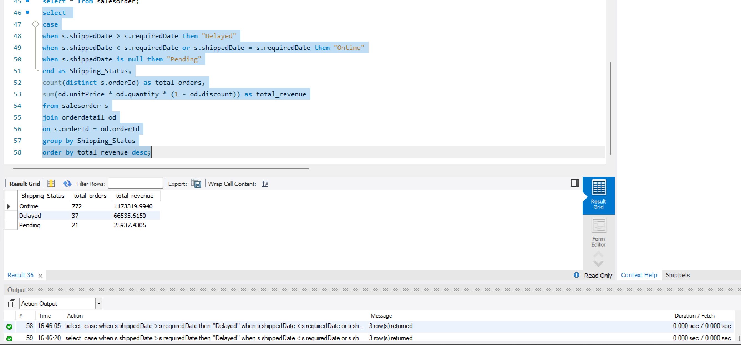
Insights: The analysis shows that more than 90% of orders i.e. 772 have been delivered On Time. While a very few which is 37 have record of Delay in delivery and undelivered/pending for delivery are 21 which together account for less than 10% of total Deliveries. This shows that the company’s delivery system/order processing is almost accurate and yielding very goods results. Overall timely delivery helped the company in customer satisfaction and increase revenue.
Strategy: Since most of the orders are delivered on time Company should continue this good work so that it wont drop customers satisfaction. The company should further improve/focus on the delayed deliveries and pending deliveries and create new mechanism so that the delivery system will result 100% On Time deliveries. For Delayed deliveries company should Introspect itself what can be the reasons and where actual delay is happening, Is it because of Inventory problem, any Transport issues etc and rectify the reasons.
============================================================

Understanding employee contribution in processing orders?
Querry:
select e.employeeId , concat(e.firstname,' ',e.lastname) as employee_name, count(distinct s.orderId) as per_employee_orders,
sum(od.unitPrice * od.quantity * (1 - od.discount)) as Revenue_per_employee,
sum(od.unitPrice * od.quantity * (1 - od.discount)) / count(distinct s.orderId) as avg_order_value
from employee e
join salesorder s
on e.employeeId = s.employeeId
join orderdetail od
on s.orderId = od.orderId
group by e.employeeId, employee_name
order by Revenue_per_employee desc;
Result:
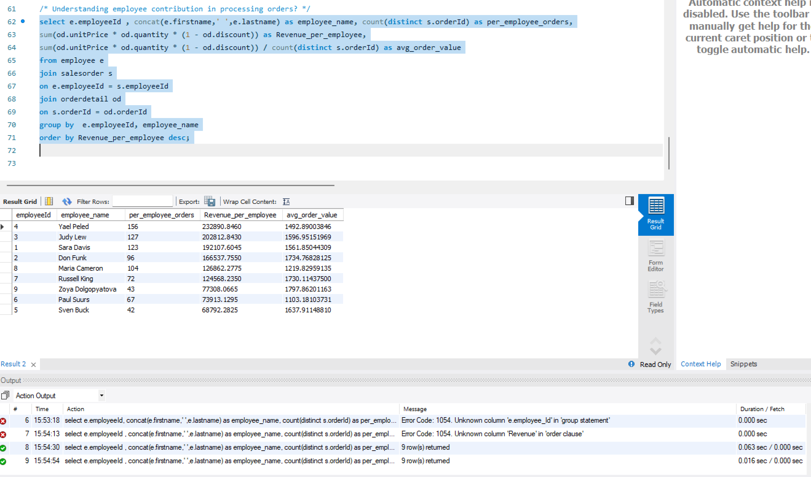
Insights: The analysis shows that the employee contribution varies across all employees not only in terms of per employee orders but also the per employee revenue and the average order values they took up. Employees such as Yael Peled, Judy Lew who are top 2 in total revenue took highest numbers of orders compared to others but when looking at the average order value their average order value was less compared to the bottom most contributor in terms of no of orders and Revenue, Sven Buck. We can infer that may be the top 2 or the persons with lot of orders have taken up low value orders where as Mr Sven Buck has taken up high value orders. We can infer from above that the company should not perform employee ability based on only no of orders processed but they can consider average order value also.
Strategy: Company should focus on different metrics like no of orders, average revenue etc so that employee morale will be maintained. High performing employees should be rewarded by Bonuses, Incentives, Paid holiday etc while the low performing employees should be given enough training, motivation so that they can improve their skills. The Company can also make the high performing employees coach the low performing employees, share their experiences etc so that the underperforming employees can also improve their performance.
============================================================
Whether credit limit of customers affecting purchase?
Answer: The Dataset provided doesn’t have enough data/ doesn’t have any direct or indirect information about the customers credit limit on any of the tables provided. So, it is difficult to analyze Customers credit limit affecting the purchases.
============================================================
From which countries/cities highest revenue is generated?
Querry:
select c.country, c.city, count(distinct so.orderId) as no_of_orders,
sum(od.unitPrice * od.quantity * (1 - od.discount)) as Revenue_per_city
from customer c
join salesorder so
on c.custId = so.custId
join orderdetail od
on so.orderId = od.orderId
group by c.country, c.city
order by Revenue_per_city desc;
Result:
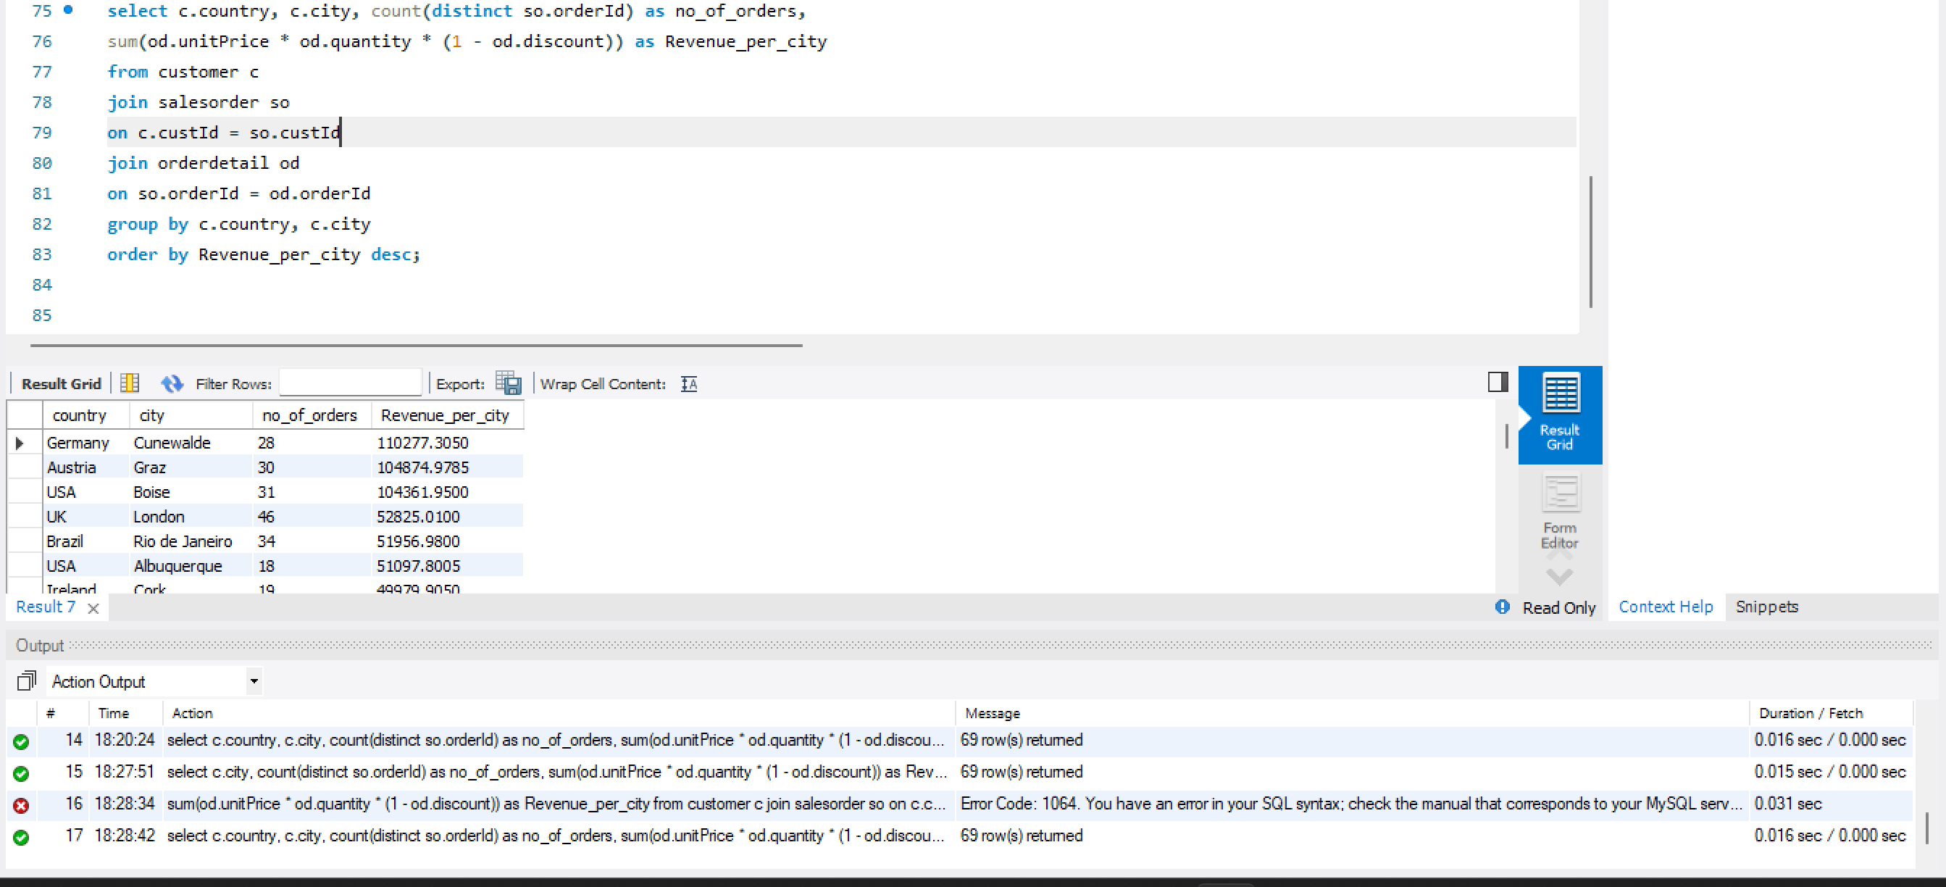
Insights: Based on the above analysis Cunewalde from Germany generated highest Revenue_per_city with 110277, while the lowest was from Walla Walla from USA with just 357. The analysis also clearly indicates that the hishest revenue generating city doesn’t put highest orders. The highest numbers of orders were placed by London from UK but its revenue contribution was significantly lower compared to the Cunewalde of Germany. This shows that some cities place small no of orders but with higher value where as some cities place large no of orders but with lower value. Many cities recorded reasonable number of orders but their overall contribution to revenue was very much lower comparatively.
Strategy: The company should focus on increasing Business and market more in high revenue contributing countries like Cunewalde in Germany, Graz of Austria etc so as to increase its customer base which further helps in higher revenue generation.
For low performing cities Company should introduce promotional strategies like combos, discounts, loyalty programs to encourage more purchases by customers.
Coming to cities with high number of orders, Company can try introducing premium products which can increase the order values.
============================================================
Which shipping company contributes the highest revenue and handles the maximum number of orders?
Querry:
select s.companyName, count(distinct so.orderId) as orders_handled_by_Shipper,
sum(od.unitPrice * od.quantity * (1 - od.discount)) as Revenue_generated
from shipper s
join salesorder so
on s.shipperId = so.shipperId
join orderdetail od
on so.orderId = od.orderId
group by s.companyName
order by Revenue_generated desc;
Result:
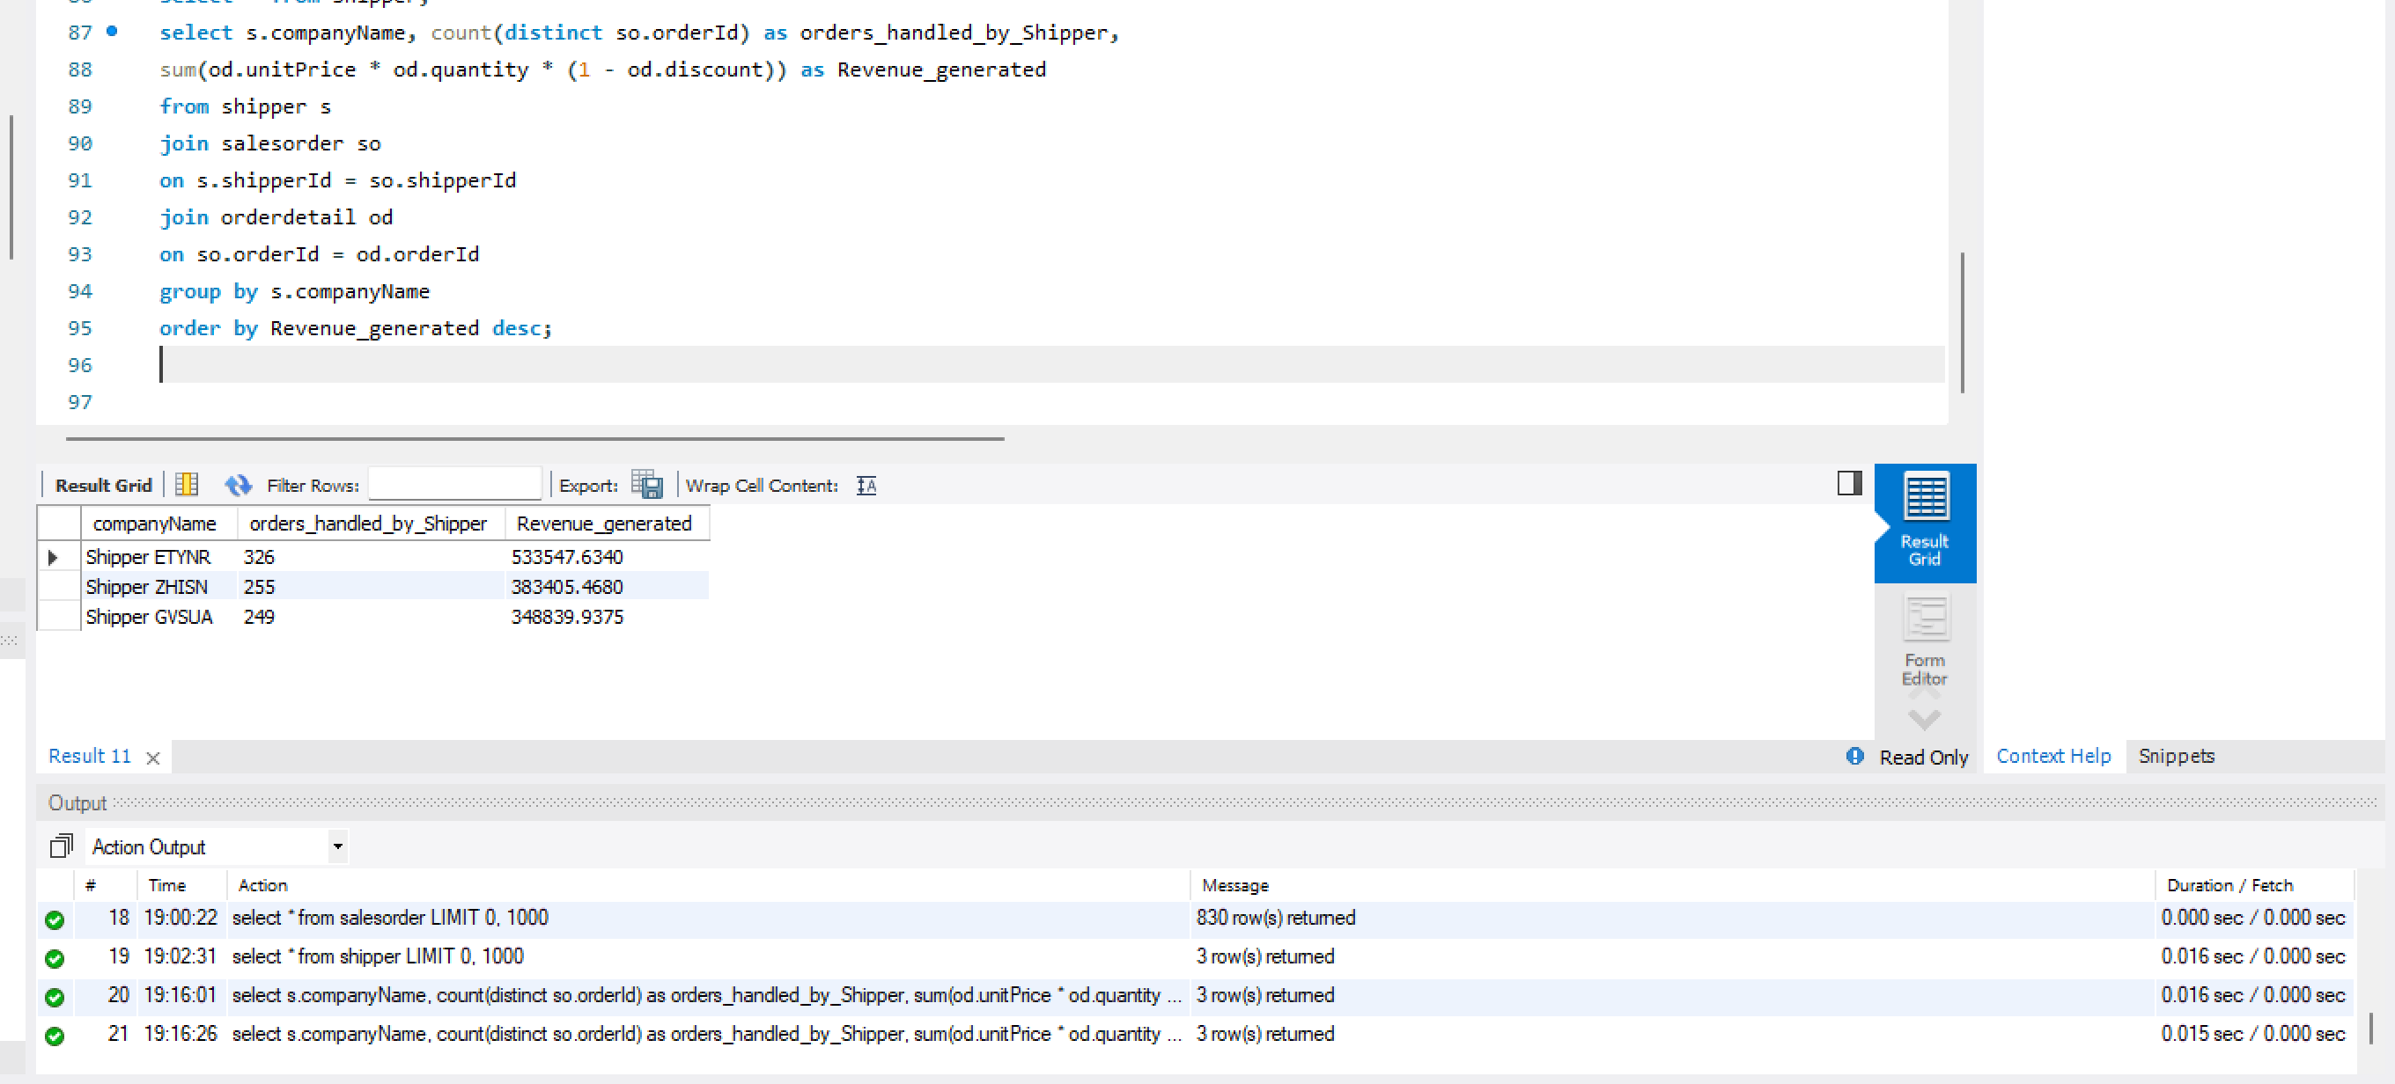
Insights: Based on the analysis shipper ETYNR handled highest number of orders (326) and also accounted for highest revenue generation association 533548. This indicates that this shipping company is most actively used among all the 3 companies. Shipper ZHISN handled 255 orders and associated in generation of revenue around 383405. Coming to the shipper GVSUA it handled lowest orders(249) among 3 shippers and associated in lowest revenue, which suggest that it is less preferred for shipping or less used for shipping.
From the analysis we can confirm that the more orders the shipper takes the more association they have on the revenue generated.
Strategy: The Company should strengthen its ties with shipping companies that are associated with higher revenue contributions and larger order volumes, as they play an important role in ensuring timely and smooth deliveries.
Since Shipper ETYNR is involved in higher revenue company can prioritize it for high-value deliveries for operational efficiencies. For lower associated shippers’ company should analyze their delivery speed and efficacy and identify areas for improvement.
============================================================

Which cities and countries incur the highest freight (shipping) charges and order volumes?
Querry:
select c.country, c.city, count(distinct so.orderId) as total_orders,
sum(so.freight) as total_Freight_cost,
avg(so.freight) as average_Freight_cost
from customer c
join salesorder so
on c.custId = so.custId
group by c.country, c.city
order by total_Freight_cost desc;
Result:
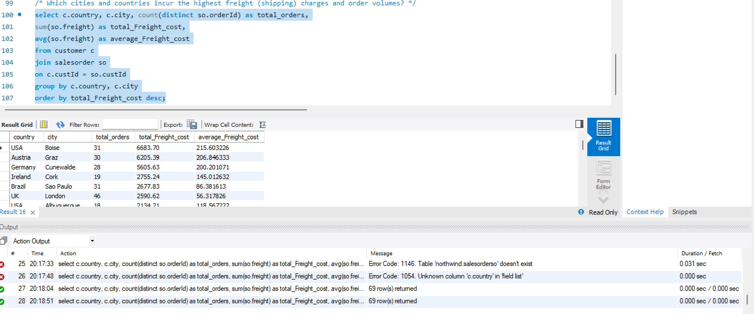
Insights: Based on analysis Boise of USA incurred highest total Freight cost amounting to 6684 handling just 31 orders followed by Graz of Austria with freight charges of 6205 and 30 total orders. In the analysis we can infer that some cities like London have more orders but incur less freight charges comparatively to others. This analysis helps identify cities where logistics and shipping expenses are significantly high, which in turn affects profitability.
Strategy: The company should focus on Cost cutting measures especially with reference to cities where freight charges are higher. Find any alternatives that are available which can help improve profitability and cut cost. The company can also negotiate with other delivery agencies which can give lower freight charges comparatively. If the orders are heavy from any city they can also plan any warehouse or special offices instead of shipping from different places they can plan for within city offices/warehouses.

