

AI 342-Deep Learning
Dr. Rasha Obeidat
[Cite your source here.]
Jana | Raghad | Samer | Mohammad

[Cite your source here.]

Clickbait Headline

Detection using

Deep Learning

Abstract
This project presents a clickbait headline detection system using machine learning and deep learning techniques. Two models were implemented and compared: Logistic Regression and LSTM. The LSTM model achieved the best overall performance with approximately 97% accuracy.
1. Introduction
Clickbait headlines are commonly used on online platforms to attract users and increase engagement. This project aims to automatically classify headlines into clickbait and non-clickbait categories using NLP and deep learning methods.

2. Dataset Description
Clickbait headlines are commonly used on online platforms to attract users and increase engagement. This project aims to automatically classify headlines into clickbait and non-clickbait categories using NLP and deep learning methods.

Figure1: Sample headlines from the dataset.
Example headlines with their labels. Label 1 represents clickbait while label 0 represents non-clickbait.

3. Data Preprocessing
Several preprocessing techniques were applied including cleaning text, tokenization, lowercasing, sequence padding, and converting text into vectors using a trainable embedding layer.
Text Cleaning → Lowercasing → Tokenization
→ Sequence Padding → Word Embedding
4. Baseline Model – Logistic Regression
Logistic Regression was implemented as the baseline model using TF-IDF vectorization. The model achieved strong classification performance and provided a comparison reference for the deep learning model.
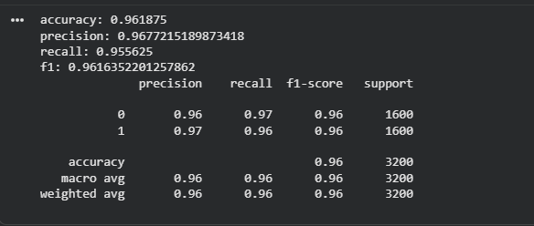
Figure 2: Classification report for the baseline Logistic Regression model.
The baseline model achieved approximately 96% accuracy with high precision and recall values.

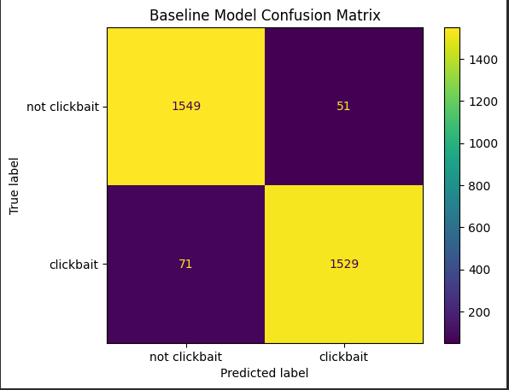
Figure 3: Baseline confusion matrix.
Most headlines were classified correctly with a small number of prediction errors.
5. Deep Learning Model – LSTM
The LSTM model was implemented to capture contextual and sequential relationships between words. The architecture included an embedding layer, LSTM layer, dropout layer, and sigmoid output layer.

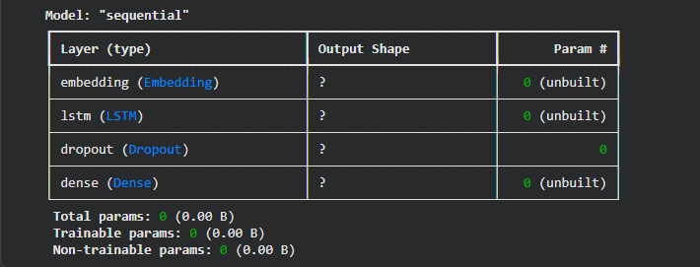
Figure 4: LSTM model architecture.
The model uses trainable word embeddings followed by an LSTM layer to learn contextual patterns in headlines.


Figure 5: Training progress across epochs.
Training accuracy increased steadily while validation accuracy remained stable.

6. Experimental Results
The LSTM model achieved better performance compared to Logistic Regression. The results indicate that deep learning methods are highly effective for clickbait classification tasks.
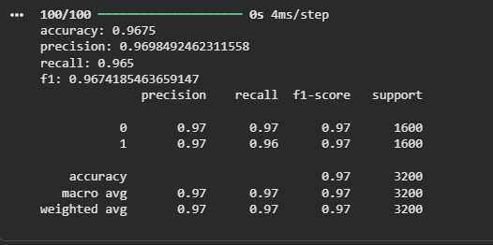
Figure 5: LSTM evaluation metrics.
The LSTM model achieved approximately 97–98% accuracy with excellent precision and recall.
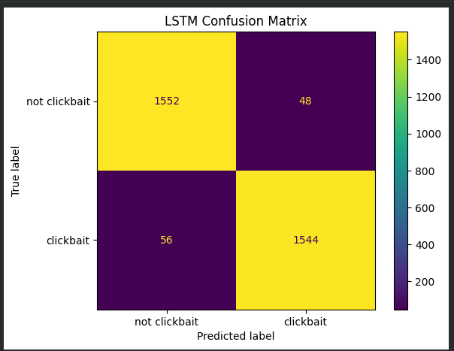
Figure 6: LSTM confusion matrix.
The confusion matrix demonstrates strong classification performance with very few incorrect predictions.

7. Accuracy and Loss Analysis
The following graphs illustrate model behavior during training. Training accuracy improved continuously while validation accuracy remained relatively stable.
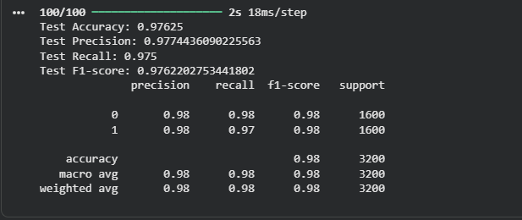
Figure 7: LSTM accuracy curve.
Training accuracy approached 99% while validation accuracy stabilized around 96–97%.

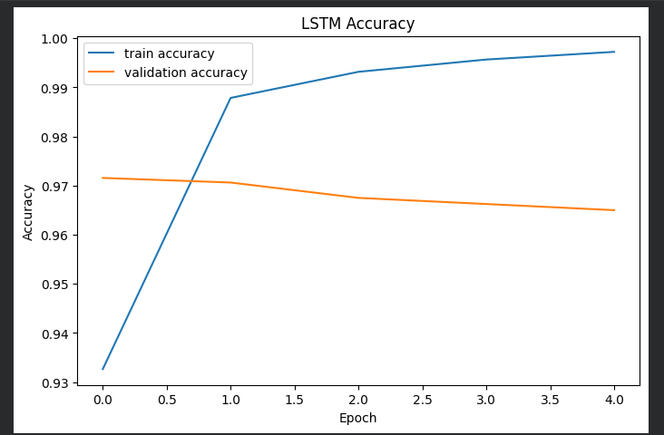
Figure 8: LSTM loss curve.
Training loss decreased significantly while validation loss slightly increased during later epochs.

8. Model Comparison
The final comparison shows that the LSTM model slightly outperformed Logistic Regression in terms of accuracy and F1-score.

Figure 9: Final comparison between implemented models.
The LSTM model achieved the best overall classification performance.
Performance Comparison Table
Model | Accuracy | F1-Score
Logistic Regression | 96.19% | 96.16%
LSTM | 97.62% | 97.62%

9. Conclusion
This project successfully demonstrated the effectiveness of deep learning for clickbait headline detection. Although Logistic Regression achieved strong baseline performance, the LSTM model produced the best overall results due to its ability to understand contextual information within text sequences.

